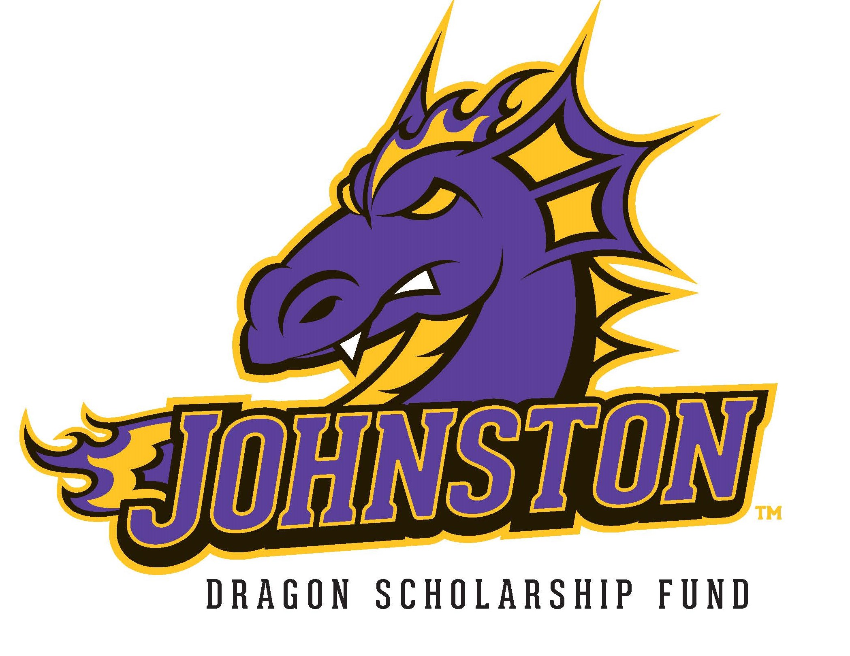

November 30, 2021

Dear Johnston High School Senior and Family,

The Dragon Scholarship Fund, Inc. is a local, volunteer organization that raises funds and awards scholarships to Johnston High School seniors prior to graduation. Our goal is to give financial assistance to every JHS senior as they continue their education beyond high school. We believe every student deserves a chance to earn a scholarship, regardless of grade point average, financial need, or ability. This letter is to notify you of the scholarship process and timeline.

Our organization is comprised of community volunteers. Through our previous Phone-a-Thon’s, online fundraising campaign, annual auction, and other events—as well as generous support from local businesses, civic organizations, private donations and memorials—we are able to fund these scholarships each year. Scholarships are in varying amounts and students will be notified of their award by the end of April 2022. All students are encouraged to apply regardless of the type of higher education they plan to pursue. All application information will be used only by the awards committee and will be kept confidential.

You do not need to provide your academic achievements. With your consent, the Johnston High School Counseling Office will supply your GPA to be included as part of our evaluation process.

In order to qualify for and receive a scholarship, you must carefully follow the steps listed on the “Six Step Process” sheet, which is included with this letter. ALL of the steps must be completed in order to qualify for a scholarship. If any steps are missing or incomplete, your scholarship may be forfeited. All scholarship decisions made at the sole discretion of Dragon Scholarship Fund and are final.

Please see the Six Step Process document for the dates and guidelines that will help you successfully complete the application process.

Please direct all questions about the scholarship process to dragonscholarshipfund@gmail.com. We look forward to meeting you in the application process and wish you the best of luck with your future plans!

Sincerely,

The Dragon Scholarship Fund Scholarship Committee
dragonscholarshipfund@gmail.com

