**Syllabus**



**Arizona Perinatal Trust**

**30th Annual Conference**

**August 18-19, 2022**

**Flagstaff, Arizona**

**ARIZONA PERINATAL TRUST**

**“A Perinatal Quality Collaborative”**

501 (c)(3) non-profit

711 East Cottonwood Lane, Suite C

Casa Grande, Arizona 85122-2725

Phone: (520) 421-9880

[www.azperinatal.org](http://www.azperinatal.org)

August 18, 2022

Dear Colleagues,

On behalf of the APT Board of Trustees and APRS Board of Directors, welcome to the 30th Annual Arizona Perinatal Trust Conference. Thank you for joining this community of health care professionals who share a common goal – improving the health of Arizona’s mothers and babies.

The aim of the conference is to offer science, methodology, practice initiatives, and discussion points for you to explore. We encourage you to actively participate in this learning experience, share your thoughts, and broaden your knowledge in support of babies, parents and families in the healthcare setting.

Many thanks to our event sponsors, exhibitors and speakers, especially those who have continued their support throughout the years. Please be sure to show your appreciation by visiting the exhibits during breaks and by attending the Wine and Cheese Reception Thursday evening in the Exhibit Room.

We hope your conference experience provides opportunities for new collegial connections and to learn new approaches and skills that inspire you to continue improving the health of Arizona’s mothers and babies throughout the coming year.

For information about the 31st Annual Arizona Perinatal Trust Conference, check our [website](http://www.azperinatal.org) at or follow us on [Facebook](https://www.facebook.com/AZPerinatalTrust) .

Best Regards,

Robert “BJ” Johnson, MD

Chairman

APT Board of Trustees

Alan Bedrick, MD

President

APRS Board of Directors

Laurie Wood

Chief Executive Officer

Arizona Perinatal Trust

**2022**

**Arizona Perinatal Trust**

**Conference Agenda**

|  |  |
| --- | --- |
| **THURSDAY, AUGUST 18, 2022** | |
| **7:00 am** | **Registration, Breakfast and Exhibits** |
| **8:00 am** | **Welcome & Announcements**  *Robert “BJ” Johnson, MD & Laurie Wood* |
| **8:30 am** | **COVID-19 and Pregnancy: What have we learned?**  *Cathleen Harris, MD* |
| **9:30 am** | **Eureka! New Insights into how we make decisions**  *Kathryn L. Reed, MD* |
| **10:30 am** | **Break and Exhibits** |
| **11:00 am** | **Pregnancy Complications as a Predictor of Cardiovascular Health in Women**  *Curtis Cook, MD* |
| **12:00 pm** | **Lunch and Exhibits** |
| **1:00 pm** | **Understanding How Post Birth Warning Signs Impact Morbidity and Mortality in the Post-Partum Period**  *Lori-Ann Satran, MSL* |
| **2:00 pm** | **Nurse Burnout: Is there more to it than COVID-19?**  *Angelina Price, MS, NNP* |
| **3:00 pm** | **Break and Exhibits** |
| **3:30 pm** | **Management of the Neonatal Patent Ductus Arteriosus**  *Michael Seckeler, MD* |
| **4:30 pm** | **Adjournment** |
| **5:30—6:30 pm** | **Reception and Exhibits** |
| **FRIDAY, AUGUST 19, 2022** | |
| **7:00 am** | **Breakfast and Exhibits** |
| **7:45 am** | **Welcome and Announcements**  *Robert “BJ” Johnson, MD and Alan Bedrick, MD* |
| **8:00 am** | **State-Wide Maternal Health Initiatives**  *Heidi Christensen, MSW and Lynn Lane* |
| **9:00 am** | **Perinatal Health: How are we doing? A Snapshot of 2021 Perinatal Data**  *Michael Clement, MD* |
| **9:30 am** | **R&Gs Highlights**  *Mary Luster, MSN* |
| **10:00 am** | **Break, Hotel Check-out and Exhibits** |
| **10:30 am** | **Developing Antepartum and NICU Acuity Tools**  *Mary Luster, MSN; Sarah Dent, MSN; Cheryl Roth, PhD* |
| **11:30 pm** | **Maternal Mortality and Severe Maternal Morbidity in Arizona**  *Glenda Ramirez* |
| **12:30 pm** | **Closing Remarks and Adjournment**  *Robert “BJ” Johnson, MD and Alan Bedrick, MD* |

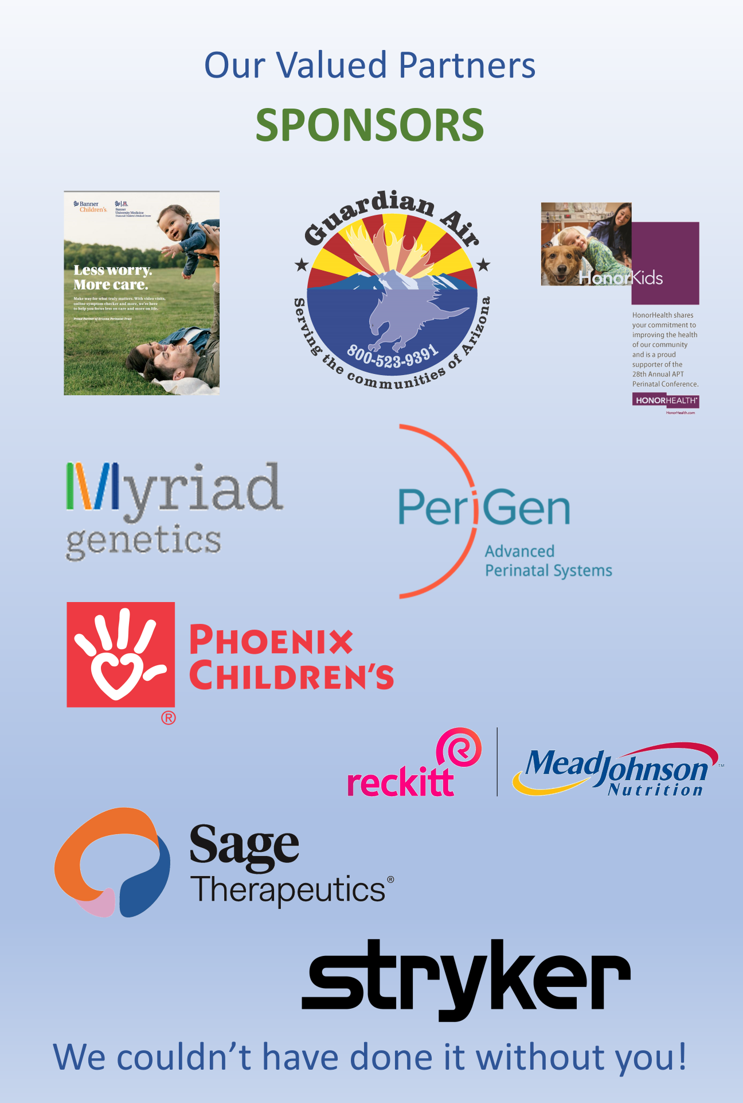

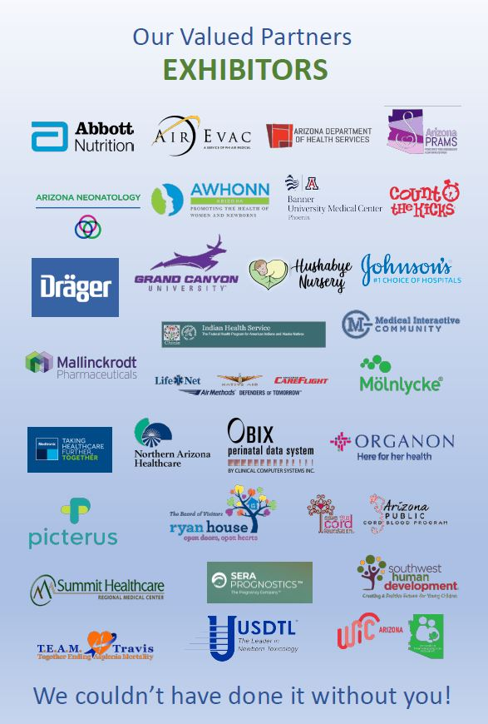

2022 Arizona Perinatal Trust

Conference Committee

|  |  |
| --- | --- |
| * **Robert “BJ” Johnson, MD (Committee Chair)**   Chairman, Board of Trustees  Arizona Perinatal Trust | * **Alan Bedrick, MD**   President, Board of Directors  Arizona Perinatal Regional System, Inc. |
| * **Deb Christian**   Former Executive Director  Arizona Perinatal Trust | * **Sarah Dent, MSN**   Treasurer, Board of Directors  Arizona Perinatal Regional System, Inc. |
| * **Mary Luster, MS-L, BSN, RN, NE-BC**   Vice President, Board of Directors  Arizona Perinatal Regional System, Inc. | * **Hugh S. Miller, MD**   Secretary, Board of Directors  Arizona Perinatal Regional System, Inc. |
| * **Kathleen Rose**   Event Coordinator  Arizona Perinatal Trust | * **Laurie S. Wood, MS, RN**   Chief Executive Officer  Arizona Perinatal Trust |

Conference Evaluations and

Continuing Education Unit/Attendance Certificates

Please make sure that you sign-in both days at the Registration Desk, submit your Conference Evaluation and your name badge to receive your Continuing Education Units/Attendance Certificates.

Thank you to HonorHealth for partnering with the APT for these Certificates.

Speaker Disclosure

All conference speakers signed the following disclosure: Neither the speakers, nor any immediate family member, currently has or has had, in the past two years a financial interest, arrangement or affiliation with one or more organizations that could be perceived as a real or apparent conflict of interest in the context of the subject of this presentation.

Welcome

Thursday, August 18, 2022 @ 8:00 am

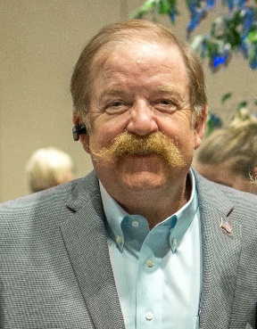

**Robert “BJ” Johnson, MD**

Chairman, Board of Trustees

Arizona Perinatal Trust



**Laurie Wood**

Chief Executive Officer

Arizona Perinatal Trust



**Alan Bedrick, MD**

President, Board of Directors

Arizona Perinatal Regional System

COVID-19 and Pregnancy-What have we learned?

Thursday 8:30 am

**Cathleen Harris, MD, MPH**

Perinatal Director, HonorHealth

Fellowship in MFM at the University of Chicago 1994-1996. Has worked as MFM in Arizona since 2000. Perinatal Director since 2016 and Women's Service Line director 2016-2021 at HonorHealth

**Objectives:**

1. Review maternal and fetal effects of COVID 19 during pregnancy
2. Discuss COVID 19 vaccines and treatment during pregnancy
3. Discuss ways health systems have responded to COVID 19 for OB patients

[Click here to view slides](https://img1.wsimg.com/blobby/go/d86972fd-1298-4c16-865a-e7c33f54ab3e/downloads/COVID%2019%20and%20Pregnancy%202022%20APT%20V2.pdf?ver=1659659395363)

**Notes:**

Type your notes here

Eureka! New insights into how we make decisions

Thursday 9:30 am

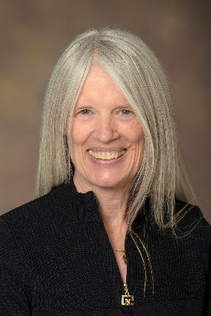

**Kathryn L Reed, MD**

Professor Emeritus, Department of OB/Gyn

University of Arizona College of Medicine

Dr. Reed is known internationally for her work in fetal cardiac physiology. Having recently rediscovered an interest in philosophy (BA, Pomona College), she is currently exploring the intersection between Behavioral Economics, health, and leadership, and the potential impact of this understanding on both health behavior and the development of more intelligent organizations.

**Objectives:**

1. Illustrate biases that affect decision-making, especially under uncertainty
2. Propose approaches to improve decision-making for individuals and groups
3. Improve health of individuals, work groups and communities

[Click here to view slides](https://img1.wsimg.com/blobby/go/d86972fd-1298-4c16-865a-e7c33f54ab3e/downloads/BE%20APT%2018%20Aug%202022%20-%20Reed.pdf?ver=1659659395363)

**Notes:**

Type your notes here

Pregnancy Complications as a Predictor of Cardiovascular Health in Women

Thursday 11:00 am



**Curtis Cook, MD**

OB Medical Director

Dignity Health Medical Group-East Valley

Dr. Cook is also Associate Clinical Professor at Creighton University School of Medicine Phoenix and Associate Clinical Professor at University of Arizona-Phoenix School of Medicine

**Objectives:**

1. Identify pregnancy risks factors associated with later cardiovascular disease
2. Describe the spectrum of increased cardiovascular risks and appropriate post pregnancy follow up
3. Discuss obstetrical interventions that might reduce later cardiovascular risks for women after childbearing years completed

[Click here to view slides](https://img1.wsimg.com/blobby/go/d86972fd-1298-4c16-865a-e7c33f54ab3e/downloads/Adverse%20Pregnancy%20Outcomes%20(APO)%20and%20Cardiovas.pdf?ver=1659659395363)

**Notes**:

Type your notes here

Understanding How Post Birth Warning Signs Impact Morbidity & Mortality in the Post-Partum Period

Thursday 1:00 pm



**Lori-Ann Satran, RN, BSN, MSL, NEBC**

Associate Vice President of Women, Infant’s and Children

HonorHealth

Lori-Ann has been a member of the HonorHealth team for 31 years. She worked her way from the bedside to her role today. She is a Board Member for the Arizona Perinatal Trust. She has been on the National AWHONN (Association for Women’s Health and Obstetrical and Neonatal Nurses) Conference Planning Committee for the past two years. She served two terms as the Secretary/Treasurer for Arizona AWHONN and two terms as Section Chair for Arizona AWHONN. She has presented at National Conferences, is published, and was an Executive Fellow of the Advisory Board out of Washington, DC.

**Objectives:**

1. There will be an understanding of severe maternal morbidity/mortality SMM
2. There will be an understanding of what POST BIRTH acronym stands for
3. The attendees will have a better understanding of maternal and pregnancy related deaths and how it is defined

[Click here to view slides](https://img1.wsimg.com/blobby/go/d86972fd-1298-4c16-865a-e7c33f54ab3e/downloads/Post%20Birth%20Warning%20Signs%202.pdf?ver=1659659395363)

**Notes**:

Type your notes here

Nurses Burnout: Is there more to it than COVID-19?

Thursday 2:00 pm



**Angelina Price, MS, NNP**

Neonatal Nurse Practitioner Supervisor

Banner University Medical Center - Tucson

Angelina Price is a NCC certified Neonatal Nurse Practitioner who received her BSN from NAU and her Masters of Science in Nursing from University of Kansas-City Missouri with the focus of Neonatal Nurse Practitioner. She has been a NNP at Banner UMC Tucson since July of 2011. She began her current role of NNP supervisor in January of 2020, and recently completed the NANN Emerging Leader Fellowship Program. Her passion is providing a voice for APP providers and building her NNP group from within her NICU.

**Objectives:**

1. Identifying staff who are at risk of burnout
2. How to prevent/intervene to prevent burnout
3. How to retain the staff you have in times of crisis

[Click here to view slides](https://img1.wsimg.com/blobby/go/d86972fd-1298-4c16-865a-e7c33f54ab3e/downloads/Burnout_A.Price_APT.pdf?ver=1659659395364)

**Notes**:

Type your notes here

Management of the Neonatal Patent Ductus Arteriosus

Thursday 3:30 pm

**Michael Seckeler, MD, MSc**

Professor of Pediatrics (Cardiology)

Banner University Medical Center - Tucson

Dr. Seckeler is a Pediatric and Adult Congenital Cardiologist specializing in cardiac catheterization procedures. He has treated hundreds of children and adults with congenital heart disease through a minimally invasive approach, most recently extending these procedures to premature infants

**Objectives:**

1. Understand the pathophysiology of the neonatal patent ductus arteriosus
2. Understand the treatment options available
3. Understand the benefits, and risks, of catheter-based patent ductus arteriosus closure in premature neonates

[Click here to view slides](https://img1.wsimg.com/blobby/go/d86972fd-1298-4c16-865a-e7c33f54ab3e/downloads/Management%20of%20neonatal%20PDA%20compressed.pdf?ver=1659659395364)

**Notes**:

Type your notes here

State-Wide Maternal Health Initiatives

Friday 8:00 am



**Heidi Christensen, MSW**

Maternal Health Innovation Program Manager

Arizona Department of Health Services

Heidi is a Program Manager at ADHS, working to improve maternal health in Arizona, through initiatives including the Maternal Health Task Force and is the AIM State Lead. For more than 20 years, Ms. Christensen has worked on intervention and prevention initiatives to improve the lives of families in Arizona.



**Lynn Lane**

Tribal Maternal Health Innovation Program Manager

Arizona Department of Health Services

Lynn Lane is the Tribal Maternal Health Innovation Program Manager with Arizona Department of Health Services. Ms. Lane's role is to engage stakeholders from Tribal communities to participate in the Tribal Maternal Health Task Force. Lynn strives to improve maternal health outcomes for indigenous families in Arizona.

**Objectives:**

1. Provide an overview of the state-focused Maternal Health Task Force
2. Provide an overview of Tribal Maternal Health Initiatives
3. Understand the importance of quality health improvement initiatives in birthing facilities

[Click here to view slides](https://img1.wsimg.com/blobby/go/d86972fd-1298-4c16-865a-e7c33f54ab3e/downloads/Christensen%20and%20Lane%20Maternal%20Health.pdf?ver=1659659395364)

**Notes**:

Type your notes here

Perinatal Health: How are we doing? A Snapshot of 2021 Perinatal Data

Friday 9:00 am



**Michael Clement, MD**

Chair, APT Data Committee

Arizona Perinatal Trust – Board of Trustees Member

Pediatrician and public health officer. Long time associate of APT, MOD. Papers and presentations on perinatal health, particularly Arizona. Outreach and practice in rural as well as Phoenix and Tucson. First pediatrician in Sierra Vista.

[Click here to view slides](https://img1.wsimg.com/blobby/go/d86972fd-1298-4c16-865a-e7c33f54ab3e/downloads/APT%20Data.pdf?ver=1660154682535)

**Notes**:

Type your notes here

R&G Highlights

Friday 9:30 am

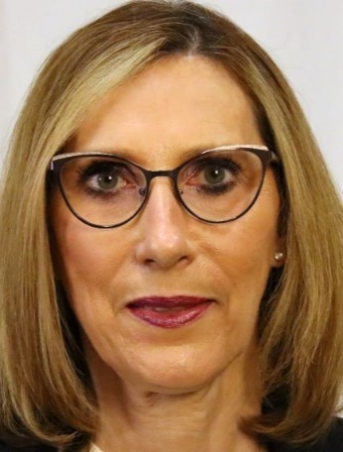

**Mary Luster, RN, BSN, MSL, NEBC**

Senior Clinical Director NICU/PICU/Pediatrics

HonorHealth Scottsdale Shea

Mary is the Senior Clinical Director for the Pediatric Department, The Neonatal Intensive Care Department and the Pediatric Intensive Care Department at HonorHealth, in Scottsdale. She has have 39 years of experience in the field of Nursing with expertise in the fields of Pediatrics, Neonatal Intensive Care, and Pediatric Intensive Care. Other roles she has held are that of Supervisor, Administrative Representative, and Director and currently as Sr. Director. She has held a management position for the past 20 years, since her promotion in 1999.

[Click here to view slides](https://img1.wsimg.com/blobby/go/d86972fd-1298-4c16-865a-e7c33f54ab3e/downloads/R%26Gs%20Update.pdf?ver=1660147938831)

**Notes**:

Type your notes here

Developing Antepartum and NICU Acuity Tools

Friday 10:30 am



**Sarah Dent, MSN, RNC-OB**

Clinical Director OB Services

Honorhealth

Sarah Dent is the Clinical Director for the Labor and Delivery Department and the Antepartum Unit at HonorHealth, in Scottsdale Arizona. Sarah has 23 years’ experience in the field of nursing with expertise in the fields of labor and delivery, antepartum and postpartum. Sarah was a supervisor in labor and delivery at HonorHealth Shea for three years before becoming Clinical Director of Labor and Delivery in 2008.

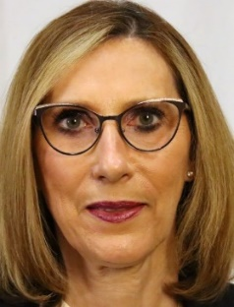

**Mary Luster, RN, BSN, MSL, NEBC**

(See above)



**Cheryl Roth, PhD, WHNP-BC, RNC-OB, RNFA**

Nurse Practitioner

HonorHealth

Dr. Cheryl Roth is the Nurse Practitioner in Obstetrics at HonorHealth. She is the Coordinator of the Coordinated Care Program for Complex Moms & Babies. She was the 2019 AWHONN National President. Cheryl received her PhD in Global Nursing from the University of Texas at Tyler.

[Click here to view slides](https://img1.wsimg.com/blobby/go/d86972fd-1298-4c16-865a-e7c33f54ab3e/downloads/Development%20of%20Antepartum%20and%20NICU%20Acuity%20Tool.pdf?ver=1659659395364)

**Notes**:

Type your notes here

Maternal Mortality and Severe Maternal Morbidity in Arizona

Friday 11:30 am



**Glenda Ramirez, MPH**

Epidemiologist

Arizona Department of Health Services

A Yuma native, Glenda currently serves as the Senior Maternal and Child Health Epidemiologist at ADHS, where she currently conducts monitoring and reporting on maternal health outcomes related to morbidity and mortality. She also supports quality improvement and evaluation efforts focusing on maternal health services and outcomes.

**Objectives:**

1. Provide an overview of access to maternal health care and the range of maternal health outcomes
2. Present data related to maternal morbidity and mortality in Arizona as it relates to Arizona’s diverse communities and demographics
3. Share ADHS and provider-based initiatives to improve maternal health outcomes in Arizona

[Click here to view slides](https://img1.wsimg.com/blobby/go/d86972fd-1298-4c16-865a-e7c33f54ab3e/downloads/Arizona%20MMRP%20Presentation%20for%20APT_Public_File.pdf?ver=1659659395364)

**Notes**:

Type your notes here

Closing Remarks & Adjournment

Friday 12:30 pm

**Robert “BJ” Johnson, MD**

Chairman, Board of Trustees

Arizona Perinatal Trust

**Alan Bedrick, MD**

President, Board of Directors

Arizona Perinatal Regional System, Inc.

Arizona Perinatal Trust

Certified Hospitals

Abrazo Arrowhead Campus

Abrazo West Campus

Banner Casa Grande Medical Center

Banner Del E. Webb Medical Center

Banner Desert Cardon Children's Medical Center

Banner Estrella Medical Center

Banner Gateway Medical Center

Banner Ironwood Medical Center

Banner Ocotillo Medical Center

Banner Page Hospital

Banner Payson Medical Center

Banner Thunderbird Medical Center

Banner University Medical Center – Phoenix

Banner University Medical Center – Tucson

Carondelet Holy Cross Hospital

Carondelet St. Joseph Hospital

Chandler Regional Medical Center

Cobre Valley Regional Medical Center

Flagstaff Medical Center

Havasu Regional Medical Center

HonorHealth Scottsdale Osborn Medical Center

HonorHealth Scottsdale Shea Medical Center

HonorHealth Sonoran Crossing Medical Center

Kingman Regional Medical Center

Mercy Gilbert Medical Center

Mountain Vista Medical Center

Northwest Medical Center - Houghton

Northwest Medical Center

St. Joseph's Hospital & Medical Center

Summit Healthcare Regional Medical Center

Tuba City Regional Health Care Corporation

Tucson Medical Center

Valleywise Health

Verde Valley Medical Center

Whiteriver USPHS Indian Hospital

Yavapai Regional Medical Center

Arizona Perinatal Trust

2022 Board of Trustees

|  |  |  |
| --- | --- | --- |
| **OFFICERS** | | |
| **Chairman** | **Vice Chairman** | **Secretary** |
| **Robert “BJ” Johnson, MD**  Maternal-Fetal Medicine Specialist | **Vacant** | **Richard Jutzi, CPA**  President  Cohen, Rife and Jutzi, PC |
| **TRUSTEES** | | |
| **Rhonda Anderson, MPA, RN, DNSc**  President  RMA Consulting AZ | **Michael Clement, MD**  Retired Pediatrician | **Melissa Day-Johnson** |
| **Grayson Guzman, MD, FACOG**  Sponsoring Physician  MomDoc Midwives | **Nancy Kinnard** | **Kathryn L. Reed, MD**  Professor Emeritus, University of Arizona College of Medicine Tucson  Department of Obstetrics and Gynecology |
| **Mark Shwer, MD**  Retired Neonatologist | **William S. Sowders, Esq**  Gust Rosenfeld, PLC | **Warren Whitney, MBA**  Senior Vice President, Gov’t Affairs  Valleywise Health |
| **EMERITUS** | | |
| **Joe Daily, MD**  Retired Neonatologist | **Len Kirschner, MD MPH**  Former Medical Director AHCCCS |  |
| **CONSULTANTS** | | |
| **Christina Becerra, MHA**  ADHS, Bureau of Women’s & Children’s Health |  |  |

Arizona Perinatal Regional System, Inc.

2022 Board of Directors

|  |  |  |
| --- | --- | --- |
| **OFFICERS** | | |
| **President** | **Vice President** | **Secretary** |
| **Alan Bedrick, MD**  Professor of Pediatrics, University of AZ College of Medicine  Attending Neonatologist  Banner University Medical Center – Tucson | **Mary Luster, MS-L, RN, NE-BC** Senior Clinical Director HonorHealth-Scottsdale Shea | **Hugh S. Miller, MD**  Maternal Director  Valley Perinatal Services of Tucson |
| **Treasurer** | **Immediate Past President** | **Ad Hoc Executive Committee** |
| **Sarah Dent, MSN, RNC**  Clinical Director Labor and Delivery HonorHealth Scottsdale Shea Med Center | **Grayson Guzman, MD, FACOG** Sponsoring Physician MomDoc Midwives |  |
| **DIRECTORS** | | |
| **Teresa K. Anzar, MSN, RNC-OB** Teresa K Anzar RNC-Ob, MSN Associate Director Optum Arizona | **Georgina “Gina” Barreras. MSN, RN**  Special Care Nursery & Couplet Care Mgr  Mercy Gilbert Medical Center | **Mary “Gina” Connelly, MD**  Perinatologist  Tucson Medical Center Obstetrics |
| **Curtis Cook, MD**  Division Director MFM East Valley Dignity Medical Group of Arizona | **Dean V. Coonrod, MD, MPH** Chair-Department of Obstetrics & Gynecology  District Medical Group | **Kimberly Couch, FNP, CNM, DNP**  Retired Director of WIS  Indian Health Services |
| **Lynn K. Daugherty, MHA, BSN, RN**  Nursing Director  Yavapai Regional Medical Center | **Margaret Earle, MD**  OB Anesthesiologist  Valley Anesthesiology Consultants | **Catherine Harris, MD, MPH** Perinatal Director, HonorHealth Scottsdale Perinatal Associates, PLCC |
| **Andrea Hassler, RN, MSN**  Senior Nursing Director WIS  Dignity Health St. Joseph’s Medical Center | **Jan Hughes, PA**  Physician Assistant – Neonatal Neonatal Associates Ltd of Mednax | **Shelly Lanagan, MS, WHNP, RNC-OB, C-EFM**  Perinatal Clinical Care Specialist Summit Healthcare Regional Med Center |
| **Deb Ledington, MSN, NNP-BC**  Northern Arizona Healthcare, Director WIS  Flagstaff Medical Center | **Michael MacKinnon, DNP, FNP-C, CRNA**  Northeastern Anesthesia PLLC | **Debra Pace, RN, BSN**  Director of Inpatient Services  Cobra Valley Regional Medical Center |
| **Lori-Ann Satran, RN, BSN, MS-L, NE-BC**  Associate VP Women and Infant Services  HonorHealth Medical Centers | **Lisa Stephens, RN, BSN**  Associate Director NICU  Banner University Tucson | **Lori Throne, MSN, RN, NE-BC**  Associate Chief Nursing Officer  Banner University Medical Center – Tucson |
| **Kathy Walker, MS, BSN, RN, NEA-BC**  Chief Nursing Officer  Banner University Medical Center - Phoenix |  |  |
| **CONSULTANTS** | | |
| **Stacey Dawson, PhD, MSN, CNM** Captain, US Public Health Service Phoenix Area Maternal Child Health | **Christina Becerra, MHA** Program Manager ADHS, HRPP | **Odette Colburn, RN, BSN**  Bureau Chief, Medical Facilities Licensing Arizona Department of Health Services |
| **Eric Tack, MD, JD, MPH** Program Manager AHCCCS |  |  |

Thank you for joining us!

For information about the next Annual Perinatal Conference visit our [website](http://www.azperinatal.org/annual-conference) in early 2023!



or follow us on [FaceBook](https://www.facebook.com/AZPerinatalTrust)

