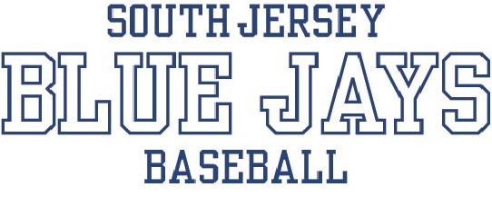

Media Waiver
Use of photos, videos and other images

Your child’s name and picture may be used on the SJ Blue Jays website for informational and promotional purposes and may be used in other forms of print or recorded media for official SJ Blue Jays use. The SJ Blue Jays internet site also provides roster information, game schedules and practice schedules, which could be used to identify your child by their roster number and team name or photo. However, no information will be published that would not be available to the general public through attendance at public SJ Blue Jays events. Only pictures taken during SJ Blue Jays activities will be posted on the internet or used in other forms of SJ Blue Jays media. In no case will a child, parent or guardians addresses, telephone numbers, school information or email addresses be identified on the SJ Blue Jays site or other media. (Coaches and other staff members have the option of placing this information on the website.)

The parent or guardian signing below does hereby give permission to SJ Blue Jays to use, distribute or publish photographs, videos, images or other recordings, in all forms, including composite or distorted presentations, for the purpose of official SJ Blue Jays advertising, or league promotion, in all media including print, video, and the internet. The parent or guardian hereby grants SJ Blue Jays a nonexclusive license to all rights in and to the photographs, videos, images, or other recordings, including copyright interest and moral rights, to such photographs, videos, images or other recordings and derivative works thereof for SJ Blue Jays use, distribution and publication of these recordings in all forms, including composite or distorted presentations, for advertising, print, video, and the internet.

Subject to the above disclaimer, please select one of the following:

( ) Yes, I do authorize SJ Blue Jays to use my child’s name, picture or roster information for promotional purposes on its public website

___________________________ ______________________________ _____________
Player Parent or Guardian Date

( ) No, I do not authorize SJ Blue Jays to use my child’s name, picture or roster information for promotional purposes on its public website. Although I understand that some photos from public events may be used in other forms of media as described above, SJ Blue Jays is not permitted to identify my child by name and photo on the website.

___________________________ ______________________________ _____________
Player Parent or Guardian Date

