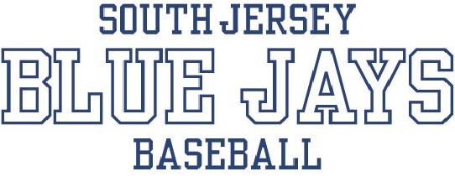

SPONSORSHIP FORM

WHO WE ARE:
The South Jersey Blue Jays is a travel baseball organization for young men ages 8 through 16. Teams consist of local players from PA, DE and South Jersey areas. Our season begins in January and continues throughout the entire year.

OUR GOAL:
Our hope is to create an exciting experience for our young players. It is our desire to give each player the necessary teachings to be able to compete and enjoy the wonderful game of baseball. To achieve these goals, we begin with indoor winter trainings for the boys. Once the weather breaks, we will take to the outdoor fields. The players will be taught the skills needed to compete against various talents in the TSE Baseball League and various tournaments. While doing this, we hope to create a cohesive unit that will potentially play together for many more years to come.

YOUR HELP:
Our teams compete in games and tournaments all over the Northeast, including New Jersey, Pennsylvania, Delaware and Maryland. The cost of our insurance, uniforms, league fees, tournament fees, umpire fees, practice space, equipment, etc. continues to grow every year. We are asking for your support and generosity for the organization and young men eager to develop against some of the best competition in the area. Without your support this would not be possible!

1. SPONSORSHIPS OPTIONS – Please select your desired level:

( ) PLAYER LEVEL: $50 and up donation for individual player

( ) WHITE: $50 and $499 donation to organization/designated team
- Your company name will be listed on team website.

( ) GREY: $500-$999 donation to organization/designated team
- Your company name will be listed on team website & will receive a sponsor plaque or framed team photo.

( ) ROYAL BLUE: $1000 donation to organization/designated team
- Your company name will be listed on team website & will receive a sponsor plaque or framed team photo.

2. Please fill out your company information.
Company Name:
Company Web Address: __ Company e-mail address:
Mailing Address: _________________________________City/State/Zip Code: ___________________
Contact Name:

3. We are sponsoring:
( ) PLAYER NAME: ___________________________
( ) Specific Team, please provide the team age group: _______________________

Please complete all sections and return with your check payable to:
SJ Blue Jays Youth Baseball Organization
P.O. Box 842, Swedesboro, NJ 08085
Please email any questions to: sjjaysbaseball@gmail.com

The South Jersey Blue Jays thank you for your support!
Check out our web site: www.sjbluejays.com

