Operation Mission Insight
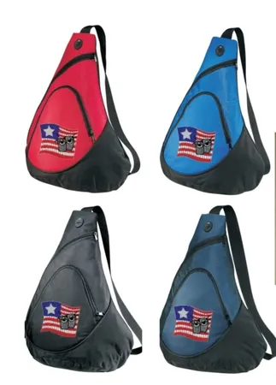
Uncle Bob Backpack Application
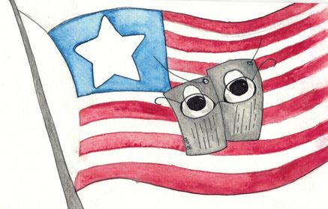
team@operationmissioninsight.com
www.operationmissioninsight.com

Veteran Name
Address

County |  |  |  |  |  |  | Phone
Email
Veteran Status | Medical Discharge |  |  |  |  |  |  | Wounded/Disabled |  |  |  |  |  |  |  |  | Service Connected
Medical Condition | Please Check all that Apply
 | Post-Traumatic Stress Disorder |  |  |  |  |  |  |  |  |  |  |  |  | Traumatic Brain Injury
 | Irritable Bowl Syndrome |  |  |  |  |  |  |  |  |  |  |  |  | Other  (Please Provide Details)
Branch | Army |  |  |  | Navy |  |  |  | Air Force |  |  |  |  |  | Marines |  |  |  | Coast Guard
 | National Guard |  |  |  |  |  |  |  |  |  |  |  | Reserves
Time of Service | Enlistment Date |  |  |  |  |  |  |  |  |  |  |  | Separation Date
Era of Service | Post 9/11 |  |  | OIF |  | OEF |  |  |  | Desert Storm |  |  |  |  |  | Cold War |  |  |  | Vietnam
 | Korean |  |  | Peace Time |  |  |  |  |  | World War II
Do you need assistance with any of the following?

Understanding Post 9/11 GI Bill |  |  | Education  Consultant |  |  |  |  |  |  |  | Employment  Consultant |  |  |  |  |  |  | Transitioning  From Service
Scholarships |  |  | Veteran |  |  |  |  |  |  |  | Spouse |  |  |  |  |  |  | Children
Veterans Benefits |  |  | Applying for Disability Rating |  |  |  |  |  |  |  | Locating and Registering w/ VA Hospital |  |  |  |  |  |  | Financial Services
Other
(Please Explain)
TeamOMI will do our best to help guide and give direction to available resources. However, OMI’s offer of assistance does not guarantee resolution. OMI, a Non for Profit 501(c)3 EIN # 83-1213121

