Addressing Homelessness among our Veterans

Scope

Why should we be concerned about homelessness among our Veterans?

Veteran homelessness has become a growing issue in Canada. A number of research papers have identified factors associated with the risks of Veterans to be confronted to episodic or chronic homelessness. In identifying the risk factors associated with becoming homeless, homelessness can be prevented by early intervention from VFCs and other intervenants during the intake process of medically-releasing CAF members and their families. Medically-releasing CAF members and medically-released Veterans are particularly vulnerable of facing such a situation.

Risk factors associated with homelessness

Researchers have identified a number of factors that are likely to increase the risk of experiencing homelessness. The purpose of this section is to present a broad overview of key identifiable risk factors that could raise some concerns and necessitate early intervention in preventing families to experience homelessness.

The most common risk factors that could potentially lead to homelessness are:

Mental illness and substance abuse disorders are considered to be important risk factors leading to homelessness. Schizophrenia, depression and drug addiction are common among the homeless population. The relationship between mental illness, substance abuse and homelessness is very complex. Homelessness can contribute to the deterioration of an already existing poor mental health condition and the presence of an addiction, while on the other hand, mental health combined with substance abuse can lead to homelessness.

The dissolution of an important relationship such as marital breakdown can have an adverse impact on the individual’s financial security, as well as on their housing situation, which could ultimately lead to homelessness. Homelessness can also be the immediate outcome of escaping from a family environment characterized by violence. Unfortunately, for a number of those fleeing their home as the result of an abusive relationship, homelessness is not a temporary situation. According to the Public Health Agency of Canada (2006), one third of people escaping from a violent home, experience prolonged periods of unstable housing or homelessness.

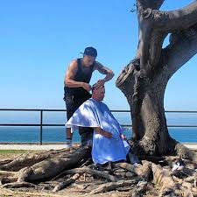

Violence experienced in childhood also constitute a risk factor of homelessness. Research found that a high proportion of the homeless population have experienced physical and sexual abuse, combined with a lack of care in their childhood. In addition, studies show that poor housing conditions contribute to create an environment characterized by interpersonal stress and conflict. Homelessness also significantly increase the risk of experiencing physical and sexual abuse.

As the results of years of compressions in the health care system, a number of patients dealing with a mental health condition have been discharged onto the streets with no resources and follow-up medical care. Once discharged from the medical institution, these patients are referred to shelters, where the resources to help them integrating into the society are largely insufficient.

People released from prison are also more likely to experience homelessness. Those incarcerated in the criminal justice system receive insufficient assistance in helping them maintaining their housing. Once they are release from prison, they are practically no resources to help them re-integrating to the society and securing housing. In addition of facing strict conditions dictated by their parole officer that limit their ability to secure housing, ex-convicts are being ostracized by landlords, as most provincial legislations allow them to discriminate against those with a criminal record.

The lack of investments in social housing from government, the shortage of affordable housing for low-income people, combined with the wages that have not been adjusted to the increasing cost of life and welfare incomes well below the poverty line are significant factors contributing to increase homelessness. In accordance to a survey conducted by the Federation of Canadian Municipalities over 22 communities in Canada, rental housing is increasingly inaccessible to low-income households. It was found that a single person earning minimum wage employed full time cannot afford a private rental unit. The real estate market has been privileging a home owner market, at the detriment of the renter market.

At the times of economic downturns, people are confronted with the scarcity of the job market and are faced with financial difficulties that can have an adverse impact on their housing situation. Conversely, the fast growing economy in Alberta that contributed to a strong migration of manpower has contributed to significantly strain the housing situation in many communities, thus, severely increasing the homeless population as many Albertans working full time could not afford housing.

The consequences associated with economic restructuring have contributed to increase the risk of homelessness for a number of people. In the quest of responding to the challenges of globalization, in shifting away from a manufacturing to a technological/knowledge focus economy, low-skilled workers have been excluded from the job market by experiencing prolonged period of unemployment, underemployment and precarious employment with lower wages and poor benefits.

Homelessness is a very complex problem. The pathway to homelessness is the outcome of a “Perfect Storm” combination of individual, economic and social factors beyond the control of the individual, and the interaction of these factors contribute to create that domino effect leading to homelessness.
In our society that valorizes performance, success and wealth, homelessness has become the symbol of failure. Our society has created a strong stigma against homelessness with the myth that becoming homeless is the outcome of having done something wrong.

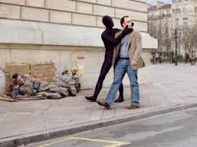

Today, homelessness is not limited to a particular segment of our society. Homelessness is omnipresent. Today, the homeless population are real people. They are brothers, sisters, moms and dads, friends, people in the job market. Putting a face to homelessness is being able to not only understand the risk factors but to recognize how vulnerable we are.

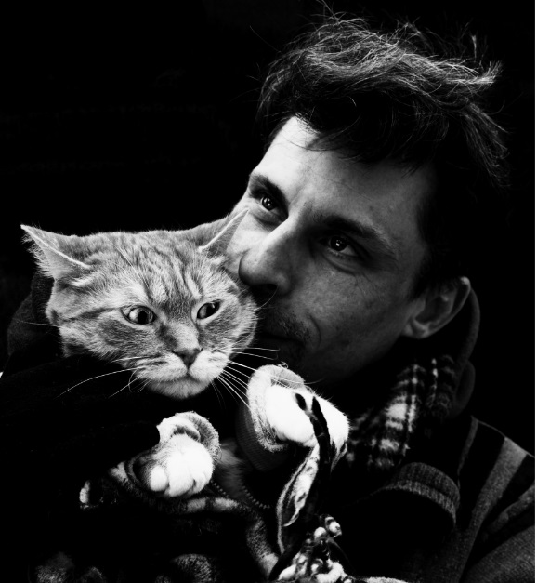

Homeless Veterans: Who are they?

Based on “The State of Homelessness in Canada 2016”, there are 2,950 Veterans staying in shelters, representing 2.2% of the annual shelter users. As the Veteran population represents 2% of the Canadian population, there is an increasing concern about the over-representation of Veterans in the homeless population. Here are some demographic characteristics of the Veteran homeless population, based on different studies conducted:

(*): The 7 Alberta’s cities include Calgary, Edmonton, Red Deer, Grande Prairie, Medicine Hat, Wood Buffalo and Lethbridge)
Volunteers form the Soldiers Helping Soldiers (SHS) has documented 409 homeless Veterans in the National Capital Region over two years of operations and most of them reported to experience some measure of PTSD. A number of those Veterans are abusing substances and have been disconnected from any structure support such as VAC, the Royal Canadian Legion, as well as from pension and benefits.

The study also showed the prevalence of chronic homelessness as many participants of the study have indicated to be homeless over 5 years on average. In addition, it was found that in getting to the state of homelessness, there was a significant period of time between the time they released from the CAF (over 24 years ago) and the time they first experienced homelessness (9.8 years ago).

There are a number of factors among releasing CAF members and Veterans leading to homelessness. According to Ray’s study, alcohol and drug addictions, followed by mental health issues (including PTSD) are the key contributing factors leading to homelessness.

Medically-released Veterans and their families are particularly vulnerable to homelessness.
In addition, in many Canadian urban areas, the increasing scarcity of affordable housing combined with poor financial security of a number of Veterans could be a contributing factor leading to homelessness. According to the Community Need Assessment released in 2017 by…., financial security is considered to be the most important factor of a successful transition to civilian life.

Considering that 25% of the Canadian Veteran population experience difficulties in transitioning from the military to the civilian life, offering multi-facet transition programs to releasing CAF members, Veterans military and their families can significantly reduce the risk of homelessness.

Addressing Homelessness Among Veterans: Key considerations

In preventing and addressing homelessness among our Veterans, there are key elements related to their specific needs that need to be considered (2):

- The unique needs of Veterans within the broader homeless population;
- The structure and routine(leisure included);
- Peer support requiring an understanding of military life and homelessness;
- Collaboration between homeless and Veteran-serving organizations;
- Permanent long-term housing preferable to transitional housing; and
- Housing first and harm reduction philosophies and interventions must drive programming.

References:

- Echenberg H, Jensen H, Background Paper, Risk Factors for Homelessness, Library of Parliament, Social Affairs Division, Parliamentary Information and Research Service, 2009 http://www.homelesshub.ca/sites/default/files/Risk%20Factors%20for%20Homelessness.pdf

- A. Aleman, What do we know about veteran homelessness in Canada?, The Homeless Hub, 10 November 2016, http://homelesshub.ca/blog/what-do-we-know-about-veteran-homelessness-canada

- S.L. Ray, C. Forchuck, The Experience of Homelessness Among Canadian Forces and Allied Forces Veterans, Homelessness Partnering Strategy Secretariat, Human Resources and Skills Development Canada, 2011, http://homelesshub.ca/sites/default/files/Homelesss%20Vets%20Article.pdf

- C. Forchuk, J. Richardson, H Atyeo, ADDRESSING HOMELESSNESS AMONG CANADIAN VETERANS, Inter-Sectoral Collaborations 3.8 Vignette, 2014 http://homelesshub.ca/sites/default/files/3.8%20Forchuk%2C%20Richardson%2C%20Atyeo_0.pdf

