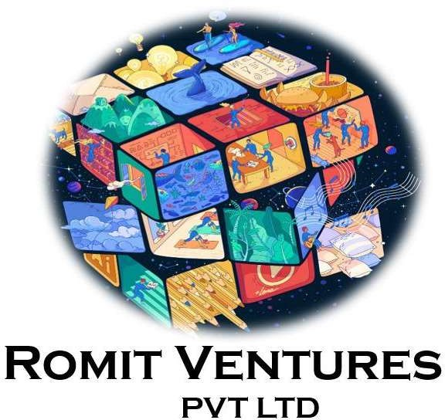   
  
  
  
  
  
  
  
 ROMIT VENTURES

PV T LTD

880 6133299 , 9960936306– M AH ARASHTR A

G O V E R N M E N T L I S C E N C E D C O N T R AC T O R N o .1  
 **Follow us on**



*foodearth.in*

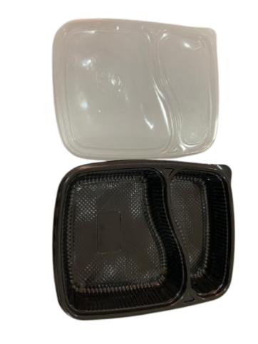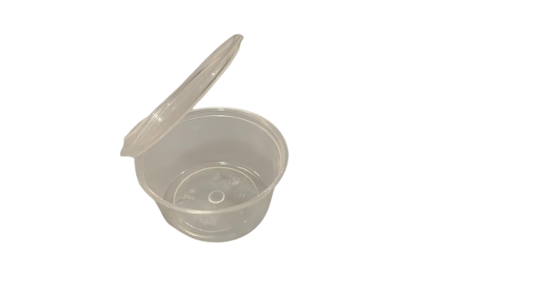

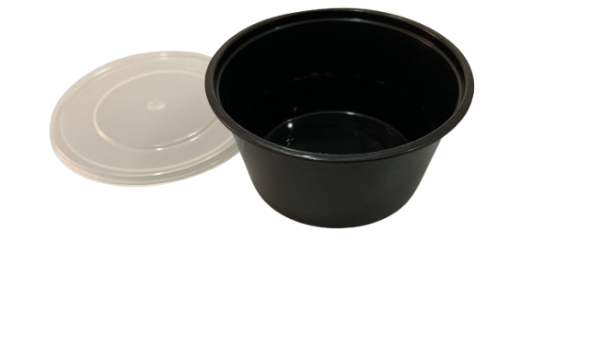

150 ml round container

Capacity: 150 Ml

Color: Black

**Food & Beverage**

MOQ: 499 qty

50 ml round container

Capacity: 150 Ml

Color: Black

**Food & Beverage**

MOQ: 499 qty

2 CP Meal Tray

Capacity: 450-750ml

Color: Black

**Food & Beverage**

MOQ: 499 qty

# 

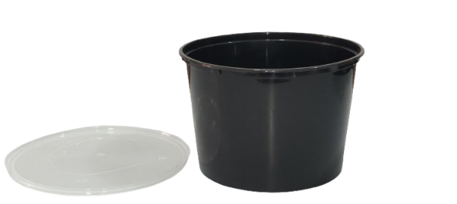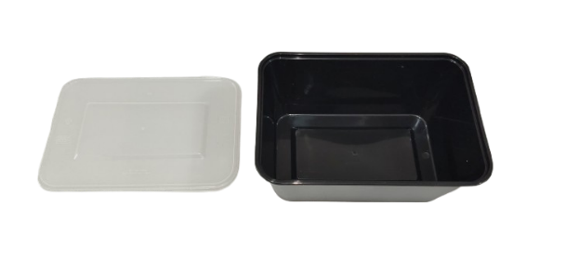



1000 ml round container

Capacity: 1000 Ml

Color: Black

**Food & Beverage**

MOQ: 499 qty

### 1200 ml round container

Capacity: 1200 Ml

Color: Black

**Food & Beverage**

MOQ: 499 qty

50 ml round container

Capacity: 150 Ml

Color: Black

**Food & Beverage**

MOQ: 499 qty   
 50 ml round container

Capacity: 150 Ml

Color: Black

**Food & Beverage**

MOQ: 499 qty

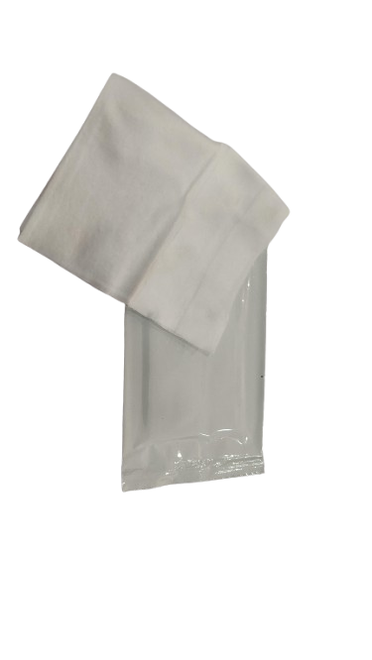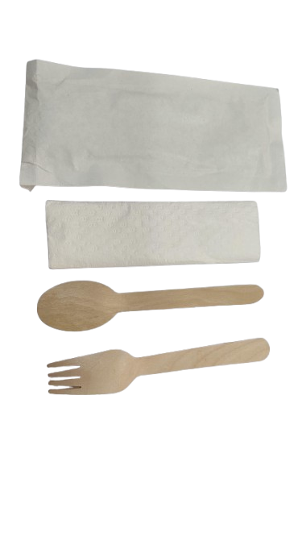

# WET WIPES

**Wet wipes**

**Color: Black**

### **Food & Beverage** MOQ: 499 qty

# CUTLERY SET

**Spoon, Fork, Tissue**

**Color: Black**

### **Food & Beverage** MOQ: 499 qty





# TABLET TISSUE

**Tablet tissue**

**Color: White**

### **Food & Beverage** MOQ: 499 qty

# CUTLERY SET

**Spoon, Fork, Tissue**

**Color: Black**

### **Food & Beverage** MOQ: 499 qty