Bob Behr in Williamstown

As a Student
In the fall of 1951 Bob enrolled at Williams College, a small liberal arts college nestled in the Berkshire mountains of western Massachusetts.
Under legendary track coach Anthony Plansky, Bob excelled in the 220 and 440-yard dashes and set school records in both events. Bob was an
English major chaired the Community Chest Fund and was treasurer of the Student Activities Council. He graduated in 1955.

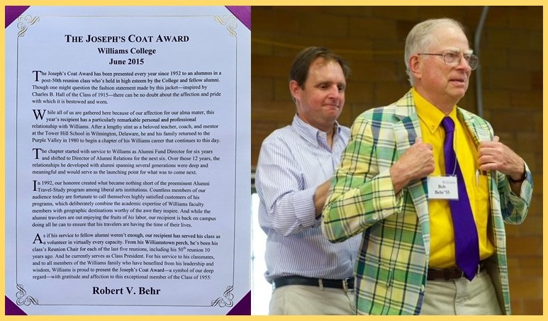
As Administrator
Bob returned to Williams in 1981 after a 19-year teaching and coaching
career at Tower Hill School. From 1981-86 he served as Director of Annual
Giving. From 1986-92 Bob was Director of Alumni Relations. In 1992 Bob
created the Williams Alumni Travel and Study Program and led that highly
successful program until 2014 when he retired after 33 years of service to the
college. During his years as administrator and on into retirement, Bob volunteered
as an assisting coach with the college track team and served as the public address
announcer at home meets. As President of the Class of 1955, Bob was the glue that
held the class together. At the 60th Reunion of the class, Bob was awarded the Joseph’s Coat,
the Society of Alumni’s highest honor.

As a Citizen
Coach Behr was also a leader in the community beyond the college. Among his many contributions, he was for
19 years on the Williamstown Village Ambulance Board; and he served on the board of Greylock A Better Chance.
He founded and ran Head Smarts, a program to encourage parents to read to their infants and toddlers, and was
active at the Friendship Center Food Pantry, serving on its board.

