Bob Behr – Track and Field at Tower Hill School, Wilmington Delaware

In 1959 a small independent school in Wilmington Delaware, Tower Hill School, was searching for new instructors for the English Department. Headmaster Malcolm Coates
had heard of a young man who was teaching at Middlesex School in Massachusetts who just happened to be a friend of the son of the English Department Dean at Tower Hill.
In November 1961 the job of English teacher and track coach was offered to Bob Behr, who began his career at Tower Hill in the fall of 1962.

Although the English department was well established, the Track and Field and Cross Country teams were in their infancy. Tower Hill did not even have a track, but practiced off campus
in an open field at the end of a small airport runway. By 1964 the school had built a new all-weather composite track and football field on the site of a former practice field and
old buildings at the corner of Rising Sun Lane and Tower Road. At the time of construction, the track was one of the finest on the East Coast.

What happened on that track over the next 17 years was more than remarkable. Bob Behr created a small school running powerhouse. From 1964-1970 Tower Hill won 25% (56-224)
of the Division 2 (small schools) championship events, with a school whose high school enrollment of boys numbered about at about 75. Bob had 6 state championship teams in
Track and Field and Cross Country and coached 6 individuals who set state track records for Delaware.
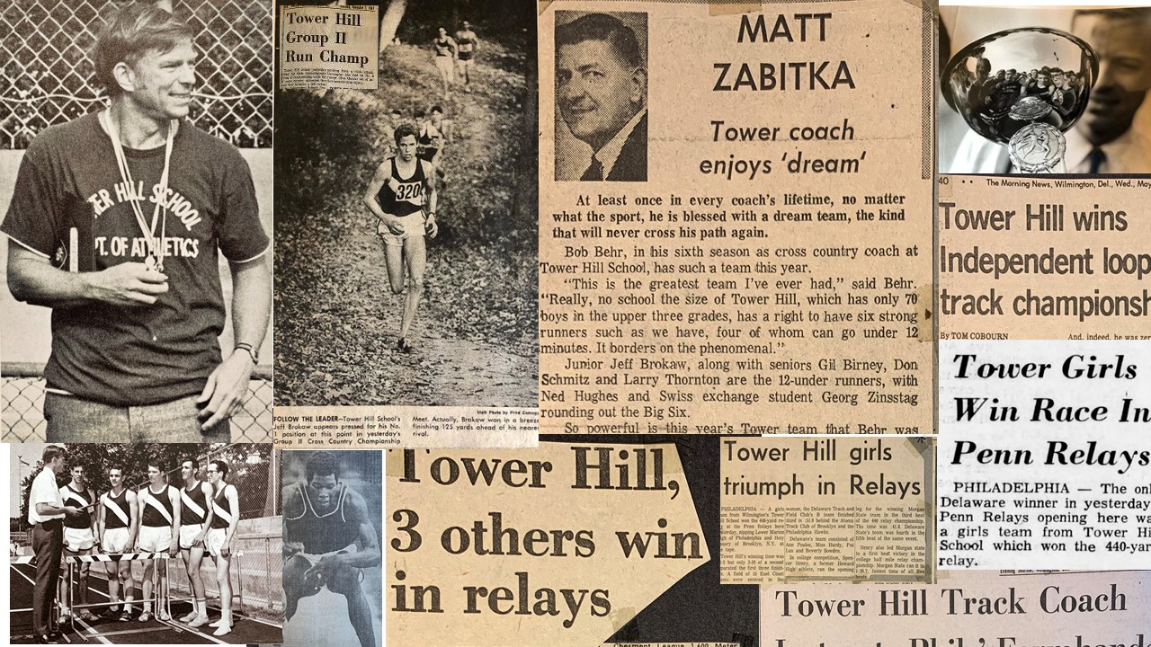
Coach Bob Behr at Tower Hill (1962-1981)
- 1964: Smallest School ever to win the New Castle County DE championship
- 1967-68: In a single year had undefeated state championship teams in Track and Field and Cross Country
- Men’s mile relay won 4 times at Penn Relays
- 1966: Coordinated creation of the Delaware Track and Field Club – the first competitive team in Delaware in the sport for women
- 1970: Coach Behr transitions the Phillies from old baseball cleats to newly fashioned Adidas
- 1974: Delaware Sports Club Officials Division Award, Bob Behr, Outstanding Track and Field Coach Delaware
- 6 Tower Hill athletes set Delaware state track records (1965-1981)
- 1970’s and 80’s: Worked as a correspondent for Sports Illustrated Magazine
- 1996: Coach Behr Elected to Delaware Track and Field Hall of Fame
- 2017: Coach Behr Elected to Delaware Sports Hall of Fame
- 1981: Completed coaching with a dual meet record of 160-28-2

