Robert Vaughn Behr (1933-2021) Early Life

Bob Behr was born in New York City on October 1, 1933. His family subsequently moved to Evanston, Illinois, and Bob graduated

from high school there in 1951. He was involved in school activities and was elected Senior President of home room class.

. 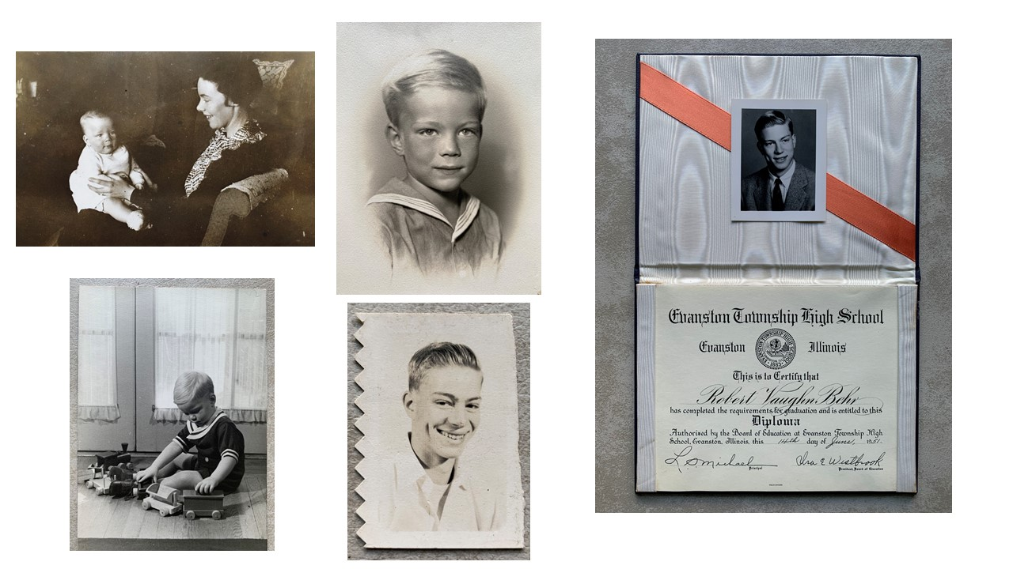

That fall Bob enrolled at Williams College, a small liberal arts college nestled in the Berkshires in the far northwest corner of Massachusetts.

It was here that Bob’s athleticism and running prowess accelerated under legendary track coach Anthony Plansky, a man who won three decathlons at the Penn Relays and played pro ball for the NY Football Giants and baseball for the Philadelphia Phillies.

Bob excelled in the 220- and 440-yard dashes and set school records in both events for Williams College. He rarely lost. Bob found a calling for service along with track and chaired the Community Chest Fund and was treasurer of the Student Activities Council.

He graduated from Williams with a BA in 1955.

After college, Bob entered the military in 1956 serving 3 years with the US Air Force as a pilot for a tanker plane in the Strategic Air Command.

While serving at a variety of bases in Texas and New England Bob formed successful military track teams with other airmen. They competed throughout New England against universities, at invitationals and in other military meets throughout the US. Because of his speed on the track and the fact

that he flew a KC97 tanker, he was known as the Flying Lieutenant.

After the Air Force, Bob began his teaching career in 1959 with a job at Middlesex School in Massachusetts before moving to

Tower Hill School in 1962.During his early teaching years he worked toward an Ed.M. from Harvard and received his degree in 1964.

While studying there he met and courted Carolyn Parks. They married in June 1968, and had two children, Brad and Alison.