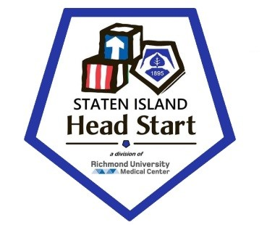
2024 Update
Community Assessment

Table of Contents

Staten Island Head Start

Executive Statement…………………………….....……………………………………………. 2.
Mission Statement ………………………………………………………………...… 2.
Goals and Objectives ………………………………………..……………………..... 2.

Early Childhood Development and Health Services ………………….………….... 3.
Education and Early Childhood Development ….….…………………………................. 4.
Child Health & Safety ………………………..…………………………...….................. 5.
Child Nutrition …………….……..…………………………………………………..… 6.
Child Mental Health ……………………..………………………………….………..…. 7.
Family & Community Partnership…………………………………………....................... 8.
Community Partnerships …..…………………………………………………………..… 9.

Program Design Management ………………………………………………………. 10.
Program Governance …..……………….…………………………………………..…… 11.
Human Resources Management ………………………………………………………..… 12.

Facilities, Material & Equipment ………………………………………………..…….. 13.
Background/ History ………………………………………………….......….................. 14.
District Needs Statement …………….…………………..……………………………..... 15.
School’s District …………………………...……………………………………..…..…. 16.
Community Challenges …………….…………………………………………………..... 17.

Updated Census Information 2024 …...………………………………………… 18- 24.
NYC Department of Health & Mental hygiene Division ……….…………………………. 25.
Program Profile …………………..…………………..……………………………….. 26.
PIR Results …………………………………………...………………………….… 27- 29.
Education & Child Development Staff …………...……….………………………….. 30- 40.
Demographic Analysis ……………………..…………………………………………… 41.
Income Demographics ……..…………………………………………………………... 42.

Resource List ……..…………………..………………………………………….. 43- 48.

A Look Inside of Staten Island Head Start
Executive Summary

Staten Island Head Start has a long and rich history, being amongst the first Head Start programs in the City of New York.

Providing comprehensive and high quality services to the community, Staten Island Head Start is comprised of four facilities: 44 Dongan Hills Avenue, 10 Kingsley Place, 16 Osgood Ave and 166 Lockman Ave.

Staten Island Head Start is providing early childhood services to families within the catchment areas of Port Richmond, Mariner’s Harbor, West Brighton, New Brighton, St. George, Tompkinsville, Stapleton, Rosebank, Clifton, South Beach, Midland Beach and Dongan Hills.

Staten Island Head Start was founded as a Head Start program in 1965 in response to a need for a free comprehensive pre-school program for economically disadvantaged children 3 – 5 year olds and their families in the Staten Island community. For 55 years Staten Island Head Start has provided quality services to thousands of children and their families.

January 1st 2019 Staten Island Mental Health Society merged with Richmond University Medical Center making us the first Head Start program in the state to be governed by a medical facility.

July 1st 2019 Staten Island Head Start became a Direct Grantee with the Federal Government and expanded our services to children 2.0 years old.

Our Mission

The mission of Staten Island Head Start is to educate pre-school and empower parents to be advocates for themselves and their children, to be positive role models and to become productive members of society. The philosophy stems from the belief that a child’s learning experience during his/her preschool years form the foundation of his/her life success. Staten Island Head Start is committed to utilizing all available resources to educate the children and to providing a safe, nurturing literacy-rich learning environment to facilitate children’s positive developmental and social growth. Staten Island Head Start believes that it must also provide every opportunity for families to fully participate in the education and development of their children. Through these efforts, Staten Island Head Start hopes to contribute to ending the cycle of poverty that has existed for too long and restore its communities to health, happiness and prosperity.

Our Goals

Staten Island Head Start provides children with activities that help them grow culturally, cognitively, mentally, socially, emotionally and physically. The Staten Island Head Starts staff recognizes that as parents, you are the first and most important teachers of your children. We will welcome your involvement in our program, and will work as partners with you to help your child progress.

At Staten Island Head Start, we offer your child love, acceptance, understanding and the opportunity to learn and to experience success. Children socialize with others, solve problems and have other experiences, which help them, become self-confidant. The children also improve their listening and speaking skills. The children spend time in stimulating settings where they form good habits and enjoy playing with toys and working on tasks with classmates.
Your child will leave Staten Island Head Start more prepared and excited about learning and ready to succeed.

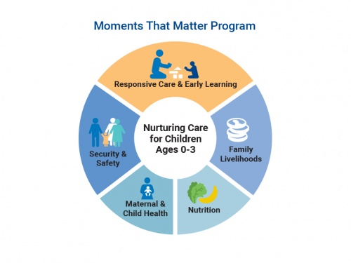
Health Services Goal and Objectives:

Goals:
- Prove each child’s health and physical abilities, including appropriate follow-up steps to correct present physical, social and mental health problems as indicated.
- To increase the family’s attitude toward future health care this includes physical, dental, nutrition and mental health.

Objectives:
- To facilitate in keeping with the Head Start Performance Standards, the utilization of comprehensive quality health services with an emphasis on preventative and follow-up services for our children and parents including children with special needs.
- To create a vehicle ( Health Services Advisory Committee) to bring together diverse health and mental health providers, recipients of services (parents) and staff of Inner Force Tots, for the purpose of evaluation and improving the health care resources available to families.

Early Childhood Development
And Health Services

Staten Island Head Start’ philosophy is to accept each child and his/her family as individuals with different physical, social and emotional needs.

They have the right to adequate health care regardless of race, color or creed. We emphasize the importance of early identification of health problems by encouraging on-going health care services with the child’s health provider, to ensure continuing care, even after the child leaves Staten Island Head Start.

Since many preschool children of low-income families have never seen a doctor or dentist, we arrange for every child to receive comprehensive health care that includes medical, dental, mental health, and nutrition services.

Our objective is to develop a positive attitude toward health care and encouraging and maintaining good health habits for the entire family.

We also strive to promote early intervention, health advocacy and community awareness at Staten Island Head Start

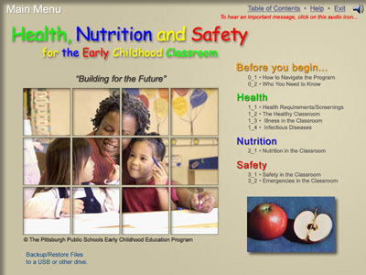
Health Services Goal and Objectives: (cont’d)

- To inform parents of all health resources in the community.
- To assist parents in understanding the inner working of available health facilities and their rights to all the services contained therein so that they will use them to the fullest extent independently, even after leaving the Head Start program.
- To provide training opportunities to parents, children and staff for the purpose of promoting a better understanding of importance and meaning of preventative and follow-up health care.

Education and Early Childhood Development

The educational goals of the program are:
- to promote the social, emotional, intellectual, and physical development of each child
- to provide an educational program which is multicultural and meets special needs of all children.
- to establish procedures for on-going observations, evaluations, and follow-up each child’s development by planning for the development and instructional needs of each child and expanding the education component as necessary to meet these needs.
- to integrate the educational aspects of the various Head Start service areas into a daily program of activities.
- to promote and encourage parent participation in helping plan an appropriate education program for center, classroom and home program activities.
- to enhance the knowledge, awareness, and understanding of parents and staff of the developmental needs of children.
- to promote language understanding and use in an atmosphere that encourages communication among children and adults.
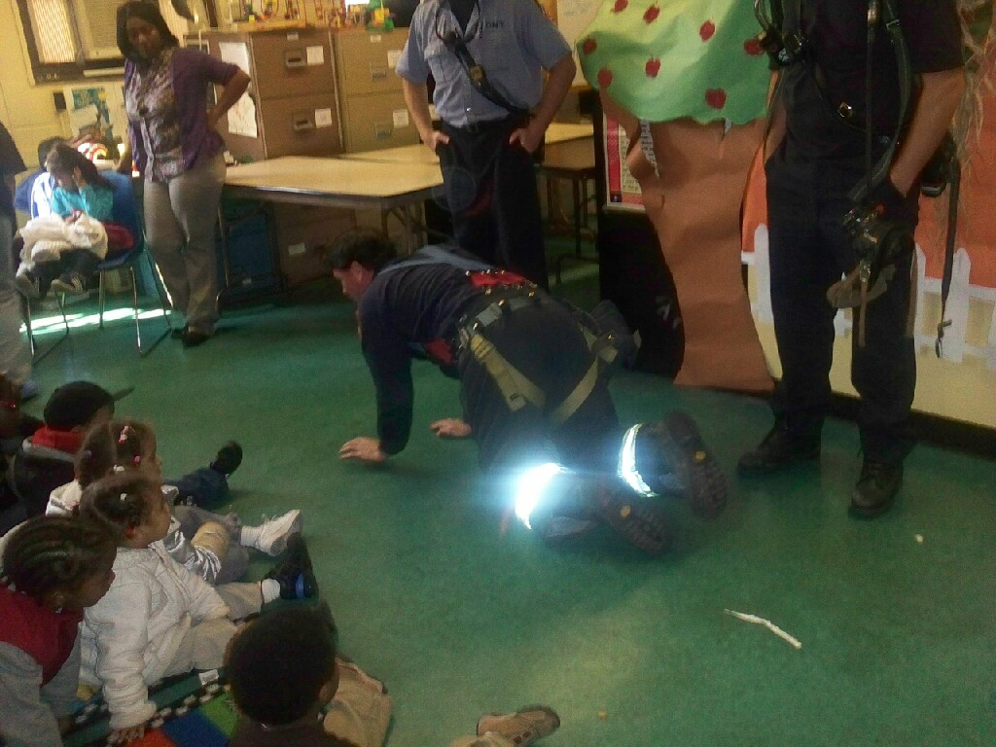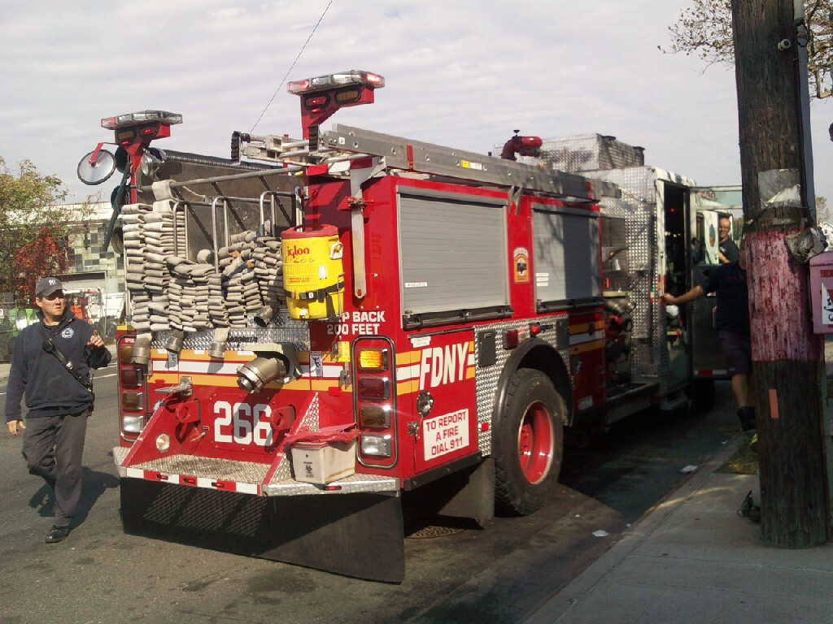

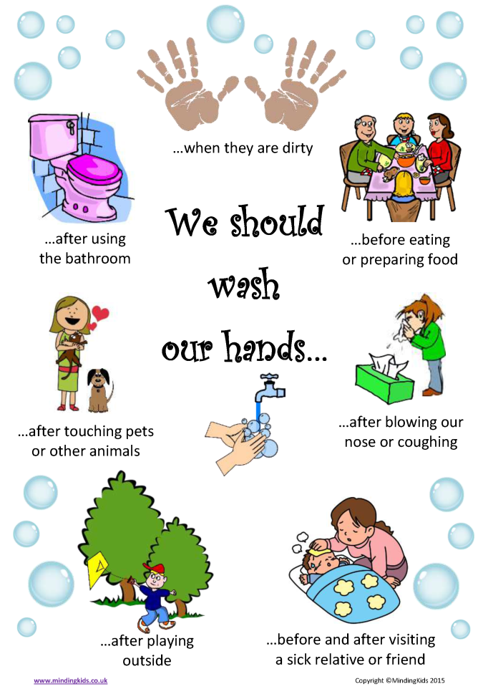
Child Health and Safety

In ensuring the health and safety of all children enrolled within Staten Island Head Start, we have taken every measure to provide an environment that is conducive to injury prevention, hygiene, and practical safety measures; promote positive culturally relevant health behaviors that enhance life-long well-being.

Staff members are trained in emergency procedures and periodic emergency practice drills are performed with children. The emergency policies and procedures are posted and clearly state the roles and responsibilities of each staff member. Workshops are given for the parents and children to help them to also develop plans of action for dealing with emergencies in their homes.
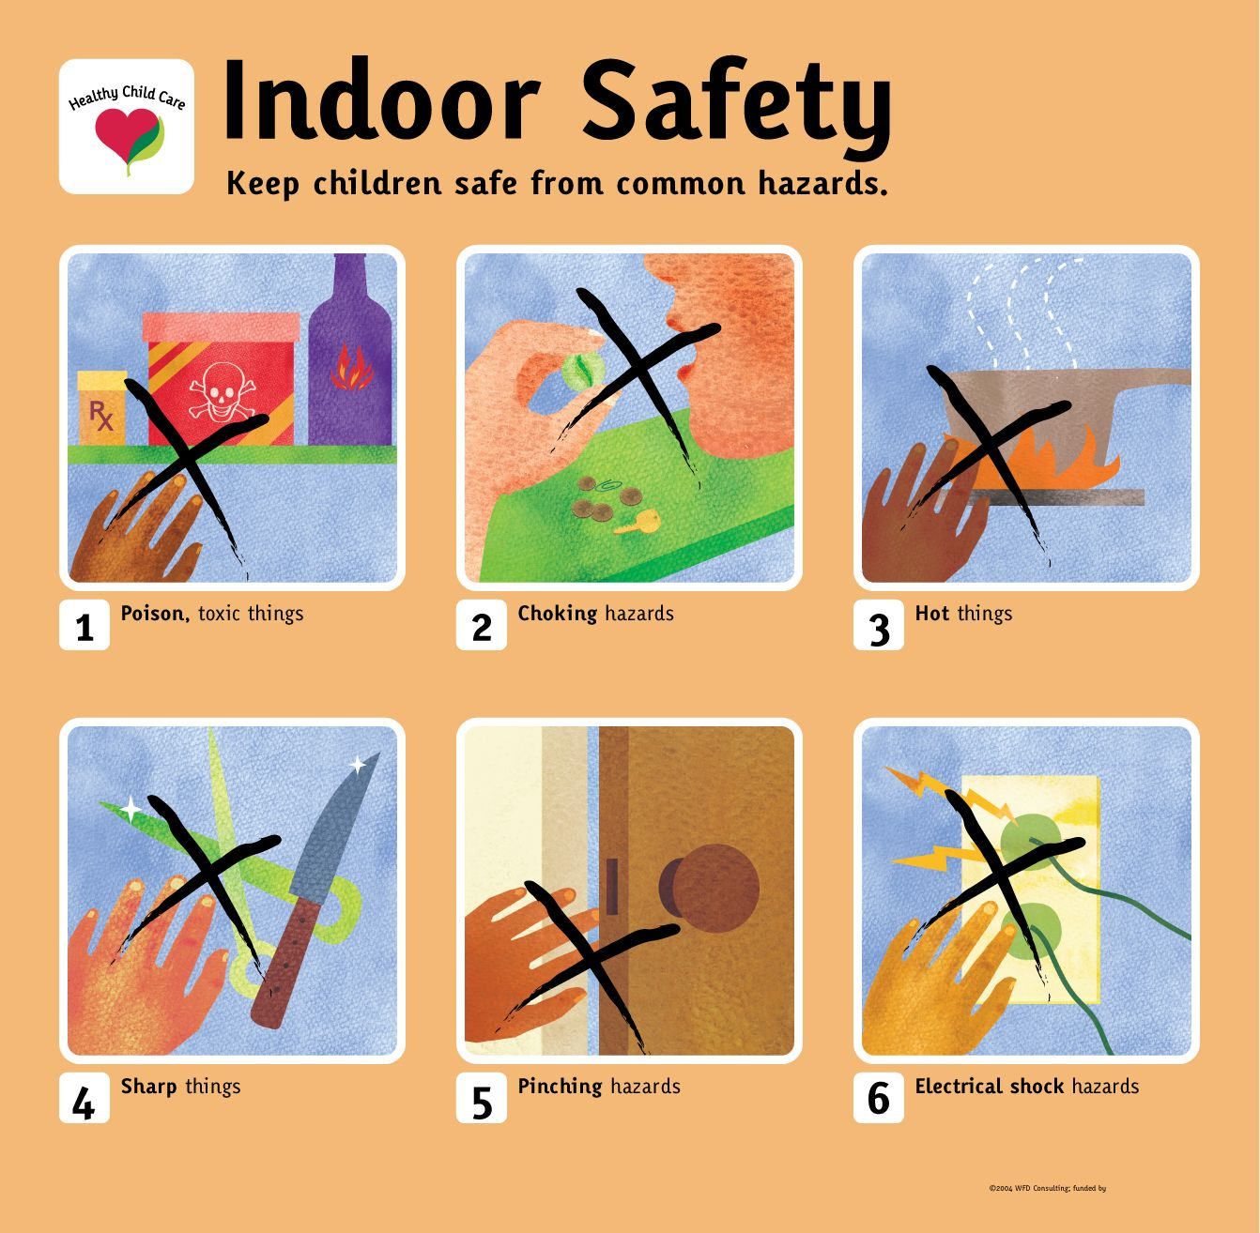

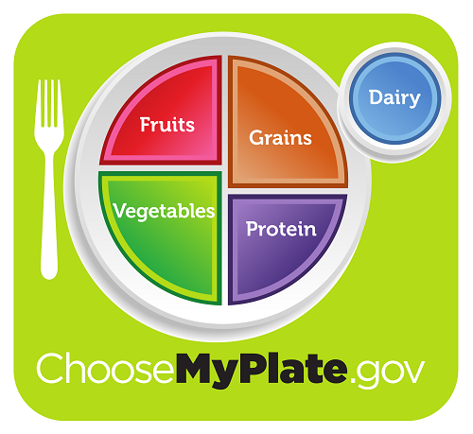



Child Nutrition

Staten Island Head Start believes that at a well-nourished child is more alert and has a better chance of learning and functioning as a healthy individual.

Our goal is to aid in the building of strong bodies and healthy minds by developing good nutritional education; encouraging good eating habits and introducing the children to different kinds of ethnic foods, including the nutritional program into the classroom activities.

The nutrition staff will teach children the many aspects of food, such as the changes involved when food is transformed from raw (natural) to cooked, and the growing process of the food, color, taste, smell, and touch with the use of the Food Guide Pyramid, etc.

Since meal times should promote the physical, social and emotional development of our children, inclusive of children with special needs, meals are served family style. Children participate in setting the tables and are encouraged to serve themselves and assist in the cleanup process (helping hands chores).

By including learning activities with food in our program, children can develop a broad appreciation for food. It’s important for good health and growth. There are many different foods that are nutritious and taste good; where foods come from; how they are processed; how to plan and prepare simple meals; and many other interesting things about food.

The food learning experience, along with eating meals and snacks in a pleasant atmosphere helps children develop good eating habits, i.e., the habit of eating nutritious foods, and a willingness to try new foods. By learning good eating habits during the first five years, the child is more likely to eat a nutritious diet for the rest of his/her life.

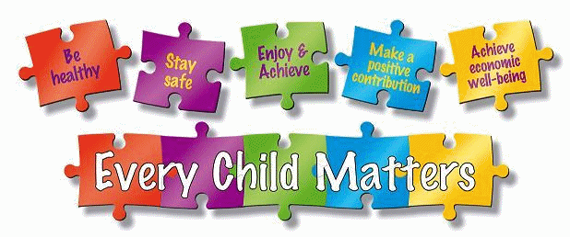

Child Mental Health

Our Head Start program works in collaboration with the Pouch Center for Special People to provide staff for two integrated classrooms in order to provide services to children with moderate to serious disabilities in a 10:10 model The classrooms are staffed with two certified teachers that hold NYS Certification in Special education and two assistant teachers with experience working with children with special needs.

A mental health professional is available to children and parents. Mental health training is also available to staff and parents to make them aware of the need for early attention to the special needs of children and to also help them learn techniques on how to handle children with difficult behaviors.
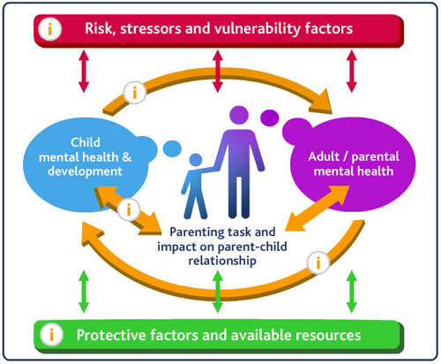

Family and Community Partnership
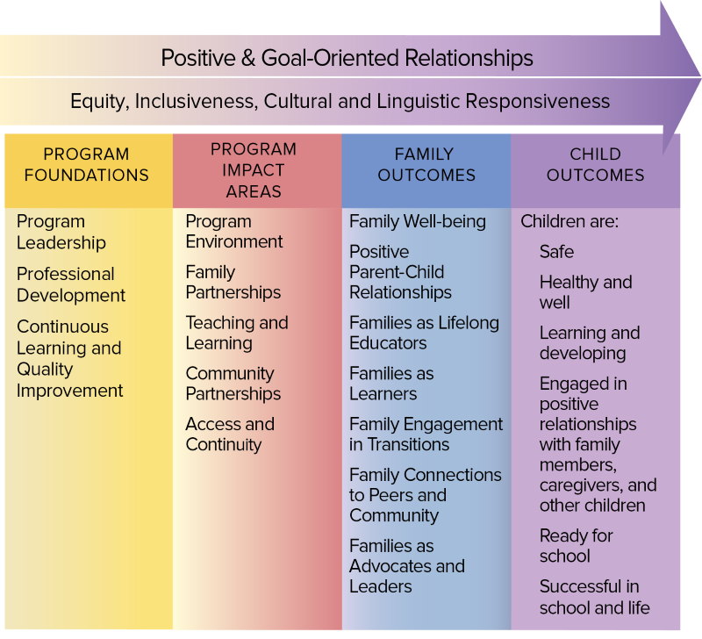

At the core of the trust building conversations is to encourage parents to see Head Start staff as a source of information, support and a resource. The intent of Staten Island Head Start Family Services is to support families. The program’s approach is to treat parents with dignity and respect, and to develop a sense of self-direction and self–esteem.

Therefore, service delivery is based on an understanding of child and family development, multicultural sensitivity, effective communication and a partnership with parents. This is accomplished by providing information about community resources and how to obtain them and including parents in the decision-making process.

The Family Worker is always respectful of the goals, aspirations, strengths and needs of the parent. All parents are recognized and respected as their child’s primary educator, so efforts to involve parents in the education and development of the child will begin at intake and continue throughout the year.. The program provides a variety of opportunities for staff and parents to establish mutual trust and a respectful collaborative relationship.

Community and Collaborating-Partners consist of the following:

•Richmond University Medical Center (RUMC) –
•Staten Island University Hospital –
•SIMHS Elizabeth Pouch Center
•Make the Road New York-
•NYC Department of Health and
•Health Plus/Ameri Group –•Community Health Center of Richmond, Inc. –
•Jewish Board of Family and Children’s Services –
•Healthy Families Program/NY Foundling –
•Commission on Human Rights Staten Island and Community Service Center
•Sovereign Bank
•Richmond County Kiwanis Club
•Comprehensive Adolescent
•NYC Fire Department of New •Staten Island Early Childhood Direction Center –
• Jewish Board of Family and Children’s Services
• YMCA Staten Island –
•Work Force 1
• Staten Island Community Partnership Program –
Community Partnerships

As a longstanding member of the Staten Island community, Staten Island Head Start has developed strong relationships with public and private entities dedicated to improving the well-being of children and families in our catchment area. These include public and private schools and child care programs, community health care service providers, foster care and preventive service programs, and government agencies that provide safety-net services to families, as well as organizations that serve special-needs students.

Staten Island Head Start collaborate with a number of community-based coalitions aimed at providing coordinated service delivery for young children and families that serve on our Health Advisory which also includes program staff, parents, that meet (at minimum) twice annually to discuss the health care needs of participating children and families.

Similarly, the Social Services Advisory Committee, comprised of staff, parents, and partner organizations, will meet twice annually (at a minimum) to discuss/ensure access to available community services, reduce or prevent duplication of services, and evaluate how best to address the changing needs of the families served. These advisory committees will continue to provide an opportunity for Staten Island providers to discuss the immediate and future needs of families currently served and to ensure that program services continue to be responsive to the needs of participants, which may change over time.

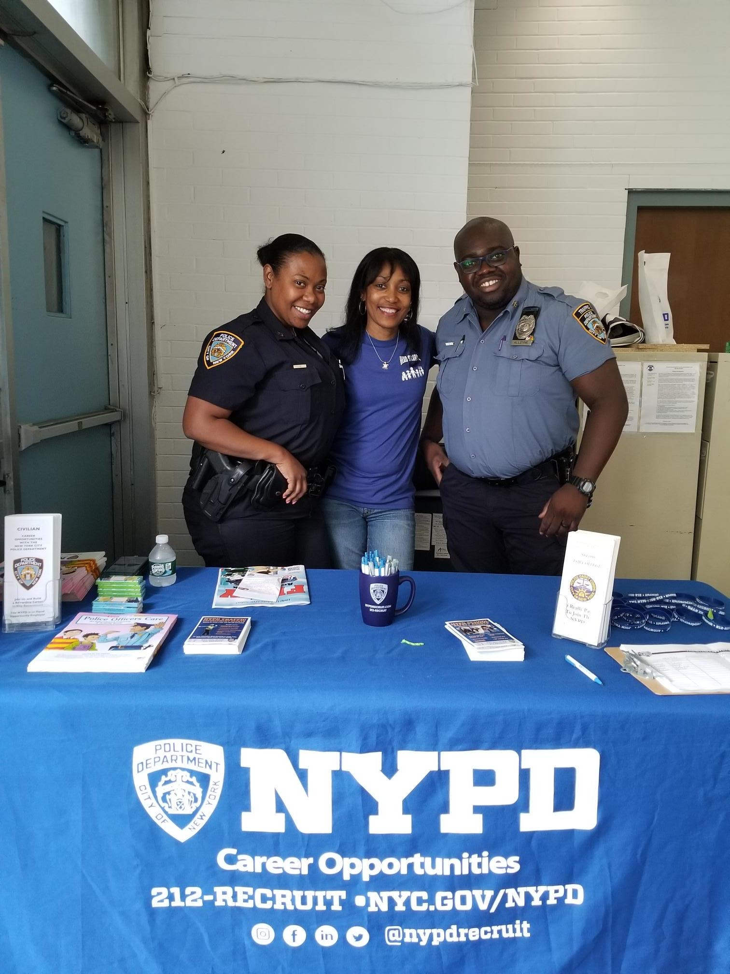
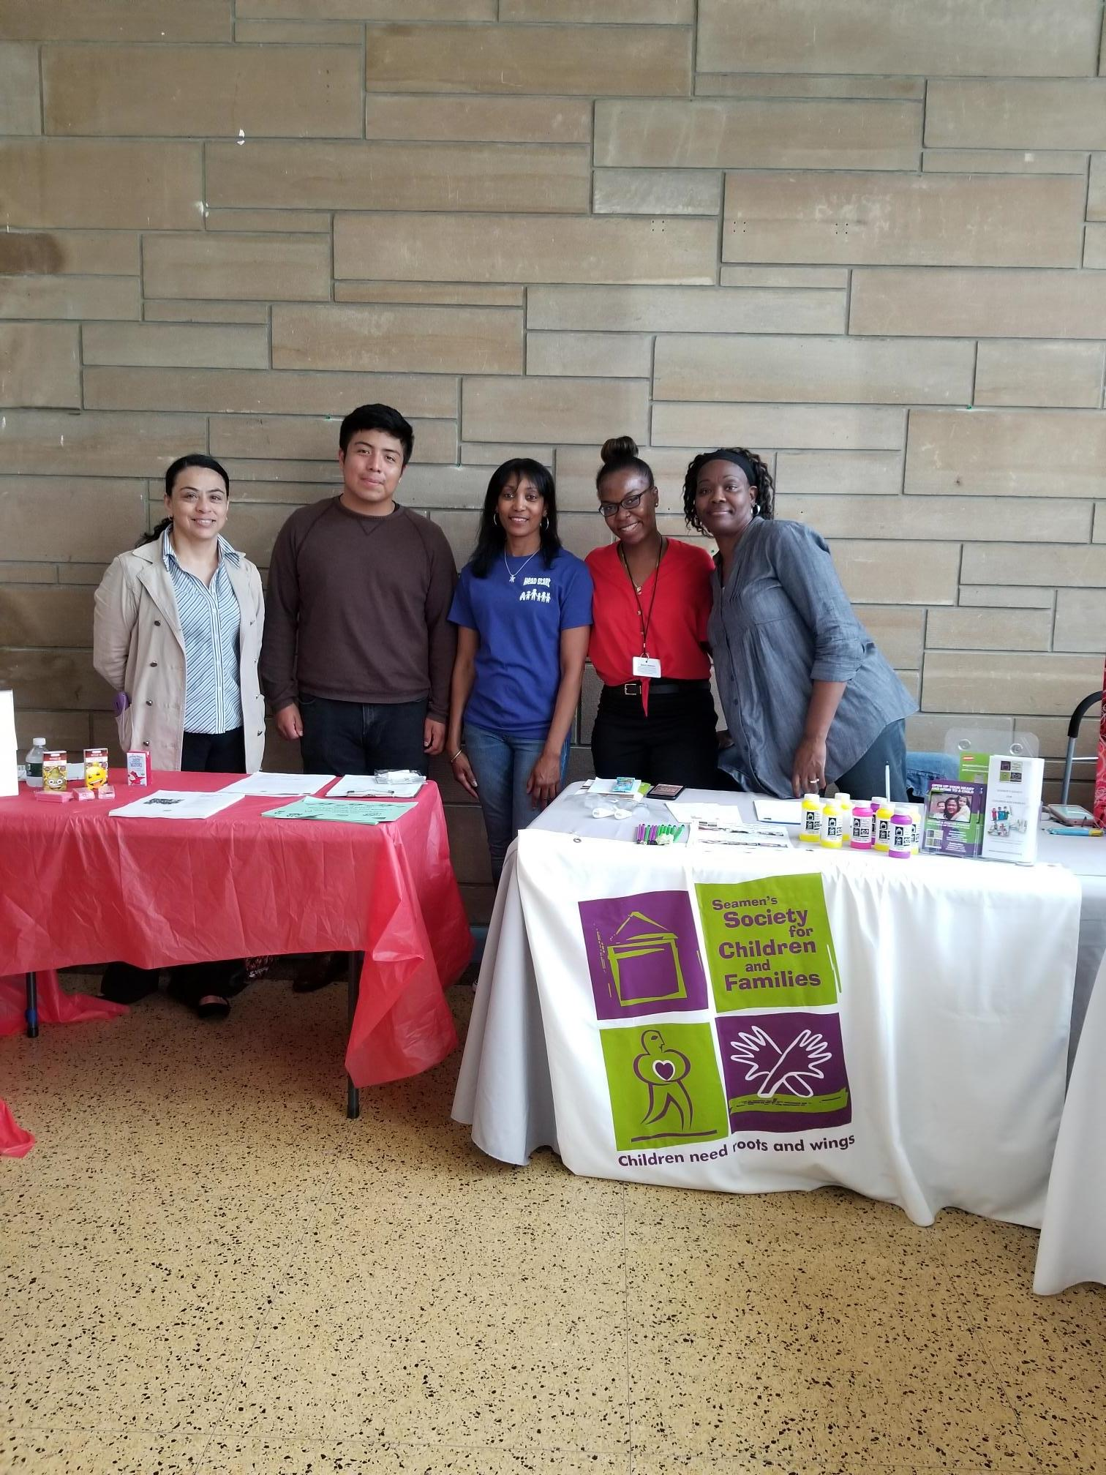
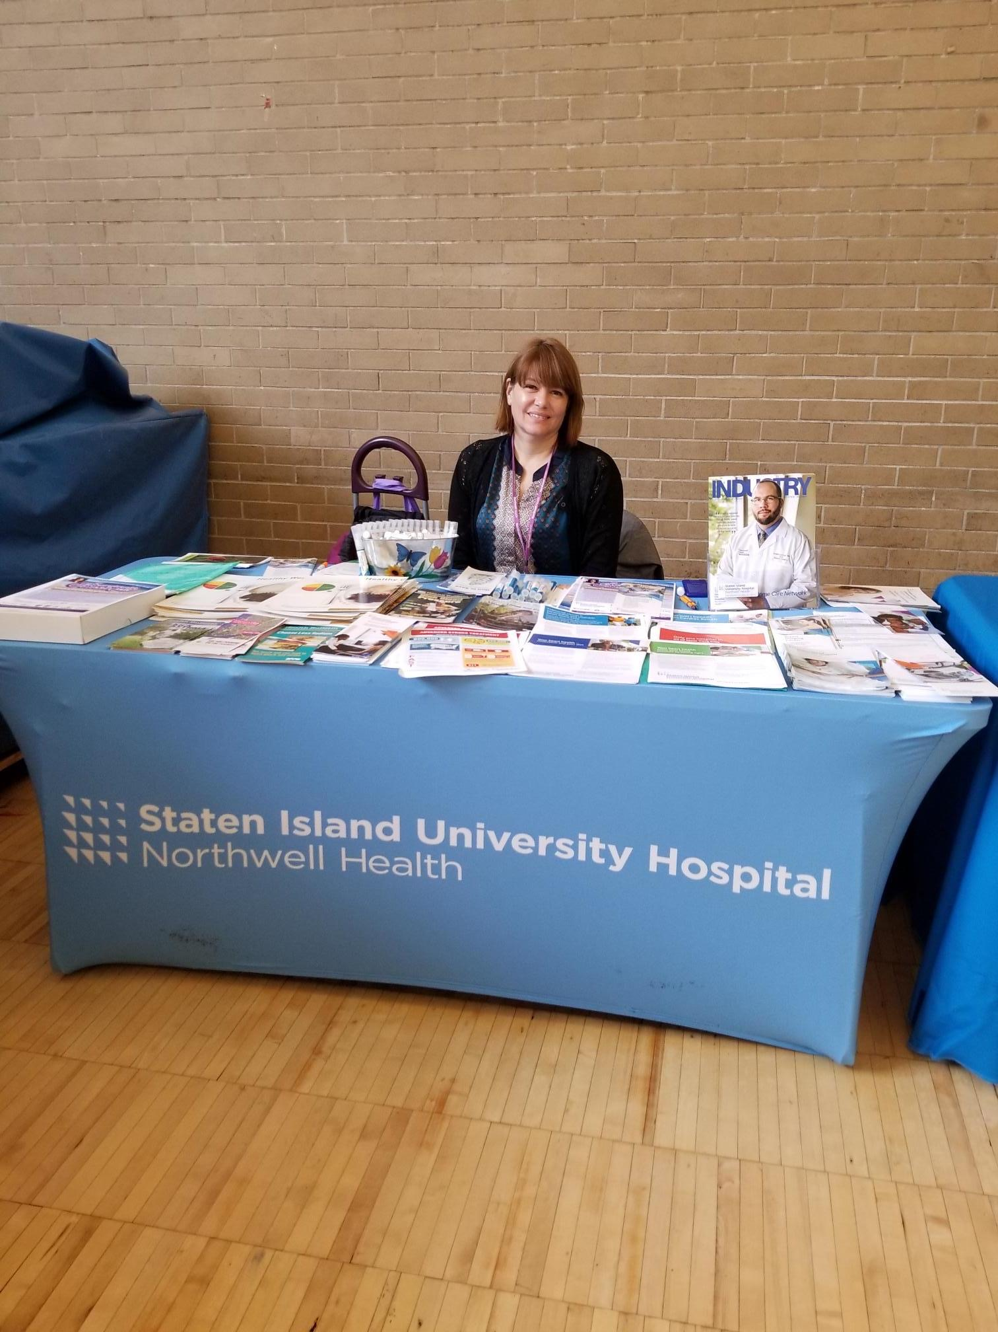
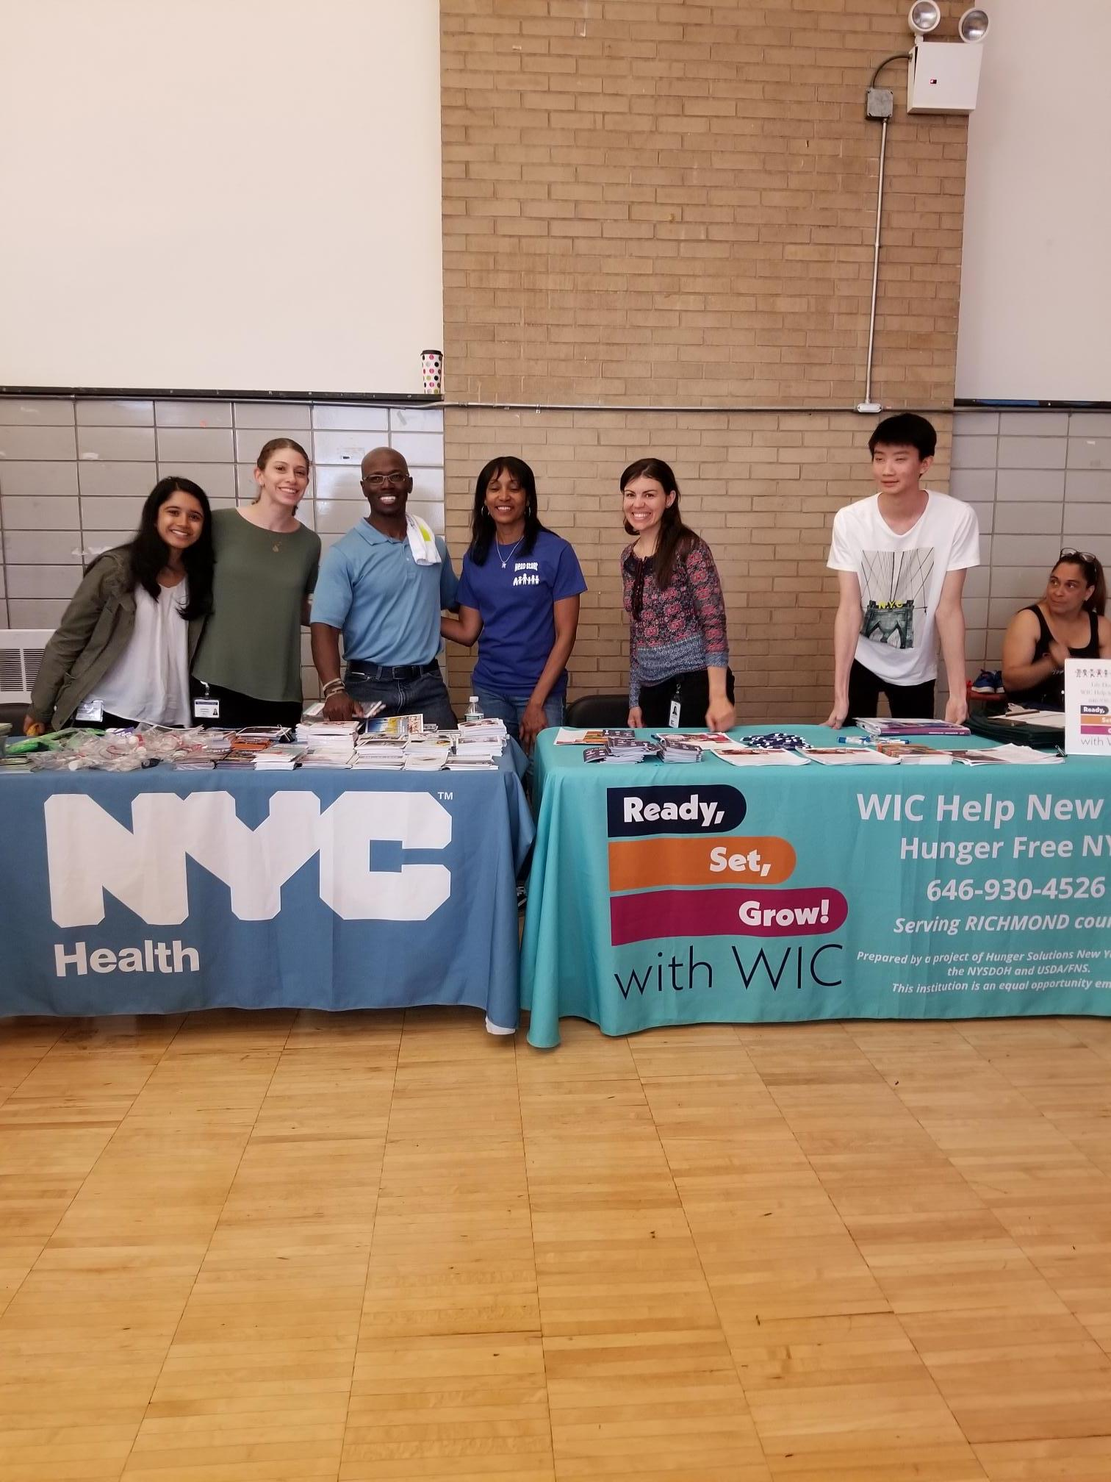
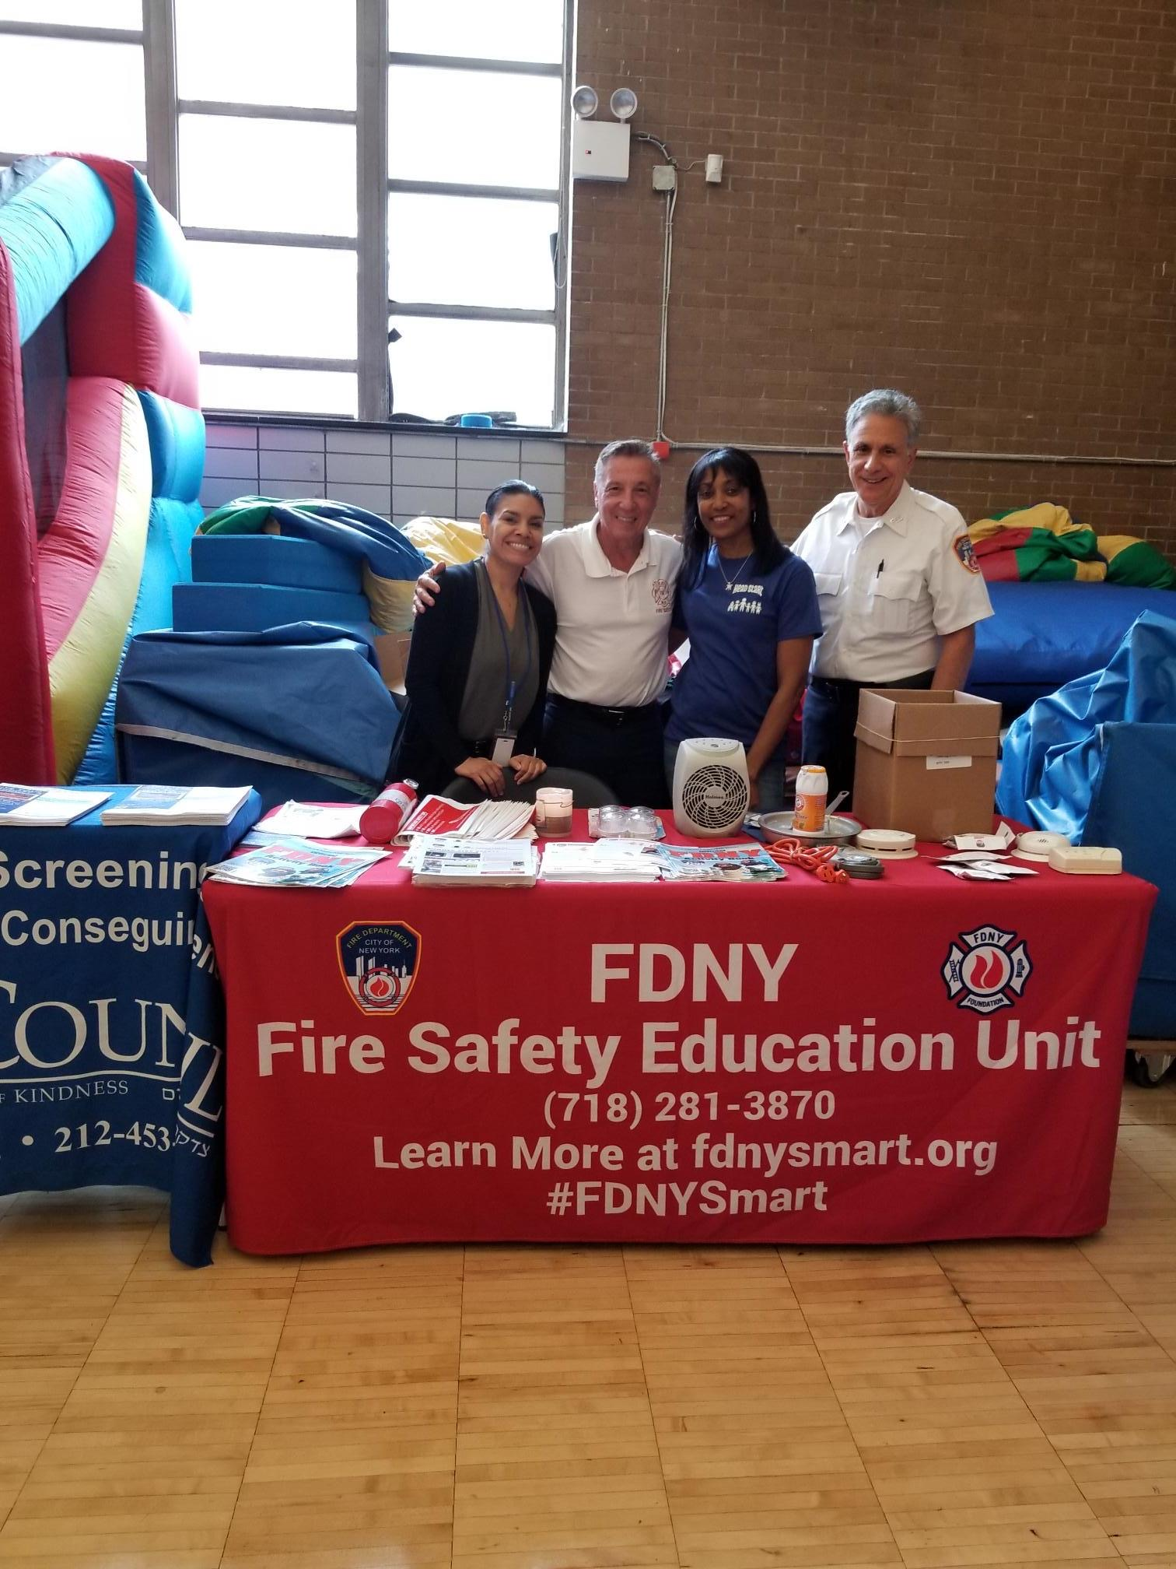

Program Design and Management

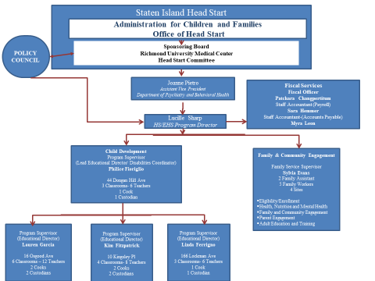

At Staten Island Head Start, we value employees who demonstrate professionalism and leadership, contribute to quality services in the agency, and pursue advanced studies. Employees who demonstrate these qualities are encouraged to remain with SIHS by investing in their professional development through internal and external training opportunities designed to enhance their knowledge, skills, and credentials, as well as through opportunities for career development opportunities within the agency.

SIHS supports the continued education and development of staff by encouraging them to apply for NYS Education Department tuition assistance programs, and providing up to five hours of educational release time weekly to attend classes and reimbursing staff who receive their CDA credential. Staff enrolled in college courses requiring internships in special education settings are offered the opportunity to observe and work in the agency’s integrated preschool classrooms and, where appropriate, in classrooms serving children in more restricted settings.

Supervisors work together with the employees to establish performance goals to be worked on for the coming year. This includes actions taken to meet credentialing requirements established in state and federal regulations, when necessary.

Program Governance

RUMC has established a committee of the Governing Board to serve as the SIHS/EHS governing body. This committee is called the Early Childhood Education Committee. This committee fosters close communication between the Policy Council and the Governing Board.

The Early Childhood Education Committee is comprised of community residents and parents of former or current HS or EHS children without any conflict of interest. It will also include at least one member with background and expertise in fiscal management or accounting, at least one member with background and expertise in early childhood education and development, and at least one member that is a licensed attorney with related experience.

Policy Committee
(PC)
Elected yearly

Human Resources Management

The organizational structure is designed to meet the requirements of the Head Start Performance Standards and the mission and goals of the program. The structure provides for daily supervision in all content areas and a partnership with parents to address the needs of children and families. The organizational structure includes the identification of governing bodies, that have regulatory and oversight responsibilities.

Staten Island HS/EHS functions under the organizational structure of the Staten Island Mental Health Society a division of RUMC. The Staten Island Mental Health Society provides a variety of educational, mental health and disabilities support services that enhance our program.

The agency procurement procedure ensures that effective recruitment of candidates is carried out by the best sources rather than selecting people who happen to be readily available. The agency management practices dictate that the program has a strong career development thrust which results in an in-house leadership development. Promotions from within will normally result in the improvement of staff morale and will have a positive effect on motivation.

All new employees go through a process that includes, but is not limited to the following:

- Application – allows for a prompt assessment of the applicant
- Interviews – verifies the information provided on the application and to obtain additional information deemed useful.
- Investigation – all employees and volunteers are fingerprinted for child abuse and submit 3 letters of reference.
- Orientation – given the roles and responsibilities as an employee and the roles and responsibilities as the employer.

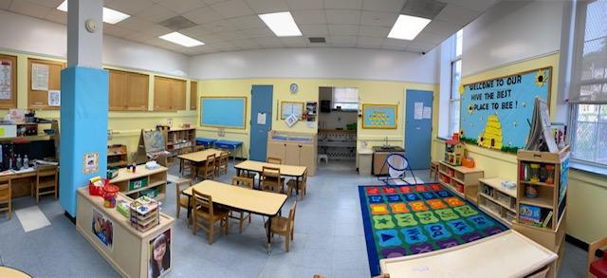

Facilities, Materials and Equipment

Staten Island Head Start’ facilities, materials and equipment are maintained to create a learning environment that is safe, accessible, welcoming, comfortable, age appropriate, culturally sensitive and meets the individual needs of children and families.

Proper attention is paid to the issues of safety and sanitation to protect the children’s health and to keep them free of injury. Our facility meets all the applicable licensing and zoning requirements for fire, health and safety regulations. To support the educational objectives and to show respect to they children and families, the equipment, toys, materials and furniture are matched to the developmental levels, interests, temperaments, languages, cultural backgrounds, and learning styles of children

An accurate equipment record is maintained that provides a description of the equipment, the serial number, and where the equipment is located. A physical inventory is done twice a year to evaluate the condition and/or continued need for certain equipment. A control system is in place to prevent loss damage or theft of any equipment. Maintenance procedures are also in place to keep equipment in good condition.
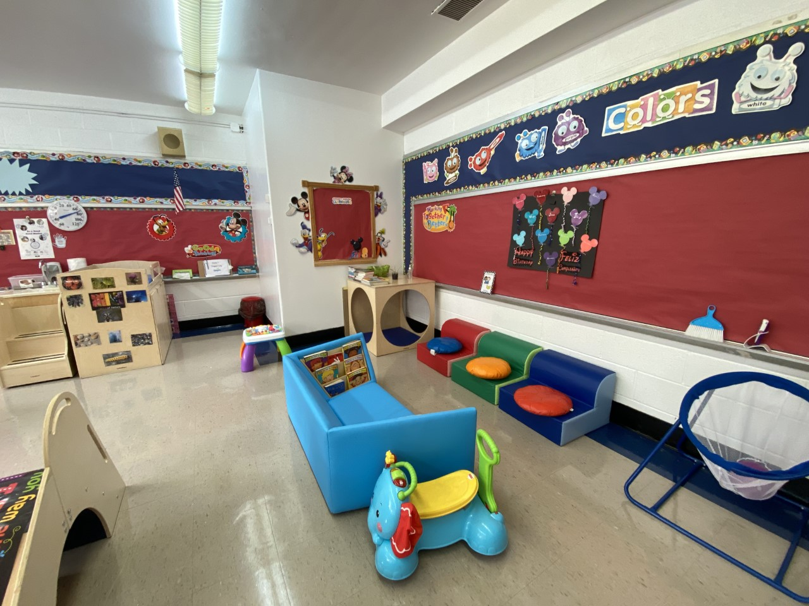
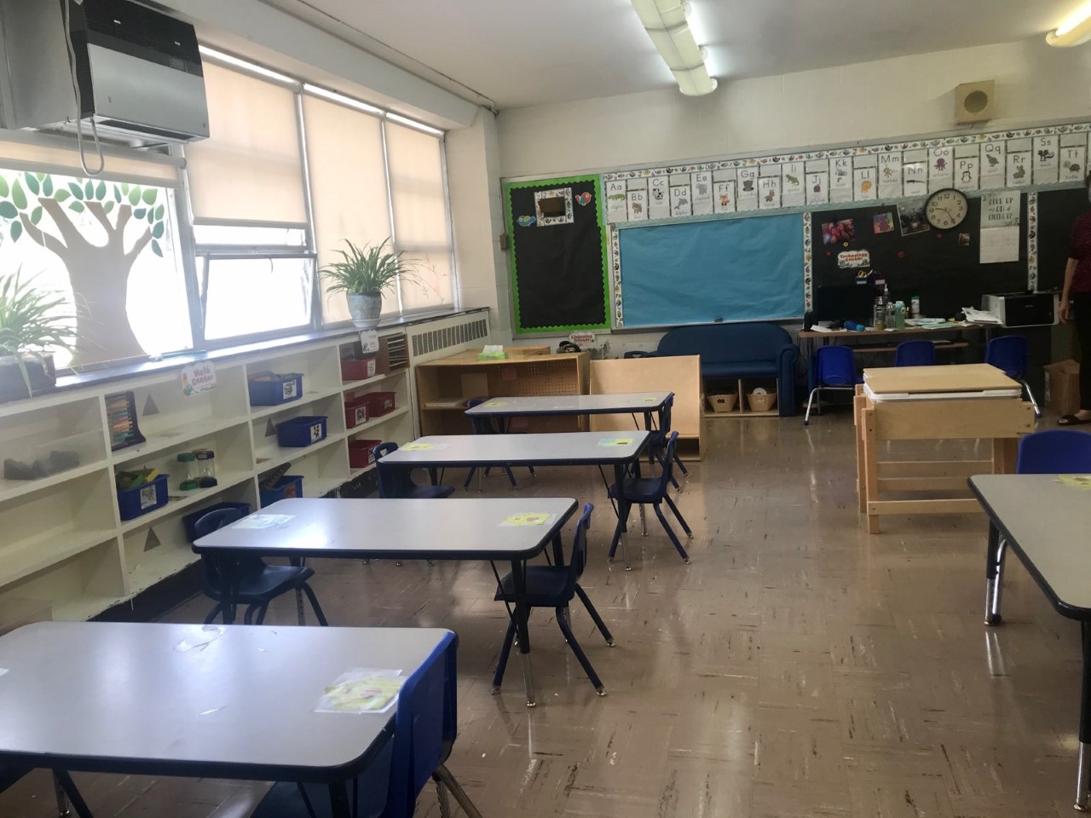
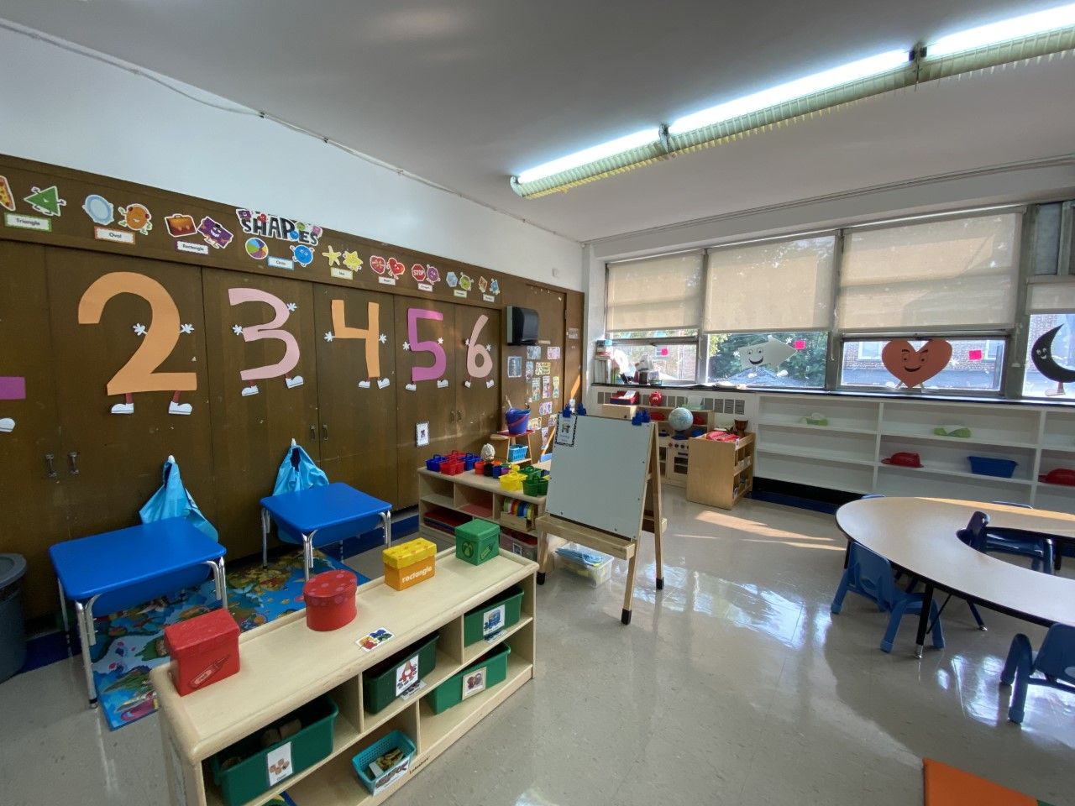

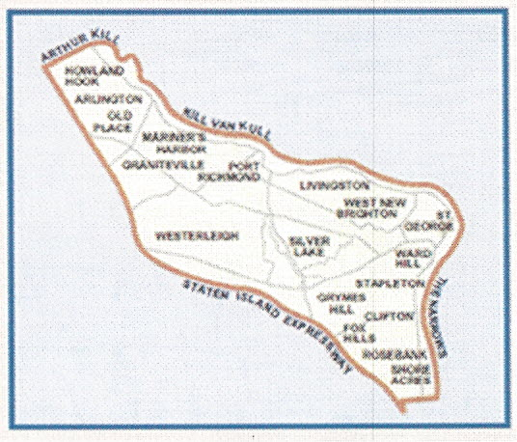
STATEN ISLAND COMMUNITY DISTRICT 1
Background/History

For decades, political reformers had been seeking a method of bringing ordinary, everyday people into the governmental process because residents, mainly those in large urban areas tended to see City Hall as a remote unapproachable, unresponsive entity.
Former Mayor Wagner tried a different approach; he experimented with “community planning councils”. Then, Mayor Lindsey set up “Little City Halls”. After twenty-five years of experimentation, the 1975 City Charter formally divided the city into 59 community-planning districts, each with its own community planning board. The name was later shortened to Community Board. All City agencies will make their offices, statistics and staff available to answer requests and complaints made by the Community Board
Each Community Board has up to fifty members. They are expected to be persons that have demonstrated their interest in civic affairs through activity in block associations, civic associations, etc. The Borough President appoints these members. The City Council members serving the area nominate half of the board members. All board members serve with out pay.
Although the Community Board has very broad mandates, allowing them to deal with any issues “affecting the welfare of the residents of their districts”. The charter specifies three major areas for Community Board involvement: planning, and reviewing - land, use in the community, improving city services, and making recommendations on the city’s capital and expense budgets.
While the Community Board role in every case is advisory, the Board input is considered very valuable and is often followed.

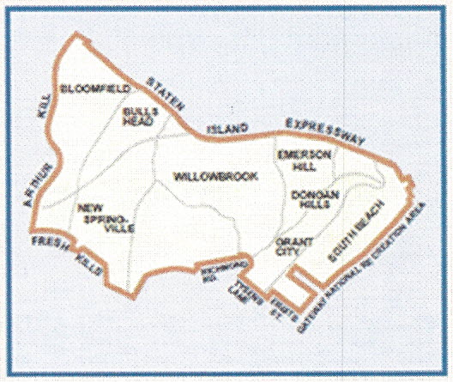
STATEN ISLAND COMMUNITY DISTRICT 2

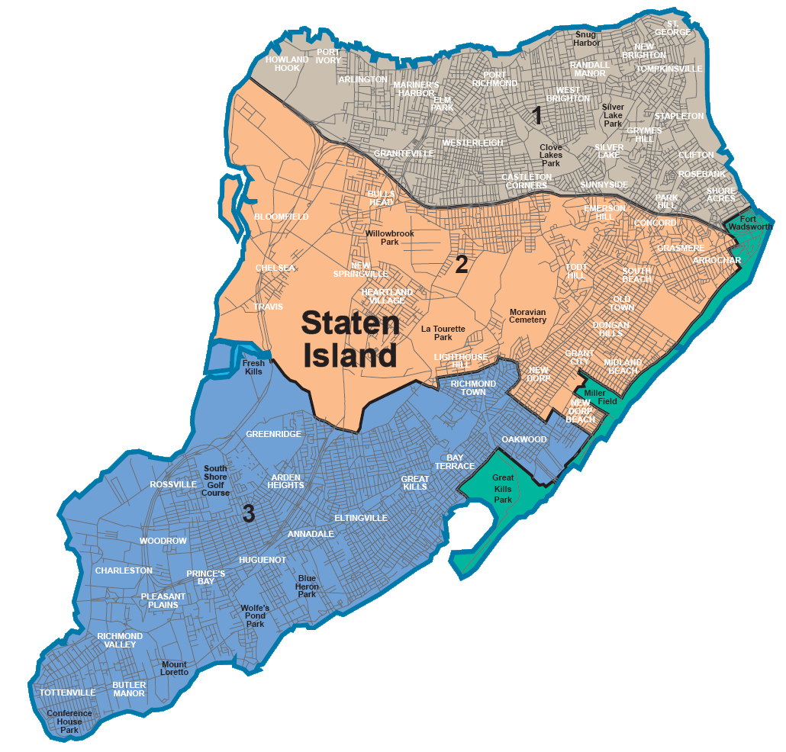

STATEMENT OF COMMUNITY DISTRICT 1 &2 NEEDS FOR FY 2024
OVERVIEW

District 1

The three most pressing issues facing this Community Board are:

Land use trends (zoning, development, neighborhood preservation, etc.)
North Shore zoning neither reflects current land use nor wisely prepares for future land use. M zones abut R zones, parking requirements do not reflect the Borough's reality of auto use, C zones are poorly sited, affordable housing corridors do not exist, there are no transit corridors, there is no thought of preservation and our open spaces are being obliterated and the waterfront is not being used for industrial, job creating, purposes

Traffic
The biggest impediment to the quality of life on Staten Island is traffic The DOT cannot keep pace with the increasing use of vehicles and contrary to Manhattan-centric thinking vehicles are the only way to get around out here. There is no grid system, the roads are in disrepair, commutes are endless, shopping is an ordeal, school buses are slow and there is only one small rail system.

Transit (buses & subways)
Commuting on SI is not good. Every bus has to trundle for miles on broken roads to deliver folks to work and children to school. Bus schedules do not meet commuters" needs, express service is inadequate, the BRT plan proposes to eliminate access to the ferry terminal and the SIRR only serves a small part of the Borough.

Most Important Issue Related to Health Care and Human Services

Equitable Hospital Services and support.
SI has no Municipal Hospital and there is no allowance made to help fiancé the operations of the two hospital systems on the Island. This lack of funding either for a municipal hospital or to help the two systems is a disregard by leadership for the health and well-being of the Staten Island community, especially in CB1 where there are more residents in medical distress than in other parts of the Island.

Community District Needs Related to Health Care and Human Services

Needs for Health Care and Facilities
Again, as stated often in this section, the health care system on Staten Island does not receive equitable funding thus placing all residents at risk.

Needs for Older NYs
The two biggest needs in the district are affordable housing and abuse prevention programming.

Needs for Homeless
Although the homeless population has increased and diversified, the resources given to our one agency are inadequate to provide housing, shelter, prevention, referrals and counseling.

Needs for Low Income NYs
Job training and employment programming and domestic abuse prevention are the most significant programs the district needs.

District 2

The three most pressing issues facing this Community Board are:

Crime and public safety
School Safety is Community Board 2’s number 1 priority this year. There is an ever-increasing demand to protect schools from threats of violence. It is important to take this threat seriously and responsibly. Community Board 2 requests

(1) every school door is locked at all times,
(2) a buzzer system is installed,
(3) a camera installed and aimed at the front door so visitors are visible,
(4) an NYPD officer is placed at the desk by the front door instead of a school safety agent
(5) two school Safety Agents inside the building, and
(6) have NYPD presence outside the school building during dismissal to harden building security. School safety measures must be improved immediately. As we all know, school safety plays a vital role in the development of the emotional health and academic success of young people.

School shootings are terrifying to children, parents, educators and the community. "School Safety" has been defined as creating a safe environment for children, starting from their homes to their schools and back. This includes safety from any kind of abuse, violence, psycho-social issue, disaster: natural and manmade, fire, and transportation. As Commissioner Banks stated "when a parent kisses their child goodbye in the morning, they trust that their child will be both emotionally and physically safe at school." The physical and mental wellbeing of every child left at the front entrance of a school, must be protected. We are pleased that there will be enhanced safety trainings for principals, assistant principals and response team leaders in the case of an emergency. We hope these trainings are done yearly.

Infrastructure resiliency
A top priority for our district is the commercial revitalization and development of the East Shore of Staten Island. It is well-known that the East Shore of Staten Island sustained severe damage from Hurricane Sandy. Residential revitalization, as well as storm damage mitigation programs, have been well underway, but there is still a lot of work that needs to be done in regards to commercial development. With an eye to attract business owners to the area, it is essential that sidewalk improvement, street improvement, and signage projects are implemented.
Sidewalk improvement needs for the East Shore are increased street furniture and lighting (i.e city benches, ornamental solar lights on street trees, holiday lighting on the main commercial corridors) and enhancement of greenery of streets (i.e. street trees, tree guards, rain gardens, bioswales). Street improvement needs include enhanced traffic calming measures (i.e. mid-block painted crosswalks on Midland Avenue and Sand Lane, medians and pedestrian refuge Island on Hylan Boulevard),
Other improvements that will beautify the area are creating a gateway between the beach and commercial corridors (i.e. gateway public art sculpture on Father Capodanno Boulevard), creating a pedestrian pathway connecting the FDR Boardwalk to Father Capodanno at Midland Avenue, and creating shared space around Fountain of the Dolphins.

Public health facilities
With a growing and aging population, homeless shelters opening, and migrants arriving in Staten Island, there is a need for a public hospital in the mid-island section of the borough. In 1970, Staten Island had five hospitals. The public hospital can be operated by the city's Health + Hospitals on the grounds of Sea View Hospital Rehabilitation
Center and Home, 460 Brielle Avenue, Staten Island which is city-owned property and is centrally located. There are abandoned/vacant buildings that could be put to good use. The emergency rooms in Staten Island’s three facilities are jam-packed and overburdened with people all hours of the day and night, especially on weekends. Patients are on gurney stretcher beds in hallways due the overcrowding and insufficient hospital beds. They have no privacy. The COVID-19 pandemic was an eye-opener. We must be prepared and well-equipped for natural and human caused disasters.

Updated Census Information 2024

The American Community Survey (ACS) helps local officials, community leaders, and businesses understand the changes taking place in their communities. It is the premier source for detailed population and housing information about our nation shared through the Census Bureau. They release new data every year, in the form of estimates, in a variety of tables, tools, and analytical reports.

Households and Families
In 2018-2022, there were 170,000 households in Richmond County, New York. The average household size was 2.86 people.
Married-couple households made up 53.2 percent of the households in Richmond County, New York while cohabiting couple households made up 5.2 percent of households. Female householders with no spouse or partner present were 26.7 percent of all households, while 14.9 percent of households had male householders with no spouse or partner present. Some households had one person, as 9.9 percent of households were male householders living alone, and 13.5 percent were female householders living alone, for a total of 23.4 percent of all households.
In Richmond County, New York, 33.2 percent of all households have one or more people under the age of 18; 35.3 percent of all households have one or more people 65 years and over.
Types of Households in Richmond County, New York in 2018-2022

 | Percent
Married-couple households | 53.2
Cohabiting Couples | 5.2
Male Householder  No spouse/partner present | 14.9
Female Householder  No spouse/partner present | 26.7

Marital Status
Among persons 15 and older, 52.7 percent of males and 47.3 percent of females are currently married.
Population 15 years and over | Percent  Males | Percent  Females
Never married | 37.0 | 32.3
Now married, except separated | 52.7 | 47.3
Separated | 1.3 | 1.7
Widowed | 2.6 | 9.0
Divorced | 6.4 | 9.8

Grandparents and Grandchildren
In Richmond County, New York, 12,371 grandparents lived with their grandchildren under 18 years old. Of those grandparents, 15.7 percent were responsible for the basic needs of their grandchildren.

Nativity and Foreign-Born
In 2018-2022, an estimated 75.2 percent of the people living in Richmond County, New York were U.S. natives. 68.6 percent of the Richmond County, New York population were living in the state where they were born.
Approximately 24.8 percent of Richmond County, New York residents in 2018-2022 were foreign-born. 68.9 percent of foreign-born were naturalized U.S. citizens and an estimated 80.1 percent entered the country before the year 2010.
Foreign-born residents of Richmond County, New York come from different parts of the world. The bar graph below displays the percentage of foreign-born from each world region of birth in 2018-2022 for Richmond County, New York.

Region of Birth for the Foreign-Born Population in Richmond County, New York in 2018-2022
Percent
Latin America | 20.9
Asia | 38.7
Europe | 29.6
Africa | 10.0
Northern America | 0.7
Oceania | 0.1

Language
Among people at least five years old living in Richmond County, New York in 2018-2022, 34.8 percent spoke a language other than English at home. Spanish was spoken by 10.1 percent of people at least five years old; 13.3 percent reported that they did not speak English "very well."

Percent of the Population 5 years and over who Speak a Language other than English in Richmond County, New York in 2018-2022
 | Percent
Spanish | 10.1
Other Indo-European languages | 12.9
Asian and Pacific Islander languages | 7.7
Other languages | 4.1

Education
In 2018-2022, 88.7 percent of people 25 years and over had at least graduated from high school and 35.3 percent had a bachelor's degree or higher. An estimated 11.3 percent did not complete high school.
The total school enrollment in Richmond County, New York was 120,420 in 2018-2022. Nursery school enrollment was 8,001 and kindergarten through 12th grade enrollment was 79,407. College or graduate school enrollment was 33,012.

Educational Attainment of People in Richmond County, New York in 2018-2022
Percent
Less than high school diploma | 11.3
High school diploma or equivalency | 29.7
Some college, no degree | 16.3
Associate's degree | 7.4
Bachelor's degree | 21.1
Graduate or professional degree | 14.2

Employment Status and Type of Employer
In Richmond County, New York, 60.0 percent of the population 16 and over were employed; 40.0 percent were not currently in the labor force.
An estimated 73.8 percent of the people employed were private wage and salary workers; 21.7 percent were federal, state, or local government workers; and 4.3 percent were self-employed in their own (not incorporated) business.
Class of worker | Number | Percent
Private wage and salary workers | 166,997 | 73.8
Federal, state, or local government workers | 49,140 | 21.7
Self-employed workers in own not incorporated business | 9,825 | 4.3

Income
The median income of households in Richmond County, New York was $96,185. An estimated 5.0 percent of households had income below $10,000 a year and 17.0 percent had income over $200,000 or more.

Household Income in Richmond County, New York in 2018-2022
 | Percent
Less than $10,000 | 5.0
$10,000 to $14,999 | 3.4
$15,000 to $24,999 | 5.0
$25,000 to $34,999 | 5.2
$35,000 to $49,999 | 7.8
$50,000 to $74,999 | 13.4
$75,000 to $99,999 | 11.6
$100,000 to $149,999 | 18.6
$150,000 to $199,999 | 12.9
$200,000 or more | 17.0

Median earnings for full-time year-round workers was $67,422. Male full-time year-round workers had median earnings of $72,325. Female full-time year-round workers had median earnings of $64,739.

Median Earnings for Full-Time Year-Round Workers by Sex in Richmond County, New York in 2018-2022
 | Dollars
Male | 72,325
Female | 64,793
An estimated 76.9 percent of households received earnings. An estimated 34.8 percent of households received Social Security and an estimated 25.5 percent of households received retirement income other than Social Security. The average income from Social Security was $21,537. These income sources are not mutually exclusive; that is, some households received income from more than one source.

Proportion of Households with Various Income Sources in Richmond County, New York in 2018-2022
 | Percent
Earnings | 77.4
Social Security | 34.8
Retirement income | 26.7
Supplemental Security Income (SSI) | 5.7
Cash public assistance income | 4.0

Poverty and Participation in Government Programs
In 2018-2022, 10.4 percent of people were in poverty. An estimated 13.6 percent of children under 18 were below the poverty level, compared with 11.1 percent of people 65 years old and over. An estimated 9.0 percent of people 18 to 64 years were below the poverty level.

Poverty Rates in Richmond County, New York in 2018-2022
 | Percent
People in poverty | 10.4
Children under 18 years below poverty | 13.6
People 65 years old and over below poverty | 11.1
People 18 to 64 years below poverty | 9.0
In 2018-2022, 12.4 percent of households received SNAP (the Supplemental Nutrition Assistance Program). An estimated 40.4 percent of households that received SNAP had children under 18, and 51.7 percent of households that received SNAP had one or more people 60 years and over. An estimated 30.3 percent of all households receiving SNAP were families with a female householder and no spouse present. An estimated 41.6 percent of households receiving SNAP had two or more workers in the past 12 months.

Housing Inventory Characteristics
In 2018-2022, Richmond County, New York had a total of 183,692 housing units. Of these housing units, 62.1 percent were single-family houses either not attached to any other structure or attached to one or more structures (commonly referred to as "townhouses" or "row houses"). 37.6 percent of the housing units were located in multi-unit structures, or those buildings that contained two or more apartments. 0.3 percent were mobile homes, while any remaining housing units were classified as "other," which included boats, recreational vehicles, vans, etc.

Maternal and Infant Health
The 2021 citywide crude birth rate was 11.7 births per 1,000 population, an increase of 2.6% from 2020. New York City’s birth rate has experienced a modest decrease in the past ten years, as has the United States’ birth rate.

In 2021, the birth rate was highest among non-Hispanic/Latino Whites at 13.4 births per 1,000 population, followed by 11.6 among both Asians and Pacific Islanders and Hispanics/Latinos, and 9.5 among non-Hispanic/Latino Blacks.

Source: New York City Department of Health and Mental Hygiene Division of Epidemiology
Location | Total Live Births | Birth Rate per 1,000
Staten Island | 4,963 | 10.1
Bronx | 15,634 | 11.0
Brooklyn | 32,683 | 12.4
Manhattan | 13,599 | 8.6
Queens | 19,867 | 8.5
New York City | 99,262 | 11.7
United States | 3,659,289 | 11.0

Program Profile
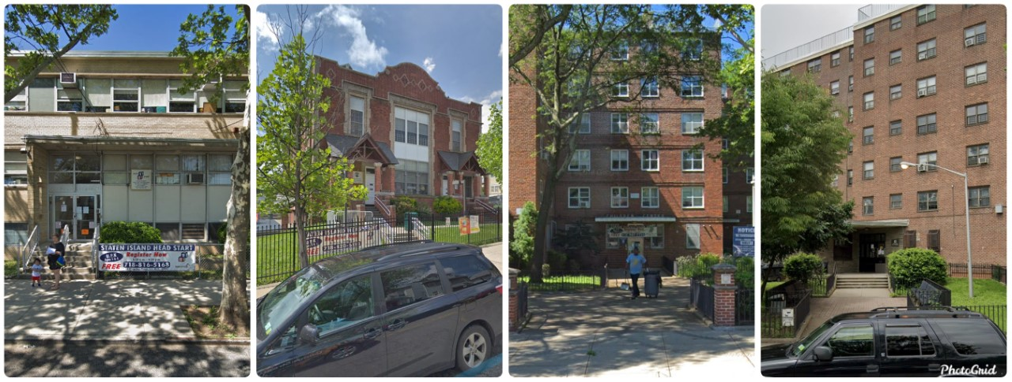

10 Kinsgley Place/100 Brighton Ave
Staten Island, NY 10303
PH: 718-816-5168
Fax: 718-816-4238
16 Osgood Ave
Staten Island, NY 10304
PH: 718-420-6138
Fax: 718-420-6250
44 Dongan Hills Ave
Staten Island, NY 10306
PH: 718-987-7755
Fax: 987-2909
166 Lockman Ave
Staten Island, NY 10303
PH: 718-494-0400
Fax: 494-4564

Staten Island HS/EHS is providing services to (171) Head Start children and (40) Early Head Start children. We offer center-based services from 8:30am to 3:00pm Monday through Friday at each of our four sites. We operate our programs year-round (September to August), except for holidays and days for pre-scheduled in-service training, for a total of 48 weeks each year, which meets the needs of the children and families in the communities we serve.

The Office of Head Start (OHS) requires all Head Start and Early Head Start programs to submit a Program Information Report (PIR) yearly, which provides comprehensive data on the services, staff, children, and families served by Head Start and Early Head Start programs nationwide. The following information is from our Program Information Report for 2022-2023.

PIR Results

: Children by Age | # of children at enrollment
Under 1 year | 0
1 year old | 0
2 years old | 59
3 years old | 104
4 years old | 69
5 years and older | 0
 | # of children
Total cumulative enrollment | 232

Primary Eligibility | # of children /  pregnant women
Income at or below 100% of federal poverty line | 134
Public assistance (TANF, SSI, and SNAP) | 44
Foster care | 4
Homeless | 10
Eligibility based on other type of need | 9
Incomes between 100% and 130% of the federal poverty line, | 31

Prior enrollment
Enrolled in Head Start or Early Head Start for: | # of children
The second year | 68
Three or more years | 13

HS Transition and turnover | # of children
Total number of preschool children who left the program any time after classes or home visits began and did not re-enroll | 17
Of the preschool children who left the program during the program year, the number of preschool children who were enrolled less than 45 days | 2
 | # of preschool children
Of the number of preschool children enrolled in Head Start at the end of the current enrollment year, the number projected to be entering kindergarten in the following school year | 66

EHS Transition and turnover | # of children
Total number of infants and toddlers who left the program any time after classes or home visits began and did not re-enroll | 18
a. Of the infants and toddlers who left the program above, the number of infants and toddlers who were enrolled less than 45 days | 0
b. Of the infants and toddlers who left the program during the program year, the number who aged out of Early Head Start | 16
Of the infants and toddlers who aged out of Early Head Start, the number who entered a Head Start program | 16
Of the infants and toddlers who aged out of Early Head Start, the number who entered another early childhood program | 0
Of the infants and toddlers who aged out of Early Head Start, the number who did not enter another early childhood program | 0

Ethnicity and Race | (1)  Hispanic or  Latino origin | (2)  Non-Hispanic or  Non-Latino origin
American Indian or Alaska Native | 0 | 0
Asian | 0 | 1
Black or African American | 71 | 73
Native Hawaiian or other Pacific Islander | 0 | 0
White | 47 | 15
Bi-racial/Multi-racial | 12 | 13

Primary language of family at home | # of children
English | 133
1. Of these, the number of children acquiring/learning another language in addition to English | 9
Spanish | 79
Middle Eastern & South Asian Languages | 9
East Asian Languages | 6
Native North American/Alaska Native Languages | 0
Pacific Island Languages | 0
European & Slavic Languages | 3
African Languages | 2

Dual language learners | # of children
Total number of Dual Language Learners | 108
Transportation- Inclusion Classrooms
Transportation- Inclusion Classrooms | # of children
Number of children for whom transportation is provided to and from classes | 15

Staff by type | (1)  # of Head Start &  Early Head Start staff | (2)  # of contracted staff
Total number of staff members, regardless of the funding source for their salary or number of hours worked - Head Start/Early Head Start Staff | 63 | 9
Of the total staff, the number who are current or former Head Start parents - Head Start/Early Head Start Staff | 24 | 1

Volunteers by type | # of volunteers
Number of persons providing any volunteer services to the program during the program year | 10
Of these, the number who are current or former Head Start or Early Head Start parents | 6

EDUCATION AND CHILD DEVELOPMENT STAFF
# of HS  classroom teachers | # of HS  assistant teachers
11 | 11
# of EHS classroom teachers
10
Classroom and assistant teachers (HS and EHS programs)

Ethnicity and race | (1)  Hispanic or  Latino origin | (2)  Non-Hispanic or  Non-Latino origin
American Indian or Alaska Native | 0 | 0
Asian | 0 | 1
Black or African American | 2 | 4
Native Hawaiian or other Pacific Islander | 0 | 0
White | 9 | 9
Biracial/Multi-racial | 0 | 2
Other | 3 | 2

Language | # of nonsupervisory  education and child development staff
The number who are proficient in a language(s) other than English. | 29
Of these, the number who are proficient in more than one language other than English | 0
Language groups in which staff are proficient: | # of nonsupervisory  education and child development staff
Spanish | 17
Native Central American, South American, and Mexican Languages | 0
Caribbean Languages | 0
Middle Eastern and South Asian Languages | 12

All staff turnover | # of Head Start or  Early Head Start staff
Total number of staff who left during the program year (including turnover that occurred while the program was not in session, e.g., summer months) | 7
Of these, the number who were replaced | 4

Education and child development staff turnover | # of staff
The number of classroom teachers, preschool assistant teachers, family child care providers, and home visitors who left during the program year (including turnover that occurred while classes and home visits were not in session, e.g., during summer months) | 6
Of these, the number who were replaced | 4
Of these, the number who left while classes and home visits were in session | 5
Of these, the number that were classroom teachers who left the program | 2
Of the number of education and child development staff that left, the number that left for the following primary reason: | # of staff
Higher compensation | 3
Of these, the number that moved to state pre-k or other early childhood program | 1
Retirement or relocation | 2
Involuntary separation | 1
Other (e.g., change in job field, reason not provided) | 0

Health insurance - children | # of children at enrollment
Number of all children with health insurance | 232
Of these, the number enrolled in Medicaid and/or CHIP | 224
Of these, the number enrolled in state-only funded insurance (e.g., medically indigent insurance), private insurance, or other health insurance | 8
Number of children with no health insurance | 0

Medical | # of children at enrollment
Number of children with an ongoing source of continuous, accessible health care provided by a health care professional that maintains the child's ongoing health record and is not primarily a source of emergency or urgent care | 232
Of these, the number of children that have accessible health care through a federally qualified Health Center, Indian Health Service, Tribal and/or Urban Indian Health Program facility | 31

Medical services | # of children at enrollment
Number of children who are up-to-date on a schedule of age appropriate preventive and primary health care, according to the relevant state's EPSDT schedule for well child care | 232
 |  | # of children
Number of children diagnosed with any chronic condition by a health care professional, regardless of when the condition was first diagnosed |  | 49
Of these, the number who received medical treatment for their diagnosed chronic health condition |  | 49
Specify the primary reason that children with any chronic condition diagnosed by a health care professional did not receive medical treatment: |  | # of children
No medical treatment needed |  | 0
No health insurance |  | 0
Parents did not keep/make appointment |  | 0
Children left the program before their appointment date |  | 0
Appointment is scheduled for future date |  | 0
Other |  | 0
Number of children diagnosed by a health care professional with the following chronic condition, regardless of when the condition was first diagnosed: |  | # of children
Autism spectrum disorder (ASD) |  | 5
Attention deficit hyperactivity disorder (ADHD) |  | 0
Asthma |  | 15
Seizures |  | 0
Life-threatening allergies (e.g., food allergies, bee stings, and medication allergies that may result in systemic anaphylaxis) |  | 20
Hearing Problems |  | 3
Vision Problems |  | 6
Blood lead level test with elevated lead levels >5 g/dL |  | 0
Diabetes |  | 0

Body Mass Index (BMI)  Number of children who are in the following weight categories according to the 2000 CDC BMI-for-age growth charts | # of children at enrollment
Underweight (BMI less than 5th percentile for child's age and sex) | 11
Healthy weight (at or above 5th percentile and below 85th percentile for child's age and sex) | 137
Overweight (BMI at or above 85th percentile and below 95th percentile for child's age and sex) | 17
Obese (BMI at or above 95th percentile for child's age and sex) | 8

Immunization services | # of children at enrollment
Number of children who have been determined by a health care professional to be up-to-date on all immunizations appropriate for their age | 232
Number of children who have been determined by a health care professional to have received all immunizations possible at this time, but who have not received all immunizations appropriate for their age | 0
Number of children who meet their state's guidelines for an exemption from immunizations | 0

Oral health | # of children at enrollment
Number of children with continuous, accessible dental care provided by an oral health care professional which includes access to preventive care and dental treatment | 232

Preschool dental services | # of children at end of enrollment
Number of children who received preventive care during the program year | 173
Number of all children, including those enrolled in Medicaid or CHIP, who have completed a professional dental examination during the program year | 173
Of these, the number of children diagnosed as needing dental treatment during the program year | 26
Of these, the number of children who have received or are receiving dental treatment | 26

EHS preventive dental services | # of children at end of enrollment
Number of all children who are up-to-date according to the dental periodicity schedule in the relevant state's EPSDT schedule | 59

Mental health consultation | # of staff
Total number of classroom teachers, home visitors, and family child care providers | 21
Indicate the number of classroom teachers, home visitors, and family child care providers who received assistance from a mental health consultant through observation and consultation | 21

Disability Services | # of children
The total number of children referred for an evaluation to determine eligibility under the Individuals with Disabilities Education Act (IDEA) during the program year | 39
Of these, the number who received an evaluation to determine IDEA eligibility | 33
Of the children that received an evaluation, the number that were diagnosed with a disability under IDEA | 23
Of the children that received an evaluation, the number that were not diagnosed with a disability under IDEA | 10
Of these children, the number for which the program is still providing or facilitating individualized services and supports such as an individual learning plan or supports described under Section 504 of the Rehabilitation Act. | 10
Of these, the number who did not receive an evaluation to determine IDEA eligibility | 6
Specify the primary reason that children referred for an evaluation to determine IDEA eligibility did not receive it: | # of children
a. The responsible agency assigned child to Response to Intervention (RTI) | 0
b. Parent(s) refused evaluation | 1
c. Evaluation is pending and not yet completed by responsible agency | 1
d. Other | 2

Preschool disabilities services (HS) | # of children
Number of children enrolled in the program who had an Individualized Education Program (IEP), at any time during the program year, indicating they were determined eligible by the LEA to receive special education and related services under the IDEA | 38
Of these, the number who were determined eligible to receive special education and related services: | # of children
1. Prior to this program year | 30
2. During this program year | 8
Of these, the number who have not received special education and related services | 3

EHS Part C early intervention services | # of children
Number of children enrolled in the program who had an Individualized Family Service Plan (IFSP), at any time during the program year, indicating they were determined eligible by the Part C Agency to receive early intervention services under the IDEA | 14
Of these, the number who were determined eligible to receive early intervention services: | # of children
1. Prior to this program year | 11
2. During this enrollment year | 3
Of these, the number who have not received early intervention services under IDEA | 1

Preschool primary disabilities | (1)  # of children determined to have this disability | (2)  # of children receiving special services
Non-categorical/developmental delay | 38 | 32

EDUCATION AND DEVELOPMENT TOOLS/APPROACHES

Screening | # of children
Number of all newly enrolled children since last year's PIR was reported | 177
Number of all newly enrolled children who completed required screenings within 45 days for developmental, sensory, and behavioral concerns since last year's PIR was reported | 164
Of these, the number identified as needing follow-up assessment or formal evaluation to determine if the child has a disability | 36

FAMILY AND COMMUNITY PARTNERSHIPS

Number of families | # of families at enrollment
Total number of families: | 227
Of these, the number of two-parent families | 107
Of these, the number of single-parent families | 120
Of the total number of families, the number in which the parent/guardian figures are best described as: | # of families at enrollment
Parent(s) (e.g., biological, adoptive, stepparents) | 223
Of these, the number of families with a mother only (biological, adoptive, stepmother) | 115
Of these, the number of families with a father only (biological, adoptive, stepfather) | 3
Grandparents | 0
Relative(s) other than grandparents | 1
Foster parent(s) not including relatives | 3

Parent/guardian education | # of families at enrollment
An advanced degree or baccalaureate degree | 38
An associate degree, vocational school, or some college | 32
A high school graduate or GED | 111
Less than high school graduate | 45

Employment, Job Training, and School | # of families at enrollment
At least one parent/guardian is employed, in job training, or in school at enrollment | 159
Of these families, the number in which one or more parent/guardian is employed | 150
Of these families, the number in which one or more parent/guardian is in job training (e.g., job training program, professional certificate, apprenticeship, or occupational license) | 7
Of these families, the number in which one or more parent/guardian is in school (e.g., GED, associate degree, baccalaureate, or advanced degree) | 7
Neither/No parent/guardian is employed, in job training, or in school at enrollment (e.g., unemployed, retired, or disabled) | 47
Total number of families in which: | # of families at end of enrollment
At least one parent/guardian is employed, in job training, or in school at end of enrollment | 174
Of these families, the number of families that were also counted in C.37.a (as having been employed, in job training, or in school at enrollment) | 76
Of these families, the number of families that were also counted in C.37.b (as having not been employed, in job training, or in school at enrollment) | 10
Neither/No parent/guardian is employed, in job training, or in school at end of enrollment (e.g., unemployed, retired, or disabled) | 28
1. Of these families, the number of families that were also counted in C.37.a | 4
2. Of these families, the number of families that were also counted in C.37.b | 2
Total number of families in which: | # of families at enrollment
At least one parent/guardian is a member of the United States military on active duty | 0
At least one parent/guardian is a veteran of the United States military | 0

Federal or other assistance | (1)  # of families at enrollment
Total number of families receiving any cash benefits or other services under the Federal Temporary Assistance to Needy Families (TANF) Program | 38
Total number of families receiving Supplemental Security Income (SSI) | 8
Total number of families receiving services under the Special  Supplemental Nutrition Program for Women, Infants, and Children (WIC) | 77
Total number of families receiving benefits under the Supplemental Nutrition Assistance Program (SNAP), formerly referred to as Food Stamps | 137

Family services | # of families
Emergency/crisis intervention (e.g., meeting immediate needs for food, clothing, or shelter) | 118
Housing assistance (e.g., subsidies, utilities, repairs) | 0
Asset building services (e.g., financial education, debt counseling) | 0
Mental health services | 0
Substance misuse prevention | 0
Substance misuse treatment | 0
English as a Second Language (ESL) training | 7
Assistance in enrolling into an education or job training program | 1
Research-based parenting curriculum | 12
Involvement in discussing their child's screening and assessment results and their child's progress | 226
Supporting transitions between programs (i.e., EHS to HS, HS to kindergarten) | 90
Education on preventive medical and oral health | 226
Education on health and developmental consequences of tobacco product use | 0
Education on nutrition | 72
Education on postpartum care (e.g., breastfeeding support) | 0
Education on relationship/marriage | 0
Assistance to families of incarcerated individuals | 0
Of these, the number of families who were counted in at least one of the services listed above | 226

Father engagement | # of father/ father figures
Family assessment | 4
Family goal setting | 3
Involvement in child's Head Start child development experiences (e.g., home visits, parent-teacher conferences, etc.) | 50
Head Start program governance, such as participation in the Policy Council or policy committees | 0
Parenting education workshops | 6

Homelessness services | # of families
Total number of families experiencing homelessness that were served during the enrollment year | 10
Total number of children experiencing homelessness that were served during the enrollment year | 10
Total number of families experiencing homelessness that acquired housing during the enrollment year | 9

Foster care and child welfare | # of families
Total number of enrolled children who were in foster care at any point during the program year | 4
Total number of enrolled children who were referred to Head Start/Early Head Start services by a child welfare agency | 1

Intensive Coaching | # of education and child development staff
The number of education and child development staff (i.e., teachers, preschool assistant teachers, home visitors, family child care providers) that received intensive coaching | 4

Management Staff | Number of Management  Staff in this Position
Executive Director | 0
Head Start and/or Early Head Start Director | 1
Education Manager/Coordinator | 4
Health Services Manager/Coordinator | 0
Family & Community Partnerships Manager/Coordinator | 1
Disability Services Manager/Coordinator | 0
Fiscal Officer | 1

Education Management Staff Qualifications | # of education managers/coordinators
D.4 Total number of education managers/coordinators | 4
a. Of these, the number of education manager/coordinators with a baccalaureate or advanced degree in early childhood education or a baccalaureate or advanced degree and equivalent coursework in early childhood education with early education teaching experience | 4
b. Of these, the number of education manager/coordinators that do not meet one of the qualifications in D.4.a | 0
1. Of the education manager/coordinators in D.4.b, the number enrolled in a program that would meet a qualification described in D.4.a | 0

Family Service Staff Qualifications | # of family services staff
D.5 Total number of family services staff: | 7
a. Of these, the number that have a credential, certification, associate, baccalaureate, or advanced degree in social work, human services, family services, counseling, or a related field | 6
b. Of these, the number that do not meet one of the qualifications described in D.5.a | 1
1. Of the family services staff in D.5.b, the number enrolled in a degree or credential program that would meet a qualification described in D.5.a. | 1
2. Of the family services staff in D.5.b, the number hired before November 7, 2016 | 0

Formal Agreements for Collaboration | # of partners or agencies
D.6 Total number of child care partners in which a formal agreement was in effect | 0
D.7 Total number of LEAs in the service area | 5
a. Of these, the total number of LEAs in which a formal agreement was in effect to coordinate services for children with disabilities | 0
b. Of these, the total number of LEAs in which a formal agreement was in effect to coordinate transition services | 0
D.8 Total number of Part C agencies in the service area | 3
a. Of these, the total number of Part C agencies in which a formal agreement was in effect to coordinate services for children with disabilities | 0
2023-2024 Demographics

Head Start

Early Head Start

Income Demographics

Early Head Start

Head Start

Resources List

Community District 1

Community District 2
Staten Island Downtown Alliance
Making Downtown Staten Island tourism ready is a major goal of the Staten Island Downtown Alliance
Staten Island Business Center
350 St. Mark’s Pl.
Phone: 311
Walk-in payment center done DMV-style where you’re handed a number depending on your business and wait for it to be called at the appropriate window.
Here you can pay parking, red light camera and most Environmental Control board (ECB) fines, real estate taxes, get registration clearances and tow releases, satisfy judgments.
An adjacent area on the main floor contains hearing rooms to dispute parking and red light and ECB violations.
Note: Moving vehicle violations (like speeding) are handled on the state level at the Department of Motor Vehicles office at West Shore Plaza, 1775 South Avenue.
Tax Map Unit
Get help dividing and merging property lots; obtain forms for tax exemptions.
Phone: 311
NYC Sheriff Services
350 St. Mark’s Pl., #409
Phone: 311, or 718-815-8407
Enforces civil laws such as judgments, process serving, arrests, and vehicle towing.

Administration for Childrens Services
Provides child protective investigation in case work; information about preventative services programs for families and help for parents who want to voluntarily place their children in foster care.
350 St. Mark’s Pl., 5th Fl.
Phone: 718-720-2764
Community Health Action
Main office: 56 Bay St., third and sixth floors
Phone: 718-808-1300; hotline, 718-448-2255
Staten Island Employment Education Consortium
Provides free employment counseling, training, placement and education classes to disadvantaged Staten Island residents ages 16 through retirement.
28 Bay St.
Phone: 718-816-6700
Website: sieec.org
Safe Horizon
Rape Crisis Program and domestic violence services for victims and children including shelters, counseling, legal representation, housing and employment assistance.
Hotline: 800-621-HOPE (4673), or 718-720-2591.
Community Agency for Senior Citizens (CASC)
56 Bay St., #5
Phone: 718-981-6226
Department of Environmental Protection
Walk-in center for water account information, problems with water meters
60 Bay St., Sixth floor
Phone: 718-595-7000,
The Legal Aid Society
A non-profit providing legal services to low-income residents in civil, criminal and juvenile rights matters.
60 Bay St., third floor
Phone: 347-422-5333

Staten Island Veterans Center
60 Bay St.
Phone: 718-816-4499 or 877-927-8387
U.S. Veterans Center
150 Richmond Terr.
Phone: 718-816-4499
Staten Island Workforce1 Career Center
Job postings, workshops and recruitment events
120 Stuyvesant Pl.
Phone: 718-285-8388
Email: workforce1@edsisolutions.com
Court Offices
Staten Island Tort Unit Phone: 718- 447-5983
Staten Island Family Court Unit Phone: 718-390-5395
County Clerk
Stephen J. Fiala, County Clerk; 130 Stuyvesant Pl.
Phone: 718-675-7700
Autism Resources and Guides
Community Agency for Senior Citizens, Inc. (CASC)

Public Librarys

Dongan Hills: 1617 Richmond Rd.; 718-351- 1444. Monday through Thursday, 11 a.m. to 7
p.m.; Friday and Saturday, 10 a.m. to 5 p.m.; closed Sunday.
https://www.nypl.org/about/locations/dongan-hills

New Dorp: 309 New Dorp Lane; 718-351- 2977. Monday, Tuesday and Wednesday, 10 a.m. to 7p.m.; Thursday, 11 a.m. to 8 p.m.; Friday and Saturday, 10 a.m. to 5 p.m.; closed Sunday.
https://www.nypl.org/about/locations/new-dorp

South Beach: 21-25 Robin Rd.; 718-816- 5834. Monday, Tuesday and Wednesday, 10 a.m. to 7p.m.; Thursday, noon to 7 p.m.; Friday and Saturday, 10 a.m. to 5 p.m.; closed Sunday.
https://www.nypl.org/locations/south-beach

Mariners Harbor: 206 South Ave; 212- 621-0690, Monday, Tuesday, Thursday,11 AM–6 PM
Wednesday 12 PM–7 PM, Friday and Saturday 11 AM–5 PM; Sunday CLOSED
https://d8.nypl.org/locations/mariners-harbor

PlayGrounds

Naples Playground: Targee and Naples Streets and Rome Avenue, Concord
Arrochar Playground: Sand Lane, Major and McFarland Avenues
Dongan Playground: Mason Avenue, Buel Avenue, Dongan Hills Avenue, Dongan Hills
Midland Playground: Between Graham Boulevard and Jefferson Avenue
Old Town Playground: Parkinson Avenue and Kramer Street, Grasmere
McArthur Park Playground: Buel Avenue and Hylan Boulevard, Dongan Hills
Playland Playground: South Beach, behind Jefferson Avenue and Father Capodanno Boulevard
Saturn Playground at South Beach: Off Father Capodanno and Sand Lane
Schmul Park Playground: Wild Avenue, Travis

Community Organizations
Community Emergency Response Team
Boy Scouts of America
Girl Scouts of America
New Dorp Central Civic Association
Preservation League of Staten Island
St. George Civic Association
Westerleigh Improvement Society
South Beach Civic Association
Staten Island Civic Association
Iron Hills Civic Association
New Dorp Business Improvement District
West Shore Business Improvement District

transportation info
Transportation Maps from the MTA
Staten Island Ferry

Cultural institutions
Alice Austen House
Garibaldi-Meucci Museum
Jacques Marchais Museum of Tibetan Art
National Lighthouse Museum
Noble Maritime Collection
Snug Harbor Cultural Center
Staten Island Children’s Museum
Staten Island Museum
Conference House
The Greenbelt
Historic Richmond Town
Staten Island Botanical Garden
Staten Island Zoo
Sandy Ground Historical Society

educational facilities
NYC Department of Education
New York Public Library
St. Johns University
College of Staten Island
Wagner College

Ethnic Organizations
Jewish Community Center of Staten Island (JCC)
Latino Civic Organization
National Association for the Advancement of Colored People – NAACP
Staten Island Hibernians
Sons of Italy

Business/Government & General information
Board of Elections
New York State Crime Victims Board
Population & Census Summaries
Staten Island Borough Historian
Staten Island Chamber of Commerce
Staten Island Economic Development Corporation

Publications
My Staten Island
Staten Island Live
Staten Island Parent Magazine

Theater/performances & Sports
CSI Center for the Arts – College of Staten Island
Council on the Arts & Humanities (COAHSI)
St. George Theatre
Staten Island Community Television
Staten Island Shakespearean Theater
Staten Island Yankees
Precincts
- NYPD 120 Precinct
Address: 78 Richmond Terrace, Staten Island, NY 10301
Phone: (718) 876-8500
- NYPD 121 Precinct
Address: 970 Richmond Ave, Staten Island, NY 10314
Phone: (718) 697-8700

- NYPD 122 Precinct
Address: 2320 Hylan Blvd, Staten Island, NY 10306
Phone: (718) 667-2211

Fire Departments
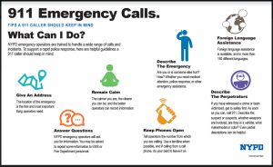
- Engine 154
3730 Victory Boulevard
Staten Island, N.Y. 10314

- Engine 158
65 Harbor Road
Staten Island, N.Y. 10303

- Engine 159
1592 Richmond Road
Staten Island, N.Y. 10304

- Engine 160, Rescue 5
1850 Clove Road
Staten Island, N.Y. 10304

- Engine 161, Ladder 81
278 McClean Avenue
Staten Island, N.Y. 10305

- Engine 165, Ladder 85
3067 Richmond Road
Staten Island, N.Y. 10306

- Engine 166, Ladder 86
1400 Richmond Avenue
Staten Island, N.Y. 10314

