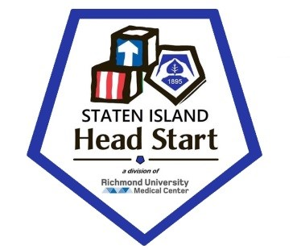

Community Assessment

Prepared for
RUMC-Staten Island Head Start

By
VERITÉ HEALTHCARE CONSULTING, LLC

December 2025

TABLE OF CONTENTS

Abstract 3
Executive Summary 4
About RUMC-Staten Island Health Start 11
RUMC-Staten Island Health Start Goals 12
RUMC-Staten Island Head Start Service Area 19
OBJECTIVES AND METHODOLOGY 21
Regulatory Requirements 21
A. Demographic information about eligible infants, toddlers, preschool age children, and expectant mothers 21
Family income falls within the federal guidelines 22
Live in temporary housing 22
Receive HRA Cash Assistance 25
Receive SNAP 25
Receive SSI (Supplemental Security Insurance) 26
Enrolled in Foster Care 26
Infants and expectant mothers - Overview 27
Births by Community District 28
Expectant Mothers 29
Newborn Infants 37
B. Information about the education, health, nutrition, and social service needs of eligible children and their families 41
C. Work, school, and training schedules of parents with eligible children 50
D. Information about other child development services, child care centers, and family child care programs that serve eligible children 52
E. Resources available in the community 53
Community Boards 53
Resource Directories 54
Other Community Resources 54
F. Strengths of the community 62
ABOUT VERITÉ HEALTHCARE CONSULTING 70
Appendix 71

Abstract

Staten Island Head Start serves Community Districts 1 and 2, with the greatest concentration of need located on the North Shore (Community District 1). Data show a significant population of children under age 5 who are income-eligible for Head Start and Early Head Start, particularly in ZIP Codes 10301, 10302, 10303, 10304, and 10310. A substantial number of families experience economic hardship, as evidenced by high rates of SNAP participation, cash assistance, SSI receipt, and foster care involvement. An estimated 1,066–1,333 children under age 5 live in temporary housing, indicating housing instability across the service area.

Birth data confirm a steady pipeline of infants and expectant mothers, with Community District 1 consistently showing the highest number of births. Perinatal data also reveal elevated rates of Medicaid/self-pay births, late or no prenatal care, and teen pregnancy in several North Shore ZIP Codes. Many elementary schools in the service area have poverty rates exceeding 75 percent, underscoring the need for early intervention prior to kindergarten entry.

Based on the data, the following priority needs have been identified:

- Expanded Access to Early Childhood Education. Additional Head Start and Early Head Start slots are needed, particularly in Community District 1, to serve income-eligible children, children experiencing homelessness, and children involved in foster care.
- Housing Stability and Family Support. High rates of temporary housing indicate a need for strong family advocacy, case management, and referrals related to housing, benefits access, and emergency supports.
- Comprehensive Health and Developmental Services. Data reflect ongoing needs for prenatal care, pediatric health services, dental care, mental health supports, nutrition services, and early identification of developmental delays.
- Support for Children with Disabilities and Special Needs. The estimated numbers of young children receiving SSI and/or enrolled in foster care highlight needs for integrated classrooms, individualized supports, and strong collaboration with early intervention and special education providers.
- Family Economic Stability and Workforce Supports. High participation in SNAP and cash assistance demonstrates a continued need for employment support, job training referrals, adult education, and financial counseling for families.
- Culturally and Linguistically Responsive Services. Given the diversity of the service area and varying family backgrounds, families benefit from services delivered in their preferred language, culturally responsive practices, and trusted relationships with staff.

Despite these challenges, Staten Island benefits from strong community assets, including hospitals, health clinics, social service agencies, public schools, libraries, parks, and transportation networks, which provide a foundation for coordinated services and partnerships.

Conclusion. Data confirms that RUMC-Staten Island Head Start is serving a community with significant economic, housing, health, and educational needs, particularly among families with very young children on the North Shore. Strong community assets ensure that the program can continue to deliver high-quality, comprehensive, and coordinated services that address school readiness while supporting overall family well-being.

Executive Summary

About RUMC-Staten Island Health Start
RUMC-Staten Island Head Start, under the auspices of the Staten Island Mental Health Society, was one of the first community agencies to deliver Head Start services in New York City. In 2019, Staten Island Mental Health Society merged with Richmond University Medical Center, making the program the first Head Start program in the state to be governed by a medical facility. Also in 2019, RUMC-Staten Island Head Start became a Direct Grantee of the Office of Head Start and launched its Early Head Start program, providing services to children 2 years of age.

As a longstanding member of the Staten Island community, RUMC-Staten Island Head Start has developed strong relationships with public and private entities dedicated to improving the well-being of children and families in the catchment area. These include public and private schools and child care programs, community health care service providers, foster care and preventive service programs, and government agencies that provide safety-net services to families, as well as organizations that serve special-needs students.

The service and recruitment areas of RUMC-Staten Island Head Start are defined as Staten Island Community Districts 1 and 2. Exhibit ES-1 presents a map displaying the RUMC-Staten Island Head Start service area and locations.

Exhibit ES-1: RUMC-Staten Island Head Start Service Area and Locations
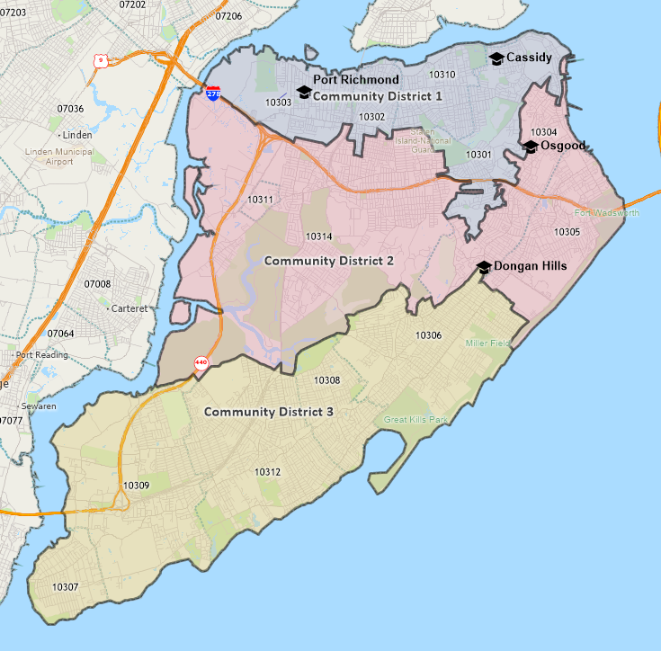
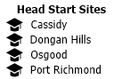
Sources: Caliper Maptitude (2025) and RUMC-Staten Island Head Start.
Note that these ZIP Code assignments do not correspond to Community District geographic boundaries exactly.
See the Appendix for a comparison of the two designations.

The addresses of RUMC-Staten Island Head Start locations are listed below.
- Cassidy - 148 Cassidy Place, Staten Island, NY 10301
- Dongan Hills - 44 Dongan Hills Ave, Staten Island, NY 10306
- Osgood - 16 Osgood Ave, Staten Island, NY 10304
- Port Richmond - 166 Lockman Ave, Staten Island, NY 10303

Regulatory Requirements
Federal regulations require that Head Start programs must conduct a community assessment (CA) at least once every three years. Such a CA is a “collection and analysis of data related to the needs and characteristics of Head Start-eligible children and families” in the geographic area serve by the program. Requirements specify that that the CA include the following:

- Demographic information about eligible infants, toddlers, preschool age children, and expectant mothers;
- Information about the education, health, nutrition, and social service needs of eligible children and their families;
- Work, school, and training schedules of parents with eligible children;
- Information about other child development services, child care centers, and family child care programs that serve eligible children;
- Resources available in the community; and
- Strengths of the community.

Summarized information on these requirements is below.
A. Demographic information about eligible infants, toddlers, preschool age children, and expectant mothers.

Demographic information about Infants, toddlers, and preschool age children
Head Start and Early Head Start programs are free, early education programs that are provided without charge for eligible children, aged two to four. Exhibit ES-2 lists eligibility guidelines are estimates of the population under 5 years for each guideline.

Exhibit ES-2: Eligibility Guidelines and Population Under 5
Guideline | Estimated Number of Community Members
Family income falls within the federal guidelines | Community District 1 – 1,548 Under 5 Years  Community District 2 – 973 Under 5 Years
Live in temporary housing | Staten Island – 1,066 to 1,333 Under 5 Years
Receive HRA Cash Assistance | Community District 1 – 8,311 Total Cases  Community District 2 – 2,612 Total Cases
Receive SNAP | Community District 1 – 2,689 Under 5 Years Estimated  Community District 2 – 1,948 Under 5 Years Estimated
Receive SSI (Supplemental Security Insurance) | Staten Island – 506 Under 5 Years Estimated
Enrolled in foster care. | Community District 1 – 244 Children  Community District 2 – 44 Children
Sources: Various; see Exhibits1 through 7.

Demographic information about expectant mothers and births
Planning for Head Start and Early Head Start programs can be informed by recent births in the community. Exhibit ES-3 lists births by Community District, 2018-2022.

Exhibit ES-3: Births by Community District by Year, 2018-2022
Community District | 2018 | 2019 | 2020 | 2021 | 2022
Community District 1 | 2,215 | 2,176 | 2,063 | 2,033 | 1,995
Community District 2 | 1,364 | 1,392 | 1,340 | 1,393 | 1,351
Community District 3 | 1,474 | 1,593 | 1,428 | 1,527 | 1,530
Staten Island | 5,053 | 5,161 | 4,831 | 4,953 | 4,876
Source: New York City Department of Health and Mental Hygiene, 2025.

New York City provides data related to expectant mothers and births for the 2019-2021 period by ZIP Code. The data includes the following indicators:

- Maternal Race/Ethnicity;
- Maternal Location of Birth, US and Foreign-Born;
- Maternal Educational Levels;
- Maternal Prenatal Care Initiation;
- Maternal Health Insurance Status;
- Maternal Marital Status;
- Maternal Pre-Pregnancy BMI Weight Category;
- Infant Birthweight Category;
- Infant Gestational;
- Births, Plurality Counts; and
- Maternal – Infant Breastfeeding.

The distributions for all indicators vary by ZIP Code.

B. Information about the education, health, nutrition, and social service needs of eligible children and their families

Educational achievement, health status, nutritional access, and social service needs vary by Community District and ZIP Code. Information categories examined include the following:

- Enrollments in nursery school / preschool and kindergarten;
- Educational achievement for adults aged 25 and older;
- Poverty and Economic Need Index by school;
- Lack of access to nutritious and affordable food (food deserts); and
- Health Professional Shortage Areas.

Head Start planning can also be informed by characteristics of students enrolled in local schools. Exhibit ES-4 summarizes the student poverty percentages and Economic Need Index for schools on Staten Island with poverty percentages at 75 percent or more.

Exhibit ES-4: Percentage of Poverty and Economic Need Index by School, 2024-2024
School Name | ZIP Code | Poverty Percent | Economic Need Index
Community District 1
P.S. 74 Future Leaders Elementary School | 10301 | Above 95% | Above 95%
P.S. 031 William T. Davis | 10301 | Above 95% | Above 95%
P.S. 016 John J. Driscoll | 10301 | Above 95% | 92.8%
Fort Hill Collaborative Elementary School | 10301 | 92.0% | 91.3%
The Harbor View School | 10301 | 75.3% | 77.2%
P.S. 65 The Academy of Innovative Learning | 10301 | 75.0% | 73.1%
P.S. 020 Port Richmond | 10302 | 91.4% | 91.9%
P.S. 21 Margaret Emery-Elm Park | 10302 | 88.0% | 89.1%
Port Richmond School for Visionary Learning | 10302 | 82.1% | 79.4%
P.S. 044 Thomas C. Brown | 10303 | 93.2% | 93.0%
P.S. 022 Graniteville | 10303 | 83.6% | 82.9%
P.S. 018 John G. Whittier | 10310 | 94.6% | 93.3%
P.S. 019 The Curtis School | 10310 | 93.7% | 90.8%
Community District 2
The Waverly Academy of Empowered Learners | 10304 | Above 95% | 91.5%
P.S. 057 Hubert H. Humphrey | 10304 | 94.9% | 91.1%
P.S. 78 | 10304 | 94.5% | Above 95%
P.S. 11 Thomas Dongan School | 10304 | 81.0% | 73.8%
P.S. 39 Francis J. Murphy Jr. | 10305 | 90.4% | 75.4%
P.S. 046 Albert V. Maniscalco | 10305 | 90.2% | 87.3%
P.S. 013 M. L. Lindemeyer | 10305 | 81.6% | 78.0%
P.S. 052 John C. Thompson | 10305 | 75.9% | 65.4%
Staten Island School of Civic Leadership | 10314 | 78.8% | 70.5%
Community District 3
P.S. 038 George Cromwell | 10306 | 79.4% | 78.1%
The Stephanie A. Vierno School | 10306 | 76.4% | 72.1%
Source: NYC Schools, 2025
Note that these ZIP Code assignments do not correspond to Community District geographic boundaries exactly.
See the Appendix for a comparison of the two designations.

C. Work, school, and training schedules of parents with eligible children
Information on work, school, and training schedules of parent with eligible children is not readily available. Accommodation for parent schedules and consideration may be informed by the 2023 contract between the United Federation of Teachers and New York City Schools. This contract stipulates that, for elementary and middle schools, “the school day will start no earlier than 8 a.m. and may end no later than 3:45 p.m.,” including time for professional development, other professional work, and parent engagement.

D. Information about other child development services, child care centers, and family child care programs that serve eligible children
Numerous programs provide services related to child development, child care, and family care to eligible children in the RUMC-Staten Island Head Start Service Area. Specific services include the following:

- Academic and emotional learning
- Breastfeeding and home safety support
- Developmental disability & early childhood services
- Evaluation, treatment, and follow-up care to support optimal childhood development
- Family support and community services
- Foster care and preventive services
- Health and nutrition
- Helps parents find licensed day care in their neighborhood
- Offers support, services, and referrals to new and expectant parents.
- Outpatient services
- Pre-school education services
- Referrals to New York City resources and services
- Sleep-related injury information
- Support for first-time pregnancy and parenting knowledge
- Support for families with children who are up to three years old and have disabilities or developmental delays

E. Resources available in the community
The RUMC-Staten Island Head Start community has a variety of community strengths and resources that can be leveraged for service delivery, coordination, and partnership efforts for education, health, nutrition, and referrals to social services to eligible children and families. An overview of facilities, organizations, and service providers, including transportation resources, and culturally appropriate and responsive supports.

- Community Boards handle complaints and requests related to City services, work with City agencies to plan local projects, review proposed zoning changes, and act as the community’s liaison with City agencies.
- NYC311 provides access to non-emergency government services and information, as well as more than 200 agencies and non-profits in New York City.
- The United Way of New York State operates 211 New York, a service that “connects New Yorkers to local resources and services --- including food, housing, mental health support, and more.”
- Cultural and recreation resources include museums, beaches, parks, and a zoo.
- Disability resources include transportation, blind and low vision support, and navigation assistance.
- Domestic violence resources include crisis intervention, support, and information services.
- Educational resources include services from early childhood education to post-graduate degrees, as well as libraries.
- Employment resources include referral services, job training, and worker protection.
- Financial resources include counseling and tax preparation assistance.
- Food and nutrition resources include SNAP, WIC, and greenmarkets.
- Health care resources include hotlines, clinics, and hospitals.
- Public safety resources include 911, police services, and emergency preparedness guidance.
- Shelter and housing resources assistance for residents with an immediate housing crisis, affordable housing for low- and moderate-income residents, and homeownership opportunities.
- Transportation resources include services for people with disabilities, reduced fares for low-income residents, and public transportation services.

F. Strengths of the community
Staten Island is a diverse community offering a high quality of life, wide-ranging and various employment opportunities, strong educational opportunities, and a “small town feel.” As the most suburban borough of New York City, it has an abundance of parks and green space while also having convenient connections to other NYC boroughs. Staten Island schools have been consistently ranked as some of the best in the city and housing is affordable compared to other boroughs.

In December 2025, students enrolled at RUMC-Staten Island Head Start were asked to identify what they considered to be community strengths. Categories of strengths identified by the students are as follows:

- Schools and libraries;
- Parks;
- Infrastructure, such as grocery stores and restaurants; and
- Resources of New York City.

About RUMC-Staten Island Health Start

History
The Staten Island Mental Health Society was one of the first community agencies to deliver Head Start services in New York City. President Lyndon B. Johnson commented on the success of the RUMC-Staten Island Head Start program during remarks in a Rose Garden speech on August 31, 1965. As the President outlined his plans to make Head Start a continuing part of the educational foundation of poor children, he talked about the difference the program’s volunteers made in the life of one child.

January 1st, 2019, Staten Island Mental Health Society merged with Richmond University Medical Center making it the first Head Start program in the state to be governed by a medical facility.

July 1st, 2019, RUMC-Staten Island Head Start became a Direct Grantee with the Federal Government.

RUMC-Staten Island Head Start Mission
The role of RUMC-Staten Island Head Start and its collaborating partners is to provide comprehensive services to children and their families. We are dedicated to serving the community and being a vital link between the families of Staten Island and all available community resources.

RUMC-Staten Island Head Start Vision
RUMC-Staten Island Head Start envisions a future in which all children—regardless of background—enter school confident, curious, and ready to excel. The vision is to ensure that every child has the opportunity to reach their fullest potential by nurturing lifelong learners, supporting strong parent-child relationships, and laying a solid foundation for success in school and in life. Through collaborative partnerships with families and the community, we create enriching, high-quality early childhood experiences and comprehensive family services that inspire children and families to thrive.
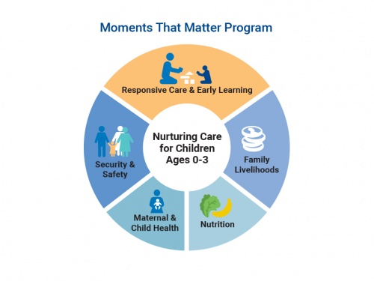

RUMC-Staten Island Health Start’s Goal

Goals

Short-Term Goals (12–18 months)

Child Outcomes & Classroom Quality
- Improve individualized instruction by reducing class size and increasing staff support in classrooms serving children with special needs.
- Ensure 100% of children with suspected developmental delays receive timely screenings and referrals within required timelines.
- Increase CLASS scores in Emotional Support and Classroom Organization through targeted coaching and professional development.

ERSEA & Enrollment
- Achieve and maintain full enrollment by strengthening recruitment in high-need ZIP codes and increasing community-based outreach.
- Reduce chronic absenteeism by implementing enhanced attendance follow-up and family support strategies.
- Improve waitlist management to ensure children with the highest need are prioritized for enrollment.

Family Engagement & Support
- Increase parent participation in family engagement activities, including parent meetings, workshops, and leadership opportunities.
- Ensure all families have an up-to-date Family Partnership Agreement reflecting goals related to health, education, and economic stability.
- Expand father engagement activities through targeted outreach and father-focused events.

Workforce Stability
- Fill all vacant teaching and support positions to maintain ratios and ensure continuity of care.
- Provide staff training on trauma-informed care, cultural responsiveness, and inclusion practices.
- Improve staff retention through wage adjustments and wellness supports.

Long-Term Goals (3–5 years)

Program Quality & Sustainability
- Sustain high-quality services across all Head Start and Early Head Start classrooms, meeting or exceeding all Head Start Performance Standards.
- Establish consistent staffing patterns with reduced turnover and a strong internal pipeline for career advancement.
- Maintain stable enrollment through ongoing data-driven ERSEA planning and community assessment updates.

School Readiness & Child Development
- Improve kindergarten readiness outcomes, particularly in language, social-emotional development, and self-regulation.
- Expand inclusive practices to ensure children with disabilities and dual language learners receive equitable, high-quality instruction.
- Strengthen transitions from Early Head Start to Head Start and from Head Start to kindergarten.

Family & Community Impact
- Strengthen family economic stability by increasing connections to workforce development, education, and benefits.
- Expand partnerships with health providers, early intervention programs, and community agencies to address identified service gaps.
- Increase parent leadership representation in Policy Council, committees, and program decision-making.

Systems & Governance
- Strengthen governance systems through ongoing training for the Governing Board, ECE Committee, and Policy Council.
- Use community assessment and outcome data to inform long-term planning, Change in Scope decisions, and resource allocation.
- Ensure fiscal sustainability while maintaining program quality through responsible budgeting and grant management.

Staten Island Health Start Program Governance
RUMC has established a committee of the Governing Board to serve as the SIHS/EHS governing body. This committee is called the Early Childhood Education Committee. This committee will foster close communication between the Policy Council and the Governing Board.

The Early Childhood Education Committee is comprised of community residents and parents of former or current HS or EHS children without any conflict of interest. It will also include at least one member with background and expertise in fiscal management or accounting, at least one member with background and expertise in early childhood education and development, and at least one member that is a licensed attorney with related experience.

Facilities, Materials and Equipment
RUMC-Staten Island Head Start’ facilities, materials and equipment are maintained to create a learning environment that is safe, accessible, welcoming, comfortable, age appropriate, culturally sensitive and meets the individual needs of children and families.

Proper attention is paid to the issues of safety and sanitation to protect the children’s health and to keep them free of injury. The facility meets all the applicable licensing and zoning requirements for fire, health and safety regulations. To support the educational objectives and to show respect to children and families, the equipment, toys, materials and furniture are matched to the developmental levels, interests, temperaments, languages, cultural backgrounds, and learning styles of children.

An accurate equipment record is maintained that provides a description of the equipment, the serial number, and where the equipment is located. A physical inventory is done twice a year to evaluate the condition and/or continued need for certain equipment. A control system is in place to prevent loss damage or theft of any equipment. Maintenance procedures are also in place to keep equipment in good condition.

Child Health and Developmental Services
RUMC-Staten Island Head Start’s philosophy is to accept each child and his/her family as individuals with different physical, social and emotional needs. They have the right to adequate health care regardless of race, color or creed. The importance of early identification of health problems is emphasized by encouraging on-going health care services with the child’s health provider, to ensure continuing care, even after the child leaves RUMC-Staten Island Head Start.

Since many preschool children of low-income families have never seen a doctor or dentist, arrangements are made for every child to receive comprehensive health care that includes medical, dental, mental health, and nutrition services. The objective is to develop a positive attitude toward health care and encourage and maintain good health habits for the entire family. RUMC-Staten Island Head Start also strives to promote early intervention, health advocacy, and community awareness at RUMC-Staten Island Head Start.

Education and Early Childhood Development
The educational goals of the program are as follows:

- Promote the social, emotional, intellectual, and physical development of each child;
- Provide an educational program which is multicultural and meets special needs of all children;
- Establish procedures for on-going observations, evaluations, and follow-up each child’s development by planning for the development and instructional needs of each child and expanding the education component as necessary to meet these needs;
- Integrate the educational aspects of the various Head Start service areas into a daily program of activities;
- Promote and encourage parent participation in helping plan an appropriate education program for center, classroom and home program activities;
- Enhance the knowledge, awareness, and understanding of parents and staff of the developmental needs of children: and
- Promote language understanding and use in an atmosphere that encourages communication among children and adults.

Child Health and Safety
In ensuring the health and safety of all children enrolled within RUMC-Staten Island Head Start, every measure has been taken to provide an environment that is conducive to injury prevention, hygiene, and practical safety measures; promote positive culturally relevant health behaviors that enhance life-long well-being. Staff members are trained in emergency procedures and periodic emergency practice drills are performed with children. The emergency policies and procedures are posted and clearly state the roles and responsibilities of each staff member. Workshops are given for the parents and children to help them also develop plans of action for dealing with emergencies in their homes.

Child Nutrition
RUMC-Staten Island Head Start believes that at a well-nourished child is more alert and has a better chance of learning and functioning as a healthy individual.

Our goal is to aid in the building of strong bodies and healthy minds by developing good nutritional education; encouraging good eating habits and introducing the children to different kinds of ethnic foods, including the nutritional program into the classroom activities.

The nutrition staff will teach children the many aspects of food, such as the changes involved when food is transformed from raw (natural) to cooked, and the growing process of the food, color, taste, smell, and touch with the use of the Food Guide Pyramid, etc.

Since meal times should promote the physical, social and emotional development of children, inclusive of children with special needs, meals are served family style. Children participate in setting the tables and are encouraged to serve themselves and assist in the cleanup process (helping hands chores).

By including learning activities with food in programs, children can develop a broad appreciation for food. It’s important for good health and growth. There are many different foods that are nutritious and taste good; where foods come from; how they are processed; how to plan and prepare simple meals; and many other interesting things about food.

The food learning experience, along with eating meals and snacks in a pleasant atmosphere helps children develop good eating habits, i.e., the habit of eating nutritious foods, and a willingness to try new foods. By learning good eating habits during the first five years, the child is more likely to eat a nutritious diet for the rest of his/her life.

Child Mental Health
Our Head Start program works in collaboration with the Elizabeth W. Pouch Center for Special to provide staff for two integrated classrooms in order to provide services to children with moderate to serious disabilities in a 10:10 model The classrooms are staffed with two certified teachers that hold NYS Certification in Special education and two assistant teachers with experience working with children with special needs.

A mental health professional is available to children and parents. Mental health training is also available to staff and parents to make them aware of the need for early attention to the special needs of children and to also help them learn techniques on how to handle children with difficult behaviors.

Family and Community Partnership Philosophy
At the core of the trust building conversations is to encourage parents to see Head Start staff as a source of information, support and a resource. The intent of RUMC-Staten Island Head Start Family Services is to support families. The program’s approach is to treat parents with dignity and respect, and to develop a sense of self-direction and self–esteem.

Therefore, service delivery is based on an understanding of child and family development, multicultural sensitivity, effective communication and a partnership with parents. This is accomplished by providing information about community resources and how to obtain them and including parents in the decision-making process.

The Family Worker is always respectful of the goals, aspirations, strengths and needs of the parent. All parents are recognized and respected as their child’s primary educator, so efforts to involve parents in the education and development of the child will begin at intake and continue throughout the year. The program provides a variety of opportunities for staff and parents to establish mutual trust and a respectful collaborative relationship.

Community Partnerships
As a longstanding member of the Staten Island community, RUMC-Staten Island Head Start has developed strong relationships with public and private entities dedicated to improving the well-being of children and families in the catchment area. These include public and private schools and child care programs, community health care service providers, foster care and preventive service programs, and government agencies that provide safety-net services to families, as well as organizations that serve special-needs students.

RUMC-Staten Island Head Start collaborate with a number of community-based coalitions aimed at providing coordinated service delivery for young children and families that serve on the Health Advisory which also includes program staff, parents, that meet (at minimum) twice annually to discuss the health care needs of participating children and families.

Similarly, the Social Services Advisory Committee, comprised of staff, parents, and partner organizations, will meet twice annually (at a minimum) to discuss/ensure access to available community services, reduce or prevent duplication of services, and evaluate how best to address the changing needs of the families served. These advisory committees will continue to provide an opportunity for Staten Island providers to discuss the immediate and future needs of families currently served and to ensure that program services continue to be responsive to the needs of participants, which may change over time.

Community and Collaborating-Partners
Community and collaboration partners include the following, in alphabetical order:

- Commission on Human Rights Staten Island and Community Service Center;
- Community Health Center of Richmond, Inc.;
- Comprehensive Adolescent;
- Health Plus/Ameri Group;
- Healthy Families Program/NY Foundling;
- Jewish Board of Family and Children’s Services;
- Jewish Board of Family and Children’s Services;
- Liberty Dental Plan;
- Make the Road New York;
- New York City Public School P.S. 74 Future Leaders Elementary School;
- New York City Public School P.S. 78;
- New York City Public School P.S. 84 The Waverly Academy of Empowered Learners;
- NYC Department of Health and Mental Hygiene;
- NYC Fire Department;
- Richmond County Kiwanis Club;
- Richmond University Medical Center (RUMC);
- SIMHS Elizabeth Pouch Center;
- Sovereign Bank;
- Staten Island Alliance for North Shore Children & Families;
- Staten Island Community Partnership Program;
- Staten Island Early Childhood Direction Center;
- Staten Island University Hospital;
- Work Force 1; and
- YMCA Staten Island.

RUMC-Staten Island Head Start Human Resources
At RUMC-Staten Island Head Start, valued are employees who demonstrate professionalism and leadership, contribute to quality services in the agency, and pursue advanced studies. Employees who demonstrate these qualities are encouraged to remain with SIHS by investing in their professional development through internal and external training opportunities designed to enhance their knowledge, skills, and credentials, as well as through opportunities for career development opportunities within the agency.

SIHS supports the continued education and development of staff by encouraging them to apply for NYS Education Department tuition assistance programs, and providing up to five hours of educational release time weekly to attend classes and reimbursing staff who receive their CDA credential. Staff enrolled in college courses requiring internships in special education settings are offered the opportunity to observe and work in the agency’s integrated preschool classrooms and, where appropriate, in classrooms serving children in more restricted settings.

Supervisors will work together with the employees to establish performance goals to be worked on for the coming year. This includes actions taken to meet credentialing requirements established in state and federal regulations, when necessary.

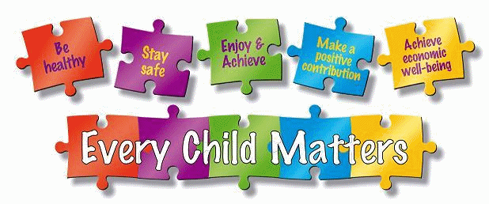

RUMC-Staten Island Head Start Service Area

Service Area and Recruitment Area
The service and recruitment areas of RUMC-Staten Island Head Start are defined as Staten Island Community Districts 1 and 2. Neighborhoods comprising these districts are listed below.

- Community District 1 includes neighborhoods Arlington, Castleton Corners, Clifton, Concord, Elm Park, Fort Wadsworth, Graniteville, Grymes Hill, Livingston, Mariners Harbor, Meiers Corners, New Brighton, Port Ivory, Port Richmond, Randall Manor, Rosebank, St. George, Shore Acres, Silver Lake, Stapleton, Sunnyside, Tompkinsville, West Brighton, and Westerleigh.
- Community District 2 includes neighborhoods Arrochar, Bloomfield, Bulls Heads, Chelsea, Dongan Hills, Egbertville, Emerson Hill, Grant City Grasmere, High Rock, Lighthouse Hill, Midland Beach, New Dorp, New Springville - Oakwood - Ocean Breeze, Old Town, South Beach, Todt Hill, and Travis.

Data about Community District 3 are also included in this Community Assessment for reference, as are data for Staten Island overall. Community District 3 includes neighborhoods Annadale, Arden Heights, Bay Terrace, Charleston, Eltingville, Great Kills, Greenridge, Huguenot, New Dorp, Oakwood, Pleasant Plains, Prince's Bay, Richmond Valley, Richmondtown, Rossville, Tottenville, and Woodrow.

Exhibit 1 lists ZIP Codes that are assigned to Community Districts for in this Community Assessment. Note that these ZIP Code assignments do not correspond exactly to Community District geographic boundaries. See the Appendix for a comparison of the two designations.

Exhibit 1: Service Area by ZIP Code
Area | ZIP Code
RUMC-Staten Island Head Start Community District 1 | 10301
RUMC-Staten Island Head Start Community District 1 | 10302
RUMC-Staten Island Head Start Community District 1 | 10303
RUMC-Staten Island Head Start Community District 1 | 10310
RUMC-Staten Island Head Start Community District 2 | 10304
RUMC-Staten Island Head Start Community District 2 | 10305
RUMC-Staten Island Head Start Community District 2 | 10314
RUMC-Staten Island Head Start Community District 3 | 10306
RUMC-Staten Island Head Start Community District 3 | 10307
RUMC-Staten Island Head Start Community District 3 | 10308
RUMC-Staten Island Head Start Community District 3 | 10309
RUMC-Staten Island Head Start Community District 3 | 10312

Map of Service Area
Exhibit 2 presents a map displaying the RUMC-Staten Island Head Start service area and locations.

Exhibit 2: RUMC-Staten Island Head Start Service Area and Locations
Sources: Caliper Maptitude (2025) and RUMC-Staten Island Head Start.
Note that these ZIP Code assignments do not correspond to Community District geographic boundaries exactly.
See the Appendix for a comparison of the two designations.

The addresses of RUMC-Staten Island Head Start locations are listed below.

- Cassidy - 148 Cassidy Place, Staten Island, NY 10301
- Dongan Hills - 44 Dongan Hills Ave, Staten Island, NY 10306
- Osgood - 16 Osgood Ave, Staten Island, NY 10304
- Port Richmond - 166 Lockman Ave, Staten Island, NY 10303

Note: ZIP Codes that are assigned to Community Districts for purposes of this Community Assessment do not exactly correspond to geographic areas identified by the City of New York. For some analyses in this assessment, ZIP Codes are designations are used because data were available at the ZIP Code level of granularity. For comparison purposes, the Appendix contains a Community District map produced by the New York City Department of City Planning and a map of ZIP Codes assigned to Community Districts for this assessment.

OBJECTIVES AND METHODOLOGY

Regulatory Requirements

Federal regulations require that Head Start programs “must conduct a community assessment (CA) at least once over the five-year grant period. Such a CA is a “collection and analysis of data related to the needs and characteristics of Head Start-eligible children and families” in the geographic area serve by the program. Requirements specify that that the CA include the following details:

- Demographic information about eligible infants, toddlers, preschool age children, and expectant mothers;
- Information about the education, health, nutrition, and social service needs of eligible children and their families;
- Work, school, and training schedules of parents with eligible children;
- Information about other child development services, child care centers, and family child care programs that serve eligible children;
- Resources available in the community; and
- Strengths of the community.

Details on these requirements are below.

Demographic information about eligible infants, toddlers, preschool age children, and expectant mothers

This section summarizes demographic information about eligible infants, toddlers, preschool age children, and expectant mothers.

- Background on Head Start and Eligibility
Head Start and Early Head Start programs are free, early education programs that are provided without charge for eligible children, aged two to four. Eligibility guidelines are as follows:

- Family income falls within the federal guidelines;
- Live in temporary housing;
- Receive HRA Cash Assistance;
- Receive SNAP;
- Receive SSI (Supplemental Security Insurance); or
- Enrolled in foster care.

Head Start programs offer full-day, year-round care. Enrolled children receive nutritious meals and health screenings. Parents and families may receive support to find employment, housing, and adult education.

Family income falls within the federal guidelines

Exhibit 1: Population Under 5 Years, 2023
Area | Population Under 5 Years, Below Poverty | Population Under 5 Years | Percentage Under 5 Years, Below Poverty
Community District 1 | 1,548 | 7,363 | 21.0%
10301 | 608 | 2,744 | 22.2%
10302 | 307 | 1,278 | 24.0%
10303 | 322 | 1,230 | 26.2%
10310 | 311 | 2,111 | 14.7%
Community District 2 | 973 | 8,609 | 11.3%
10304 | 369 | 2,109 | 17.5%
10305 | 149 | 1,392 | 10.7%
10314 | 455 | 5,108 | 8.9%
Community District 3 | 994 | 10,683 | 9.3%
10306 | 240 | 3,093 | 7.8%
10307 | 12 | 997 | 1.2%
10308 | 71 | 1,045 | 6.8%
10309 | 98 | 1,854 | 5.3%
10312 | 573 | 3,694 | 15.5%
Staten Island Total | 3,515 | 26,655 | 13.2%
Source: U.S. Census ACS 2023 5-year estimates.
Note that these ZIP Code assignments do not correspond to Community District geographic boundaries exactly.
See the Appendix for a comparison of the two designations.

The 2023 Staten Island Population Under 5 Years, Below Poverty, was 3,515, or 13.2 percent of the total Population Under 5 Years of 26,655. The Population Under 5 Years, Below Poverty and the total Population Under 5 Years vary by neighborhood and ZIP Code. Community District 1 had the highest Population Under 5 Years, Below Poverty with a total of 1,548.

Live in temporary housing

New York City School District 31 is comprised of Staten Island. As illustrated in Exhibit 2, four percent of elementary and high school students, as well as five percent of middle school students, on Staten Island lived temporary housing for the 2023-2024 period.

Exhibit 2: Students in Temporary Housing, 2023-2024
Indicator | Elementary School |  | Middle School |  | High School
Indicator | Staten Island | New York City | Staten Island | New York City | Staten Island | New York City
Number of Students in Temporary Housing | 960 | 44,977 | 627 | 24,004 | 773 | 29,136
Percent of Students in Temporary Housing | 4% | 11% | 5% | 11% | 4% | 10%
Source: NYC Schools, 2025.

Applying the four percent of students in temporary housing as reported for elementary and high school students to the 2023 Staten Island Population Under 5 Years of 26,655, an estimated 1,066 individuals under 5 years lived in temporary housing in the 2023-2024 period. Applying the five percent of students in temporary housing as reported for middle school students to the 2023 Staten Island Population Under 5 Years of 26,655, an estimated 1,333 individuals under 5 years lived in temporary housing in the 2023-2024 period.

As detailed in Exhibit 3A, twelve schools on Staten Island had ten percent or more of students living in temporary housing during the 2023-2024 period.

Exhibit 3A: Schools with More than Ten Percent of
Students in Temporary Housing, 2023-2024
School | Percentage of Students Living in Temporary Housing
P.S. 016 John J. Driscoll (31R16) | 19%
Fort Hill Collaborative Elementary School (31R010) | 18%
P.S. 018 John G. Whittier (31R018) | 17%
P.S. 74 Future Leaders Elementary School (31R74) | 15%
P.S. 019 The Curtis School (31R019) | 14%
Port Richmond School for Visionary Learning (31R020) | 12%
I.S. 061 William A. Morris (31R61) | 12%
P.S. 020 Port Richmond (31R020) | 12%
P.S. 022 Graniteville (31R022) | 11%
P.S. 031 William T. Davis (31R031) | 11%
P.S. 78 (31R078) | 11%
I.S. 051 Edwin Markham (31R051) | 10%
Source: NYC Schools, 2025.

Exhibit 3B presents a map of Staten Island schools with more than ten percent of students in temporary housing, 2023-2024.

Exhibit 3B: Map of Staten Island Schools with More than Ten Percent of Students in Temporary Housing, 2023-2024
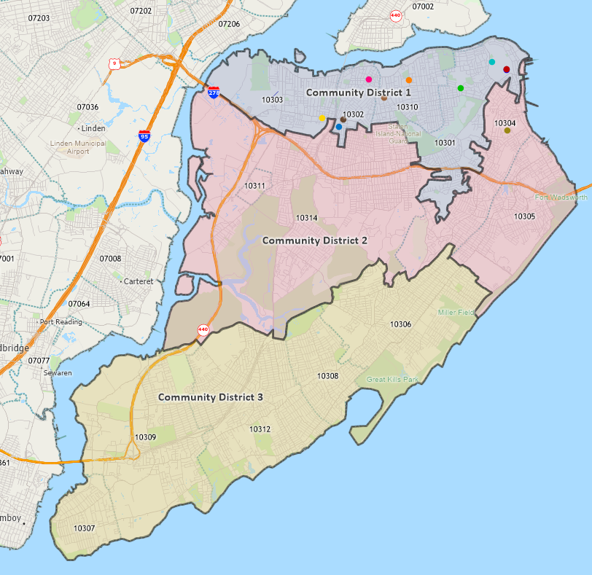
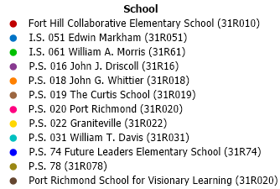
Sources: NYC Schools and Caliper Maptitude (2025).
Note that these ZIP Code assignments do not correspond to Community District geographic boundaries exactly.
See the Appendix for a comparison of the two designations.

All Staten Island schools with more than ten percent of students in temporary housing, 2023-2024, are in ZIP Codes 10301, 10302, 10303, 10304, and 10310.

Receive HRA Cash Assistance

The Human Resources Administration (HRA) of the New York City Department of Social Services (DSS) administers “programs that address poverty and income inequality, including cash assistance, food assistance, and Medicaid public health insurance.” As summarized in Exhibit 4, over 25,000 recipients across nearly 13,000 households on Staten Island received HRA Cash Assistance in September 2025.

Exhibit 4: NRA Cash Assistance Recipients and Cases, September 2025
District | Borough Consultation Total Cash Assistance Recipients | Borough Consultation Total Cash Assistance Cases
Staten Island District 1 | 16,929 | 8,311
Staten Island District 2 | 4,635 | 2,612
Staten Island District 3 | 3,561 | 2,058
Staten Island Total | 25,125 | 12,981
Source: Human Resources Administration via NYC OpenData, 2025.

Staten Island District 1, which corresponds to the North Shore, had the largest number of cash assistance recipients and cash assistance cases on Staten Island.

Receive SNAP

The Supplemental Nutrition Assistance Program (“SNAP”) is a federal program that provides food assistance to low-income individuals. In New York City, SNAP is administered by the Human Resources Administration (HRA) of the New York City Department of Social Services (DSS). As summarized in Exhibit 5, over 75,000 recipients in nearly 43,000 households on Staten Island received SNAP in September 2025.

Exhibit 5: SNAP Recipients and Cases, September 2025
District | Borough Consultation Total SNAP Recipients | Borough Consultation Total SNAP Households
Community District 1 | 41,291 | 22,547
Community District 2 | 19,401 | 11,080
Community District 3 | 14,469 | 9,014
Staten Island Total | 75,161 | 42,641
Source: Human Resources Administration via NYC OpenData, 2025.

Staten Island District 1, which corresponds to the North Shore, had the largest number of SNAP recipients and SNAP households on Staten Island.

As summarized in Exhibit 6, 6,411 recipients under 5 Years on Staten Island were estimated to receive SNAP in September 2025, with the highest number in Community District 1.

Exhibit 6: Estimated SNAP Recipients and Eligible Recipients Under 5 Years
Area | Percent of Households Receiving SNAP with Children Under 18 Years | Percent of Households Below Poverty Level Not Receiving SNAP | Population Under 5 Years | Estimated Population Under 5 Years Receiving SNAP | Estimated Population Under 5 Years Not Receiving SNAP but Eligible
Community District 1 | 30.7% | 7.5% | 8,753 | 2,690 | 203
10301 | 28.3% | 6.3% | 2,744 | 777 | 49
10302 | 30.5% | 11.0% | 1,278 | 390 | 43
10303 | 34.0% | 8.4% | 1,230 | 418 | 35
10310 | 31.2% | 6.4% | 2,109 | 657 | 42
Community District 2 | 27.5% | 6.2% | 7,219 | 1,984 | 124
10304 | 39.4% | 6.6% | 2,111 | 832 | 55
10305 | 35.7% | 6.1% | 2,111 | 754 | 46
10314 | 17.7% | 6.1% | 5,108 | 905 | 55
Community District 3 | 17.5% | 5.7% | 10,683 | 1,873 | 107
10306 | 31.0% | 5.4% | 3,093 | 960 | 52
10307 | 10.9% | 4.1% | 997 | 109 | 4
10308 | 10.5% | 6.4% | 1,045 | 110 | 7
10309 | 16.3% | 6.5% | 1,854 | 303 | 20
10312 | 11.8% | 5.6% | 3,694 | 437 | 24
Staten Island Total | 24.1% | 6.3% | 26,655 | 6,411 | 404
Source: U.S. Census ACS 2023 5-year estimates and Verité analysis.

Receive SSI (Supplemental Security Insurance)

Supplemental Security Income (SSI) is a federal program that provides “monthly benefits to people with limited income and resources who are blind, age 65 or older, or have a qualifying disability” and to “children with disabilities or who are blind.” SSI is administered by the U.S. Social Security Administration (SSA).

In December 2024, 2,030 recipients under the age of 18 on Staten Island received SSI. Using the 2023 Census estimates of 107,343 individuals under 18 years of age as residing on Staten Island as a base for SSI recipients, 1.9 percent received SSI. Applying this percentage to the 2023 Staten Island Population Under 5 Years of 26,655, an estimated 506 residents Under 5 Years on Staten Island were SSI recipients.

Enrolled in Foster Care

Foster care is a “nurturing temporary home for children” because “their parents are unable to care for them.” “Most are eventually able to return to their birth families.” As summarized in Exhibit 7, over 300 children on Staten Island were in foster care on December 31, 2024.

Exhibit 7: Children Enrolled in Foster Care, 2024
District | New Entries to Foster Care from the Community, CY 2024 | Children in Foster Care in the Community, December 31, 2024
Staten Island District 1 | 89 | 244
Staten Island District 2 | 19 | 44
Staten Island District 3 | 15 | 33
Staten Island Total | 125 | 321
Source: Human Resources Administration via NYC OpenData, 2025.

Staten Island District 1 had the largest new entries to foster care during 2024, as well as the largest number of children in foster care at December 31, 2024.

Infants and expectant mothers - Overview
The New York State Department of Health publishes perinatal profiles by county and ZIP Codes within the state. The State Department of Health’s profile for Staten Island is reproduced in Exhibit 8.

Exhibit 8: Perinatal Data Profile, 2020-2022
Location | Total | Percent of Births |  |  |  |  | Infant and Neonatal Deaths,  Rate per 1,000 Live Births |  |  |  | Teen Rates per 1,000
Location | Three-year Births | Premature Birth | Low Birth Weight | Unmarried Parent | Medicaid or Self-Pay | Late or No Prenatal Care | Three-year Infant Deaths | Infant Death Rate | Three year Neonatal Deaths | Neonatal Death Rate | Teen Birth Rate | Teen Pregnancy Rate
Community District 1
10301 | 1,362 | 10.6% | 9.2% | 47.7% | 57.0% | 4.0% | 8 | 5.9 | 7.0 | 5.1 | 10.2 | 23.0
10302 | 718 | 10.3% | 8.8% | 50.7% | 64.6% | 2.4% | 5 | 7.0 | 4.0 | 5.6 | 15.5 | 31.1
10303 | 888 | 12.3% | 11.6% | 58.3% | 66.4% | 3.5% | 5 | 5.6 | 2.0 | 2.3 | 8.0 | 24.5
10310 | 919 | 11.4% | 10.0% | 48.1% | 55.9% | 3.5% | 3 | 3.3 | 2.0 | 2.2 | 11.1 | 24.1
Community District 2
10304 | 1,405 | 10.1% | 9.4% | 49.9% | 61.8% | 3.7% | 6 | 4.3 | 2.0 | 1.4 | 11.9 | 24.3
10305 | 1,349 | 11.0% | 8.6% | 32.5% | 52.6% | 3.4% | 9 | 6.7 | 6.0 | 4.4 | 6.4 | 13.7
10314 | 2,778 | 7.8% | 7.1% | 23.5% | 43.9% | 2.0% | 14 | 5.0 | 8.0 | 2.9 | 3.7 | 11.3
Community District 3
10306 | 1,541 | 10.3% | 8.5% | 31.4% | 44.1% | 2.5% | 8 | 5.2 | 6.0 | 3.9 | 3.9 | 7.6
10307 | 381 | 7.6% | 5.8% | 21.8% | 20.3% | 1.0% | - | - | - | - | 2.0 | 2.0
10308 | 773 | 7.2% | 6.5% | 22.5% | 28.6% | 2.2% | 2 | 2.6 | 2.0 | 2.6 | 1.8 | 3.2
10309 | 984 | 7.8% | 5.5% | 20.4% | 25.4% | 1.6% | 3 | 3.0 | 2.0 | 2.0 | 0.6 | 2.1
10312 | 1,672 | 9.3% | 7.4% | 20.0% | 24.9% | 2.3% | 5 | 3.0 | 3.0 | 1.8 | 1.0 | 3.0
Staten Island | 14,770 | 9.6% | 8.2% | 34.1% | 45.9% | 2.7% | 68 | 4.6 | 44.0 | 3.0 | 6.0 | 13.9
Source: New York State Department of Health, 2025.
Note that these ZIP Code assignments do not correspond to Community District geographic boundaries exactly.
See the Appendix for a comparison of the two designations.

ZIP Codes with more than 50 percent of Medicaid or Self-Pay births, 2020-2022, were in ZIP Codes 10301, 103202, 10303, 10304, 10305, and 10310.

ZIP Codes with Teen Pregnancy Birth Rates exceed ten per 1,000 teens, 2020-2022, were in ZIP Codes 10301, 10302, 10304, and 10310.

Births by Community District

Births by year, 2018-2022
The New York City Department of Health and Mental Hygiene (NYC Health) publishes perinatal profiles by borough and ZIP Codes within the city. Maternal age data from the NYC Health’s Public Use Birth Data Sets for Staten Island and associated ZIP Codes are reproduced in Exhibit 9.

Exhibit 9: Births by Community District by Year, 2018-2022
Community District | 2018 | 2019 | 2020 | 2021 | 2022
Community District 1  (501 Port Richmond) | 2,215 | 2,176 | 2,063 | 2,033 | 1,995
Community District 2  (502 Willowbrook, South Beach) | 1,364 | 1,392 | 1,340 | 1,393 | 1,351
Community District 3  (503 Tottenville) | 1,474 | 1,593 | 1,428 | 1,527 | 1,530
Staten Island | 5,053 | 5,161 | 4,831 | 4,953 | 4,876
Source: New York City Department of Health and Mental Hygiene, 2025.

The number of births were highest in Community District 1 in each year from 2018 to 2022.

Births were lower in 2022, compared to 2018, for Community District 1, Community District 2, and Staten Island overall.

Expectant Mothers

Maternal Age
The New York City Department of Health and Mental Hygiene (NYC Health) publishes perinatal profiles by borough and ZIP Codes within the city. Maternal age data from the NYC Health’s Public Use Birth Data Sets for Staten Island and associated ZIP Codes are reproduced in Exhibit 10.

Exhibit 10: Maternal Age, 2019-2021
Area | Maternal Age 15-17 | Maternal Age 18-19 | Maternal Age 20-24 | Maternal Age 25-29 | Maternal Age 30-34 | Maternal Age 35-39 | Maternal Age 40-44 | Maternal Age 45+ | Total
Community District 1 | 25 | 111 | 560 | 1,021 | 1,247 | 705 | 188 | - | 3,857
10301 | 15 | 25 | 150 | 357 | 461 | 254 | 71 | - | 1,333
10302 | 5 | 23 | 108 | 158 | 208 | 137 | 43 | - | 682
10303 | - | 23 | 162 | 286 | 275 | 147 | 31 | - | 924
10310 | 5 | 40 | 140 | 220 | 303 | 167 | 43 | - | 918
Community District 2 | 25 | 66 | 614 | 1,464 | 2,038 | 1,168 | 271 | 12 | 5,658
10304 | 20 | 41 | 225 | 409 | 478 | 278 | 84 | 7 | 1,542
10305 | - | 12 | 167 | 388 | 449 | 264 | 61 | - | 1,341
10314 | 5 | 13 | 222 | 667 | 1,111 | 626 | 126 | 5 | 2,775
Community District 3 | - | 12 | 360 | 1,211 | 2,278 | 1,238 | 242 | 6 | 5,347
10306 | - | 12 | 144 | 390 | 628 | 320 | 70 | - | 1,564
10307 | - | - | 14 | 76 | 168 | 83 | 14 | - | 355
10308 | - | - | 40 | 170 | 327 | 161 | 29 | - | 727
10309 | - | - | 67 | 234 | 372 | 245 | 52 | - | 970
10312 | - | - | 95 | 341 | 783 | 429 | 77 | 6 | 1,731
Staten Island Total | 50 | 189 | 1,534 | 3,696 | 5,563 | 3,111 | 701 | 18 | 14,862
Source: New York City Department of Health and Mental Hygiene, 2025.
Note that these ZIP Code assignments do not correspond to Community District geographic boundaries exactly.
See the Appendix for a comparison of the two designations.

The distribution of births by maternal age, 2019-2021, varies by ZIP Code.

Maternal Race/Ethnicity
NYC Health publishes perinatal profiles by borough and ZIP Codes within the city. Maternal race/ethnicity data from the NYC Health’s Public Use Birth Data Sets for Staten Island and associated ZIP Codes are reproduced in Exhibit 11.

Exhibit 11: Maternal Race/Ethnicity, 2019-2021
Area | Maternal Race/Ethnicity Hispanic | Maternal Race/Ethnicity Asian/PI | Maternal Race/Ethnicity NH White | Maternal Race/Ethnicity NH Black | Total
Community District 1 | 1,553 | 326 | 1,026 | 913 | 3,818
10301 | 461 | 116 | 453 | 284 | 1,314
10302 | 367 | 45 | 148 | 122 | 682
10303 | 369 | 88 | 137 | 314 | 908
10310 | 356 | 77 | 288 | 193 | 914
Community District 2 | 1,202 | 987 | 2,757 | 642 | 5,588
10304 | 448 | 211 | 417 | 435 | 1,511
10305 | 303 | 277 | 664 | 86 | 1,330
10314 | 451 | 499 | 1,676 | 121 | 2,747
Community District 3 | 768 | 513 | 3,918 | 118 | 5,317
10306 | 299 | 243 | 946 | 75 | 1,563
10307 | 51 | - | 295 | - | 346
10308 | 100 | 56 | 567 | - | 723
10309 | 106 | 57 | 782 | 19 | 964
10312 | 212 | 157 | 1,328 | 24 | 1,721
Staten Island Total | 3,523 | 1,826 | 7,701 | 1,673 | 14,723
Source: New York City Department of Health and Mental Hygiene, 2025.
Note that these ZIP Code assignments do not correspond to Community District geographic boundaries exactly.
See the Appendix for a comparison of the two designations.

The distribution of births by maternal race/ethnicity, 2019-2021, varies by ZIP Code.

Maternal Location of Birth, US and Foreign-Born
NYC Health publishes perinatal profiles by borough and ZIP Codes within the city. Maternal location of birth data from the NYC Health’s Public Use Birth Data Sets for Staten Island and associated ZIP Codes are reproduced in Exhibit 12.

Exhibit 12: Maternal Location of Birth, 2019-2021
Area | US-born | Foreign-born | Total
Community District 1 | 2,403 | 1,492 | 3,895
10301 | 852 | 490 | 1,342
10302 | 366 | 329 | 695
10303 | 574 | 355 | 929
10310 | 611 | 318 | 929
Community District 2 | 3,156 | 2,526 | 5,682
10304 | 783 | 761 | 1,544
10305 | 654 | 703 | 1,357
10314 | 1,719 | 1,062 | 2,781
Community District 3 | 3,873 | 1,530 | 5,403
10306 | 929 | 652 | 1,581
10307 | 312 | 53 | 365
10308 | 534 | 202 | 736
10309 | 795 | 183 | 978
10312 | 1,303 | 440 | 1,743
Staten Island | 9,432 | 5,548 | 14,980
Source: New York City Department of Health and Mental Hygiene, 2025.
Note that these ZIP Code assignments do not correspond to Community District geographic boundaries exactly.
See the Appendix for a comparison of the two designations.

The distribution of births by maternal location of birth, 2019-2021, varies by ZIP Code.

Maternal Educational Levels
NYC Health publishes perinatal profiles by borough and ZIP Codes within the city. Maternal educational level data from the NYC Health’s Public Use Birth Data Sets for Staten Island and associated ZIP Codes are reproduced in Exhibit 13.

Exhibit 13: Maternal Education Levels, 2019-2021
Area | Maternal Education 11th grade or less/12 grade no diploma | Maternal Education High school graduate/GED | Maternal Education Some college/Associates degree | Maternal Education Bachelors degree | Maternal Education Masters degree or more | Total
Community District 1 | 718 | 953 | 953 | 724 | 535 | 3,883
10301 | 226 | 291 | 292 | 300 | 230 | 1,339
10302 | 151 | 179 | 172 | 105 | 85 | 692
10303 | 153 | 269 | 279 | 162 | 63 | 926
10310 | 188 | 214 | 210 | 157 | 157 | 926
Community District 2 | 583 | 1,228 | 1,409 | 1,415 | 1,032 | 5,667
10304 | 248 | 405 | 395 | 311 | 179 | 1,538
10305 | 153 | 252 | 378 | 367 | 203 | 1,353
10314 | 182 | 571 | 636 | 737 | 650 | 2,776
Community District 3 | 250 | 787 | 1,285 | 1,597 | 1,474 | 5,393
10306 | 132 | 286 | 410 | 404 | 349 | 1,581
10307 | 5 | 48 | 91 | 121 | 94 | 359
10308 | 28 | 99 | 153 | 223 | 231 | 734
10309 | 23 | 140 | 239 | 301 | 274 | 977
10312 | 62 | 214 | 392 | 548 | 526 | 1,742
Staten Island | 1,551 | 2,968 | 3,647 | 3,736 | 3,041 | 14,943
Source: New York City Department of Health and Mental Hygiene, 2025.
Note that these ZIP Code assignments do not correspond to Community District geographic boundaries exactly.
See the Appendix for a comparison of the two designations.

The distribution of births by maternal education levels, 2019-2021, varies by ZIP Code.

Maternal Prenatal Care Initiation
NYC Health publishes perinatal profiles by borough and ZIP Codes within the city. Maternal prenatal care initiation data from the NYC Health’s Public Use Birth Data Sets for Staten Island and associated ZIP Codes are reproduced in Exhibit 14.

Exhibit 14: Maternal Prenatal Care Initiation, 2019-2021
Area | PNC Initiated 1st Trimester (0-90 days) | PNC Initiated 2nd Trimester (91-180 days) | PNC Initiated 3rd Trimester (181-304 days) | PNC Initiated None | Total
Community District 1 | 3,266 | 477 | 87 | 10 | 3,840
10301 | 1,125 | 161 | 31 | 5 | 1,322
10302 | 582 | 95 | 7 | - | 684
10303 | 767 | 125 | 21 | 5 | 918
10310 | 792 | 96 | 28 | - | 916
Community District 2 | 4,803 | 669 | 114 | 17 | 5,603
10304 | 1,231 | 236 | 45 | - | 1,512
10305 | 1,163 | 149 | 28 | - | 1,340
10314 | 2,409 | 284 | 41 | 17 | 2,751
Community District 3 | 4,868 | 385 | 43 | 24 | 5,320
10306 | 1,371 | 156 | 21 | 5 | 1,553
10307 | 338 | 20 | - | - | 358
10308 | 669 | 56 | - | - | 725
10309 | 884 | 71 | 6 | 5 | 966
10312 | 1,606 | 82 | 16 | 14 | 1,718
Staten Island | 12,937 | 1,531 | 244 | 51 | 14,763
Source: New York City Department of Health and Mental Hygiene, 2025.
Note that these ZIP Code assignments do not correspond to Community District geographic boundaries exactly.
See the Appendix for a comparison of the two designations.

The distribution of births by maternal prenatal care initiation, 2019-2021, varies by ZIP Code.

Maternal Health Insurance Status
NYC Health publishes perinatal profiles by borough and ZIP Codes within the city. Maternal health insurance data from the NYC Health’s Public Use Birth Data Sets for Staten Island and associated ZIP Codes are reproduced in Exhibit 15.

Exhibit 15: Maternal Health Insurance Status, 2019-2021
Area | Primary Payer Medicaid | Primary Payer HMO/Other 3rd Party | Total
Community District 1 | 2,283 | 1,407 | 3,690
10301 | 735 | 552 | 1,287
10302 | 438 | 222 | 660
10303 | 612 | 274 | 886
10310 | 498 | 359 | 857
Community District 2 | 2,876 | 2,517 | 5,393
10304 | 971 | 507 | 1,478
10305 | 709 | 575 | 1,284
10314 | 1,196 | 1,435 | 2,631
Community District 3 | 1,596 | 3,493 | 5,089
10306 | 659 | 857 | 1,516
10307 | 71 | 267 | 338
10308 | 198 | 494 | 692
10309 | 242 | 673 | 915
10312 | 426 | 1,202 | 1,628
Staten Island Total | 6,755 | 7,417 | 14,172
Source: New York City Department of Health and Mental Hygiene, 2025.
Note that these ZIP Code assignments do not correspond to Community District geographic boundaries exactly.
See the Appendix for a comparison of the two designations.

The distribution of births by maternal health insurance status, 2019-2021, varies by ZIP Code.

Maternal Marital Status
NYC Health publishes perinatal profiles by borough and ZIP Codes within the city. Maternal marital status data from the NYC Health’s Public Use Birth Data Sets for Staten Island and associated ZIP Codes are reproduced in Exhibit 16.

Exhibit 16: Maternal Marital Status, 2019-2021
Area | Derived Not Married | Derived Married | Total
Community District 1 | 1,964 | 1,936 | 3,900
10301 | 623 | 719 | 1,342
10302 | 342 | 353 | 695
10303 | 555 | 376 | 931
10310 | 444 | 488 | 932
Community District 2 | 1,824 | 3,860 | 5,684
10304 | 765 | 779 | 1,544
10305 | 434 | 924 | 1,358
10314 | 625 | 2,157 | 2,782
Community District 3 | 1,278 | 4,125 | 5,403
10306 | 496 | 1,085 | 1,581
10307 | 83 | 282 | 365
10308 | 164 | 572 | 736
10309 | 204 | 774 | 978
10312 | 331 | 1,412 | 1,743
Staten Island Total | 5,066 | 9,921 | 14,987
Source: New York City Department of Health and Mental Hygiene, 2025.
Note that these ZIP Code assignments do not correspond to Community District geographic boundaries exactly.
See the Appendix for a comparison of the two designations.

The distribution of births by maternal marital status, 2019-2021, varies by ZIP Code.

Maternal Pre-Pregnancy BMI Weight Category
NYC Health publishes perinatal profiles by borough and ZIP Codes within the city. Maternal pre-pregnancy BMI weight category data from the NYC Health’s Public Use Birth Data Sets for Staten Island and associated ZIP Codes are reproduced in Exhibit 17.

Exhibit 17: Maternal Pre-Pregnancy BMI, 2019-2021
Area | Pre-Preg BMI Underweight <18.5 | Pre-Preg BMI Normal 18.5-<25 | Pre-Preg BMI Overweight 25-<30 | Pre-Preg BMI Obese 30+ | Total
Community District 1 | 108 | 1,515 | 1,192 | 1,069 | 3,884
10301 | 53 | 574 | 369 | 341 | 1,337
10302 | 11 | 267 | 228 | 184 | 690
10303 | 23 | 310 | 300 | 296 | 929
10310 | 21 | 364 | 295 | 248 | 928
Community District 2 | 223 | 2,719 | 1,527 | 1,206 | 5,675
10304 | 59 | 683 | 444 | 355 | 1,541
10305 | 67 | 681 | 340 | 269 | 1,357
10314 | 97 | 1,355 | 743 | 582 | 2,777
Community District 3 | 205 | 2,709 | 1,373 | 1,111 | 5,398
10306 | 83 | 766 | 406 | 325 | 1,580
10307 | 5 | 192 | 83 | 81 | 361
10308 | 22 | 365 | 184 | 165 | 736
10309 | 36 | 507 | 250 | 185 | 978
10312 | 59 | 879 | 450 | 355 | 1,743
Staten Island Total | 536 | 6,943 | 4,092 | 3,386 | 14,957
Source: New York City Department of Health and Mental Hygiene, 2025.
Note that these ZIP Code assignments do not correspond to Community District geographic boundaries exactly.
See the Appendix for a comparison of the two designations.

The distribution of births by maternal pre-pregnancy BMI, 2019-2021, varies by ZIP Code.

Newborn Infants

Infant Birthweight Category
NYC Health publishes perinatal profiles by borough and ZIP Codes within the city. Infant birthweight data from the NYC Health’s Public Use Birth Data Sets for Staten Island and associated ZIP Codes are reproduced in Exhibit 18.

Exhibit 18: Infant Birthweight, 2019-2021
Area | Infant Birthweight <500g | Infant Birthweight 500-999g | Infant Birthweight 1000-1499g | Infant Birthweight 1500-1999g | Infant Birthweight 2000-2499g | Infant Birthweight 2500-2999g | Infant Birthweight 3000-3499g | Infant Birthweight 3500-3999g | Infant Birthweight 4000+g | Total
Community District 1 | - | 18 | 25 | 55 | 228 | 866 | 1,547 | 901 | 216 | 3,856
10301 | - | 7 | 13 | 17 | 66 | 286 | 527 | 352 | 66 | 1,334
10302 | - | - | - | - | 42 | 159 | 278 | 157 | 42 | 678
10303 | - | 6 | 6 | 13 | 54 | 225 | 382 | 189 | 45 | 920
10310 | - | 5 | 6 | 25 | 66 | 196 | 360 | 203 | 63 | 924
Community District 2 | - | 12 | 13 | 95 | 258 | 1,122 | 2,338 | 1,422 | 377 | 5,637
10304 | - | - | 7 | 36 | 73 | 336 | 640 | 333 | 102 | 1,527
10305 | - | - | - | 22 | 61 | 263 | 570 | 340 | 85 | 1,341
10314 | - | 12 | 6 | 37 | 124 | 523 | 1,128 | 749 | 190 | 2,769
Community District 3 | - | - | 13 | 59 | 241 | 1,012 | 2,255 | 1,414 | 351 | 5,345
10306 | - | - | 6 | 31 | 79 | 331 | 645 | 381 | 102 | 1,575
10307 | - | - | - | - | 8 | 65 | 152 | 104 | 24 | 353
10308 | - | - | - | - | 34 | 135 | 311 | 190 | 55 | 725
10309 | - | - | - | 7 | 41 | 171 | 418 | 271 | 52 | 960
10312 | - | - | 7 | 21 | 79 | 310 | 729 | 468 | 118 | 1,732
Staten Island Total | - | 30 | 51 | 209 | 727 | 3,000 | 6,140 | 3,737 | 944 | 14,838
Source: New York City Department of Health and Mental Hygiene, 2025.
Note that these ZIP Code assignments do not correspond to Community District geographic boundaries exactly.
See the Appendix for a comparison of the two designations.

The distribution of births by infant birthweight, 2019-2021, varies by ZIP Code.

Infant Gestational Age
NYC Health publishes perinatal profiles by borough and ZIP Codes within the city. Infant gestational age data from the NYC Health’s Public Use Birth Data Sets for Staten Island and associated ZIP Codes are reproduced in Exhibit 19.

Exhibit 19: Infant Gestational Age, 2019-2021
Area | Infant Gestational Age <28 weeks | Infant Gestational Age 28-31 weeks | Infant Gestational Age 32-33 weeks | Infant Gestational Age 34-36 weeks | Infant Gestational Age 37+ weeks | Total
Community District 1 | 12 | 20 | 19 | 315 | 3,466 | 3,832
10301 | 6 | 14 | 5 | 91 | 1,210 | 1,326
10302 | - | - | - | 55 | 625 | 680
10303 | - | 6 | 8 | 89 | 811 | 914
10310 | 6 | - | 6 | 80 | 820 | 912
Community District 2 | 17 | 12 | 73 | 380 | 5,162 | 5,644
10304 | - | 12 | 18 | 113 | 1,388 | 1,531
10305 | - | - | 20 | 105 | 1,218 | 1,343
10314 | 17 | - | 35 | 162 | 2,556 | 2,770
Community District 3 | - | 27 | 48 | 353 | 4,925 | 5,353
10306 | - | 16 | 22 | 114 | 1,424 | 1,576
10307 | - | - | - | 20 | 336 | 356
10308 | - | - | - | 47 | 677 | 724
10309 | - | 5 | 10 | 61 | 890 | 966
10312 | - | 6 | 16 | 111 | 1,598 | 1,731
Staten Island | 29 | 59 | 140 | 1,048 | 13,553 | 14,829
Source: New York City Department of Health and Mental Hygiene, 2025.
Note that these ZIP Code assignments do not correspond to Community District geographic boundaries exactly.
See the Appendix for a comparison of the two designations.

The distribution of births by infant gestational age, 2019-2021, varies by ZIP Code.

Births – Plurality Counts
NYC Health publishes perinatal profiles by borough and ZIP Codes within the city. Birth plurality count data from the NYC Health’s Public Use Birth Data Sets for Staten Island and associated ZIP Codes are reproduced in Exhibit 20.

Exhibit 20: Birth Plurality, 2019-2021
Area | Singleton | One of multiple births | Total
Community District 1 | 3,785 | 109 | 3,894
10301 | 1,306 | 36 | 1,342
10302 | 673 | 18 | 691
10303 | 909 | 20 | 929
10310 | 897 | 35 | 932
Community District 2 | 5,488 | 196 | 5,684
10304 | 1,489 | 55 | 1,544
10305 | 1,314 | 44 | 1,358
10314 | 2,685 | 97 | 2,782
Community District 3 | 5,233 | 160 | 5,393
10306 | 1,520 | 61 | 1,581
10307 | 358 | 5 | 363
10308 | 714 | 18 | 732
10309 | 949 | 25 | 974
10312 | 1,692 | 51 | 1,743
Staten Island Total | 14,506 | 465 | 14,971
Source: New York City Department of Health and Mental Hygiene, 2025.
Note that these ZIP Code assignments do not correspond to Community District geographic boundaries exactly.
See the Appendix for a comparison of the two designations.

The distribution of births by birth plurality, 2019-2021, varies by ZIP Code.

Maternal – Infant Breastfeeding
NYC Health publishes perinatal profiles by borough and ZIP Codes within the city. Infant breastfeeding data from the NYC Health’s Public Use Birth Data Sets for Staten Island and associated ZIP Codes are reproduced in Exhibit 21.

Exhibit 21: Infant Breastfeeding, 2019-2021
Area | US-born, Infant Fed Breast Milk Only | US-born, Infant Fed Other | Foreign-born, Infant Fed Breast Milk Only | Foreign-born, Infant Fed Other | Infant Fed Breast Milk Only, Total | Infant Fed Other, Total | Total
Community District 1 | 740 | 1,595 | 408 | 1,058 | 1,148 | 2,653 | 3,801
10301 | 287 | 549 | 155 | 324 | 442 | 873 | 1,315
10302 | 117 | 238 | 74 | 250 | 191 | 488 | 679
10303 | 150 | 409 | 88 | 265 | 238 | 674 | 912
10310 | 186 | 399 | 91 | 219 | 277 | 618 | 895
Community District 2 | 986 | 2,077 | 717 | 1,781 | 1,703 | 3,858 | 5,561
10304 | 197 | 560 | 206 | 549 | 403 | 1,109 | 1,512
10305 | 203 | 437 | 196 | 502 | 399 | 939 | 1,338
10314 | 586 | 1,080 | 315 | 730 | 901 | 1,810 | 2,711
Community District 3 | 1,229 | 2,572 | 490 | 1,015 | 1,719 | 3,587 | 5,306
10306 | 297 | 609 | 198 | 448 | 495 | 1,057 | 1,552
10307 | 107 | 201 | 7 | 39 | 114 | 240 | 354
10308 | 160 | 367 | 70 | 131 | 230 | 498 | 728
10309 | 248 | 531 | 59 | 120 | 307 | 651 | 958
10312 | 417 | 864 | 156 | 277 | 573 | 1,141 | 1,714
Staten Island Total | 2,955 | 6,244 | 1,615 | 3,854 | 4,570 | 10,098 | 14,668
Source: New York City Department of Health and Mental Hygiene, 2025.
Note that these ZIP Code assignments do not correspond to Community District geographic boundaries exactly.
See the Appendix for a comparison of the two designations.

The distribution of births by infant breastfeed, 2019-2021, varies by maternal location of birth and by ZIP Code.

Information about the education, health, nutrition, and social service needs of eligible children and their families

Enrollments in Nursery School / Preschool and Kindergarten
The U.S. Census Bureau publishes educational data by multiple geographic areas, include ZIP Code Tabulation Areas (ZCTAs); ZCTA boundaries approximate ZIP Code boundaries. Nursery School / Preschool and Kindergarten data from the U.S. Census Bureau for relevant ZIP Codes are reproduced in Exhibit 22.

Exhibit 22:Nursery School / Preschool and Kindergarten Enrollment, 2023
Geographic Area Name | Population 3 years and over enrolled in nursery school, preschool | Population 3 years and over enrolled in kindergarten
Community District 1 | 1,915 | 1,275
10301 | 900 | 340
10302 | 221 | 148
10303 | 351 | 496
10310 | 443 | 291
Community District 2 | 3,002 | 1,927
10304 | 645 | 510
10305 | 562 | 403
10314 | 1,795 | 1,014
Community District 3 | 3,313 | 2,314
10306 | 1,004 | 522
10307 | 346 | 263
10308 | 541 | 195
10309 | 491 | 276
10312 | 931 | 1,058
Staten Island Total | 8,230 | 5,516
Source: U.S. Census ACS 2023 5-year estimates and Verité analysis.
Note that these ZIP Code assignments do not correspond to Community District geographic boundaries exactly.
See the Appendix for a comparison of the two designations.

The number of residents aged 3 years and older enrolled in nursery school, preschool, or kindergarten varies by ZIP Code.

Enrollments in Nursery School / Preschool and Kindergarten
The U.S. Census Bureau publishes educational data by multiple geographic areas, include ZIP Code Tabulation Areas (ZCTAs); ZCTA boundaries approximate ZIP Code boundaries. Educational achievement data for adults aged 25 and older from the U.S. Census Bureau for relevant ZIP Codes are reproduced in Exhibit 23.

Exhibit 23 Educational Achievement for Adults Aged 25 and Older, 2023
Geographic Area Name | Percent of Population 25 years and over, 9th grade | Percent of Population 25 years and over, 9th to 12th grade, no diploma | Percent of Population 25 years and over, High school graduate (includes equivalency) | Percent of Population 25 years and over, Some college, no degree | Percent of Population 25 years and over, Associate's degree | Percent of Population 25 years and over, Bachelor's degree | Percent of Population 25 years and over, Graduate or professional degree
Community District 1 | 6.3% | 7.4% | 29.6% | 16.0% | 7.9% | 18.4% | 14.5%
10301 | 5.8% | 6.6% | 24.8% | 17.6% | 7.0% | 18.9% | 19.3%
10302 | 8.7% | 6.1% | 35.0% | 12.6% | 8.7% | 17.6% | 11.3%
10303 | 6.8% | 9.7% | 30.4% | 14.4% | 9.0% | 19.7% | 9.9%
10310 | 4.8% | 7.2% | 32.2% | 17.4% | 7.5% | 17.1% | 13.7%
Community District 2 | 6.7% | 6.3% | 29.9% | 15.5% | 6.9% | 21.7% | 12.8%
10304 | 7.5% | 8.8% | 31.2% | 15.3% | 5.7% | 19.4% | 12.0%
10305 | 8.2% | 6.5% | 29.5% | 14.9% | 8.9% | 19.9% | 12.0%
10314 | 5.6% | 5.1% | 29.5% | 15.9% | 6.6% | 23.6% | 13.6%
Community District 3 | 3.9% | 4.9% | 28.9% | 16.4% | 7.5% | 22.8% | 15.7%
10306 | 6.0% | 5.9% | 32.1% | 16.2% | 6.2% | 20.5% | 13.1%
10307 | 3.8% | 6.0% | 22.9% | 16.8% | 11.0% | 21.5% | 18.0%
10308 | 2.4% | 3.2% | 29.3% | 16.3% | 8.5% | 23.3% | 17.0%
10309 | 2.3% | 5.2% | 26.8% | 17.8% | 8.0% | 23.1% | 16.8%
10312 | 3.6% | 4.5% | 28.2% | 15.8% | 7.0% | 24.7% | 16.2%
Staten Island Total | 5.5% | 6.0% | 29.4% | 16.0% | 7.4% | 21.4% | 14.3%
Source: U.S. Census ACS 2023 5-year estimates and Verité analysis.
Note that these ZIP Code assignments do not correspond to Community District geographic boundaries exactly.
See the Appendix for a comparison of the two designations.

Educational achievement in adults aged 25 and older, 2023, varies by ZIP Code.

Poverty and Economic Need Index by School
NYC Schools provides a “Demographic Snapshot” of students at the citywide, borough, district, and school levels. Include in the snapshots are estimates of percentages of students in poverty, based on “families who have qualified for free or reduced price lunch, or are eligible for Human Resources Administration (HRA) benefits.” Also included is an Economic Need Index indicator, based on HRA eligibility, residence in temporary housing in the past four years, home language other than English, or poverty level in the census tract of residence. Exhibit 24A summarizes the student poverty percentages and Economic Need Index for schools in Community Districts 1 and 2.

Exhibit 24A: Percentage of Poverty and Economic Need Index by School, 2024-2024, Community Districts 1 and 2
School Name | ZIP Code | Poverty Percent | Economic Need Index
Community District 1
P.S. 74 Future Leaders Elementary School | 10301 | Above 95% | Above 95%
P.S. 031 William T. Davis | 10301 | Above 95% | Above 95%
P.S. 016 John J. Driscoll | 10301 | Above 95% | 92.8%
Fort Hill Collaborative Elementary School | 10301 | 92.0% | 91.3%
The Harbor View School | 10301 | 75.3% | 77.2%
P.S. 65 The Academy of Innovative Learning | 10301 | 75.0% | 73.1%
The Michael J. Petrides School | 10301 | 67.9% | 64.6%
P.S. 35 The Clove Valley School | 10301 | 41.2% | 41.3%
P.S. 020 Port Richmond | 10302 | 91.4% | 91.9%
P.S. 21 Margaret Emery-Elm Park | 10302 | 88.0% | 89.1%
Port Richmond School for Visionary Learning | 10302 | 82.1% | 79.4%
P.S. 044 Thomas C. Brown | 10303 | 93.2% | 93.0%
P.S. 022 Graniteville | 10303 | 83.6% | 82.9%
P.S. 018 John G. Whittier | 10310 | 94.6% | 93.3%
P.S. 019 The Curtis School | 10310 | 93.7% | 90.8%
P.S. 045 John Tyler | 10310 | 62.9% | 62.5%
Community District 2
The Waverly Academy of Empowered Learners | 10304 | Above 95% | 91.5%
P.S. 057 Hubert H. Humphrey | 10304 | 94.9% | 91.1%
P.S. 78 | 10304 | 94.5% | Above 95%
P.S. 11 Thomas Dongan School | 10304 | 81.0% | 73.8%
Naples Street Elementary School | 10304 | 55.1% | 48.2%
P.S. 048 William G. Wilcox | 10304 | 51.9% | 49.8%
P.S. 39 Francis J. Murphy Jr. | 10305 | 90.4% | 75.4%
P.S. 046 Albert V. Maniscalco | 10305 | 90.2% | 87.3%
P.S. 013 M. L. Lindemeyer | 10305 | 81.6% | 78.0%
P.S. 052 John C. Thompson | 10305 | 75.9% | 65.4%
Staten Island School of Civic Leadership | 10314 | 78.8% | 70.5%
P.S. 069 Daniel D. Tompkins | 10314 | 72.9% | 66.5%
P.S. 060 Alice Austen | 10314 | 70.2% | 63.6%
P.S. 054 Charles W. Leng | 10314 | 69.6% | 63.3%
Space Shuttle Columbia School | 10314 | 65.6% | 62.2%
P.S. 026 The Carteret School | 10314 | 61.5% | 54.6%
P.S. 029 Bardwell | 10314 | 57.0% | 52.8%
The Richmond Pre-K Center | 10314 | 54.4% | 57.3%
P.S. 030 Westerleigh | 10314 | 41.0% | 38.7%
Source: NYC Schools, 2025 Note that these ZIP Code assignments do not correspond to Community District geographic boundaries exactly.
See the Appendix for a comparison of the two designations.
Exhibit 25B summarizes the student poverty percentages and Economic Need Index for schools in Community Districts 1 and 2.

Exhibit 25B: Percentage of Poverty and Economic Need Index by School, 2024-2024, Community District 3
School Name | ZIP Code | Poverty Percent | Economic Need Index
Community District 3
P.S. 038 George Cromwell | 10306 | 79.4% | 78.1%
The Stephanie A. Vierno School | 10306 | 76.4% | 72.1%
P.S. 050 Frank Hankinson | 10306 | 55.2% | 52.3%
P.S. 023 Richmondtown | 10306 | 39.5% | 39.1%
P.S. 6 Corporal Allan F. Kivlehan School | 10307 | 55.9% | 42.7%
P.S. 001 Tottenville | 10307 | 37.0% | 34.0%
The Barbara Esselborn School | 10308 | 51.9% | 46.2%
P.S. 032 The Gifford School | 10308 | 51.7% | 48.0%
P.S. 8 Shirlee Solomon | 10308 | 49.4% | 43.1%
The Kathleen Grimm School for Leadership and Sustainability | 10309 | 39.8% | 33.0%
P.S. 56 The Louis Desario School | 10309 | 39.2% | 34.9%
P.S. 003 The Margaret Gioiosa School | 10309 | 36.2% | 40.8%
P.S. 042 Eltingville | 10312 | 48.7% | 44.7%
P.S. 004 Maurice Wollin | 10312 | 46.8% | 46.7%
P.S. 036 J. C. Drumgoole | 10312 | 45.9% | 37.1%
P.S. 055 Henry M. Boehm | 10312 | 43.8% | 39.5%
P.S. 005 Huguenot | 10312 | 29.8% | 26.2%
Source: NYC Schools, 2025
Note that these ZIP Code assignments do not correspond to Community District geographic boundaries exactly.
See the Appendix for a comparison of the two designations.

The percentages of students in poverty and the Economic Need Index varies by school throughout the Service Area and Staten Island.

Lack of Access to Nutritious and Affordable Food (Food Deserts)
The U.S. Department of Agriculture’s Economic Research Service estimates the number of people in each census tract that live in low-income areas with low access to nutritious and affordable food, colloquially known as “food deserts.” Many government-led initiatives aim to increase the availability of nutritious and affordable foods to people living in these food deserts.

Exhibit 26 illustrates the location of food deserts on Staten Island.

Exhibit 26: Food Deserts by Census Tract, 2019
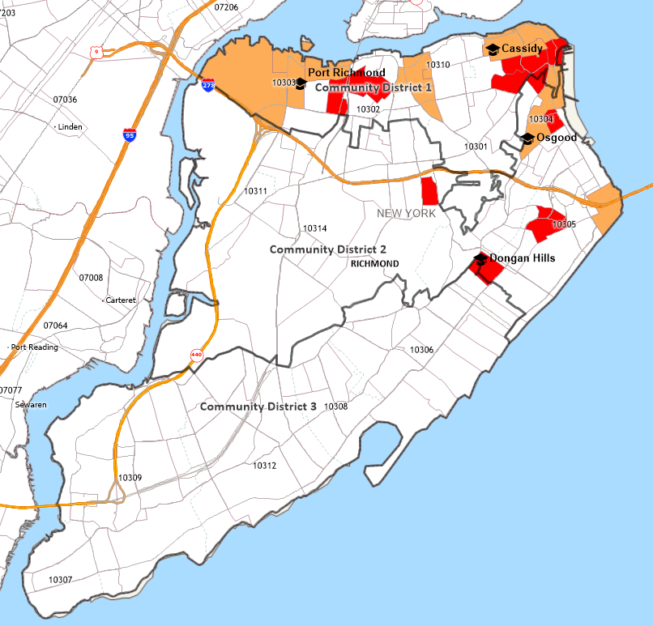
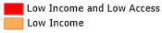
Sources: Economic Research Services, U.S. Department of Agriculture (2021) and Caliper Maptitude (2025).
Low access in this map is defined as “more than one-half mile from a supermarket or large grocery store in urban areas and more than 10 miles from a supermarket or large grocery store in rural areas.”
Note that these ZIP Code assignments do not correspond to Community District geographic boundaries exactly.
See the Appendix for a comparison of the two designations.

Food deserts are present within the RUMC-Staten Island Head Start Service Area.

Health Professional Shortage Areas
An area can receive a federal Health Professional Shortage Area (HPSA) designation if a shortage of primary medical care, dental care, or mental health care professionals is found to be present. In addition to areas and populations that can be designated as HPSAs, a facility can receive federal HPSA designation and an additional Medicare payment if it provides primary medical care services to an area or population group identified as having inadequate access to primary care, dental, or mental health services. HPSAs can be: “(1) An urban or rural area (which need not conform to the geographic boundaries of a political subdivision and which is a rational area for the delivery of health services); (2) a population group; or (3) a public or nonprofit private medical facility.” Areas and populations in the community are designated as HPSAs (Exhibits 27).

Exhibit 27A: Location of Federally Designated Primary Care HPSA Census Tracts in the RUMC-Staten Island Head Start Service Area, 2025
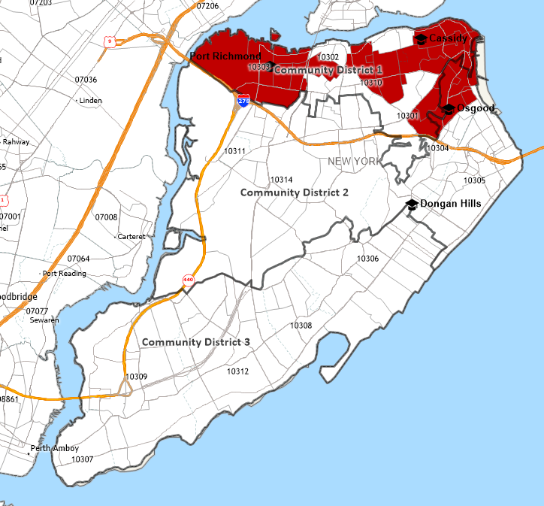
Sources: HRSA (2025) and Caliper Maptitude (2025).
Note that these ZIP Code assignments do not correspond to Community District geographic boundaries exactly.
See the Appendix for a comparison of the two designations.

Census tracts designated as Primary Care HPSAs are located within the RUMC-Staten Island Head Start Service Area.

Exhibit 27B: Location of Federally Designated Dental Health HPSA Census Tracts in the RUMC-Staten Island Head Start Service Area, 2025
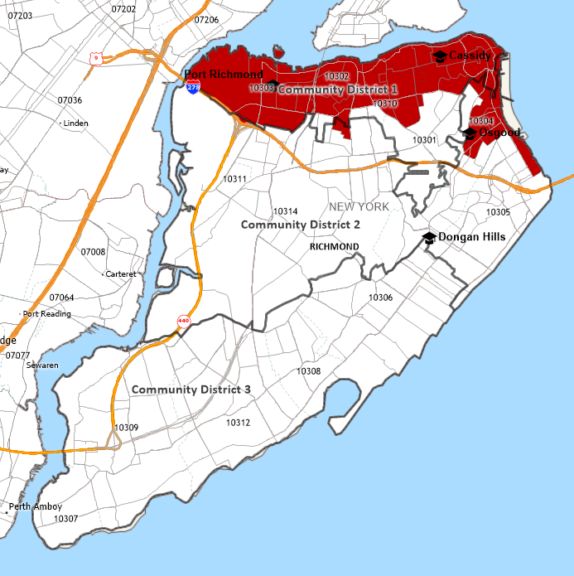
Sources: Caliper Maptitude (2025) and HRSA, 2023.
Note that these ZIP Code assignments do not correspond to Community District geographic boundaries exactly.
See the Appendix for a comparison of the two designations.

Census tracts designated as Dental Health HPSAs are located within the RUMC-Staten Island Head Start Service Area.

Exhibit 27C: Location of Federally Designated Mental Health HPSA Census Tracts in the RUMC-Staten Island Head Start Service Area, 2025
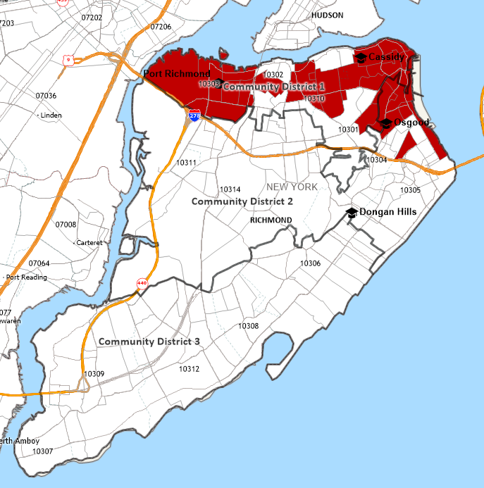
Sources: Caliper Maptitude (2025) and HRSA, 2023.
Note that these ZIP Code assignments do not correspond to Community District geographic boundaries exactly.
See the Appendix for a comparison of the two designations.

Census tracts designated as Mental Health HPSAs are located in within the RUMC-Staten Island Head Start Service Area.

Social Service Needs
The Office of Head Start at the Administration of Children & Families, an agency of the U.S. Department of Health and Human Services, indicates that Head Start programs “support children's growth in a positive learning environment through a variety of services.” Specific services identified by the Office of Head Start are summarized below.

- Early learning and development services
  - Social skills
  - Emotional well-being
  - Language and literacy skills
  - Mathematics and science concepts
- Health
  - Health screenings
  - Nutritious meals
  - Connections to medical, dental, and mental health services
- Family well-being
  - Housing stability
  - Continued education
  - Financial security

Work, school, and training schedules of parents with eligible children

Information on work, school, and training schedules of parent with eligible children is not readily available. Accommodation for parent schedules and consideration may be informed by the 2023 contract between the United Federation of Teachers and New York City Schools. This contract stipulates that, for elementary and middle schools, “the school day will start no earlier than 8 a.m. and may end no later than 3:45 p.m.,” including time for professional development, other professional work, and parent engagement. Hours for the Future Leaders Elementary School, for example, are 8:20 am to 2:40 pm daily, with breakfast available 8:00 am to 8:18 am.

RUMC-Staten Island Head Start hours are similar. Specifically, RUMC-Staten Island Head Start offers services from 8:30 am to 3:00 pm, Monday through Friday, at each of the four sites. Programs operate year-round (September to August), except for holidays and days for pre-scheduled in-service training, for a total of 48 weeks each year.

Parents complete a community assessment questionnaire during enrollment at the RUMC-Staten Island Head Start. Exhibit 28 summarizes responses to questions about community resources from the 2024-2025 parent questionnaire.

Exhibit 28: Parent Responses About Community Resources, 2024-2025
Question | Response | Port Richmond Site | Dongan Hills Site | Cassidy Site | Osgood Site | Total
Do you have access to a supermarket in walking distance of your home? | Yes | 20 | 9 | 25 | 15 | 69
 | No | 1 | 1 | 5 | 4 | 11
In order to get to your doctor’s office, how do you travel? | Car | 14 | 9 | 14 | 11 | 48
In order to get to your doctor’s office, how do you travel? | Bus | 6 | 1 | 14 | 7 | 28
In order to get to your doctor’s office, how do you travel? | Cab | 6 | 0 | 4 | 1 | 11
In order to get to your doctor’s office, how do you travel? | Walk | 2 | 2 | 3 | 3 | 10
In your neighborhood, do you have the following? | Post Office | 15 | 5 | 17 | 14 | 51
In your neighborhood, do you have the following? | Bank | 13 | 7 | 11 | 10 | 41
In your neighborhood, do you have the following? | Pharmacy | 14 | 7 | 20 | 16 | 57
In your neighborhood, do you have the following? | Park | 19 | 7 | 23 | 18 | 67
Is crime a problem in your neighborhood? | Yes | 1 | 1 | 4 | 4 | 10
Is crime a problem in your neighborhood? | No | 20 | 10 | 24 | 14 | 68
Do you walk your children to school? | Yes | 14 | 5 | 15 | 11 | 45
Do you walk your children to school? | No | 6 | 6 | 13 | 0 | 25
Do you believe your local public school provides a quality education? | Yes | 18 | 11 | 26 | 19 | 74
 | No | 1 | 0 | 0 | 0 | 1
What hospital would you use in an emergency? | SI University Hospital | 7 | 9 | 17 | 12 | 45
What hospital would you use in an emergency? | Richmond University Medical Center | 11 | 2 | 13 | 9 | 35
What services do you feel are most needed on Staten Island? | Medical | 3 | 4 | 8 | 3 | 18
What services do you feel are most needed on Staten Island? | Housing | 9 | 3 | 4 | 8 | 24
What services do you feel are most needed on Staten Island? | Transportation | 0 | 3 | 6 | 4 | 13
What services do you feel are most needed on Staten Island? | Schools | 2 | 3 | 7 | 3 | 15
Total Responses on Survey |  | 21 | 10 | 30 | 19 | 80
Sources: Caliper Maptitude (2023) and HRSA, 2023.

The service identified as most needed on Staten Island, 2024-2025, was housing.

Information about other child development services, child care centers, and family child care programs that serve eligible children

Exhibit 29 summarizes information about child development support, child care centers, and family care programs that serve eligible children in the RUMC-Staten Island Head Start Service Area.
Exhibit 29: Child Development Support, Child Care Centers, and Family Care Programs
Organization/Program  Website/Contact Information | Services | Child Development Services | Child Care Centers | Family Child Care Programs
Children’s Aid  https://www.childrensaidnyc.org/ | - Academic and emotional learning  - Health and nutrition  - Family and community support
Healthy Families Staten Island  https://www.nyfoundling.org/what-we-do/our-programs/child-welfare/healthy-families/ | - Foster care and preventive services  - Home visits for new/expectant parents  - Developmental Disabilities Program
NYC Health – Child Care Connect  https://a816-healthpsi.nyc.gov/ChildCare/ChildCareList.action | - Helps parents find licensed day care in their neighborhood  - Lists inspection results
NYC Health – Infant Sleep Safety  https://www.nyc.gov/site/doh/health/health-topics/pregnancy-sleep-safety.page | - Provides prevention information about sleep-related injury
NYC Health – Nurse-Family Partnership  https://www.nyc.gov/site/doh/health/health-topics/nurse-family-partnership.page | - Support to first-time for healthy pregnancy and parenting knowledge, for babies’ best-starts
NYC Health – Parents Connect Groups  718-495-8211 | - Provides an opportunity for parents to connect and support each other
NYC Health – Pediatric Bundle Initiative  https://www.nyc.gov/site/doh/providers/resources/pediatric-bundle.page | - Offers evidence-based programs and promising practices for pediatric health care providers
NYC Health – The Early Intervention Program  https://www.nyc.gov/site/doh/health/health-topics/early-intervention.page | - Supports families with children who are up to three years old and have disabilities or developmental delays
NYC Health – The New Family Home Visits Initiative  https://www.nyc.gov/site/doh/health/health-topics/new-family-home-visits.page | - Offers support, services, and referrals to new and expectant parents.
NYC Health – The Newborn Home Visiting Program  https://www.nyc.gov/site/doh/health/health-topics/pregnancy-newborn-visiting.page | - Provides breastfeeding and home safety support
NYC Health – The Parents Help Line  Call 311 and ask for “Our Littlest New Yorkers” | - Connects to a specialist who can refer to City resources and services that match needs
Cohen Children’s, Northwell Staten Island University Hospital  )https://siuh.northwell.edu/pediatrics/developmental-behavioral-services | - Evaluation, treatment, and follow-up care to support optimal childhood development
Staten Island Mental Health Society (RUMC)  https://rumcsi.org/services/behavioral-health/staten-island-mental-health-society/ | - Developmental disability & early childhood services  - Family support and community services  - Outpatient services  - Pre-school education services

Resources available in the community

The RUMC-Staten Island Head Start community has a variety of community strengths and resources that can be leveraged for service delivery, coordination, and partnership efforts for education, health, nutrition, and referrals to social services to eligible children and families. This section identifies facilities, organizations, and service providers, including transportation resources, and culturally appropriate and responsive supports.

Community Boards

Community Boards are local bodies representing fifty-nine (59) New York City neighborhoods. The boards consist of up to fifty unsalaried, involved members of each neighborhood and are appointed by the Borough President. Community Boards handle complaints and requests related to City services, work with City agencies to plan local projects, review proposed zoning changes, and act as the community’s liaison with City agencies.

There are three NYC Community Boards representing Staten Island. The RUMC-Staten Island Head Start community is represented by Community Boards 1 and 2. Exhibit 30 summarizes details about the three Staten Island Community Boards.
Exhibit 30: Summary Details of Staten Island Community Boards
Community Boards | Areas Represented | Phone Number | Website
1 | Arlington, Castleton Corners, Clifton, Concord, Elm Park, Fort Wadsworth, Graniteville, Grymes Hill, Livingston, Mariners Harbor, Meiers Corners, New Brighton, Port Ivory, Port Richmond, Randall Manor, Rosebank, St. George, Shore Acres, Silver Lake, Stapleton, Sunnyside, Tompkinsville, West Brighton, Westerleigh | 718-981-6900 | https://www.nyc.gov/site/statenislandcb1/index.page
2 | Arrochar, Bloomfield, Bulls Head, Chelsea, Dongan Hills, Eggertsville, Emerson Hill, Grant City, Grasmere, High Rock, Lighthouse Hill, Midland Beach, New Dorp, New Springville, Oakwood, Ocean Breeze, Old Town, Richmond town, South Beach, Todt Hill and Travis | 718-568-3581 | https://www.nyc.gov/site/statenislandcb2/index.page
3 | Annadale, Arden Heights, Bay Terrace, Charleston, Eltingville, Great Kills, Greenridge, Huguenot, Pleasant Plains, Prince's Bay, Richmond town, Richmond Valley, Rossville, Tottenville, and Woodrow | 718-356-7900 | https://www.nyc.gov/site/statenislandcb3/index.page
Source: City of New York, 2025.

Resource Directories

NYC311. NYC311 provides access to non-emergency government services and information, as well as more than 200 agencies and non-profits in New York City. NYC311 is accessible by phone (311 and 212-639-9675), online (https://portal.311.nyc.gov/ and social media sites), and by mobile application 24 hours a day, 365 days a year. NYC311 is accessible to non-English speakers with assistance in 175 languages.

211 New York State. The United Way of New York State operates 211 New York, a service that “connects New Yorkers to local resources and services --- including food, housing, mental health support, and more.” The service is free and available 24/7 in multiple languages. The service can be accessed by telephone at 211 or online at https://www.211newyork.org/.

Other Community Resources

Categories of community resources include the following:

- Culture and Recreation;
- Disabilities;
- Domestic Violence;
- Education;
- Employment;
- Financial;
- Food and Nutrition;
- Health Care;
- Public Safety;
- Shelter and Housing; and
- Transportation.

Community resources for these categories are summarized below.
- Culture and Recreation
Organization/Program | Services | Phone Number | Website
Beaches – Staten Island | - Wolfe’s Pond Park  - Franklin D. Roosevelt Boardwalk and Beach  - Great Kills Park | N/A | https://www.nycgovparks.org/facilities/beaches
Cool Culture Family Pass | - Allows families free and unlimited general admission to 90 participating cultural institutions in NYC for one year | 718-230-4186 | https://www.coolculture.org/faqs-for-families/
Historic Richmond Town (Staten Island Historical Society) | - Interprets and restores a living history village, operates a historical museum, and collects and preserves material culture | 718-351-1611 | https://www.historicrichmondtown.org/
Nature Centers – Staten Island | - Blue Heron Park  - Latourette Park and Golf Course | N/A | https://www.nycgovparks.org/facilities/naturecenters
NYC Events | - Get information about recreational and cultural events held in NYC, including street and plaza events, outdoor concerts, farmers markets, athletic races, health fairs, and parades | N/A | https://www.nyc.gov/main/events/
NYC Parks – Staten Island | - Alice Austen Park  - Blue Heron Park  - Brookfield Park  - Clove Lakes Park  - Conference House Park  - Cpl. Thompson Park  - Faber Pool and Park  - FDR Boardwalk and Beach  - Freshkills Park  - Great Kills Park  - Latourette Park and Golf Course  - Lemon Creek Park  - Silver Lake Park  - Tappen Park  - Westerleigh Park  - Willowbrook Park | N/A | https://www.nycgovparks.org/park-features/parks-list?boro=R
Snug Harbor Cultural Center & Botanical Garden | - A place where history, architecture, visual and performing arts, gardens, agriculture, and education come together and provide dynamic experiences for all ages | 718-448-2500 | https://snug-harbor.org/
Staten Island Children’s Museum | - Offers imaginative, creative, and cultural hands-on experiences for children ages 1 and up | 718-273-2060 | https://sichildrensmuseum.org/
Staten Island Museum | - Provides interdisciplinary exhibitions, public programs, and educational activities for all ages | 718-727-1135 | https://www.statenislandmuseum.org/
Staten Island Zoological Society | - An 8-acrea urban zoo with over 1,400 animals and 320 species | 718-442-3100 | https://www.statenislandzoo.org/

- Disabilities
Organization/Program | Services | Phone Number | Website
Access-A-Ride | - Provides transportation for people with disabilities whose disability prevents their use of mass transit | 511 | https://www.mta.info/accessibility/access-a-ride
Blind and Low Vision Support | - Provides audio description services, books, Braille and technology, family services, guide-dog schools, and mobility and rehab services | 212-639-9675 | https://www.nyc.gov/site/mopd/resources/blind-low-vision.page
Children and youth with special healthcare needs | - Provides assessment and help finding health care and community resources | 212-639-9675 | https://www.nyc.gov/site/doh/health/health-topics/children-with-special-healthcare-needs.page
Technology-Related Assistance for Individuals with Disabilities (TRIAD) | - Helps connect people who need assistive technology devices | 800-624-4143 | https://www.justicecenter.ny.gov/traid-program

- Domestic Violence
Organization/Program | Services | Phone Number | Website
Love is Respect | - Offers support, information, and advocacy to those involved in dating abuse relationships | 866-331-9474 | https://www.loveisrespect.org
National Domestic Violence Hotline | - Crisis intervention, safety planning, and information and referrals to agencies nationwide for domestic violence victims and those calling on their behalf | 512-453-8117 | https://www.thehotline.org/

- Education
Organization/Program | Services | Phone Number | Website
3-K for All | - Provides free, full-day, high-quality early childhood education for three year olds | 718-935-2009 | https://www.schools.nyc.gov/enrollment/enroll-grade-by-grade/3k
Adult Education | - Provides tuition free classes for eligible students who are 21 years and older and have not earned a U.S. high school diploma or equivalency | 646-481-8227 | https://adultedu.nyc/
College of Staten Island | - A public college that is part of the City University of New York (CUNY) offering undergraduate and graduate degrees | 718-982-2000 | https://www.csi.cuny.edu/
Department of Education – Special Education | - Special education services are available in most public schools for students aged 3 to 21 | 718-935-2007 | https://www.schools.nyc.gov/learning/special-education/the-iep-process/starting-the-process
GED and Literacy | - Training programs including basic education, preparation for GED, and English for speakers of other languages | 212-639-9675 | https://www.nyc.gov/site/dycd/services/reading-writing.page
Head Start | - Provides free child development activities and educational programs for children ages 3 and 4 and for their families | 212-639-9675 | https://www.schools.nyc.gov/enrollment/enroll-grade-by-grade/head-start
New York City College of Technology (City Tech) | - Offers a range of technical and professional programs, including associate and bachelor’s degrees | 718-260-5000 | https://www.citytech.cuny.edu/
New York Public Library | - Fourteen Staten Island locations  - Access to books and other media  - Provides educational programs and resources including storytime for young learners, English language classes, and technology training | 917-275-6975 | https://www.nypl.org/
NYC Public Schools | - NYC families can apply to public schools from 3-K to high school  - Explore student’s personalized school options  - Get guidance on the admissions process from start to finish | 718-935-2009 | https://www.myschools.nyc/en/

- Employment
Organization/Program | Services | Phone Number | Website
Career Discovery NYC | - Provides free information and training for specific careers | N/A | https://careerdiscovery.cityofnewyork.us/
NYC Consumer and Worker Protection | - Protects and promotes labor standards and policies that create fair workplaces | 212-436-0380 | https://www.nyc.gov/site/dca/index.page
Summer Youth Employment Program | - Provides summer employment information, assistance, and referrals for City residents ages 14 to 24 | 800-246-4646 | https://application.nycsyep.com
Workforce1 Career Centers | - Prepares and connects qualified candidates to job opportunities in NYC | 311 | https://www.nyc.gov/site/sbs/careers/careers.page

- Financial
Organization/Program | Services | Phone Number | Website
Financial Counseling - Department of Consumer and Worker Protection | - Provides counseling to manage debt, navigate student loans, improve credit, create a budget, open a bank account, save, and plan for future | 212-487-4583 | https://www.nyc.gov/site/dca/talk-money/get-free-financial-counseling.page
Financial Literacy for Youth | - Provides financial educators and banking services to public school students | N/A | https://www.nyc.gov/site/dca/talk-money/fly-financial-literacy-for-youth.page
NYC Free Tax Prep | - Provides assistance to prepare and file tax returns | N/A | https://www.nyc.gov/site/dca/talk-money/file-your-taxes.page

- Food and Nutrition
Organization/Program | Services | Phone Number | Website
Food for Women, Infants, and Children (WIC) | - Healthy food, including baby formula, for pregnant women, mothers, and young children | 800-522-5006 | https://www.health.ny.gov/prevention/nutrition/wic/
Food Help NYC | - Food Pantries and Soup Kitchens | N/A | https://finder.nyc.gov/foodhelp/locations
Go!Healthy Food Box & Farmstand – Goodhue Center | - Hands-on, sensory based nutrition education and activities for children and their parents | 212-949-4800 | https://www.childrensaidnyc.org/programs/gohealthy
SNAP (Food Stamps) Nutrition Incentives | - Provide healthy foods through various nutrition programs | 646-355-1475 | https://portal.311.nyc.gov/article/?kanumber=KA-01018
Snug Harbor Heritage Farm Stand | - Farm Stand offers vegetables, fruits, herbs, and flowers  - Community Supported Agriculture (CSA) subscription program | N/A | https://snug-harbor.org/find-heritage-farm-produce/
St. George Greenmarket | - Offers fresh, seasonal fruit, produce, cheese, meat, seafood, and baked goods at a weekly market | N/A | https://www.grownyc.org/greenmarket/staten-island/saint-george
Staten Island Mall Greenmarket | - Offers local honey, orchard picket fruit, vegetables, and baked goods at a weekly market | N/A | https://www.grownyc.org/greenmarket/staten-island/si-mall
Summer Meals for Children | - Provides free breakfast and lunch to anyone ages 18 and under at designated public schools, community pool centers, parks, and food trucks | 718-707-4398 | https://www.opt-osfns.org/schoolfoodny/meals/Default.aspx

- Health Care
Organization/Program | Services | Phone Number | Website
988 Mental Health Support | - Provides free, confidential help with mental health or substance abuse issues, including crisis services and treatment referrals | 988 | https://nyc988.cityofnewyork.us/en/find-services/
Alcohol and Substance Use | - Free, confidential hotline with information and referrals for counseling, therapy, safe drug use, anger management, and medication to treat opioid dependence | 988 | https://oasas.ny.gov/treatment
Beacon Christian Community Health Center, Inc. | - A Federally Qualified Health Center (FQHC) that provides routine care for the entire family  - Offers services in mental health, podiatry, nutrition counseling, and spiritual care | 347-991-7882 | https://beaconcchc.com/
Child Health Plus and Children’s Medicaid | - Health insurance programs for children that covers health care and dental needs | 855-355-5777 | https://www.health.ny.gov/health_care/child_health_plus/
Community Health Center of Richmond, Inc. | - An FQHC with 4 Staten Island locations providing podiatry, behavioral health, primary care, women’s health, nutrition, and dentistry | 718-924-2254 | https://chcrichmond.org/
Northwell Staten Island University Hospital | - 668 bed healthcare facility and teaching institution, with two SI campuses (North and South) | 718-226-9000 | https://siuh.northwell.edu/
NYC Health + Hospitals | - A municipal health care delivery system dedicated to providing the highest quality health care services to all New Yorkers | 844-NYC-4NYC | https://www.nychealthandhospitals.org/
Richmond University Medical Center (RUMC) | - 470 bed healthcare facility and teaching institution serving SI residents in the areas of acute medical and surgical care and emergency care | 844-934-2273 | https://rumcsi.org/
RUMC-Bayley Seton | - Provides inpatient chemical dependence and psychiatric care | 718-390-6000 | https://rumcsi.org/

- Public Safety
Organization/Program | Services | Phone Number | Website
911 Information | - Call 911 to report an emergency situation or condition that might cause danger to life or personal property  - Text 911 when a call is not possible due to deafness, hard of hearing, speech disability, or it is not safe to call | 911 | N/A
New York Police Department | - The 120th Precinct serves the North Shore  - The 121st Precinct serves the northwestern shore  - The 122nd Precinct serves the South Shore  - The 123rd Precinct serves a portion of the South Shore | 718-876-8500  718-697-8700  718-667-2211  718-948-9311 | https://www.nyc.gov/site/nypd/index.page
Ready New York – Emergency Preparedness | - Provides guides and education for residents to prepare for all types of emergencies in NYC | 212-639-9675 | https://www.nyc.gov/site/em/ready/guides-resources.page

- Shelter and Housing
Organization/Program | Services | Phone Number | Website
CityFHEPS Rental Assistance | - Assists people living in shelters or at risk of becoming homeless find and pay for permanent housing | 718-557-1399 | https://www.nyc.gov/site/hra/help/cityfheps.page
Eviction Prevention and Homebase | - Aids with those who recently received an eviction notice or are in an immediate housing crisis | 212-639-9675 | https://www.nyc.gov/site/hra/help/homebase-locations.page
New York City Housing Authority (NYCHA) | - Provides decent and affordable housing in a safe and secure living environment for low- and moderate-income residents | 212-639-9675 | https://www.nyc.gov/site/nycha/index.page
NYC Affordable Housing Programs | - NYC Housing Connect provides affordable rental and homeownership opportunities  - The Mitchell-Lama program provides affordable rental and cooperative housing to moderate-and middle-income families | 212-863-6300 | https://www.nyc.gov/site/hpd/services-and-information/find-affordable-housing.page

- Transportation
Organization/Program | Services | Phone Number | Website
Access-A-Ride | - Provides transportation for people with disabilities whose disability prevents their use of mass transit | 511 | https://www.mta.info/accessibility/access-a-ride
Fair Fares NYC | - Helps eligible New Yorkers with low incomes manage their transportation costs (50% discount for subway and eligible bus fares or Access-A-Ride fare) | 311 | https://www.nyc.gov/site/fairfares/contact-us/contact-us.page
Metropolitan Transit Authority | - Provides public transportation in New York City | 511 | https://www.mta.info/
School Transportation | - Provides students with transportation to and from school by yellow bus or OMNY card on MTA subways and buses | 718-392-8855 | https://www.schools.nyc.gov/school-life/transportation/transportation-overview
Staten Island Ferry | - Provides free transportation between Staten Island and Manhattan | 311 | https://siferry.com/about/
Staten Island Railway | - Provides rapid transit line on Staten Island, as part of NYC Transit | 511 | https://www.mta.info/agency/staten-island-railway

Strengths of the community

Staten Island is a diverse community offering a high quality of life, wide-ranging and various employment opportunities, strong educational opportunities, and a “small town feel.” As the most suburban borough of New York City, it has an abundance of parks and green space while also having convenient connections to other NYC boroughs. Staten Island schools have been consistently ranked as some of the best in the city and housing is affordable compared to other boroughs.

In December 2025, students enrolled at RUMC-Staten Island Head Start were asked to identify what they considered to be community strengths. Categories of strengths identified by the students are as follows:

- Schools and libraries;
- Parks;
- Infrastructure, such as grocery stores and restaurants; and
- Resources of New York City.

Results and illustrations created by four- and five-year-old RUMC-Staten Island Head Start students are below.
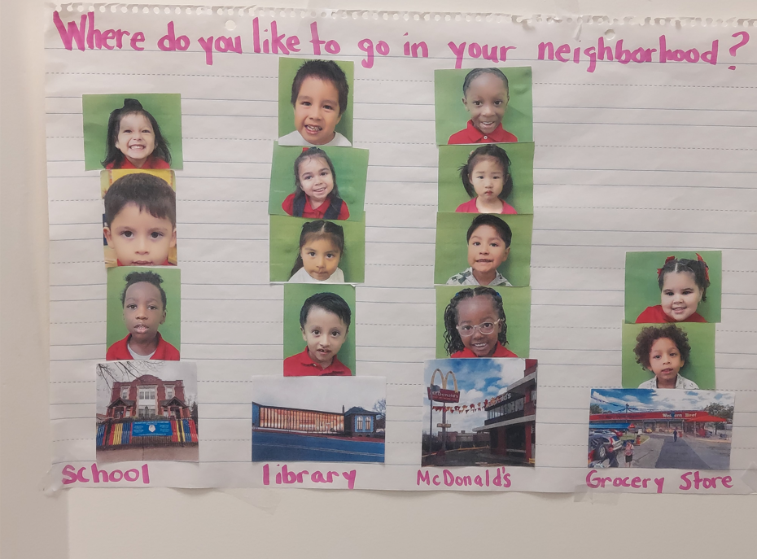
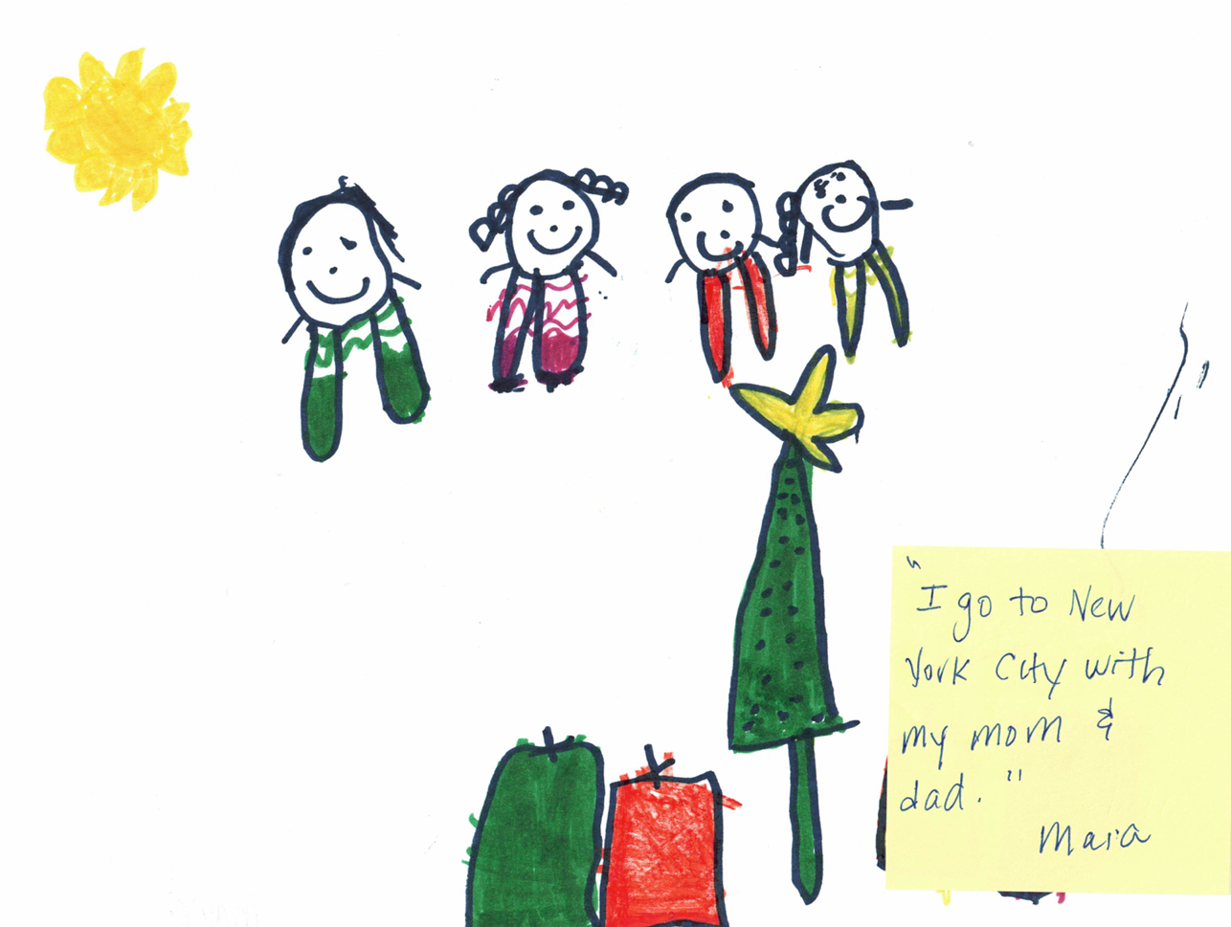
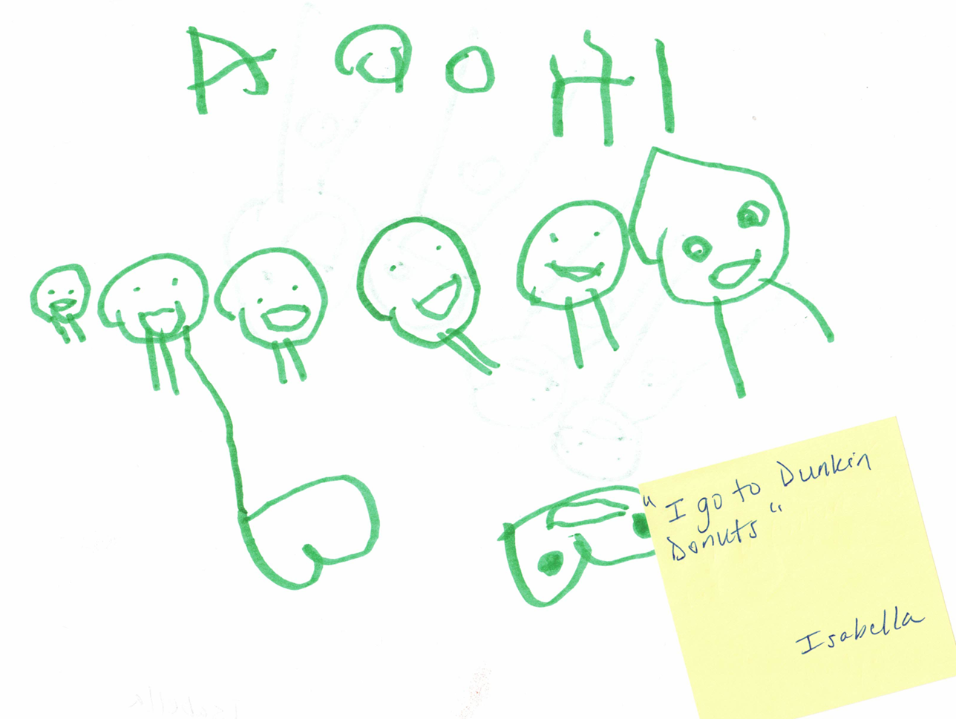
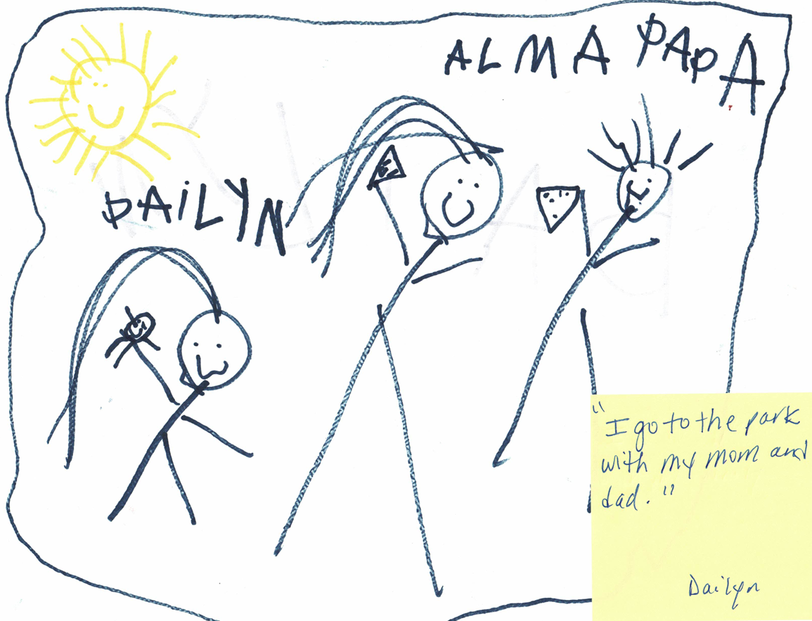
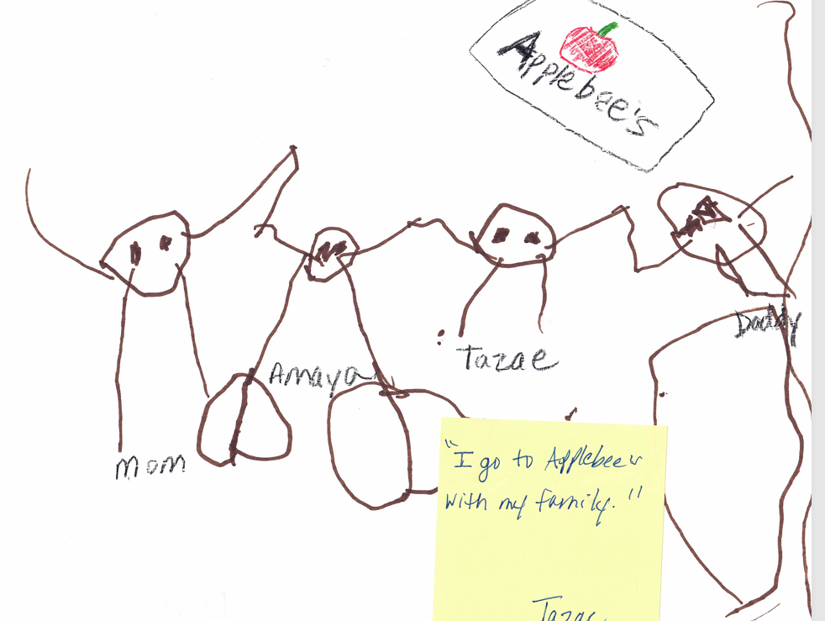
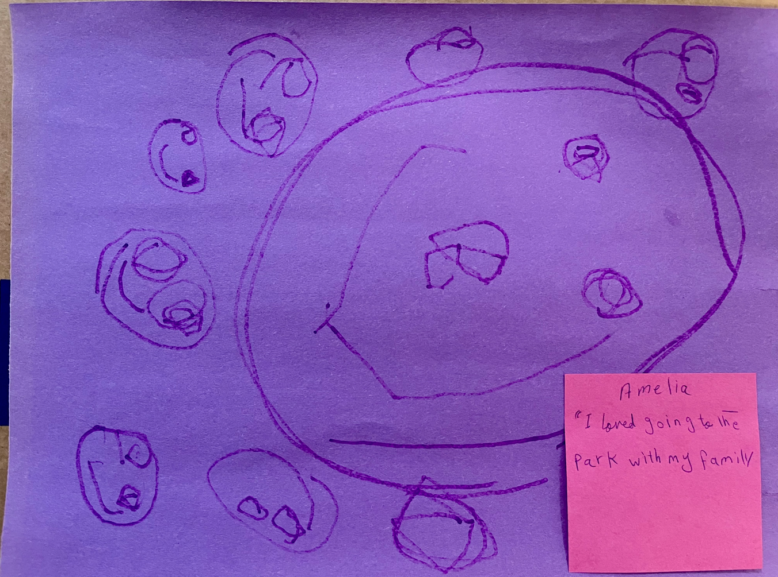
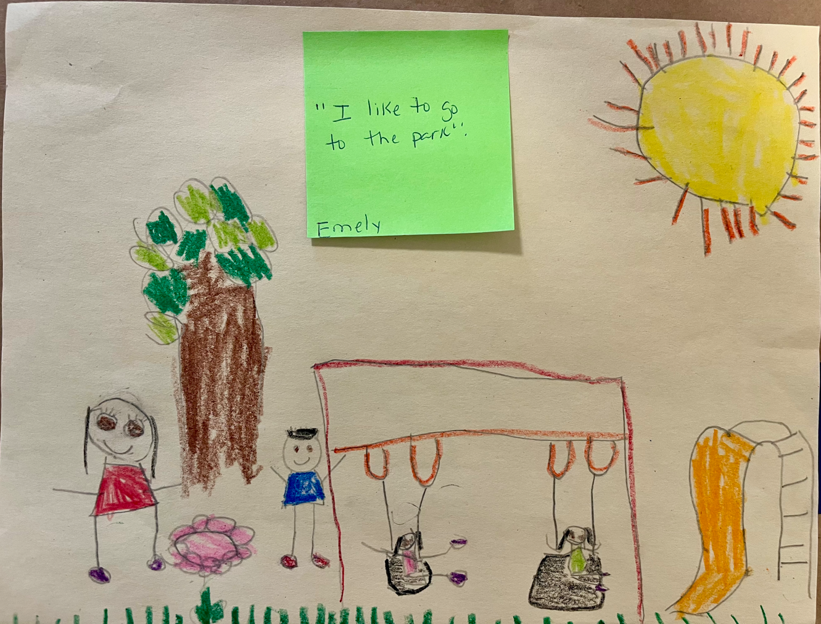
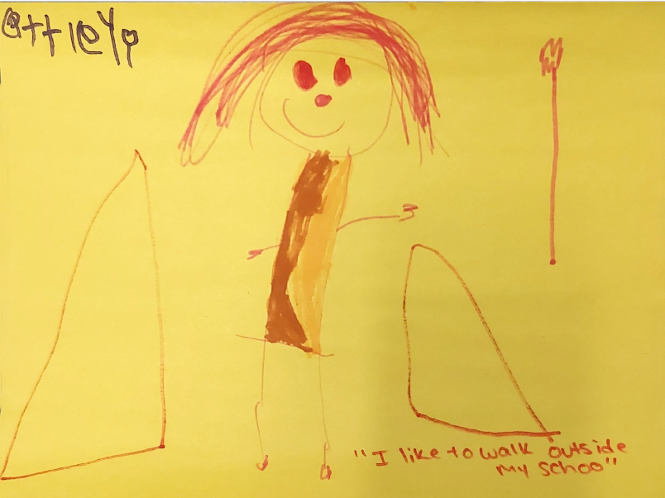
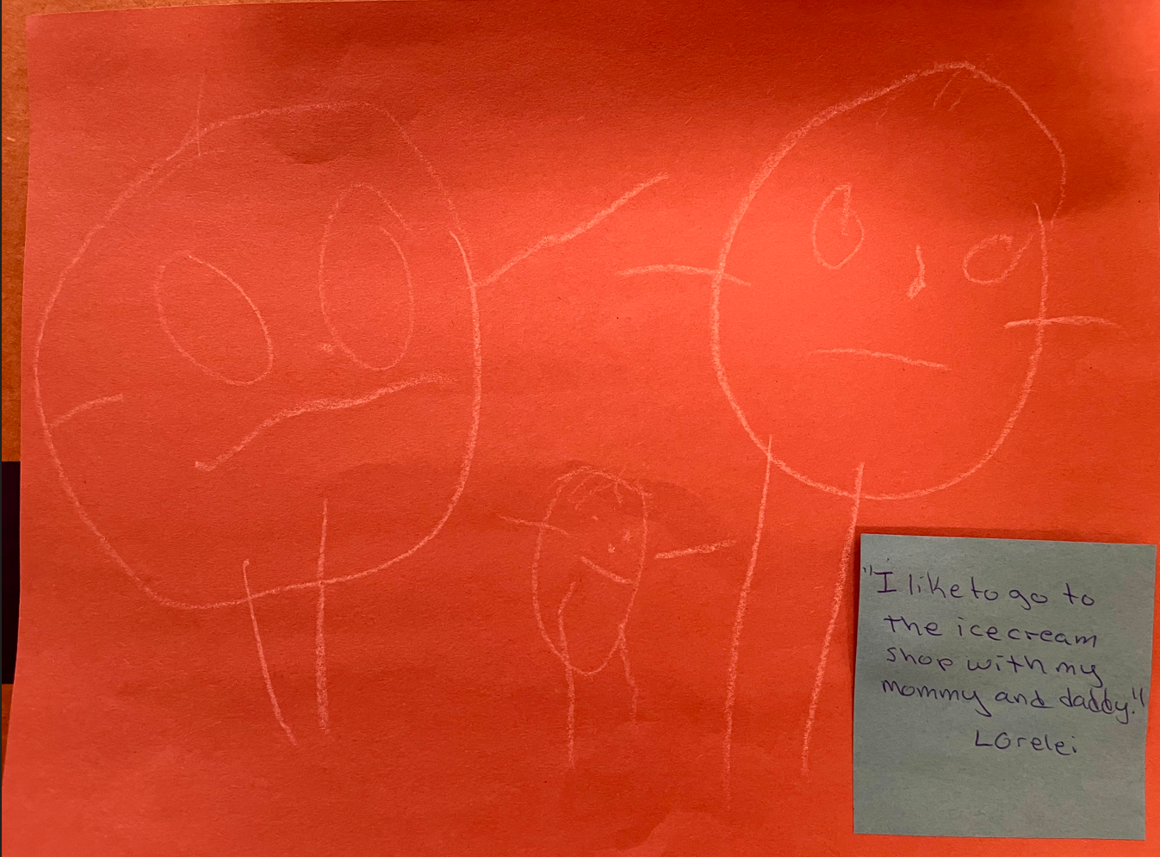
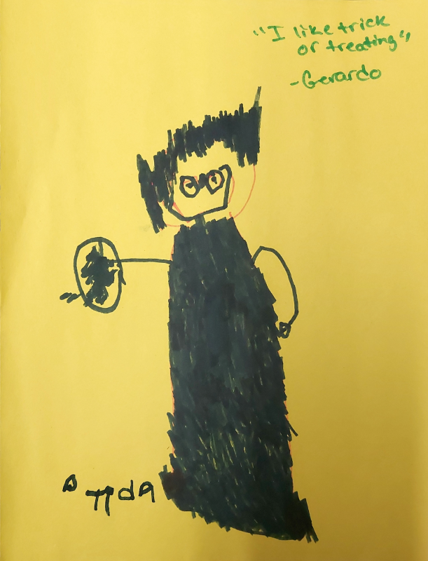
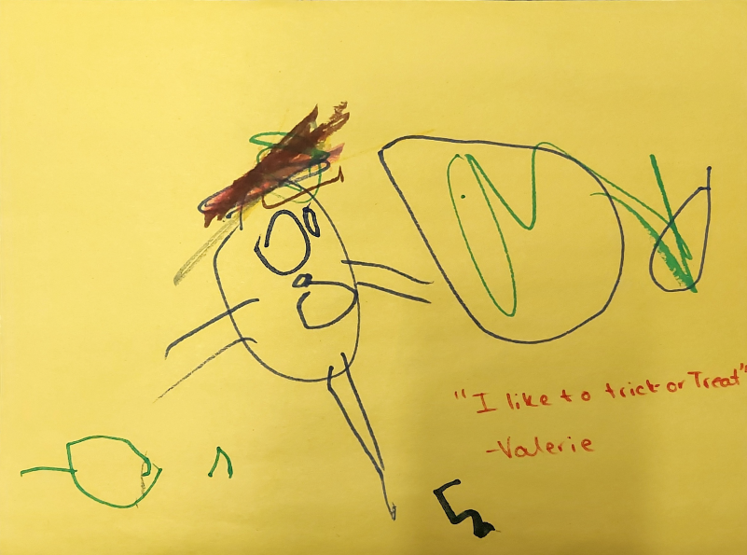
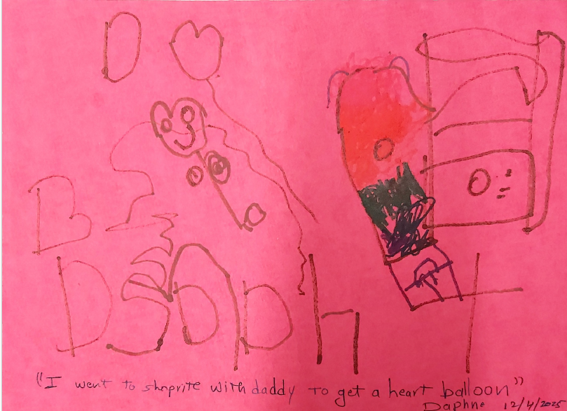
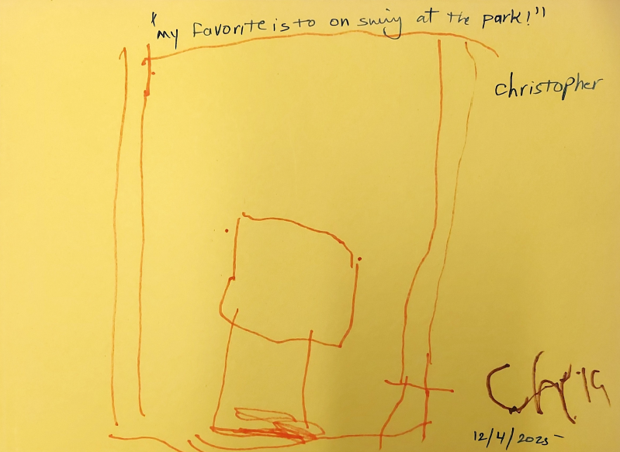
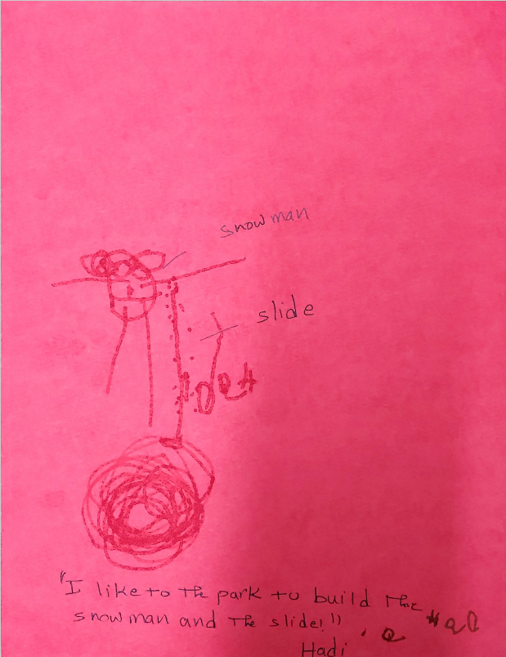
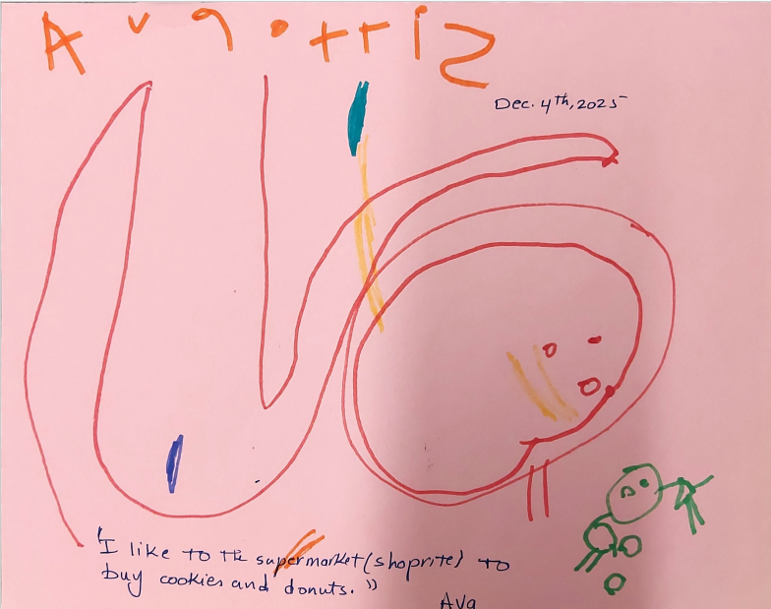

ABOUT VERITÉ HEALTHCARE CONSULTING

Verité Healthcare Consulting assisted RUMC-Staten Island Head Start with this Community Assessment.

Verité Healthcare Consulting, LLC (Verité) was founded in May 2006 and is located in Arlington, Virginia. The firm serves clients throughout the United States as a resource to help organizations conduct needs assessments. Since 2012, Verité has conducted more than 150 needs assessments for hospitals, health systems, and community partnerships nationally.

The firm also helps hospitals, hospital associations, and policy makers with community benefit reporting, financial assistance policies, program infrastructure, compliance, and community benefit-related policy and guidelines development. Verité is a recognized national thought leader in hospital community benefits, 501(r) compliance, and Community Health Needs Assessments.

Appendix

Exhibit X is a map of 2020 Staten Island Community Districts. For comparison, Exhibits 31 are a map of Community Districts and a map of ZIP Codes as assigned to Community Districts for this assessment.

Exhibit 31A: Staten Island Community Districts, 2020
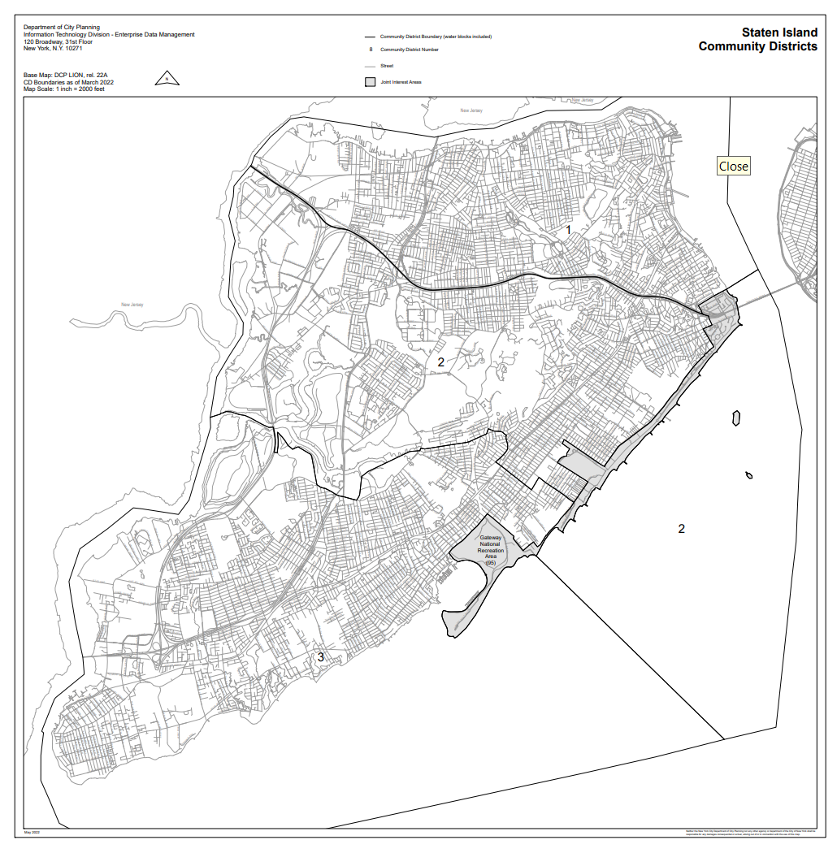
Sources: New York City Department of City Planning, 2025.

Exhibit 31B: ZIP Codes to Districts for this Assessment
Source: Verité and Maptitude (2025).

New York City Department of Health and Mental Hygiene, EpiQuery. Birth (Natality), accessed November 25, 2025, at https://a816-health.nyc.gov/hdi/epiquery/visualizations?PageType=ts&PopulationSource=Birth&Topic=8&Subtopic=38&DisplayViz=Main&MainDashboard=Indicator%20by%20Neighborhood&MainCustomView=https%3A%2F%2Fa816-healthtableau.nyc.gov%2Ft%2FHDI-EPIQUERY%2Fviews%2FHDIVitalModules_birth%2FIndicatorbyNeighborhood%2FHDI_Publicprdsvc%2Fcv1764095975698PS&VIQLDashboard=View%20Indicator%20Quick%20Look&VIQLCustomView=https%3A%2F%2Fa816-healthtableau.nyc.gov%2Ft%2FHDI-EPIQUERY%2Fviews%2FHDIVitalModules_birth_IOOnly%2FViewIndicatorQuickLook%2FHDI_Publicprdsvc%2Fcv1764095975698VIQLPS.
Demographic Snapshot, Information and Data Overview, New York City Schools. See https://infohub.nyced.org/docs/default-source/default-document-library/demographic-snapshot-2020-21-to-2024-25-public.xlsx.
Contract 2023: Time, the workday and remote work, United Federation of Teachers. See https://www.uft.org/your-rights/contracts/contract-2023/contract-2023-time-workday-and-remote-work.
https://www.siedc.org/staten-island-strengths
Ibid.
Staten Island Community Board 1, New York City. See https://www.nyc.gov/site/statenislandcb1/index.page.
Staten Island Community Board 2, New York City. See https://www.nyc.gov/site/statenislandcb2/index.page.
Staten Island Community Board 3, New York City. See https://www.nyc.gov/site/statenislandcb3/index.page.
Head Start, NYC Schools, no date. See https://www.schools.nyc.gov/enrollment/enroll-grade-by-grade/head-start.
District 31 Data Summary, 2025-2026 Strategic Planning Data Considerations, New York City Public Schools | Office of District Planning, Spring 2024. See https://pwsblobprd.schools.nyc/prd-pws/docs/default-source/default-document-library/district-31-data-summary-2024.pdf?sfvrsn=edabd5b1_2.
District 31 Data Summary, 2025-2026 Strategic Planning Data Considerations, New York City Public Schools | Office of District Planning, Spring 2024. See https://pwsblobprd.schools.nyc/prd-pws/docs/default-source/default-document-library/district-31-data-summary-2024.pdf?sfvrsn=edabd5b1_2.
District 31 Data Summary, 2025-2026 Strategic Planning Data Considerations, New York City Public Schools | Office of District Planning, Spring 2024. See https://pwsblobprd.schools.nyc/prd-pws/docs/default-source/default-document-library/district-31-data-summary-2024.pdf?sfvrsn=edabd5b1_2.
Human Resources Administration, 2025. See https://www.nyc.gov/assets/operations/downloads/pdf/pmmr2025/hra.pdf.
Borough/Community District Report, Human Resources Administration, October 15, 2025. The report is the “Population of individuals and households receiving Supplemental Nutrition Assistance Program (SNAP), Cash Assistance (CA), or Medicaid Benefits (MA) as shown on the Borough Consultation Report.” See https://data.cityofnewyork.us/Social-Services/Borough-Community-District-Report/5awp-wfkt/about_data.
Borough/Community District Report, Human Resources Administration, October 15, 2025. The report is the “Population of individuals and households receiving Supplemental Nutrition Assistance Program (SNAP), Cash Assistance (CA), or Medicaid Benefits (MA) as shown on the Borough Consultation Report.” See https://data.cityofnewyork.us/Social-Services/Borough-Community-District-Report/5awp-wfkt/about_data.
Verité analysis of SSA data (SSI Recipients by State and County, 2024) and Census ACS 2023 five year data. See https://www.ssa.gov/policy/docs/statcomps/ssi_sc/index.html.
Annual Community District Snapshots, CY 2024. The documents provide data from a “2024 Child Welfare, Juvenile Justice and Child Care Voucher Snapshot.” https://www.nyc.gov/site/acs/about/annual-cd-snapshots.page.
Richmond County, County/ZIP Code Perinatal Data Profile - 2020-2022, New York State Department of Health, January 2025. See https://www.health.ny.gov/statistics/chac/perinatal/county/2020-2022/richmond.htm#richmond.
New York City Department of Health and Mental Hygiene, EpiQuery. Birth (Natality), accessed November 25, 2025, at https://a816-health.nyc.gov/hdi/epiquery/visualizations?PageType=ts&PopulationSource=Birth&Topic=8&Subtopic=38&DisplayViz=Main&MainDashboard=Indicator%20by%20Neighborhood&MainCustomView=https%3A%2F%2Fa816-healthtableau.nyc.gov%2Ft%2FHDI-EPIQUERY%2Fviews%2FHDIVitalModules_birth%2FIndicatorbyNeighborhood%2FHDI_Publicprdsvc%2Fcv1764095975698PS&VIQLDashboard=View%20Indicator%20Quick%20Look&VIQLCustomView=https%3A%2F%2Fa816-healthtableau.nyc.gov%2Ft%2FHDI-EPIQUERY%2Fviews%2FHDIVitalModules_birth_IOOnly%2FViewIndicatorQuickLook%2FHDI_Publicprdsvc%2Fcv1764095975698VIQLPS.
New York City Department of Health and Mental Hygiene, Bureau of Vital Statistics. Public Use Birth Datasets [Zip Code: Aggregated Three Year Counts, 2019-2021, distributed by Bureau of Vital Statistics, accessed November 19, 2025, at https://www.nyc.gov/site/doh/data/data-sets/public-use-birth-datasets.page].
New York City Department of Health and Mental Hygiene, Bureau of Vital Statistics. Public Use Birth Datasets [Zip Code: Aggregated Three Year Counts, 2019-2021, distributed by Bureau of Vital Statistics, accessed November 19, 2025, at https://www.nyc.gov/site/doh/data/data-sets/public-use-birth-datasets.page].
New York City Department of Health and Mental Hygiene, Bureau of Vital Statistics. Public Use Birth Datasets [Zip Code: Aggregated Three Year Counts, 2019-2021, distributed by Bureau of Vital Statistics, accessed November 19, 2025, at https://www.nyc.gov/site/doh/data/data-sets/public-use-birth-datasets.page].
New York City Department of Health and Mental Hygiene, Bureau of Vital Statistics. Public Use Birth Datasets [Zip Code: Aggregated Three Year Counts, 2019-2021, distributed by Bureau of Vital Statistics, accessed November 19, 2025, at https://www.nyc.gov/site/doh/data/data-sets/public-use-birth-datasets.page].
New York City Department of Health and Mental Hygiene, Bureau of Vital Statistics. Public Use Birth Datasets [Zip Code: Aggregated Three Year Counts, 2019-2021, distributed by Bureau of Vital Statistics, accessed November 19, 2025, at https://www.nyc.gov/site/doh/data/data-sets/public-use-birth-datasets.page].
New York City Department of Health and Mental Hygiene, Bureau of Vital Statistics. Public Use Birth Datasets [Zip Code: Aggregated Three Year Counts, 2019-2021, distributed by Bureau of Vital Statistics, accessed November 19, 2025, at https://www.nyc.gov/site/doh/data/data-sets/public-use-birth-datasets.page].
New York City Department of Health and Mental Hygiene, Bureau of Vital Statistics. Public Use Birth Datasets [Zip Code: Aggregated Three Year Counts, 2019-2021, distributed by Bureau of Vital Statistics, accessed November 19, 2025, at https://www.nyc.gov/site/doh/data/data-sets/public-use-birth-datasets.page].
New York City Department of Health and Mental Hygiene, Bureau of Vital Statistics. Public Use Birth Datasets [Zip Code: Aggregated Three Year Counts, 2019-2021, distributed by Bureau of Vital Statistics, accessed November 19, 2025, at https://www.nyc.gov/site/doh/data/data-sets/public-use-birth-datasets.page].
New York City Department of Health and Mental Hygiene, Bureau of Vital Statistics. Public Use Birth Datasets [Zip Code: Aggregated Three Year Counts, 2019-2021, distributed by Bureau of Vital Statistics, accessed November 19, 2025, at https://www.nyc.gov/site/doh/data/data-sets/public-use-birth-datasets.page].
New York City Department of Health and Mental Hygiene, Bureau of Vital Statistics. Public Use Birth Datasets [Zip Code: Aggregated Three Year Counts, 2019-2021, distributed by Bureau of Vital Statistics, accessed November 19, 2025, at https://www.nyc.gov/site/doh/data/data-sets/public-use-birth-datasets.page].
New York City Department of Health and Mental Hygiene, Bureau of Vital Statistics. Public Use Birth Datasets [Zip Code: Aggregated Three Year Counts, 2019-2021, distributed by Bureau of Vital Statistics, accessed November 19, 2025, at https://www.nyc.gov/site/doh/data/data-sets/public-use-birth-datasets.page].
New York City Department of Health and Mental Hygiene, Bureau of Vital Statistics. Public Use Birth Datasets [Zip Code: Aggregated Three Year Counts, 2019-2021, distributed by Bureau of Vital Statistics, accessed November 19, 2025, at https://www.nyc.gov/site/doh/data/data-sets/public-use-birth-datasets.page].
New York City Department of Health and Mental Hygiene, Bureau of Vital Statistics. Public Use Birth Datasets [Zip Code: Aggregated Three Year Counts, 2019-2021, distributed by Bureau of Vital Statistics, accessed November 19, 2025, at https://www.nyc.gov/site/doh/data/data-sets/public-use-birth-datasets.page].
Demographic Snapshot, Information and Data Overview, New York City Schools. See https://infohub.nyced.org/docs/default-source/default-document-library/demographic-snapshot-2020-21-to-2024-25-public.xlsx.
Demographic Snapshot, Information and Data Overview, New York City Schools. See https://infohub.nyced.org/docs/default-source/default-document-library/demographic-snapshot-2020-21-to-2024-25-public.xlsx.
U.S. Health Resources and Services Administration, Bureau of Health Professionals. (n.d.). Health Professional Shortage Area Designation Criteria. Retrieved 2013, from http://bhpr.hrsa.gov/shortage/hpsas/designationcriteria/index.html.
Head Start Services, Office of Head Start, Administration of Children & Families, U.S. Department of Health and Human Services, June 30, 2024. See https://acf.gov/ohs/head-start-services.
Contract 2023: Time, the workday and remote work, United Federation of Teachers. See https://www.uft.org/your-rights/contracts/contract-2023/contract-2023-time-workday-and-remote-work.
Family and Student Handbook 2025-2026, Future Leaders Elementary School. See https://flesonline.org/wp-content/uploads/2025/09/fles-family-handbook-2025-2026.docx.pdf.
See https://portal.311.nyc.gov/article/?kanumber=KA-02498. Accessed October 2025.
https://www.siedc.org/staten-island-strengths
Ibid.
Department of City Planning, New York City. See https://www.nyc.gov/assets/planning/downloads/pdf/resources/downloadable-maps/si-community-districts-map-2020.pdf.

