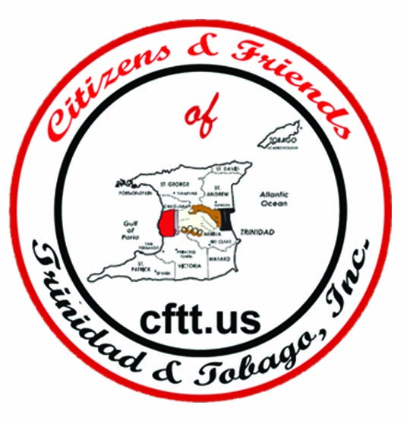

“MAKE A DIFFERENCE IN A CHILD’S LIFE”

CITIZENS AND FRIENDS OF TRINIDAD AND TOBAGO, INC.
P.O. Box 881806, Los Angeles, CA 90009

Telephone: 310-762-2253
Email: citizensfriends@cftt.us

MEMBERSHIP IS $60 ANNUALLY

Membership Application

Applicant Information
Full Name: |  |  |  | Date:
 | Last | First | M.I.

Address:
 | Street Address | Apartment/Unit #

 | City | State | ZIP Code

Phone: |  | Email

Gender | M | F

Are you a new member? | YES | NO

Is this a renewal? | YES | NO

Education
High School: |  | Address:

From: |  | To: |  | Did you graduate? | YES | NO | Diploma::

College: |  | Address:

From: |  | To: |  | Did you graduate? | YES | NO | Degree:

Other: |  | Address:

From: |  | To: |  | Did you graduate? | YES | NO | Degree:

Employment
Company:
Address: |  | :

Job Title:

Responsibilities:

After filling out the application, please email it back to citizensfriends@cftt.us. This form is in both adobe pdf format and Microsoft word format. You need adobe acrobat reader and/or Microsoft word to access this form.

The Pay Pal membership payment link is on the membership page of our website.

Disclaimer and Signature
I certify that my answers are true and complete to the best of my knowledge.

Signature: |  | Date:

