Tap Shoes Options
JUST GETTING STARTED OPTION #1
  - find white shoes with a slippery bottom (no rubber)
  - order steven stompers glue on taps online
  - purchase shoe goo (you can find it at Walmart)
  - glue taps on your shoes-they will need 72 hours for the glue to set

JUST GETTING STARTED OPTION #2
We have a donation bin that you can look through to see if there is anything that will work for your dancer-donations shoes can be used for free we just ask that you return the favor when you can

JUST GETTING STARTED OPTION #3
We have a studio Facebook page where students can buy/sell used tap shoes.
NEW SHOE ORDERS
Double Tap Clogging Shoes 2026
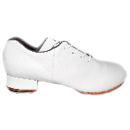Split Sole Clogging Shoes with Steven Buck Taps
$160 - Youth 13, 13.5, 1, 1.5
$160 - Adult 4, 4.5,5, 5.5, 6, 6.5, 7, 7.5, 8, 8.5, 9, 9.5, 10, 10.5, 11, 11.5, 12
$170 - Mens 11, 11.5, 12
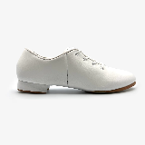Adult Econo Vinyl Split Sole Shoes with Steven Buck Taps
$96 - Adult 5, 5.5, 6, 6.5, 7, 7.5, 8, 8.5, 9, 9.5, 10, 10.5, 11, 11.5, 12
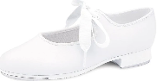Little Girl Tie Tap shoes with Steven Buck toes/Regular heels
$55 - Youth 6-1.5
Venmo

In description of payment list:
LACHERE FAB 5
STUDENT NAME
Bloch Split Sole size _____ OR Economy Split Sole size _____ OR
Yth full sole size _____ OR Tie Tap size _____

