Navy League Orientation, Basic – New England- 2025
Recruit Welcome Aboard

PRIOR TO ARRIVING

- Have a full sea bag (all items accounted for including notebook & pens) according to the Sea Bag list included in this document. Most items are mandatory for training. We do not have any spare to provide in case you forget something. Do not bring anything that is not on the list. There is a Wal-Mart about 15 minutes away.
- The Sea Bag List may be found as a separate link at the webpage https://barque-eagle-seacadets.org/nlo-basic Please start collecting these items now. As noted on the list, be sure that all NLCC Flash(es) is attached as directed in the USNSCC/USNLCC Uniform Manual along with appropriate nametapes. All items should be marked with the recruit’s name. NLCC Orientation New England is not responsible for any items lost or stolen.
- Two (2) sets of NWUs are required for the training. We do NOT do laundry except in extreme circumstances. Be sure you have the required amount of underwear and socks. Also –Coyote Brown T-shirts for NWU Type IIIs and Long Sleave Black Button Down with black pants (Dress Uniform).
- Don’t forget to bring enough blousing bands.
- Hair: See USNSCC/USNLCC Regulations, also located at Homeport.seacadets.org.
- No facial hair (exceptions made for League Cadet males who have not yet started to shave).
- Have your ID card (must be current) – without this you will be sent home.
- Have your paperwork – You will not be checked in without it – This is an 8.5 x 11 envelope containing the following.
- Original and Signed Training Orders (Cadet)
- Original of the Base Access/Mode of Travel Form.
- Any Medical forms not uploaded to the Parent Portal
- Other forms required by your unit.

If your online record is not up to date and if your paperwork does not arrive with you, or we do not have it, you will have to wait until it arrives to check in. Check-in starts at 1000 (10AM) & ends at 1130 hours (11:30AM) on Sunday, June 22, 2025

ALL MEDICAL FORMS MUST UP TO DATE ONLINE. Not having complete medical forms undated is the single most cause of delay at check-in.

Physical Fitness
- Start working out to get physically fit and stay physically fit:
There are two P.T. (physical training) sessions each day. This is strenuous exercise. If you anticipate a problem, let us know when you send in your Request for Training Authority. Start practicing NOW. Upon arrival you should be able to do at least the following exercises, at the satisfactory level:
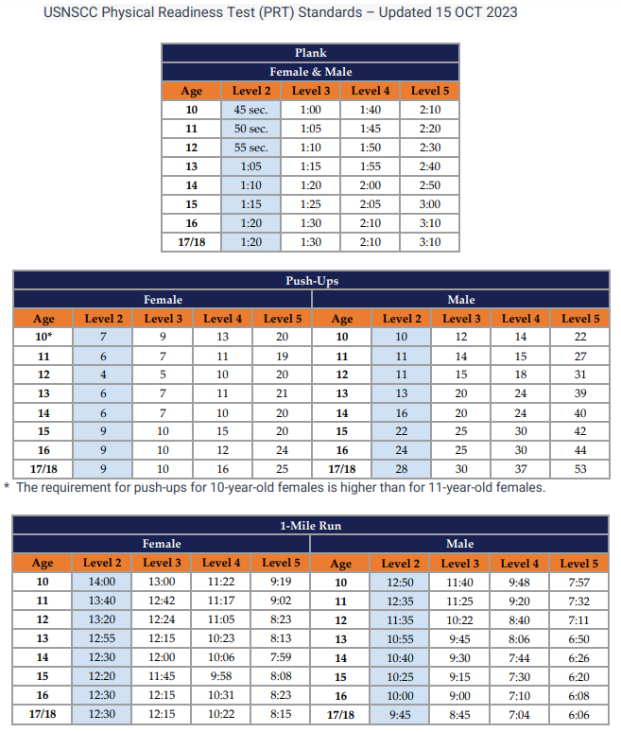

- Note: Push-ups are performed in 1 minute. See the NSCC/NLCC Physical Readiness Policy at https://barque-eagle-seacadets.org/nlo-basic We will not turn you away if you are with 2-3 or push-ups or within 30 seconds of passing the 1-mile run Day 1, but PT will be harder for you. Our program is designed so that if you really try to do each exercise correctly and show enthusiasm and NOT FAKE IT, you will be up to this standard for the Physical Readiness Test (PRT).

- You MUST pass the PRT to graduate. We will be conducting the standard NSCC/NLCC PRT.

EAT HEALTHY
- You will receive only 3 meals a day. There will be no in-between meal snacks. No soda, no geedunk (junk food), etc. Start eliminating these items from your diet now before your arrival at boot camp. You will find that you will feel better at training if you do.
- If you have dietary restrictions, let the COTC know when submitting your application package.
- Staying hydrated is of CRITICAL IMPORTANCE at boot camp. You will be required to carry a full canteen of water each time you go out of the barracks. You will drink the equivalent of at least 8 glasses of water each day. More in some cases depending on the weather.
- Start drinking water now prior to boot camp and increase the quantity gradually so that your body is prepared upon arrival. Again, you’ll feel better at training if you do and not lose valuable training time by constantly running to the head.
- If you are accustomed to drinking coffee/tea, energy drinks, etc. start eliminating those from your diet now. The only items available to drink at boot camp are water, milk, and fruit juice at meals. It is better to go through the “lack of caffeine headaches” at home rather than at boot camp where you could miss valuable training that you need to graduate.

ARRIVAL DAY & TIME
- All recruits will arrive on Sunday, June 22, 2025, between 1000 (10AM) and 1130 (11:30AM).
- Training Deposits and Base access forms are to be received no later than Wednesday, June 18, 2025, or until the quota is met whichever comes first. The Registration deadline in Magellan is Friday, June 20, 2025.
- Report in NWUs.

TIPS FOR A SUCCESSFUL CHECK-IN
- Get off to a good start.
- Address or respond to officers and staff cadets as appropriate: Sir/Ma’am (all adults & officers), Chief (Navy/Coast Guard or NSCC), Petty Officer (PO3-PO1), Seaman/Seaman Apprentice (E3/E2), or Able Cadet or Apprentice Cadet (LC3/LC2).
- Be attentive to instructions.
- Recruits will only speak if spoken to while waiting to check-in. If you have questions, you may raise your hand to ask.
- You will undergo a paperwork check; medical records check and a sea bag inspection. Have your orders, ID, 2nd key to your lock and any medications out when you get in line and ready to present when requested. If you take medications of any kind, a Medical History Supplemental form (NSCADM001 p. 7 & 8) must be uploaded with any prescription and over the counter medications you may be taking listed on it – the form must be signed by your medical provider for prescription medications. If you start a medication just prior to training, be sure to upload and bring the form with you, pre-filled in and signed by the medical provider. This also applies to inhalers that you may never use. If it is prescribed, bring it. It is better to be safe than sorry.
- Please tell your parents/escorts that they will not be able to walk with you through check-in but are required stay until you are fully checked in. We will have an area for them to wait where someone will tell them about the type of experience you will have. We will be able to ask them if there are any questions that arise during the check-in process.
- You will get to say good-bye at the end of check-in. Be sure to tell your parents the recruit division you are assigned to. Usually, your parents need this more that you do so if you find yourself on the way to your barracks without having said good-bye say something immediately.

MORE TIPS FOR A SUCCESSFUL TRAINING

ASSIGNMENT TO DIVISION
- You will be assigned to a recruit division: Alfa, Bravo, Charlie or Delta.
- Get along with your Recruit Division Commander (RDC)/Assistant Recruit Division Commander (ARDC) and Recruit Petty Officer in Charge (RPOC) – NEVER TALK BACK or refuse to participate.
- Try to obtain a position of leadership within your division, for example:
RPOC, Recruit Master-At-Arms (MAA), Guidon Bearer or Squad Leader.
- Volunteer and show company spirit.
- Be a team player (get along and work with others).
- Your RDC will have the most input on your evaluation.
BUNK/LOCKER ASSIGNMENT
- This are your personal responsibility to keep squared away.
- Make your bunk and arrange your locker as prescribed in your manual (issued at check-in). NOTE: It is important to make your bunk and keep your gear (that you don’t carry with you) in your locker (NO GEAR ADRIFT). Your division will lose points in division competition for the Honor Division if your gear is found adrift.

CLASSROOM INSTRUCTION
- Stay alert – if you feel drowsy, it’s okay to get up with your notebook and pen and
stand in the back of the room. Don’t make the instructor to tell you to stand up. This loses points.
- Take notes – particularly on subjects that the instructor indicates may be on the final
exam. Sometimes instructors will write stuff on the board. These would be good to note. Also, if the instructor hints that you may see something again, it is good to take note of that as well. Those items will likely be on the Final Exam.

FINAL EXAM
- Try your best – take good notes in each class. Listen during study sessions scheduled in division time.
- NO ONE has ever failed boot camp solely because they failed the final exam.
Failure of boot camp is usually based on inappropriate conduct/performance, as viewed by your RDC or failure to pass the Physical Readiness Test.
- NOTE: Relative to the exam, you can request that an officer read the exam aloud to you. Let us know of any learning disabilities. If you have any type of accommodation at school, we can usually accommodate you also.

FINAL EVALUATIONS
- You will receive grades on such things as adaptability, military bearing, appearance, leadership ability, etc. Be aware that your RDC will have the most say about these grades.

MANAGING TIME
- Be on time for EVERYTHING – you will not have a wristwatch or your cell phone so stay attentive to your RDC.
- Plan ahead – To the extent possible, prepare for the next training evolution in advance.
- Use any undedicated time you may have to help a shipmate; study; review notes; work on bunk/locker;
shine shoes, etc.

IN GENERAL
- Listen more than you speak.
- Always be respectful, even when it is difficult.
- Pay close attention to instructions and follow through.
- Maintain a neat appearance, i.e.: gig line straight, uniform buttoned up properly and wrinkle free, pant legs bloused properly, boots clean and free of dirt. If in dress uniform: gig line straight, shirt buttoned up properly, tucked in and wrinkle-free, belt worn properly, shoes shined, etc.
- No skylarking or fooling around at inappropriate times.

PLEASE SHARE ALL INFORMATION WITH YOUR PARENTS/GUARDIANS
Parents/Guardians:

In addition to all the above...

Check-In (See Above)

Check-in is at 1000 on Sunday, June 22, 2025, at Camp Nett, 38 Smith St., Niantic, CT. Please be sure that your recruit(s) has/have eaten breakfast prior to arriving.

Be prepared to stay until your recruit is fully checked in. All recruits (and families) will get a chance to say good-bye.

Contact Information
Telephone
Your Recruit will not be reachable by telephone, and they will not be allowed to call you. If there is a true emergency, you may contact the NLCC Orientation Commanding Officer, LCDR Stephen Smith by calling or texting 860-338-0066 or 203-715-4425. Recruits are not allowed to bring cell phones or any other electronic device. You will be sent home if you try to bring a cell phone or other electronic device.

Graduation
Graduation will be Saturday, June 28, 2025. Cadets may leave following graduation.

Please plan to arrive early enough to get a good place to view your recruit’s graduation. You are invited to bring cameras. You may bring chairs and possibly umbrellas. The graduation should last about an hour.

After graduation, your recruit is free to leave. Please be sure your recruit has all their belongings.
Staff Cadets may depart depending on the barracks inspection. Please plan for this when scheduling this training.

Mail
You are encouraged to write to your Recruit or Staff member. Since graduation will be on Saturday June 28, 2025, you should send mail to your Recruit no later than Wednesday. June 25, 2025. Other family members and friends are also encouraged to write. Address letters as follows:

(Recruit Name), (Division Name)
ATTN: U.S. Naval Sea Cadet Corps
C/O CTARNG, Camp Nett
38 Smith Street
Niantic, CT 06357

Mail is picked up each day and distributed to the recruits in the early evening.

Do not send food, drinks, or anything else that is not on the Recruit’s Sea bag list. It will be confiscated. It will not reach the Recruit.

1. During recruit training, incoming mail will be distributed daily (each weekday) and outgoing mail will be delivered to
the post office each day. Time is allotted for writing letters.

2. Your recruit will be encouraged to write home, but we do not force them. Their first letter will probably be written
Sunday night, mailed Monday, and received by you no earlier than Wednesday or Thursday. Do not panic if you do
not receive mail by Wednesday. It may come later. Also, you may want to ignore their first letter. Some cadets have a
hard time adjusting the first day or two and may write this to you. By the second letter, they should be fine. If you are
concerned, you may call the COTC. However, your home division’s commanding officer should be able to answer any
questions you may have.

For questions, please feel free to contact me after checking with your commanding officer first.

- Prior to the arrival date: 860-338-0066 (C) and leave a message or at co.012bea@seacadets.org.
- During training: 860-338-0066 (C) or at co.012bea@seacadets.org

Best address for GPS: 38 Smith Street, Niantic, CT

Directions to Camp Nett (Formerly Camp Niantic)
From Hartford, CT
- Take I-91 South to Exit 22S (Rt 9 South)
- Follow Rt 9 to I-95 North (Follow I-95 procedures below)
From I-95 North or South
- Take Exit 74
- Take a right at the end of the ramp onto Rt 161
- Follow the road straight through until the area turns residential
- Camp Nett sign points left
- Left onto Smith Street
- Bypass the first road and continue to Main Gate on the Left

