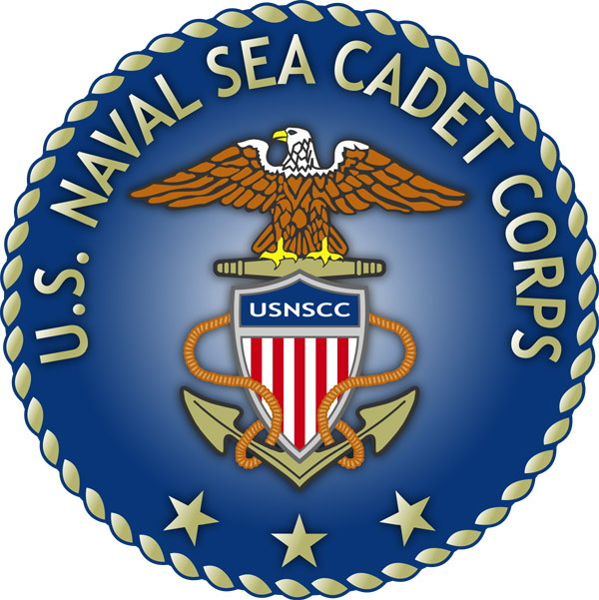
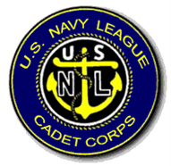
U.S. Naval Sea Cadet Corps
BARQUE EAGLE DIVISION
RIBBON AND AWARD REQUEST PROCEDURES
OBJECTIVE:
ESTABLISH AND IMPLEMENT PROCEDURES FOR CADETS TO REQUEST AND RECEIVE ALL DUE RIBBONS AND AWARDS IN A TIMELY FASHION
BELOW OUTLINES THE PROCEDURES FOR ALL HANDS REGARDING REQUESTS FOR RIBBONS AND AWARDS.

- CADETS WHO BELIEVE THEY HAVE COMPLETED THE REQUIREMENTS FOR RIBBONS OR AWARDS OUTLINED IN THE USNSCC AWARDS MANUAL WILL SUBMIT A REQUEST TO THE COC WITH THE FOLLOWING:
  - SECTION AND NAME OF AWARD
  - ALL NECESSARY DOCUMENTATION OUTLINED IN THE CORRESPONDING SECTION OF THE USNSCC AWARDS MANUAL
  - IF REQUESTED RIBBON OR AWARD IS THE RESULT OF A TRAINING, CADET WILL SUBMIT THE NAME AND DATES OF THE TRAINING THEY ATTENDED ALONG WITH PROPER DOCUMENTATION
- CADETS WILL NOTE THE DATE THEY SUBMITTED THEIR REQUEST TO THE COC IN THEIR WHEELBOOK
- COC WILL NOTIFY ADMIN (AWARDS OFFICER) OF REQUEST BY PLACING THE REQUEST AND REQUIRED DOCUMENTATION INTO PROPER INBOX LOCATED IN THE ADMIN OFFICE
- UPON RECEIPT OF REQUEST, ADMIN WILL RESEARCH THE REQUEST AND VERIFY THAT ALL PREREQUISITES HAVE BEEN MET
- APON VERIFICATION THAT REQUIREMENTS HAVE BEEN MET, ADMIN WILL PROCESS THE RIBBON OR AWARD FOR THE CADET’S SERVICE JACKET
- RIBBONS OR AWARDS WILL BE DISTRIBUTED AT THE CURRENT DRILL OR THE FIRST DRILL OF THE MONTH PROCEEDING THE REQUEST (IF TIME PERMITS

NOTES: RIBBONS OR AWARDS RESULTING FROM TRAINING EVOLUTIONS REQUIRE COTC TO SUBMIT REQUEST PRIOR TO CLOSING OUT THE TRAINING. PRIOR TO LEAVING TRAINING MAKE SURE YOU VERIFY THAT THE RIBBON/AWARD HAS BEEN SUBMITTED.

*Ribbons and Awards are not a guarantee and awarded at the CO’s discretion.

