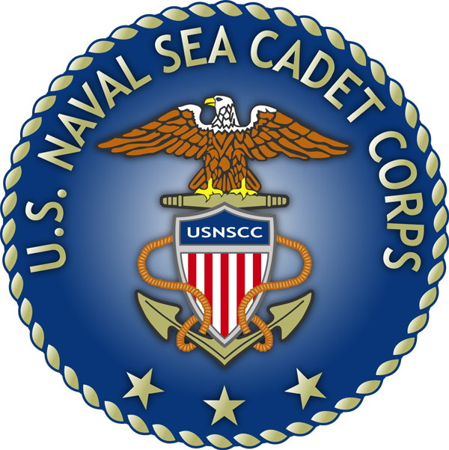
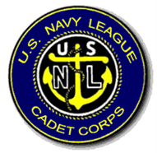
U.S. Naval Sea Cadet Corps
BARQUE EAGLE DIVISION
RIBBON AND AWARD REQUEST PROCEDURES
OBJECTIVE:
ESTABLISH AND IMPLEMENT PROCEDURES FOR CADETS TO REQUEST AND RECEIVE ALL DUE RIBBONS AND AWARDS IN A TIMELY FASHION
BELOW OUTLINES THE PROCEDURES FOR ALL HANDS REGARDING REQUESTS FOR RIBBONS AND AWARDS.

- CADETS WHO BELIEVE THEY HAVE COMPLETED THE REQUIREMENTS FOR RIBBONS OR AWARDS OUTLINED IN THE USNSCC AWARDS MANUAL WILL SUBMIT A REQUEST TO THE LPO/ALPO WITH THE FOLLOWING:
  - SECTION AND NAME OF AWARD
  - ALL NECESSARY DOCUMENTATION OUTLINED IN THE CORRESPONDING SECTION OF THE USNSCC AWARDS MANUAL
  - IF REQUESTED RIBBON OR AWARD IS THE RESULT OF A TRAINING, CADET WILL SUBMIT THE NAME AND DATES OF THE TRAINING THEY ATTENDED ALONG WITH PROPER DOCUMENTATION
- CADETS WILL NOTE THE DATE THEY SUBMITTED THEIR REQUEST TO THE LPO/ALPO IN THEIR WHEELBOOK
- LPO/ALPO WILL NOTIFY ADMIN (AWARDS OFFICER) OF REQUEST BY PLACING THE REQUEST AND REQUIRED DOCUMENTATION INTO PROPER INBOX LOCATED IN THE ADMIN OFFICE
- UPON RECEIPT OF REQUEST, ADMIN WILL RESEARCH THE REQUEST AND VERIFY THAT ALL PREREQUISITES HAVE BEEN MET
- APON VERIFICATION THAT REQUIREMENTS HAVE BEEN MET, ADMIN WILL PROCESS THE RIBBON OR AWARD FOR THE CADET’S SERVICE JACKET
- RIBBONS OR AWARDS WILL BE DISTRIBUTED AT THE CURRENT DRILL OR THE FIRST DRILL OF THE MONTH PROCEEDING THE REQUEST IF TIME PERMITS

NOTES: RIBBONS OR AWARDS RESULTING FROM TRAINING EVOLUTIONS REQUIRE COTC DOCUMENTATION ON THE ADMINISTRATIVE REMARKS ENTERED INTO THE CADET’S SERVICE JACKET BY COTC AT THE CLOSE OF THE TRAINING COMMAND
IF NO DOCUMENTATION WAS INCLUDED BY THE COTC, RIBBONS OR AWARDS WILL NOT BE AUTHORIZED.

*Ribbons and Awards are not a guarantee and awarded at the CO’s discretion.

