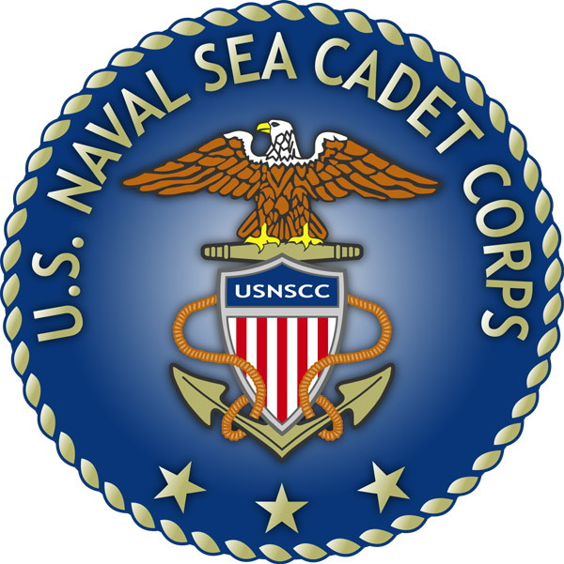
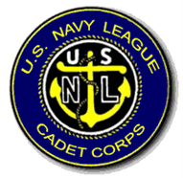
U.S. Naval Sea Cadet Corps
BARQUE EAGLE DIVISION
TRAINING REQUESTS
OBJECTIVE:
ESTABLISH AND IMPLEMENT PROCEDURE FOR SUBMISSION OF TRAINING REQUESTS FOR ALL HANDS
BELOW OUTLINES THE PROCEDURE FOR THE SUBMISSION OF AND APPROVAL/DENIAL PROCEDURES FOR TRAINING REQUESTS. ANY REQUESTS NOT ADHERING TO THIS PROCEDURE WILL BE DENIED.

STANDING ORDERS
- NO CADET IS AUTHORIZED TO DIRECTLY CONTACT A COTC FOR TRAINING WITHOUT APPROVAL FROM THE COC.
- CADETS ARE NOT AUTHORIZED TO COMMIT TOO OR PARTICIPATE IN A LOCALLY ARRANGED TRAINING NOT SANCTIONED BY BARQUE EAGLE DIVISION’S TRAINING OFFICER OR HIGHER AUTHORITY.
- CADETS WHO ARE CONTACTED BY CADETS OR OFFICERS OUTSIDE OF BARQUE EAGLE DIVISION WITH TRAINING OPPORTUNITIES WILL DIRECT THE INDIVIDUAL TO CONTACT THE TRAINING OFFICER OR HIGHER AUTHORITY.
HOMEPORT TRAININGS
- CADETS WILL SUBMIT TO THE COC VIA EMAIL OR A WORD DOCUMENT LISTING THE FOLLOWING:
  - CADET RANK
  - CADET AGE
  - DATE OF REQUEST
  - TRAINING NAME AND DATES
  - TRAINING LOCATION
  - COPY OF TRAINING DESCRIPTION AS LISTED on HOMEPORT
- THE TRAINING OFFICER OR HIGHER AUTHORITY WILL ACKNOWLEDGE RECEIPT OF THE REQUEST BY SENDING AN EMAIL CONFIRMING.
- TRAINING OFFICER OR HIGHER AUTHORITY WILL CONFIRM CADET HAS MET PREREQUISITES FOR TRAINING.
- CO, XO, TRAINING OFFICER, CPO, LPO AND OTHER NECESSARY PERSONNEL WILL DISCUSS TRAINING REQUEST WITH CADET AS NEEDED
- TRAINING OFFICER OR HIGHER AUTHORITY WILL NOTIFY THE CADET IF REQUEST HAS BEEN ACCEPTED FOR SUBMISSION OR DENIED.
- IF ACCEPTED: CADET WILL RECEIVE NOTIFICATION THAT THE REQUEST HAS BEEN SUBMITTED TO COTC AND CONFIRMED AND CADET WILL SUBMIT NECESSARY USNSCC TRAINING REQUEST FORMS AND DEPOSIT TO THE TRAINING OFFICER FOR SUBMISSION
- IF DENIED: CADET WILL BE NOTIFIED OF THE REASON FOR DENIAL AND WILL BE REQUIRED TO SELECT AN ALTERNATE TRAINING

LOCALLY ARRANGED TRAINING
- ALL AUTHORIZED LOCAL TRAININGS WILL BE COMMUNICATED TO CADETS BY THE TRAINING OFFICER
- WHEN TRAINING OPPORTUNITIES ARE OFFERED, INTERESTED CADETS WILL BE REQUIRED TO SUBMIT USNSCC TRAINING FORMS AND DEPOSITS (AS NEEDED) TO THE TRAINING OFFICER FOR PROCESSING
- LPO WILL NOTIFY CADETS WHO HAVE BEEN SELECTED TO PARTICIPATE IN LOCALLY ARRANGED TRAINING OF APPROVAL

NOTES:
Trainings are located on the Homeport website. http://homeport.seacadets.org/secure/home.aspx
Please check often for training updates. Summer trainings usually start to appear late FEB or MAR time frame and Winter trainings usually late SEP or OCT time frame.
All Barque Eagle Sea Cadets are required to attend at least one training per their anniversary year. You must attend an RT or an Advanced Training to stay in compliance with Barque Eagle regulations. Failure to do so is GROUNDS FOR ADMINISTRATIVE ACTION, UP TO AND INCLUDING DISENROLLMENT. ***League Cadets are not required to attend annual training although it is highly encouraged in fact actively promoted in our unit and hurts the unit at annual inspection if they do not.

