PHOTOJOURNALISM – New England- 2025
Welcome Aboard
Saturday 21JUN25 – Saturday 28JUN25

PRIOR TO ARRIVING

- Have a full sea bag (all items accounted for including notebook & pens) according to the Sea Bag list included in this document. Most items are mandatory for training. We do not have any spare to provide in case you forget something. Do not bring anything that is not on the list. There is a Wal-Mart about 15 minutes away.
- The Sea Bag List may be found as a separate link at the webpage https://barque-eagle-seacadets.org/photojournalism Please start collecting these items now. As noted on the list, be sure that all NSCC Flash(es) is attached as directed in the USNSCC/USNLCC Uniform Manual along with appropriate nametapes. All items should be marked with the recruit’s name. Photojournalism New England is not responsible for any items lost or stolen.
- Two (2) sets of NWUs are required for the training. We do NOT do laundry except in extreme circumstances. Be sure you have the required amount of underwear and socks. Also –Coyote Brown T-shirts for NWU Type IIIs and Long Sleave Black Button Down with black pants (Dress Uniform).
- Don’t forget to bring enough blousing bands.
- Hair: See USNSCC/USNLCC Regulations also located at Homeport.seacadets.org.
- No facial hair
- Have your ID card (must be current) – without this you will be sent home.
- Have your paperwork – You will not be checked in without it – This is an 8.5 x 11 envelope containing the following.
- Original and Signed Training Orders (Cadet)
- Original of the Base Access/Mode of Travel Form.
- Any Medical forms not uploaded to the Parent Portal
- Other forms required by your unit.

If your online record is not up to date and if your paperwork does not arrive with you, or we do not have it, you will have to wait until it arrives to check in. Check-in starts at 1000 (10AM) & ends at 1130 hours (11:30AM) on Saturday 21 JUNE 2025.

ALL MEDICAL FORMS MUST UP TO DATE ONLINE. Not having complete medical forms undated is the single most cause of delay at check-in.

Physical Fitness
- Start working out to get physically fit and stay physically fit:
There are two P.T. (physical training) sessions each day. This is strenuous exercise. If you anticipate a problem, let us know when you send in your Request for Training Authority. Start practicing NOW. Upon arrival you should be able to do at least the following exercises, at the satisfactory level:
PHOTOJOURNALISM STUDENTS should be able to pass a PRT. Likely you will not be scored on this training unless you request it.
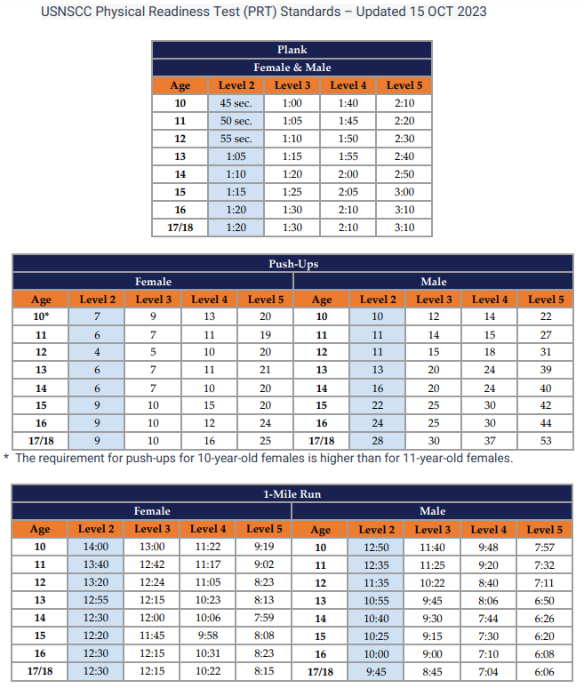

- Note: Push-ups are performed in 1 minute. See the NSCC/NLCC Physical Readiness Policy at https://barque-eagle-seacadets.org/photojournalism Our program is designed so that if you really try to do each exercise correctly and show enthusiasm and NOT FAKE IT, you will be up to this standard for the Physical Readiness Test (PRT).

EAT HEALTHY

- You will receive 3 meals a day. There will be no in-between meal snacks. Photojournalism students will have access to Gee Dunk but please keep this limited. Start eliminating these items from your diet now before your arrival at training. You will find that you will feel better at training if you do.
- If you have dietary restrictions, let the COTC know when submitting your application package.
- Staying hydrated is CRITICAL IMPORTANCE at training. You will be required to carry a canteen full of water each time you go out of the barracks. You will drink the equivalent of at least 8 glasses of water each day. More in some cases depending on the weather.
- Start drinking water now prior to training and increase the quantity gradually so that your body is prepared upon arrival. Again, you’ll feel better at training if you do and not lose valuable training time by constantly running to the head.

ARRIVAL DAY & TIME
- All students will arrive on Saturday June 21, 2025, between 1000 (10 a.m.) and 1130 (11:30 a.m.).
- Training Deposits and Base access forms are to be received no later than Monday, Wednesday June 18 2025, or until the quota is met whichever comes first. The Registration deadline in Magellan is Friday June 20, 2025.
- Report in NWUs.

TIPS FOR A SUCCESSFUL CHECK-IN
- Get off to a good start.
- Address or respond to officers and staff cadets as appropriate: Sir/Ma’am (all adults & officers), Chief (Navy/Coast Guard or NSCC), Petty Officer (PO3-PO1), Seaman/Seaman Apprentice (E3/E2), or Able Cadet or Apprentice Cadet (LC3/LC2).
- Be attentive to instructions. .
- You will undergo a paperwork check; medical records check and a sea bag inspection. Have your orders, ID, 2nd key to your lock and any medications out when you get in line and ready to present when requested. If you take medications of any kind, a Medical History Supplemental form (NSCADM001 p. 7 & 8) must be uploaded with any prescription and over the counter medications you may be taking listed on it – the form must be signed by your medical provider for prescription medications. If you start a medication just prior to training, be sure to upload and bring the form with you, pre-filled in and signed by the medical provider. This also applies to inhalers that you may never use. If it is prescribed, bring it. It is better to be safe than sorry.
- Please tell your parents/escorts that they will not be able to walk with you through check-in but are required stay until you are fully checked in. We will have an area for them to wait where someone will tell them about the type of experience you will have. We will be able to ask them if there are any questions that arise during the check-in process.

MORE TIPS FOR A SUCCESSFUL TRAINING

ASSIGNMENT TO DIVISION
- You will be assigned to the Photojournalism company.
- Volunteer and show company spirit.
- Be a team player (get along and work with others).
- Your DIVO will have the most input on your evaluation.
BUNK/LOCKER ASSIGNMENT
- This is your personal responsibility to keep squared away.
- Make your bunk and arrange your locker as prescribed in your manual (issued at check-in). NOTE: It is important to make your bunk and keep your gear (that you don’t carry with you) in your locker (NO GEAR ADRIFT).
- You will be assigned berthing with the NLO staff Cadets.

CLASSROOM INSTRUCTION
- Stay alert – if you feel drowsy, it’s okay to get up with your notebook and pen and
stand in the back of the room. Don’t make the instructor to tell you to stand up.
- Take notes – particularly on subjects that the instructor indicates may be on the final
exam.
- Sometimes instructors will write stuff on the board. This would be good to note. Also, if the instructor hints that you may see something again, it is good to take note of that as well. Those items will likely be on the Final Exam.

FINAL EXAM
- You will have a final exam.
- You should have no trouble passing the exam if you pay attention.

FINAL EVALUATIONS
- You will receive grades on such things as adaptability, military bearing, appearance, leadership ability, and of course the quality of your work.

MANAGING TIME
- Be on time for EVERYTHING
- Plan ahead – To the extent possible, prepare for the next training evolution in advance.
- Use any undedicated time you may have to help a shipmate; study; review notes; work on bunk/locker;
shine shoes, etc.

IN GENERAL
- Listen more than you speak.
- Always be respectful, even when it is difficult.
- Pay close attention to instructions and follow through.
- Maintain a neat appearance, i.e.: gig line straight, uniform buttoned up properly and wrinkle free, pant legs bloused properly, boots clean and free of dirt. If in dress uniform: gig line straight, shirt buttoned up properly, tucked in and wrinkle-free, belt worn properly, shoes shined, etc.
- No skylarking or fooling around at inappropriate times.

PLEASE SHARE ALL INFORMATION WITH YOUR PARENTS/GUARDIANS.

Parents/Guardians:

In addition to all the above...

Check-In (See Above)

Check-in is at 1000 on Saturday, June 21, 2025 at Camp Nett, 38 Smith St., Niantic, CT. Please be sure that your student has/have eaten breakfast prior to arriving.

Be prepared to stay until your student is fully checked in. All students (and families) will get a chance to say good-bye.

Contact Information
Telephone
Your student will not be reachable by telephone, and they will not be allowed to call you. If there is a true emergency, you may contact the training Commanding Officer, LCDR Stephen Smith by calling or texting 860-338-0066 or 203-715-4425. Students are not allowed to bring cell phones.

Graduation
Graduation will be held on Saturday June 28 at 1100, rain or shine. Please plan to arrive early enough to get a good place to view your student’s graduation. You are invited to bring cameras. You may bring chairs and possibly umbrellas. The graduation should last about an hour.

After graduation, Photojournalism students may have to stay just a bit longer to get their graduation pictures into their divo and turnover of the barracks to Camp Nett Staff. Please plan for this when scheduling this training.

Please be sure your student has all their belongings.

Mail
You are encouraged to write to your Recruit or Staff member. Since graduation will be on Saturday June 28, 2025 you should send mail to your Student no later than Wednesday June 18 2025. Other family members and friends are also encouraged to write. Address letters as follows:

(Student Name), (Division)
ATTN: U.S. Naval Sea Cadet Corps
C/O CTARNG, Camp Nett
38 Smith Street
Niantic, CT 06357

Mail is picked up each day and distributed to the recruits in the early evening.

Do not send food, drinks, or anything else that is not on the Photojournalism Sea bag list.

1. During photojournalism training, incoming mail will be distributed daily (each weekday) and outgoing mail will be delivered to the post office each day. Time is allotted for writing letters.

2. Your student will be encouraged to write home, but we do not force them. Their first letter will probably be written
Sunday night, mailed Monday, and received by you no earlier than Wednesday or Thursday. Do not panic if you do
not receive mail by Wednesday. It may come later. If you are concerned, you may call the COTC. However, your home division’s commanding officer should be able to answer any questions you may have.

For questions, please feel free to contact me after checking with your commanding officer first.
- Prior to the arrival date: 860-338-0066 (C) and leave a message or at co.012bea@seacadets.org.
- During training: 860-338-0066 (C) or at co.012bea@seacadets.org

Best address for GPS: 38 Smith Street, Niantic, CT

Directions to Camp Nett (Formerly Camp Niantic)
From Hartford, CT
- Take I-91 South to Exit 22S (Rt 9 South)
- Follow Rt 9 to I-95 North (Follow I-95 procedures below)
From I-95 North or South
- Take Exit 74
- Take a right at the end of the ramp onto Rt 161
- Follow the road straight through until the area turns residential
- Camp Nett sign points left
- Left onto Smith Street
- Bypass the first road and continue to Main Gate on the Left

