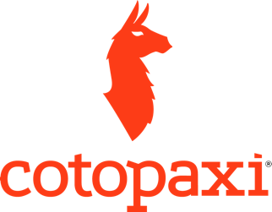

Cotopaxi is an outdoor gear and apparel company with a social-focused mission of eradicating extreme poverty. Every piece of gear is tied to a humanitarian cause in the world’s poorest countries.
Every pack provides between one and three weeks of education to a child. The sale of a water bottle provides six months of clean water. All apparel is tied to health-related projects.

Cotopaxi's #1 aim is to help the world's poorest of the poor and to provide transparency by showing the exact impact of donations.
The company was founded in 2014 and is headquartered in Salt Lake City, Utah.
The founder Davis Smith witnessed first-hand the glaring hardship that stems from unequal access to opportunity while growing up throughout Latin America. He has since dedicated himself to developing business models that use their influence to address the problems he first witnessed as a child.
Listen to How I Built This Interview

Cotopaxi Gives Back:

Cotopaxi integrates giving back into their company culture. They see their business as a vehicle to make an impact. Each year, Cotopaxi provides grants to nonprofits. This includes volunteering at local farms or helping install irrigation pumps in Myanmar. They have committed to help irradicate poverty.

Gear For Good®
Their promise is to make durable gear in the most ethically sustainable way possible and to use our influence to develop and uplift communities. In short, make products that last — and have a lasting impact.

Develop and Uplift
Cotopaxi concentrates their efforts to empower communities in the Americas, focusing on healthcare, education, and livelihood. 1% of revenues goes to the Cotopaxi Foundation, which distributes grants to humanitarian organizations, including the International Rescue Committee (IRC), Mercy Corps, and United to Beat Malaria. Double-blind studies and proven methodologies help us to ensure that our giving is effective.

Del Dia Colorway Story of Hip-packs and Backpacks

Totally Unique - Using repurposed fabrics means that every Del Día pack’s colors are one-of-a-kind. That’s why they are so colorful and different. Each pack is built from remnants so no two are alike!

