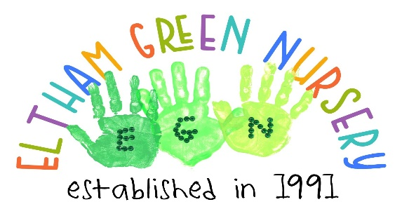
Teynham House
41 Alderwood Road
Eltham
SE9 2LR
020 8850 4720
elthamgreennursery@outlook.com
Equal Opportunities Policy
Policy Statement
It is our intention to make our setting accessible to children and families from all sections of the local community and beyond. We aim to ensure that all sections of our community have access to our setting regardless of their religious persuasion, racial origin, cultural and linguistic background, sexuality, social and economic backgrounds as well as gender or disability. Eltham Green Nursery is committed to anti-discriminatory practice to promote equality of opportunity and valuing diversity for all children and families.
Admissions
At Eltham Green Nursery we accept children for our application list as soon as parents/carers wish. It is never too early to add your child to our waiting list. The length of time a child’s name is on the application list does not give a child priority over later applicants.
We do not accept any discriminatory practice by staff or parents who openly display this through the use of offensive materials, name calling or threatening behaviour which are all unacceptable and will be dealt with in the strongest manner.
Employment
Applicants are welcome from all backgrounds and posts are open to all. The applicant who best meets the criteria is offered the post, subject to references and checks by the DBS (Disclosure and Barring Service) This ensures fairness in the selection process. All job descriptions include a commitment to promoting equality and recognising and respecting diversity as part of their specifications. We monitor our application process to ensure that it is fair and accessible.
Curriculum
The curriculum offered at Elham green Nursery encourages children to develop positive attitudes about themselves as well as to people who are different from themselves.
We encourage children to show empathy towards others which enables them to develop the skills of critical thinking. Activities and play resources offered at the nursery provide children the opportunities to develop in an environment free from prejudice and discrimination.
Environment
Our environment is accessible as possible for all children. Parents and visitors. We do this by:
- Making children feel valued and building their self esteem
- Ensuring that all children have equality of access to learning
- Creating adaptations to the environment to accommodate various disabilities
- Avoiding stereotypes or derogatory images in the selection of books or other visual materials
- We also celebrate a range of festivals
- Creating an environment of mutual respect and tolerance (British Values)
- Differentiate the curriculum to meet children’s special educational needs
- Encouraging children to understand that discriminatory behaviour and remarks are hurtful and unacceptable
- Enabling children with English as an additional language access to the full curriculum and ensure they are supported in the development of their home languages
Valuing diversity in families
We encourage all our parents and carers to take part in the life of our nursery.
For families who speak languages in addition to English, we will develop means to ensure their full inclusion.
We encourage children to contribute stories of their everyday life to our nursery.
Food
We work in partnership with parents to ensure that the medical, cultural and dietary needs of children are met.
We help children to learn about a range of food and experience different cultural dishes.
Language
Bilingual/multilingual children and adults are an asset. They will be valued, and their languages recognised and respected in our nursery. We will endeavour to promote different languages through our displays and labelling.
Legal Framework
We work in accordance with all legislation including:
Equality Act 2010
Disability Discrimination Act 1995 & 2005
Special Educational Needs and Disability Act 2001
Race Relations Act 2000
Sex Discrimination Act 1986
Children Act 1989, 2004
Childcare Act 2006

Updated June 2021.
Company number 2666215

