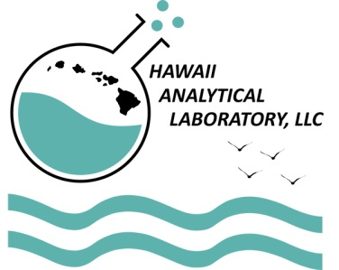

Hawaii Analytical Laboratory

3615 Harding Avenue

Suite 308

Honolulu, Hawaii 96816

Dear Valued Client,

We are constantly refining our processes and methods to provide you with the best service. The most important aspect of our business is our service and how we fulfill the needs of our clients. It would be very beneficial to us if you would take a moment to fill out the survey on the back of this page and return it to us.

As an incentive to help us serve you better, you will receive a 20% off discount on your next sample(s) submission; the discount is valid for 3 month thereafter if we receive your survey by December 31, 2017. Please indicate "survey discount" in the comment section of your coc. If you would like to remain anonymous, simply leave the client name blank and submit the survey back to us.

Your thoughts and remarks allow us to continuously improve and we look forward to hearing from you.

Mahalo!

Kind Regards,



Anne Antin

Environmental Specialist / Quality Manager

Hawaii Analytical Laboratory



Hawaii Analytical Laboratory’s

Client Service Survey

In order to better serve you, we are conducting this brief survey of your current experience with our services. We would appreciate you completing this form and mailing it back to us using the enclosed self-addressed stamped envelope.

CLIENT Name (optional): …………………………………….

On a scale of 1 to 5 (5 being the best)

1. How would you rate Hawaii Analytical Laboratory (HAL)'s sample Turn-Around-Time compliance?......
2. How would you rate HAL’s sample analyses fees?......
3. How would you rate HAL's analytical report?.....
4. How do you rate HAL's administrative and client contact support services?......
5. How would you rate your experience with our technical staff and analytical services?......
6. How do you rate our “Sample Pick-Up” service?......

On a scale of 1 to 5 (5 being the most important)

1. How important are HAL’s credentials to your work (NVLAP, EMLAP, IHLAP, ISO 17025, NLLAP)?......
2. If you use a U.S. Mainland laboratory, please select all reasons that may apply.

|  |  |
| --- | --- |
| * + Convenience   + Business Relationship   + Lab Performance/TAT   + Credentials | * + Pricing   + Report Format   + Other (please explain) |

1. What analyses would you like to see us add to our scope of work?......
2. Would you need accreditation for these? ......
3. Would you be interested in PCBs, pesticides, TPH screen analyses? …..
4. Would you be interested in our “Sample Pick-Up” service (if you are not part of it yet)?......
5. Would you like your COC and report merged (if you have not requested it yet)?.......
6. Would you be interested in receiving EDD (Electronic Data Deliverable)?......
7. Do you have any other suggestions that could help us improve our services?.......

Thank you so much for your business and your help in improving our services to you. Serving your analytical interests is our number one priority. If you have any additional feedback/comments please write them below. **Mahalo!**

Sincerely,



Anne Antin

Environmental Specialist / Quality Manager / Partner

Hawaii Analytical Laboratory