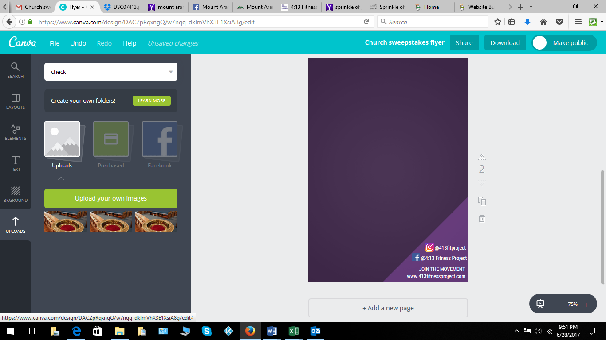

**“I Can Do All Things Through Christ Who Strengthens Me” Phil. 4:13**

**CHURCH COMMITMENT FORM**

**The 4:13 Fitness Project is committed to improving health statistics in minority and church communities by helping to create better habits and healthier lifestyles. This is not about weight loss, although a positive side effect, this is about healthier ways to live.**

**Will you join us in this commitment?**

**If so, we are asking your church leadership to take 3 simple steps in 2019:**

1. **Commit your church to living and speaking about living healthier lives; mentally, physically and spiritually**
2. **Commit that your church will have at least one bible study or one sermon on mental, physical and spiritual wellness**
3. **Commit that your church will increase healthy options at**

**church hospitality and social functions**

**Small steps make a huge difference. If you and your leadership team are committed, please let us know. Email us at info@413fitnessproject to let us know that you are committed.**

**We will shout you out on social and on the web. If your pastor or a church leader is open to being interviewed, we will contact you. If you are interested in getting more involved we are happy to help. Otherwise, we look forward to hearing the positive results of your changes!**