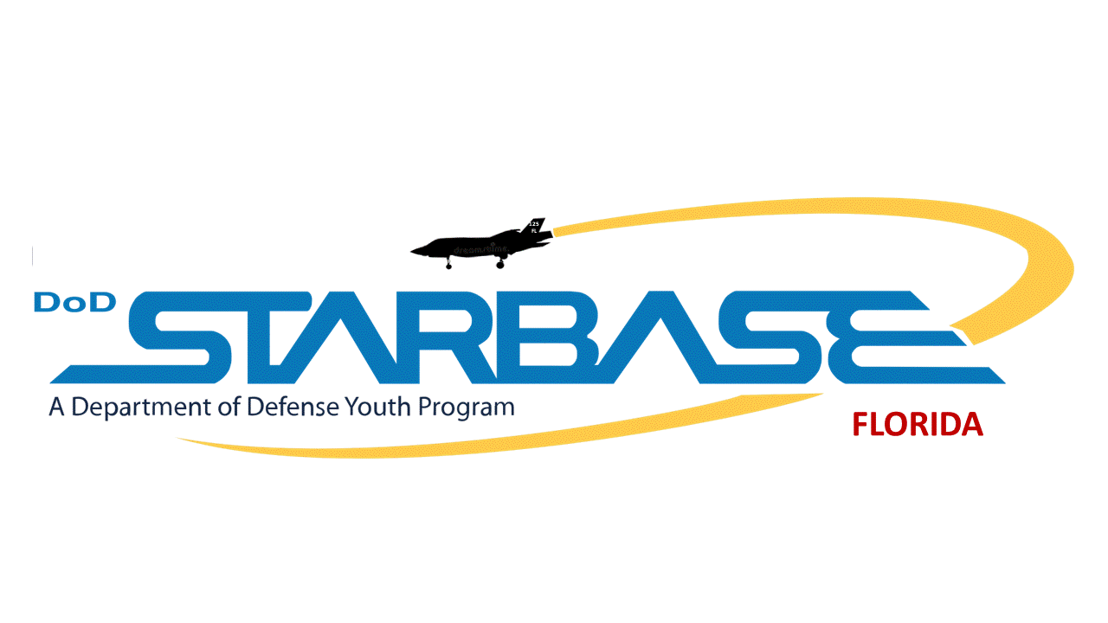

**STARBASE TECHNOLOGY POLICY EFFECTIVE DATE:** 01 August 2024 **COMPLIANCE:** This policy complies with the Air Force policies listed in Air Force Manual 1703 on technology use and cybersecurity.

**1.0 Use of Cell Phones - Student**

This part of the policy applies to the use of cell phones by students while on the Florida Air National Guard 125th Fighter Wing Base during visits.

* 1.1 Students are prohibited from using cell phones at all times.
* 1.2 Students shall keep their cell phones in a secure place, such as a closed backpack, or a storage device provided by their district, at all times when cell phone use is prohibited.
* 1.3 Exceptions:
  + 1.3.1 Student may use a cell phone for a purpose documented in the student’s individualized education program or a plan developed under section 504 of the "Rehabilitation Act of 1973," 29 U.S.C. 794.
  + 1.3.2 A student may use a cell phone to monitor or address health concerns.

**2.0 Use of Cell Phones – Adult civilian visitors (Teacher/Chaperones)**

This part of the policy applies to the use of cell phones by adult civilian visitors while on the Florida Air National Guard 125th Fighter Wing Base during visits.

* 2.1 Civilian visitors are asked to not use their cell phones during class instructional periods and to keep them in silent mode to avoid distracting students. If a visitor needs to access their device for essential purposes they should do so outside the classroom.
* 2.2 Civilian visitors may not access the base or facility WIFI network at any time.

**3.0 Personal computers, laptops, and other technology devices**

This part of the policy applies to the use of personal computers, laptops, and other devices (excluding cell phones) by civilian visitors while on the Florida Air National Guard 125th Fighter Wing Base during visits.

* 3.1 Civilian visitors may not bring or operate personal computers, laptops, and other devices

on the base

* 3.2 Civilian visitors may not access any Department of Defense computer system.
* 3.3 Civilian visitors may access non-Department of Defense computers linked to a non-military network while being supervised by a Department of Defense-approved instructor or military staff.
* 3.4 Civilian visitors may not access the base or facility WIFI network at any time.

*I affirm that I have read, understand, and will comply with this policy*

____________________________ ___________________________ ______________

Print name Signature Date