User Guide
GPS 500
RTK GNSS Receiver

  - February 2, 2020
  - Version 1.0

Monaghan Engineering
862 Las Colinas Drive
Dripping Springs, TX 78620 USA
Telephone: 1-512-858-4271
Facsimile: 1-512-858-1355
http://www.monaghan-engineering.com
Email: techsupport@monaghan-engineering.co
Document Revisions

Date | Version Number | Document Changes
2/2/2020 | 1.00 | Preliminary Draft

California Proposition 65
WARNING: This product contains a chemical known to the state of California to cause cancer.
All trademarks and registered trademarks are the property of their respective owners.
Subject to change without notice.

© Monaghan Engineering, Inc. 2020 All Rights Reserved

Table of Contents
1 Introduction 1
1.1 Front Panel 2
1.2 Rear Panel 2
2 I/O Connectors 4
2.1 Power Connector 4
2.2 Ethernet Connector 4
2.3 Serial Connector 5
2.4 eGPS Connector 5
2.5 Antenna Connector 6
3 Hardware Installation 7
4 Specifications 9

Introduction
The GPS 500 is a low-cost, high-performance GNSS receiver with Real Time Kinematics (RTK) technology for centimeter-level positioning accuracy. Its rugged construction, fast position solution update rate and robust feature set make the GPS 500 ideal for machine positioning and robotics. Multi-band and multi-constellation support enable GPS 500 to oﬀer fast RTK convergence times. An integrated MEMS inertial measurement unit (IMU) provides raw IMU data for user applications.

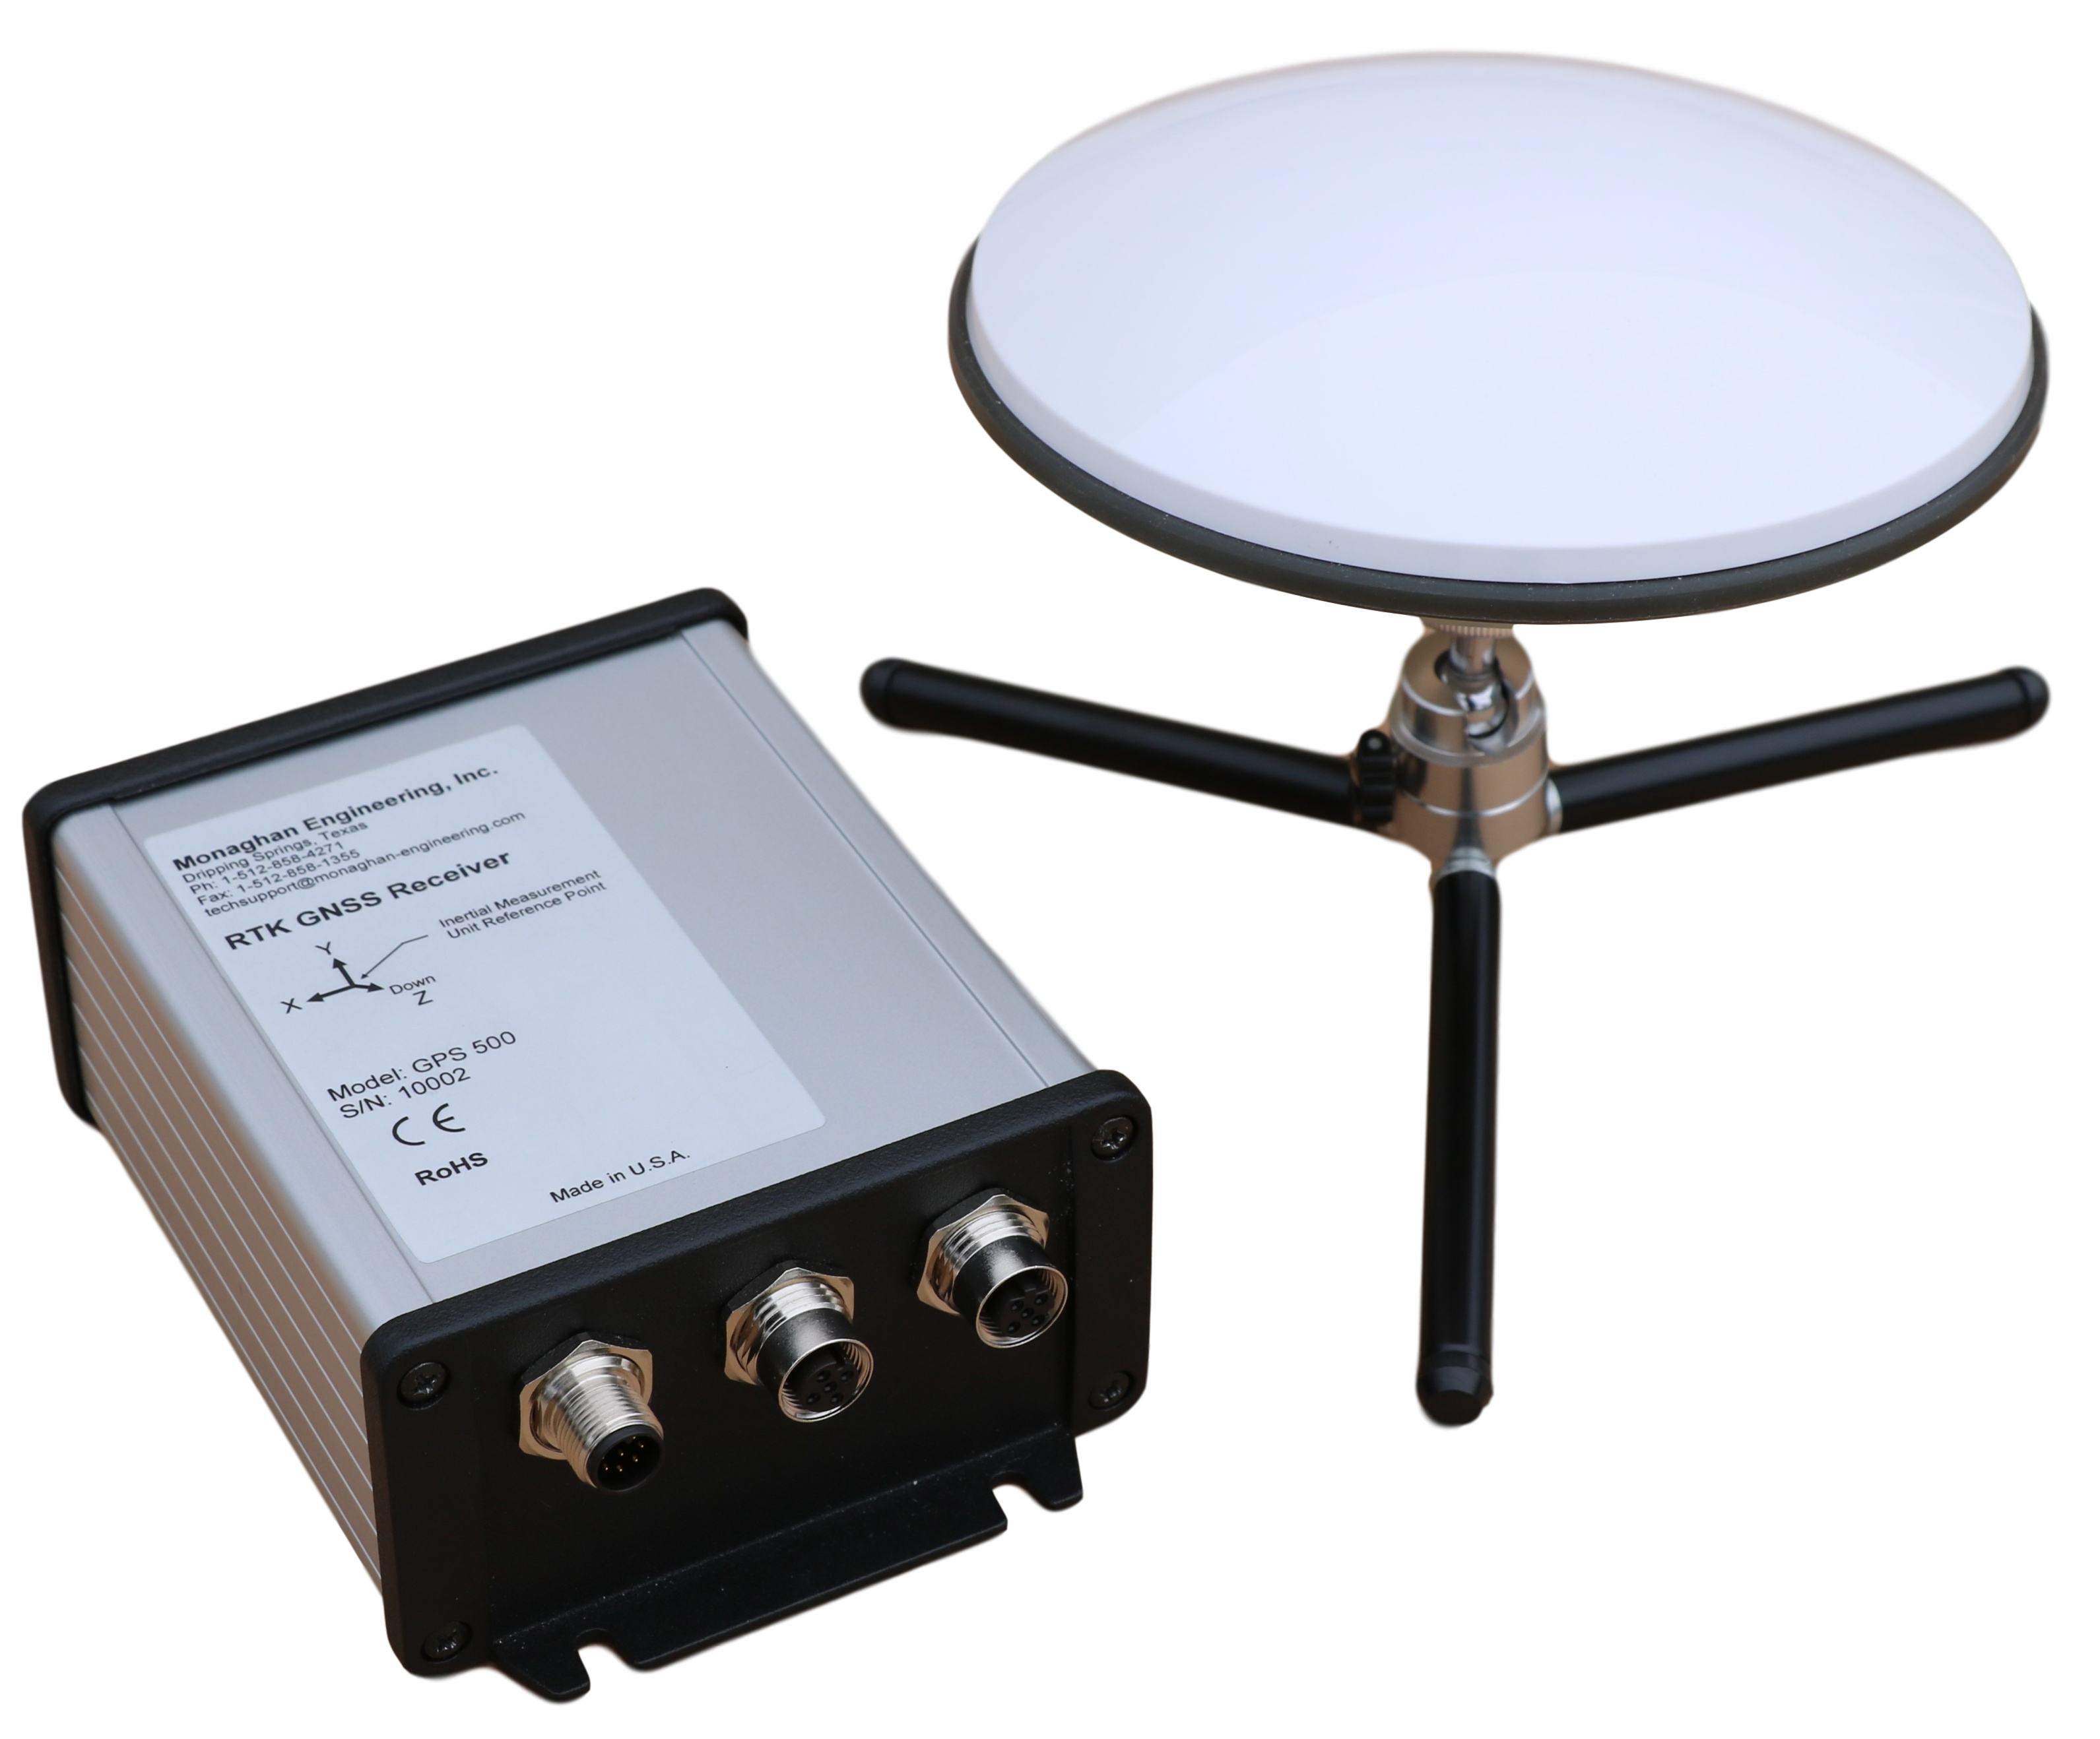

The GPS 500 provides a direct communucations interface to the PME GPS 0100 Network Time Server module to allow an M580 Controller access to precise time and position information. It provides 2 cm position accuracy and a 1 Pulse per Second output accurate to +/- 60 nS.
RTK communications are provided through a serial data link connection to a radio or through an Ethernet interface. The GPS 500 supports both Swift Binary Prorocol (SBP) and RTCMv3 messages as well as an NTRIP network client.
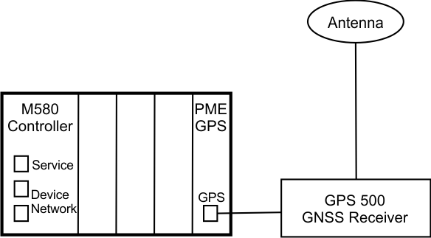

The GPS 500 may be mounted up to 1,000 Ft. from the PME GPS 0100 module. The antenna may be mounted up to 50 Ft. from the GPS 500 using RG-58 coaxial cable without the use of an amplifier.

Front Panel
The GPS 500 has three M12 connectors mounted on the front panel.
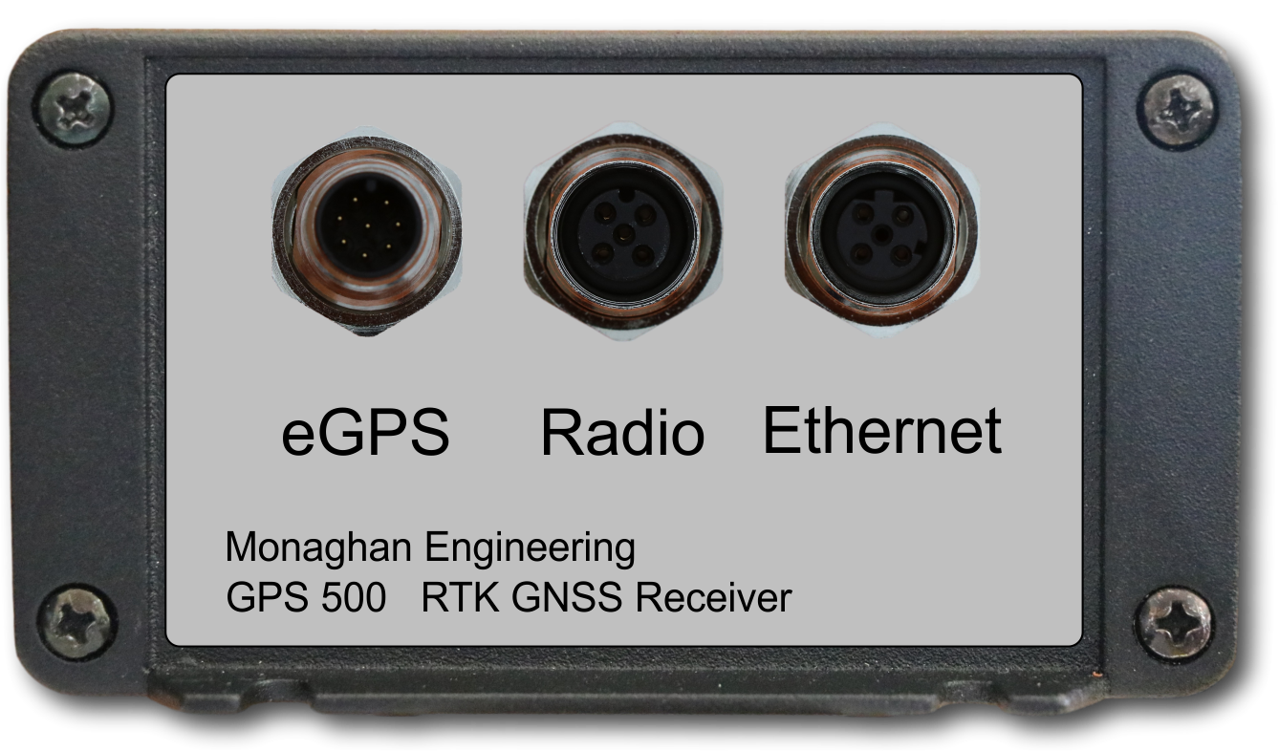
- eGPS – This connector connects the GPS 500 to a PME GPS 0100 Network Time Server module which resides in an M580 I/O rack. The signals are RS-422 voltage levels and the cable length should not exceed 1,000 ft.
- Radio – This connector connects the GPS 500 to a two-way radio for receiving RTK correction messages. The signals are RS-232 voltage levels and the cable length should not exceed 25 ft.
- Ethernet – This connector provides a 100 Mbit connection to the GPS 500. The cable length should not exceed 100 m.

Rear Panel
The GPS 500 has one M12 connector and one coaxial cable connector on the back panel. Four LEDs are included to indicate the current status of the module.
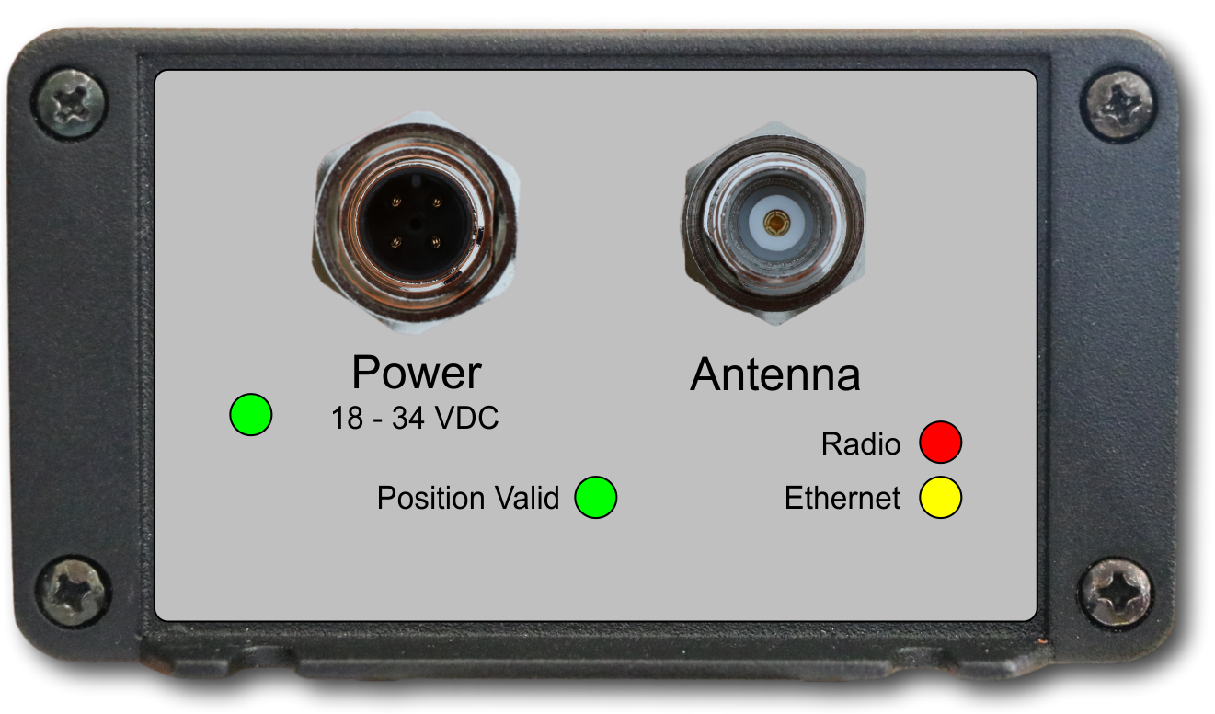
- Power – This connector provides power for the GPS 500. The input voltage must be in the range of 18 VDC to 34 VDC.
- Antenna – This is a TNC coaxial cable connection for the antenna. The attenuation of the cable at 1.5 GHz must be less than 10 dB. For RG-58U cable this is approximately 50 ft. Lower loss cables will allow longer cables to be used. If the cable loss is greater than 10 dB, an amplifier will need to be used.
- Power LED – This green LED will indicate when power is present.
- Position Valid LED – This green LED will indicate when the GPS 500 has calculated a valid position.
- Radio LED – This red LED will flash when serial data is received over the Radio connector.
- Ethernet LED – This yellow LED will turn on when an Ethernet connection has been made and it will flash as Ethernet data is received.

I/O Connectors
The GPS 500 uses industry standard sealed M12 connectors which are both rugged and easy to use. No external sealing is required to deploy the GPS 500, in even the harshest conditions. The GPS 500 has the following connectors:
- Power
- Ethernet
- Serial
- eGPS
- GNSS Antenna
WARNING: The connectors or their respective caps need to be used to meet IP65 standards.

Power Connector
The power connection provides power input to the GPS 500 from a DC source. It also provides a chassis ground pin.
- Connector – M12 – 3 Pin – Male – A Code
- Mating Connector – TE Connectivity T4110001031-000

Pin | Name | Description
1 | Vin | Voltage Input – 18VDC to 34 VDC
2 | GND | Power Ground
3 | CHASSIS | Internally connected enclosure

Ethernet Connector
The Ethernet connector is provided as the de-facto standard for industrial Ethernet with M12 circular connectors. There are many off-the-shelf cables available to mate with this connector. The table below shows the wiring for a T-568B RJ45 connection.
- Connector – M12 – 4 Pin – Female – D Code
- Mating Connector – TE Connectivity T4111501041-000

Pin | Name | Description | RJ45 Plug | Wire Color
1 | TX+ | Ethernet TX+ | 1 | Orange/White
2 | RX+ | Ethernet RX+ | 3 | Green/White
3 | TX- | Ethernet TX- | 2 | Orange
4 | RX- | Ethernet RX- | 6 | Green

Serial Connector
The serial connector is provided to allow communications through a two-way radio. The table below shows the wiring for a connection to a Schneider Electric Trio 900 radio.
- Connector – M12 – 5 Pin – Female – A Code
- Mating Connector – TE Connectivity T4111001051-000

Pin | Name | Description | 9 Pin Male D Connector
1 | TXD | Transmit Data | 3
2 | RXD | Receive Data | 2
3 | CTS | Clear to Send
4 | RTS | Request to send
5 | GND | Ground | 5

eGPS Connector
The eGPS connection is provided to allow communications with a PME GPS 0100 module. The table below shows the wiring for a T-568B RJ45 plug which is used to connect to the PME GPS 0100.
- Connector – M12 – 8 Pin – Male – A Code
- Mating Connector – TE Connectivity T4110002081-000

Pin | Name | Description | RJ45 Plug | Wire Color
1 | RX+ | RS422 Receive Data + | 1 | Orange/White
2 | RX- | RS422 Receive Data - | 2 | Orange
3 | TX+ | RS422 Transmit Data + | 3 | Green/White
4 | 1PPS+ | RS422 One Pulse Per Second + | 4 | Blue
5 | 1PPS- | RS422 One Pulse Per Second - | 5 | Blue/White
6 | TX- | RS422 Transmit Data - | 6 | Green
7 |  | +24 VDC | 7 | Brown/White
8 | GND | Ground | 8 | Brown

WARNING: Make sure that the cable connecting the PME GPS 0100 and the GPS 500 is wired correctly before the connection is made. Pin 7 of the M12 connector is not used on the GPS 500, but an incorrectly wired cable can cause damage by applying 24 VDC from the PME GPS 0100 to the line drivers in the GPS 500.

Antenna Connector
The antenna connection provides both a signal path for the GNSS signal and power for the antenna.
- Connector – TNC – Female

Hardware Installation
The GPS 300 is designed to be resistant to moisture, dust and vibration. With an extruded aluminum case, diecast aluminum end panels and rubber gaskets it offers environmental protection to IP65.

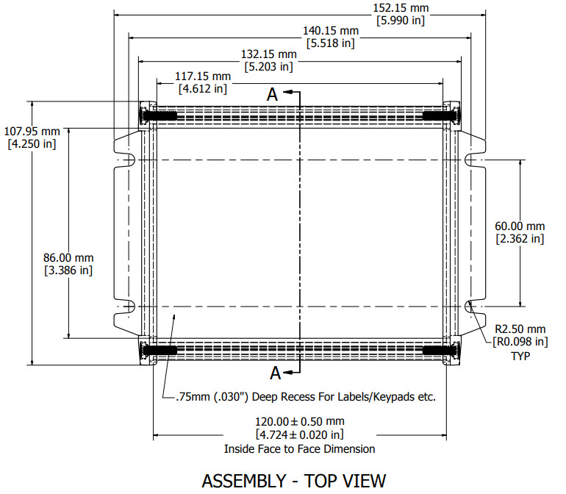

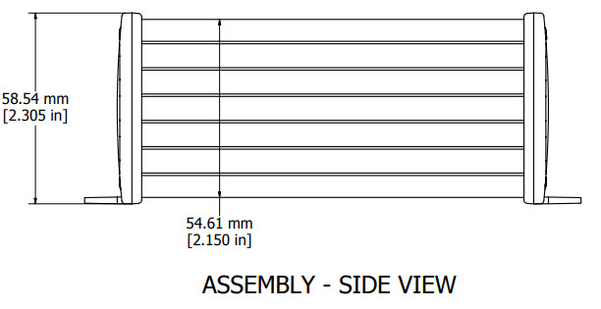
The GPS 500 may be mounted using four M5 or #10 screws. For GNSS operation, the module may be mounted in any orientation. When data from the IMU is used for applications programming, caution must be taken to position the receiver in the desired reference frame. It should also be noted that GNSS position calculations are based on the center point of the receiving antenna and IMU data is referenced to a point in the GPS 500 receiver. This reference point is shown on the mounting hole drawing. Correlating position measurements resulting from GNSS data and IMU data, require translation between the two reference frames.

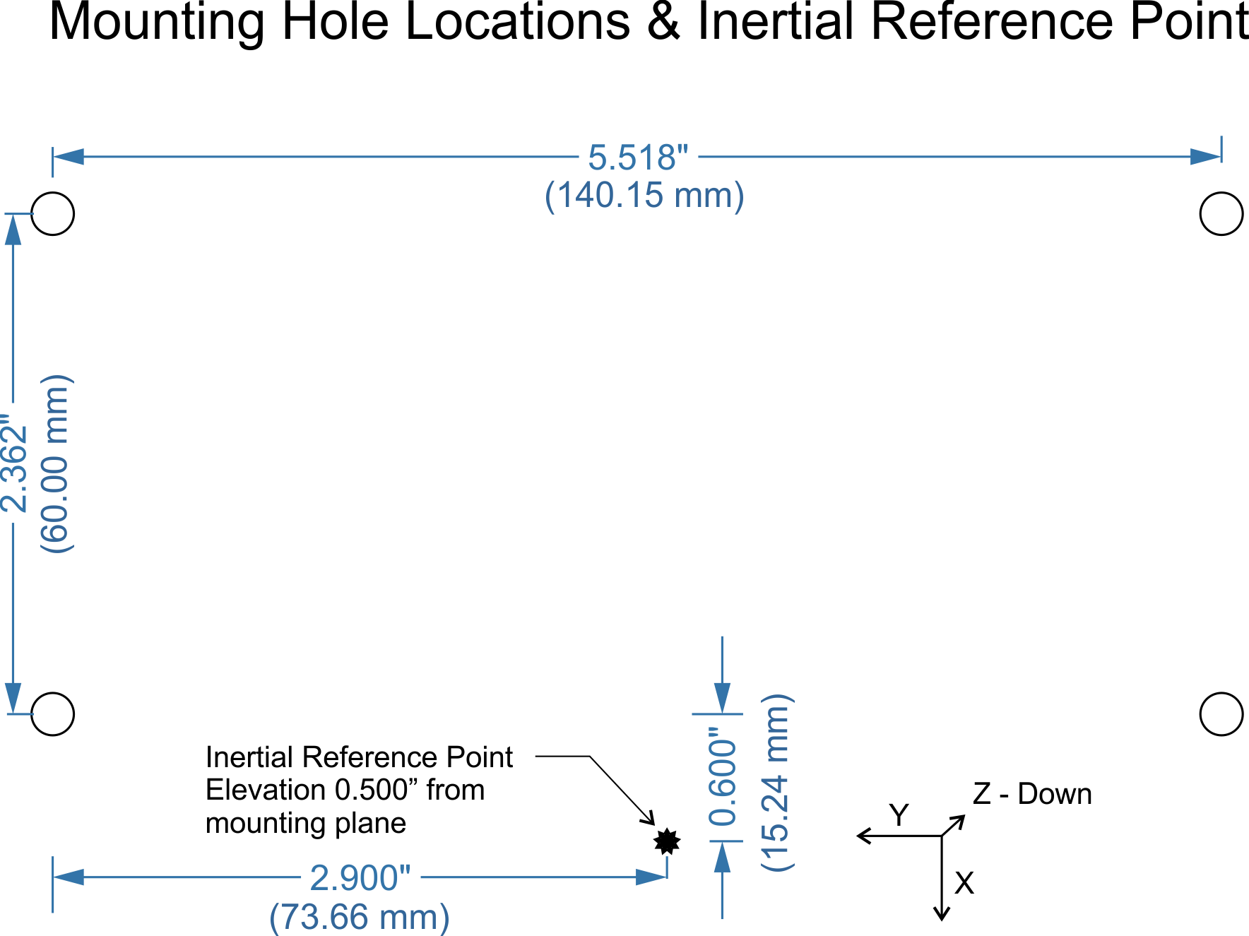

Specifications

Power Requirements
- 18 to 34 VDC
- 175 mA @ 24 VDC
Temperature
- -13°F to +149°F (-25°C to +65°C)
Dual Frequency RTK Bands
- GPS L1/L2
- GLONASS G1/G2
- BeiDou B1/B2
- Galileo E1/E5b
Antenna
- Dual Band
- Bias Voltage – 4.85 VDC
- Maximum Bias Current – 100 mA
- Impedance – 50 𝛀
Ethernet
- 100 Mbit
Serial
- 8 Data bits – No Parity
- Baud Rate – 1200, 2400, 4800, 9600, 19200, 38400, 57600, 115200, 230400
- Input Voltage - +/- 25 V
- Output Voltage - +/- 5 V
Protocols
- Swift Binary Protocol (SBP)
- RTCMv3
- NTRIP
IMU
- Acceleration Range (selectable) - +/-2 g, +/-4 g, +/-8 g, +/-16 g
- Gyroscopic Range (selectable) - +/-125, +/-250, +/-500, +/-1000, +/-2000 (°/s)
- Resolution – 16 bit
RTK Solutions
- 5 per second
Accuracy
- Horizontal Position (CEP 50 in SPP Mode) – 2.5 m
- Velocity – 0.03 m/s RMS
- Time – 60 nS RMS
- RTK Horizontal – 0.02 m + 1 ppm
- RTK Vertical – 0.025 + 1 ppm

