Fort Belknap Indian Community are Reintroducing Swift Fox After Being Gone for Over 50 Years
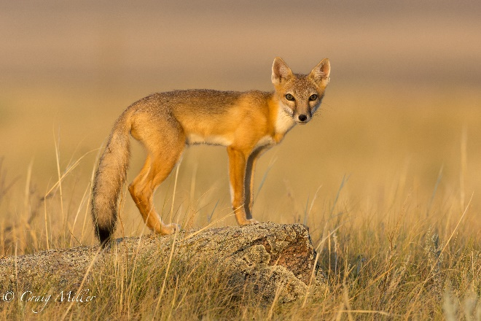
Photo credit: Craig Miller
Many of you over 50 might remember what a swift fox is, but younger folks may have never heard of this species and know that it was quite common around these areas not long ago. Swift foxes are short/mid-grass prairie specialists. These small carnivores are about the size of a house cat — smaller than their plains neighbors, the red foxes and coyotes.
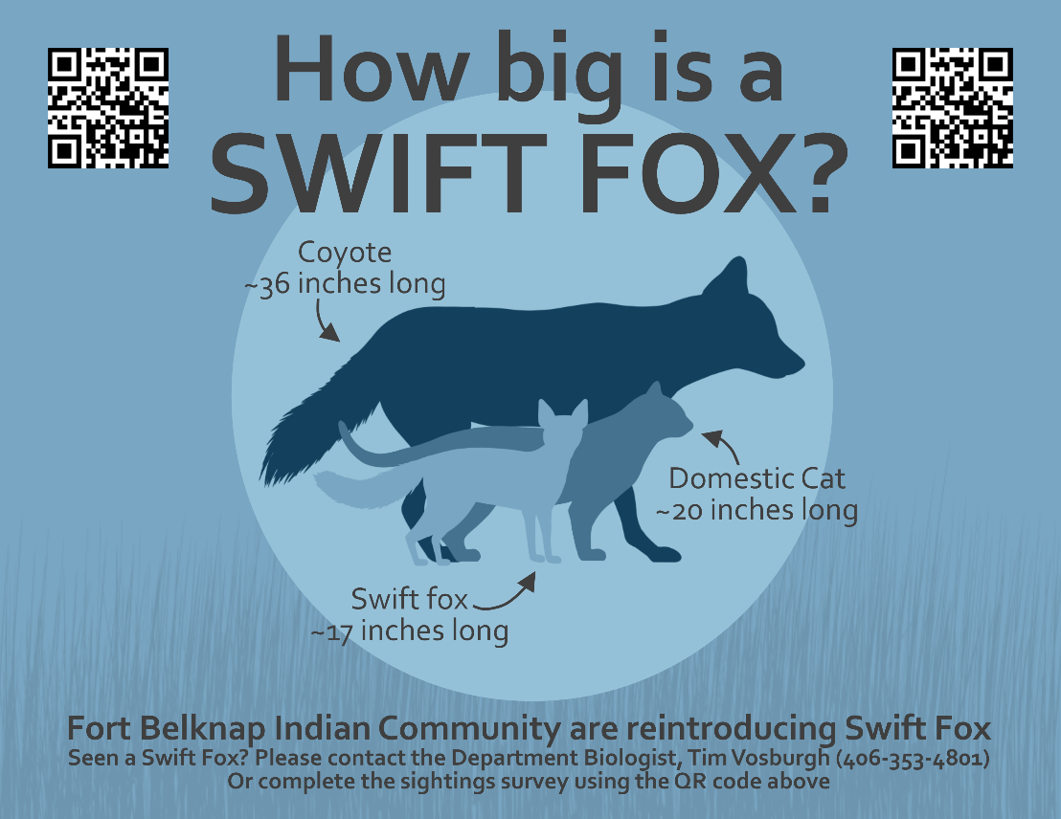

They mostly eat small mammals (like rodents and rabbits), as well as insects, birds, dead animals and occasionally plants. These foxes are mainly monogamous, with pairs forming in February, mating in March and rearing three to six kits from May through August. Historically, swift foxes lived in North America’s prairies. By the late 1800s and early 1900s, their populations had dropped to 5% of their historic range, mainly due to unintentional trappings and poisoning intended for coyotes and wolves.
Swift foxes were declared extinct in Montana in 1969 but could still be found in the southern U.S. Conservationists successfully reintroduced them to Blackfeet Nation in northwestern Montana in 1998, Fort Peck community reintroduced swift fox in 2009 in a two year effort, as well as to Canada from 1983 to 1991. The foxes also made it back to northern Montana in the early 2000s, but they live in a specific region north of the Milk River. 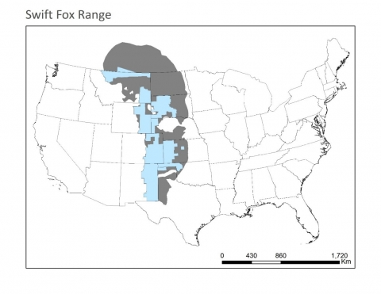
This map based on IUCN records shows the historic range of the swift fox (gray) compared to its current range (light blue).
We know that these foxes rarely cross the river, because agricultural practices in the region create unsuitable habitat. If any swift foxes do live south of the river, it is unlikely that there are enough of them to establish a reproducing population.
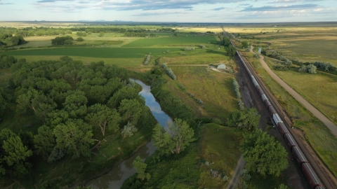
A train can be seen passing through agricultural areas along the Milk River.
The Fort Belknap Indian Reservation (Reservation) is situated just to the south of the Milk River, which provide critical habitat for some of Montana’s most treasured and rare species. The Tribes are committed to conserving native species and their habitats on the Fort Belknap Reservation (Reservation) and preserving and protecting the cultural values of the Fort Belknap Indian Community (FBIC). Wildlife on the Reservation is managed by the Fort Belknap Fish and Wildlife Department (Department). The Department has evaluated the habitat suitability and population viability assessment for potential swift fox (reintroduction. The Department partnered with scientists from Smithsonian Conservation Biology Institute and Defenders of Wildlife (and many others) to develop a swift fox reintroduction program to the Reservation. Harold Main (Jiggs), Director of Fort Belknap Fish and Wildlife, with the support of the Tribal Council, is planning to reintroduce swift foxes here through coordinated release efforts known as “translocations.” In other words, move swift foxes from one area to another. The reintroduction is planned to start this fall under an approved COVID-19 safety protocol. The project will span over five years where 40-50 foxes will be translocated from Wyoming, Colorado and Kansas to Fort Belknap in hopes to establish a viable population on the Reservation.
Before any reintroduction is carried out, there are several steps we have to take to determine if it is even possible. The Department and Smithsonian scientists followed the IUCN’s guidelines for this process. First, they looked at the entire landscape to make sure that there is enough food for the foxes to eat and enough places for them to live. Swift foxes choose to live in flat landscapes with short-grasses and soils that can be easily dug for burrows, which they use for shelter.
Next, they sought expert advice on how many foxes we would need to release each year in order to ensure a healthy population. They also read a lot of studies and papers on prior fox reintroductions to learn what worked (or didn’t work) for others.
Finally, they presented the results of these research efforts to a group of swift fox experts, including wildlife biologists and researchers, as well as representatives from American Indian tribes, Bureau of Indian Affairs, state and federal agencies and local NGOs. Following a discussion of the research results, they worked with this group to set the reintroduction plan, goals and budget.
2020 will be the first year of this effort. The Department and partners will trap 40 individuals from the state of Wyoming and release on tribal lands. The Department seeks the communities help to monitor these individuals and help this project become a success like with the black-footed ferret reintroduction that are now established on Snake Butte. If you see a swift fox please contact the Department Biologist Tim Vosburgh (Phone number (406)-353-4801, email: vosburghtim@gmail.com). Starting the last two weeks of September we would appreciate if you can let us know if you see a fix, or if you know of a den location.
How to tell the difference between a swift fox, red fox, and cayote
Swift foxes are smaller than a house cat. The winter fur is dark buffy-gray above, and orange-tan on the sides, legs, and lower surface of the tail. The chest and belly are buff to white and the tail is tipped with black. In summer the coat is shorter, harsher, and more reddish. The swift fox are one-fifth the size of a coyote and are also smaller than the red fox. A good indication of a swift fox is the black-tipped tail which is different than a red fox with a white-tipped tail.
