Agency: Fort Belknap Dated: _________________________________
Reservation: Fort Belknap Indian Community
Permission is hereby granted to:
_______________________________________ _______________________________________
_______________________________________ _______________________________________
(Name) (Address)
To drive livestock across the above reservation entering the reservation on ___/___/________, and exiting no later than ___/___/________, and using the following route: ___________________________
______________________________________________________________________________________________________________________________________________________________________________________________________________________________________________________________________________________________________________________________________________________________________________________________________________________________________________________________________________________________________________________________
This permit is subject to all applicable state and federal laws and regulations dealing with quarantine and the movement of livestock and to such special instructions as may be issued by the Land Department Director or his/her duly authorized representative. No authority is granted to cross trust Indian lands unless specifically set out in this permit. In consideration of the permission granted herein, the permittee shall pay in advance the sum of $_____________
Issued by the above Department this ______ day of ________, __________

Approved: Accepted:
_________________________________________ _______________________________________
(Director/Authorized Rep) (Permittee)

This information is collected to manage agriculture and grazing leases. The information is supplied by a respondent to obtain or retain a benefit, that is, a lease. It is estimated that responding to the request will take an average of 20 mins to complete. This includes the amount of time it takes to understand directions, gather the information and fill out the form. If you wish to make comments on the form, please send them to the Tribal Land Department (address above). Note: comments, names and addresses of commenters are available for public review during regular business hours. If you wish us to withhold this information, you must state this prominently at the beginning of your comment. We will honor your request to the extent allowable by law.
Name: ________________________________  No. of head per brand____________________  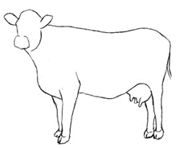  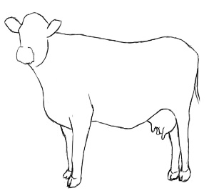 | Name: ________________________________  No. of head per brand____________________

Name: ________________________________  No. of head per brand____________________ | Name: ________________________________  No. of head per brand____________________

For Bulls: A Copy of the Trichomoniasis test signed by a veterinarian is required for each bull before the bull(s) are allowed to enter the reservation, FBIC Ordinance No. 1-90, section 103, sub-section

Date of copy received: __________________________ Copy must be attached.

Compliance of Fence Line Date of compliance check: _________________

Conditions: ___________________________________________________________________________
__________________________________________________________________________________________________________________________________________________________________________

Approval for use: ___________________________ ________________________________
(Name) (Title)

