**Laminitis and Founder**

Laminitis is common problem here is Arizona. Dr Hulse typically sees 90% of her cases during the monsoon season (July-September) which we also call “laminitis season” in Arizona. Simply stated it is inflammation of the laminae structure within the hoof, most commonly in the front feet. The back feet are rarely involved. The laminae are interlocking connective tissue which attaches the coffin bone inside the hoof to the hoof wall. When these structures are inflamed, it causes a lot of pain in the front feet because there is little room inside the hoof for swelling. This increased swelling and inflammation causes a lot of pressure and pain inside the foot.

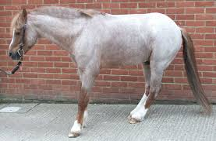 Signs: Typical signs of laminitis include:

* Difficulty walking- usually front feet
* Reluctance to walk
* Horses may walk like they are walking on eggshells.
* Pivoting on hind legs, rocking back on hind legs when standing or turning around
* Tenderness walking on hard ground
* Shifting weight frequently on front feet

Diagnosis:

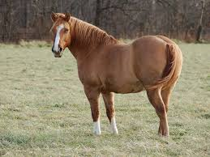Laminitis is diagnosed by a veterinarian by performing an exam. Laminitis may be diagnosed if the horse shows any of the lameness signs listed above, positive response to hoof testers applied at the toes (acute laminitis), increased digital pulses to the feet (acute cases), and performing radiographs of the front feet. In cases of founder or chronic laminitis, the horse may be negative to hoof testers, have normal digital pulses, and may have changes in the hoof conformation such as rings on the hoof wall and dished feet or a dropped sole. Also, during the initial exam, your veterinarian may take blood samples to test the insulin/glucose levels, ACTH or TRH Stim Test to test for Cushing’s disease.

**Causes:**

Laminitis has many different causes and can be multiple factors. The most common that we diagnose is Hyperinsulinemia/ Equine Metabolic Syndrome. 90% of laminitis cases are caused by hyperinsulinema. Laminitic horses are often overweight or were previously overweight. They may have 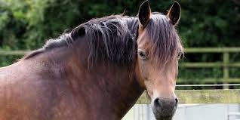cresty necks or excessive fat pockets and are commonly being fed high carbohydrate diets like pasture, grain, and 100% alfalfa. This causes hyperinsulinemia in horses which is similar to Type-2 diabetes in humans who are overweight. Our "laminitis season" here in Arizona correlates to the Monsoon season which is late June through the end of September. The theory behind this is correlated with the high heat and humidity triggering horses already predisposed to this disease (high carbohydrate diets, overweight, insulin resistance, etc). Other causes include: severe systemic illness causing secondary endotoxemia (pleuritis, pneumonia, enteritis, Salmonella, retained placenta), excessive weight-bearing on one leg (severe injury to opposite leg), grain overload, high & prolonged doses of corticosteroids, and Cushing's disease.

**Laminitis vs Founder**

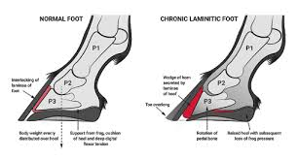The names laminitis and founder are commonly used interchangeably by horse owners. However, they are not the same thing. Laminitis is the condition which always precedes founder. Laminitis is acute and causes inflammation in the foot. Founder is a permanent condition which occurs if laminitis is chronic and causes the coffin bone in the foot to rotate down or drop towards the sole (sinker). Founder is caused by the laminae inside the hoof detaching or stretching resulting in the displacement of the coffin bone. Due to the coffin bone rotating or sinking, this can also affect the circulation to the feet due to the blood vessels being crushed or torn. This can also permanently affect the growth and healing of the foot. Chronic founder can also change the appearance of the hoof. The sole may be dropped, the hoof wall may become dished, founder rings can form on the hoof walls and the laminae may be visibly stretched. Also, chronically foundered horses are more prone to hoof abscesses and White Line Disease due to altered blood supply to the feet. Not all horses that have laminitis will founder. If we can stop the inflammation and treat the underlying cause, we can often prevent the horse from foundering (permanent damage to the foot).

**Treatment:**

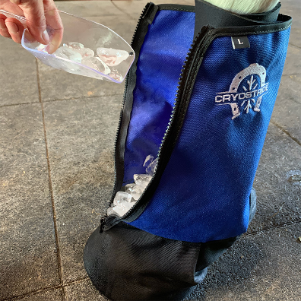Determine the cause: If we suspect hyperinsulinemia or Cushing's disease, we may take blood samples to determine if these are the causes. If the animal is systemically ill, we will treat the cause of the illness. If the animal is on corticosteroids or grain, these will be immediately discontinued. Change in feeding program: We always will change the feeding program to a low-carbohydrate diet. If the horse is on pasture, we will usually take them off while the horse is actively laminitic, especially during the summer. If they are being fed alfalfa, we switch them to a grass hay diet or bermuda-blend pellets. If they are on any type of grain, this is immediately discontinued. Low-carbohydrate feeds like Wellsolve, Safe Choice Special Care, etc may be used in combination with grass hay.

Icing the feet in ice boots at least 20-30 min 2-3x per day can be helpful to reduce inflammation and pain.

Hoof protection/ shock absorption: We will usually place EDSS styrofoam pads on the front feet initially to protect the soles, cushion the foot to reduce the pressure on the soles, and reduce concussion to the sole. If the horse continues to be lame for greater than 10 days, we usually will recommend either therapeutic shoes- natural balance or similar type shoe (possibly frog support pads too), Freedom shoes, Soft Ride Boots, clogs, or Easy Boot Clouds for more chronic cases. Increased bedding in the stall may also be recommended. If the laminitis is not responding to Styrofoam pads or support boots, therapeutic shoes and pads or clogs with casting may be recommended to support the coffin bone.

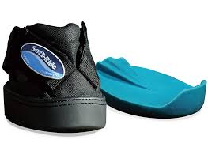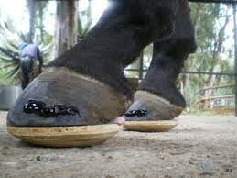

**Medications**: We usually will start the horse on a course Banamine (flunixin meglumine) or phenylbutazone (Bute) for at least 10-14 days. Both are anti-inflammatory medications which help reduce swelling, inflammation and pain in the foot. If the laminitis is acute, we may also treat the horse with DMSO (dimethyl sulfoxide) either by IV or through a nasogastric tube. DMSO is a free radical scavenger which helps prevent further damage and also has some anti-inflammatory properties.

Other medications which may be prescribed for your horse:

* 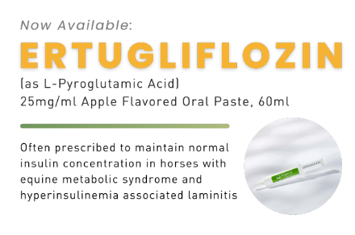Ertugliflozin- new compounded medication used for acute cases in horses with high insulin levels. It has been very successful in reducing insulin levels and helping controlling the cause of laminitis.
* Pentoxifylline, isosxuprine or acepromazine: These medications may help improve blood-flow to the feet.
* Supplements like InsulinWise, Platinum Metabolic Support or Smart IR
* Thyro-L (thyroxine): helps horses that are overweight lose weight faster and improves insulin sensitivity in insulin-resistant horses
* 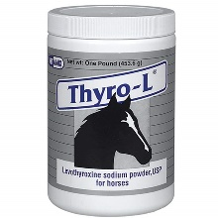Acetaminophen in conjunction with bute or Banamine for pain relief
* Gabapentin for nerve pain control
* Tramadol for short term pain control (controlled medication)
* Pergolide- may be started if Cushing’s disease is suspected as underlying cause
* Ice Boots- may be used for acute cases to reduce swelling and inflammation in the front feet
* Laminae Saver Supplement has been helpful for some horses- can order online.

Prognosis: Prognosis is excellent if the horse does not founder and responds favorably to treatment. If the horse does not improve with the treatments listed above, the prognosis is more guarded. If the horse's coffin bones rotate, there is some permanent damage to the hooves and will cause chronic lameness. We can determine the extent of damage with radiographs. If the horse rotates < 5 degrees, the prognosis for soundness is still fair to good for riding and a good quality of life. If the horse rotates 5-10 degrees, the prognosis for a comfortable quality of life is fair and riding is guarded. If the horse's coffin bone rotates more than 10 degrees the prognosis for a riding horse is poor and quality of life is guarded. If a horse is chronically foundered, they may have rings on their feet and may have a dished hoof appearance. Chronic founder is more difficult and costly to maintain. This horse’s lameness will fluxuate like a rollercoaster...some days and weeks better, some days and weeks worse. In Dr Hulse’s experience, if a horse has rotated more than 10 degrees or is a sinker- prognosis is poor and these horse’s will eventually be euthanized due to poor quality of life from 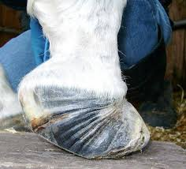founder.

Founder is not fatal but may cause the horse's quality of life to be poor and they may end up lying down a lot, losing weight, and not being happy. Many times the horse will continue eating but their body condition may deteriorate or lose weight If the horse is in chronic pain and suffering, it may force the owner to make the difficult decision to have the horse euthanized.

Prevention:

* Maintain normal/ good body weight. Don’t allow horse to become overweight
* Limit intake of “rich/high carbohydrate” feeds- especially during Arizona’s Monsoon season (rich pasture, straight alfalfa, or grain)- typically I recommend grass hay during June-September if your horse is an easy keeper.
* If your horse is diagnosed with Cushing’s disease or Insulin Resistance, keep horse on controlled diet and veterinarian prescribed medications
* Regular hoof care/trimming
* Keep grains/high concentrate feeds locked up

If you suspect your horse of having laminitis, call your veterinarian right away to diagnose the cause and start treatment. Our goal is to treat the laminitis and prevent founder before it starts.