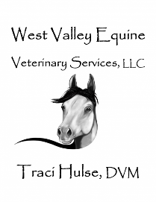**Equine Cushings Disease**

(Equine Pituitary Pars Intermedia Dysfunction)

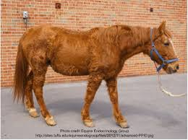Equine Cushing’s disease is one of the most common diseases of horses greater than 15 years of age affecting up to 30% of senior horses. The clinical signs are associated with abnormally elevated hormone concentrations in the blood including cortisol which plays an important role in this disease. This syndrome is also referred to as Equine Pituitary Pars Intermedia Dysfunction (PPID) because it reflects the location within the brain that is abnormal. The pituitary gland is located at the base of the brain. In horses with PPID, the middle lobe of the pituitary gland (pars intermedia) becomes enlarged with age and results in over production of hormones. The growth of the middle lobe of the pituitary gland can compress the adjacent structures in the pituitary and hypothalamus resulting in loss of their function. The enlargement of the pituitary gland is often referred to as a pituitary adenoma.

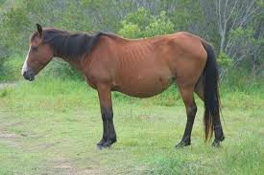Clinical Signs:

Clinical signs of PPID can vary depending upon the stage of disease. The average age of horses diagnosed with PPID is 20 years, with over 85 percent of the horses being greater than 15 years of age. Although most common in aged horses, PPID has been diagnosed in horses as young as10 years of age. All breeds of horses can develop PPID. The most classic symptom which owners associate with Cushing’s Disease is long hair coat that does not shed properly. This condition is referred to as hirsutism. Other symptoms that have been associated with PPID include slow to shed or patchy hair loss, excessive drinking and urination (polyuria/polydipsia), laminitis, lethargy, excessive sweating, muscle mass loss, repeated infections such as sole abscesses, tooth root infections, and sinusitis; anhidrosis (stop sweating), infertility and bulging eyes that are a result of redistribution of supraorbital fat. Horses with PPID may also be insulin resistant. Insulin resistance can contribute to muscle loss, abnormal fat accumulation, and laminitis.

Diagnosis:

The most common clinic sign of Cushing’s is hirsutism (long haircoat or slow to shed out) in the aged horse. Horses that have subtle signs of PPID need to be tested to confirm the disease. Of the tests available, no single test is 100 percent accurate. The most commonly used tests in the field is the measurement of resting plasma ACTH concentration or the TRH Stimulation Test. A single blood measurement of ACTH concentration is commonly used to test for PPID. If this test comes back inconclusive or your horse has subtle symptoms, the TRH Stim Test (Thyrotropin Releasing Hormone) is a more definitive test. Insulin resistance can occur in horses with PPID, but it also occurs in horses with equine metabolic syndrome and obese horses. We commonly will test both insulin and glucose levels at the same time as testing the ACTH levels. Not all horses with PPID are insulin resistant. Testing for both diseases is recommended if your horse or pony has laminitis. Horses will have natural elevations of ACTH levels in the late summer and fall (Mid July- Mid November). This will be taken in consideration when evaluating the ACTH test. Also, the TRH Stim Test is not recommended during July-November.

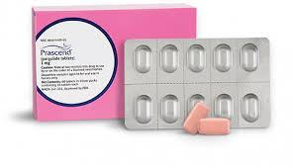Therapy:

Treatment may not achieve complete resolution or remission of disease. The most important reason to treat is to improve the quality of life, reduce clinical signs, and prevent future problems. Pergolide is the drug of choice for treatment of PPID. Usually, we will start the horse on a ½ dose for the 1-2 weeks and then increase to a full dose. This medication is for life and is given orally. The most common side effect is reduced appetite initially (which is why we start at ½ dose to prevent this from happening). A common complaint is the medication is not very palatable (tasty) and horses don’t like it. Putting the pergolide in something tasty like Senior Feed or Fig Newtons can help but horses tend to get wise to tricks and may refuse start to refuse any treats which the pergolide has been hidden in. There is a compounded injectable medication, Cabergoline available if pergolide is completely refused by your horse. After starting treatment, it is recommended to recheck bloodwork in 1-2 months and then annually after that.

Supportive care is also important for enhancement of the quality of life of horses with PPID. High quality preventative medicine such as regular deworming, current vaccinations, dental care and consistent farrier work is recommended. In the summer, clipping of a long haircoat will keep the horse more comfortable. Some horses with Cushing’s will become heat intolerant and stop sweating. This is really tough on horses in Arizona during the summer. Some anhidrosis supplements will help (One-AC, True Sweat, Platinum Refresh). Other things which may help include keeping the horse in during the day in shade, cold-hosing as needed, and fans and misters. Some horses with PPID have been documented to be insulin resistant/fat and require a special diet. Insulin sensitivity can be improved by reducing body fat and avoiding feeds high in starch and sugar. Horses or ponies that have both insulin resistance and PPID should be fed grass hay and low carbohydrate feeds (ex. Purina Wellsolve, Nutrena Safe Choice Special Care) are recommended. Pasture access should be limited to one to two hours a day in addition to elimination of all treats such as sugar cubes and apples. Horses with both insulin resistance and Cushing’s disease are at high risk for laminitis. If your horse has Cushing’s and is not overweight or thin, severe diet restrictions may not be necessary and these horses may need alfalfa or senior or pasture in their diet. If your Cushing’s horse is thin, the addition of fat in the form of rice bran, Purina Enrich Plus, or canola oil can be supplemented for added calories. Horses with just Cushing’s disease and not insulin resistant and not overweight have much lower risk of laminitis.

Recognition of the clinical signs and early diagnoses are the first steps in identification of horses with PPID/ Cushing’s. Treatment and implementation of excellent wellness practices are important in extending the life of a horse with Cushing’s Disease