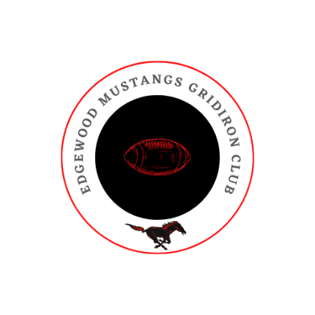

March 27, 2024

Dear Mustang Parents,

Mustang Gridiron Club plans to continue to raise funds through Givebutter for the 2025 season! Givebutter is a fundraising platform that makes the process painless and easy to reach out to family and friends. It is entirely web-based, so athletes can use their phones to make their asks to family and friends. In addition, it is a fantastic way to outreach to family, friends, and community members through Facebook and other social media platforms. The best part of Givebutter is that it allows 100% of funds to be donated to the athletes and the program. We ask each player to raise $425 each, of which the first $175 goes to MGC for player fees for the 2025 season. After the $175 is raised, the remainder will go to the Anderson University Camp fees.

How the Site Works:
- The site URL can be texted to supporters at givebutter.com/edgewoodmustangsfootball2025. Each player can text supporters a dedicated URL of their personal fundraising profile. The site is also searchable by athlete’s name if you click “DONATE TODAY.”
- Text ‘EDGEWOODFOOTBALL25’ to 535-55
- Donations tracked by student-athletes.
- Donors can leave personal messages encouraging their athletes when they donate.
- The donor can donate 7% to cover the cost of the site. If they choose not to do that, the 7% is taken from their donation.

How athletes benefit:
- The first $175 raised goes towards meal/food fees.
  - $125 food fee for game day food, afterschool/after practice drinks and snacks
  - $25 preseason cookout after Mustang Mayhem scrimmage for player & family.
  - $25 postseason banquet for player & family.
- $250 will be applied to the Anderson University team camp fees for JV/Varsity.
- Parents can use this site to pay fees.

How we are encouraging participation:
- Incentive
  - Each player who raises over $500 gets two entries into a $100 gift card drawing.

Time Frame:
- Start raising funds TODAY through June 30th.

We appreciate you as parents and community members – thank you for all you do!

If you have any additional questions or concerns, please email the Gridiron Club at edgewoodmustangsgridironclub@gmail.com.

GO MUSTANGS!

