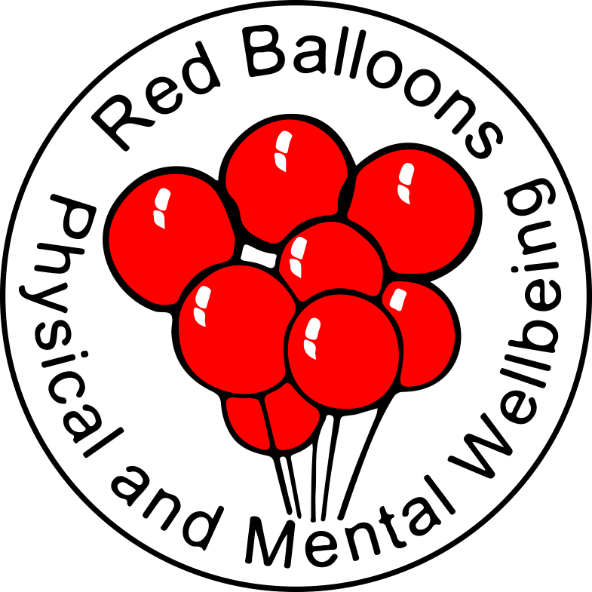

RED BALLOONS
ADVERT

LEAD ADMINISTRATOR

Red Balloons is a Lived Experience Charity offering people support with their mental health. Where we can we support people to use physical activity to improve their mental and physical wellbeing. Our Volunteers use lived experience of ill mental health, physical health conditions and difficult times to support members who attend our sessions. This Peer Support is offered through 1-1 and Group Sessions. Our Volunteers provide people with a safe space to talk about how they feel with no judgement. Our services are warm, safe and welcoming.

Engagement with our services is increasing and we’re recruiting more Volunteers and expanding our services. This means the workload in the office is increasing. We are, therefore, looking to add a Lead Administrator to our Team.

Hours of Work: 28 hours per week (working pattern to ensure that office is covered on a full-time basis in agreement with Operations Administrator)

Salary: £25134 pro rata (actual salary £20,107.36)

12 Months Fixed Term Contract

Responsible to:

Operations Manager

You will have:-

At least 3 years’ experience in a busy administration environment

At least 1 year’s experience of a cloud based Bookkeeping System, preferably Xero

Excellent IT and organisational skills

The ability to communicate confidently with a wide range of stakeholders, including good social interaction and listening skills

The ability to work independently but also be a good team player

To be able to quickly build strong working relationships with people

(see full Job Description)

You will be:-

Non-judgemental with a positive approach to all people regardless of their background, lifestyle and choices

Compassionate, empathetic and positive

A good problem-solver
(see full Person Specification)

You will get:-

Full support and relevant training

30 days holiday (pro rata for part-time)

The chance to be part of a developing and expanding Charity

Please download Job Description and Person Specification from our Website for further information – www.redballoons.org.uk

For an informal chat please contact Leigh Trimble – CEO on 07871 658157

To apply please send full CV with covering letter to leigh@redballoons.co.uk

Your covering letter should include a clear explanation as to why you feel you fit the criteria for this post.

Closing Date for Applications is 5pm on Monday 5th January 2026
Interviews expected to be w/c 12th January 2026

