Name | Monday | Tuesday | Wednesday | Thursday | Friday
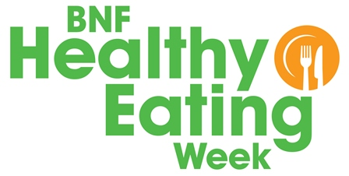
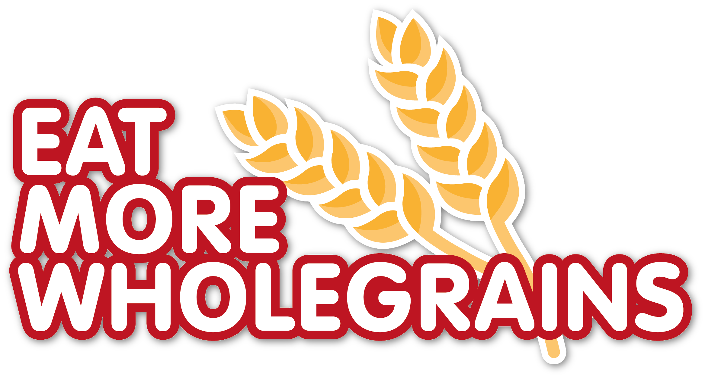
Challenge tracker for___________________.
Add a tick every time you have a portion of a wholegrain food. Who will have wholegrains every day?

