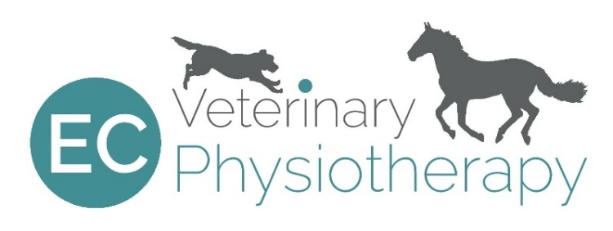

Eloise Collins BSc(Hons) RVN, PgD Vet Phys, MNAVP
Tel: 07910499566 Email: ecvetphysiotherapy@outlook.com

Veterinary Consent for Physiotherapy
Owner’s details
Name:
Address:
Telephone: |  | Mobile:
Email:

Animal’s details
Name:
Breed: |  | Age:
Sex: |  | Colour:
Veterinary diagnosis:
(please email any additional relevant history or images)
Current medication:
Pre-existing conditions:

Veterinary Surgeon Declaration
I can confirm that this animal is a patient under my care and in my opinion is fit to receive physiotherapy treatment.
Vet’s details
Name:
Practice address:
Telephone:
Email:
Vet’s signature: |  | Date:
