Rumford woman on a mission to help fellow celiac sufferers enjoy their favorite foods again

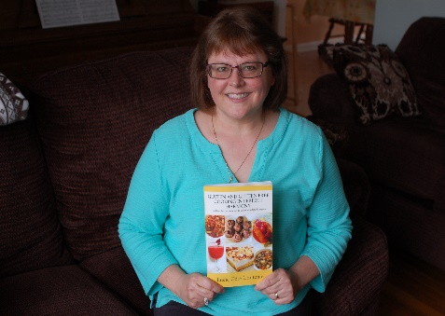

Lucie Cote Contente is currently working on a follow-up to her first cookbook and guide to gluten free cooking, Gluten and Gluten Free Cooking in Perfect Harmony.
Posted Thursday, April 5, 2018 11:45 am
By Christy Nadalin
There is not much that is more central (and essential) to your well-being than what you eat. So finding out, as an adult, that what you eat needs to change — dramatically — can be an extremely challenging adjustment to make.
This is exactly what happened to Lucie Cote Contente of Rumford. About a decade ago, the mother of four began to suffer from unexplained stomach ailments. Doctor's visits, a parade of nutritionists, and even gallbladder surgery, failed to diagnose the issue.
Lucie had heard that gluten sensitivity was an issue for some people, so she laid off the bread and pasta. But her issues persisted.
Her problem was, in fact, gluten, but knocking off bread and pasta was not enough. As it turns out, gluten is in so many things that we eat — things in which you would not expect to find gluten. And while medicine can diagnose an issue, as Lucie found, follow-through can be lacking.
A gastroenterologist found that she "failed" several of the tests that identify markers for gluten sensitivity, and told her it was "highly likely" that she was developing celiac disease.
"Then he said, 'okay — have a nice day'," Lucie said. "I left his office and I didn't know what to eat."
Several nutritionists were of little help (though she likes the one she has now.) Once suggested she eat nothing but salads; another was "too earthy" for Lucie's taste.
As a home cook, Lucie is like most of us. She likes what she likes: home cooking, comfort foods — the kinds of recipes her husband and four kids enjoyed.
Except for one, undeniable fact: those recipes were making her very sick.
Still, Lucie was not interested in abandoning the foods she had enjoyed all her life.
"Maybe I'm a plain Jane," she laughed. "But I don't want to cook a pig tail."
Taking matters into her own hands, Lucie turned to her computer and dove headfirst into researching gluten-free foods. It was discouraging at first. "I found gluten in everything," she said.
She reached out to the online community of people who were facing the same struggles. She started her own blog, hoping to grow it into an online support site. She did more research, exchanged recipes, and discovered what did and didn't work. She discovered an app — Shopwell — that lets you input your food restrictions (not limited to gluten!) and with a quick scan of a bar code, she can get a green or red light on most any bar-coded food in the supermarket. Shopping became easier.
A medicine coder with Lifespan by day, Lucie spent her free time sharing all she learned on her blog, while she was learning how to adapt her family's favorite recipes for her gluten-free lifestyle. The result is a new, recently-released book, Gluten and Gluten Free Cooking in Perfect Harmony. The title reflects the fact that each one of her traditional, accessible recipes is written both with and without gluten.
It's a format that not only allows home cooks to easily adapt recipes for all members of the household, it is also an education for the gluten-free cooking novice to learn how to adapt their own favorite recipes.
Even more than cooking, Lucie enjoys the opportunity for outreach her new endeavor affords. She recently appeared on a WNRI radio show, and is scheduling library appearances, demos and local author festivals in the coming months.
"So many people are undiagnosed," she said. "Everywhere I go I meet someone who is trying to learn to deal with this issue."
"I was angry about my diagnosis at first, and I think it brought on a depression of sorts," Lucie said. "There's not enough info out there, and you don't know what you don't know."
"Now, nothing makes me happier than meeting someone and being able to help them with this journey. It's both enlightening and humbling."
Lucie's book can be purchased online at Amazon, Barnes and Noble, and from her publisher, Outskirtspress. She is working on a follow-up title, that she hopes will be out it the fall. For more information about Lucie's journey and her book, please visit www.glutenandglutenfreecookinginperfectharmony.com.

