
Month: September 2025 Issue no: 87
This month we attended at the route 54 vintage bus running day in Plumstead or Woolwich Arsenal to Plumstead or Elmers End. More about this on page three. This month we were meant to attending at Winchester King Alfred vintage bus running day but cancelled for personal reasons. More about this on page three. This month we were meant to be attending at the Chesham bus running day but decided against this to attend a different event more on page three. This month we attended at the Lowestoft Transport Museum in East Anglia this was a weekend event from 27th and 28th September 2025. More about to follow on page four
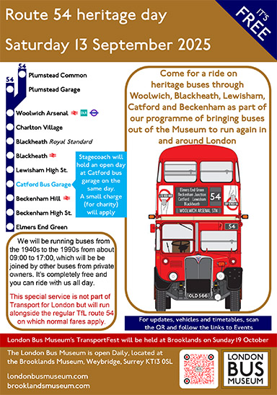
Flickr Albums
Flickr album date | Flickr album title | Flickr album link
13th September 25 | Route 54 vintage bus running & Catford Stagecoach depot open day | https://flic.kr/s/aHBqjCu7a5
16th September 25 | Bracknell, Windsor & Maidenhead | https://flic.kr/s/aHBqjCuvfH
18th & 22nd Sept 25 | Bracknell, Ascot and Maidenhead | https://flic.kr/s/aHBqjCuUaM
24th September | Bracknell & Maidenhead | https://flic.kr/s/aHBqjCvsBu
26th/28th September 25 | Bracknell, Colchester, and East Anglia Transport Museum Event | https://flic.kr/s/aHBqjCvHLM
---------------------------- | Bracknell, Colchester, and East Anglia Transport Museum Event | https://flic.kr/s/aHBqjCvEFC
Photo of the month
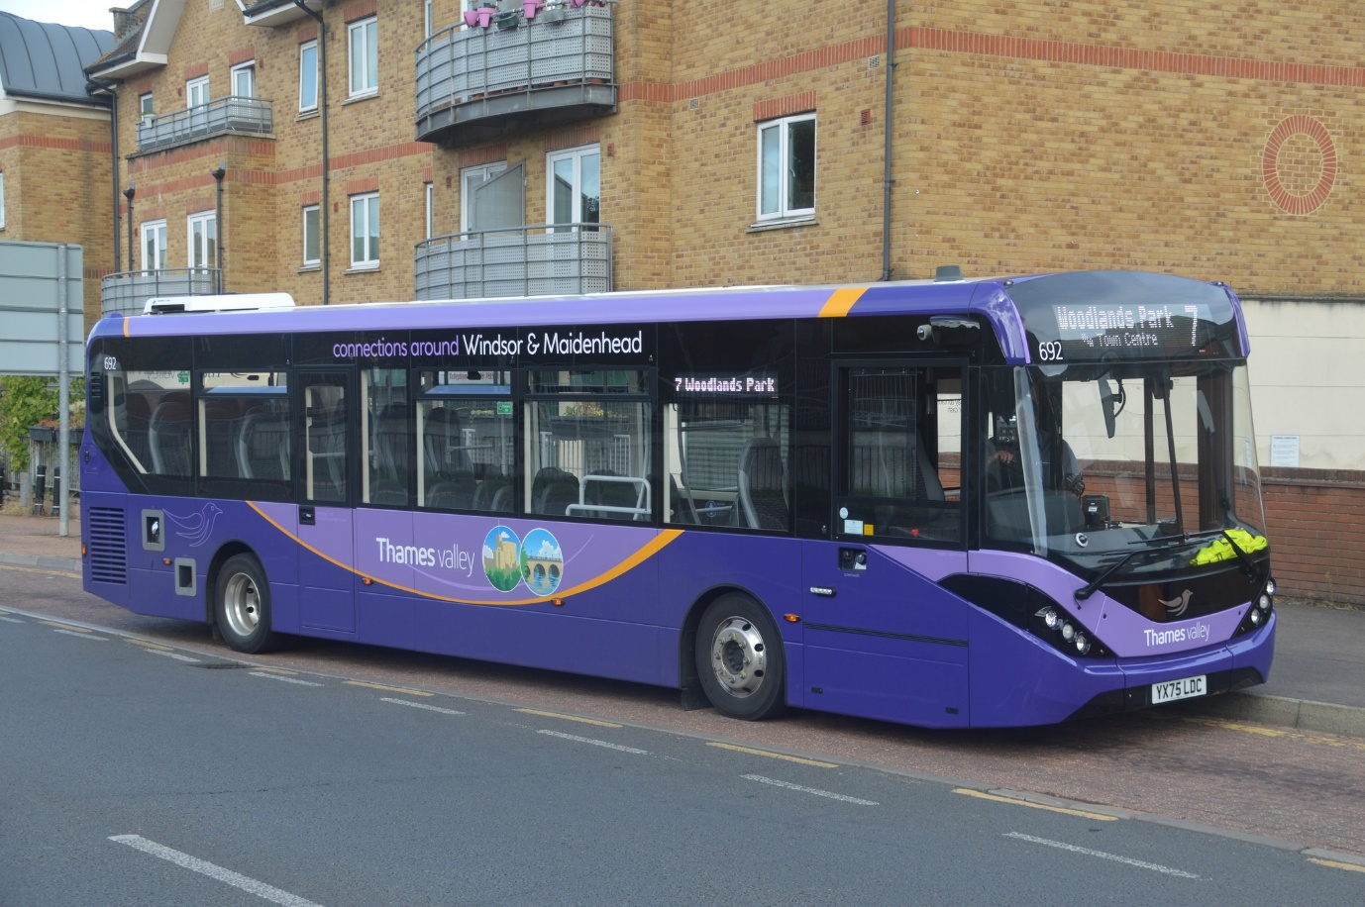
GB&CP Photo of the month for September Photo credit to Gary Baxter Administration of Gary’s bus and coach photos: TV692 YX75LDC ADL Enviro200mmc in Windsor and Maidenhead Generic branding.
Fourth coming events in October
Date: | Event:
Sunday 12th | Reading vintage bus running day
Sunday 19th | Brooklands London bus museum autumn gathering transport festival
Route 54 Vintage bus running from Plumstead to Elmers end Organised by the London bus museum
We attended this event in Plumstead to Elmers end it was a good opportunity to ride more vintage buses in this town along with being able to attend a depot open day in Catford bus depot owned by Stagecoach London. It was also a good opportunity for photos in the different destinations along the way. Video and photos from this day can be found at www.garysbusandcoachphotos.co.uk links also here. https://flic.kr/s/aHBqjCu7a5
Friends of king Alfred vintage open days and running day
This month we were meant to be attending at the Winchester King Alfred vintage bus running day but cancelled for personal reasons and for unforeseen circumstances. The event would have been an excellent day, but due to circumstances we changed our minds.
Chesham bus running day
We decided to cancel doing this event even though it would have been nice we decided to attend a weekend event in Lowestoft East Anglia.

Lowestoft Transport Museum in East Anglia
This month we attend at the Lowestoft transport museum in East Anglia We travelled a few different ways for low cost. We enjoyed the weekend in East Anglia, we attended at the running day on both days on the Saturday we did the runs and photos stops on the runs and then on the Sunday we did the museum, and the museum was excellent we really did enjoy days in the area. We spend some time with a friend. Which made the days even better. Photos from this event can be found at www.garysbusandcoachphotos.co.uk or on our flickr at www.flickr.com/photos/garysbusandcoachphotos link also here: https://flic.kr/s/aHBqjCvHLM https://flic.kr/s/aHBqjCvEFC
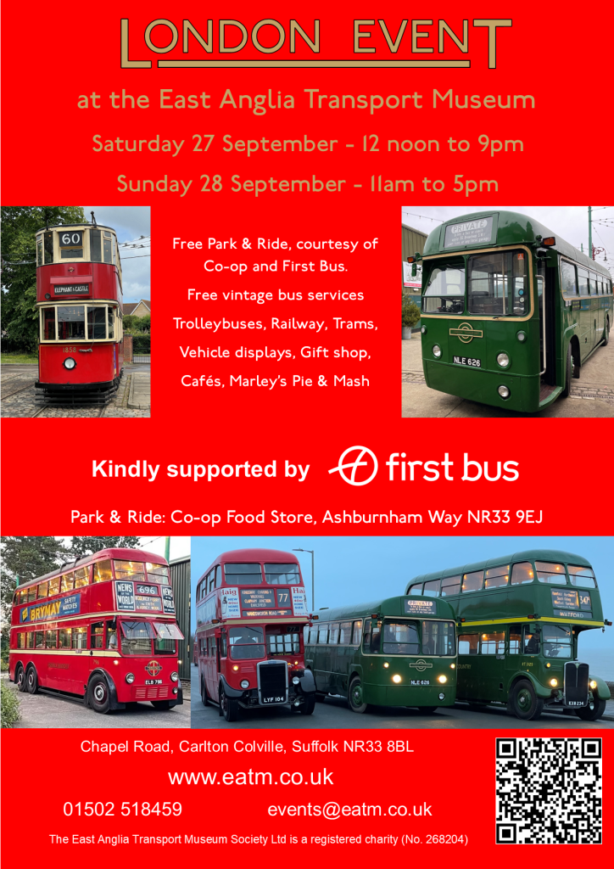
Facebook group cover photo competition
Place: | Name:
1st | Gary Baxter (Administration)
2nd | Oliver King
3rd | Gerwyn Cory, Barry Smith, and Anthony Armitage
4th | Ben Barman and Alican Reilly
Thanks to all who take part in this month’s Facebook Group cover photo competition. Next month’s Facebook group cover photo competition will be on 10th, October 2025.
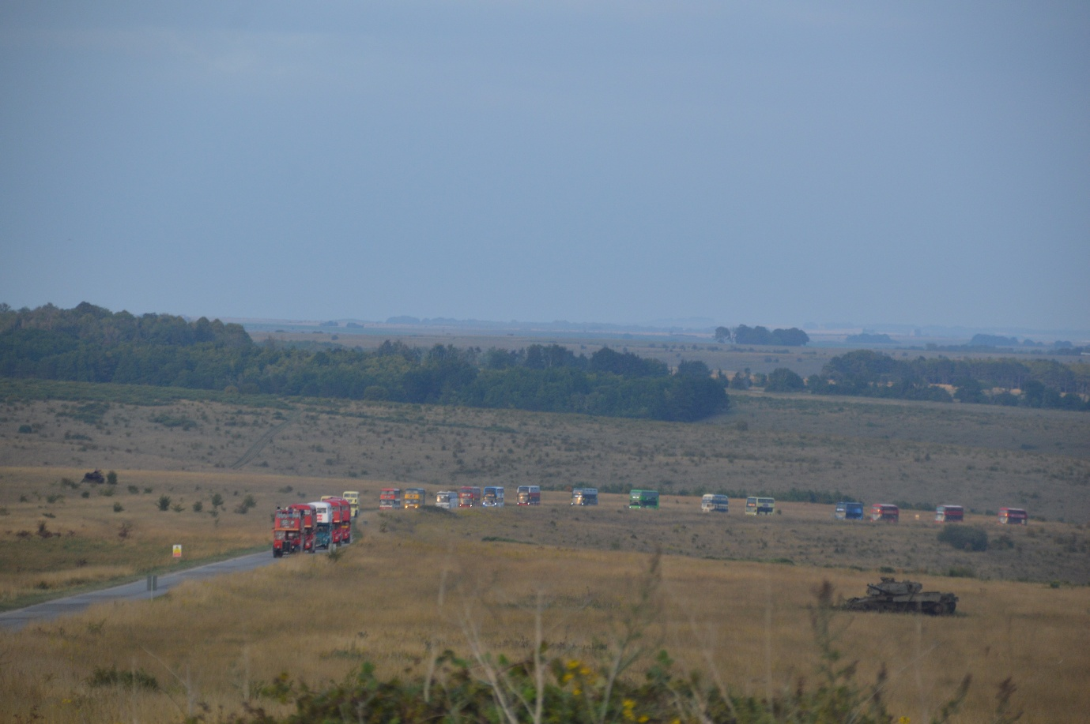
Photo credit to Gary Baxter (Administration of Gary’s bus and coach photos). Photo taken at Imberbus on the Salisbury plains on the village of Imber in August 2025. Photo will be available to view on the group at www.facebook.com/groups/garysbusandcoachphotos and on the website at www.garysbusandcoachphotos.co.uk
Events Diary
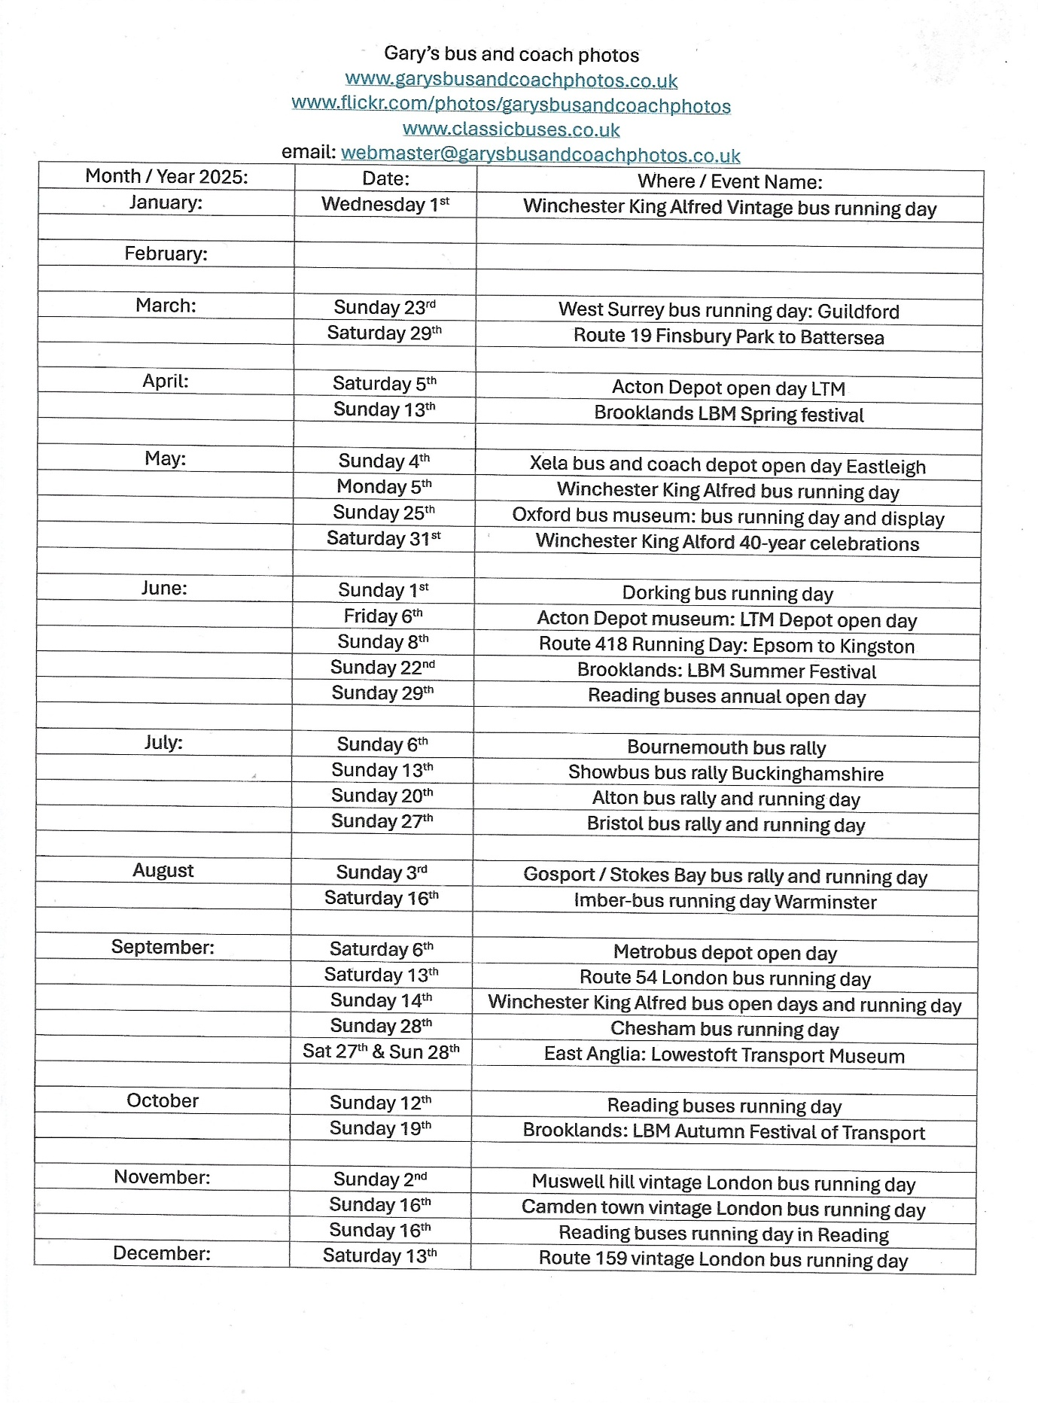

Friend’s Media sites
Friends name: | Media Name: | Link
Theo Thompson | YouTube | www.youtube.com/@theoThompsonbusenthusiast
Theo Thompson | Flickr | Theo Thompson | Flickr
Tracy Churchill | Flickr | https://flickr.com/photos/202982794@N05
Alex Young | Flickr | Alex Young | Flickr
Alex Young | YouTube | www.youtube.com/@hellowallace
Adam Conner | Facebook Group | www.facebook.com/groups/RTECmembers
Adam Conner | Facebook Group | www.facebook.com/groups/rockytheroutemaster
Gary’s bus and coach photos media links
Media name | Links
Facebook Group | www.facebook.com/groups/garysbusandcoachphotos
Facebook page | www.facebook.com/garysbusandcoachphotos
Flickr | www.flickr.com/photos/garysbusandcoachphotos
YouTube | www.youtube.com/@garysbusandcoachphotos
Instagram | www.instagram.com/garysbusandcoachphotosgb7cp
Threads | www.threads.com/garysbusandcoachphotosgb7cp
Website | www.garysbusandcoachphotos.co.uk
Email | webmaster@garysbusandcoachphotos.co.uk

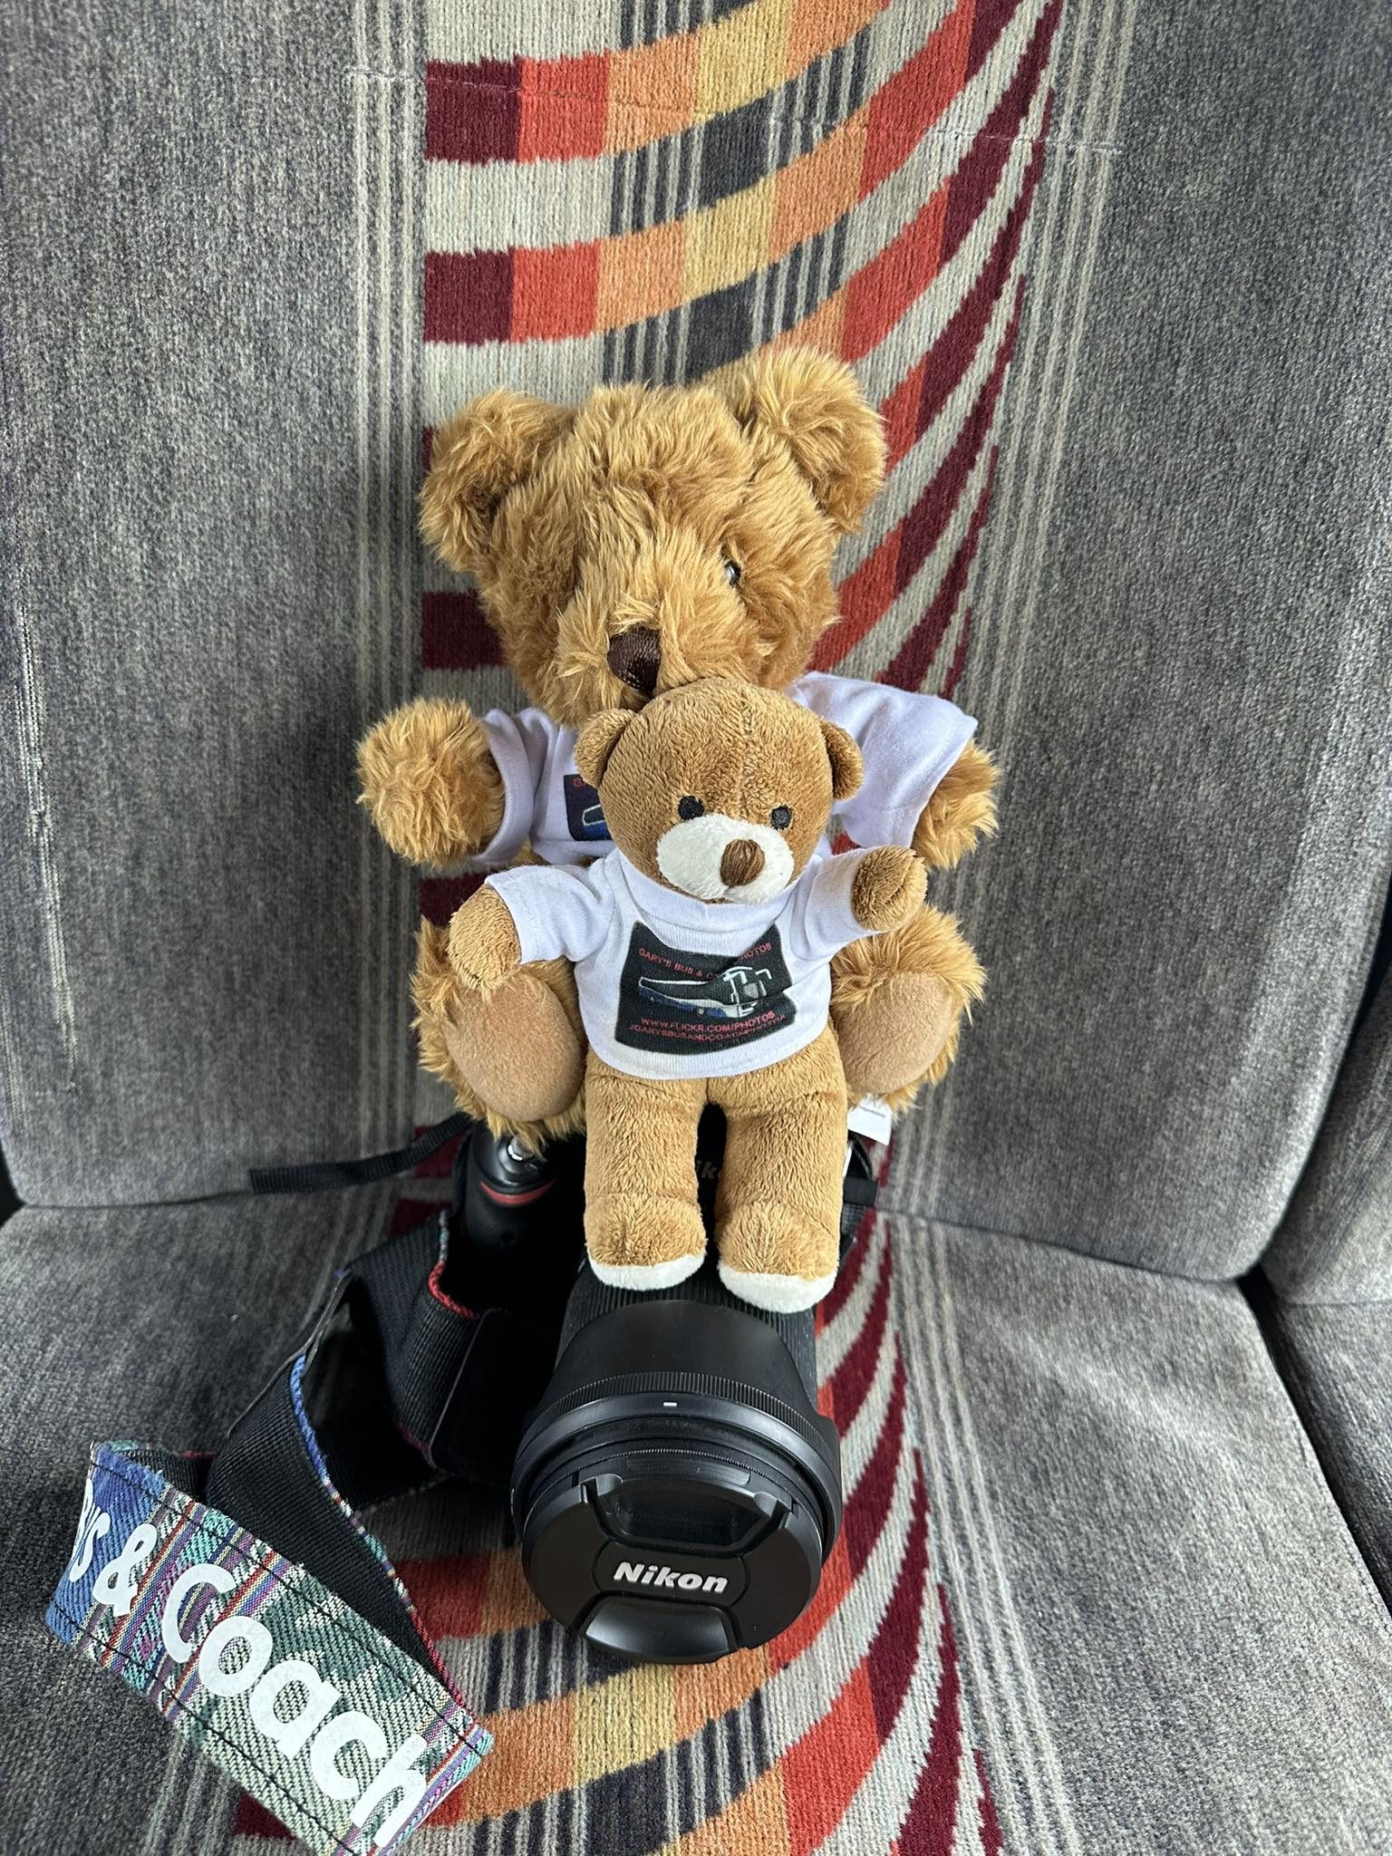
Go Ahead – Thames travel division
Last month saw Thames travel receive new buses for route X40 from Oxford to Reading on the River rapids. I bared witness to this on social media and other sites for the route they have ten Evo Setti Volvo B8L Double decker buses. These all being for route X40 the River rapid route from Reading to Oxford. The fleet of ten entered service late to early August 2025 one such one was at the Imber bus running day in Warminster near Salisbury.
Fleet no | Reg No | Engine | Body
80987 | BU25ZHK | Volvo B8L | Evo Seti
80988 | BU25ZHL | Volvo B8L | Evo Seti
80989 | BU25ZHM | Volvo B8L | Evo Seti
80990 | BU25ZHN | Volvo B8L | Evo Seti
80991 | BU25ZHO | Volvo B8L | Evo Seti
80992 | BU25ZHP | Volvo B8L | Evo Seti
80993 | BU25ZHR | Volvo B8L | Evo Seti
80994 | BU25ZHT | Volvo B8L | Evo Seti
80995 | BU25ZHW | Volvo B8L | Evo Seti
80996 | BU25ZHX | Volvo B8L | Evo Seti

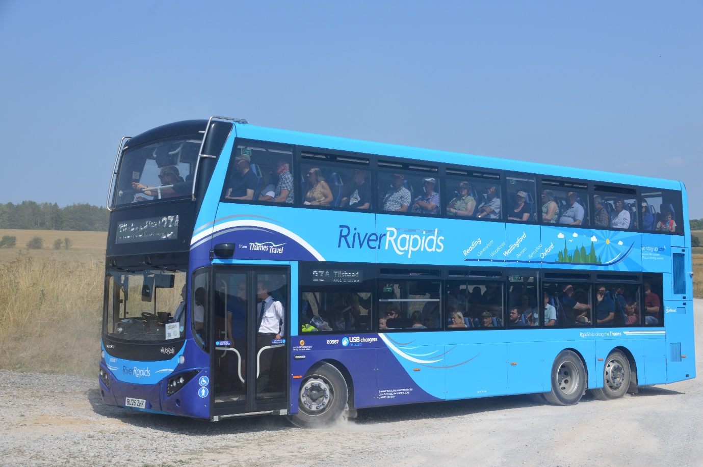
Photo credit to Gary Administration of Gary’s bus and coach photos: GH/TT80987 BU25ZHK Volvo B8L Evo Seti photographed on Salisbury Plains in or near the village of Imber on the Imber bus running day.


Thames Valley Division of the Reading Transport group sister companies.
Thames valley has received new buses for routes within Windsor and Maidenhead this month. Fleet list of vehicles listed below.
Fleet no: | Registration No: | Body | Engine | Length | Company
171 | YX75LCY | Enviro200mmc | ADL Dennis | 8.9m | Thames Valley
690 | YX75LCZ | Enviro200mmc | ADL Dennis | 10.8m | Thames Valley
691 | YX75LDA | Enviro200mmc | ADL Dennis | 10.8m | Thames Valley
692 | YX75LDC | Enviro200mmc | ADL Dennis | 10.8m | Thames Valley
693 | YX75LDD | Enviro200mmc | ADL Dennis | 10.8m | Thames Valley
694 | YX75LDE | Enviro200mmc | ADL Dennis | 10.8m | Thames Valley
695 | YX75LDF | Enviro200mmc | ADL Dennis | 10.8m | Thames Valley
696 | YX75LDJ | Enviro200mmc | ADL Dennis | 10.8m | Thames Valley
These are yet still to enter service within the Thames Valley Maidenhead and Windsor division.
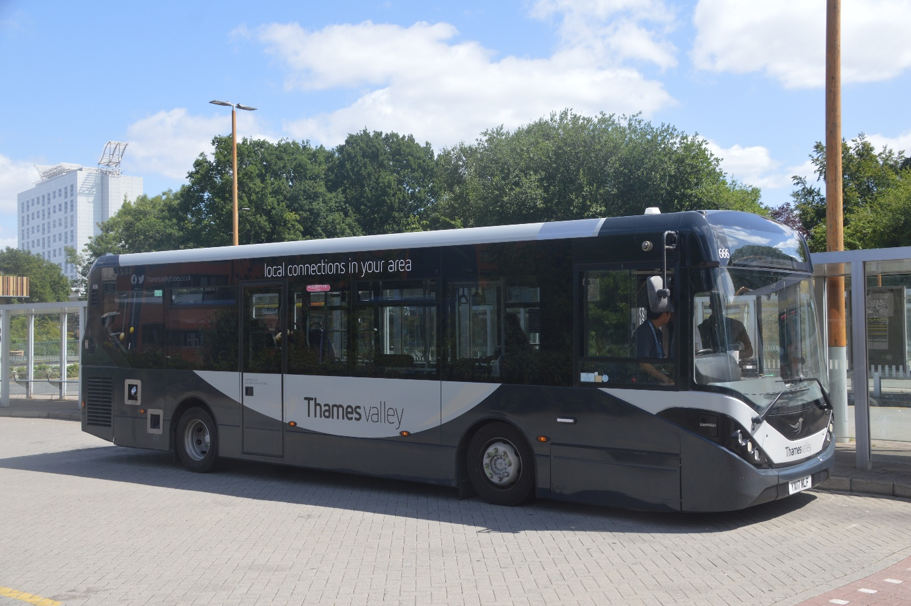
TV666 YX17NLF ADL Dennis Enviro200mmc photographed in Bracknell bus station in July 2025.
Photo above used for example for bus 171 YX75LCY has 171 is the shot vision of the ADL Enviro200mmc and 690-696 are the longer visions of the ADL Enviro200mmc.
This month saw new buses for the Maidenhead area entering service across the Maidenhead and Windsor area. The new buses are Enviro200mmc’s built by Alexander Dennis. In lengths 8.9m and 10.8m the list below along with entering service dates.
Fleet No: | Registration No: | Body | Engine | Length | Date Entered Service | Photographed on
171 | YX75LCY | Enviro200mmc | ADL | 8.9m | 9th September 2025 | 24th September 2025
690 | YX75LCZ | Enviro200mmc | ADL | 10.9m | 1st September 2025 | 18th September 2025
691 | YX75LDA | Enviro200mmc | ADL | 10.9m | 2nd September 2025 | 16th September 2025
692 | YX75LDC | Enviro200mmc | ADL | 10.9m | 12th September 2025 | 16th September 2025
693 | YX75LDD | Enviro200mmc | ADL | 10.9m | 9th September 2025 | 16th September 2025
694 | YX75LDE | Enviro200mmc | ADL | 10.9m | 1st September 2025 | 16th September 2025
695 | YX75LDF | Enviro200mmc | ADL | 10.9m | 18th September 2025 | 22nd September 2025
696 | YX75LDJ | Enviro200mmc | ADL | 10.9m | 13th September 2025 | 22nd September 2025

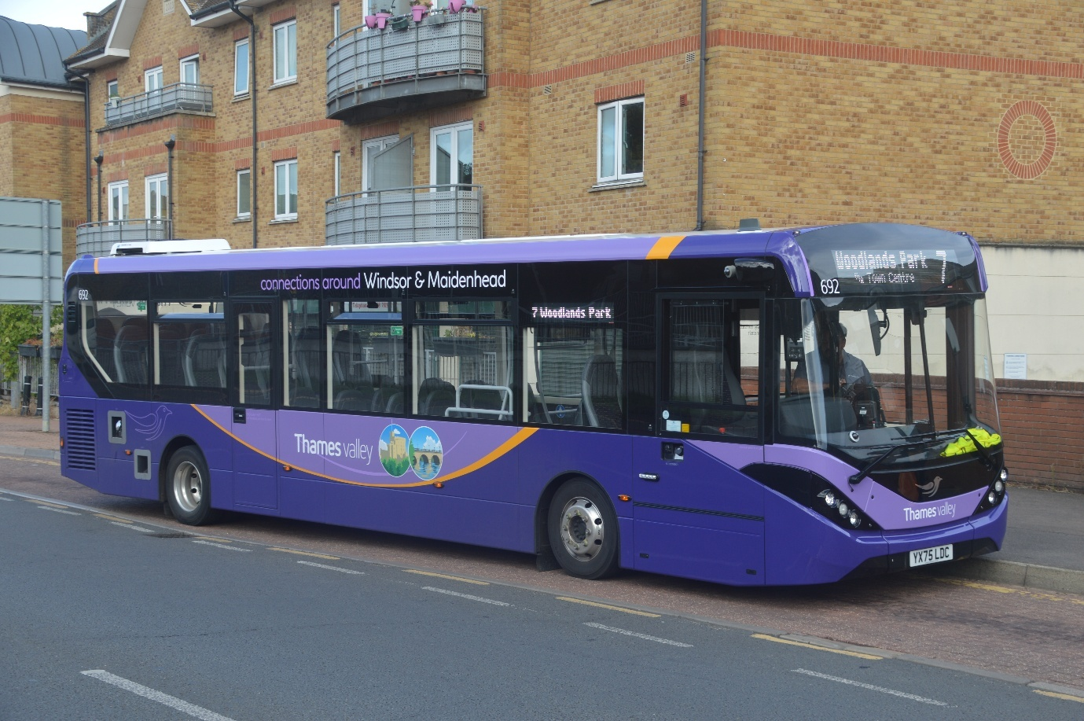
Photo credit to Gary Baxter administration of Gary’s bus and coach photos: Thames Valley 692 YX75LDC Enviro200mmc Alexander Dennis 10.9m photographed in Maidenhead-on-Maidenhead route seven to Woodlands Park. More photos can be found via this link https://flic.kr/s/aHBqjCuvfH
https://flic.kr/s/aHBqjCuUaM, And https://flic.kr/s/aHBqjCvsBu.

Facebook group member photos
Photos posted in the group from our members these can also be seen in the facebook group at www.facebook.com/groups/garysbusandcoachphotos / www.facebook.com/garysbusandcoachphotos
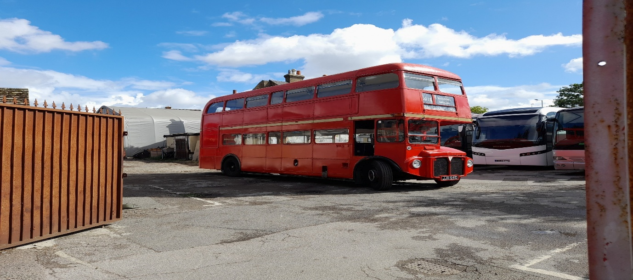
Alican Reilly member of Gary’s bus and coach photos: RM1541 JJD541D London Transport Routemaster.
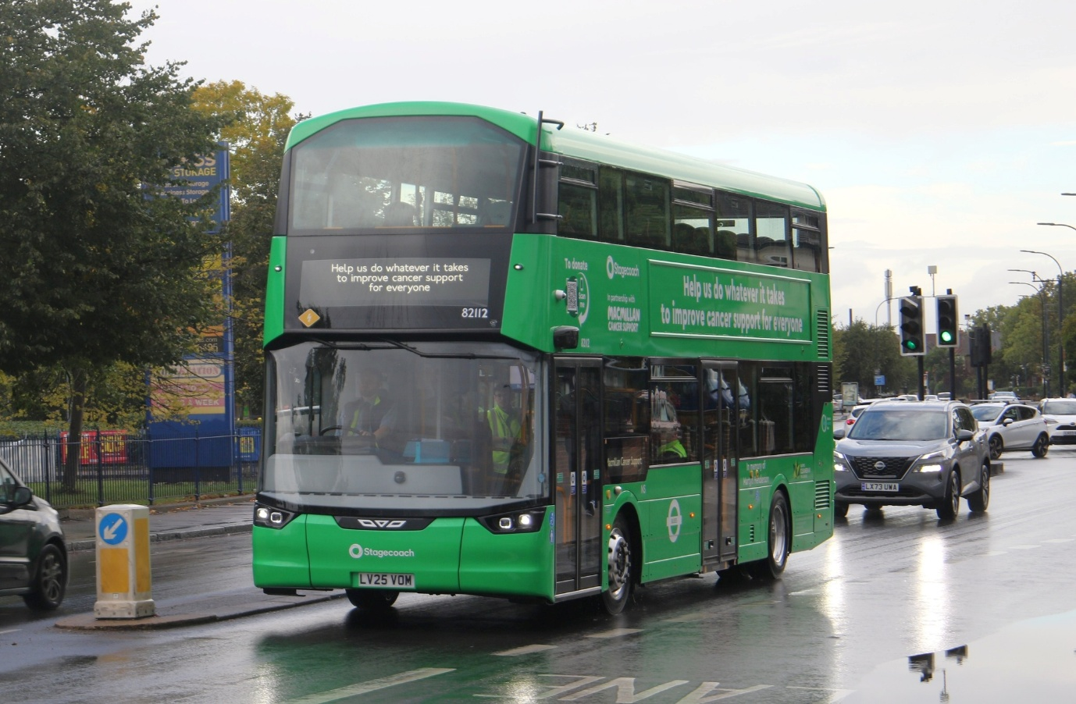
Andy Dyer Administration & Member of Gary’s bus and coach photos: Stagecoach London 82112 LV25VOM Wright bus Streetdeck electric McMillan cancer research livery.
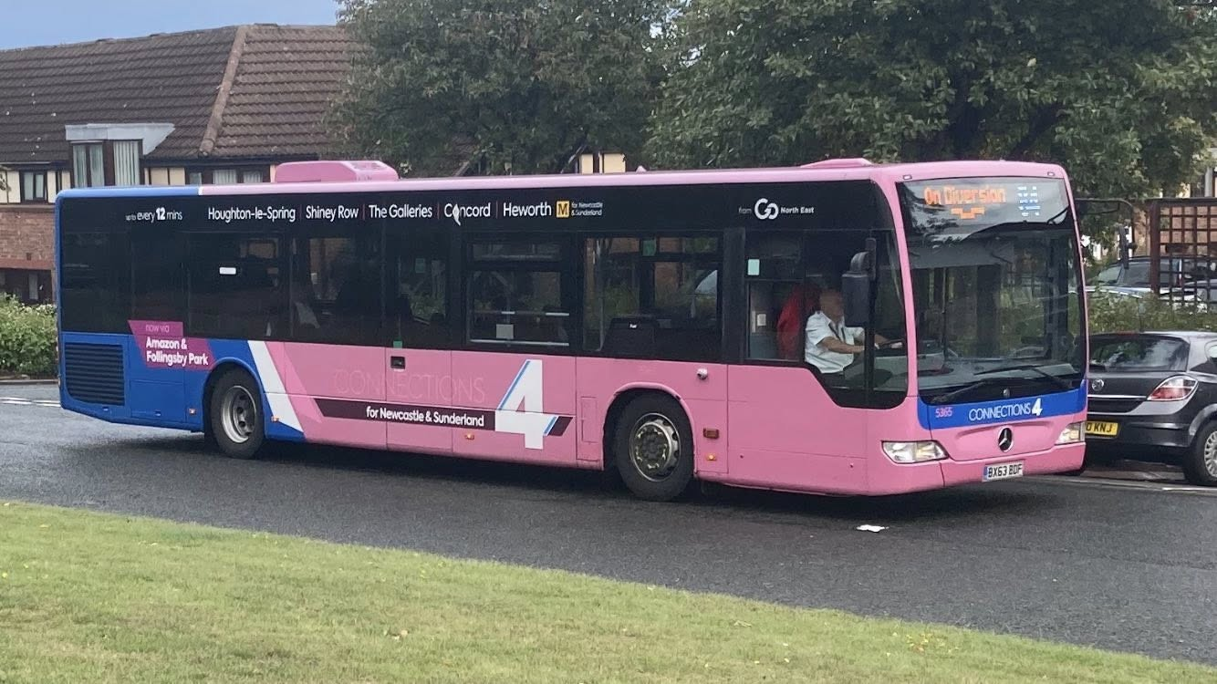
Anthony Armitage Member of Gary’s bus and coach photos: GNE5365 BX63BCF Mercedes Benz Citaro Go Northeast.
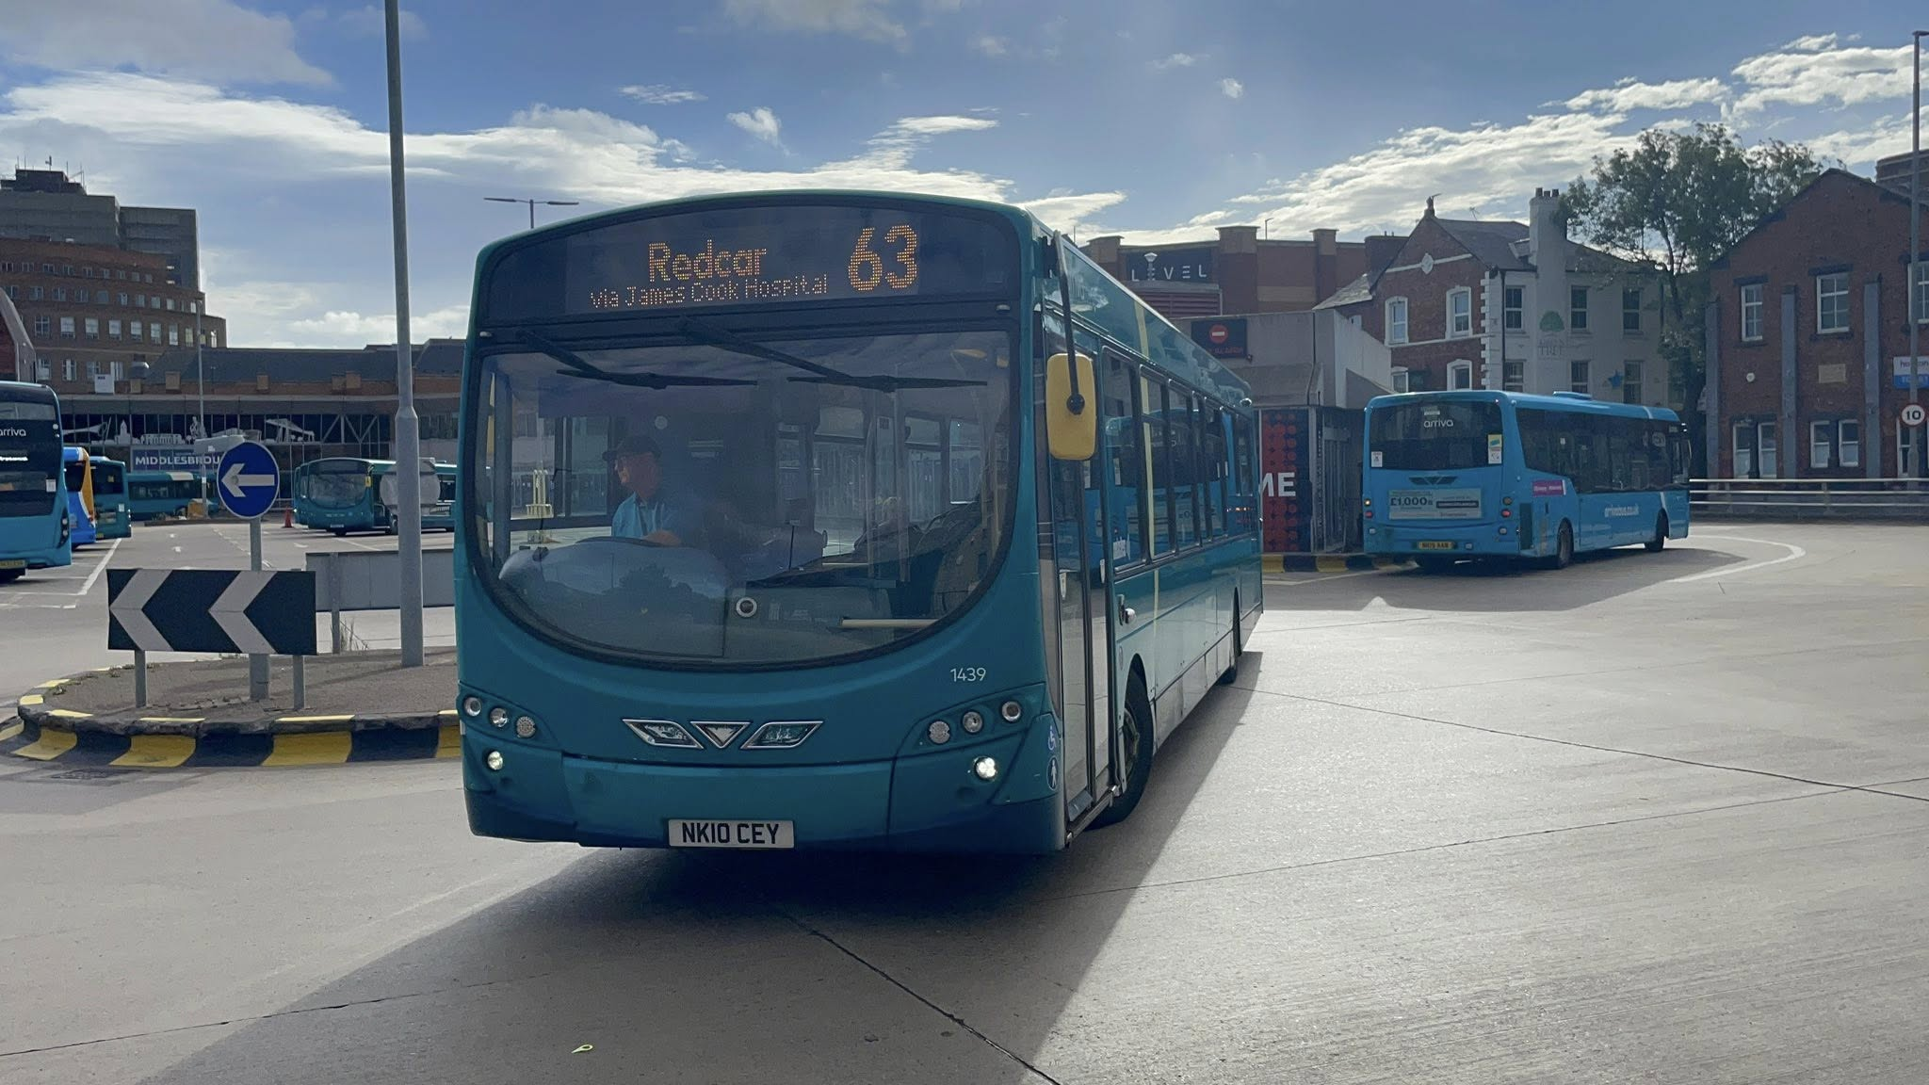
Ben Barman member of Gary’s bus and coach photos; Arriva North-east 1439 NK10CEY Wrightbus Pulsar VDL SB200
www.facebook.com/groups/garysbusandcoachphotos
www.facebook.com/garysbusandcoachphotos
www.garysbusandcoachphotos.co.uk
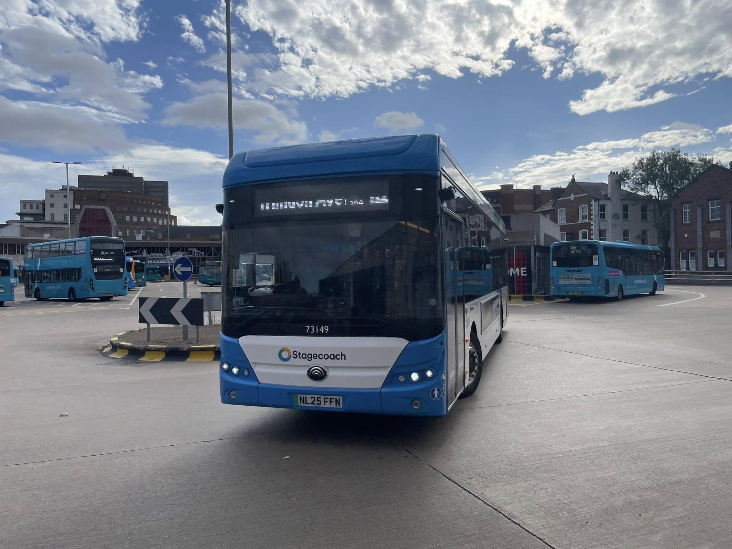
Ben Barman member of Gary’s bus and coach photos; Stagecoach North-east 73149 NL25FFN Yutong.
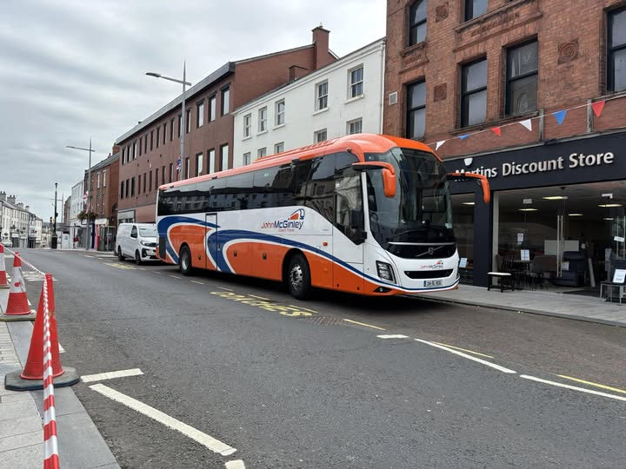
Connor McCausland member of Gary’s bus and coach photos: 241DL1836 Volvo 9700 John McGuinley's.
www.facebook.com/groups/garysbusandcoachphotos
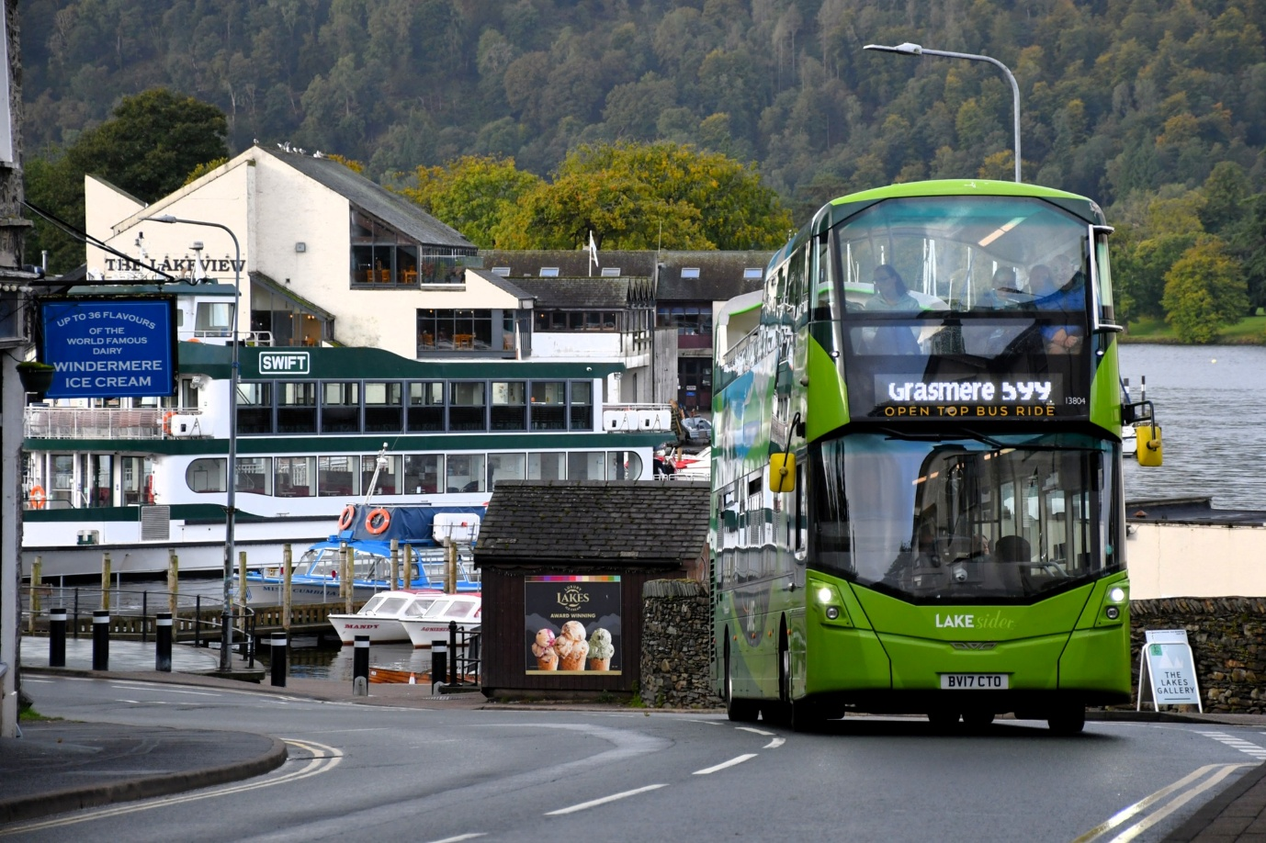
Steve Poole member of Gary’s bus and coach photos: Stagecoach Lakesider 13804 BV17CTO Wrightbus Streetdeck branded for route 599 Grasmere.
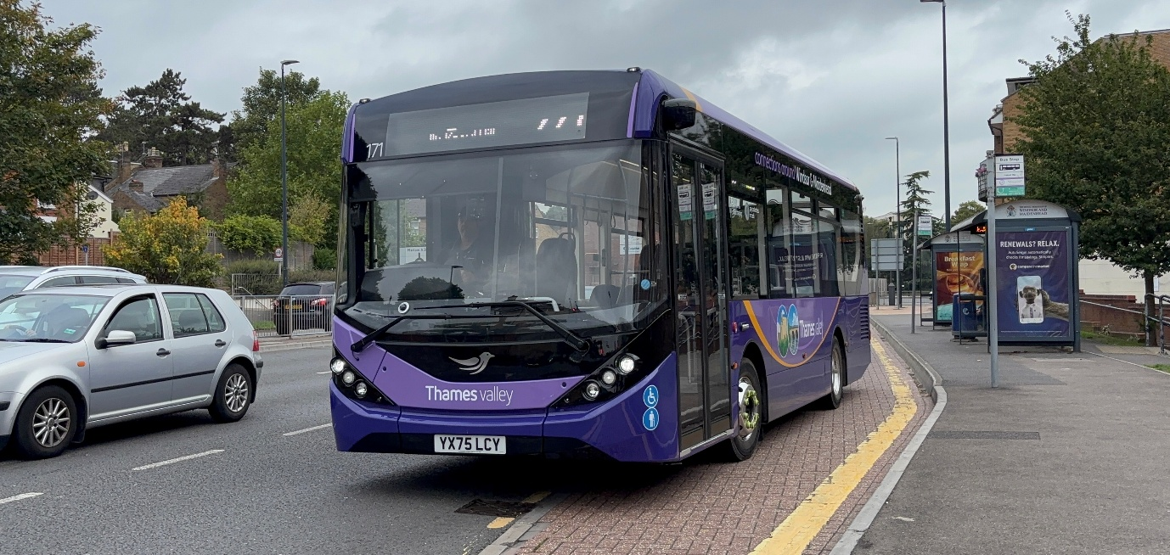
Robert Thompson on behalf of Theo Thompson members of Gary’s bus and coach photos: Thames Valley 171 YX75LCY ADL Enviro200mmc.
www.facebook.com/groups/garysbusandcoachphotos
www.facebook.com/garysbusandcoachphotos
www.garysbusandcoachphotos.co.uk
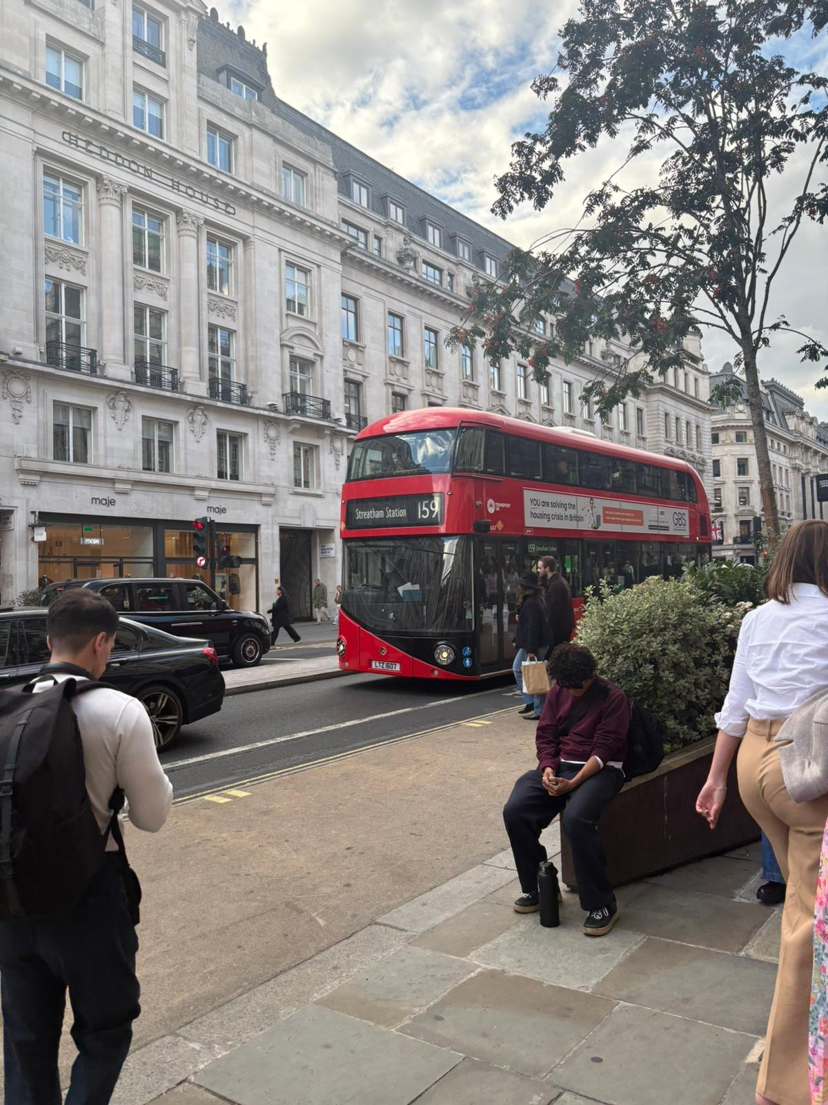
Donna Levett member of Gary’s bus and coach photos; LT607 LTZ1607 Boris master Transport UK on route 159 to Streatham.
www.facebook.com/groups/garysbusandcoachphotos

