
Month: May 2025 Issue No 83
This month we attended the friends of king Alfred vintage bus running day in Winchester on the bank holiday Monday 5th, May 2025. The event saw some nice weather several different vehicles including some visiting vehicles from other organisation / preservationist come along to the friends of King Alfred vintage bus running day in Winchester more about this on page two. Friends of King Alfred Events on Page three. We attended at Oxford bus museum: Bus running day and display on the 25th, May 2025 more about this on five.
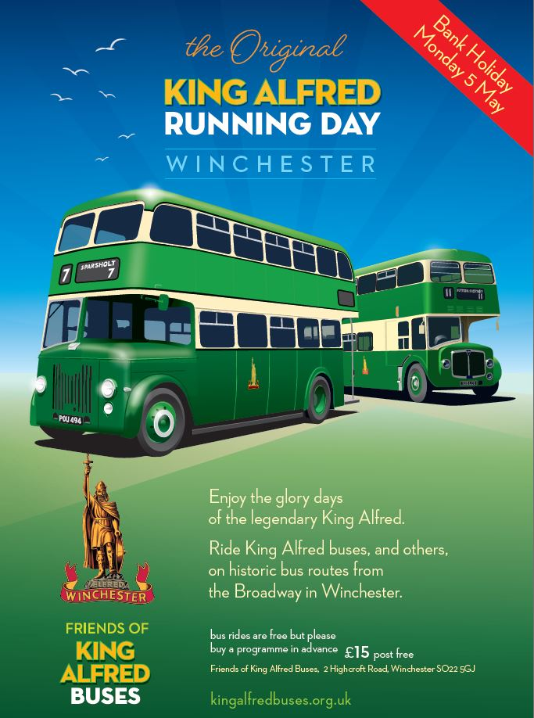
Friends of King Alfred vintage bus running day
The friends of king Alfred vintage bus running day take place on bank holiday Monday 5th, May 2025. I attended this event with my good friend Tim Wild, Steve, Robert and Theo Thompson. The event was a good day for photographs and video along with plenty of different buses and coaches to ride on round Winchester. The event saw several different vehicles come along to the event from all different organisations and preservationists. Which was good it was to ride on all the different buses and coach to all the different destinations advertised in the event programme which cost £15 bearing in mind some of that money goes towards the upkeep of the Friends of King Alfred buses. Photos and Video from the Event here. https://flic.kr/s/aHBqjCd9CK https://youtu.be/Zb4bQD0aZlA
More Events by Friend of King Alfred listed here.
Month Date: | Where:
May 5th Mon | King Alfred vintage bus running day in Winchester
31st May Saturday | King Alfred 40th Anniversary celebrations Winchester
September 14th Sunday | Friend of King Alfred Display and running day Winchester
January 1st Thursday | Friends of King Alfred vintage bus running day Winchester new year’s day.

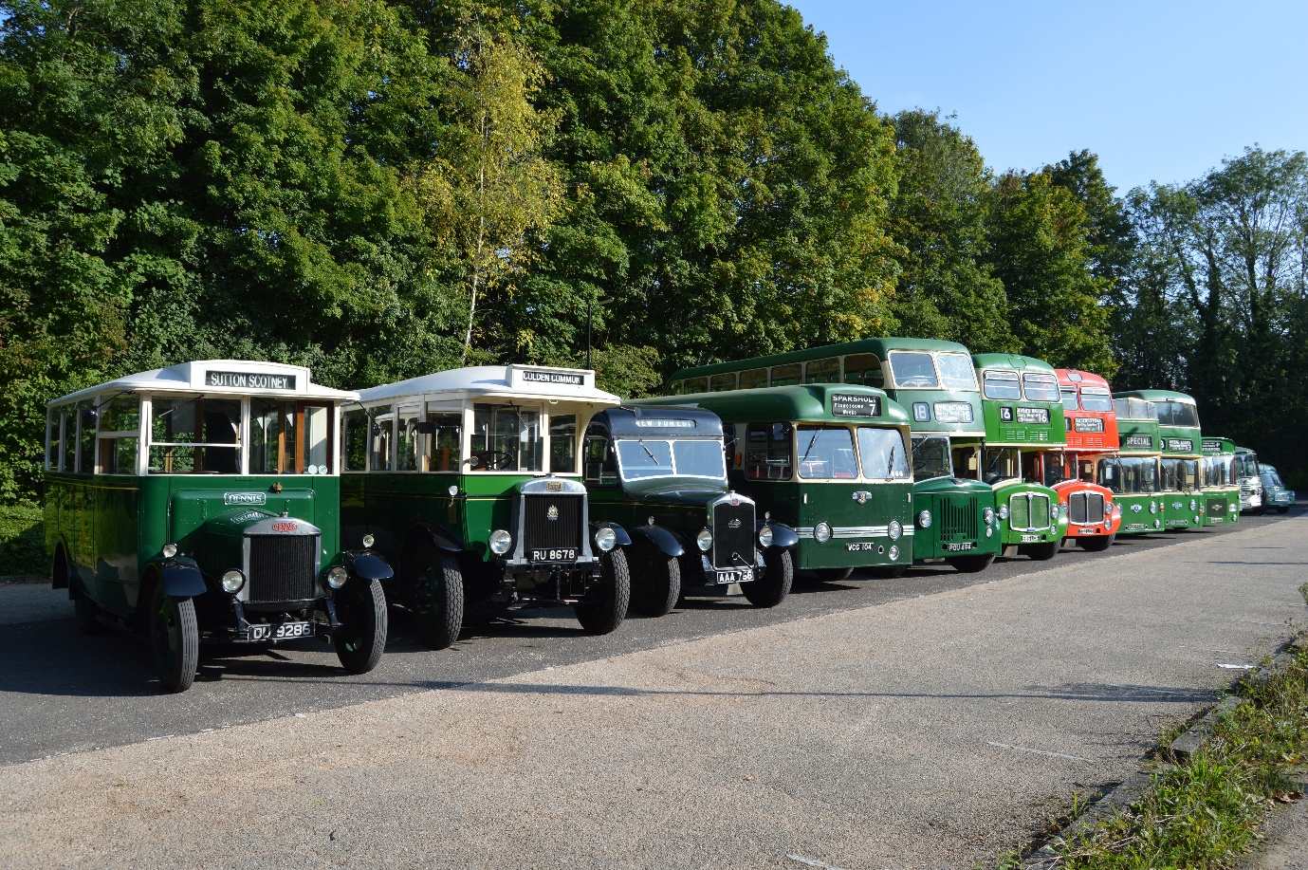
Photo credit to Gary Baxter Admin of GB&CP: Friends of King Alfred line up at St ’Catherine’s Park and ride 15th, September 2024 before heading out to Winchester Broadway to provide a running day to all sorts of different destinations in Winchester and the surrounding area of Winchester.

Facebook Group Cover Photo Competition
Place: | Name:
1st | Andy Dyer
2nd | Andy Wilson
3rd | Anthony Moore, Barry Smith & Steve Poole
4th | Andy Dyer on behalf of Phillippa Dyer
Thanks to everyone who take part in the Facebook group cover photo competition next month’s Facebook group cover photo competition will be on the 20th, June 2025.
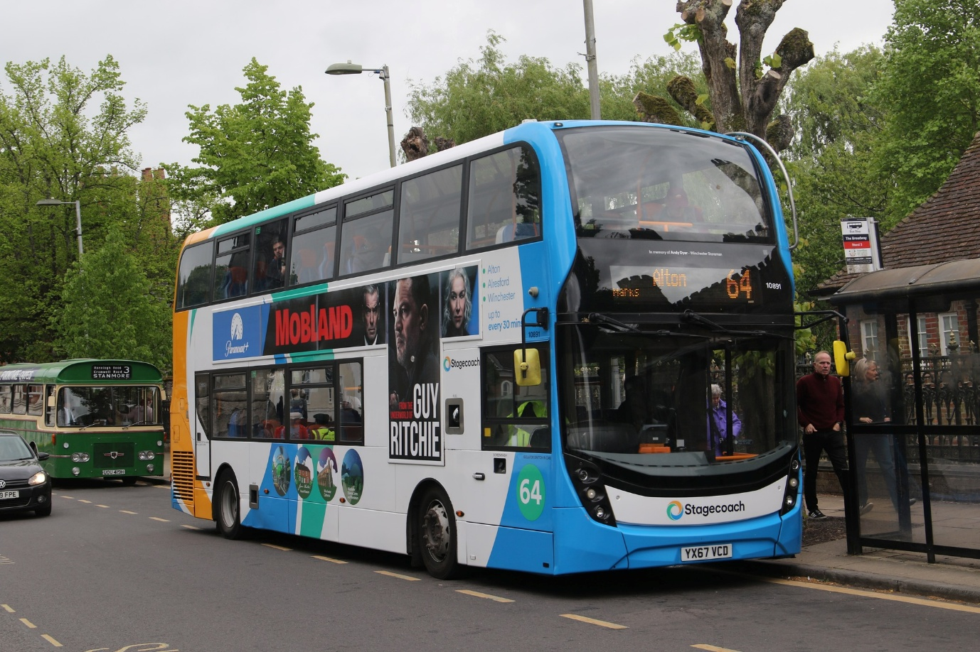
Photo credit to Andy Dyer member & Admin of GB&CP Stagecoach South Winchester 10891 YX67VCD ADL Enviro400mmc photographed in Winchester Broadway on route 64 to Alton named after Andy Dyer or in memory of Andy Dyer one of the engineers or maintenance people at Winchester.

Oxford bus museum: Bus running day & Display (Erne’s retro wheels)
We attended at the Oxford bus museum with Rocky the Routemaster and Adam Conner. This day was a good day it made a change going to different museum within the United Kingdom. The day was lovely it was good to meet people with the same interest has me. The museum was great it was good to see all the differently owned and preserved bring along they own collection of Vehicles. The museum also had some other exhibits which was good. It was also good to attend this event with Adam Conner and Rocky the Routemaster. Photos and Videos from this day links here and available on website at www.garysbusandcoachphotos.co.uk. They were no video from this occasion for an unknown reason, but link to album here https://flic.kr/s/aHBqjCfHXh
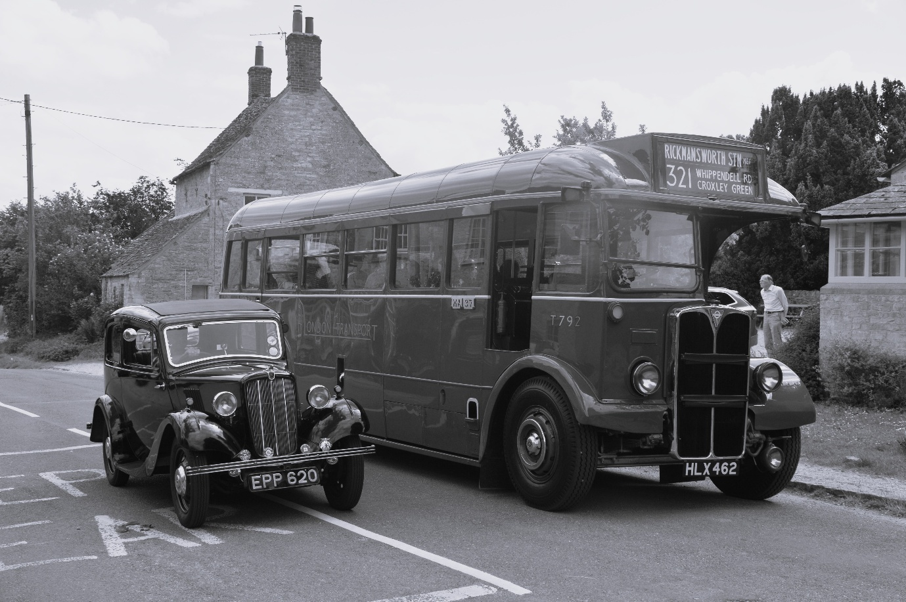
Photo credit & edited by Gary Baxter administration of Gary’s Bus and Coach Photos: Epp620 Morris manor & HLX462 T792 London transport AEC Regal owned and preserved the London Transport Museum or museum depot. Photograph is taken at Long Hanborough near a village recreating a theme from 1930’s the photo was taken in colour and edited into black and white to make it look more authentic to the 1930’s. The Photo was also taken on the day of the Oxford bus museum event Ernie’s retro wheels at Long Hanborough Oxford bus museum 25th, May 2025.

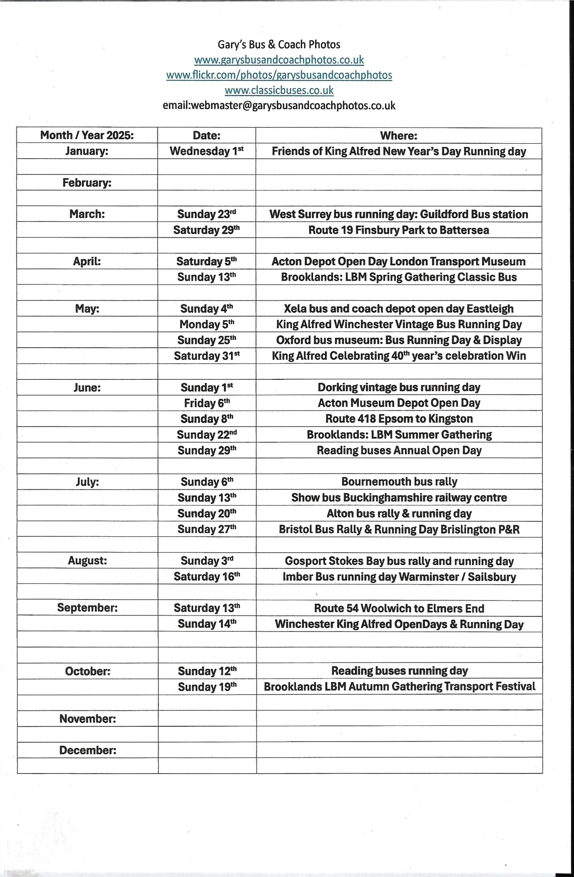
Key-Buses Publishing
The Key buses publishing added they events calendar to the buses magazine in April 2025 I missed out on putting this out they in our newsletter. It is now an A4 edition and not an A5 or A6 edition. The A4 comes packed full of events and details of the events in question.
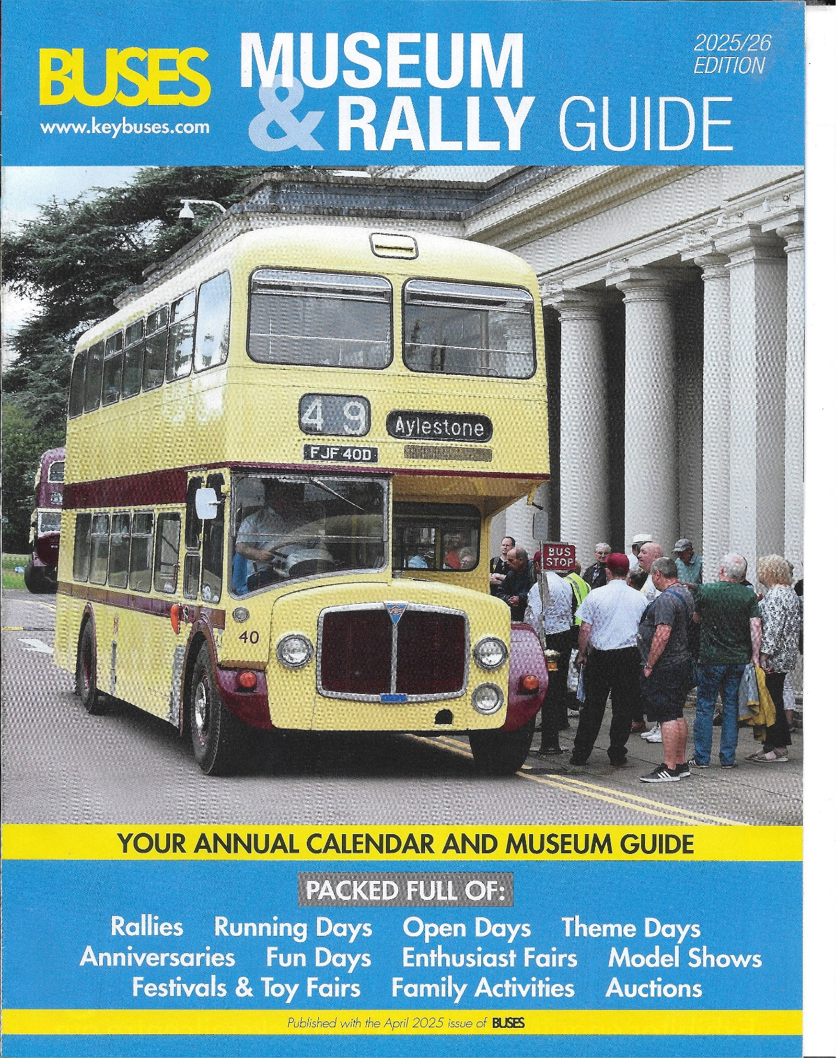
Photocopy of the event calendar / guide this can be purchased by going to key buses publishing website at www.keybuses.com this was in the April 2025 buses magazine.
Reading Transport Group of companies
Reading buses are soon to be taking delivery of the Stagecoach Northeast Gas buses and are expected sometime in the summer. This are fleet numbered 444-450. Thames Valley also has an order for eight new Enviro200mmc’s for its Maidenhead operations. The new gas Enviro300CNG’s listed below along with registration numbers and branding names
Fleet Number | Registration Number | Make/Engine | Brand
444 | YR14CFY | Enviro300CNG Scania | Winnersh P&R
445 | YR14CFZ | Enviro300CNG Scania | Winnersh P&R
446 | YR14CGE | Enviro300CNG Scania | Winnersh P&R
447 | YR14CGG | Enviro300CNG Scania | Generic
448 | YR14CGK | Enviro300CNG Scania | Generic
449 | YR14CGO | Enviro300CNG Scania | Generic
450 | YR14CGU | Enviro300CNG Scania | Generic
451 | YR14CGV | Enviro300CNG Scania | Buzz

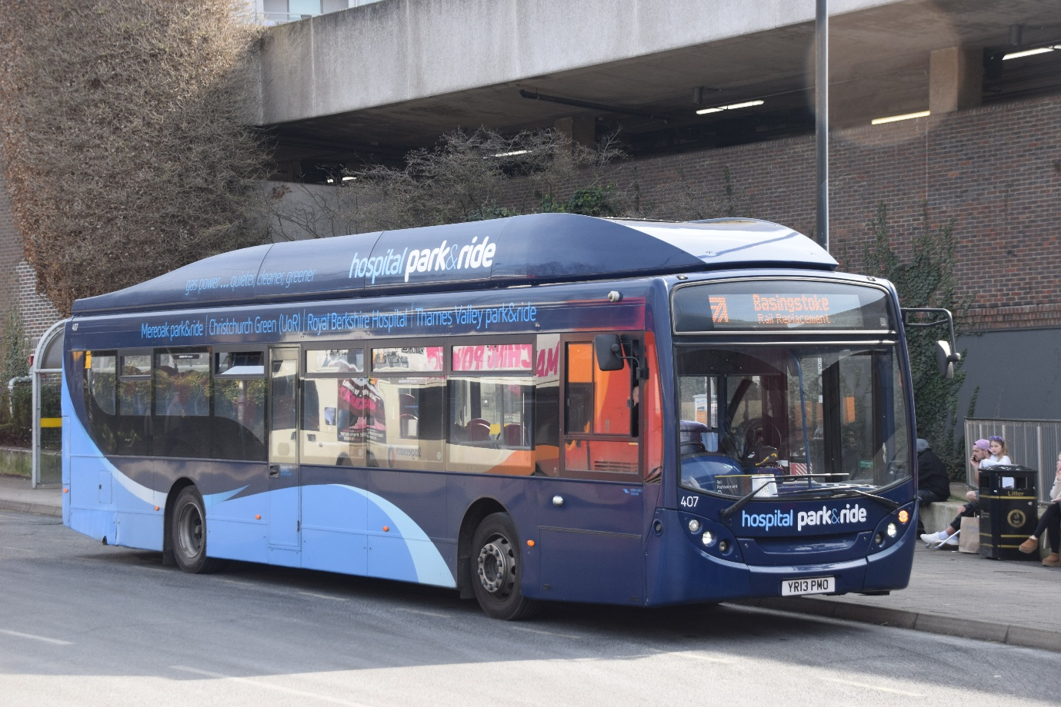
Photo credit to Gary Baxter Administration of GB&CP: Reading buses 407 YR13PMO Enviro300CNG Scania Gas bus on Railway replacement in Basingstoke in March 2025.

Administrator Gary Anthony Ernest Baxter new YouTube channel
Our Administrator Gary Baxter has a casual YouTube channel which can be found by going to www.youtube.com/@garyanthonyernestbaxter this is where he will cover stuff he does in his spare time away from the Gary’s bus and coach photos community this channel will also cover stuff he is doing with family members. This channel will also cover other stuff like going to museums away from the Gary’s bus and coach photos and enjoying life to the full. Click again to the channel is www.youtube.com/@garyanthonyernestbaxter Please subscribe and put the notification bell on thank you
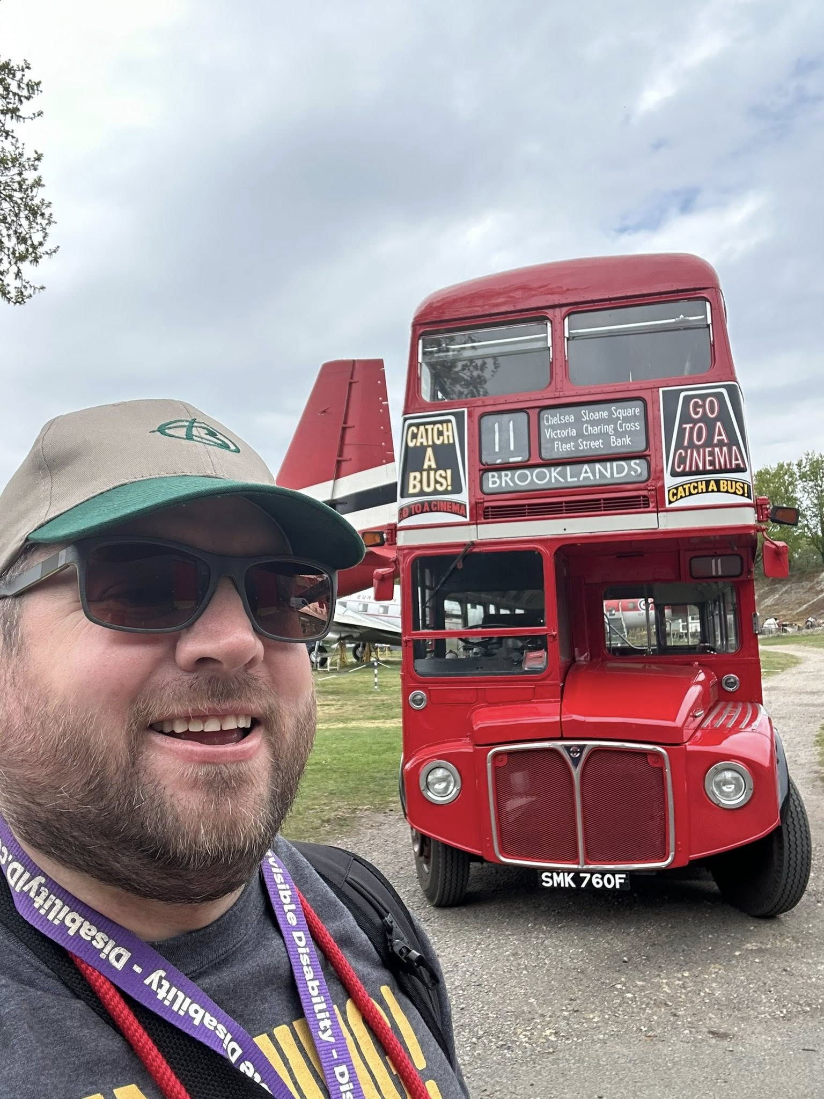
Friends of King Alfred fam laughing out loud
this month has reported about on page two we attended at the Friends of king Alfred running in Winchester along with this we become a little famous has we take part in the newscast this along with Robert Thompson was a very good piece of journalism. I was happy to take part and tell them what I thought of the Friends of King Alfred vintage bus running day in Winchester. Links to the video and radio broadcast here. https://youtu.be/wkt7OYx9t-g?si=zASQPdU4C7txTVu6 https://youtu.be/tacHwmlBkzQ?si=Zl82JYf3mH9GfZo- thanks goes to Winchester journalism can be found on YouTube at www.youtube/@Winchesterjournalismnews.
Reading Transport Enthusiast Club
The Reading transport enthusiast club are looking for new members to join the club or paying members to join the club they group can be found by going to www.facebook.com/groups/RTLMembers they can also be found by going to www.garysbusandcoachphotos.co.uk and clicking on they page on our website. The enthusiast club do a few bus events in the UK and take along relevant vehicles being to the club treasurer and the Reading buses company. They events calendar can be found on they page on our website.
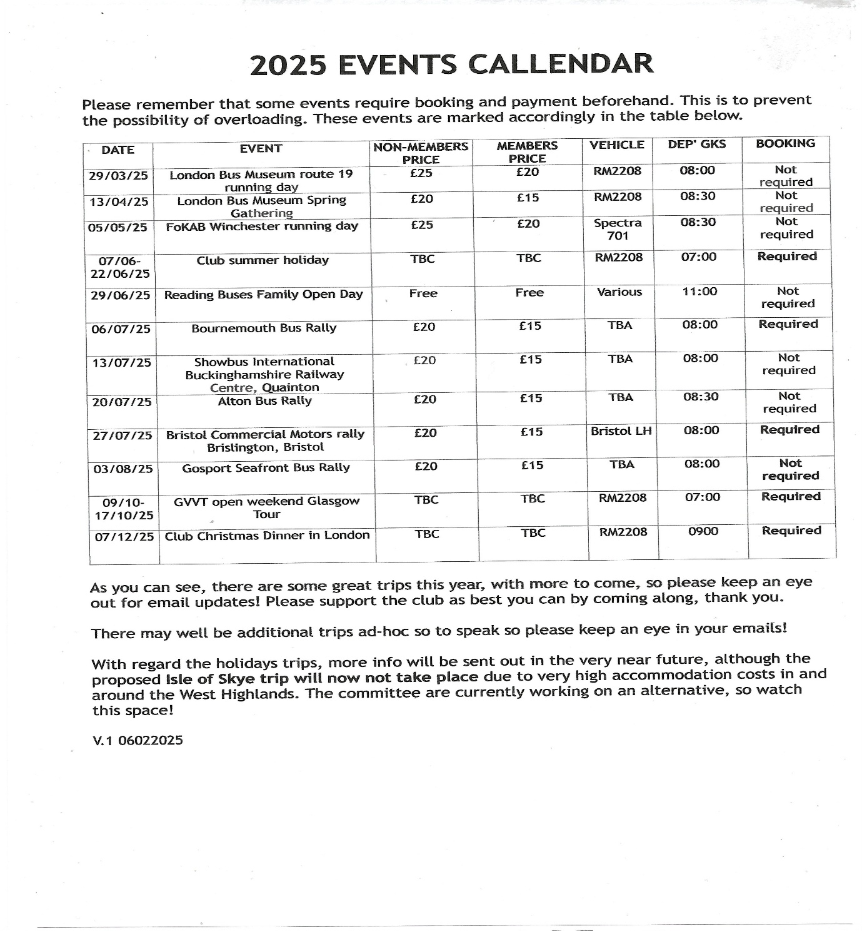
This is the event Diary for the enthusiast club the membership form can be found on they page on our website at www.garysbusandcoachphotos.co.uk.
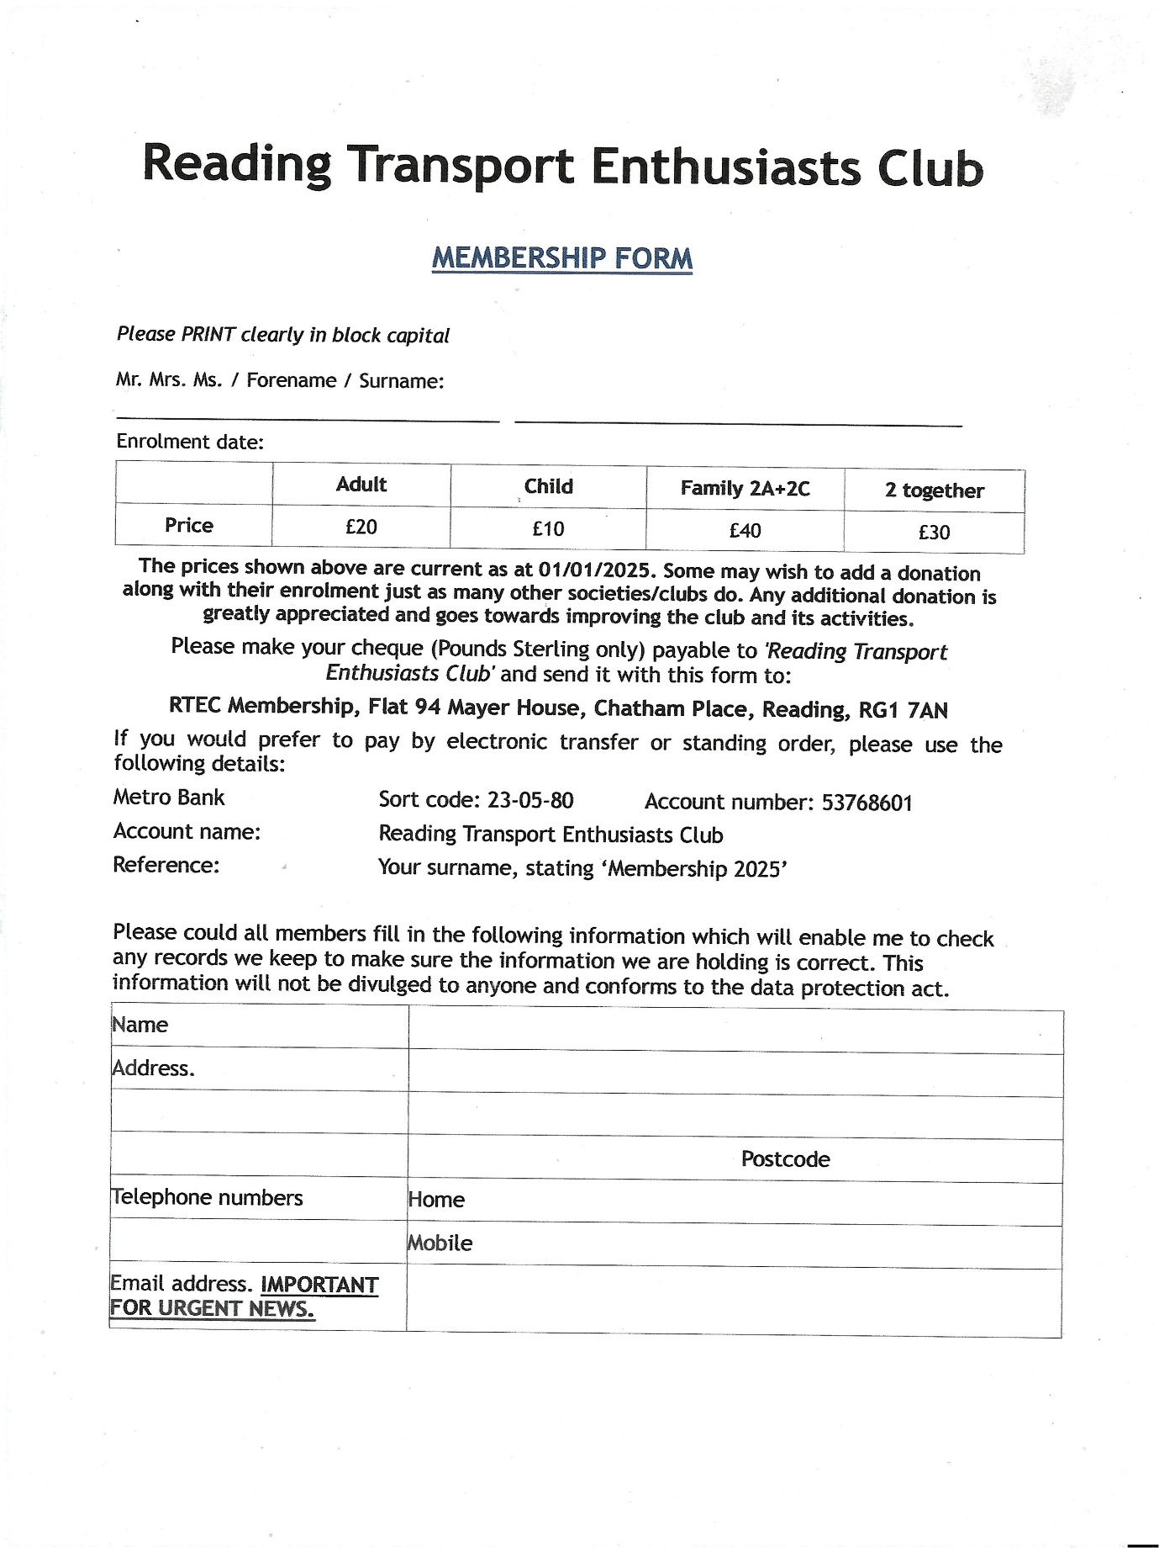
This is a photocopy of the membership for the enthusiast club it is well worth joining as the trips are sometimes well worth doing. This can be found on website at www.garysbusandcoachphotos.co.uk/RTEC. The membership generally restarts in January / February.
Facebook member photos
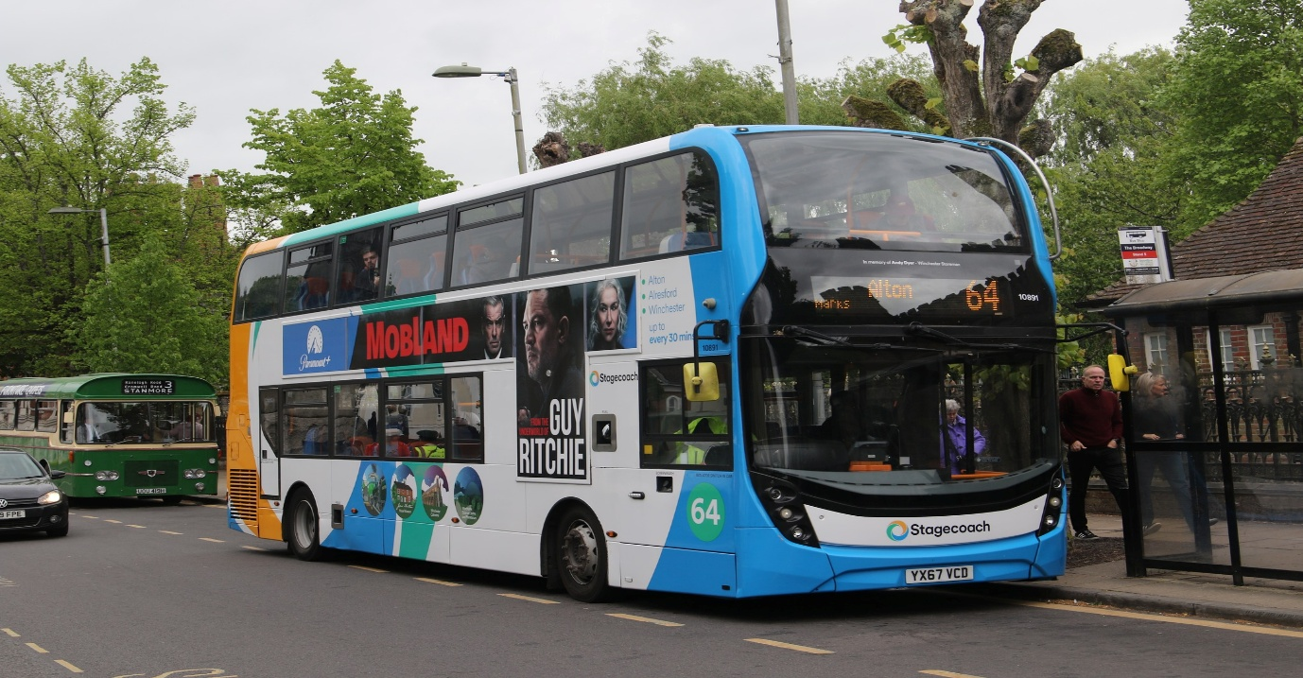
Photo credit to Andy Dyer 10891 YX67VCD Stagecoach South Winchester ADL Enviro400mmc. Named Andy Dyer in memory of someone that worked they with the same name laughing out loud.
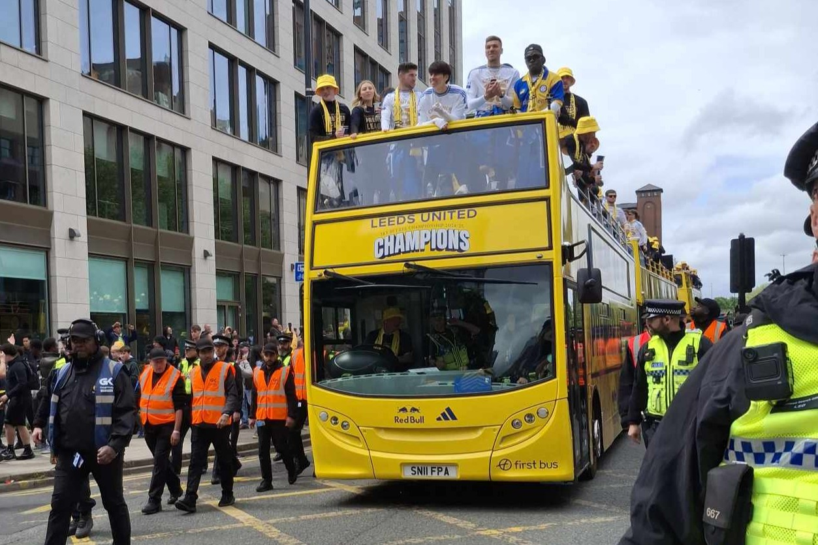
Photo credit to Andy Dyer on behalf of Phillippa Dyer SN11FPA ADL Enviro400 Leeds united celebrations on they promotion to the premier league.
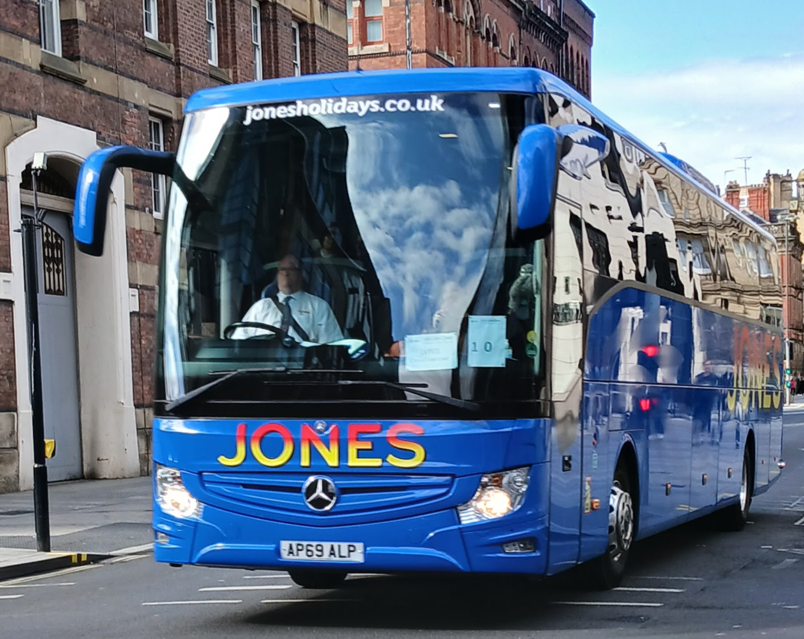
Photo credit to Barry smith AP69ALP Mercedes Benz Tourismo Jones Holidays seen in Liverpool.
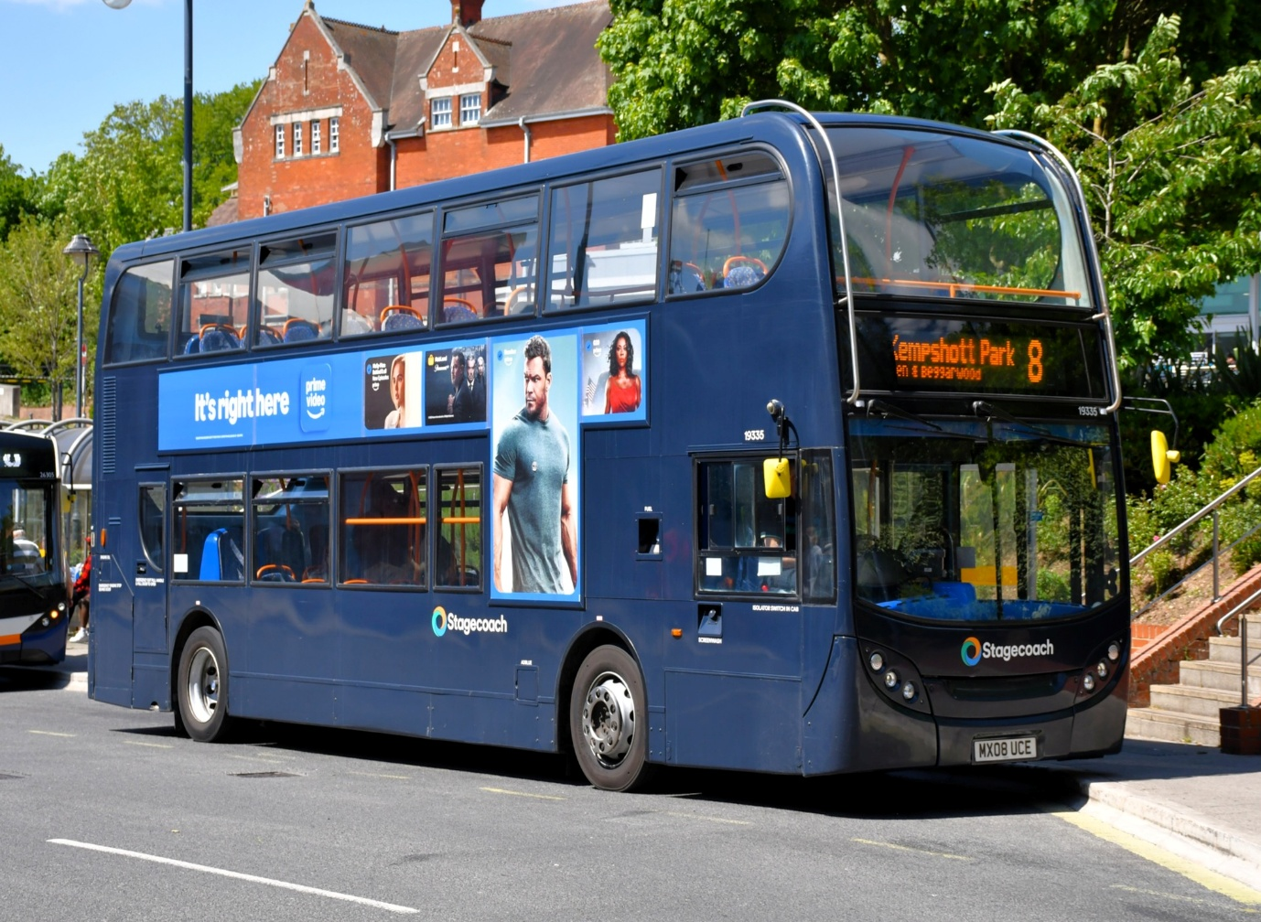
Photo credit to Steve Poole 19334 MX08UCE ADL Enviro400 Stagecoach South Navy colour Basingstoke.
Reminder of fourth coming events
June 2025
Date: | Event
Sunday 1st | Dorking Vintage bus running day
Friday 6th | Acton museum depot open day
Sunday 8th | London bus museum: Route 418 Vintage bus running day from Epsom to Kingston
Sunday 22nd | LBM Brooklands: Summer gathering celebrating Dennis’s buses
Sunday 29th | RTL: Reading buses annual open day at Great Knollys Street
all these to be reported about in the June 2025 newsletter.
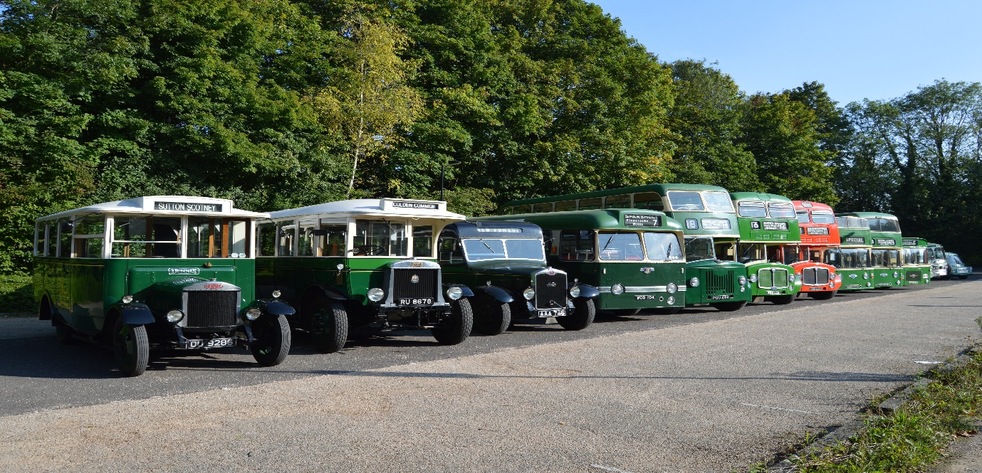
Photo credit to Gary Baxter Administration of GB&CP: Line up of Friend of King Alfred buses at St’ Catherine’s P&R in September 2024.
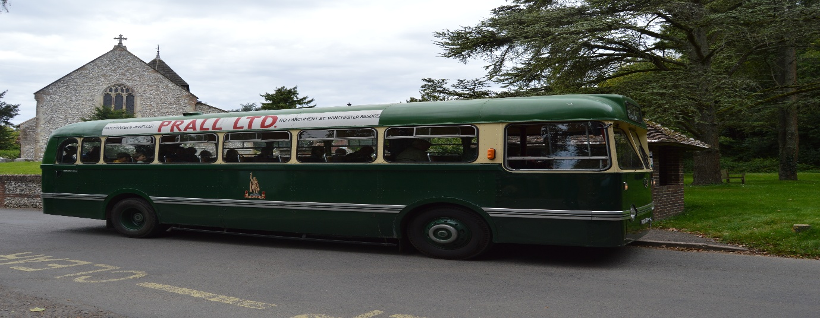
Photo credit to Gary Baxter Administration of GB&CP: Friend of king Alfred bus outside a church outside of Winchester photo taken in September 2024.
Thames Valley diversion of Reading buses
Thames valley buses announced a new route back in March / April 25 when tenders were changing hands. This new route is 704 from Maidenhead to London Heathrow Airport T5. This new route will run approximately on an hourly frequency from Maidenhead to London Heathrow Airport T5, and the same approximately from London Heathrow Airport T5 to Maidenhead. Timetable and front cover below
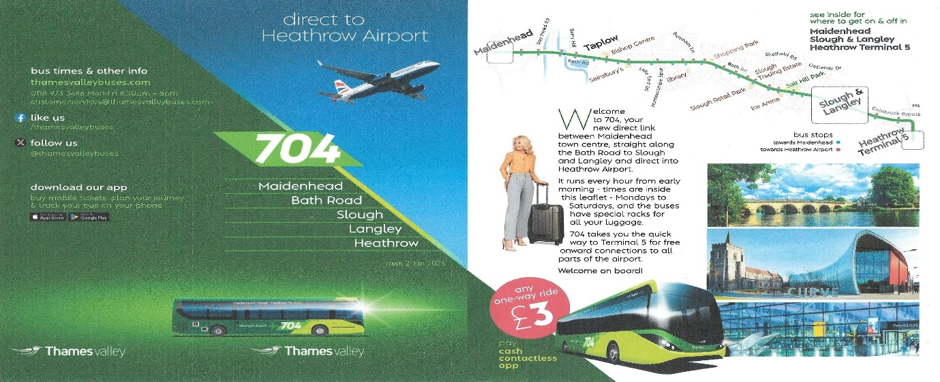
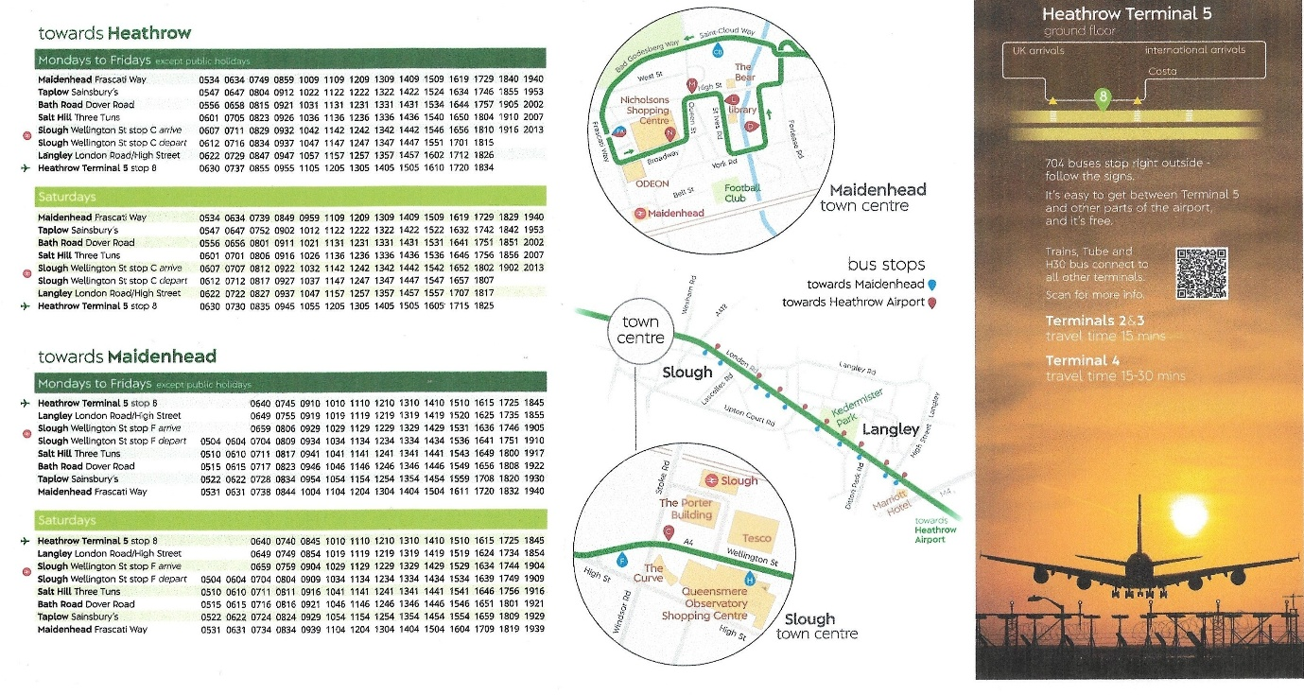
Above is a copy of the timetable leaflet.
It is also reported that two Enviro200mmc’s will come on trial for the route 704, and will remain in white with 704 vinyl or liveried up in dark green and lime green this is not 100% certain and not sure if this will be another part of the Windsor Express 702/3 think that is yet to be confirmed by the operator’s Thames Valley & Reading buses. More about this in June 2025 Newsletter.

Photo of the Month
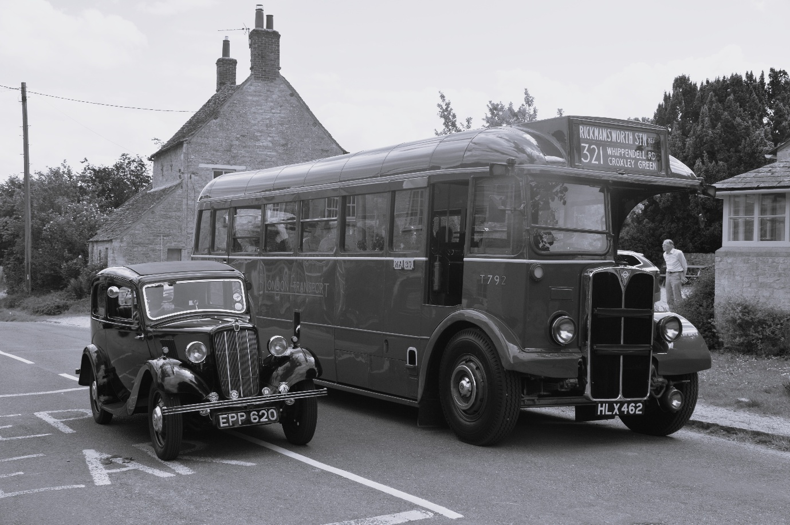
Photo credit & edited by Gary Baxter administration of Gary's Bus & Coach Photos EPP620 Morris Manor & T792 HLX462 London Transport AEC Regal photographed near a church just outside a village in Long Hanborough recreating the 1930's this is my photo of the month for May 2025 in Black & White style images from the 25th, May 2025 can be found at www.flickr.com/photos/garysbusandcoachphotos

