
Month: August 2026 Issue No: 98
This month we attended at the Oxford bus museum in Hanborough Oxfordshire for the grand day out event they were holding to show people want it was like in the 50’s and 60’s travelling by coach from Oxford Gloucester Green coach and bus station to different destinations. on the event day the Locations were Oxford Airport, Freeland’s, Peartree, and Woodstock more about this on page four. This month we also attended at Imberbus in Warminster near Sailsbury Wiltshire for the annual road run to the village of Imber more about this on page four. This month we attended at Cotswolds bus event organised by Dave Bickley with the Reading transport enthusiast club this was an excellent day more about this on page four.
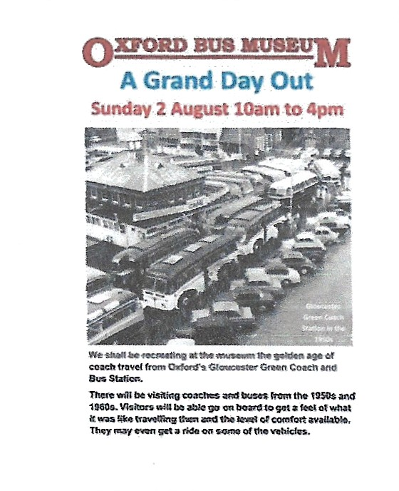

www.flickr.com/photos/garysbusandcoachphotos
Date: | Name: | Link:
2nd August | Oxford bus museum grand day out | https://flic.kr/s/aHBqjD1ung
14th August | Bracknell | https://flic.kr/s/aHBqjD2MPu
15th August | Imberbus Warminster | https://flic.kr/s/aHBqjD2MCh
22nd August | Bracknell | https://flic.kr/s/aHBqjD3g1W
23rd August | Cotswolds bus event | https://flic.kr/s/aHBqjD3cjq
Photo of the month
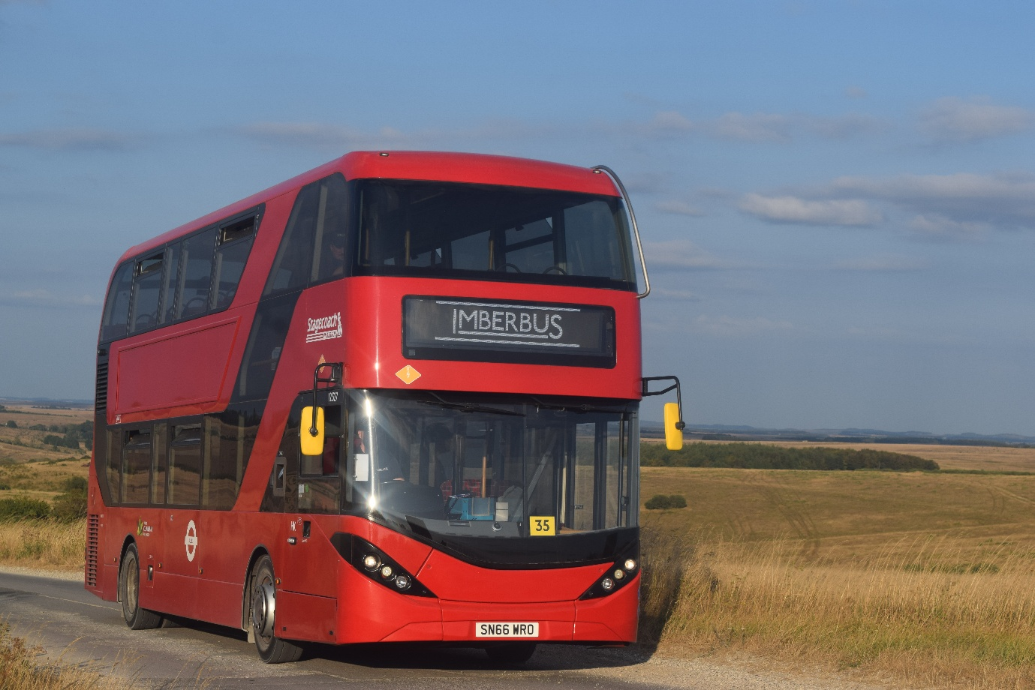
Photo of the month for August 2026 Stagecoach London / Stagecoach Imberbus 12527 SN66WRO ADL Enviro400city at Imberbus Photo Credit Gary Baxter more photos from this found here. https://flic.kr/s/aHBqjD2MCh
Events
www.garysbusandcoachphotos.co.uk
www.classicbuses.co.uk
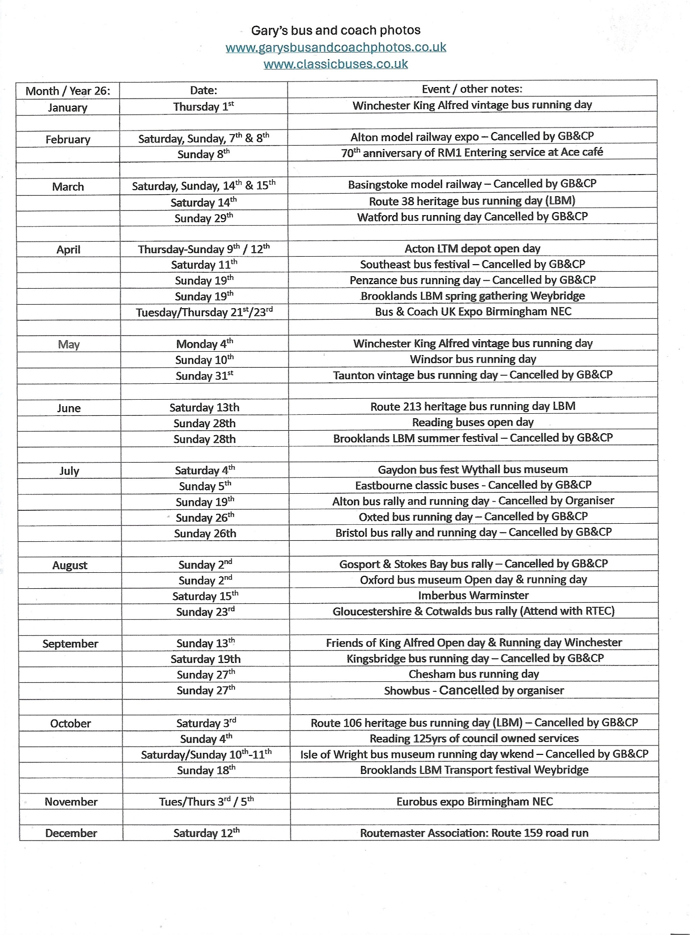
Events attended
Oxford bus museum
This month we attended at the Oxford bus museum grand day out with Theo and Robert Thompson I travelled to the event by train from my local area to the museum in Hanborough in Oxford. The day saw some good rides to the different locations on offering such as Oxford Airport, Freeland’s, Peartree, and Woodstock. It was a lovely day and a good surprise for Theo Thompson even though already sort of known I would be attending. Photos and video from this can be found at www.garysbusandcoachphotos.co.uk or via these links https://flic.kr/s/aHBqjD1ung they is no video from this event just photos.
Imberbus
We were in attendance at the Imberbus event with Robert and Theo Thompson this was a good day with lots of rides around the different locations on the village Imber on the day when arrived at Warminster we queued for the bus to ride straight through to Gore cross where you can interchange buses and ride to different locations on the village of Imber. This event was a fabulous event again the cavalcade was awesome again and did not disappoint one-bit photos and video from this event can be found at www.garysbusandcoachphotos.co.uk or via these links here. https://flic.kr/s/aHBqjD2MCh https://youtu.be/PJpd2jnk3rs?si=WrXxvWck1Zki0743
Cotswolds bus event
We attended this event with the Reading transport enthusiast club now it is the first time we have attended this event I think also it is the first time this event has been on or organised by Dave Bickley. On the day we travelled up to the event we take Robert Williams Optare Vecta in the heritage Reading buses livery the day was great and was a good ride up on the Vecta. Photos and video from this event can be found at www.garysbusandcoachphotos.co.uk or via these links here. https://flic.kr/s/aHBqjD3cjq https://youtu.be/HaTNKKR_Pn8?si=xbX6KAuZQopwKdnw


Last month we reported that Newbury and district received new coaches for the 730/1 service from Basingstoke to London Heathrow Airport this was so and they entered service on the 23rd, July 2026. Fleet numbers and Registration numbers below
Fleet number | Registration number
1430 | YS26UGT
1431 | YS26UGU
1432 | YS26UGV
Along with this news Plaxton panther III’s or two of the Plaxton Panther III’s joined the Flixbus services. The Flixbus services operated under Newbury and district are 044/046 these services operate from London to Gloucester / London to Swansea 046 operates via Bristol and 044 via Cheltenham. The two operating the services or with the vinyl stickers are 1423 YX73MUU and 1424 YX73MUV.

Reading buses withdraw operating route 12 to Twyford from Reading this now has freed a couple of vehicles which were livered for this route and now operate in other locations on the Reading Transport group of companies Fleet number 789 SN16OHG went to Newbury and district and 790 SN16OHH went to Thames Valley to operate on services they to give a spare vehicle and to allow more frequency for Thames valley route 194 from Bracknell to Camberley / Farnborough due school and college term. The 194 now operates every 20 mins during Monday to Friday and Saturday and Sunday every 30 mins.

Reading buses 125-year anniversary event on Broad Street will take place on the 4th, October 2026 from 10am to 16:00hrs.
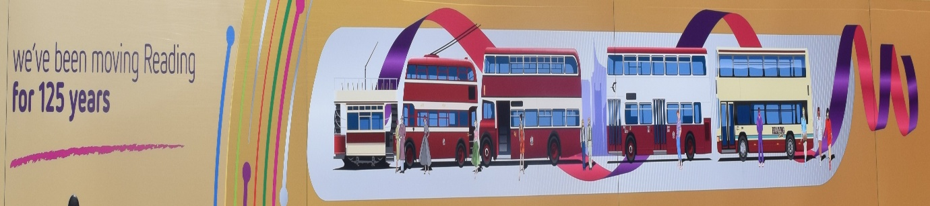

Newbury and district part of the Reading transport group of sister companies is to receive three Irizar I4’s for private hire and school contracts in September or October 2026. Fleet numbers and Registration numbers below here
Fleet Number | Registration numbers
1433 | YT76AOX
1434 | YT76AOY
1435 | YT76AOZ
These are believed to be replacing current coach 1426/7 YX73MVG/H Plaxton Panther III’s Volvo B8R
1423/4 YX73MUU/V on lease to Flixbus for 044/046 services from London to Gloucestershire and Swansea this appears to be only for cover during the summer holidays.

Thames Valley has expanded on route 194 on Monday to Friday buses will be every 20 minutes Saturday and Sunday’s buses will every 30 minutes. To be able to expand on this route Reading buses has transferred one of its vehicles over to the Thames valley fleet this being 790 SN16OHH ADL Enviro400mmc this bus is ex branded route 12 from Reading buses. June / July and August saw induction of new timetable booklets for all routes and 194 branded booklets to advertise all new timings for the route 194 so out of term time the route 194 will not operate to Farnborough it will only operate to Farnborough during the term time all this can be found in the route 194 branded booklet.

YouTube
We have been looking at ideas on how to expand our YouTube channel one of the ideas that came across was to do podcasts of different sorts. We have sent out letters to our supporters for there interest in taking part in this type of thing for my channel to bringing up the subscribers of the channel. This is to expand on what we can offer all our previous productions can be found on our channel at www.youtube.com/garysbusandcoachphotos our channel has been going for some time now and we have just reached 197/8 subscribers so bringing this over the K mark would be good. I know we have not been putting many videos out at moment, but the weather has been overly warm and not been able to focus on the work for this. So, we are looking forward to working with our supporters to bringing some videos from behind the scenes at their workplace and hopefully doing a podcast or video podcast with them. This might happen in late 2026 or early 2027.

www.youtube.com/@garysbusandcoachphotos
for all our vlogs, podcasts and event videos
thanks to everyone who has subscribed so far.
www.youtube.com/@garysbusandcoachphotos
Facebook Group member photos
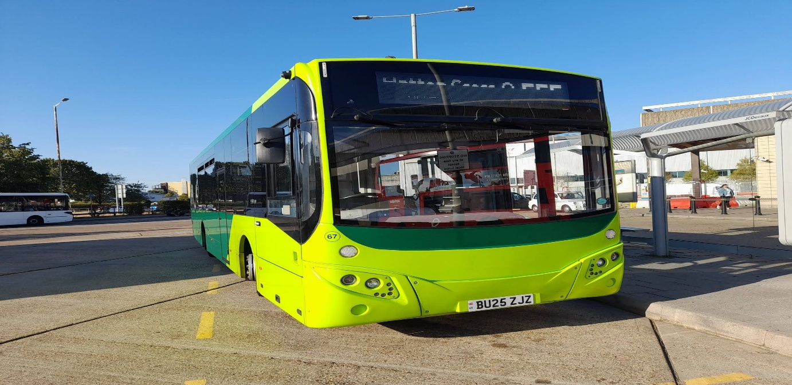
Photo credit to Alican Reilly member of Gary's bus and coach photos Whitebus Rowgate group 67 BU25ZJZ Volvo B8RLE Evoseti.
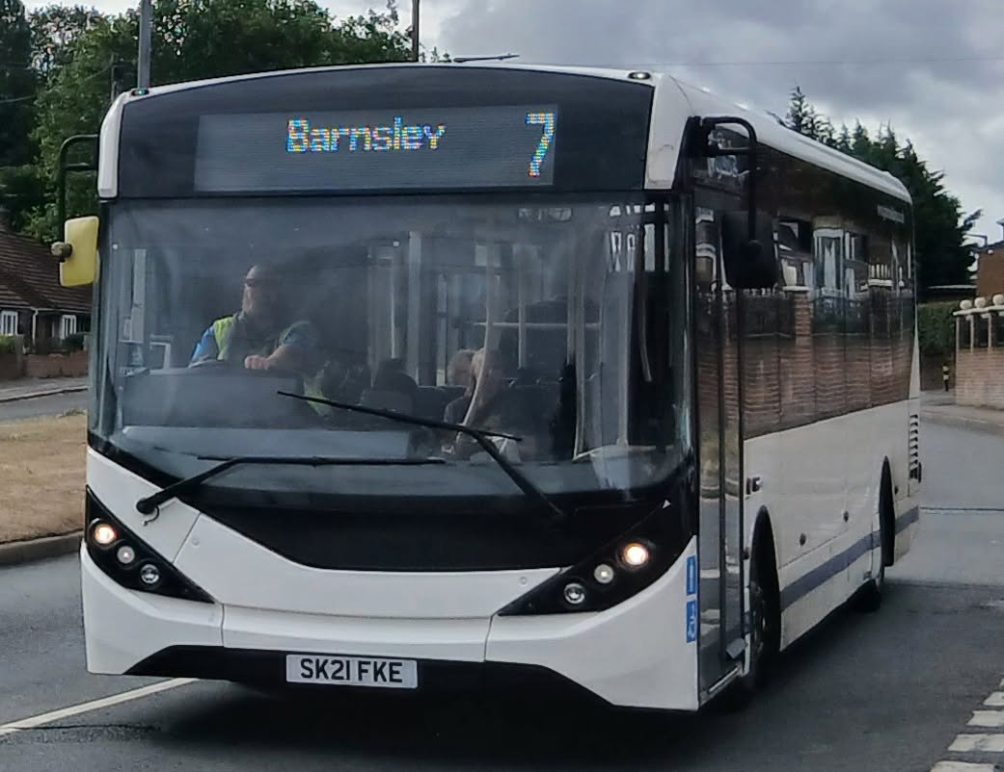
Photo credit to Barry Smith member of Gary's bus and coach photos Globe of Barnsley 1212 SK21 FKE ADL Enviro200 MMC Previous reg EX21 ONE seen here in Barnsley 20-08-26.
www.facebook.com/@garysbusandcoachphotos
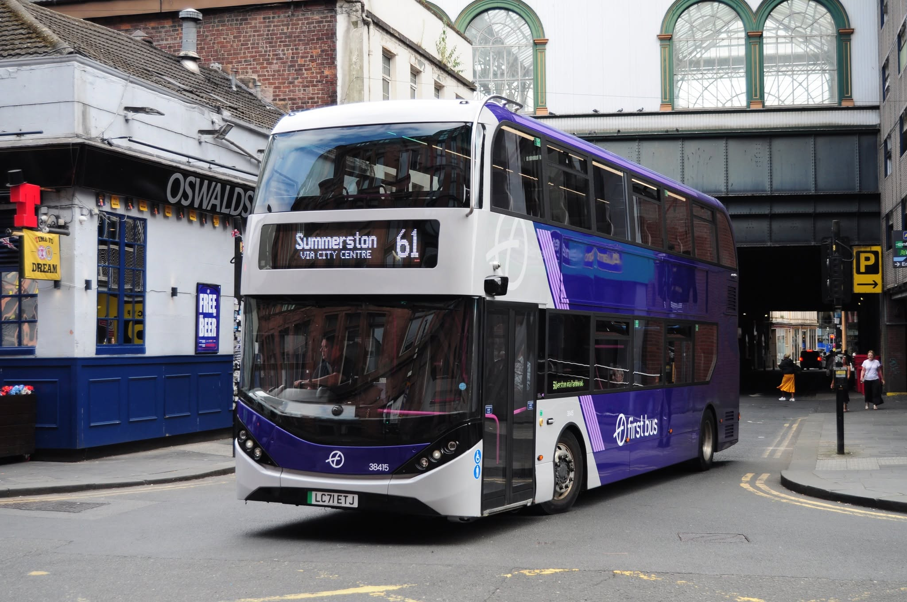
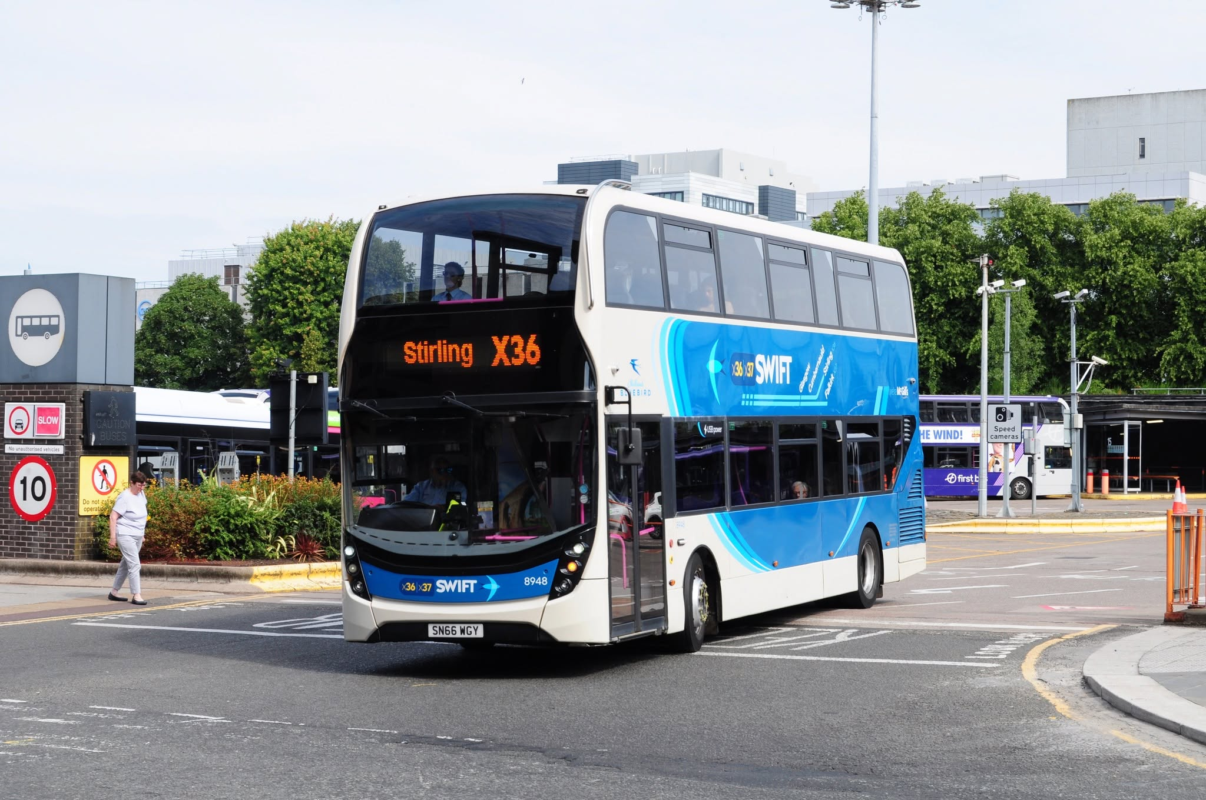
Photo above: Photo credit to Anthony Moore member of Gary's bus and coach photos 38415 LC71ETJ ADL Enviro400city First Bus Glasgow.
Photo below: Photo credit to Anthony Moore member of Gary's bus and coach photos 8948 SN66WGY ADL Enviro400mmc McGill’s buses.
Flickr Friends
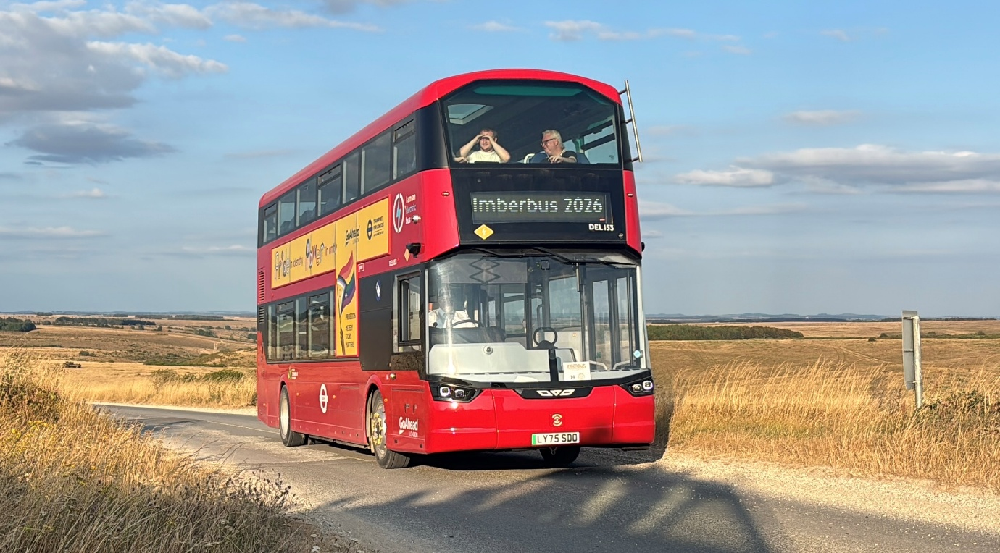
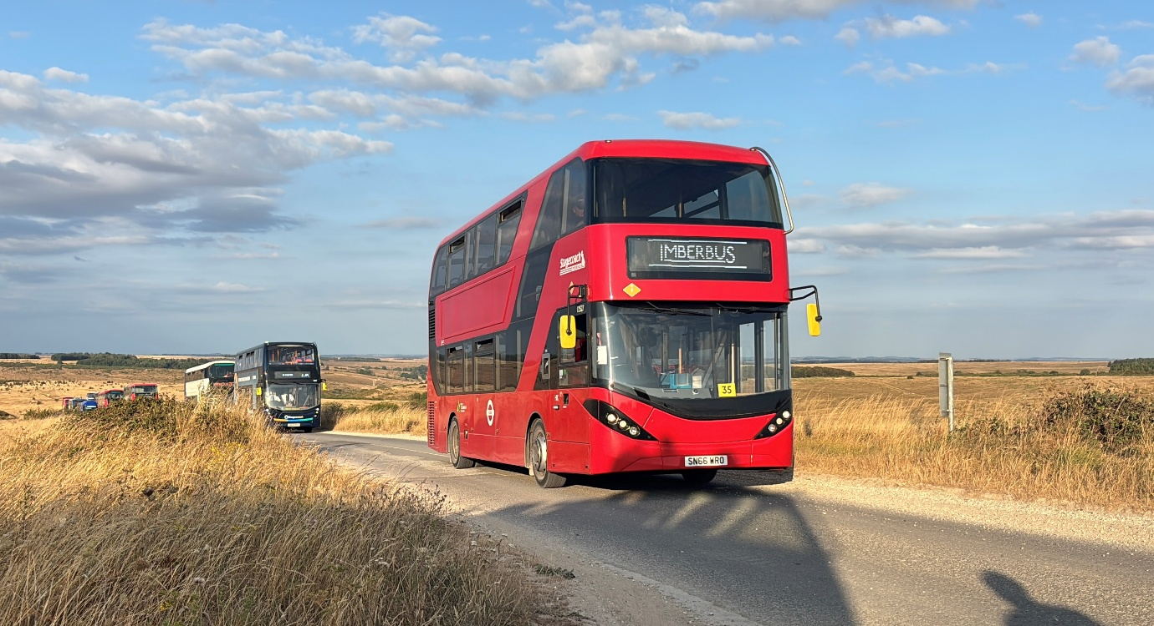
Photo above: Photo credit to Theo Thompson member of Gary's bus and coach photos & Flickr friend Del153 LY75SDO Wrightbus Electricliner at Imberbus August 2026
Photo below: Photo credit to Theo Thompson member of Gary's bus and coach photos and Flickr friend 12527 SN66WRO ADL Enviro400city Stagecoach London with Stagecoach Imberbus
https://www.flickr.com/photos/199041540@N05
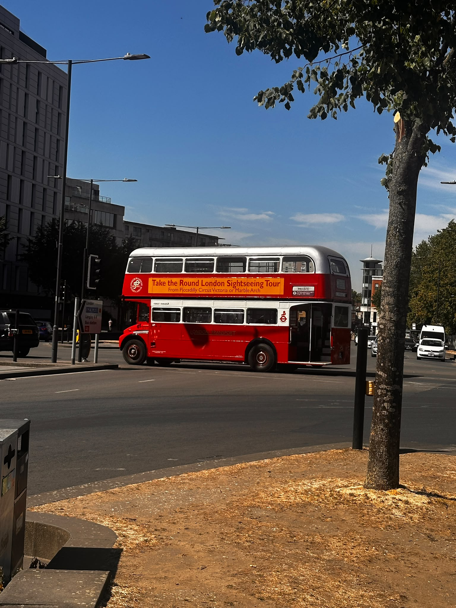
Photo credit to Dorothy Rose Baxter Administration of Gary’s bus and coach photos: RML2116 CUV116C photographed in Slough Berkshire in July / August 2026 original person of photo was a good friend called Tim mystery.
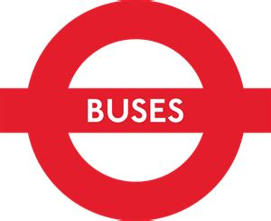
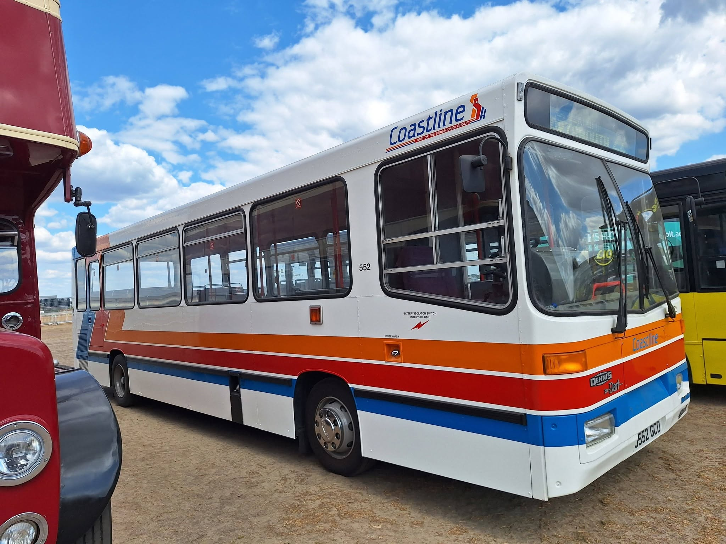
Photo credit to James Rayburn J552GCD Alexander Dennis Dart Dash at Farnborough British motor show.
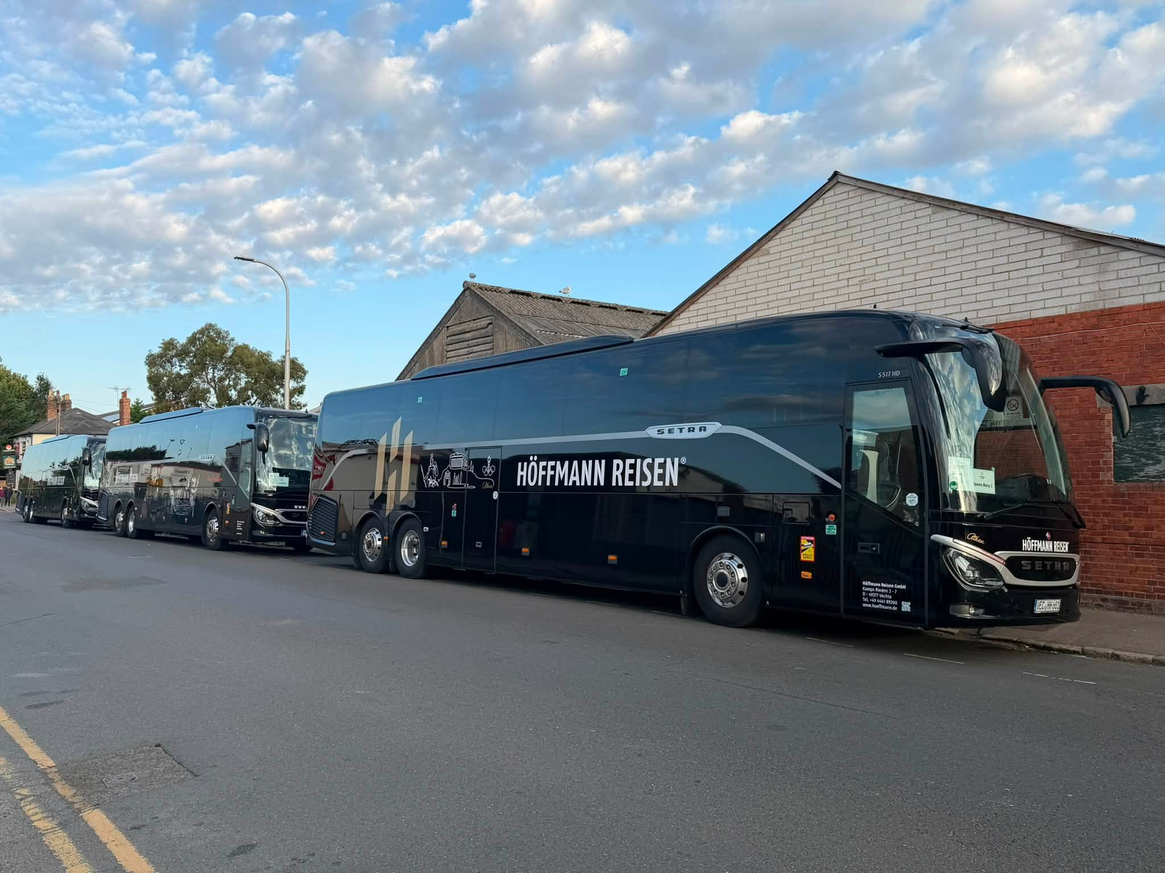
Photo credit to Gary Baxter Administration of Gary’s bus and coach photos: VEC-HH-681, 23, 75 parked up in Great Knollys Street Reading Berkshire on Sunday 23rd August 2026 Photo taken with iPhone 17Pro.
www.flickr.com/photos/garysbusandcoachphotos
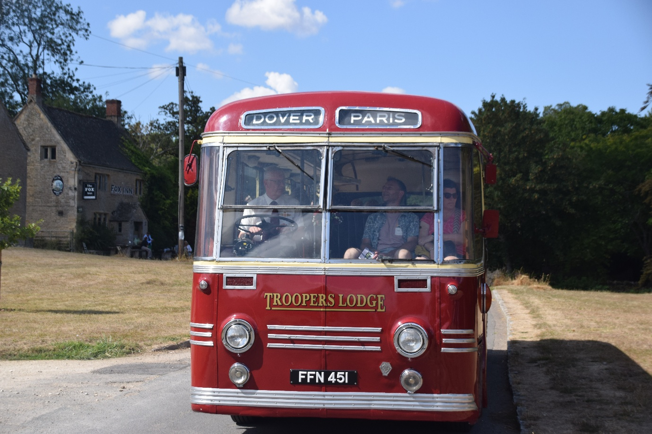
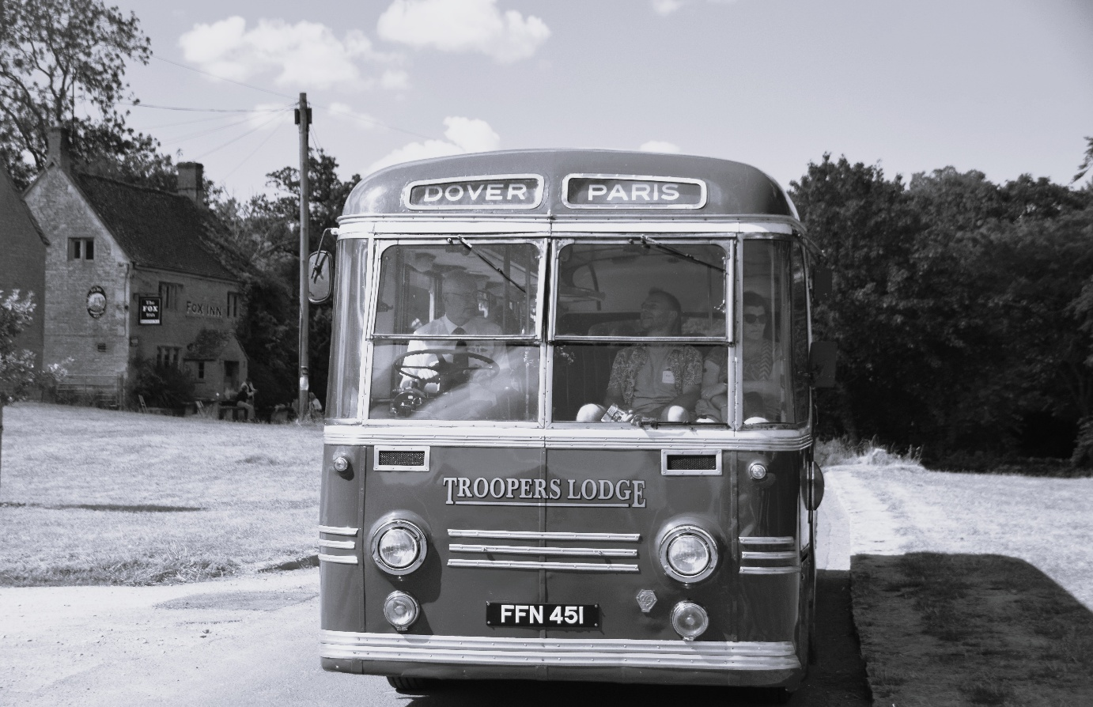
Photo above: Photo credit to Gary Baxter Administration of Gary’s bus and coach photos: FFN451 photo taken at the Cotswolds bus event on the 23rd, August 2026.
Photo below: Photo credit / edit to Gary Baxter Administration of Gary’s bus and coach photos: FFN451 photo taken at the Cotswolds bus event on the 23rd, August 2026 edited on the personal computer to black and white to give an Authentic look.
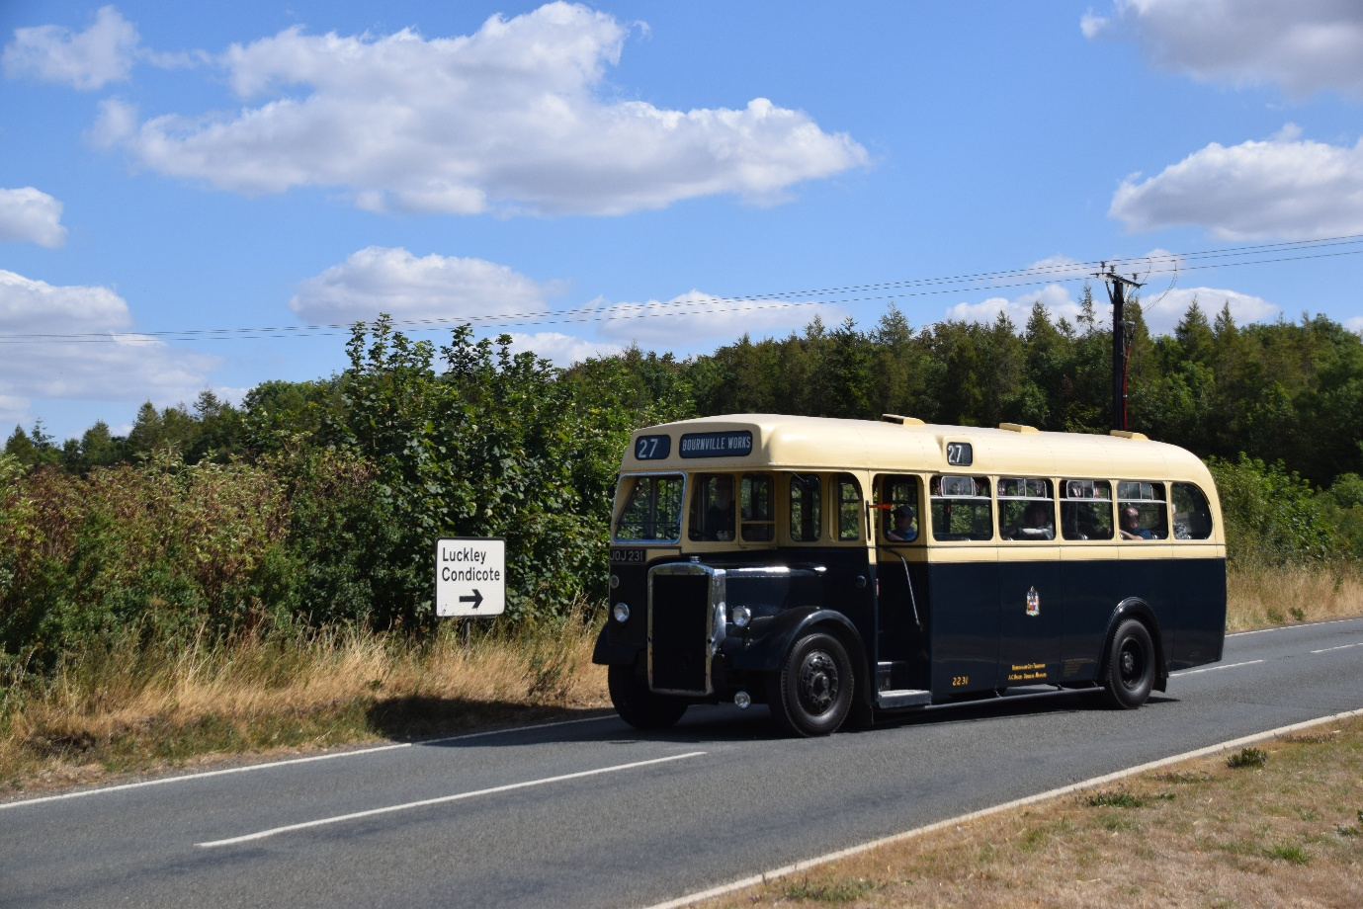
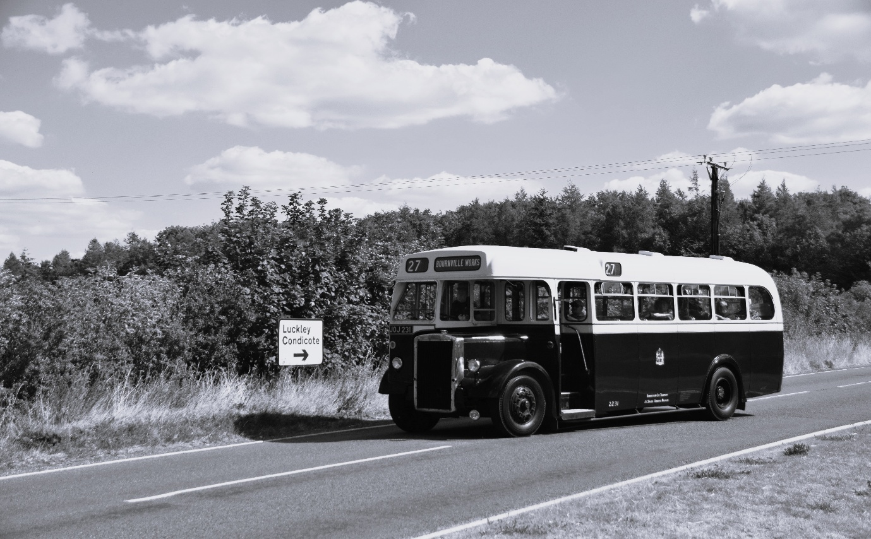
Photo above: Photo credit to Gary Baxter Administration of Gary’s bus and coach photos: Photo of JOJ251 at the Cotswolds bus event on the 23rd, August 2026.
Photo below: photo credit to Gary Baxter Administration of Gary’s bus and coach photos JOJ251 at the Cotswolds bus event on the 23rd, August 2026 edited to the Black and white to the authentic look. Edited on personal computer.
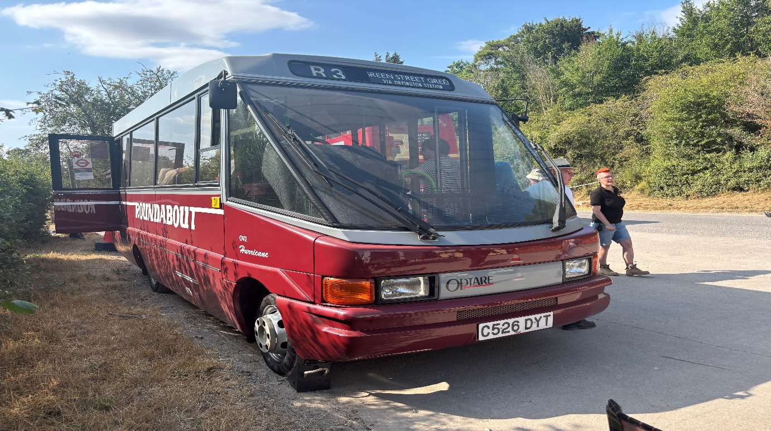
Photo credit to Theo Thompson member of Gary's bus and coach photos and flickr friend OV2 C526DYT Optare Hurricane TFL Roundabout.
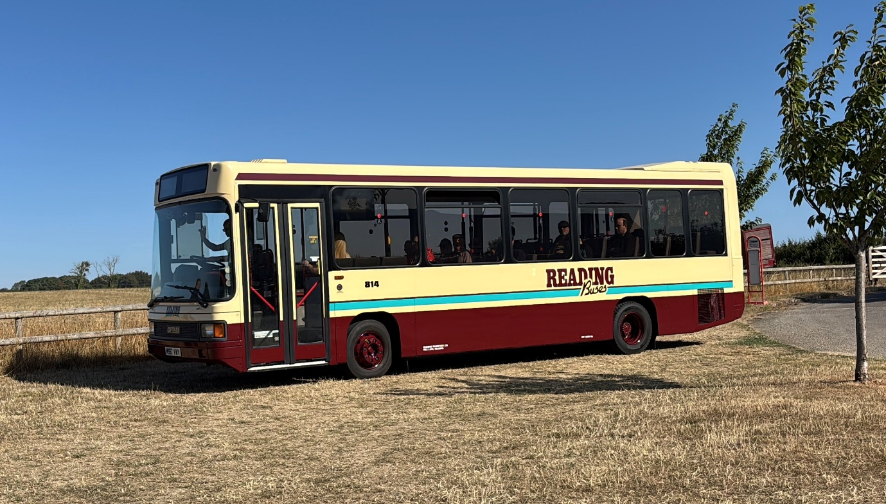
Photo credit to Theo Thompson member of Gary's bus and coach photos and flickr friend Reading buses 814 M957VWY Optare Vecta at Cotswolds
Reading buses this month also introduced ADL Enviro400mmc’s on to the Orange 13/14 route to replace the Streetdecks after 901 was damaged in an accident the MMC’s to replace these are 752/758 RG52BUS/58BUS registration plates.
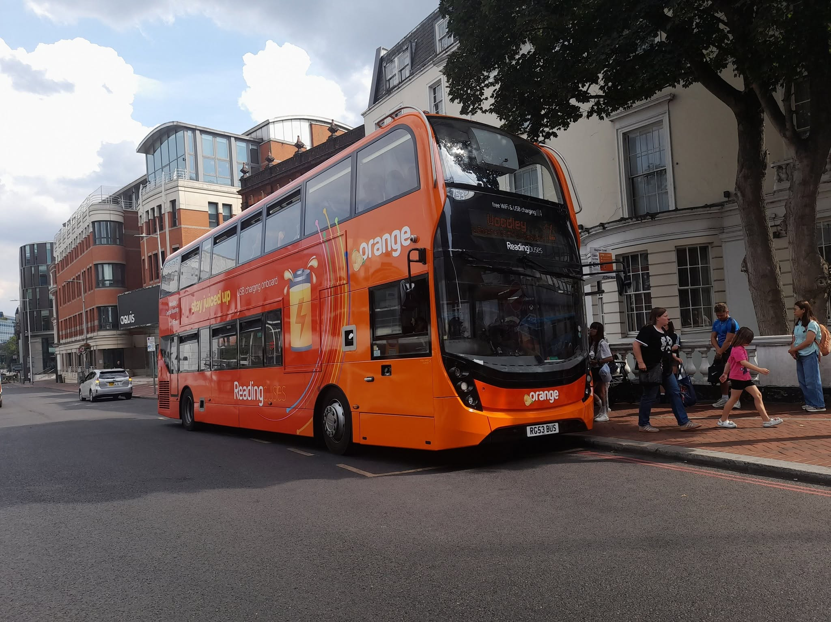
Photo credit to Alican Reilly member of Gary's bus and coach photos Reading buses 753 RG53BUS in new orange livery.

