
Month: July 2026 Issue No: 97
This month we attended at the Wythall transport museums event at British motor museum in Gaydon near Leamington spa in the midlands. We attended this event with our good friends Theo and Robert Thompson this was a good day with some nice weather more about this on page seven and maybe more of exaltation on later page.
www.facebook.com/groups/garysbusandcoachphotos
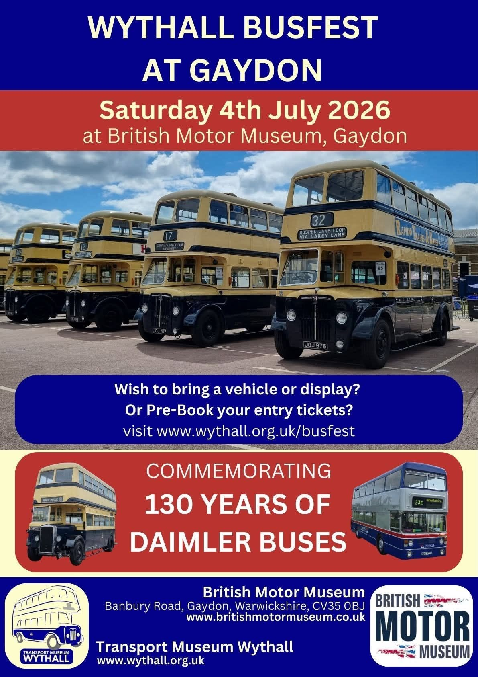

www.flickr.com/photos/garysbusandcoachphotos
Date: | Name: | Link:
28th June 2026 | Reading buses open day | https://flic.kr/s/aHBqjCY7A3
4th July 2026 | Gaydon Wythall bus fest | https://flic.kr/s/aHBqjCYuMx
13th July 2026 | Camberley | https://flic.kr/s/aHBqjCYY5W
22nd & 23rd July | Farnborough & Camberley | https://flic.kr/s/aHBqjCZKKT
27th & 28th July 2026 | Camberley, Bracknell & Reading | https://flic.kr/s/aHBqjD1jgg
Photo of the month
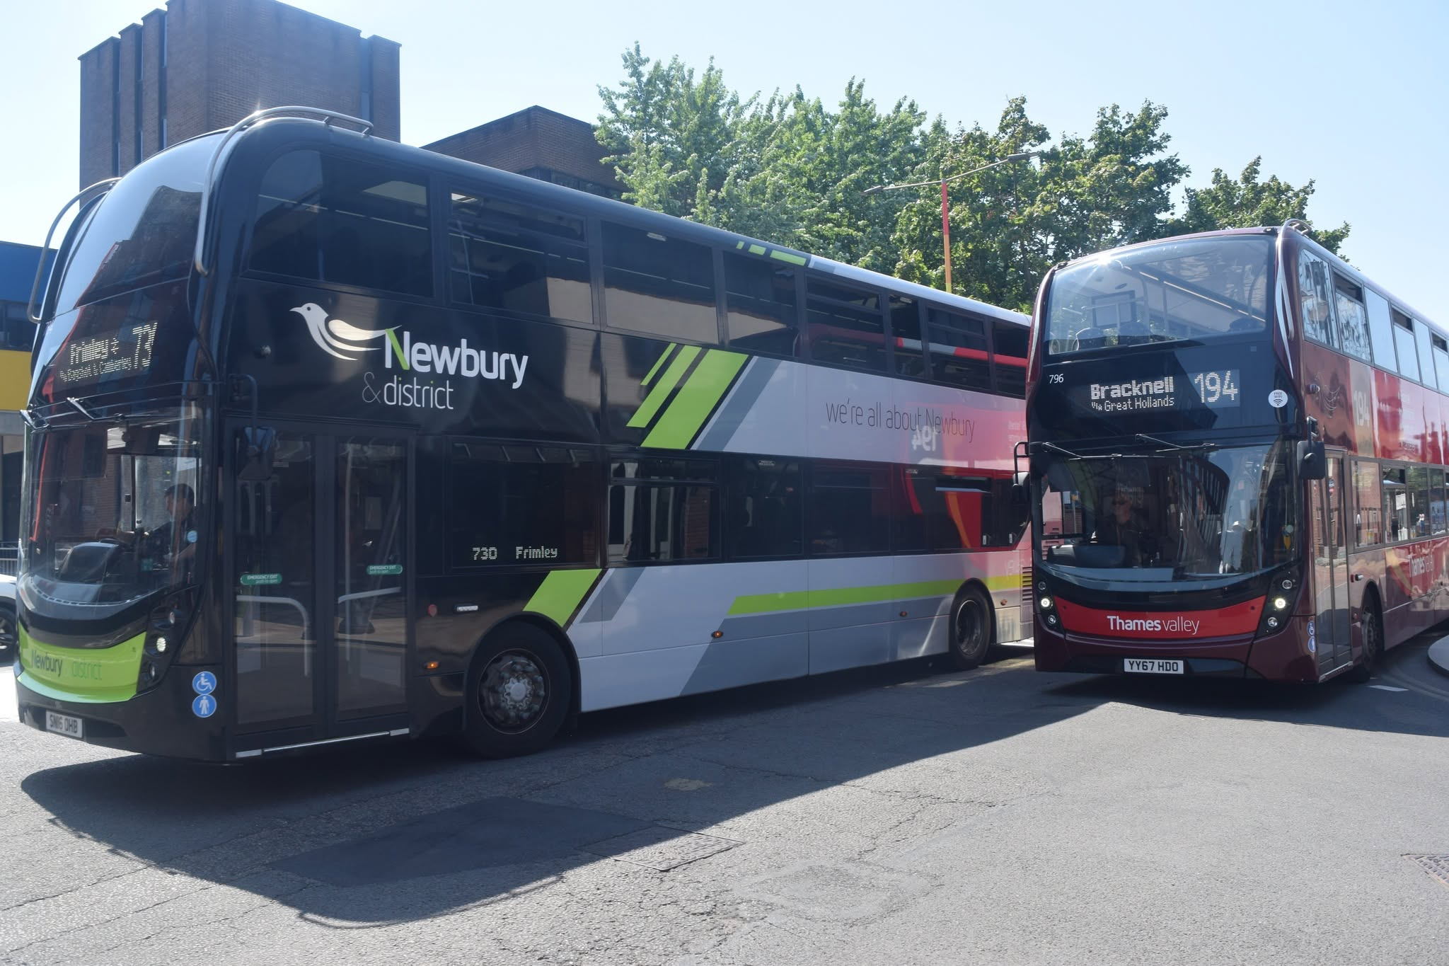
Photo credit to Gary Baxter Administration of Gary's bus and coach photos; ND784 SN16OHB & 796 YY67HDO ADL Enviro400mmcs photo of the month for July 2026 more photos found at www.garysbusandcoachphotos.co.uk/social-media album link here https://flic.kr/s/aHBqjCYY5W
Gary’s bus and coach photos: Events diary
Events diary can be found on our website at www.garysbusandcoachphotos.co.uk for downloadable version for more reliable information on events go to www.classicbuses.co.uk.
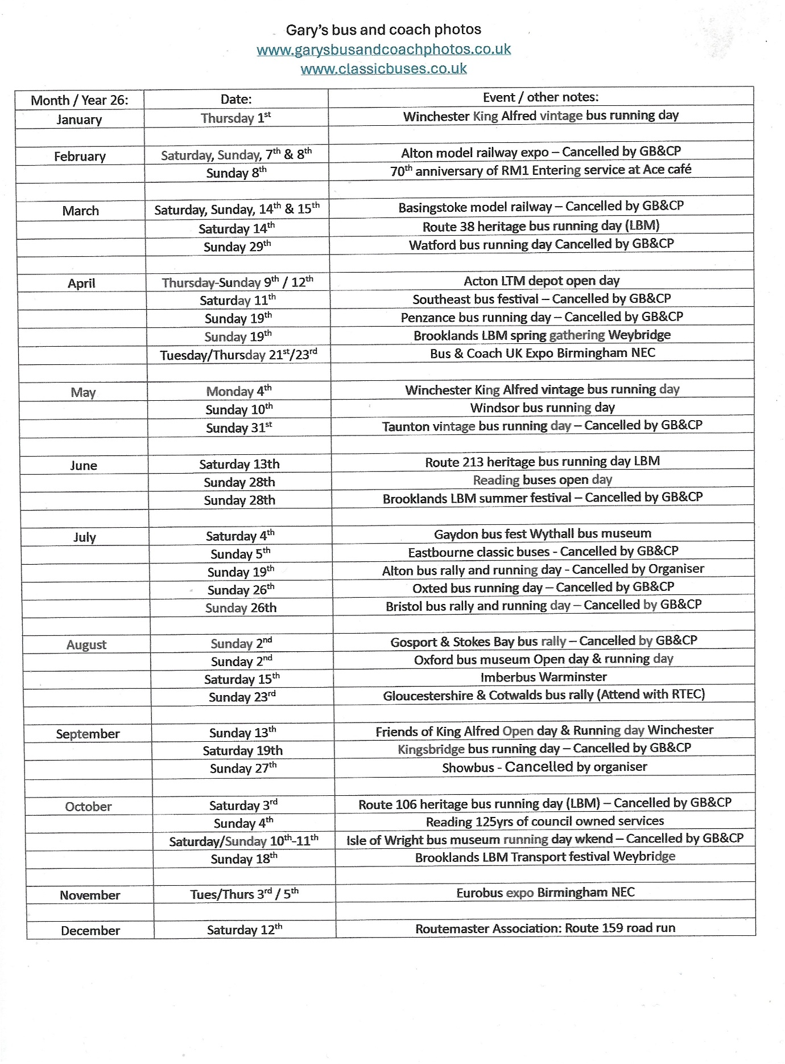

Last month we reported on Reading buses receiving new buses for route twenty-six from Reading to Ikea Calcot these buses entered service on and around the 1st, June 2026.
Fleet no | Reg no | Body | Engine | Branded | Date:
25 | RG25ZEB | Enviro400EV | Alexander Dennis | Yellow 26 | 01/06/26
26 | RG26ZEB | Enviro400EV | Alexander Dennis | Yellow 26 | 01/06/26
27 | YX26JZG | Enviro400EV | Alexander Dennis | Yellow 26 | 01/06/26
28 | YX26JZH | Enviro400EV | Alexander Dennis | Yellow 26 | 01/06/26
29 | YX26JZJ | Enviro400EV | Alexander Dennis | Yellow 26 | 01/06/26
30 | YX26JZK | Enviro400EV | Alexander Dennis | Yellow 26 | 02/06/26
31 | YX26JZL | Enviro400EV | Alexander Dennis | Yellow 26 | 01/06/26
32 | RG26BUS | Enviro400EV | Alexander Dennis | Generic | 02/06/26

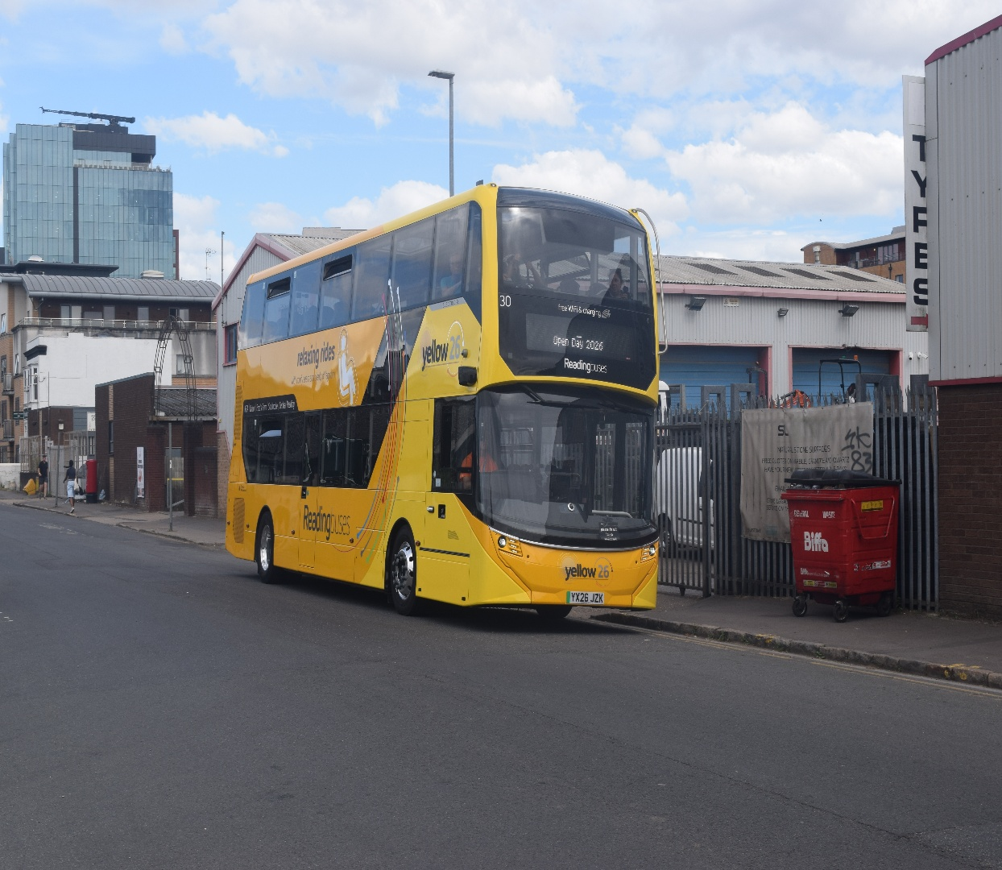
Photo credit to Gary Baxter Administration of GB&CP; Reading buses 30 YX26JZK ADL Enviro400EV branded route 26. Photographed while at Reading buses open day on the 28th, June 2026.

Newbury and district sister company to Reading buses have taken delivery of new coaches for Flightline 730/1 from Basingstoke to London Heathrow Airport. this company sees three new Irizar coaches being added to the fleet for the flightline operation. They is also believed to be another three of these Irizar’s coming in September / October 2026. For the operations.
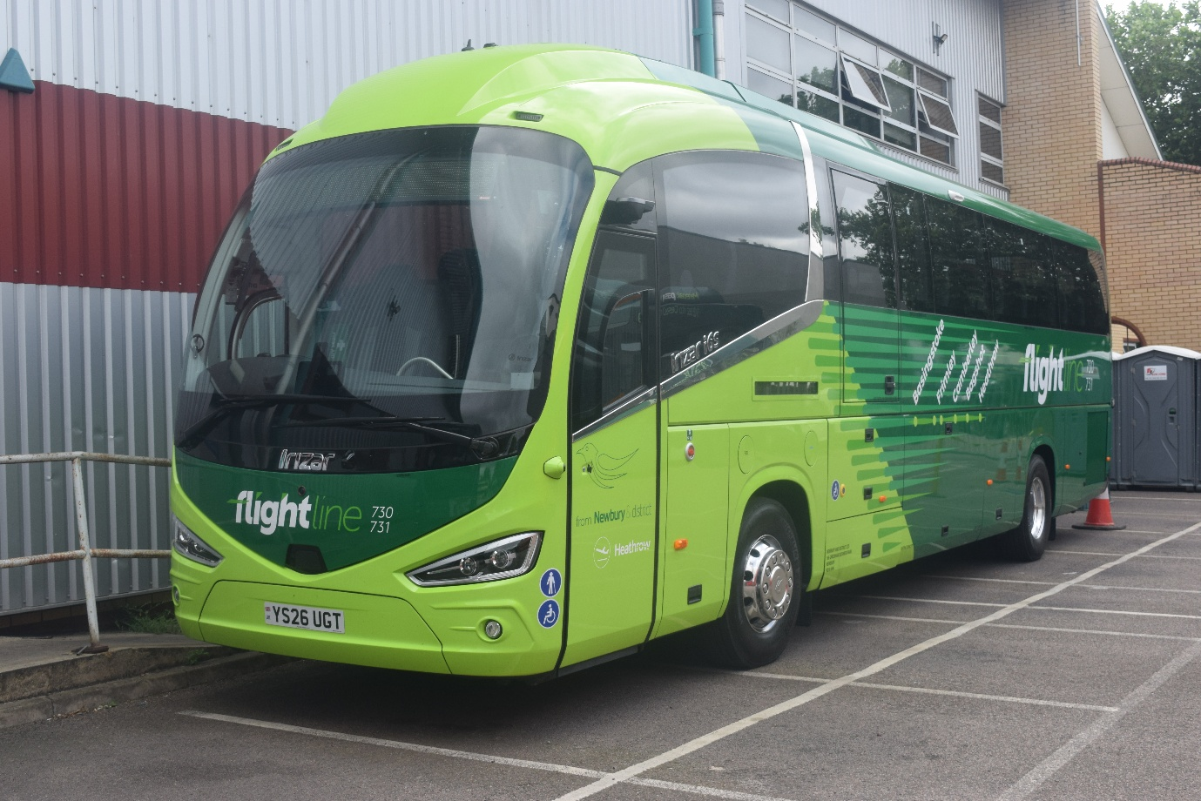
Photo credit to Gary Baxter Administration of Gary’s bus and coach photos: YS26UGT Irizar I6s at the Reading buses open day 2026 three of these are for the flightline 730/1 to London Heathrow Airport from Basingstoke.


Last month saw us add a supporter for the Gary’s bus and coach photos community this was announced on our social media and the logo above is the new supporter of us. This is the Thames valley and great western omnibus trust. We’d like to thank them for coming aboard as a supporter. Last month also saw us travel to Basingstoke for the Royal blue run from Basingstoke to Taunton on the first day to photograph the coaches leaving from the milestone’s museum in Basingstoke. It was a lovely turn out of all the vintage coaches take part in this three-day weekend tour of the southeast or west of England. Video and photos from this found on website at www.garysbusandcoachphotos.co.uk or via these links https://flic.kr/s/aHBqjCXntB https://youtu.be/WCHdBTgCmfs?si=rU0n4oHu0RsInz5W
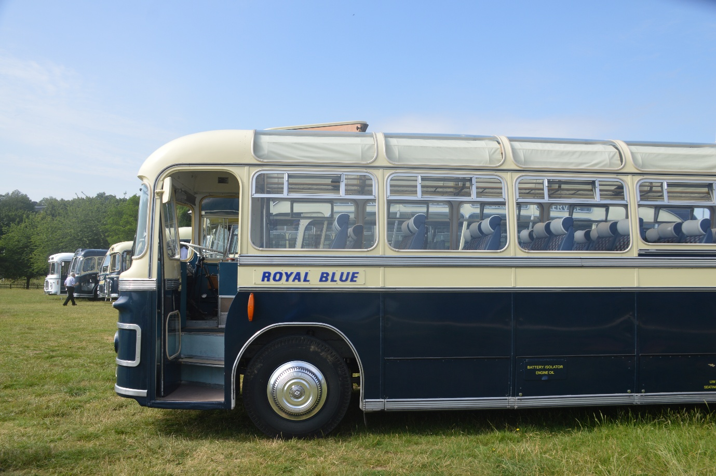
Photo credit to Gary Baxter Administration of Gary’s bus and coach photos: Royal blue coaches at Basingstoke Milestone’s museum heading off for Taunton on the 19th, June 2026. On a three-day tour of the southwest of England.
Gaydon Wythall bus festival
We attended at the Gaydon Wythall bus festival on the 4th, July 2026. We attended this event with Robert and Theo Thompson his son it was a lovely day with some lovely weather we also caught up with our friends at TTC-Diecast we take over thousand photos on this day now for not being they for such a long time it was good. The day we had couple rides on buses and coaches they were doing trips. One trip we went on went to place Kineham this trip was done on Duple 420 then when that arrived back at Gaydon Theo and Robert went off on West Midlands bus and went off on an open topper bus ride. The day was a good finish and some good memories made with these guys again. Photo album from this event found at www.garysbusandcoachphotos.co.uk or by going to this link https://flic.kr/s/aHBqjCYuMx Video from this event provided by Theo Thompson bus enthusiast channel on YouTube link here https://youtu.be/cd_CdMPVk78?si=973evlrn8F0hpB7S https://youtu.be/BSYGVSzVmRI?si=0SPYMJsn16mKhJEL. It was also good to see Hampshire bus liveried Leyland Olympian at this event Registration F602MSL
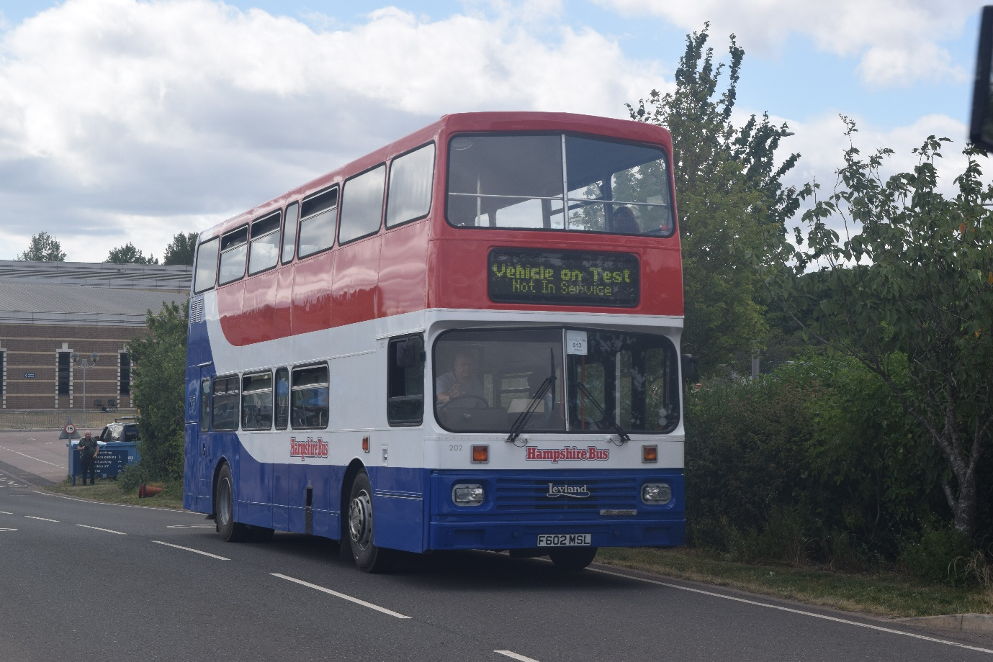
Photo credit to Gary Baxter Administration of Gary’s bus and coach photos F602MSL Leyland Olympian Hampshire bus liveried at Gaydon Wythall bus fest on the 4th, July 2026.

The celebrations for the Reading Transport limited company anniversary of 125 years still coming along the 4th, October 2026 they will be another event held on the Broad Street in Reading with buses running on different routes of Reading and a static display of buses from the early years up until now. Looking back at the past of Reading Transport right up until now with the static display and enjoy some fantastic rides round the local area and explore the history while exploring. When Reading started out it was at Mill Lane in the early 1900’s then when council announced it was going to be building / redeploying Mill Lane to build a shopping centre called the Oracle Reading buses was moved to Great Knollys Street.
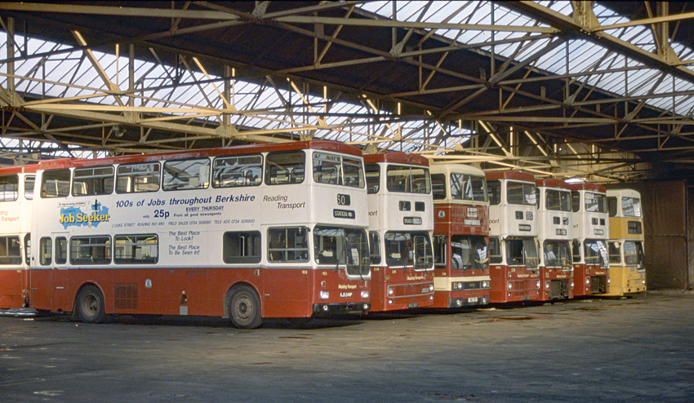
Photo credit to Robert Willams (BusZone) Mill Lane bus depot.
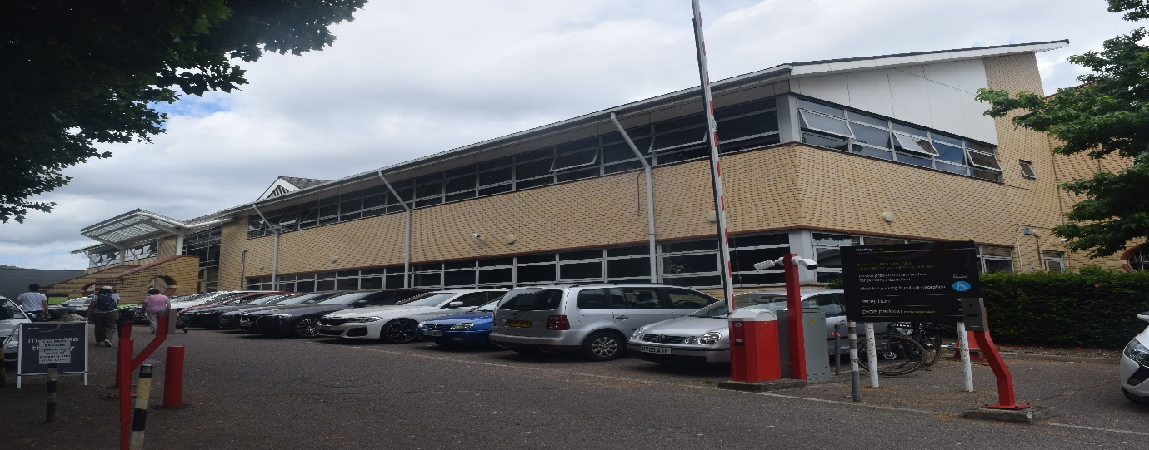
Photo credit to Gary Baxter Administration of Gary’s bus and coach photos: front entrance to the Reading buses depot in Great Knollys Street.
At the old Mill Lane depot where the Oracle is they is now a plaque in place and in general you can past this has buses don’t go past this on general routes.
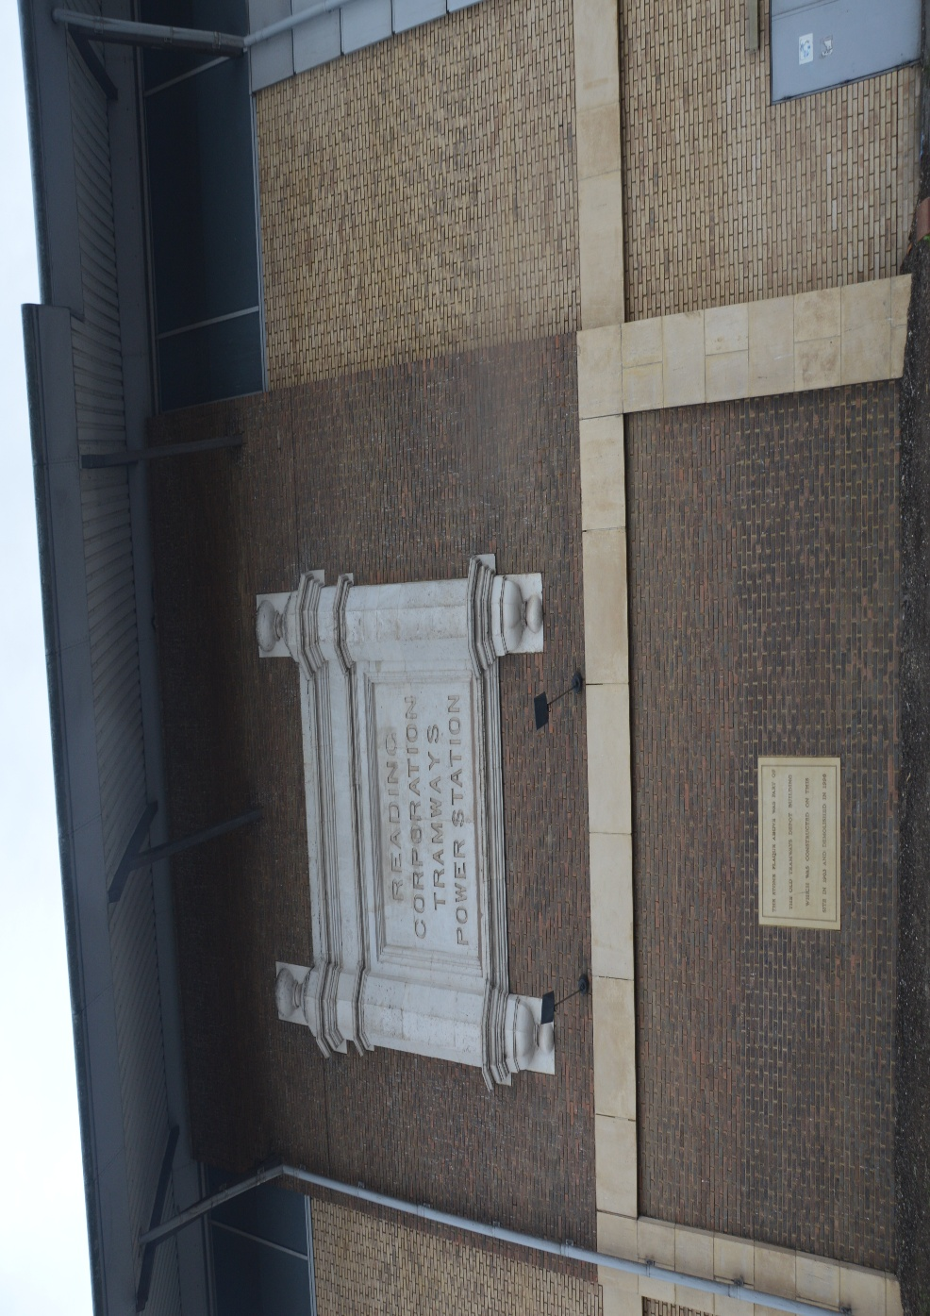
Photo credit to Gary Baxter Administration of Gary’s bus and coach photos: Reading Corporation Tramways power station. Reading Corporation / Reading buses was here from 1901 till 1998 when the council announced it was to be redeployed to make way for the Oracle cinema and shopping complex.
Newbury and distract new coach for route 730/1 from Basingstoke to London Heathrow Airport are Scania Irizar I6s. these are believed to be replacing the Volvo B8R’s. Fleet numbers and Registration numbers below here.
Fleet Number | Registration | Make | Date:
1430 | YS26UGT | Scania Irizar I6s | 22/07/2026
1431 | YS26UGU | Scania Irizar I6s | 22/07/2026
1432 | YS26UGV | Scania Irizar I6s | 27/07/2026

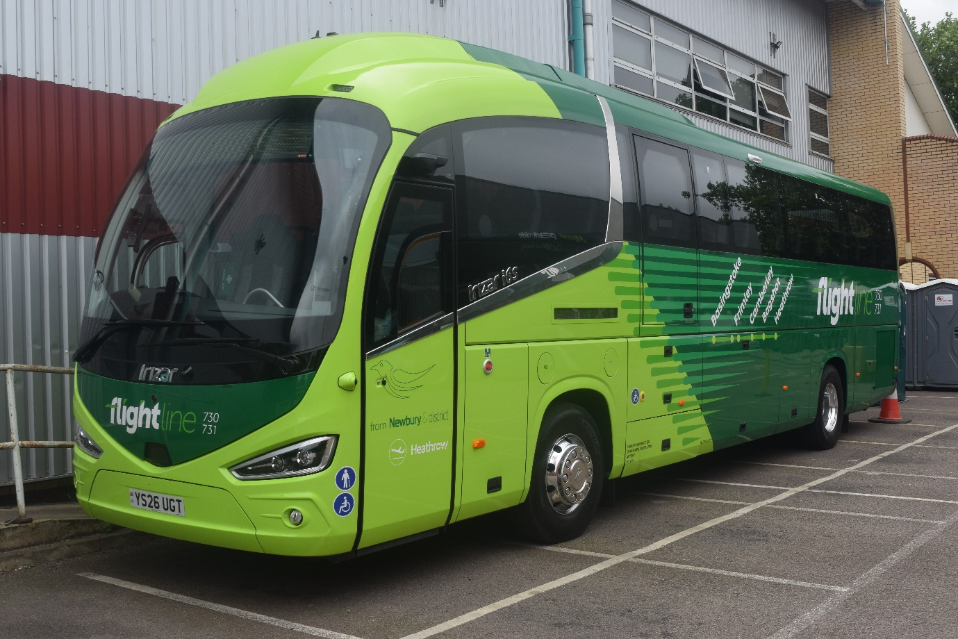
Photo credit to Gary Baxter Administrator of Gary’s bus and coach photos: Newbury and district 1430 YS26UGT Scania Irizar I6s on display at the Reading buses annual open day on the 28th, June 2026.

This month it was announced that there will be changes to the 194 in a way of timings from Monday to Friday, Saturday and Sunday timings Monday to Saturday will see buses running every 20mins throughout the day and on Sunday buses will run every 30mins timetables will be made available at www.thamesvalleybuses.com near to the time the changes will take effect on the 2nd, August 2026. More about timings on page 17 to 20.
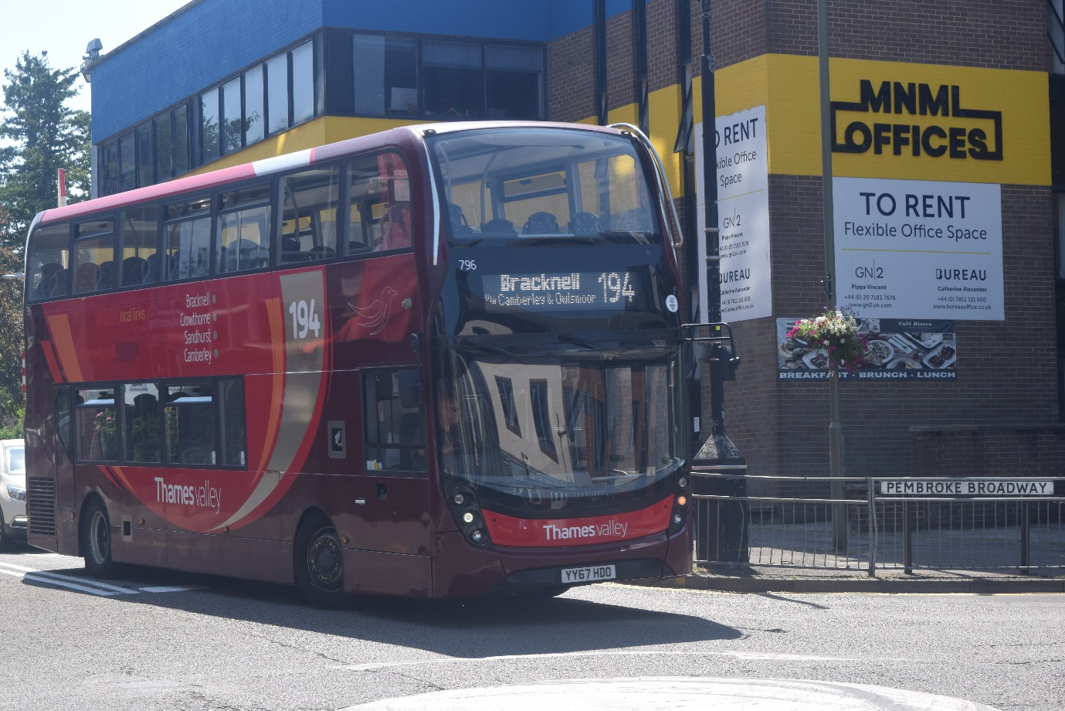
Photo credit to Gary Baxter Administrator of Gary’s bus and coach photos Thames Valley 796 YY67HDO ADL Enviro400mmc arriving at Camberley from Farnborough college on the 12:50ish on the 13th, July 2026.

Friends Flickr / member of Gary’s bus and coach photos
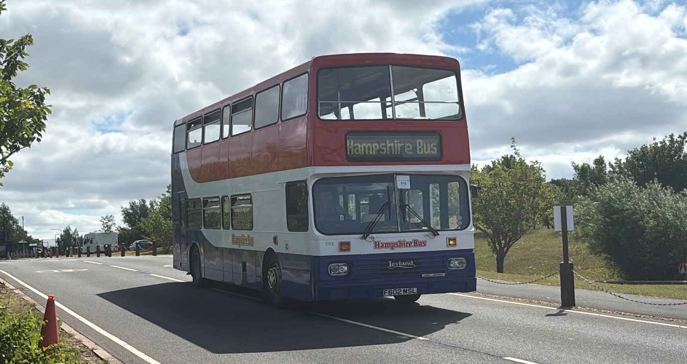
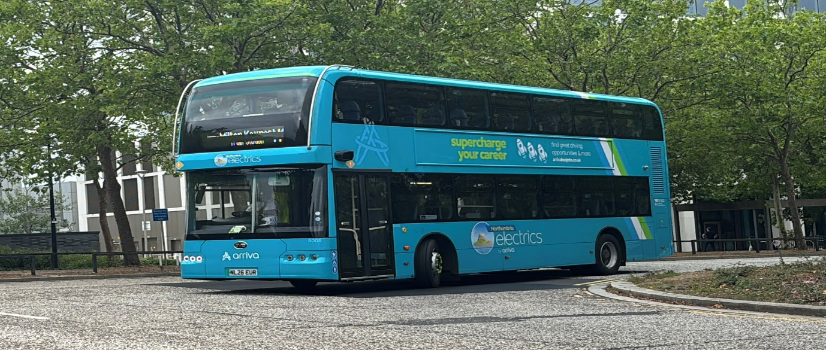
Photo Above: Photo credit to Theo Thompson member of Gary’s bus and coach photos: F602MSL Leyland Olympian at Gaydon British motor museum for the Wythall bus fest on the 4th, July 2026. https://www.flickr.com/photos/199041540@N05
Photo below: Photo credit to Theo Thompson member of Gary’s bus and coach photos: NL26EUR Arriva Northeast 8008 at Silverstone Grandpix F1 shuttles in Milton Keynes. https://www.flickr.com/photos/199041540@N05
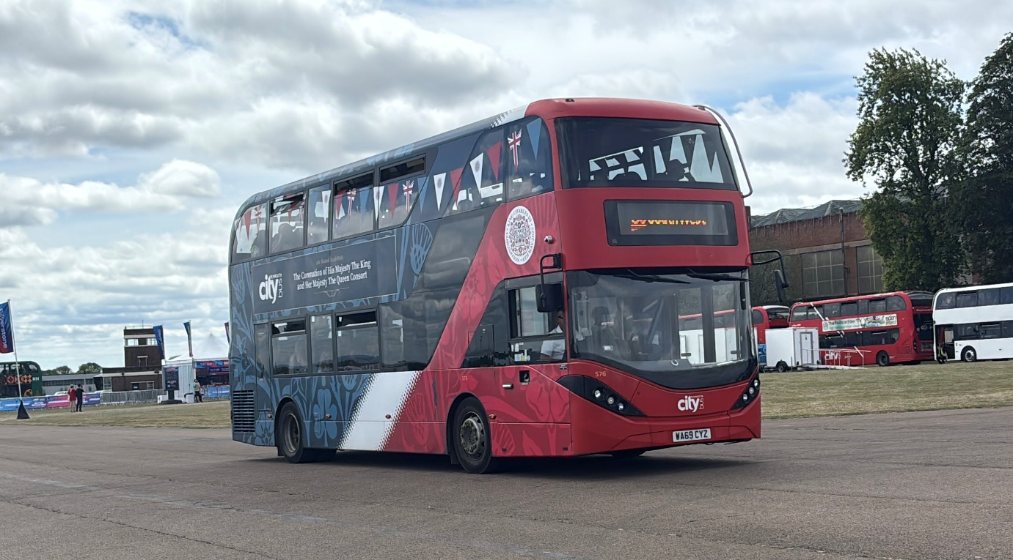
Photo credit to Theo Thompson member of Gary’s bus and coach photos: Portsmouth CityBus 576 WA69CYZ on Silverstone Grandpix F1 Shuttles. https://www.flickr.com/photos/199041540@N05
Facebook group member photos
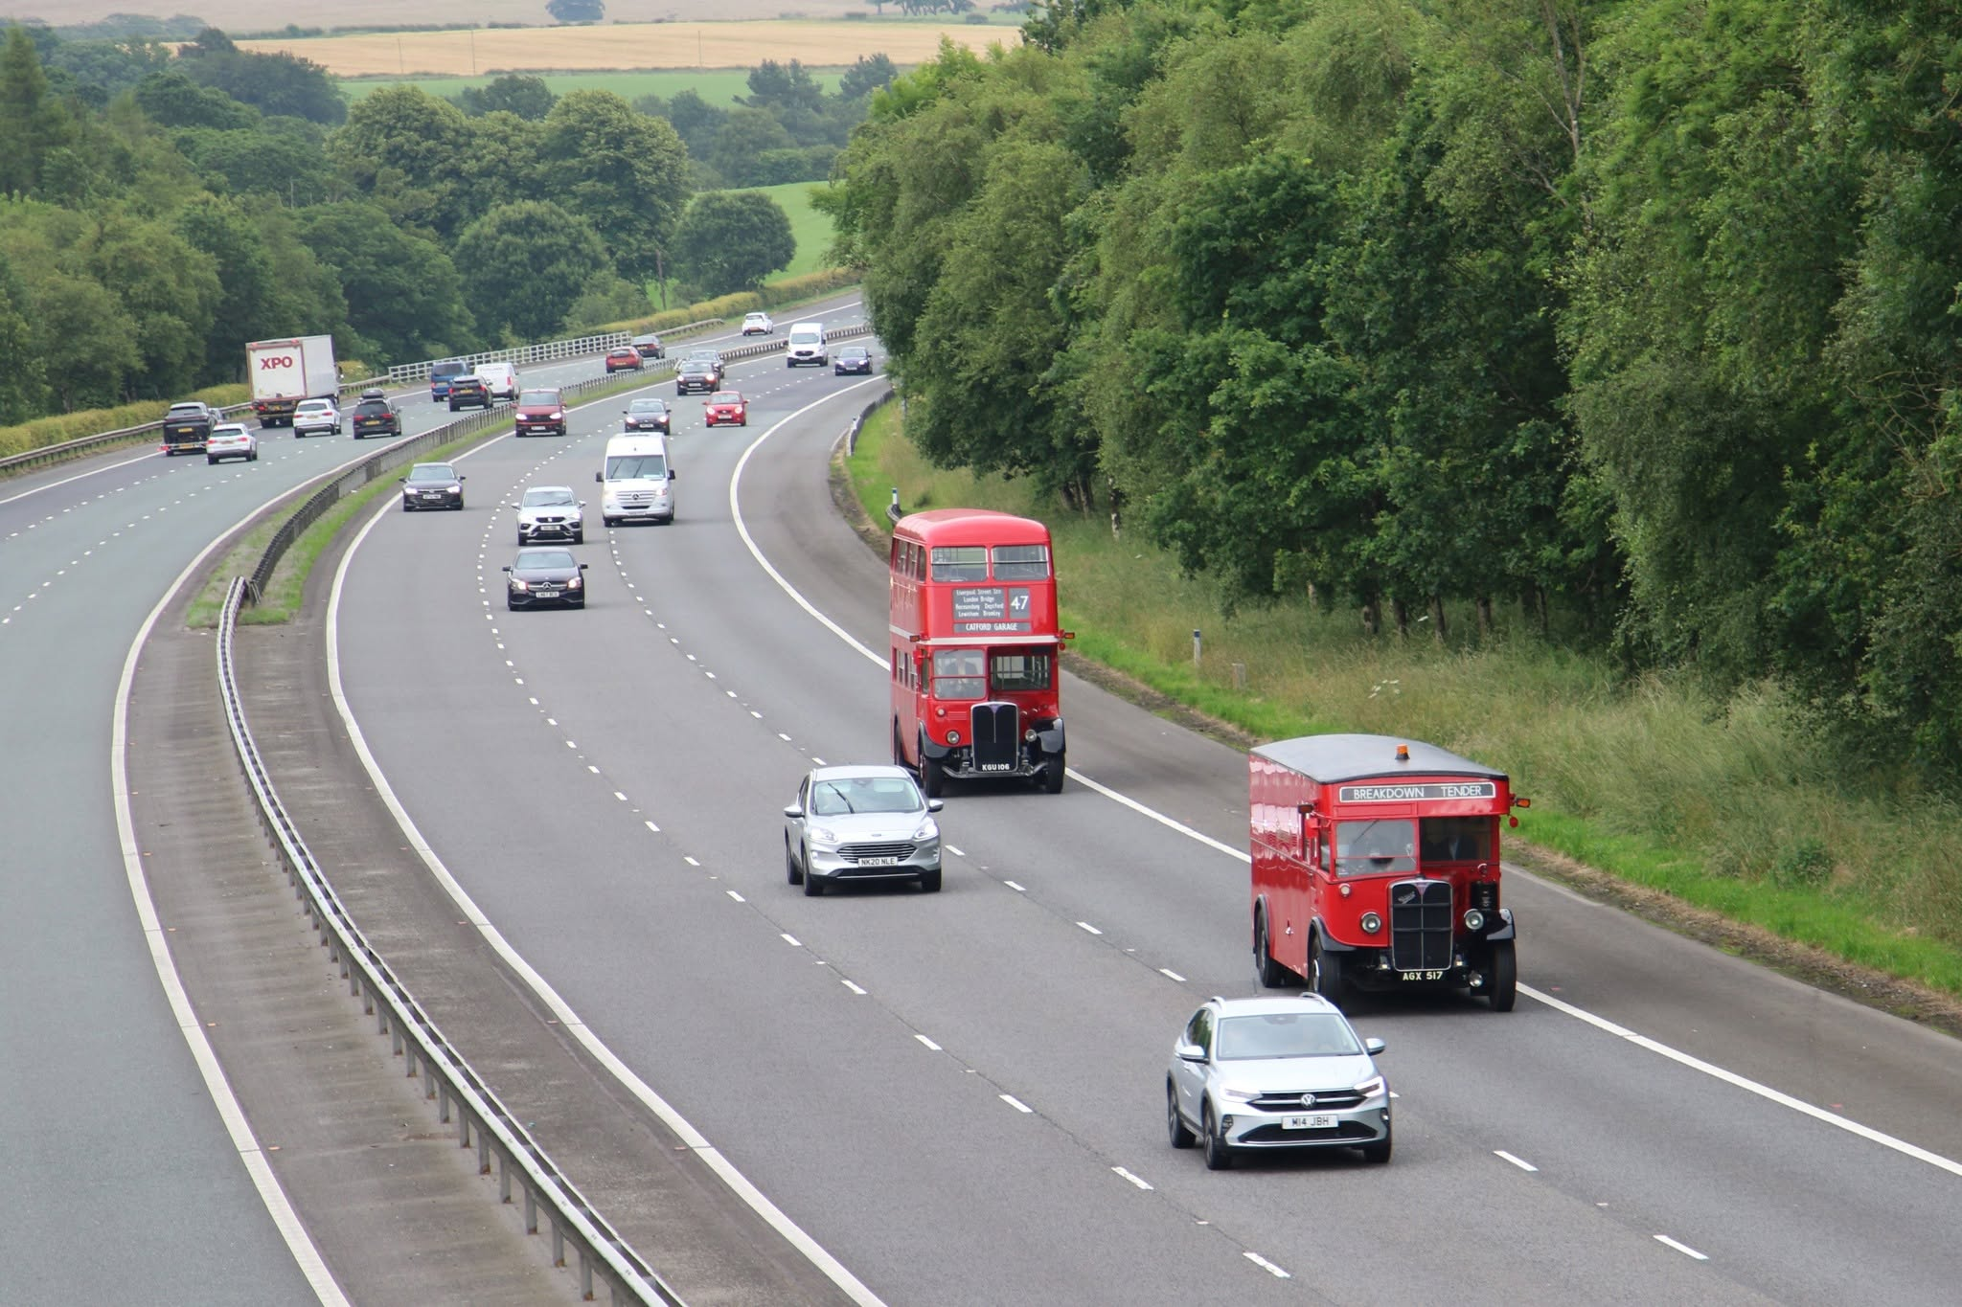
Photo credit to Mapgroup publications - Andy Dyer Administration of Gary's bus and coach photos London came to Glasgow last weekend. RT2177 with AEC Breakdown Tender.
www.facebook.com/groups/garysbusandcoachphotos
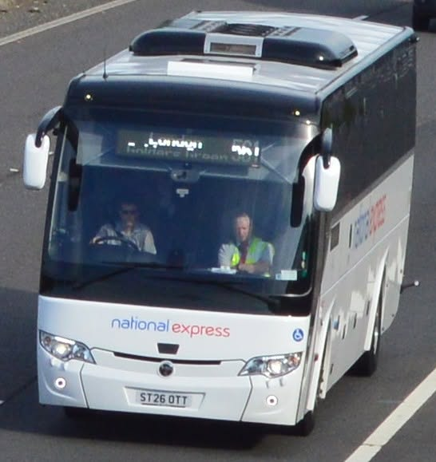
Photo credit to Barry Smith member of Gary's bus and coach photos; Stotts of Milnsbridge ST26 OTT a Temsa HD13 seen here on M1 Barnsley 22-06-26.
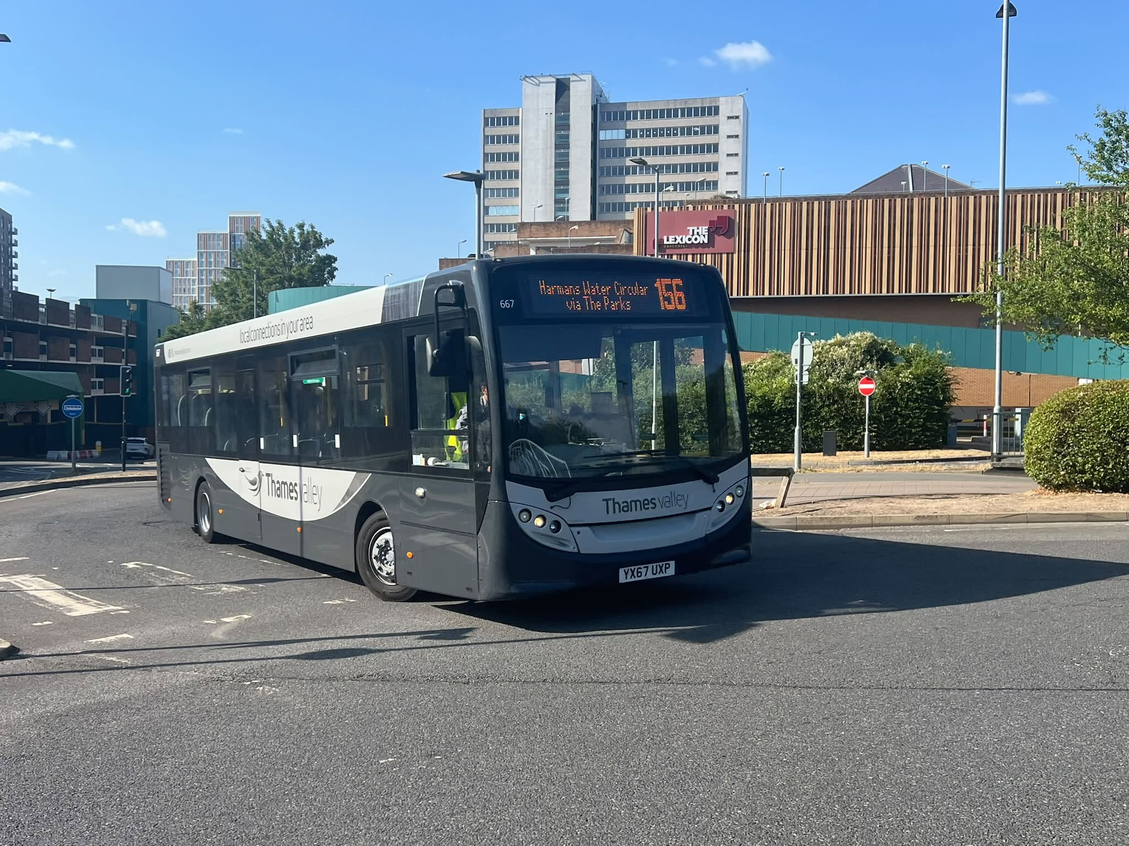
Photo credit to Blain Rhys member of Gary's bus and coach photos Thames Valley 667 YX67UXP ADL Enviro200 in Generic livery.
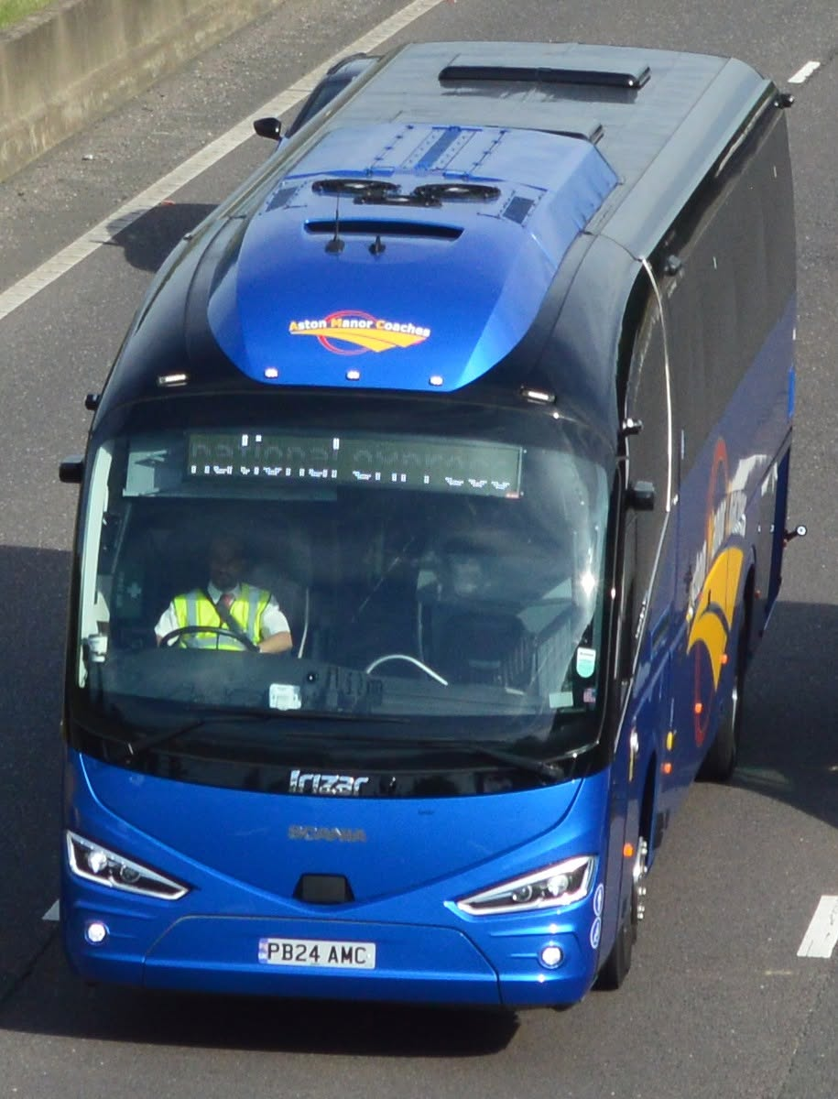
Photo credit to Barry Smith member of Gary's bus and coach photos: PB24 AMC, a Scania K360CB4Irizar i6s Efficient Treinta coach new to Aston Manor, Aston in March.

Route 194 from the 2nd, August 2026 is inducting new timings from Monday to Saturday and Sunday Monday to Saturday buses will be running every 20mins from Bracknell and Camberley.
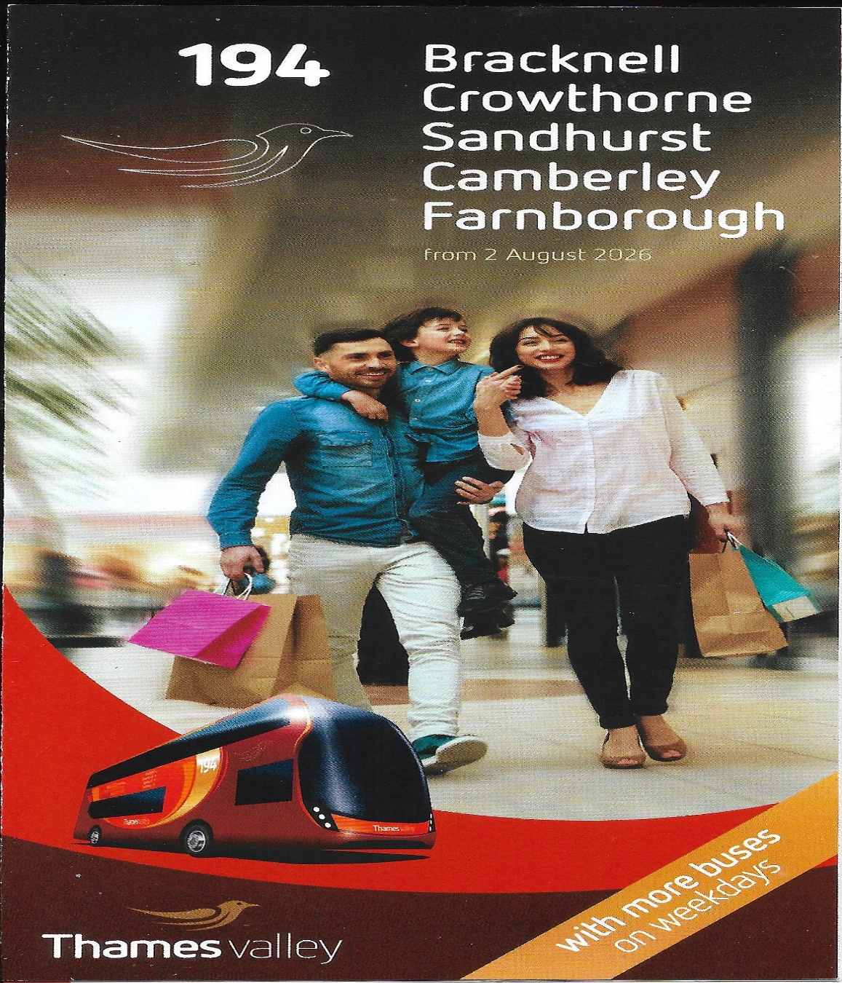
Front cover of the new timetable for route 194 from Bracknell to Camberley and from Camberley to Bracknell.
www.thamesvalleybuses.com
www.facebook.com/garysbusandcoachphotos
www.facebook.com/groups/garysbusandcoachphotos
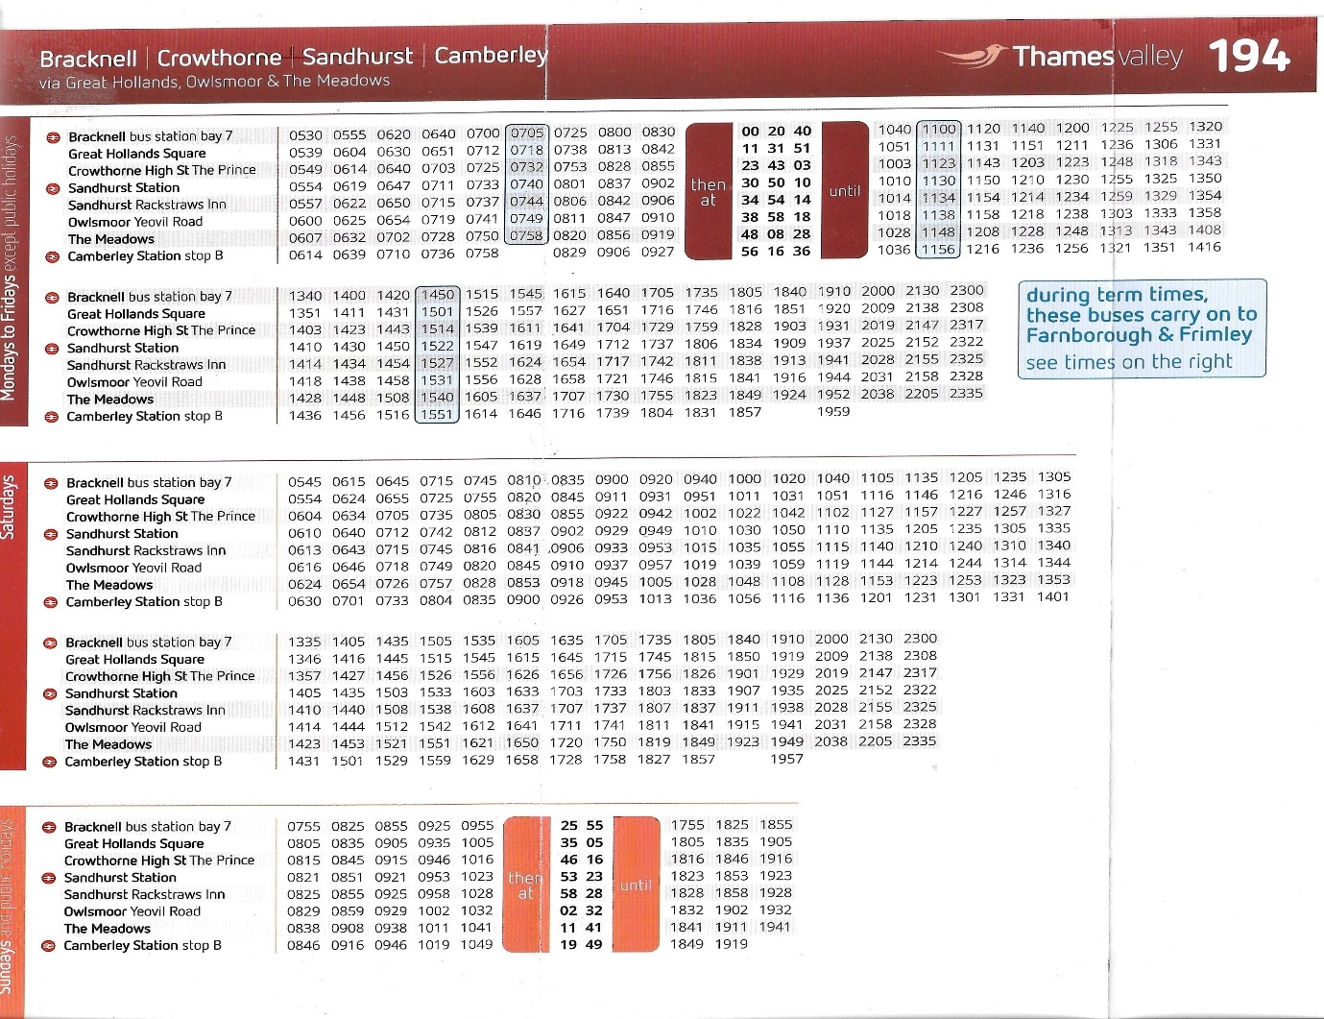
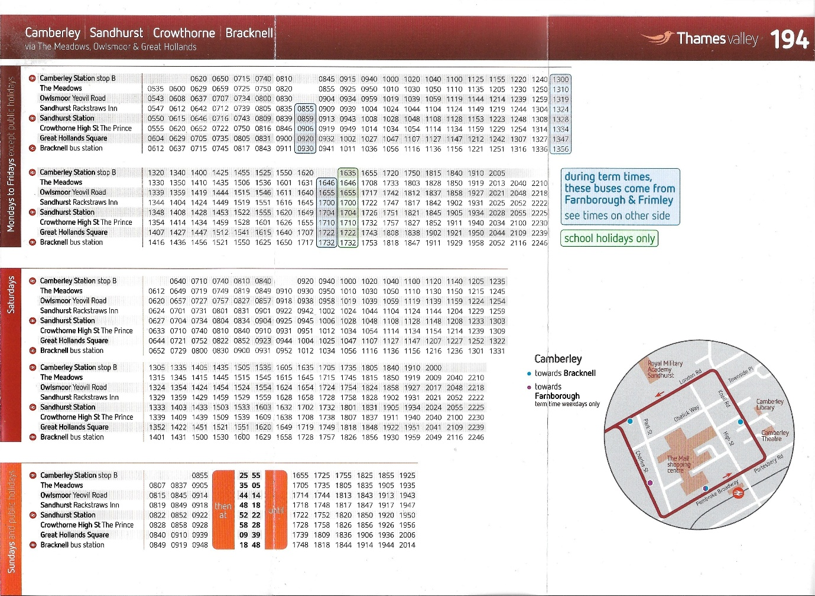
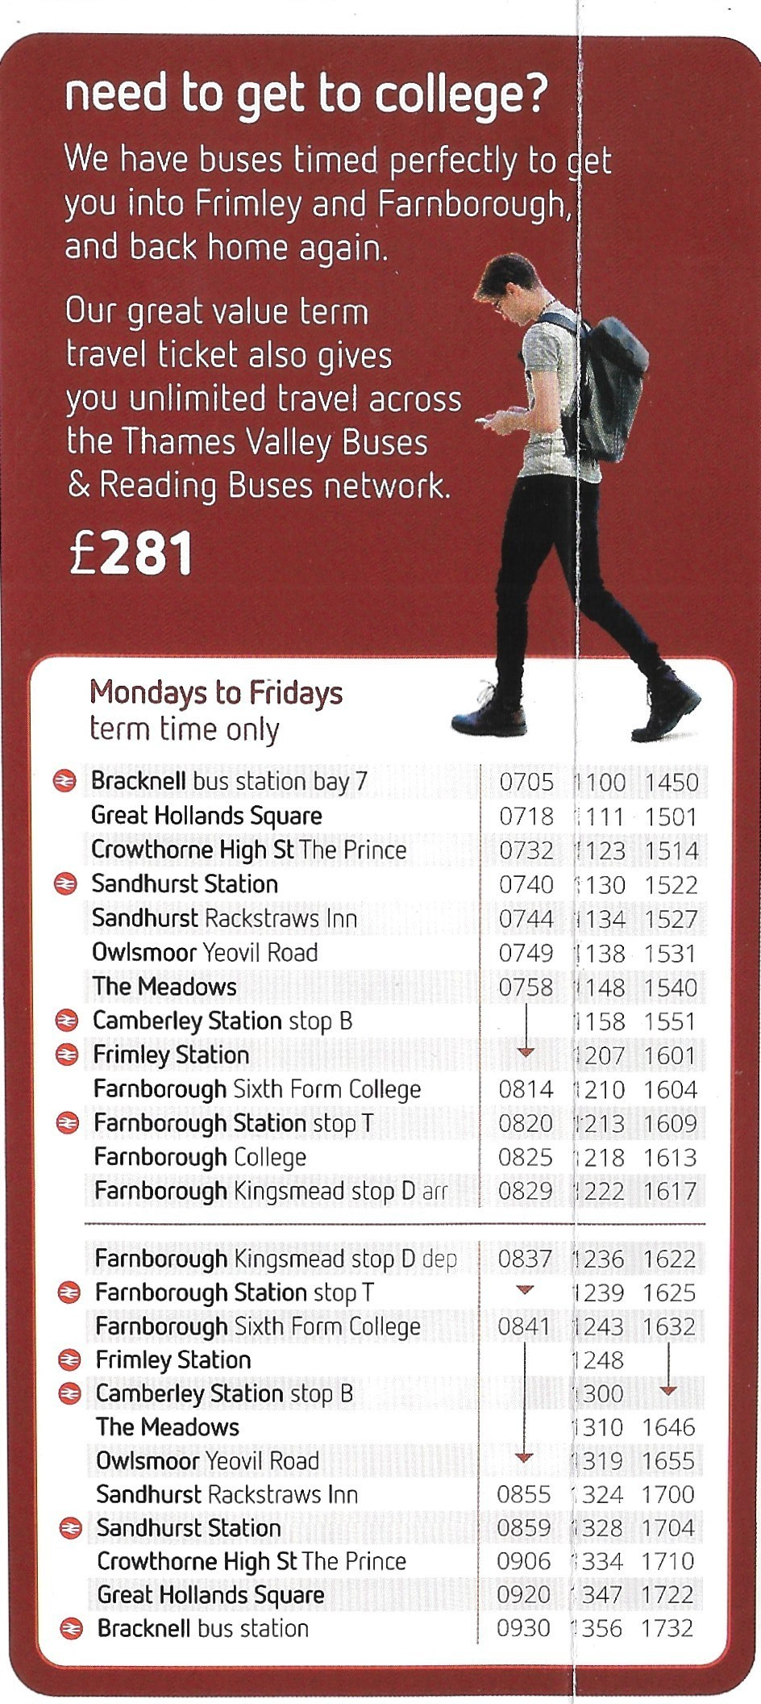
The term times as above have not changed still three buses to Farnborough and three buses from Farnborough to Bracknell.

We are inducting a new part of our YouTube channel which will be podcasts and video podcasts we are looking into this and looking for special guest appearances to expand on this to join in email me at webmaster@garysbusandcoachphotos.co.uk so to join with us and help us expand. We will also induce this sometime in 2026 and 2027.
YouTube videos so far for 2026
Winchester King Alfred heritage bus running day | https://youtu.be/ZgnvA0EOu-0?si=B-Dp66k0mshegNRf
Acton museum depot open day | https://youtu.be/Te_N8OHd7ao?si=4J8OFnp-umCJLUcl
Brooklands LBM Spring gathering | https://youtu.be/Zw3_E4ocHVQ?si=xdchR74IX2MiWOO6
Birmingham NEC coach and bus expo | https://youtu.be/VvUU_qIb4sM?si=9cBvHyrS4ygplpaU
Winchester King Alfred heritage bus running day | https://youtu.be/JovRNA1KuF0?si=nQVsrGuW286DdD89
Windsor heritage bus running day | https://youtu.be/GluXpLQlKWY?si=En0OLFz1gdmyU2Kg
Basingstoke royal blue run | https://youtu.be/WCHdBTgCmfs?si=Q9CRRXOIX6M_rlNQ
Reading buses open day | https://youtu.be/BUolavvfxWg?si=s8NQMSGivZzyp9KX
Visit our YouTube channel at www.youtube.com/@garysbusandcoachphotos
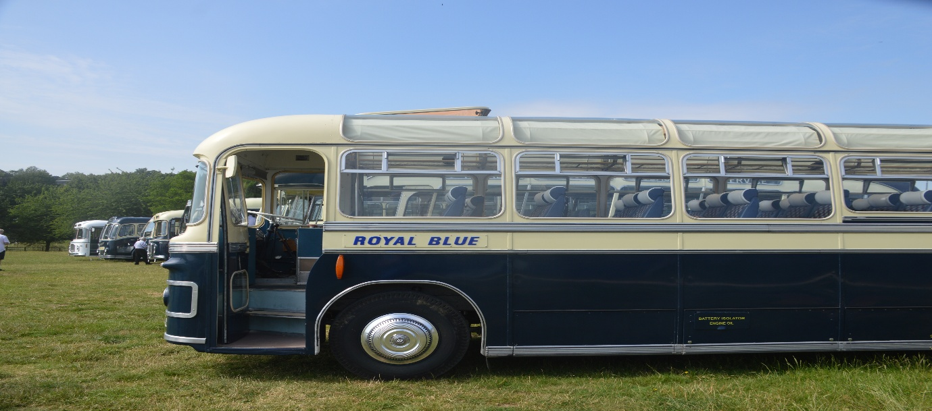
Photo credit to Gary Baxter Administration of GB&CP; Royal blue line up for the Royal blue run in June 2026.
www.facebook.com/groups/garysbusandcoachphotos

