**Month April 2025 Issue No: 82**

This month we attended at the London Transport Museum depot in Acton on the 5th, April 2025. More about this on page two. We also attended at the spring gathering at Brooklands in Weybridge more about this on page three. Route 1/1a also started earlier this month which replaced the route 01 and going has far has Dedworth Maypole in Slough This operation goes through the Windsor Great Park like the zero-one used to do.

**Acton museum Depot open day**

We attended the Acton Museum depot in Acton this was a lovely event with plenty to do at the event and lots to look thorough and admire. The museum depot in Acton was a good event the weather for the event was nice and warm it was a good event for looking through all the different of Transport for London. The museum was full of tube and road transport. This was all good and interesting and looking at all the different signs was good to.



Photos and video from the event were non-existent due to techno errors. The depot museum was amazing though with lots to look at and though.



**London bus museum Brooklands Weybridge Spring Gathering**

We attended the London bus museum spring gathering at Brooklands in Weybridge with the Reading transport enthusiast club and Adam Conner with Rocky the Routemaster. It was also good to meet up with friend Robert Thompson and Theo Thompson, and general spending time with friends so was a good day with good weather. Photos from this event can be found here <https://flic.kr/s/aHBqjCbHUU> video from the event was lost due to techno issues.

**Facebook Cover photo competition**

|  |  |
| --- | --- |
| Place | Name |
| 1st | Aaron Hampton |
| 2nd | Tim Wild |

Thanks to everyone who take part in this Facebook cover photo competition. The next facebook cover photo competition will be on the 16th, May 2025

Photo credit to Aaron Hampton member of Gary’s bus and coach photos: D25BUS ADL Enviro500 photographed on railway replacement for Southwestern railway at Virginia water railway station. This can be viewed on our website at [www.garysbusandcoachphotos.co.uk](http://www.garysbusandcoachphotos.co.uk).

**Facebook member photos**

Photo credit to Alan Lockey member of Gary’s Bus and coach photos: Bee network 11915 YX74OMV ADL Enviro400city photographed in Manchester liveried up in Bee Network livery with logo for Transport for Great Manchester.

Photo credit to Alan Lockey member of Gary’s bus and coach photos: LK57KBJ Scania Omnicity photo taken in Blackpool.

Photo credit to Anthony Moore member of Gary’s bus and coach photos: YY25JAU ADL Enviro400mmc Fare saver photographed in Bath.

Photo credit to Barry Smith member of Gary’s Bus and Coach Photos: SG24UGW Yutong GT12 Flixbus photographed on motorway M1 to Glasgow on route 010.

Hirasawa Yui member of Gary’s bus and coach photos: Reading buses 414 YR13PMV photographed at London bus museum spring gathering at Brooklands in Weybridge for the spring gathering on the 13th, April 2025.

Barry Smith member of Gary’s Bus and Coach Photos: YN08JHJ ADL Enviro200 Stagecoach Yorkshire 22628 Man 18.240.

Reading buses have put in another order with ADL for another eight Enviro400EV’s these will be for route twenty-six these along with the twenty-four EV’s to come to Reading buses bring they order up to thirty-six new EV’s to come to Reading buses. The twenty-four Ev’s from the first order are for routes seventeen and twenty-one.

Photo credit to Gary Baxter Admin of Gary’s bus and coach photos: AD24BEV ADL Enviro400EV Photographed at Reading buses open day in June 2024. This was also on demonstration after the event for two weeks and was fleet numbered 1008.

This month also saw new routes being announced for Thames valley one since route taken from White bus and renumbered 1/1A which goes from Ascot to Dedworth Via Windsor Great Park and Windsor High Street in both directions. Along with new timetables for Bracknell, Windsor, Slough and Maidenhead.

Along with all this saw one of the existing Thames valley buses getting a new coat of paint in to a flightline bottle green lime green colour

Photo credit to Gary Baxter Admin of Gary’s bus and coach photos Thames Valley 664 YX65RKK ADL Enviro200mmc. Photographed at Heathrow Airport after completing route 5 from Cippenham to London Heathrow Airport.

White bus also lost its existing route 01 from Ascot to Windsor Via Windsor Great Park to Thames Valley this month, but this did also see White bus reroute X94 and Expand on the operating times Monday to Friday. Leaflet front cover and times found below.

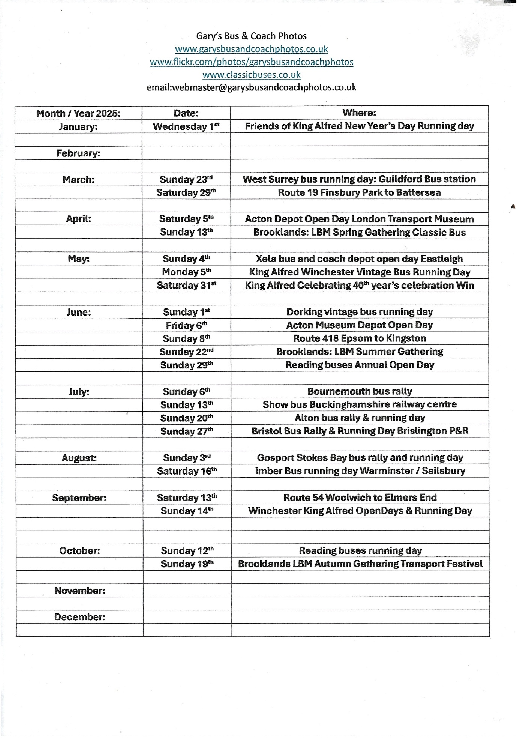

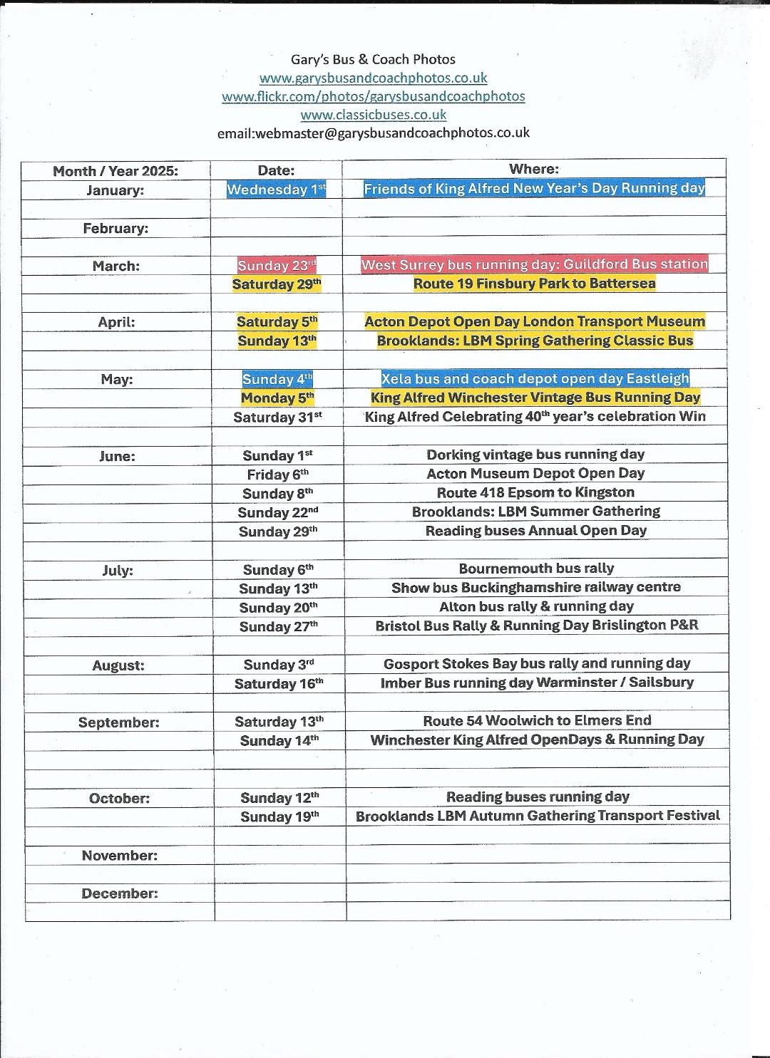

**Friend Theo and Robert Thompson**

Last year I met two people who came into live called Theo and Robert Thompson at my local bus station has Theo was videoing one of the new Greenline / Flightline buses at Bracknell and found out he had a YouTube channel like want we do at Gary’s bus and coach photos so over time we met a couple of different events always talking and laughing and getting on really well so have become really good friends. Theo has a page on our website for his YouTube and Flickr and can be found by going to [www.garysbusandcoachphotos.co.uk/theos-flickr-and-youtube](http://www.garysbusandcoachphotos.co.uk/theos-flickr-and-youtube). Now to this day we are still very good friends and always talking about our next events that we are all going to be attending they are very good friends to me, and I thank them from the bottom of my heart for they kind friendship and support.

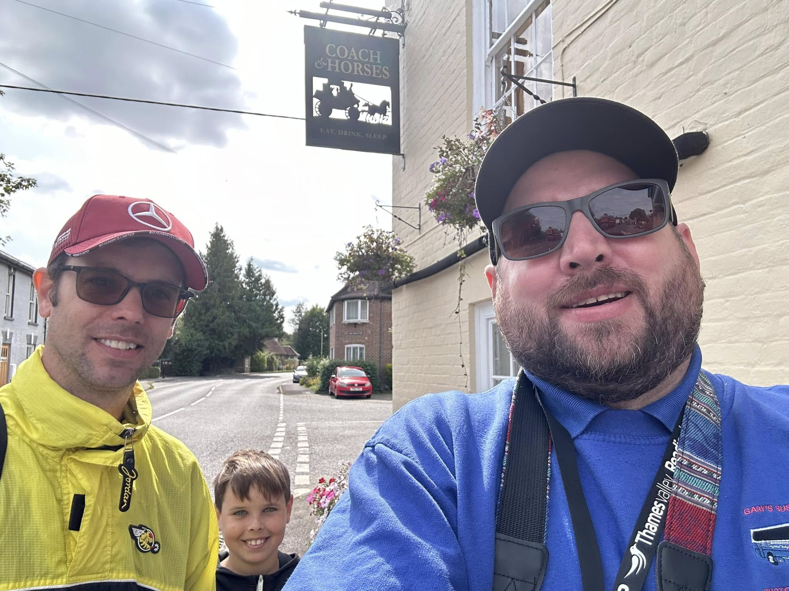

Photo credit to Gary Baxter Admin of GB&CP: Photo of Robert, Theo Thompson and myself at Friends of king Alfred bus running day in September 2024.

Theo’s YouTube channel can be found by going to [www.youtube.com/@theothompsonbusenthusiast](http://www.youtube.com/@theothompsonbusenthusiast) his flickr can be found on our website at [www.garysbusandcoachphotos.co.uk](http://www.garysbusandcoachphotos.co.uk)



**Photo of the month**

my photo of the month was chosen randomly has I did not do much photography this month due to taking couple weeks break but this month it was hard picking out one photo. I have managed to do it and the photo of the month is of Thames Valley 664 YX65RKK in new route two branding from Slough to Wexham Park hospital Via Windsor. At the time of the photo being taken it was on route five from Cippenham to London Heathrow Airport and is photographed leaving London Heathrow Airport on this route.

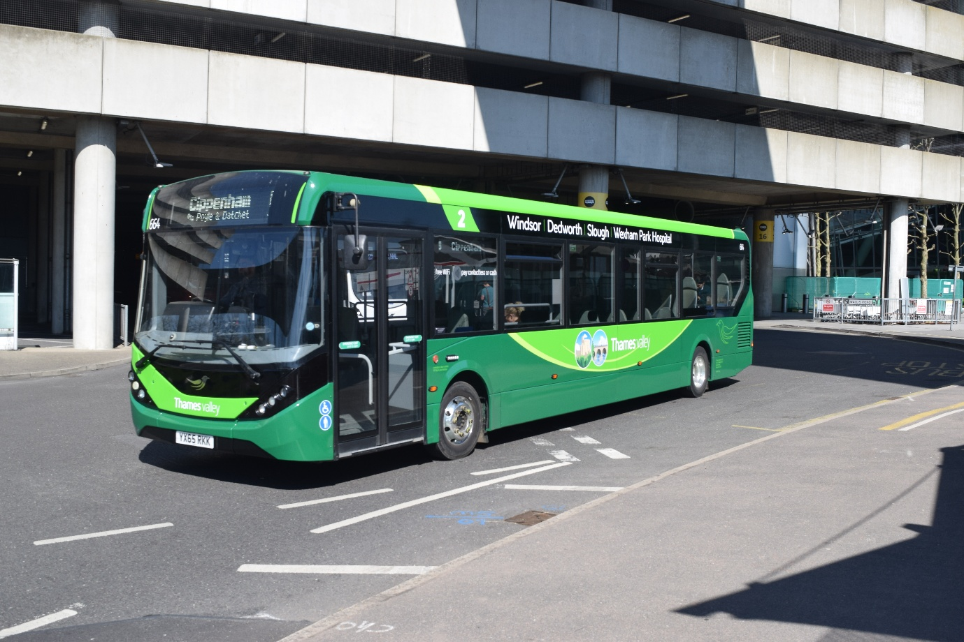

Photo credit to Gary Baxter Administrator of Gary’s bus and coach photos: Thames Valley 664 YX65RKK ADL Enviro200mmc photographed departing on route five to Cippenham from London Heathrow Airport Via Slough. This being off route that is branded for. Which is route two from Windsor to Wexham Park hospital Via Dedworth and Slough. More images can be found at [www.flickr.com/photos/garysbusandcoachphotos](http://www.flickr.com/photos/garysbusandcoachphotos)

