
Month: March 2025 Issue no: 81
This month saw Thames Valley announce routes for Windsor, Maidenhead and Slough one of the new routes is former White bus route 01 from Ascot to Windsor now being operated by Thames Valley and being renumbered route 1/1a from Ascot to Old Windsor this was a big announcement from Thames Valley. Thames Valley also announced other changes to routes on this sector it can be found at www.thamesvalleybuses.com. Events we will be doing this month are Route 19 running Day organised by the London bus museum Brooklands Weybridge on the 29th, March 2025 more about this on page three.
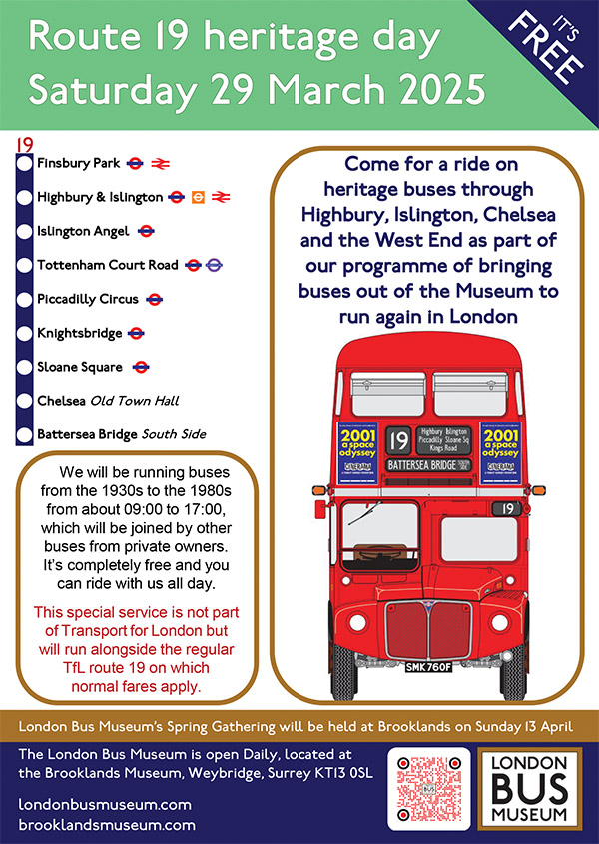

Battersea to Finsbury Park
We enjoyed this lovely running day in London on route Nineteen from Finsbury Park to Battersea from London bus museum. The day was excellent with some good rides around on the different vehicles operating on this route from Finsbury Park to Battersea. We had lunch in Hyde Park corner and spend a few hours in Hyde Park corner photographing the buses that were operating on the route. Photo album and video blog from the event links here: https://flic.kr/s/aHBqjC7pdY https://youtu.be/hIsIJX4v_HE
New Sponsors
Last month February 2025 we take on a couple of new sponsors to our community at Gary’s bus and coach photos, but you wouldn’t have seen this in the newsletter has we didn’t send one out for February along with this we have added a couple of administrations Adam Conner and Martin Warne. This will help us manage the Gary’s bus and coach photos community more affectively. It is also a pleasure to announce that your coach hire is another new sponsor to our community, so this was a good result for us has well at Gary’s Bus and Coach Photos.
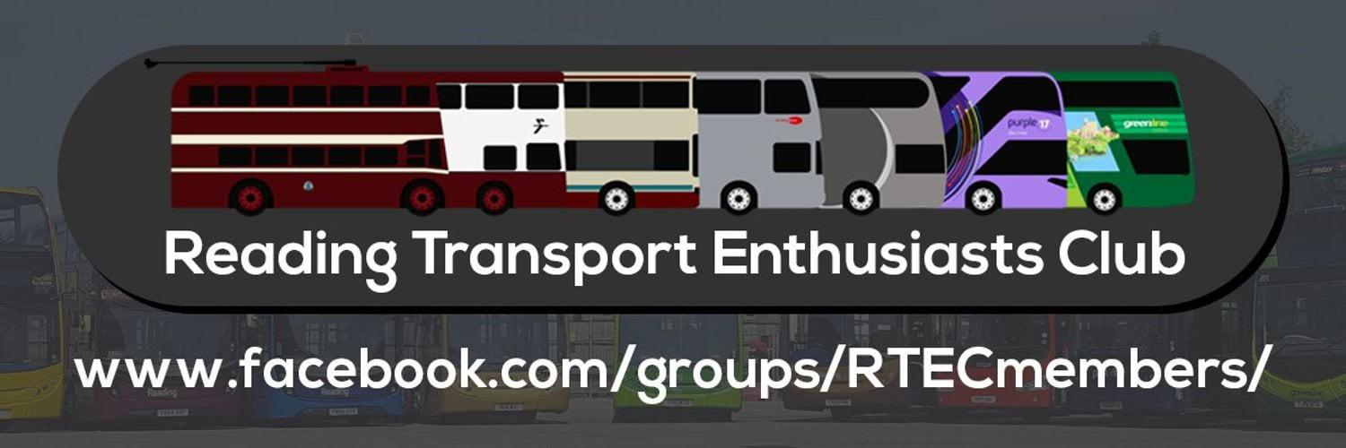

Logos have permission to use and use at your risk
Thanks to Reading Transport enthusiast club and your coach hire for coming on board has sponsors of Gary’s bus and coach photos.
General news
The event in red on the events calendar on page four was cancelled and will be rearranged for later in the year. The next event after the 29th, March 2025 will be the spring gathering at London bus museum at Brooklands in Weybridge on the 13th, April 2025 this will also appear in the April 2025 newsletter. Reading buses Thames Valley division has taken on new routes / renumbered some routes in the Slough, Maidenhead and Windsor areas. One of the new routes to be announced is ex Whitebus 01 from Windsor / Ascot to Windsor Thames Valley start new routes 1/1A on the 6th, April 2025 with buses coming from Newbury and district to cover for these routes. The new route 1/1A is being extended has far has Dedworth in Slough and this will still operate via the Windsor Great Park. Back earlier on in the year reading buses renumbered the route 4/X4 to Route 4/4A and this is still doing the original route, but just been renumbered 4/4A has Reading buses do not do express routes there only routes like 4/4A and some ABC. No Express routes. The London line and Flightline now operates Half Hourly from Legoland and Bracknell for the Flightline this is a good change has this does seem to be working for the operator. Reading buses last month also announced they charity of the year and repainted 1210 KX59GNU in Berkshire youth Charity livery
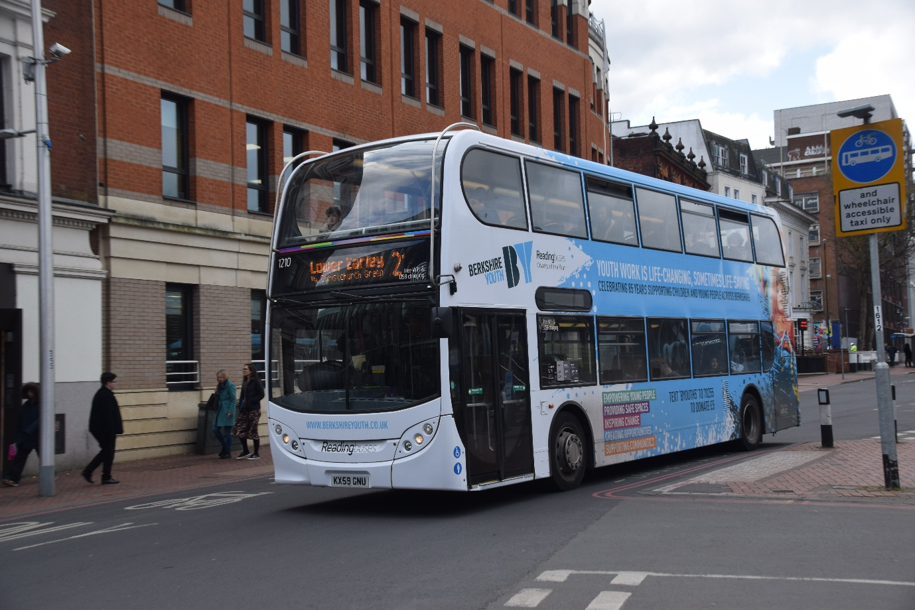
Photo credit to Gary Baxter Volunteer Administrator Manager / Photographer & videographer for GB&CP RB1210 KX59GNU Alexander Dennis Enviro400 photographed departing Reading on route 21 to Lower Early. Photo album can be found at www.garysbusandcoachphotos.co.uk or www.flickr.com/photos/garysbusandcoachphotos. The newish buses being transferred to Thames Valley for use on route 1/1A our has follows 655 = YX65RWV and 656 = YX65RWW both Alexander Dennis Enviro200’s for route 1/1a or to help cover any other local routes.
New Timetables for Bracknell, Windsor, Slough & Maidenhead
New timetables launched for new routes and withdrawn routes in Bracknell, Windsor, Slough and Maidenhead. Has announced on page four Thames Valley buses have taken the 01 from Whitebus and have changed the route and renumbered it 1/1A to go has far has Dedworth maypole all new routes start on the 6th/7th, April 2025.
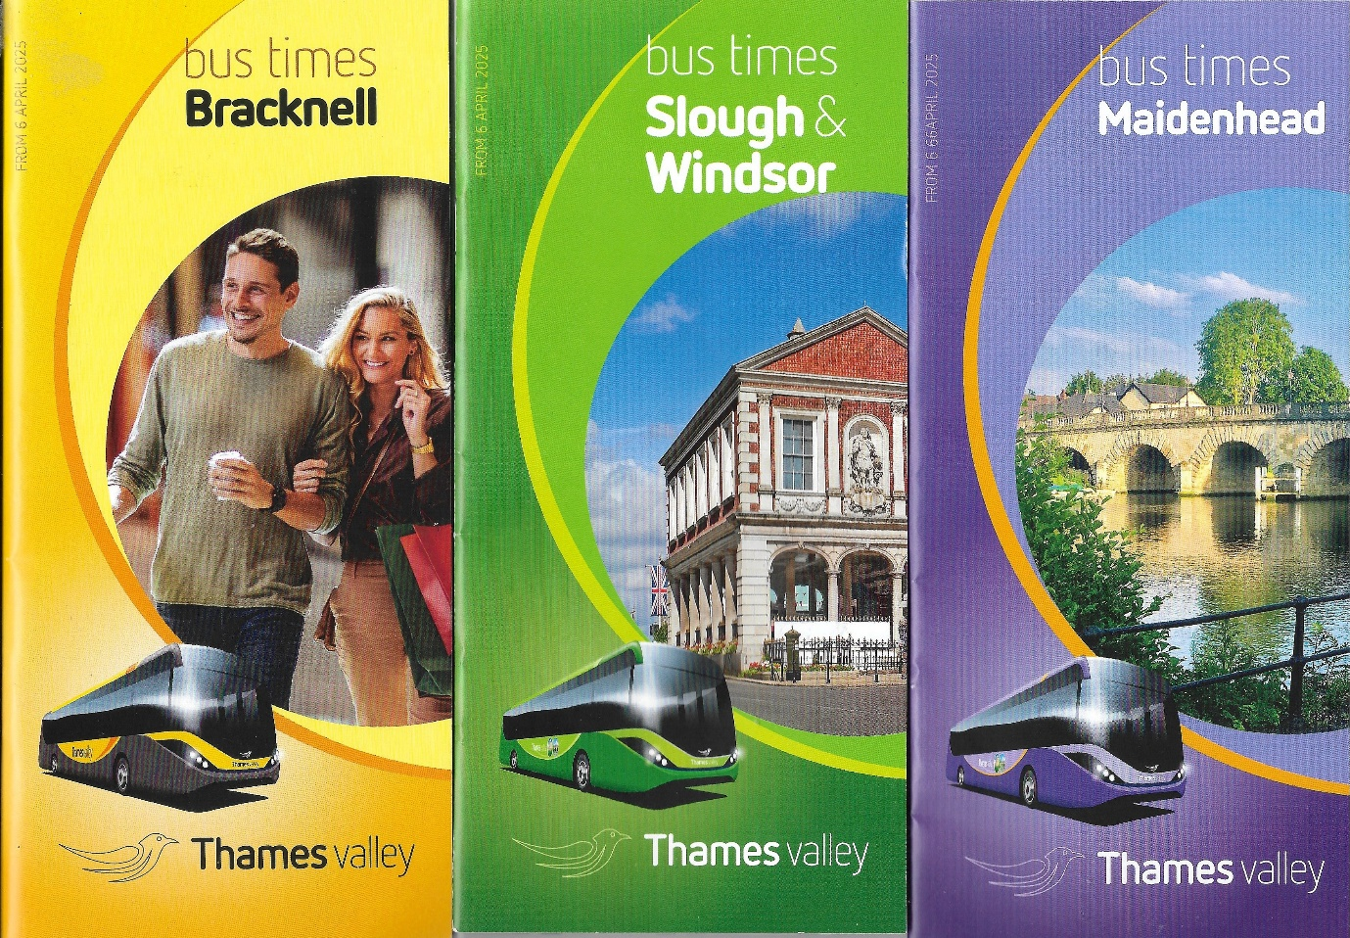
Photocopies of the new timetables being launched for the new routes and withdrawn starting from the 6th/7th, April 2025. Whitebus X94 has also been rerouted to now include Martins Heron and Rackstraws up to the Frimley Park Hospital, and the last bus will be 20.00hrs from Frimley Park and 19.45hrs from Ascot Heatherwood hospital.

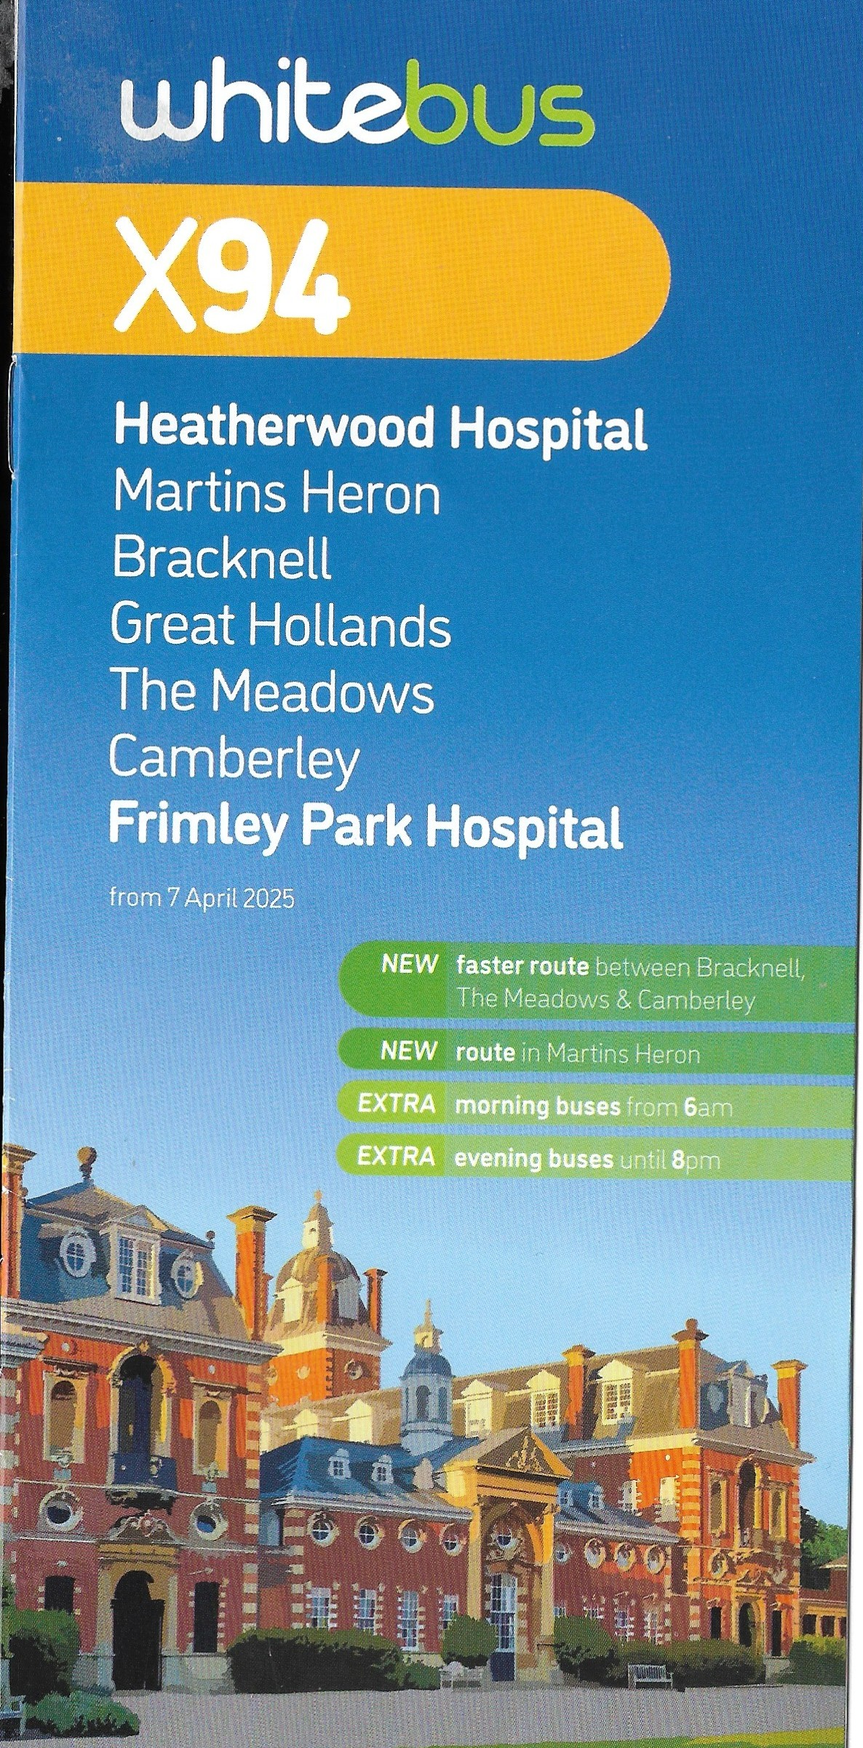


This month saw the release of model UKBUS6535 Hampshire bus Alexander Dennis Enviro400mmc on the TTCDIECAST page this along with other models have been changed to Purchase from on www.garysbusandcoachphotos.co.uk/ttcdiecast or you can direct to the seller at www.ttcdiecast.com
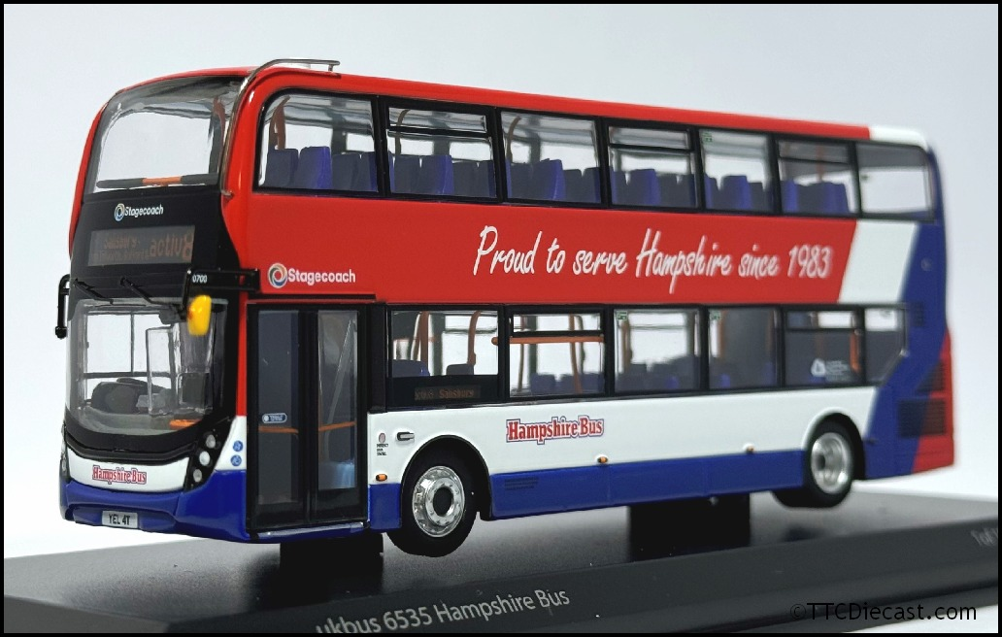
Photo credit to TTCDIECAST UKBUS6535 ADL Enviro400mmc Hampshire Stagecoach South proud to serve since 1983. Purchase price is £52.00 direct from the seller.
Facebook Group member photos
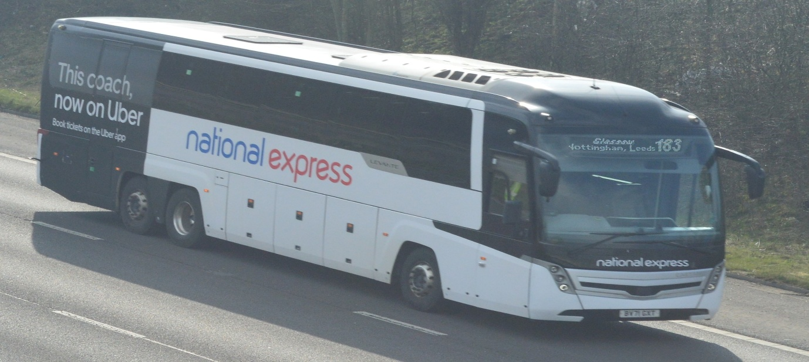
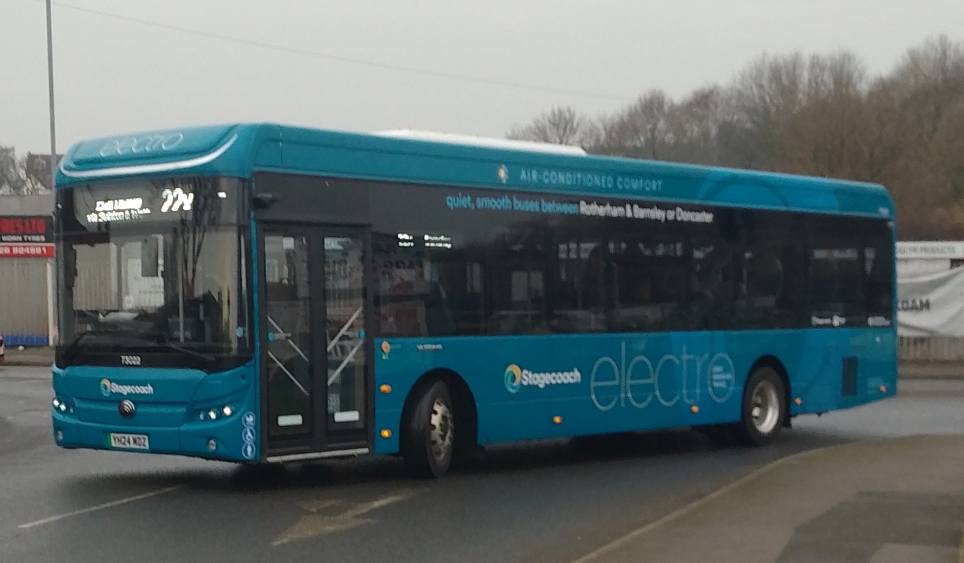
Photos credit to Barry Smith member of Gary’s bus and coach photos: Photo Above: Scania K410EB6 Caetano Lavante III on route 183 to Glasgow photographed on the M1 photo below: YH24MDZ Yutong Publican Stagecoach Yorkshire 73022.
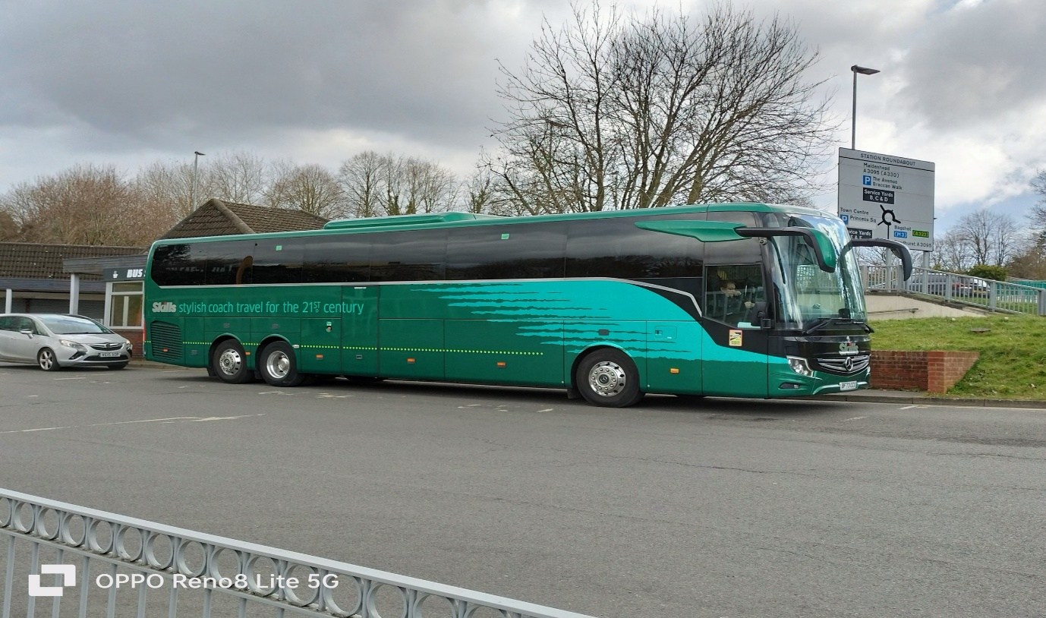
Photo credit to Dottie Rose Baxter Administrator of Gary’s bus and coach photos: Skills coaches BF73CCX Mercedes Benz Tourismo photographed in Bracknell.
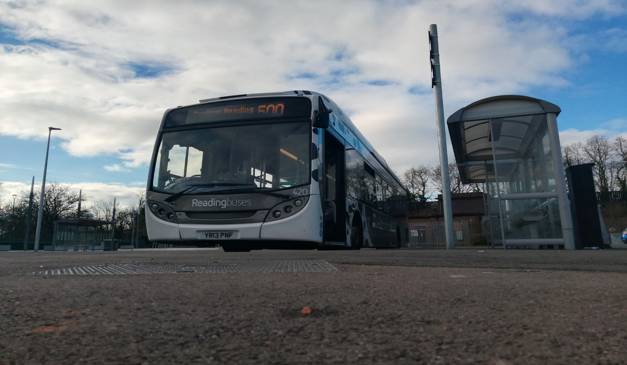
Photo credit to Katie Parry Smart member of Gary’s bus and coach photos: Reading buses 420 YR13PNF Alexander Dennis Enviro300SNG cow poo livered photographed at Winnersh P&R.
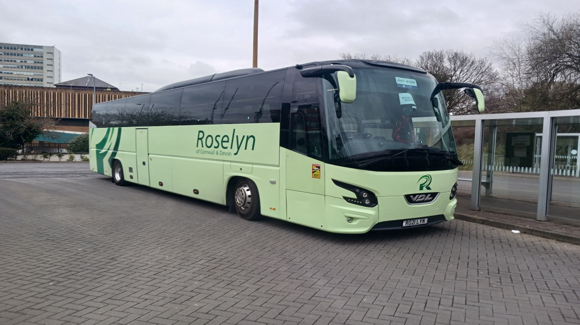
Photo credit to Tim Wild Administrator of Gary’s bus and coach photos: RO21LYN Roselyn coaches VDL Bova photographed in Bracknell bus station.
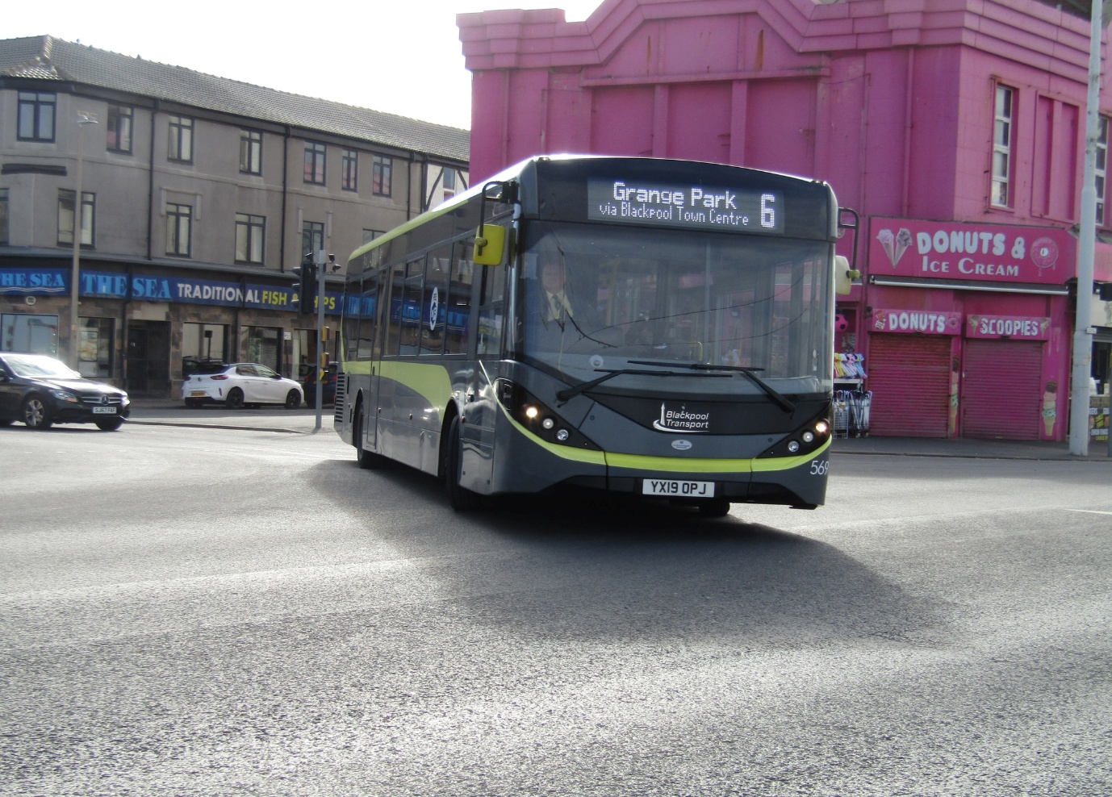
Photo credit to Alan Lockey member of Gary’s bus and coach photos: YX19OPJ ADL Enviro200mmc Blackpool Transport.
Riding routes before tenders are traded over
Administrator Tim Wild and I take the opportunity to ride one of the tenders that has been purchased by Thames Valley. So, before that happens, we take the opportunity to go up to Ascot on route 703 and ride the route 01 to Windsor Via Windsor Great Park this was an awesome opportunity has the weather was nice and bright for photographs. The opportunity to ride the route 01 take us to Windsor and we spent a bit of time they before heading off to get route 16 from Windsor to Maidenhead once in Maidenhead we spent a bit time they photographing while we were they it went a bit quiet so we change our plan going back to Bracknell on route fifty-three to we would get a route sixteen again and head back to Windsor and ride the zero-one back to Ascot and then the 703 back to Bracknell. Photos and video from this day links are below here
https://youtu.be/uXAnFoH7kp0
https://flic.kr/s/aHBqjC65uj
We also decided to do the same again the following this time staying in Windsor and riding routes 703,01,W1, and P1 and taking photos in the coach the video blog and photo album links here
https://youtu.be/OWUwHlIZFhw?si=CvnlSZr7Lee7ZVi3
https://flic.kr/s/aHBqjC6Y5t
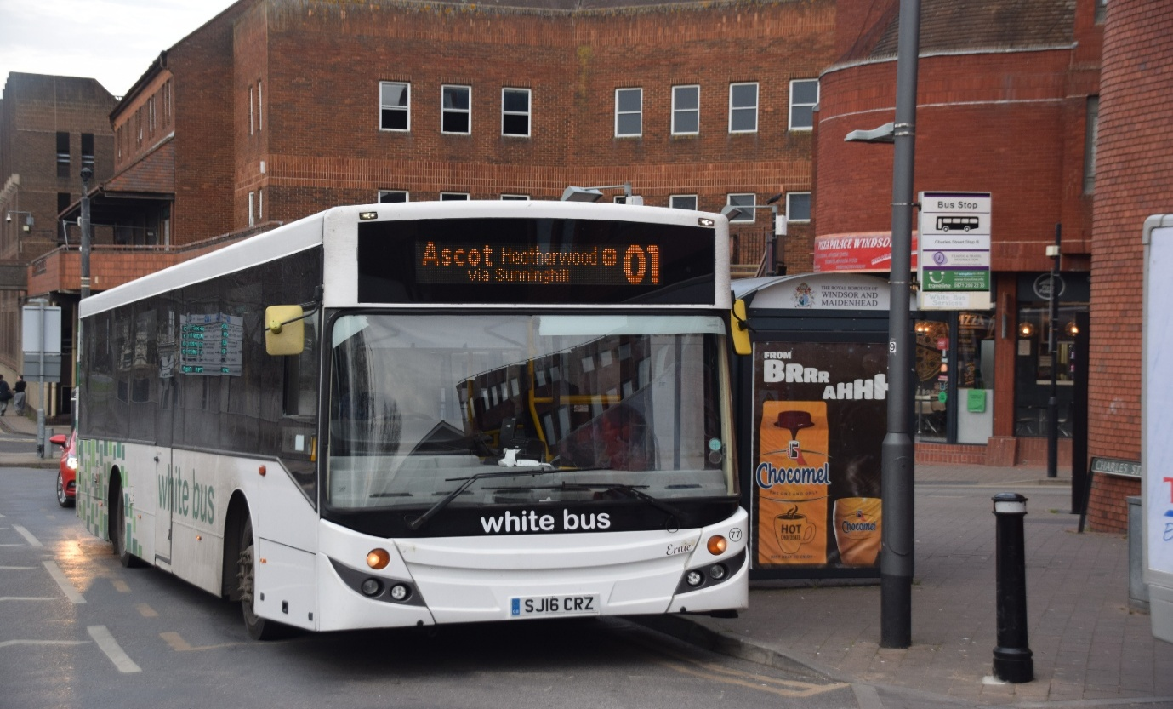

Photo credit to Gary Baxter Administrator of Gary’s bus and coach photos: Rowgate group / White bus 77 SJ16CRZ Volvo Evosetti Ernie on Charles Street waiting for 17.10 departure to Ascot Via Windsor Great Park.

Open Day 2025
We have launched a countdown to the next Reading buses open day on our website at www.garysbusandcoachphotos.co.uk/reading-buses-open-days this will be on the website until the actual open day on the 29th, June 2025 at 11am. We at Gary’s bus and coach photos are very much looking forward to volunteering photography and videography for this event again. This will be or should be an excellent event with all the new buses coming in this year and the rainbow colours shining has much as ever for 2025.
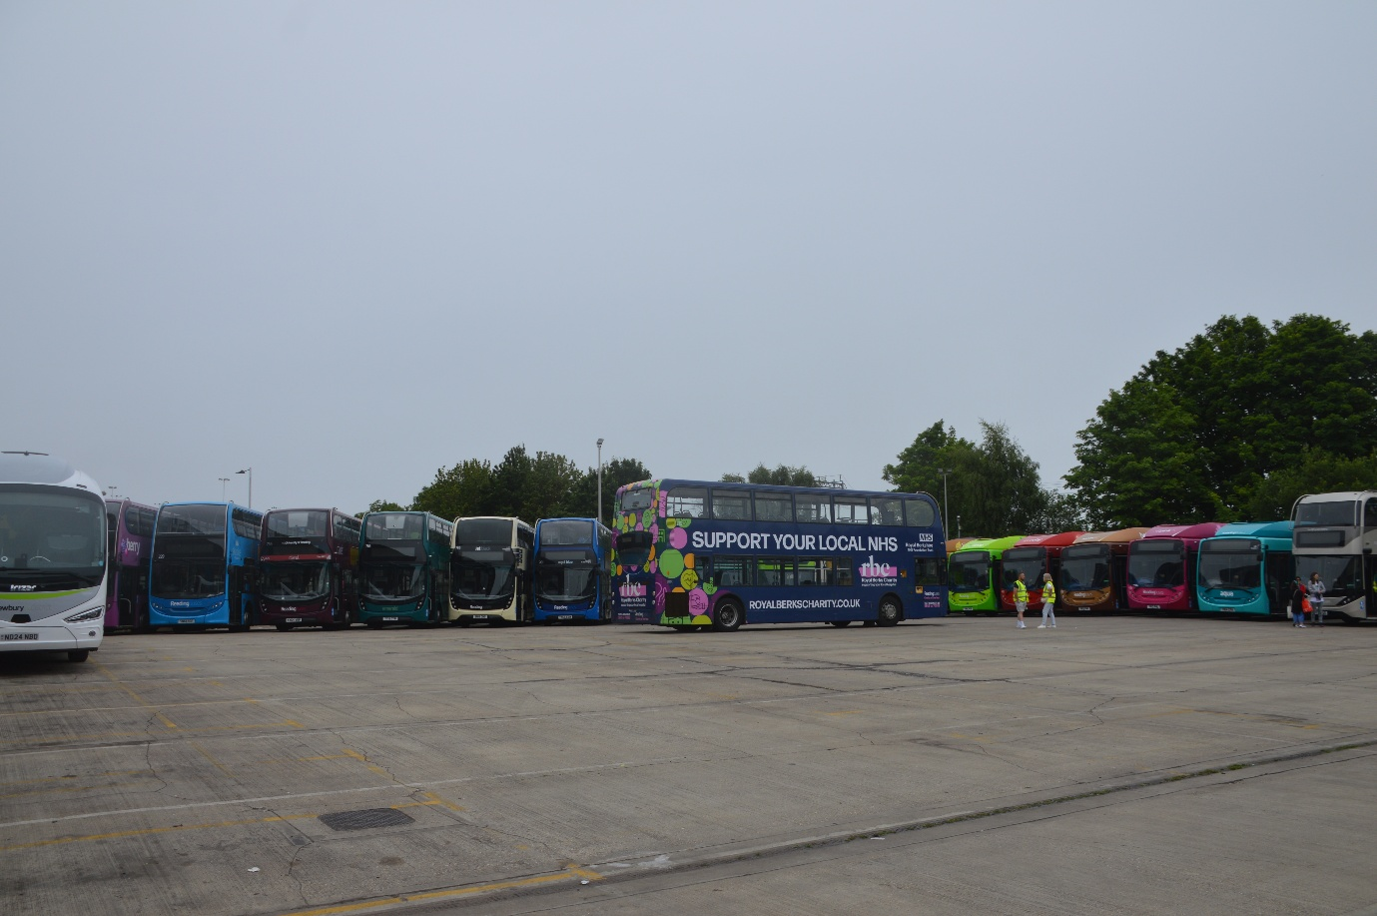
Reading buses rainbow colours all lined up for the open day along with the charity of the year bus NHS Berkshire 1210 KX59GNU ADL Enviro400. These years might look the same along with 1210 KX59GNU in Berkshire Youth Charity of the year.
Events Calendar
Simple of the events calendar. The events calendar can also be found on our website at www.garysbusandcoachphotos.co.uk pictures of and downable version to on www.garysbusandcoachphotos.co.uk/events
Month / Year 2025: | Date: | Where:
January: | Wednesday 1st | Friends of King Alfred New Year’s Day Running day
February:
March: | Sunday 23rd | West Surrey bus running day: Guildford Bus station
 | Saturday 29th | Route 19 Finsbury Park to Battersea
April: | Sunday 13th | Brooklands: LBM Spring Gathering Classic Bus
May: | Sunday 4th | Xela bus and coach depot open day Eastleigh
 | Monday 5th | King Alfred Winchester Vintage Bus Running Day
June: | Sunday 1st | Dorking vintage bus running day
 | Saturday 8th | Route 418 Epsom to Kingston
 | Sunday 22nd | Brooklands: LBM Summer Gathering
 | Sunday 29th | Reading buses Annual Open Day
July: | Sunday 6th | Bournemouth bus rally
 | Sunday 13th | Show bus Buckinghamshire railway centre
 | Sunday 20th | Alton bus rally & running day
 | Sunday 27th | Bristol Bus Rally & Running Day Brislington P&R
August: | Sunday 3rd | Gosport Stokes Bay bus rally and running day
 | Saturday 16th | Imber Bus running day Warminster / Sailsbury
September: | Saturday 13th | Route 54 Woolwich to Elmers End
 | Sunday 14th | Winchester King Alfred OpenDays & Running Day
 | Saturday 20th | Kingsbridge Vintage Bus Day
October: | Sunday 12th | Reading buses running day
 | Sunday 19th | Brooklands LBM Autumn Gathering Transport Festival
November:
December:
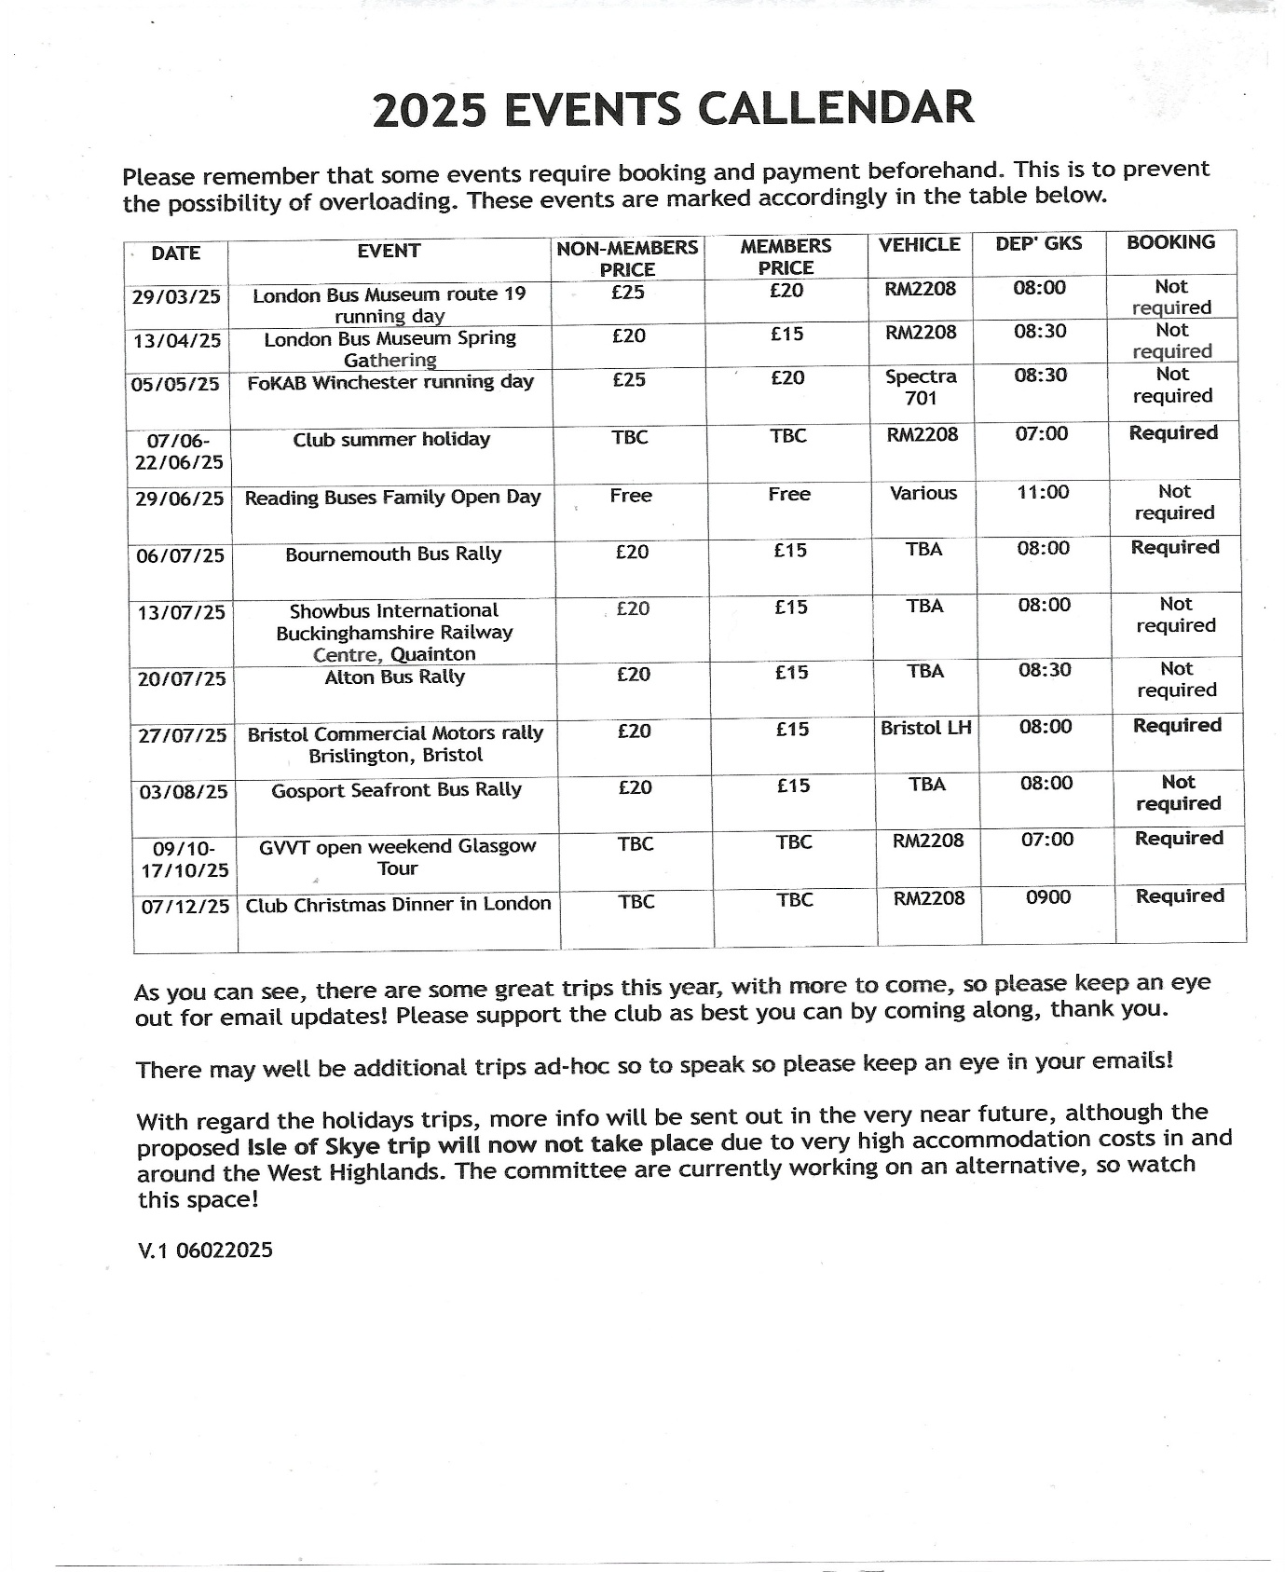
About events we look forward to attending in April 2025
Events we look forward to attending in April. This one is not in the events diary and that is on the 5th, April 2025 at Acton depot of the London transport museum in Acton and the second event is on the 13th, April 2025 at Brooklands Museum in Weybridge for the spring gathering so that should be a good day and looking forward to it. Last year’s spring gathering was a good one so this should have more buses and coaches attend this one more than they do the summer or autumn gatherings. We are we are also proud members of the London bus museum and the London transport museum in Covent Garden.
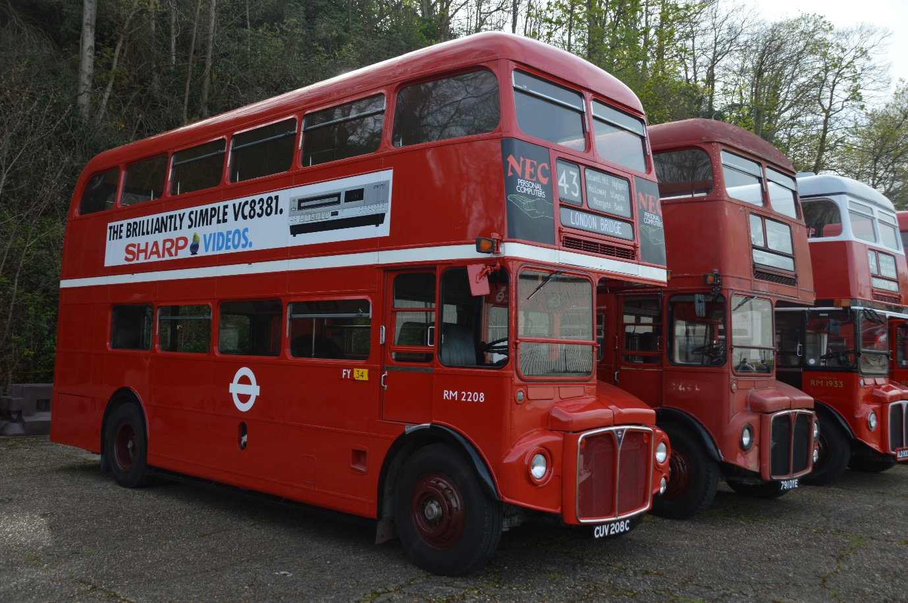
Photo credit to Gary Baxter Administrator of Gary’s bus and coach photos: RM2208 CUV208C London Transport Routemaster Called Rocky at London bus museum annual spring gathering on the 14th, April 2024.
In other news: We have removed images of models from TTC diecast page on our website at www.garysbusandcoachphotos.co.uk but a link to ttc diecast is still they has they are still our sponsor we just have removed images of models has the Coastliner stagecoach that just come out has sold out for preorder at Ttc diecast so to save updating all the time I’ve removed all the images they is just a link for the website with the logo above.

