
Month: July 2025 Issue No: 85
this month we attended at the Bournemouth bus rally in Bournemouth on the 6th, July 2025. This event was good with plenty of buses and coaches to be seen at the event more about this on page four. This month we were meant to attend at Showbus in Buckinghamshire heritage railway centre in Buckinghamshire on the 13th, July 2025, but ended up being cancelled more about this on page Four. This month we also attended at the Alton bus rally again this event was held at the Alton College in Alton on the 20th, July 2025 more about this on page five. This month we also attended at the Bristol bus rally in Bristol on the 27th, July 2025. More about this on page five.
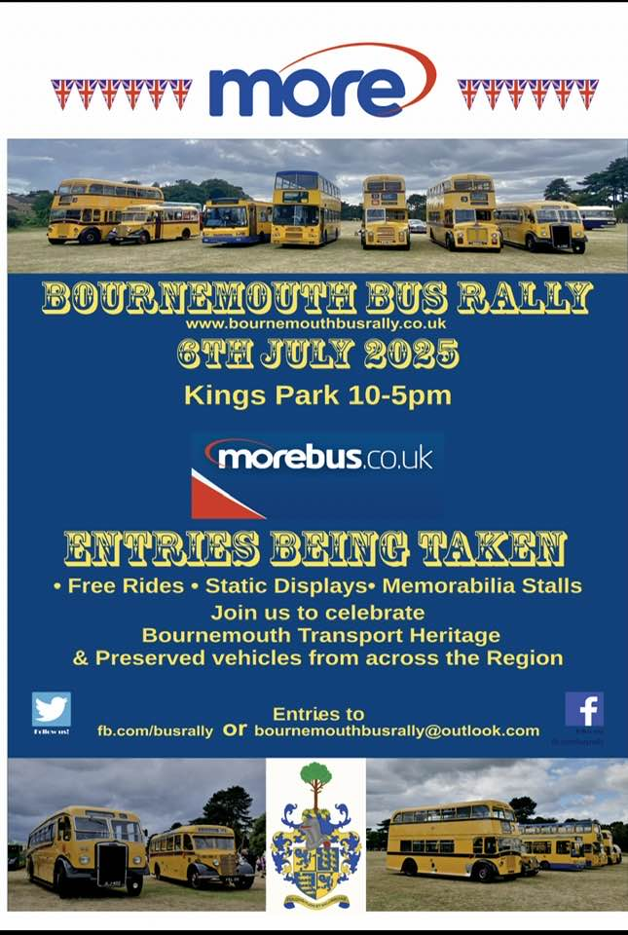
Flickr Albums
Flick Album Date: | Flickr Album Title | Flickr Album link
6th July 2025 | Bournemouth bus rally | https://flic.kr/s/aHBqjCkCnE
8th/ 9th July 2025 | Bracknell & Camberley | https://flic.kr/s/aHBqjCm1qh
17th July 2025 | London Heathrow Airport & London | https://flic.kr/s/aHBqjCmXvy
20th July 2025 | Alton bus rally and running day | https://flic.kr/s/aHBqjCnfNz
27th July 2025 | Bristol – Brislington P&R bus show | https://flic.kr/s/aHBqjCocNQ
27th July 2025 | Bristol – Brislington P&R bus show | https://flic.kr/s/aHBqjCojxn
Photo of the month
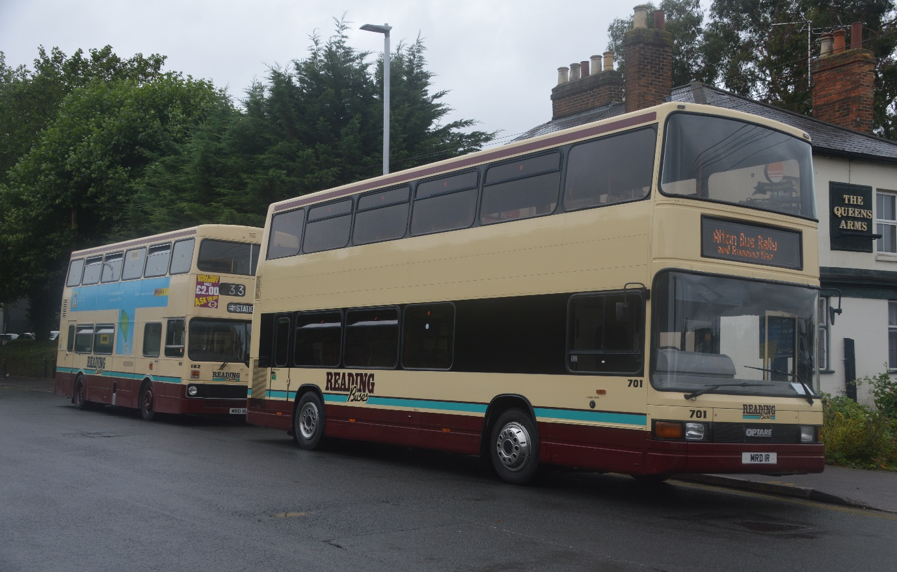
Photo credit to Gary Baxter administration and member of Gary’s bus and coach photos; Reading buses preserved 701 MRD1R & 162 WRD162T photographed at GKS before departure for Alton Bus rally and running day 20th, July 2025. Photo of the month for July 2025.
Events Diary
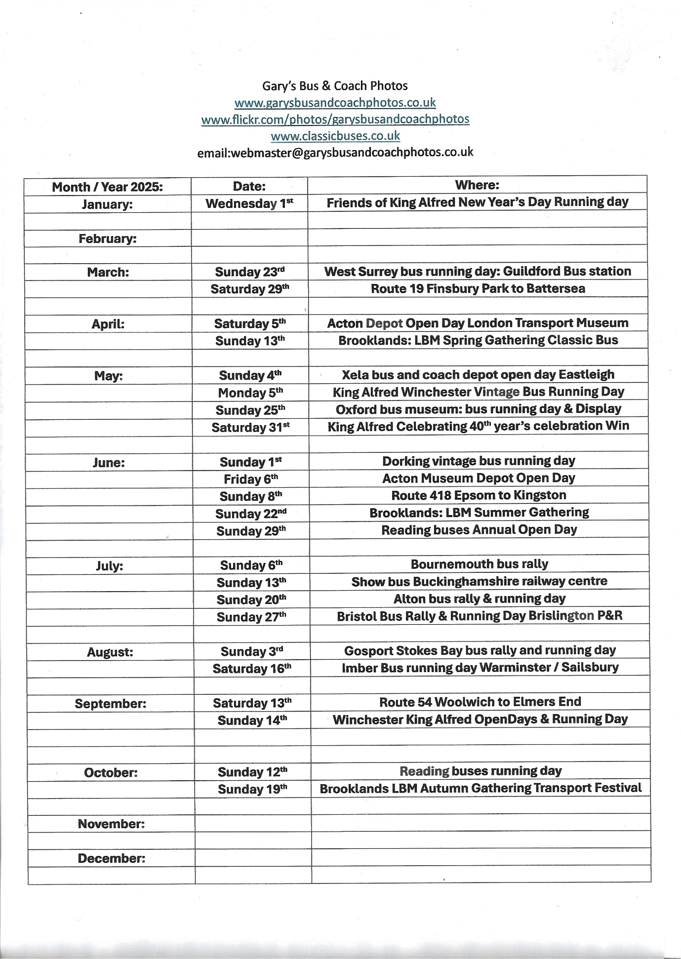
Bournemouth bus rally & running day
We attended at the Bournemouth bus rally and running day, we travelled on the Train from Blackwater / Sandhurst to Bournemouth. The day saw me spending time with friends Paul hazard, Robert and Theo Thompson his son. We looked round the event at all the different buses and coaches. The Reading Transport Enthusiast club did not attend due to change of plans for the club organiser and not having a driver available to drive a bus down for the event. So I travelled down by train there and back to Sandhurst which was good with no stress trains were running okay so was ok for the event Photos from the event can be found at www.garysbusandcoachphotos.co.uk and photo album link here https://flic.kr/s/aHBqjCkCnE no video from this event.
Showbus Buckinghamshire Heritage railway centre
We were meant to be attending this event, but this event got cancelled due to ongoing or presumably on going HS2 rail work near the site off the Buckinghamshire railway centre due to accessing the road to the railway centre, so there had to cancel the event for this with next year’s waiting to be announced. Let’s hope it goes ahead next year.
Alton Bus Rally & Running Day
We attended at Alton bus rally and running day with the Reading transport enthusiast club. We travelled up to Reading to meet up with the enthusiast club to go to Alton. We left Reading for 08:30 once we arrived at Alton bus rally and running day, it was just a question of parking up. The day again was well organised by the event organiser. The day saw plenty bus rides out to the different destinations advertised, along with plenty to see and do. Video and photos from the event can be found on www.garysbusandcoachphotos.co.uk links to video and photos here. https://flic.kr/s/aHBqjCnfNz
Unfortunately, there was no video from this event due to poor weather.
Bristol Bus Rally & Running Day
We attended at the Bristol bus rally with the Reading transport enthusiast club. We travelled up to Reading by Train from Sandhurst to Reading to meet up with the enthusiast club. We left Reading for 08:00. Once we had arrived at the event it was just a question of getting parked up and enjoying the day in Bristol. We did some photos and video before heading out on rides to the destinations advertised. Photos and video from the event can be found on www.garysbusandcoachphotos.co.uk links to video and photos here. https://flic.kr/s/aHBqjCocNQ https://flic.kr/s/aHBqjCojxn

Facebook cover photo competition
Place | Name
1st | Andy Dyer
2nd | Andy Dyer & Andy Wilson
3rd | Barry Smith
4th | Daniella West & Hirasawa Yui
5th | Gary Baxter
Well done to all who take part in this month’s Facebook group cover photo competition next month’s Facebook group cover photo competition will take place on the 15th, August 2025. 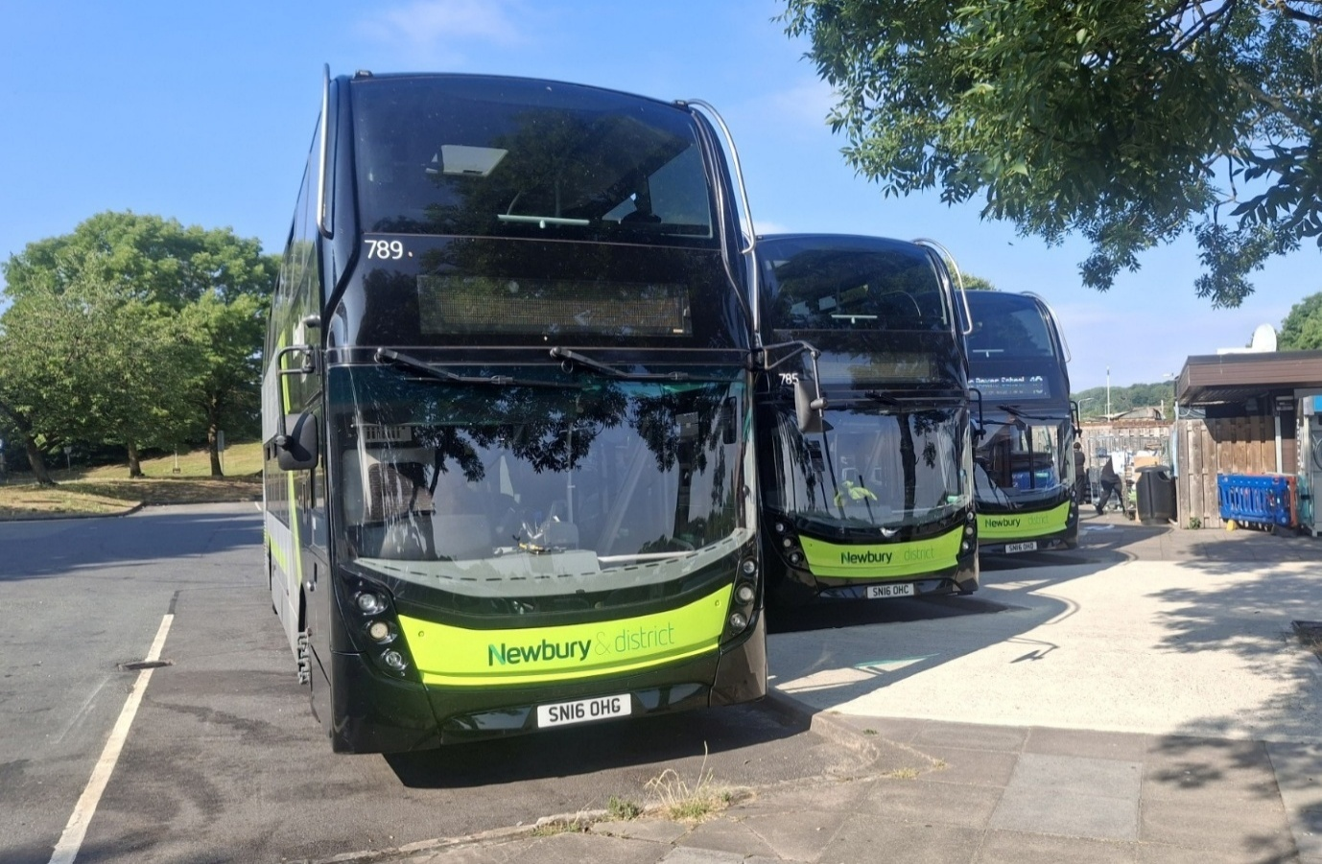

Photo credit to Andy Dyer Administration and member of GB&CP; 789 SN16OHG, 785 SN16OHC & 786 SN16OHD photographed at a services taking a break Facebook group Cover Photo of the month for July 2025
Reading Transport Enthusiast Club
Events & Membership
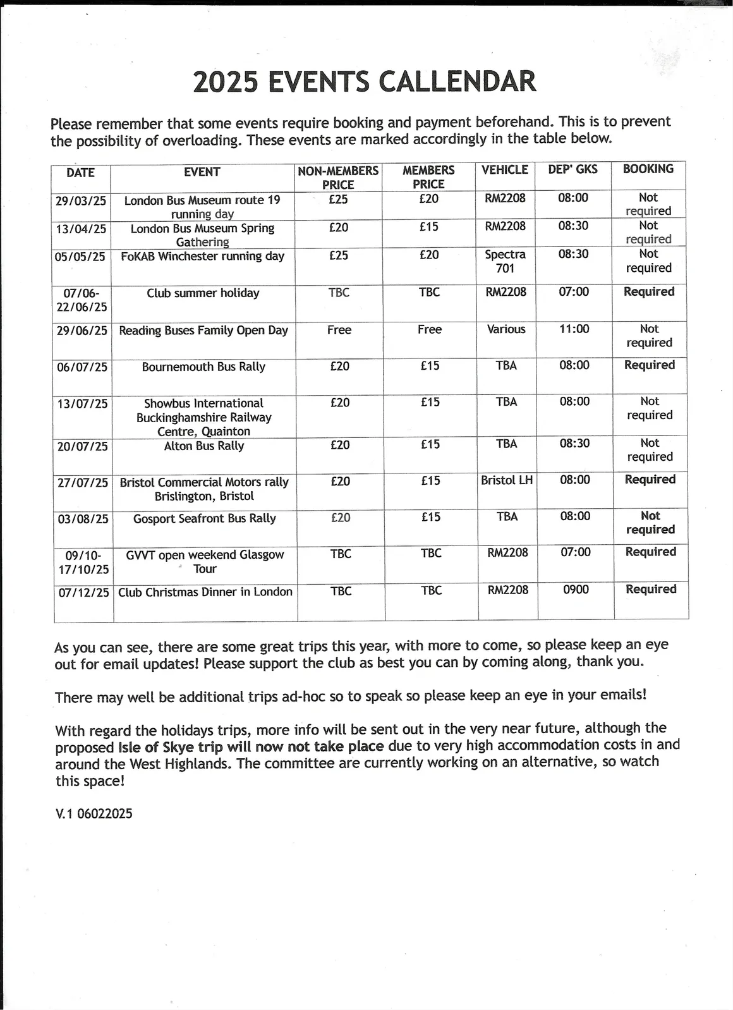
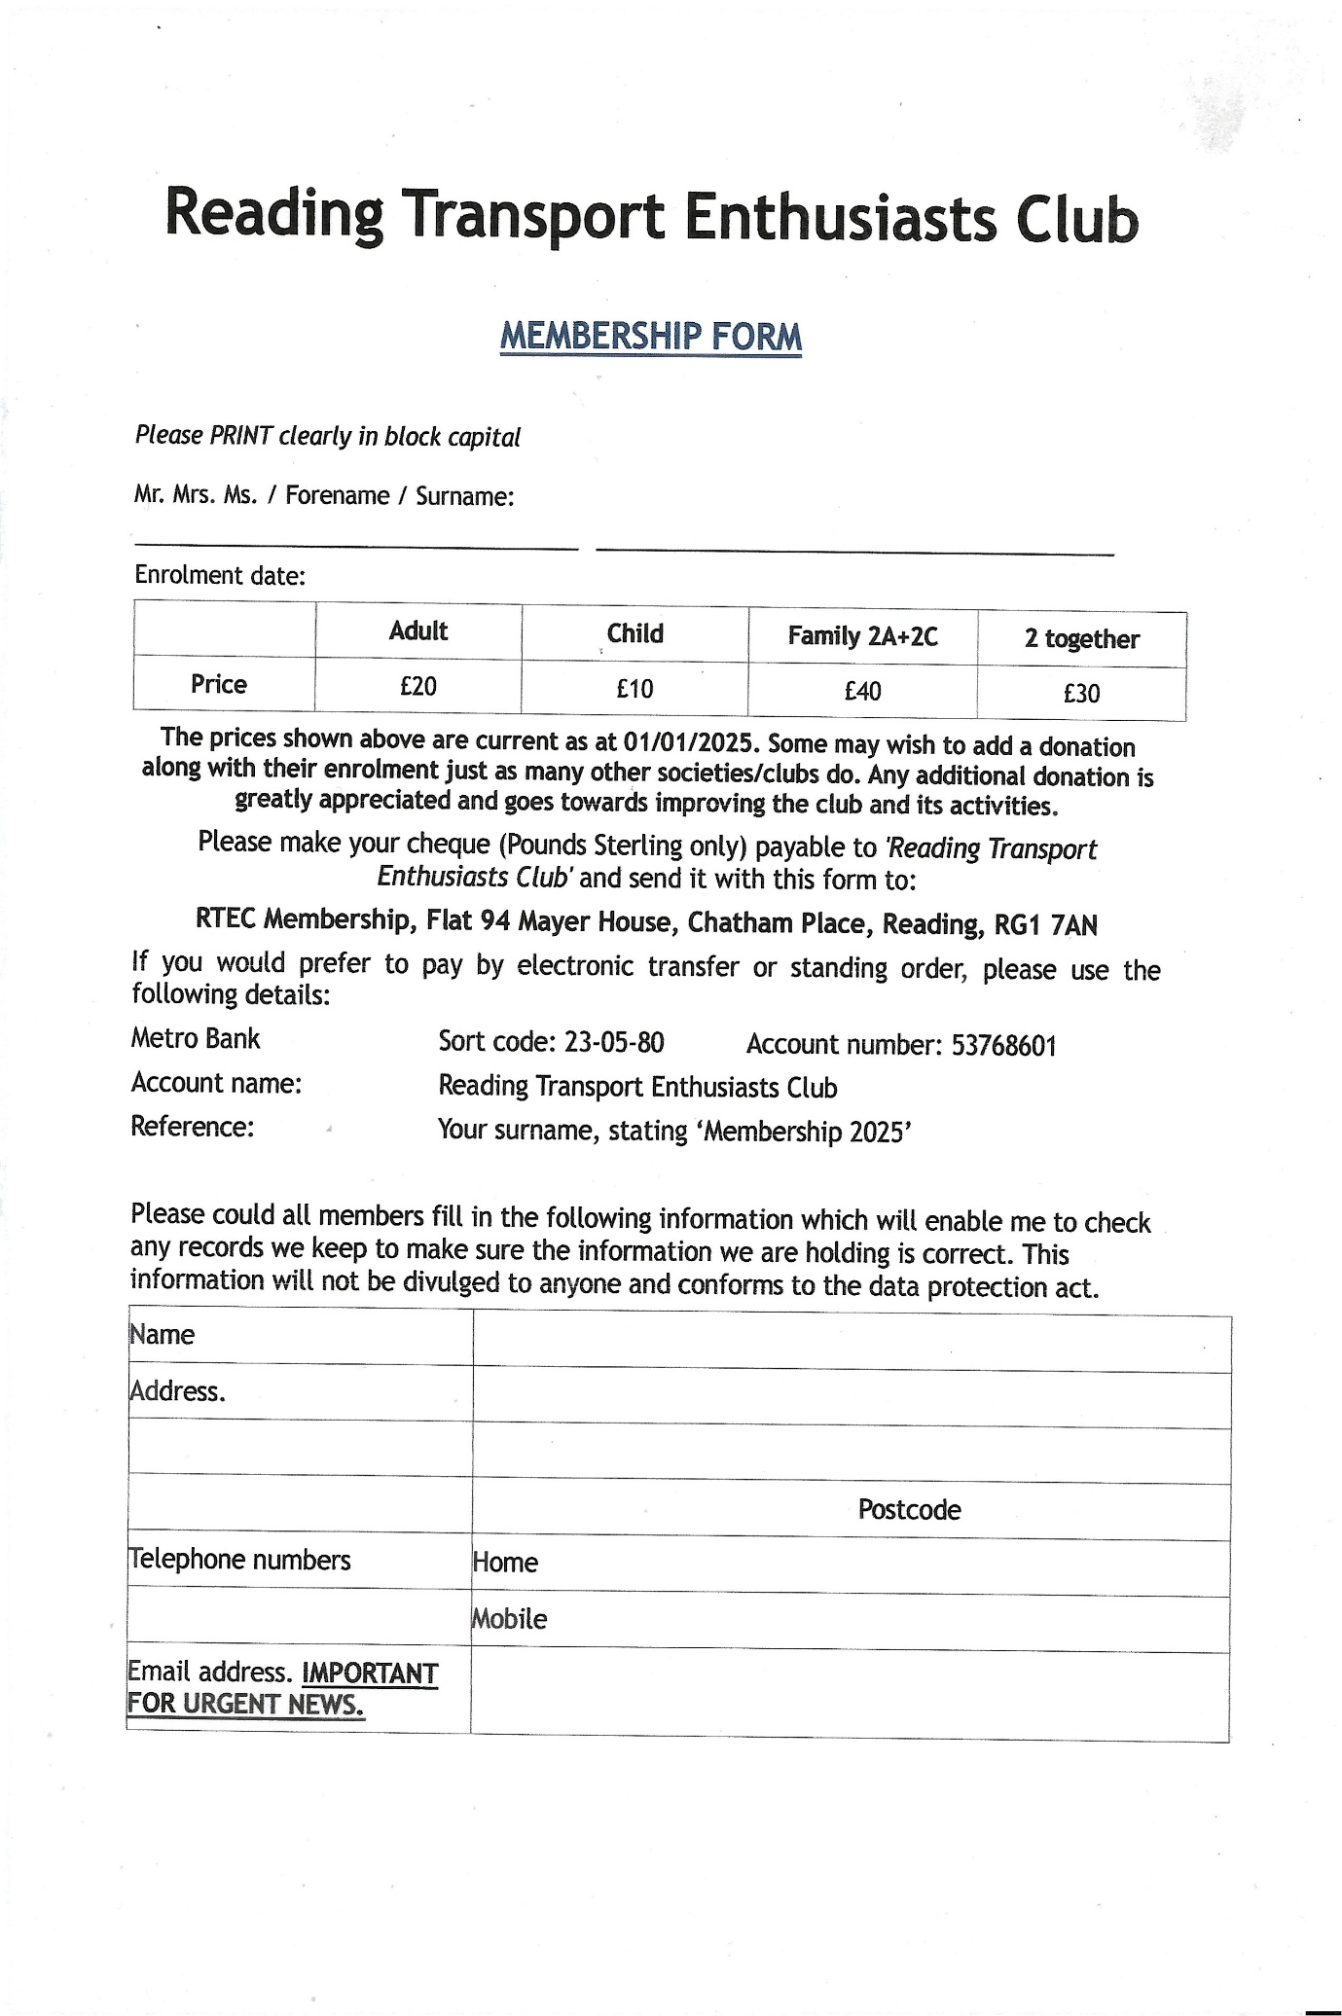
Fourth coming events in August 2025
Date: | Event:
Sunday 3rd | Gosport / Stokes Bay bus rally and running day
Saturday 16th | Imber bus running day Warminster / Sailsbury

Reading Transport Enthusiast Club Fourth Coming events
August 2025
Date: | Event:
Sunday 3rd | Gosport / Stokes Bay bus rally & running day
Thames Valley 704 from Maidenhead to London Heathrow Airport
Last month we reported on new route 704 from Maidenhead to London Heathrow Airport T5. This service is very good even though it is only one bus an hour it is good, I think the service is getting well used from Maidenhead to London Heathrow Airport which means the town has more of a connection to Heathrow airport without having to change buses at Slough. The service was announced March, April to get approval from the local authorities. The service was later announced to have approval from the local authorities, and the service then started on the 2nd, June 2025.
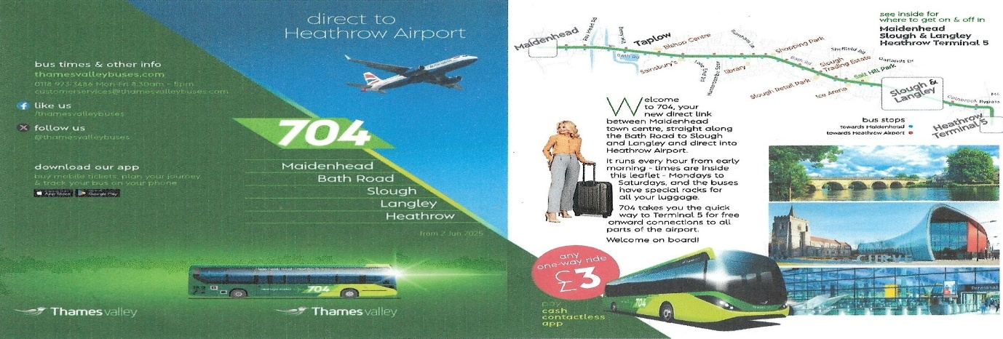
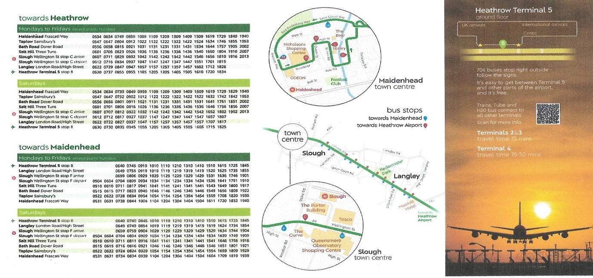
The timetable for new route 704 running every hour from Maidenhead and London Heathrow Airport.
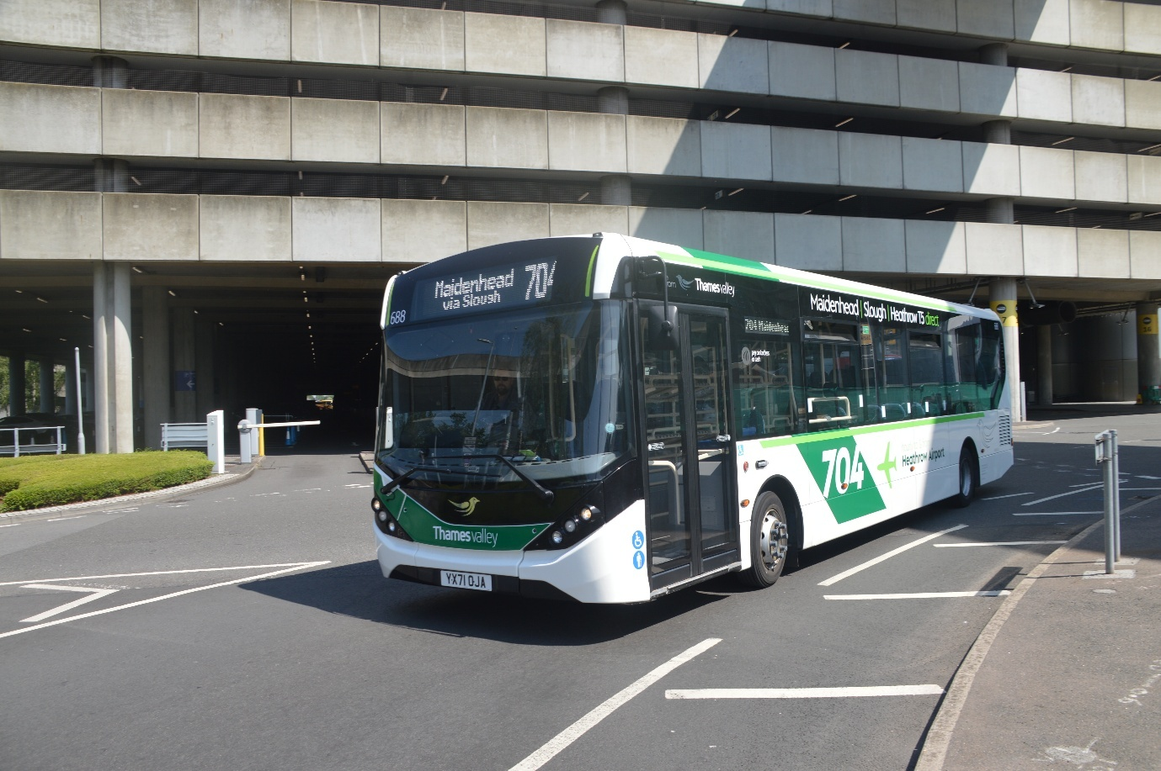
Photo credit to Gary Baxter Administration of Gary’s bus and coach photos: TV688 YX71OJA photographed departing London Heathrow Airport on route 704 to Maidenhead.
Fleet no: | Reg No:
688 | YX71OJA
689 | YX71OJB
So, 688 YX71OJA along with 689 YX71OJB our branded for this route that operates every hour from Maidenhead and London Heathrow Airport. The Heathrow services now go up five services operated by sister companies.
Service no | From / to | Operator
703 | Bracknell to London Heathrow Airport | Reading Buses / Thames valley
704 | Maidenhead to London Heathrow Airport | Reading buses / Thames Valley
GO2Gate | Dedworth to London Heathrow Airport Taxi | Reading Buses / Thames valley
730 | Basingstoke to Frimley | Reading Buses / Newbury & District
731 | Frimley to London Heathrow | Reading Buses / Newbury & District




Theo Thompson & other friend links
Theo Thompson’s Links
Link Name: | Link:
Theo Thompson Bus Enthusiast YouTube channel | Theo Thompson Bus Enthusiast - YouTube
Theo Thompson Flickr | Theo Thompson | Flickr

Link Name | Name Site | Link
Alex Young / Hello Wallace | YouTube | Hello Wallace - YouTube
Alex Young / Hello Wallace | Flickr | Alex Young | Flickr
Tony & Tracy | Flickr | https://flickr.com/photos/202982794@N05

Website Name: | Website Links
Workwear Express | Personalised Work Clothing & Work Uniforms | Workwear Express
Snapfish | www.snapfish.co.uk
Vista print | www.vistaprint.co.uk
Paul Turner / Bus stop | www.pauls-bus-stop.creator-spring.com
Shed no2 | www.shedno2.co.uk
My personalised phone case | Personalised Phone Cases | iPhone | iPad | Samsung | Google | Oppo | OnePlus | Huawei
Personalisation Websites
All links above are people who I know personally and people who I trust to do personalisation on items brought by them. For embroidery I really do recommend workwear express has every time we have gone to them for an item, they have always attached the logo or logos with no problem at all. Paul Turner and Bus stop he is also a great guy and well recommended he is always at the Reading buses depot open days in June / July. Flickr’s and YouTuber’s Theo Thompson is a good youtuber and a good friend to me always makes good videos and does good photos for his flickr. Alex Young / Hello Wallace is another good YouTuber he also makes good videos and takes some good photos for his Flickr. Tony and Tracy even though they have only just started they flickr they a good photographer and always get some good photos in different locations of London or wherever they go to.

Celebrating
This year in May we celebrated running Gary’s bus and coach photos group for twelve years in August will be celebrating running our page for eight years in this time we have achieved so much making five hundred odd members hundred odd subscribers to our YouTube channel and over five hundred odd followers to our flickr making a website for all of the community to go to view all things related to this. Each year we grow bigger along with gaining new friends and followers to each of our sites we use. I am grateful to everyone for sharing photos on our group for us all to enjoy and share into newsletter and on the cover photo competitions. In time we have been going we have gained so much over time. Some of what we do would not be possible without administrations and one special administrator Dorothy Rose Baxter who looks out for our finances and having a catalogue where I can get cameras from to pay on a monthly. So, it is with thanks to Dorothy Rose Baxter that we can do what we do and offer what we can offer. The work is always on-going events back-to-back and days out for general bus spotting. This year has seen us adding a few new administrations to our group and website which makes mine work lighter with they help to run things in general. This year has also seen us getting new sponsors on volunteer basis these being Reading transport enthusiast club and your coach hire, both based in Reading and Wokingham. Now here is to another few years. I would like to thank everyone of our members for joining and thank all the administrations for all they hard work to keep adding members to the group. On behalf of Dorothy Rose Baxter and myself thank you all now let’s hope we have another few years to keep going and keep creating the work we do. Our website is www.garysbusandcoachphotos.co.uk
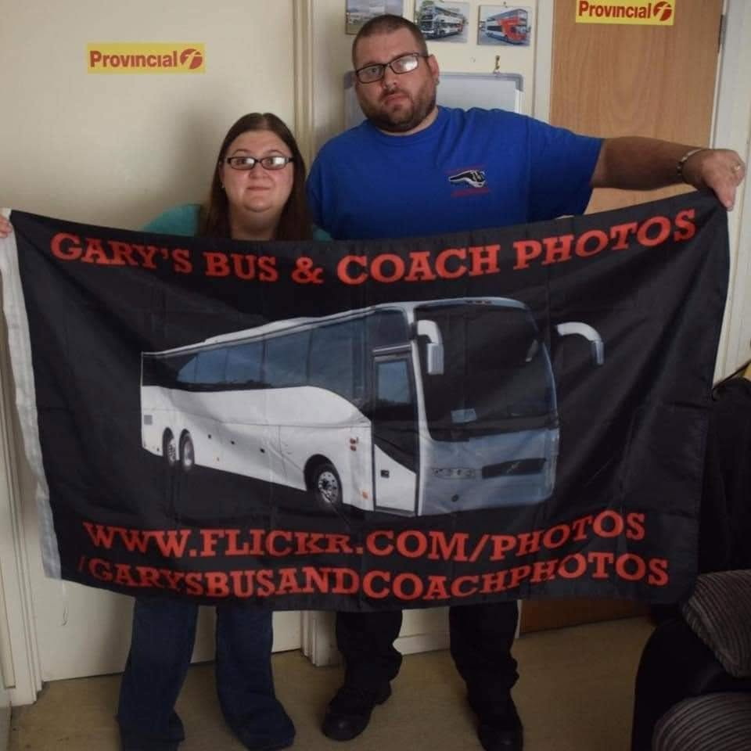
Photo credit to Gary Baxter Administration of Gary’s bus and coach photos: Gary & Dottie with the Gary’s bus and coach photos flag with our flickr site on.
What happened this month for trips out
This month saw me take one more trip up to Windsor and London Heathrow airport before the children break for the summer holidays. So, we take the opportunity to go and photograph buses and coaches within Windsor and London Heathrow airport. It was a good time for photographing all the different coaches coming though on different routes from Flixbus and National express since Megabus no longer operate out of London or London Heathrow Airport. This saw me taking about three hundred photos on this day. This month also saw me take the opportunity to visit London with my good friend Tracy Churchill take a trip round London getting photos of all the different tour buses and general buses and coaches in London since Megabus / Stagecoach pulled out all their coach services from London which has left services being operated by National express and Flixbus. It was an awesome opportunity to photograph and to spend a bit of time round London. It was also good to spend time with a new friend. It was a lovely day to be going to London and photographing all the tour buses in London. We were also trying to photograph new tour bus for Harry Potter tours in London which was a Routemaster but unfortunately was not successful has new friend did not know where it started from or do the research probably but was still a good day. Spending time with a new friend and photographing all tour buses and coaches within London.
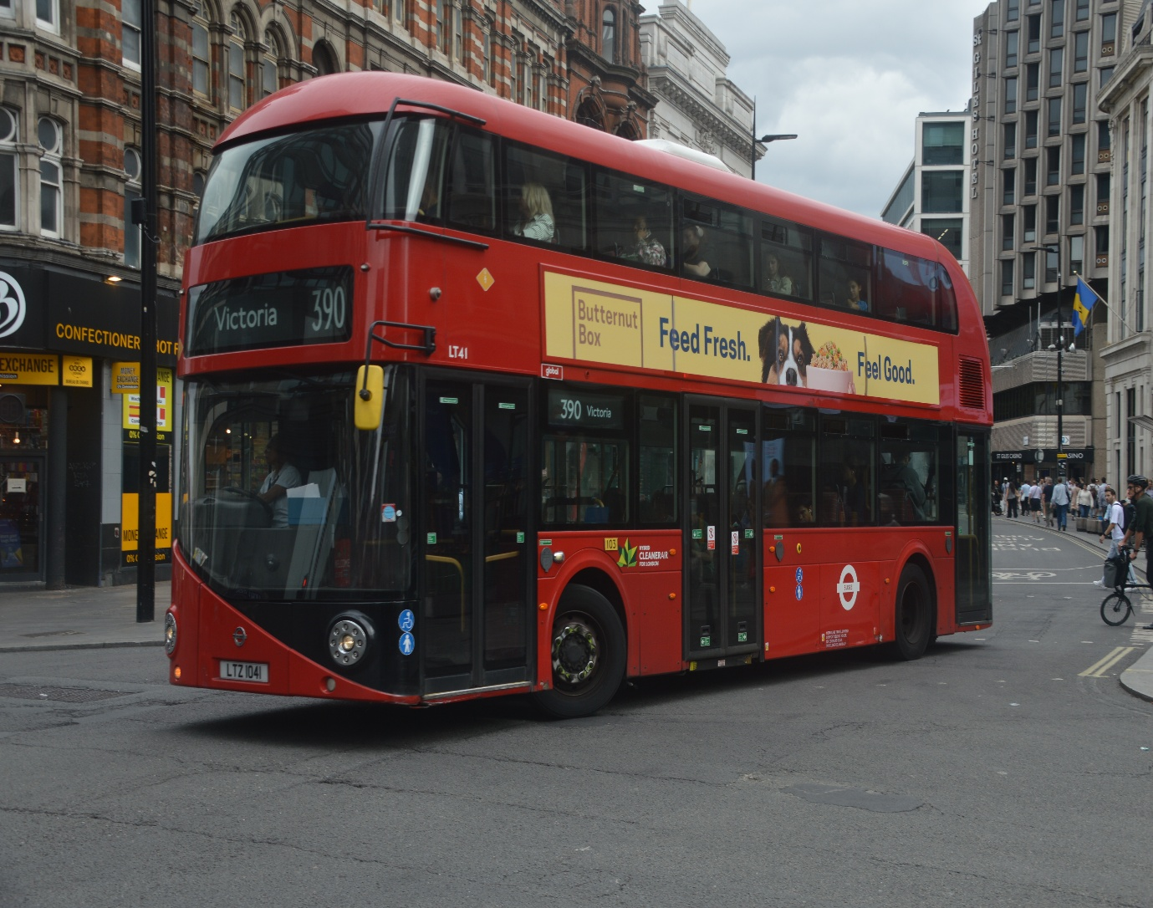
Photo credit to Gary Baxter Administration of Gary’s Bus & Coach Photos: LT41 LTZ1041 Boris-master in Tottenham Court Road on route 390 towards London Victoria.
Facebook Group: Member Photos
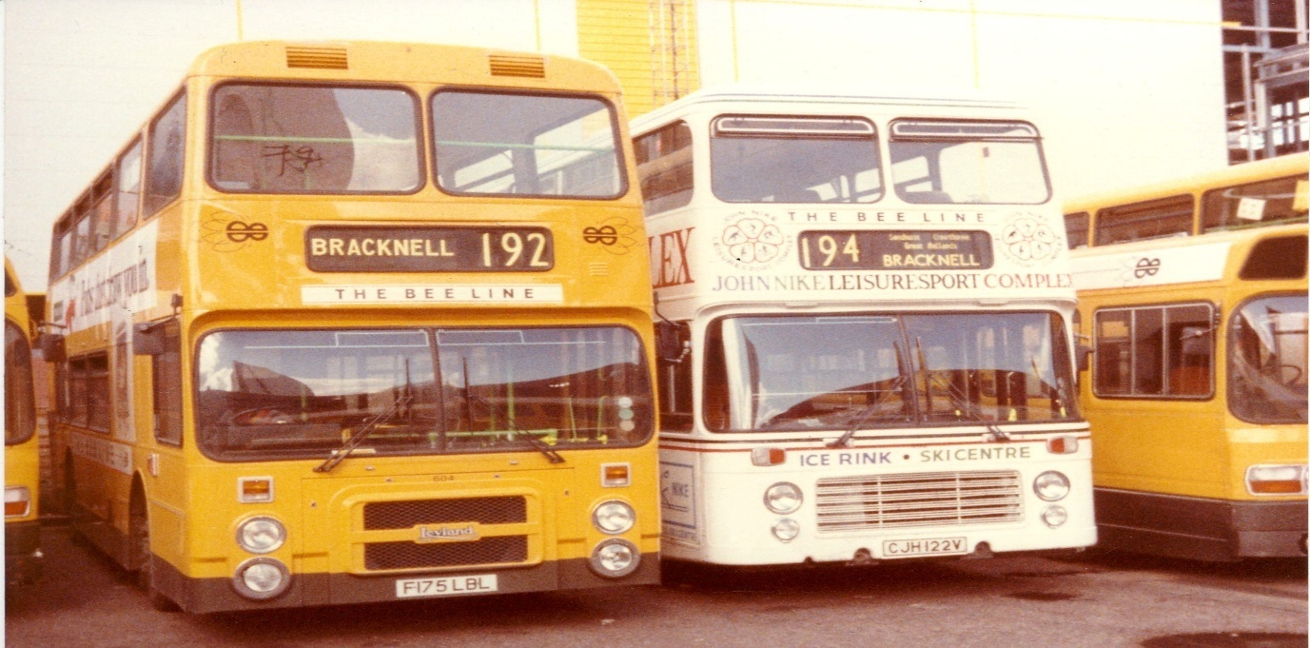
Photo credit to Andy Dyer Member & Administration of Gary’s bus and coach photos; F175LBL Leyland Olympian CJH122V Bristol VR the beeline Bucks Berks bus co Bracknell
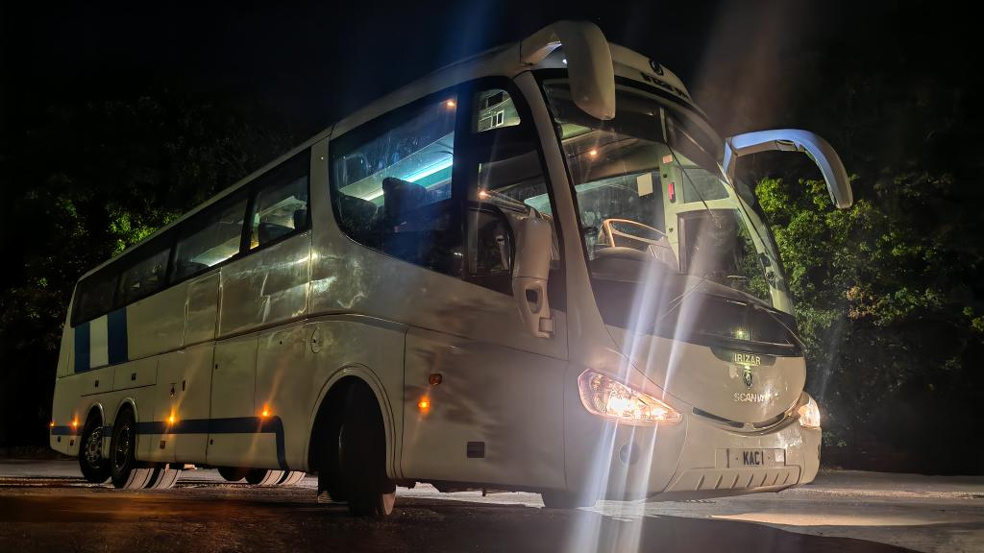
Photo credit to Andy Wilson member of Gary’s bus and coach photos; KAC1 Scania Irizar I6s Dolphin Travel Norfolk.
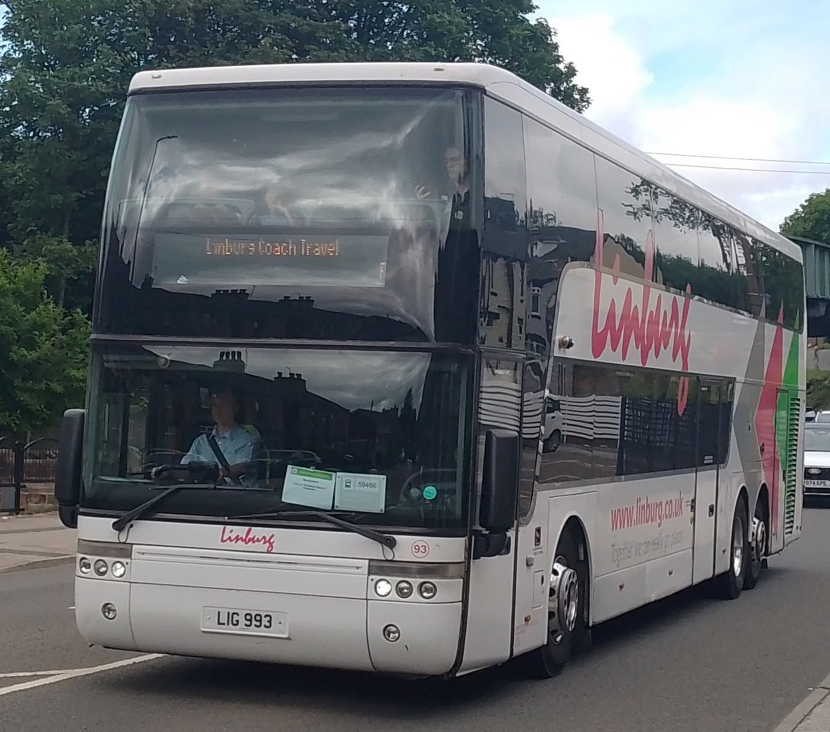
Photo credit to Barry Smith member of Gary’s bus and coach photos: LIG993 Vanhool coach Linburg coaches.
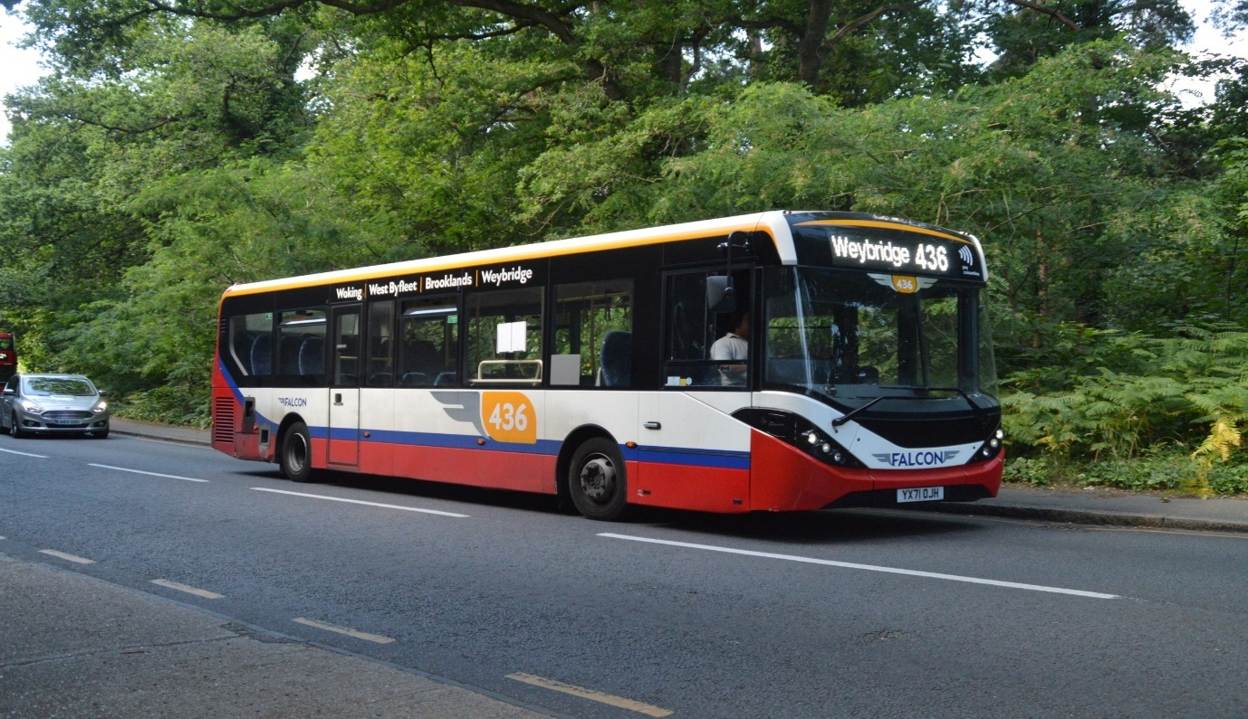
Photo credit to Daniella West member of Gary’s bus and coach photos; FBOJH YX71OJH ADL Enviro200mmc on route 436 to Weybridge.
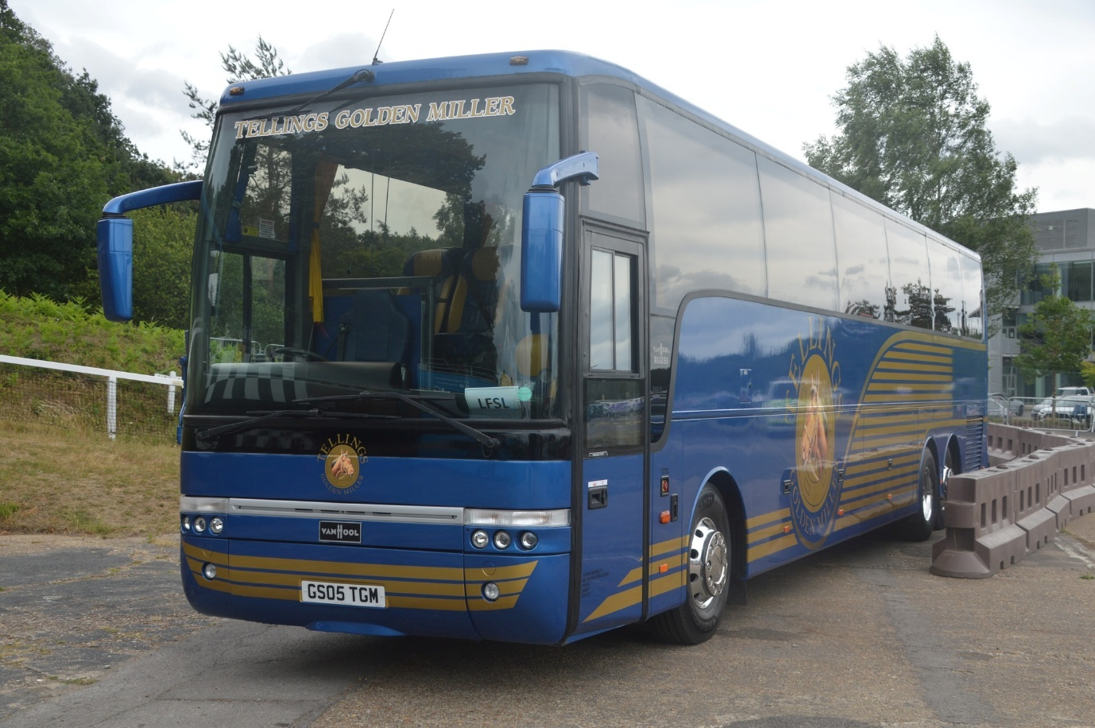
Photo credit to Gary Baxter Administration and member of Gary’s bus and coach photos; Telling Golden Miller GS05TGM Vanhool Alizee at Brooklands Weybridge summer festival.
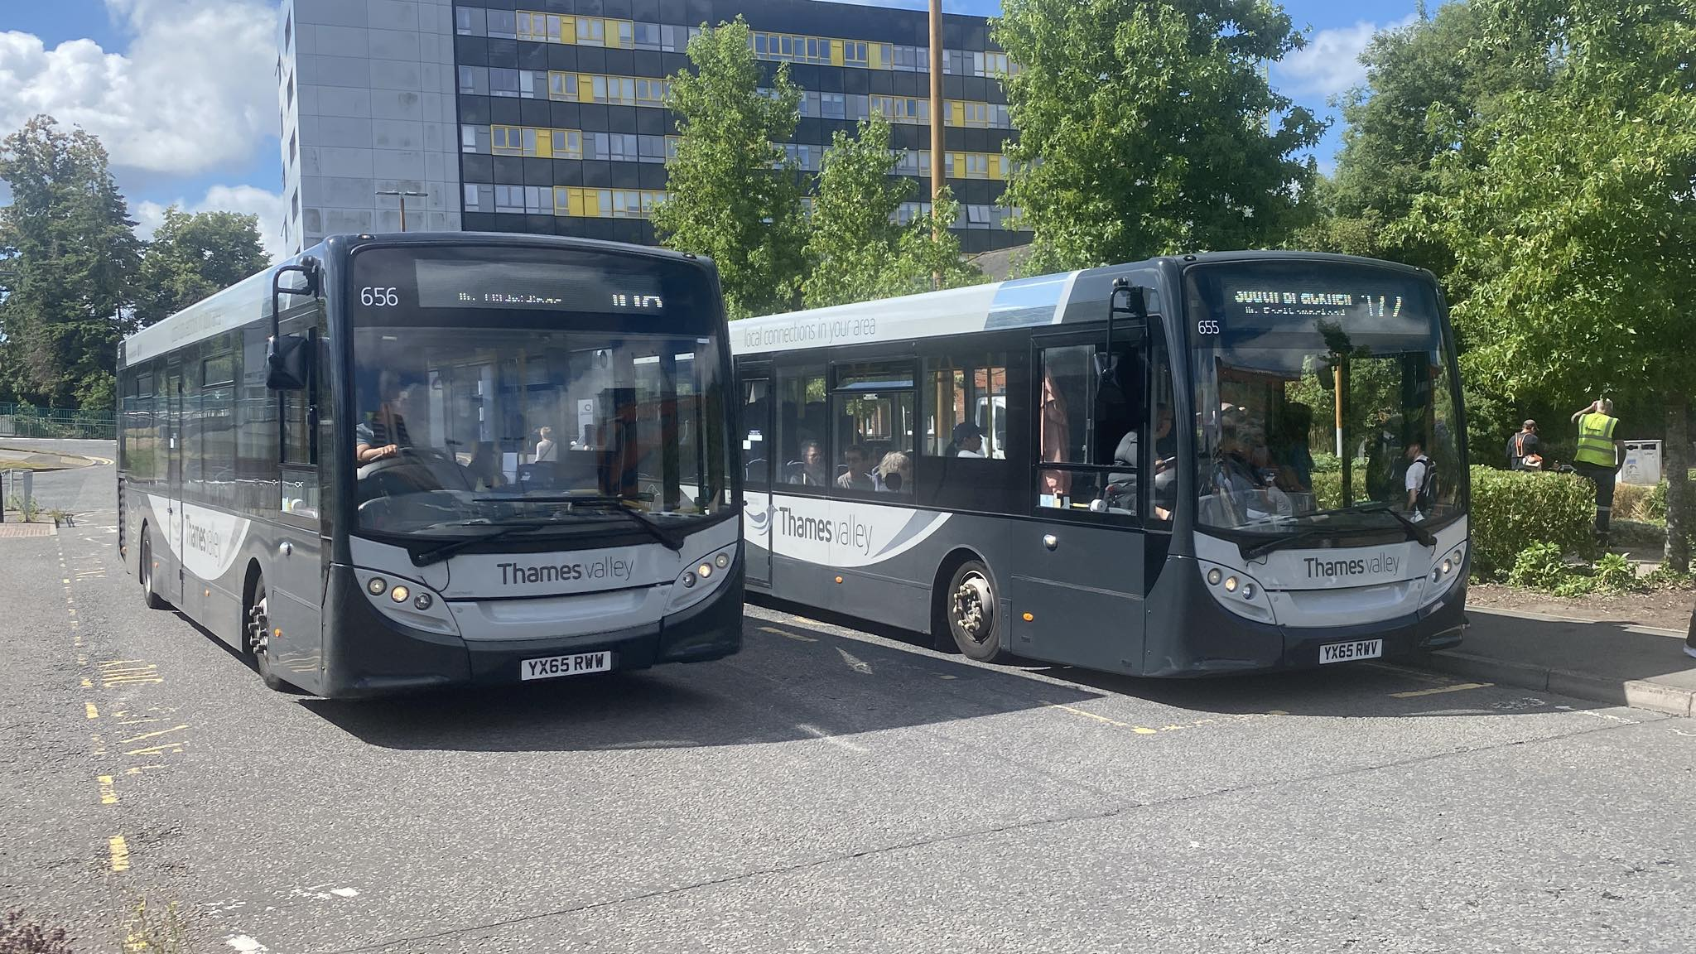
Photo credit to Yui Hirasawa member of Gary’s bus and coach photos; 655 YX65RWV & 656 YX65RWW ADL Enviro200 photographed together in Bracknell.
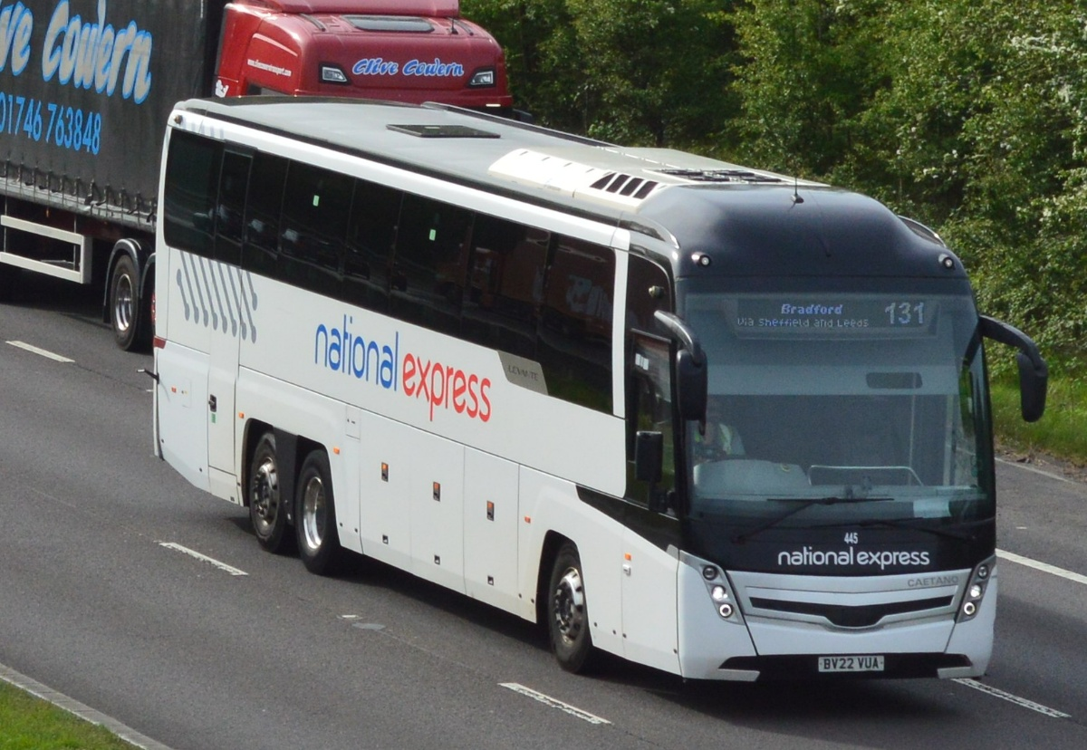
Photo credit to Barry Smith Member of Gary’s bus and coach photos; Bruce coaches of Salsburgh Caetano Levante III Scania BV22VUA seen in Barnsley.
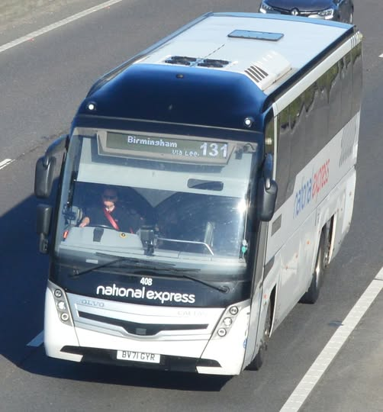
Photo credit to Barry Smith Member of Gary’s bus and coach photos; Woods coaches 408 BV71GYR Volvo B11RT Caetano Levante 3 seen in Barnsley.

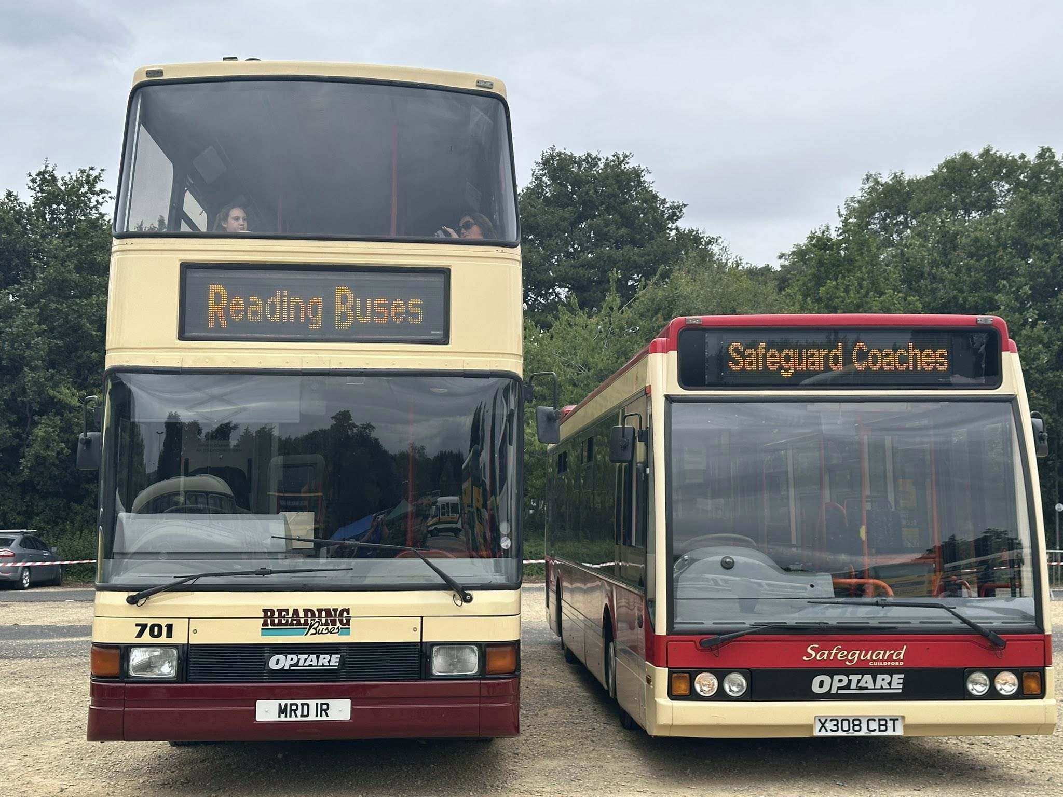
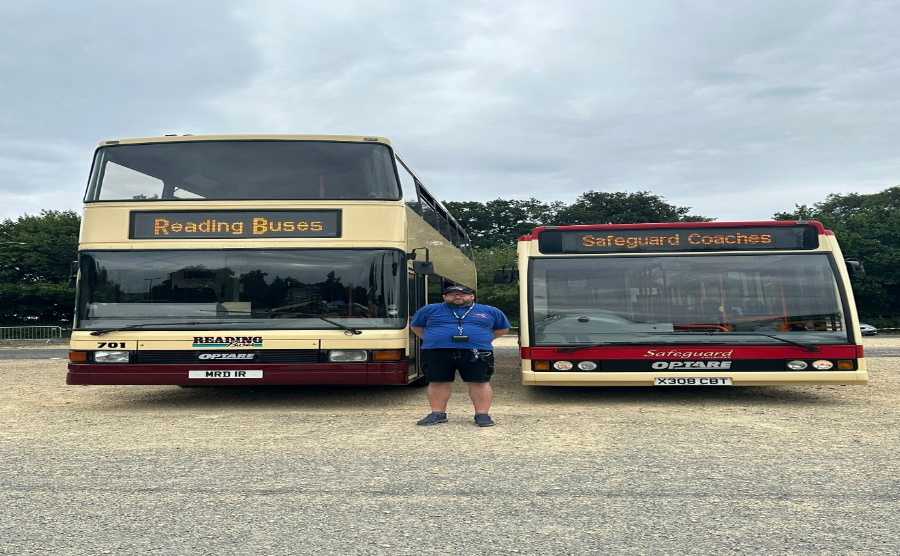
Photo above: Photo copyright to Gary Baxter Administration of Gary’s bus and coach photos Preserved Reading Buses & Safeguard coaches Optare Spectra & Excel at Bristol bus show in Brislington P&R on the 27th, July 2025. Photo bottom: Photo copyright to Gary Baxter Administration of Gary’s bus and coach photos: yours truly in front of preserved Reading buses and Safeguard coaches Optare Spectra and Excel RB701 MRD1R and X308CBT at Brislington Park and ride on the 27th, July 2025.

