
Month: May 2026 Issue No 95
This month we attended at the Friends of King Alfred heritage bus running day in Winchester on the 4th, May 2026. This day was excellent with some excellent rides out on different buses round the city of Winchester more about this on page Five. This month we also attended at the Windsor heritage bus running day organised by the Amersham and district along with Thames Valley and great western omnibus trust. This event was a good day and well organised by the A&D and TV&GWOT too. More about this on page Five. We did not attend at the Taunton bus running due to personal reasons.
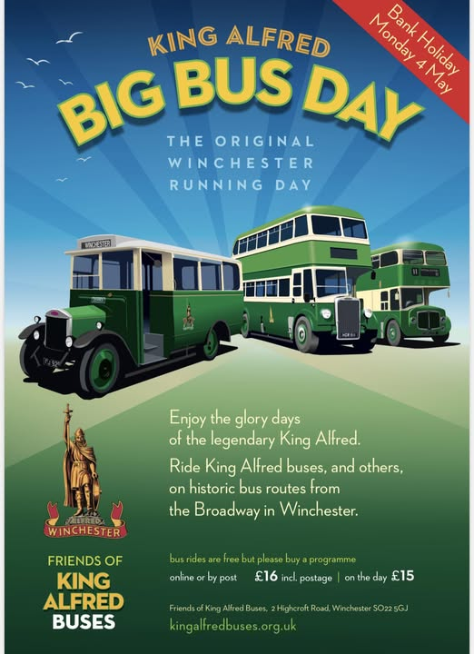

Album Date | Album Name | Album link
1st May 2026 | Your coach hire visit | https://flic.kr/s/aHBqjCSYfu
4th May 2026 | Winchester | https://flic.kr/s/aHBqjCT2Wd
10th May 2026 | Windsor & Windsor heritage bus running day | https://flic.kr/s/aHBqjCTseH
Photo of the month by Gary’s bus and coach photos
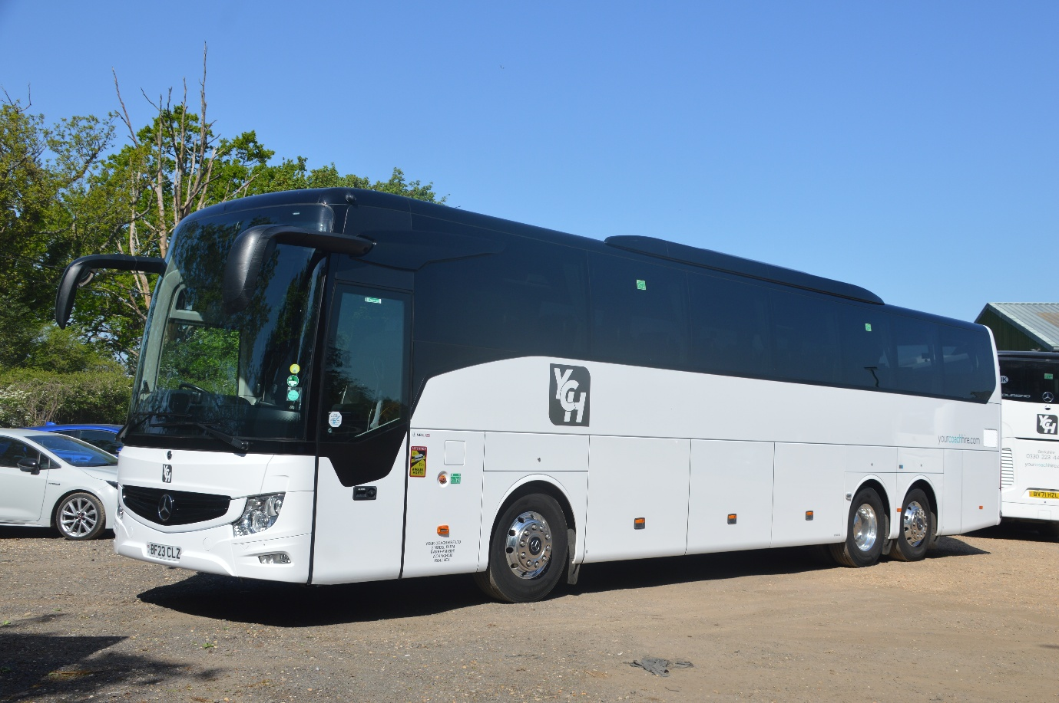
Photo credit to Gary Baxter Administration of Gary's bus and coach photos Yourcoachhire BF23CLZ Mercedes Benz Tourismo photo of the month for May 2026. More photos from this visit found in the grid above.

Events
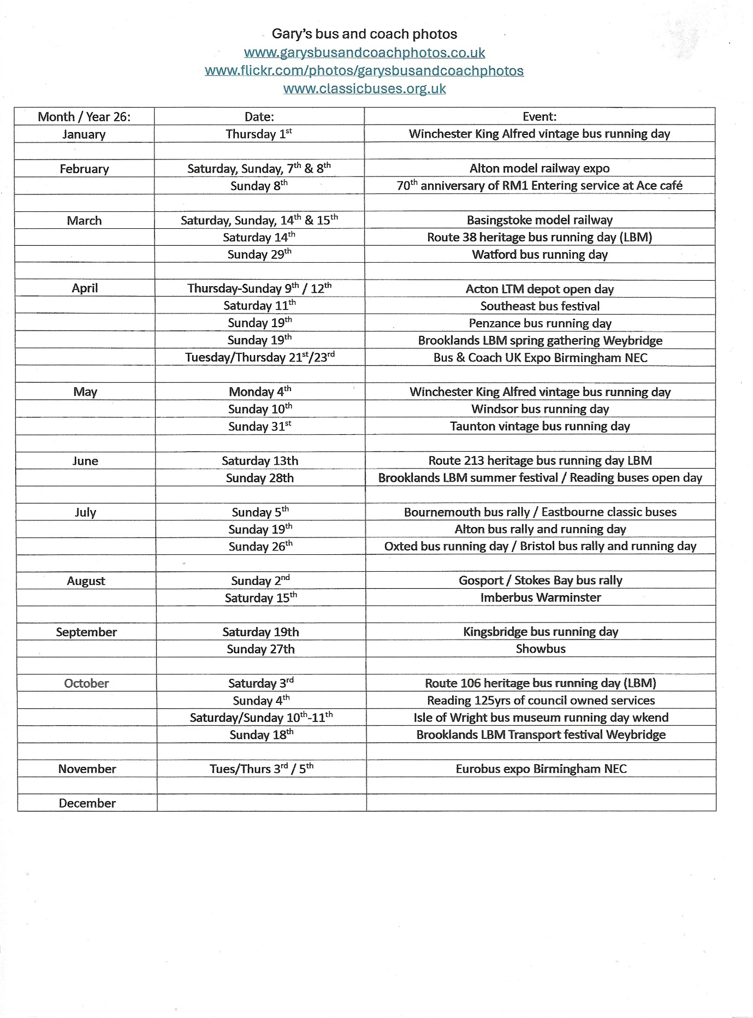
www.facebook.com/groups/garysbusandcoachphotos
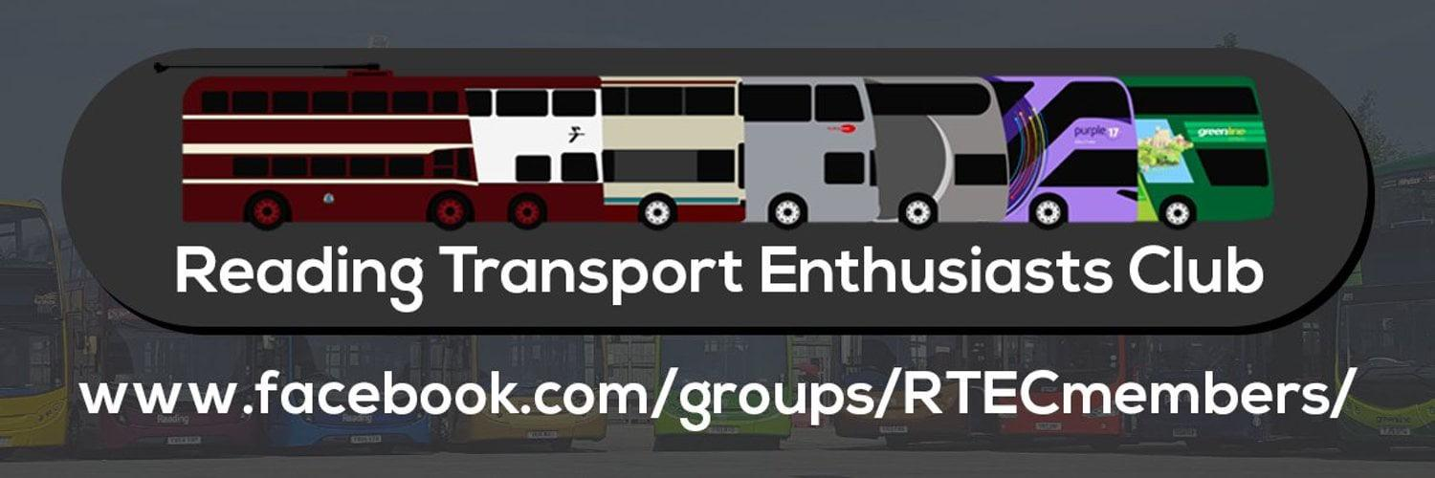
The events list below here shows Events being done by the Reading Transport enthusiast club can also be found on our website at www.garysbusandcoachphotos.co.uk
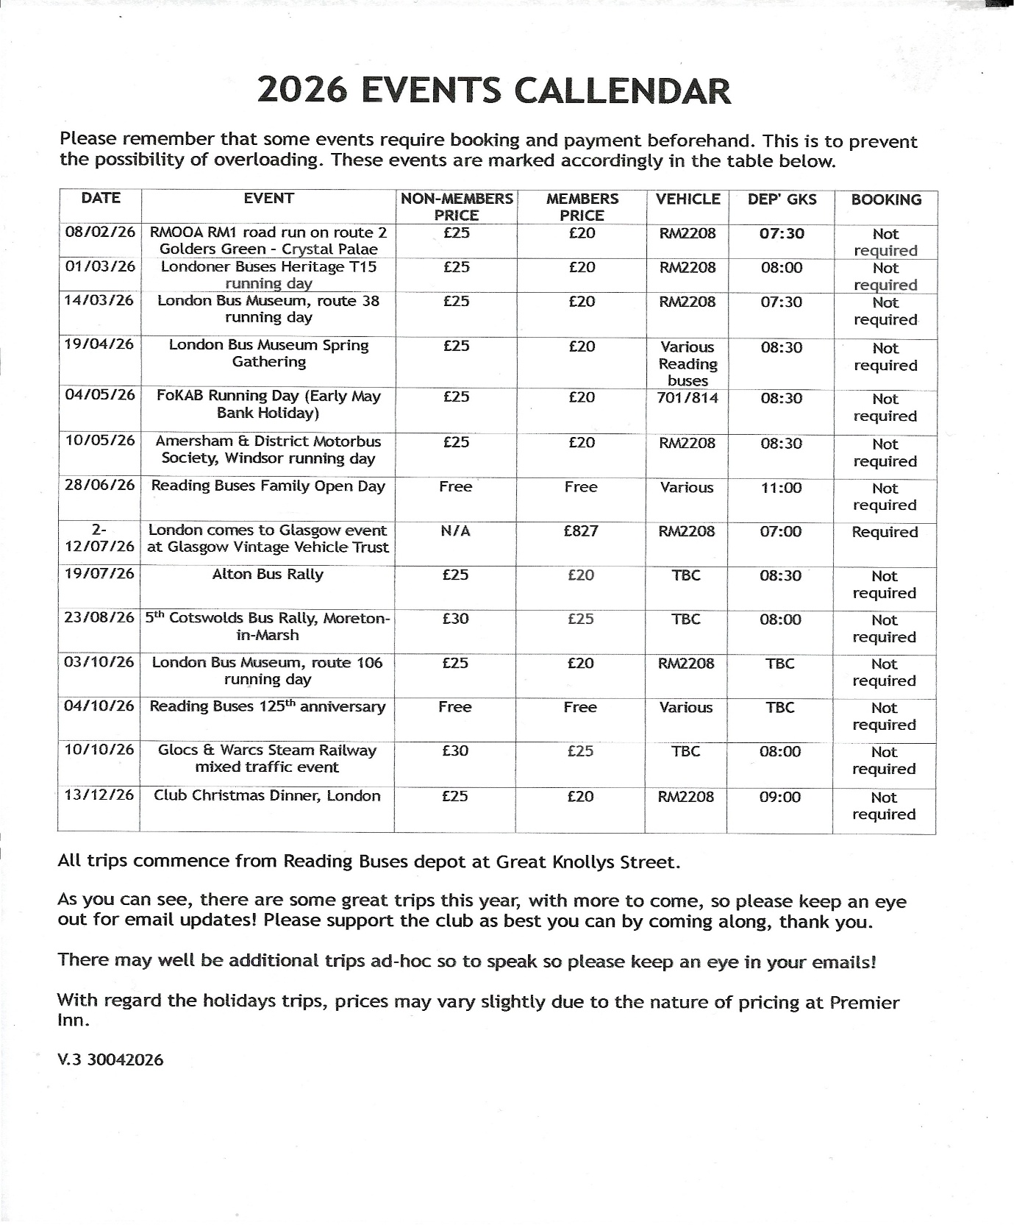
Winchester King Alfred heritage bus running day / Big bus day
We attended the big bus day at Winchester organised by the friends of king Alfred buses. This was a good day catching up with friends and people with similar interests. The event saw a good few buses turning up and joining in the running and running to different places in the city of Winchester again 2026 another well organised event by James Freeman and his team at the friend of king Alfred buses. Video and photos from this day links here https://flic.kr/s/aHBqjCT2Wd https://youtu.be/JovRNA1KuF0 also available via our website at www.garysbusandcoachphotos.co.uk more details about event on pages 14 to 15
Windsor heritage bus running day organised by the Amersham and district and Thames Valley & Great Western omnibus trust
The Windsor heritage bus running day was a good day with buses going to different locations in and out of Windsor this was also a good day for catching up with friends and people with similar interests. The day saw some lovely rides out to all the different locations advertised in the booklet or published on the websites or social media platforms. Video and photos from this day links here https://flic.kr/s/aHBqjCTseH https://youtu.be/GluXpLQlKWY?si=pKaYan4LewiBPMG6 and available on our website at www.garysbusandcoachphotos.co.uk more details about event on pages 16 to 18
Taunton bus running day
The Taunton bus running day. We at the community of Gary’s bus and coach photos did not attend this event even though a close relative is living nearby down they we did not attend this event for reason unknown, but it was due to giving relative time to get settled in down they then we may look in to attending next year in 2027. We did however see some lovely photos and video from the event just a shame we couldn’t attend, but in 2027 we will sure try our best to get down they to be with relative and to attend the running day.
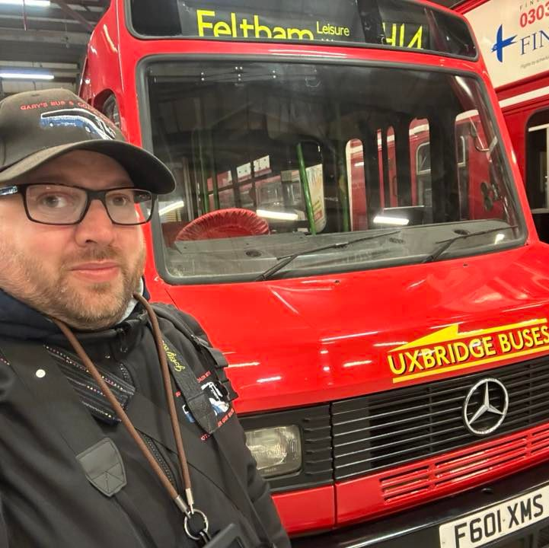
Photo credit to Gary Baxter Administration of Gary’s bus and coach photos: photo taken at Acton Depot Museum in Acton during the open day on the 11th, April 2026, with F601XMS Uxbridge buses destination displayed for Feltham on the route H14. Lovely little minibus.
This month we also went to visit the team at your coach hire to photograph two or three of the new coaches but only managed to photograph the one due to a heavy workload going on at the company and a lot of tours and holidays and other jobs coming through for them. Like in January 2025 it was a pleasure to go and pay them a visit and have a good chat and catch up. The team behind your coach hire are amazing for someone with learning disability and border line cerebral palsy they treated me well like there did in 2025 and had time to chat and catch up with things that had been happening. Chris Bray and Gavin Rutter, the two main people behind the company who has far has we know has they supporter they the two mains. It was a great pleasure to be in the company again and will hopefully be going to see them again sometime soon or when were at Eurobus together for coffee or general drinks. Photo album from this visit can be found here https://flic.kr/s/aHBqjCSYfu or on the website at www.garysbusandcoachphotos.co.uk and by going to Flickr and YouTube page.
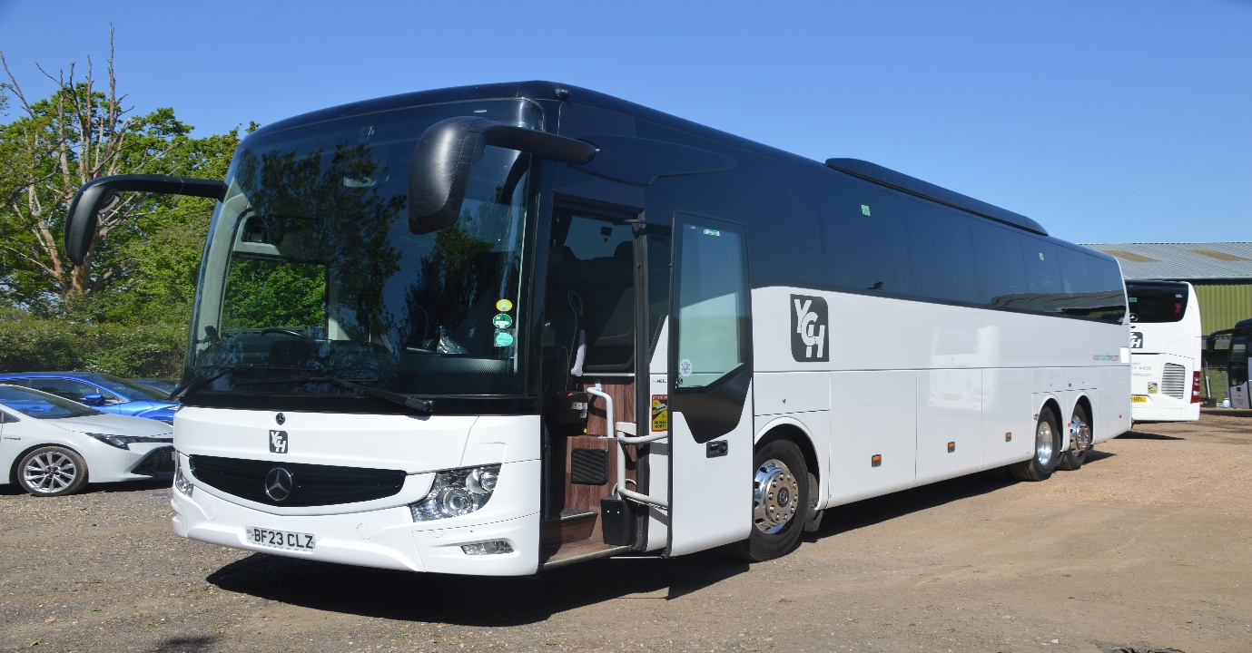
Photo credit to Gary Baxter Administration of Gary’s bus and coach photos: BV23CLZ Mercedes Benz Tourismo Your coach hire new coach for 2026.

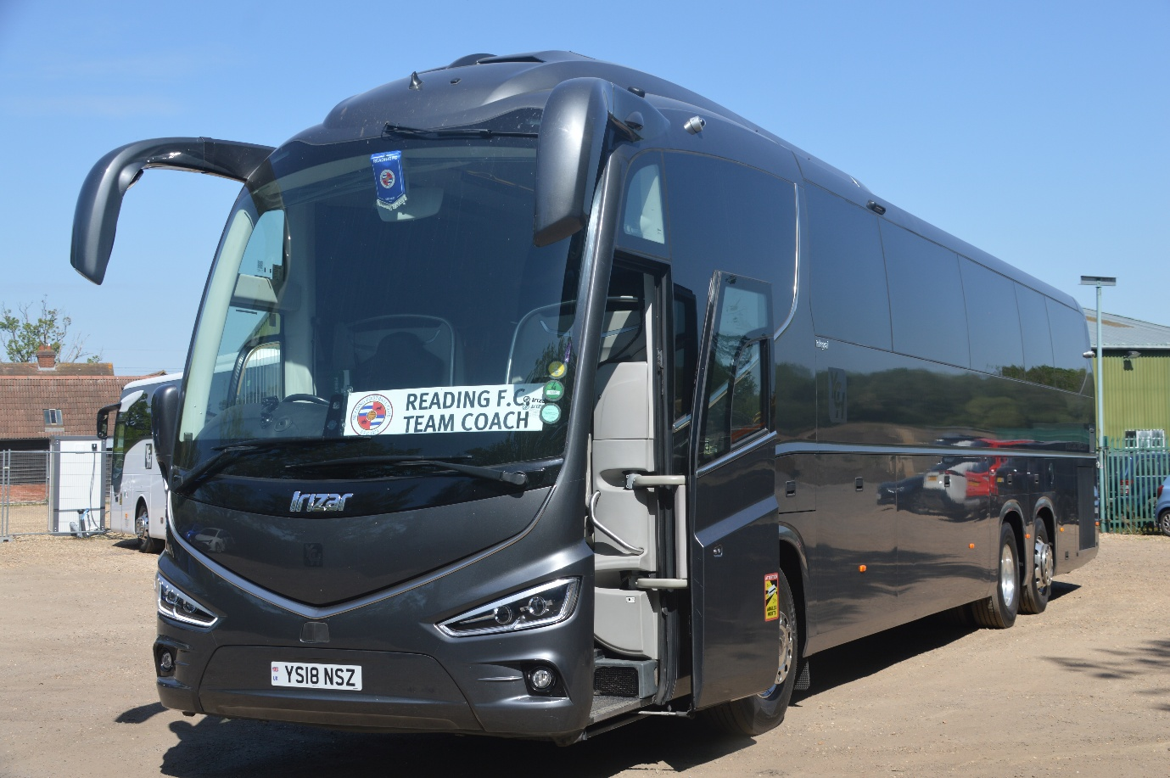
YS18NSZ Scania Irizar Reading football team coach from your coach hire in Finchampstead in Wokingham. With the Reading Football team coach displayed in the window. Also did this in memory of my granddad who is a long-life Reading FC supporter who died in March 2013. Always in my thoughts and never ever forgotten.

Photo credit to Gary Baxter Administration of Gary’s bus and coach photos: drinking his first coffee out of mug that the team at your coach hire gave to him for come to pay a visit to the yard in Wokingham. In May 2026.
New coaches in the grid below
Registration number | Make / body | Colour
BF23CLY | Mercedes Benz Tourismo | White
BF23CLZ | Mercedes Benz Tourismo | White
Y3YCH | Vanhool | Brown / Bronze

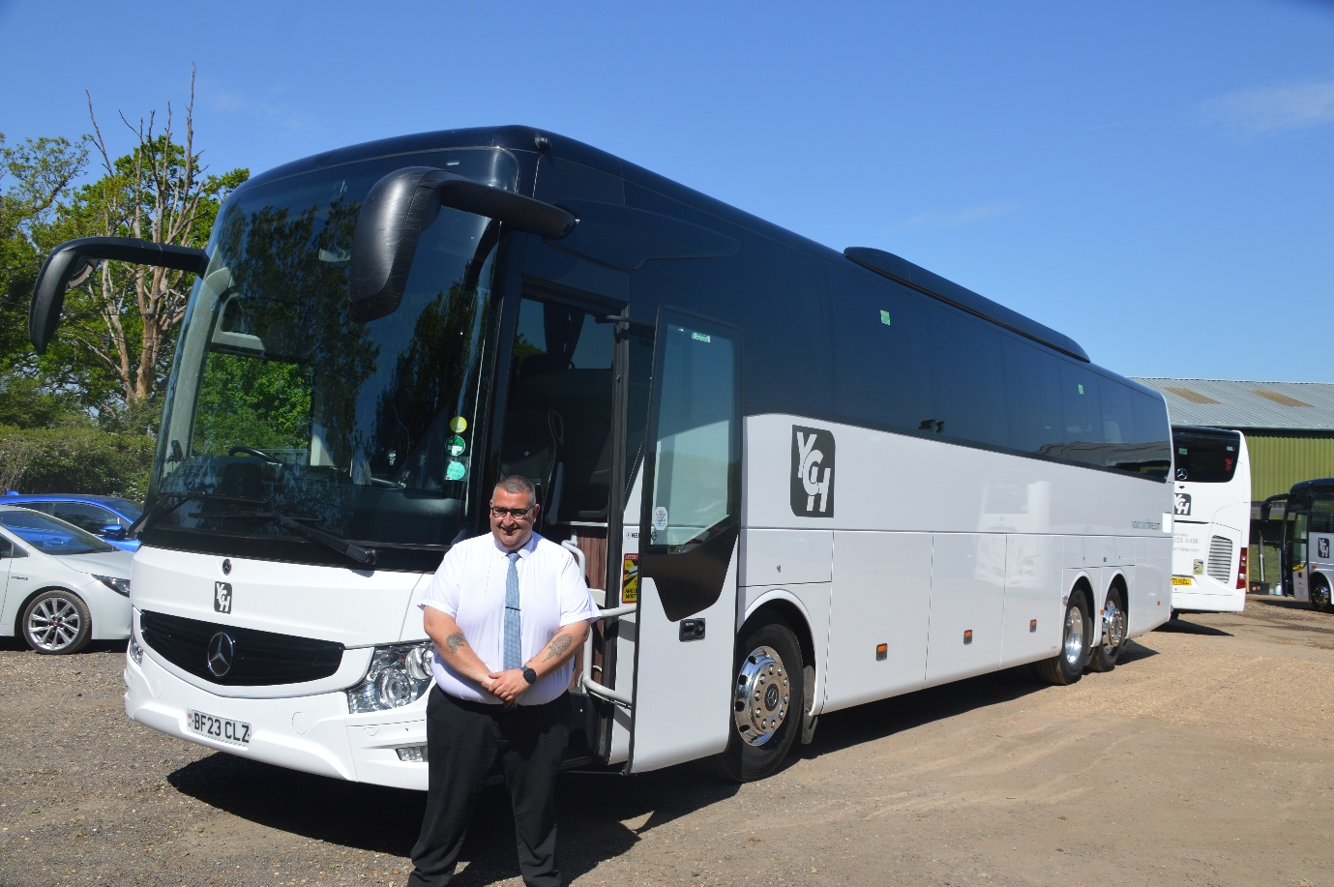
Photo credit to Gary Baxter Administration of Gary’s bus and coach photos: couple of team members at your coach hire agreed to pose for photos Neil Lunn in pickler agreed has he was rushed out on job in Guildford looking smart ready to pick up the customers in Guildford. A credit to the team with BF23CLZ all cleaned and ready to go with him.
Again, thanks to the guys behind your coach hire for good fun laughs and catch ups we will be back they again sometime soon to photograph the remaining coaches we have to photograph but for now this is it. Unless we get them to joining on one of the podcast or live stream on our YouTube channel.
This month we also celebrated being running the community now for thirteen years in this time we have had ups and downs in the running of this community, but the Facebook group now has over eight-hundred members our page now has a few more followers and our website is ever so popular with more people visiting each week or month. We have grown so much in the thirteen years we have being doing this we now have more administrations than originally planned to we also have more supporters than originally planned but this is a good thing the more we grow the more our community will come together. Dottie and I are very proud of where we have come in the thirteen years. Dottie may not attend events with me has much has she used to, but she deals with all the background work like keep things running so we can keep the community going has well dealing and battling with her anxiety and depression. We are keeping the community running which is a good thing. We are looking in to bringing you podcast where we can talk about all things bus and coach industry. Now we have a lot of videos going out on the YouTube channel. Thank you to everyone our members and supporters for your kind and loyal support in 2025/2026 and beyond.
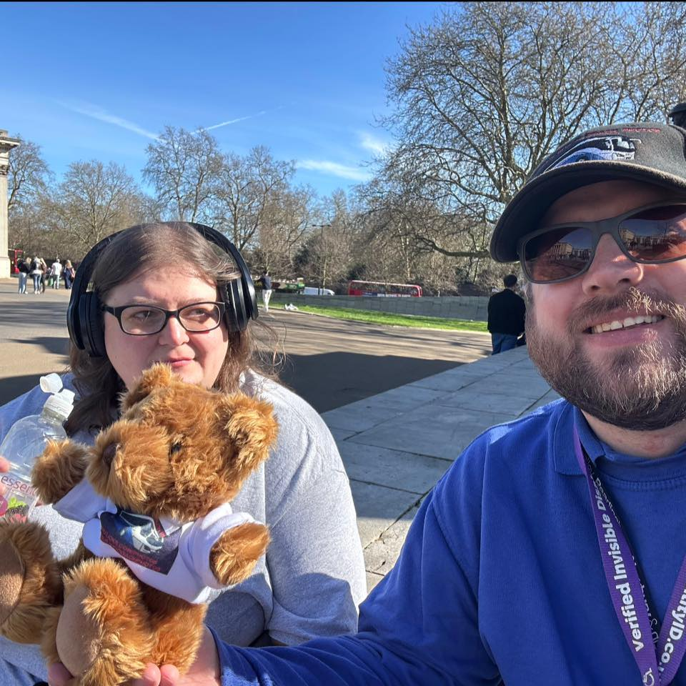
Photo credit to Gary Baxter Administration of Gary’s bus and coach photos: Gary & Dottie Baxter enjoying the sunshine in Hyde Park London in March 2025 during the route 19 running day organised by the London bus museum.


New coaches have been ordered for Flightline 730/731 the new coaches for this route are going to be Irizar I6’s it is believed we will receive three of the coaches in batch which are due for delivery soon and three more in September 2026. I am not sure if this is to incuse the timetable for this route. Time will tell when all the coaches arrive for this service.
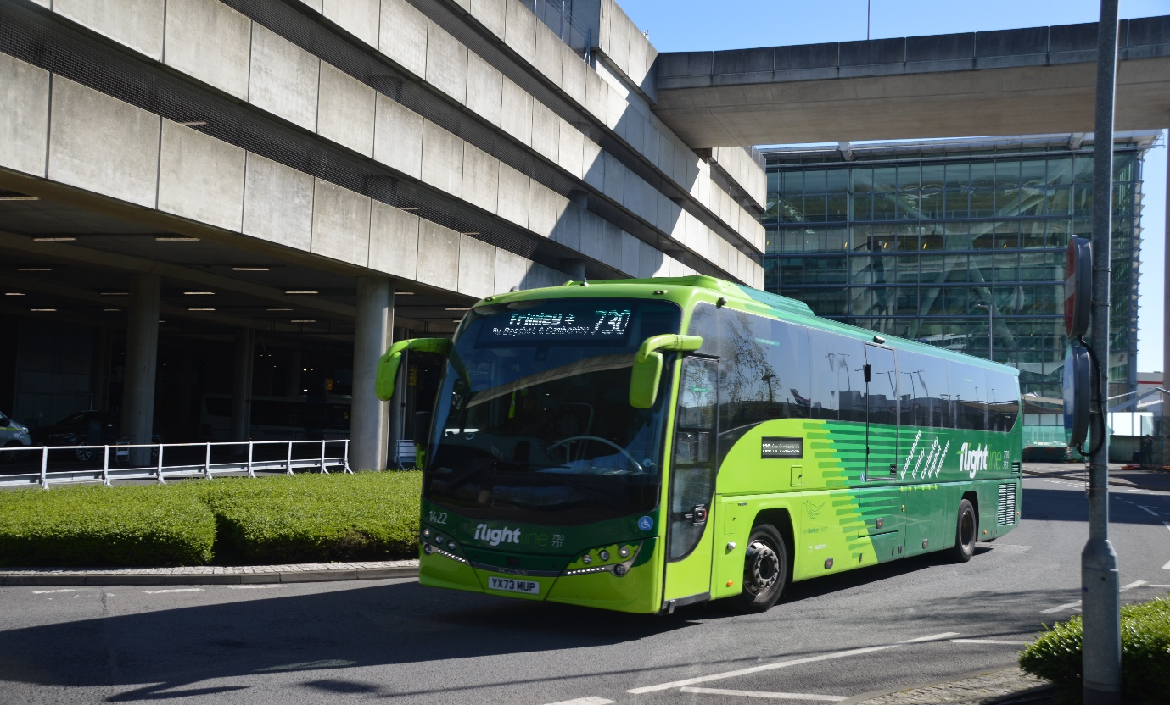
Photo credit to Gary Baxter Administration of Gary’s bus and coach photos: N&D/FL1422 YX73MUP Volvo B8R Plaxton Panther III leaving London Heathrow Airport on route 730 to Frimley then 731 back to Basingstoke. Photo taken April 2026.
Bus & Coach Expo in Birmingham
On April 21st, 2026, Tim Wild and I went to the expo at Birmingham national exhibition centre, and the event was okayish but very disappointing in the mains of coach and bus it was not want we expected it would be like. The only good thing about the exhibition was good to meet the man behind the voice of buses, trains, and stations (please mind the gap). It was a pleasure to meet this legend that is David Sheppard and for him to give an interview on our YouTube channel. The video can be found by going to www.youtube.com/@garysbusandcoachphotos or by this link https://youtu.be/VvUU_qIb4sM?si=Hkn6TCgKSleO4onm also available on website at www.garysbusandcoachphotos.co.uk

Photo credit to Gary Baxter Administration of Gary’s bus and coach photos: Tim Wild, David Sheppard and myself Gary Baxter at Coach and bus expo in Birmingham. Teddy & George got to meet an exhibition bear called Simon who was Exhibition for a care company or charity
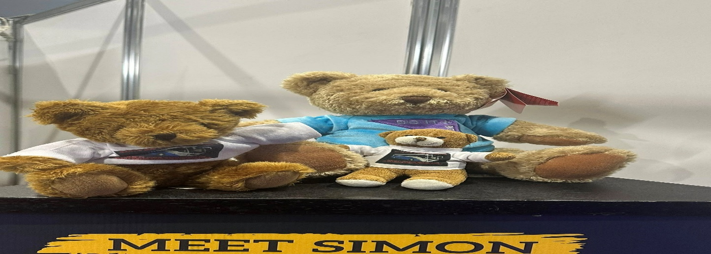
London bus museum spring gathering
Last month when we attended at the London bus museum spring gathering we did not mention that while we were there, they launched a new item they had been working on for a while. This being a horse bus. It was good to see to be honest I have cousin and her daughters who are in to horses or ponies so I had to get photo of this for them it was really good to see to be honest has Brooklands London bus museum before covid did have and ran a horse bus for a little while before covid hit and then this was stopped. So was great to see this back in action. Another thing I wasn’t expecting to see was a fish and chip Routemaster bus they had on display and that looked good but according to Robert Thompson Theo Thompson’s dad it was a bit pricey, but the food was excellent. So, I guess that’s a good thing I guess
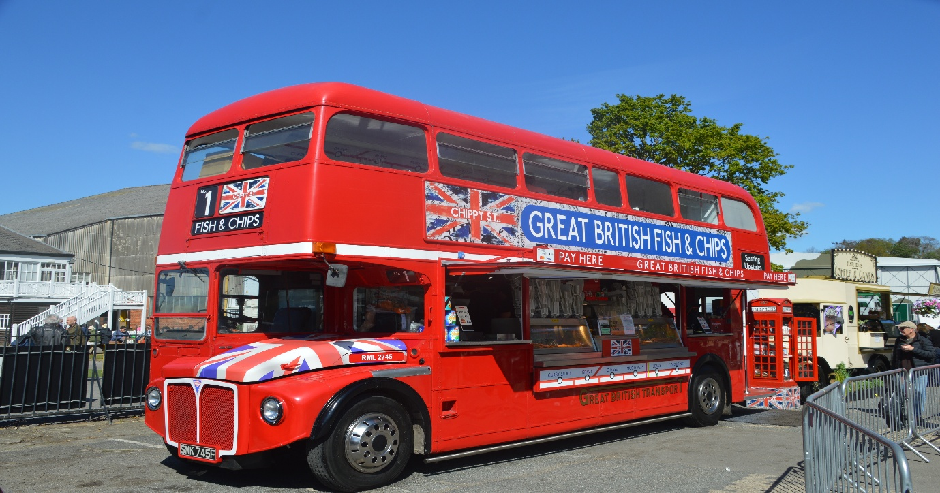
Photo credit to Gary Baxter Administration of Gary’s bus and coach photos: SMK745F fish and chip Routemaster on display at the London bus museum spring gathering at Brooklands.
It was also good to see the bus, tube, and train they I think this had been retreated and repainted a little has not been on the bus show seen for some time, so this was another good see at the Brooklands London bus museum spring gathering in April.
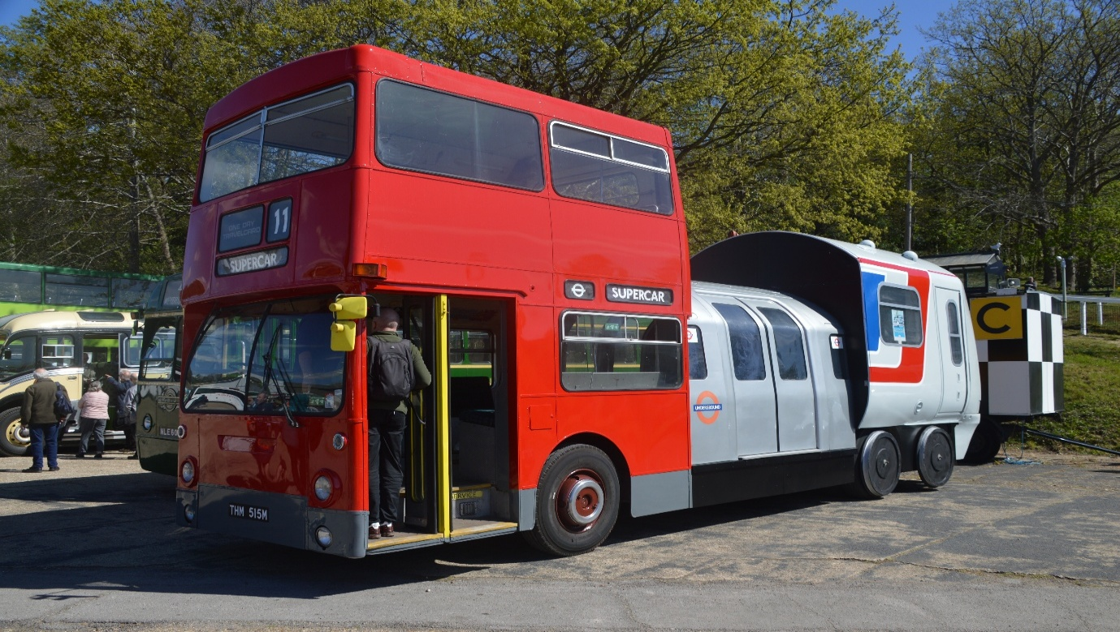
Photo credit to Gary Baxter Administration of GB&CP: bus, tube and train at Brooklands London bus museum spring gathering in April 2026. The first time this bus has been seen for some time. At bus shows in the United Kingdom and was good to see this back attending shows.
London bus museums next event will be the 213/293 event from Kingston to Epsom this event will be taking place on the 13^{th,} June 2026. This should be another jolly good day.
More about events from this month
Has reported earlier on in the newsletter we attended at Winchester bus running day now the day of this event was good and was good to see Robert Williams CEO at Reading buses brought his two preserved buses along to the event it was nice and along with them he brought the open topper reading buses 520 so was good to see that has well and have ride on it on a route it was doing for the Winchester King Alfred buses heritage bus running day.
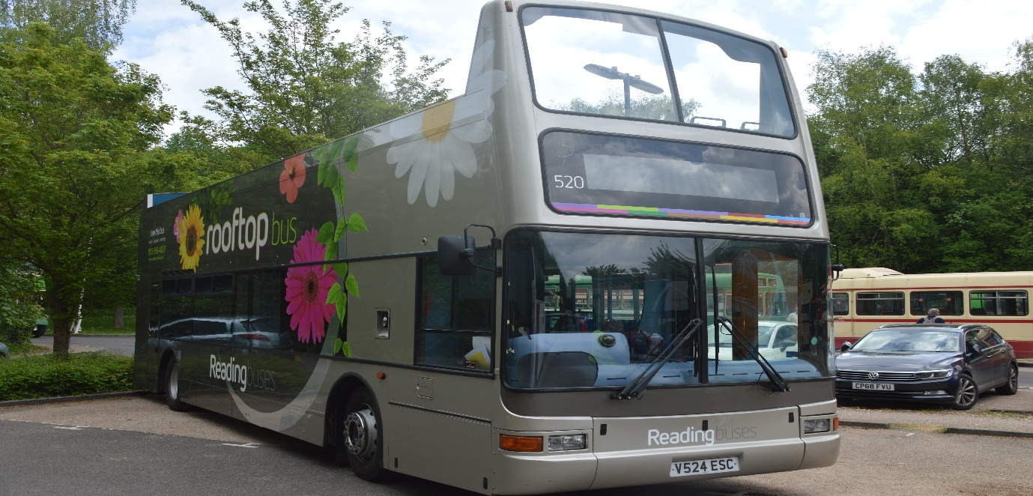
Photo credit to Gary Baxter Administration of Gary’s bus and coach photos: Reading buses 520 V524ESC Alexander Dennis Plaxton President at the Friends of King Alfred buses heritage bus running day in Winchester on the 4th, May 2026.
Along with this it was also good to see the Thames Valley buses Bristol K come along to the event at Winchester looking nice and refreshed in poppy red without the Thames Valley lettering at moment, but I am sure that in time that this will be applied to the vehicle.
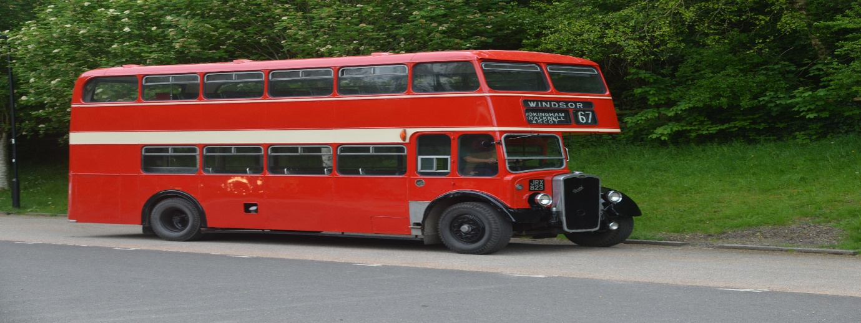
Photo credit to Gary Baxter Administration of Gary’s bus and coach photos: Thames Valley omnibus Bristol K at Winchester for the friends of King Alfred buses heritage bus running day on the 4th, May 2026.
It was also good to see a preserved Alexander Dennis Trident from Torquay Devon at the Friends of King Alfred buses heritage bus running day this is preserved by a friend of mine called James Bell.
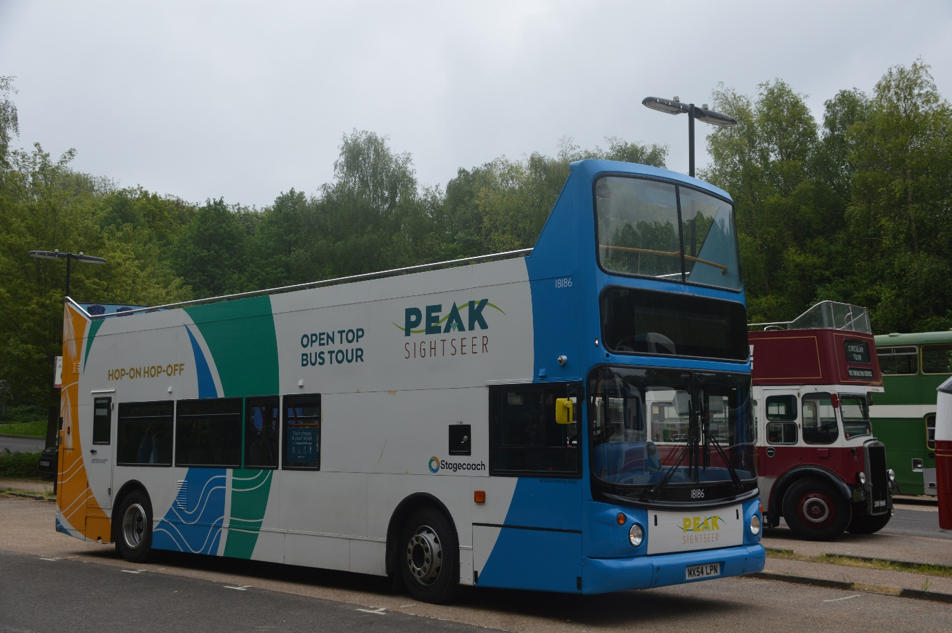
Photo credit to Gary Baxter Administration of Gary’s bus and coach photos: Stagecoach Devon 18186 MX54LPN now preserved by a friend of mine called James Bell he now owns this one along with 33306 AE51VFV Alexander Dennis Plaxton Pointer Dart SLF which is an ex-Fleet buzz.
It was also good to a preserved Hants and Doret Bristol VR at Winchester for the running day unfortunately this did not seem to do any runs has it would have been nice to have ride on it
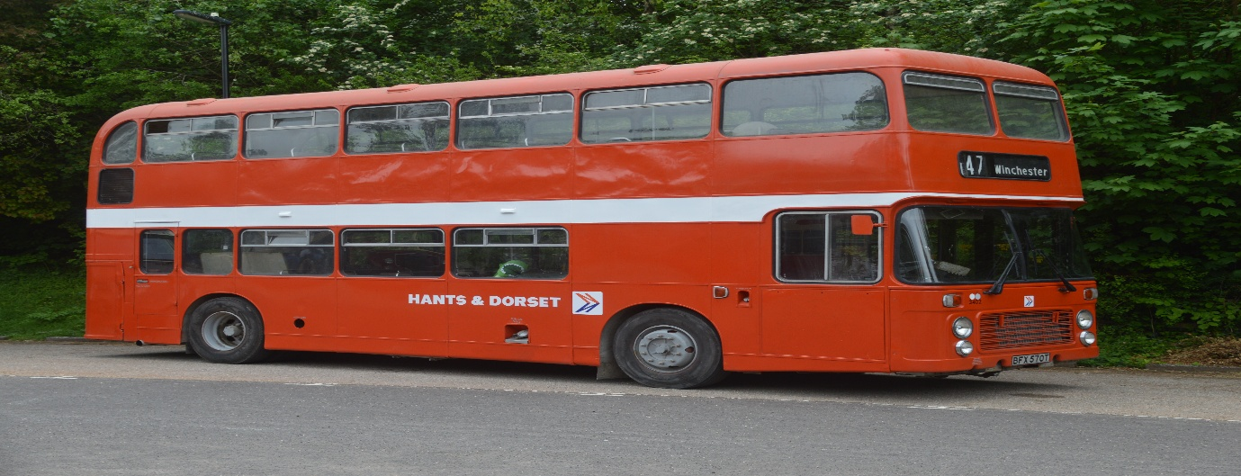
Photo credit to Gary Baxter Administration of Gary’s bus and coach photos: Hants and Dorset preserved Bristol VR 3402 BFX570T photographed on Display at St ’Catherine’s park and ride in Winchester on the 4th, May 2026.
The next event we attended this month was in Windsor on the 10th, May 2026 this event is believed to be celebrating the anniversary of the coach park in Windsor which opened it doors 40 years ago to over Seventy-four coach parking spaces it opened on the 10th, July 1986. On the 10th, May 2026 the heritage running day used twenty of the parking space to host the running day from Windsor coach park to all different locations round Windsor. The running day saw over thousand or more visitors taking photos and video of the heritage running day from the coach park to different locations offered for the running day. It is believed that the coach park is going to be closed for redeployment meaning more flats or houses to be built on it. The running day was a good way to celebrate the anniversary for this lovely coach park in Windsor. I enjoyed having some rides on different buses and one I have never rode on before which was a Jersey Motor services Transport TD1 photo of this below.
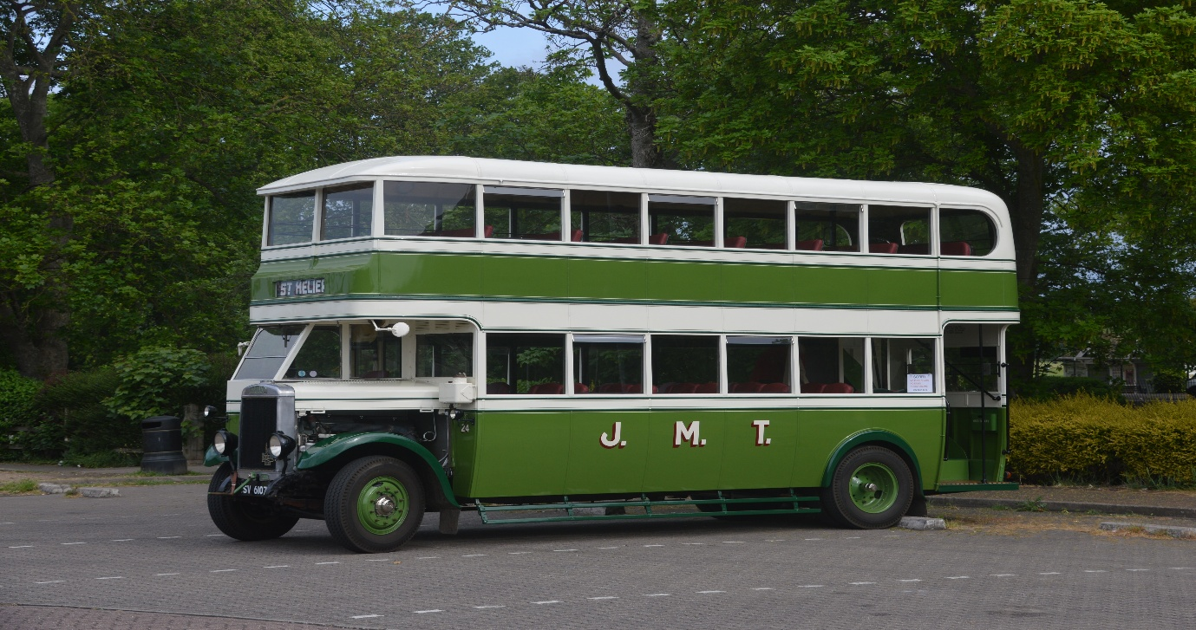
Photo credit to Gary Baxter Administration of Gary’s bus and coach photos: SV6107 J.M.T Leyland Titan TD1 Photographed in Windsor coach park Windsor 10th, May 2026.
The TD1 take passengers on ride round Datchet doing the semi old route of Windsor guide Friday sightseeing and city sightseeing route. Round Datchet and ending the route back at Windsor and Eton Riverside station. Which was nice to see for the day. Then I went on ride on Routemaster 2208 CUV208C on route 100 which was meant to be done with ex first Berkshire 34218 and Ex capital city 218 Volvo Olympian but due to be damaged on route to the heritage running day it was no longer visible for this to do runs on route 100 to Runnymede so Adam Conner replaced it with RM2208 ( Rocky the Routemaster). It was a lovely run out on this we did leave Windsor coach park a little late but only had to stop a couple of time so time was easily made up. Photo of Rocky the Routemaster below.

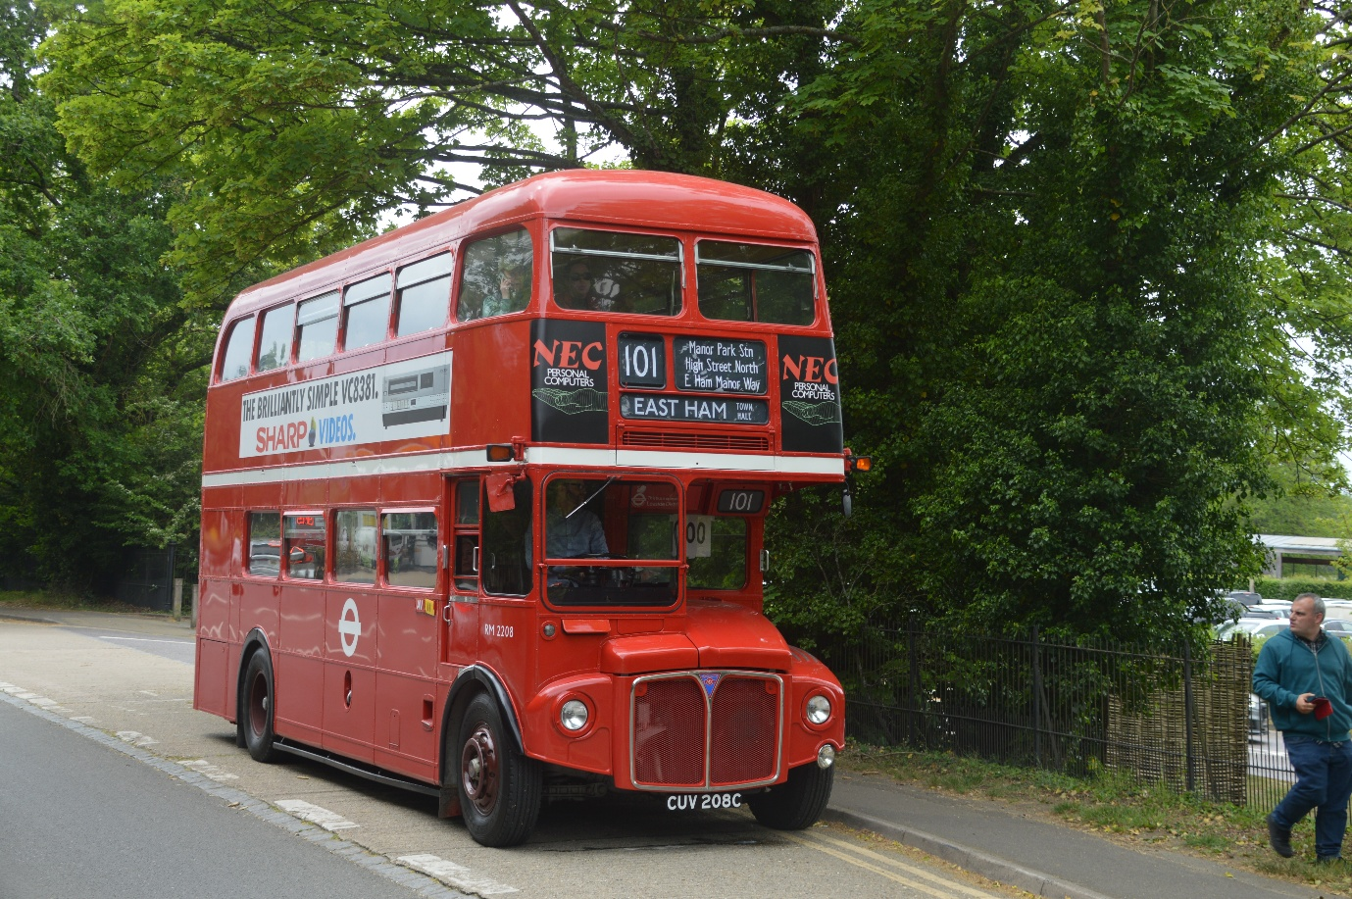
Photo credit to Gary Baxter Administration of Gary’s bus and coach photos: RM2208 CUV208C Rocky the Routemaster photographed in Runnymede on route 100 replacing Volvo Olympian 218 EX first Berkshire 34218 at the Windsor heritage bus running organised by the Amersham and district and Thames Valley and great western omnibus trust.
The event saw some nice weather, and it was well organised by the two organisations who organised it the organisations being Amersham and district motor services and Thames Valley and great western omnibus trust. The programme for the event was very informative and detailed with a lot to read and take in. The event was also a good time for catching up with friends with similar interests has myself and networking with others. A fare few buses and coaches turned up for the occasion, and it was good for myself and my good friend Rooty-master’s (Steve Foster) to photograph new coaches on 25/26 plates. Laughing out loud.
It was also good to see the London bus museum bring RFW from the London bus museum and the chair Leon Daniels at the wheel driving this beast.
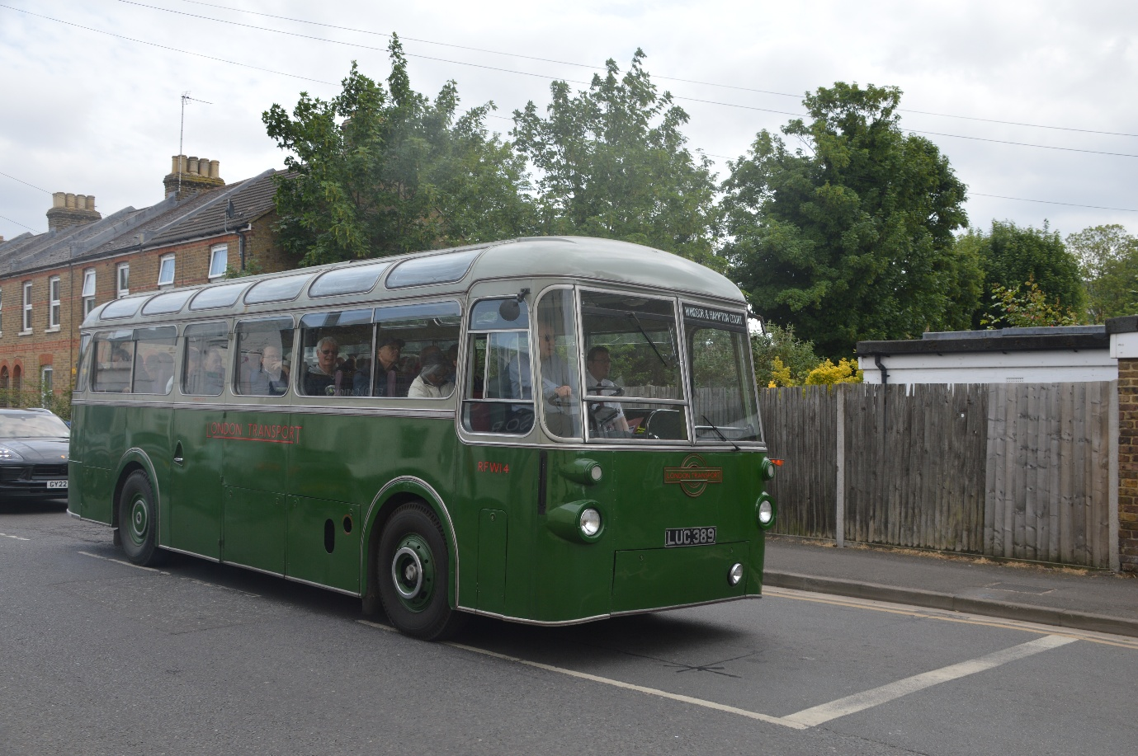
Photo credit to Gary Baxter Administration of Gary’s bus and coach photos: RFW14 LUC389 doing a tour to Viginia Water and Runnymede photographed here departing Windsor coach park.
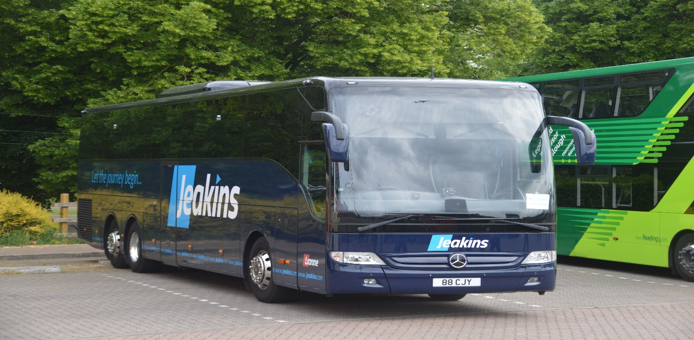
Jeakins / Lianne coach hire 88CJY Mercedes Benz Tourismo at Windsor coach park on display at the event Windsor heritage bus running day on the 10th, May 2026 it was good to see our supporter taking part in this day. Was good to see David Jeakins.
It was also good to see the legend himself again David Sheppard.

Facebook group member photos to join follow this link www.facebook.com/groups/garysbusandcoachphotos
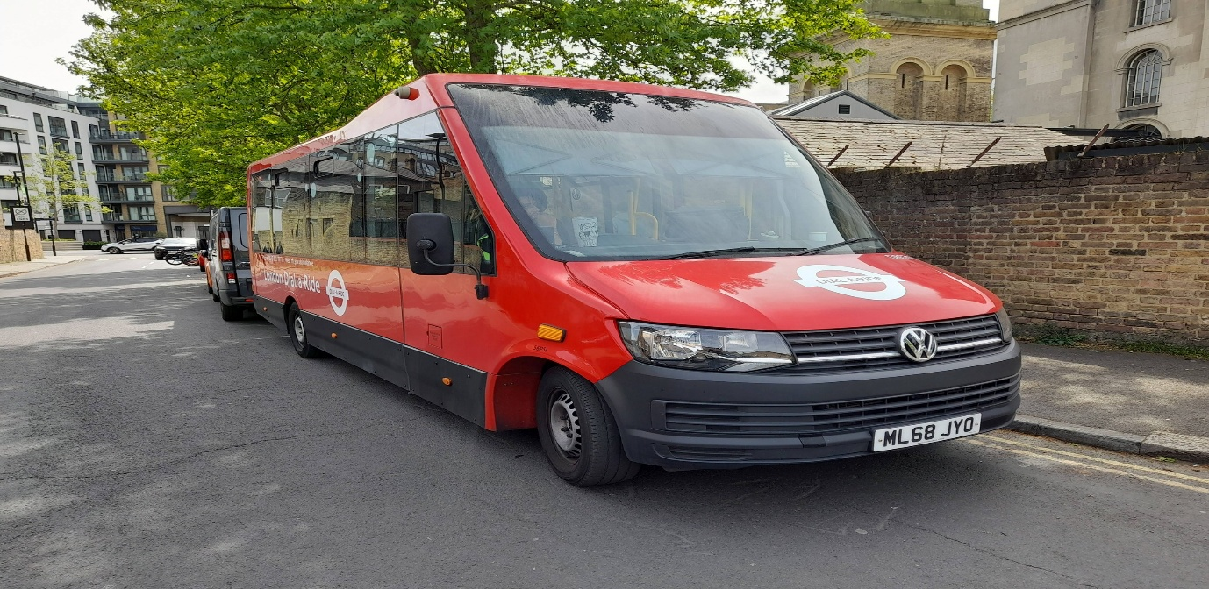
Photo credit to Alican Reilly member of GB&CP ML68JYO Dial a ride London TFL Dial a ride mini bus.
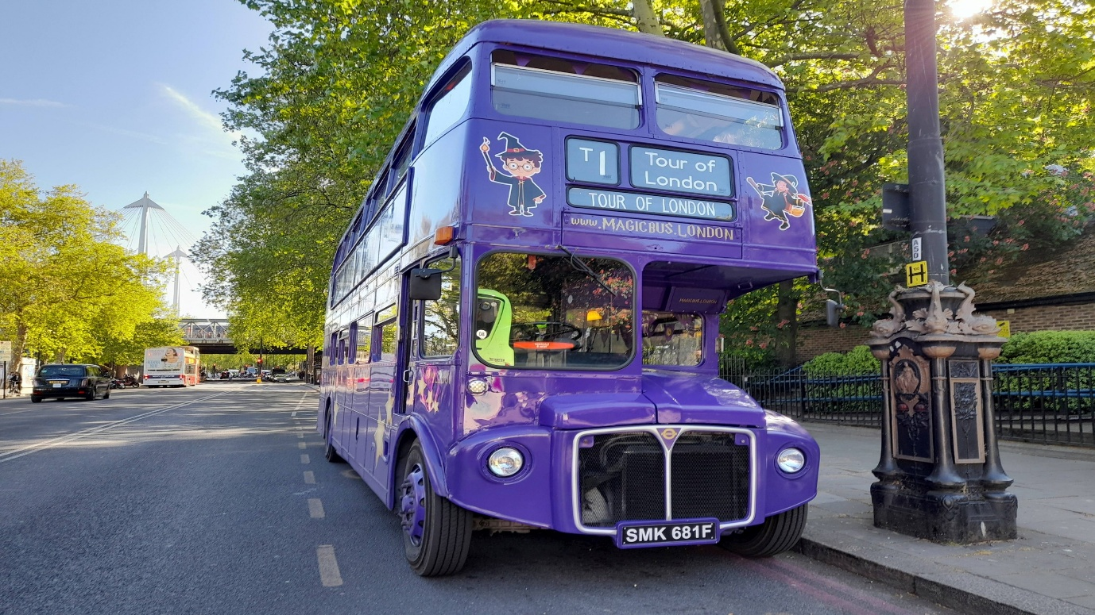
Photo credit to Alican Reilly member of GB&CP SMK681F RM2681 magic bus London UK.
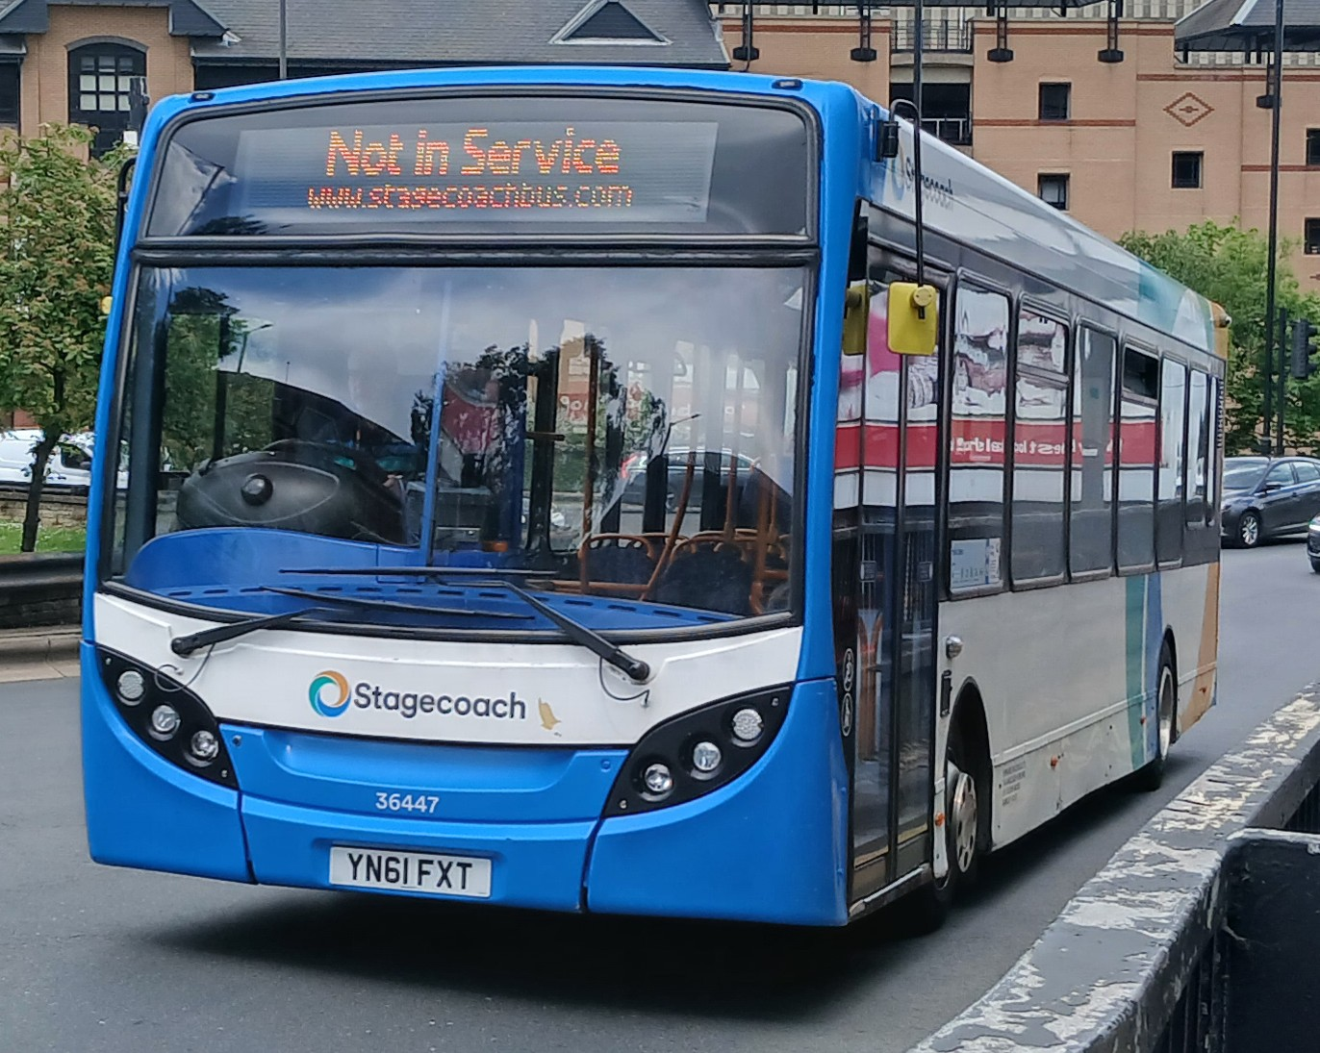
Photo credit to Barry Smith member of Gary's bus and coach photos 36447 YN61FXT ADL Enviro200 Stagecoach Yorkshire.
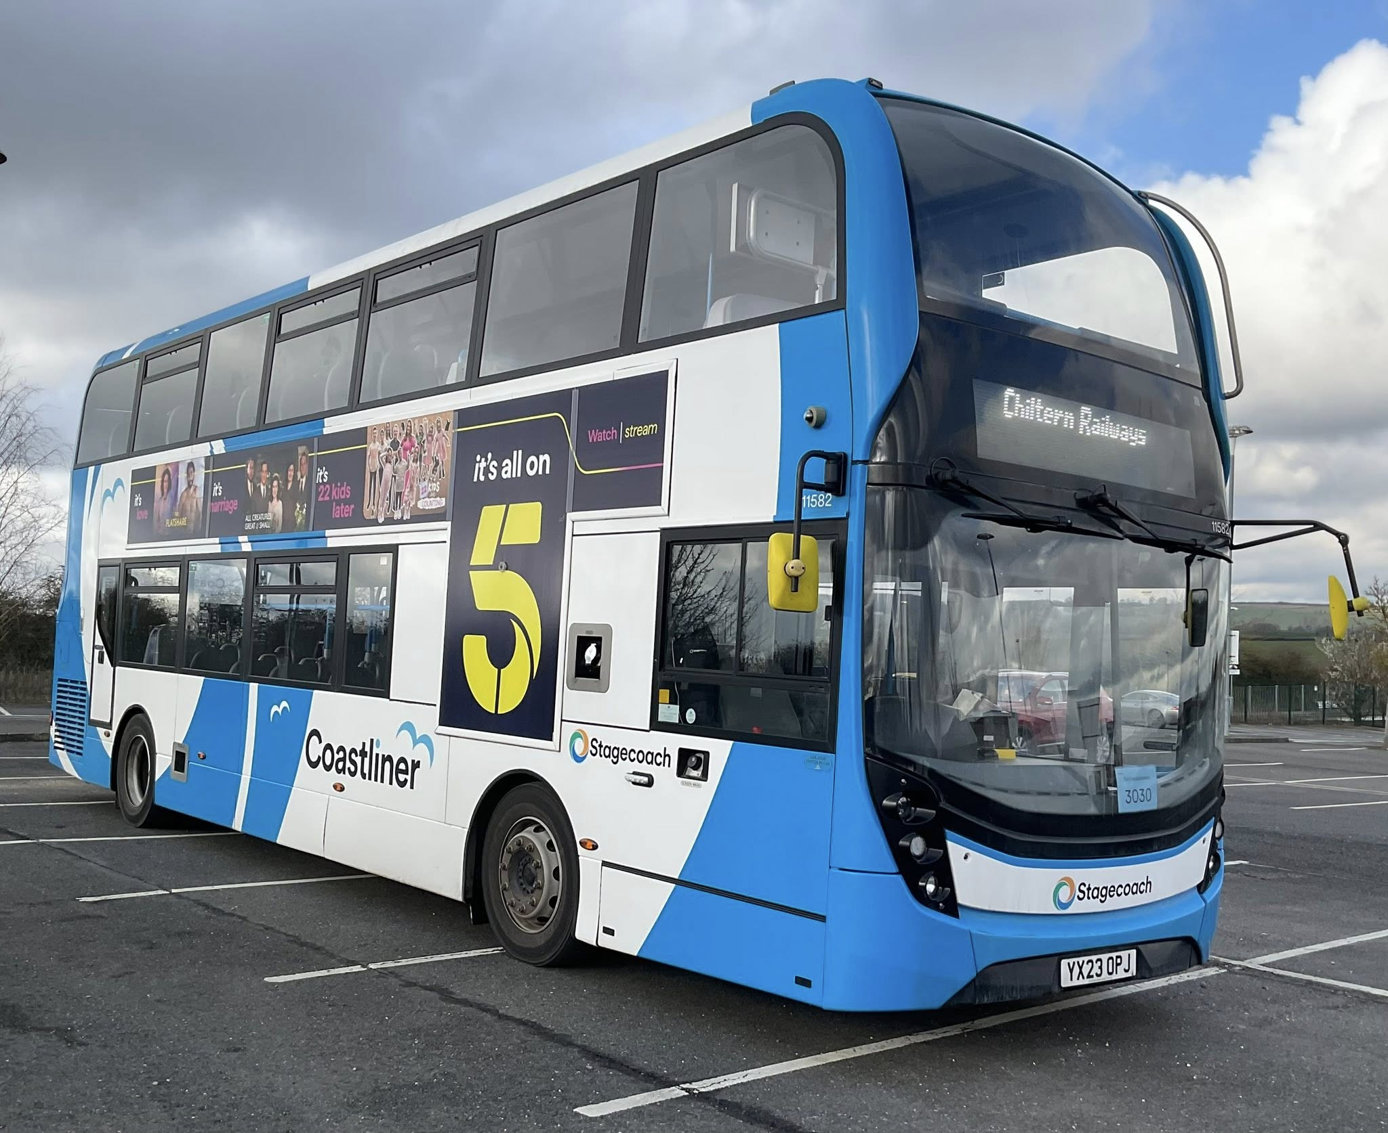
Photo credit to Barry Coom member of Gary's bus and coach photos 11582 YX23OPJ ADL Enviro400mmc Stagecoach South Worthing Coastliner.
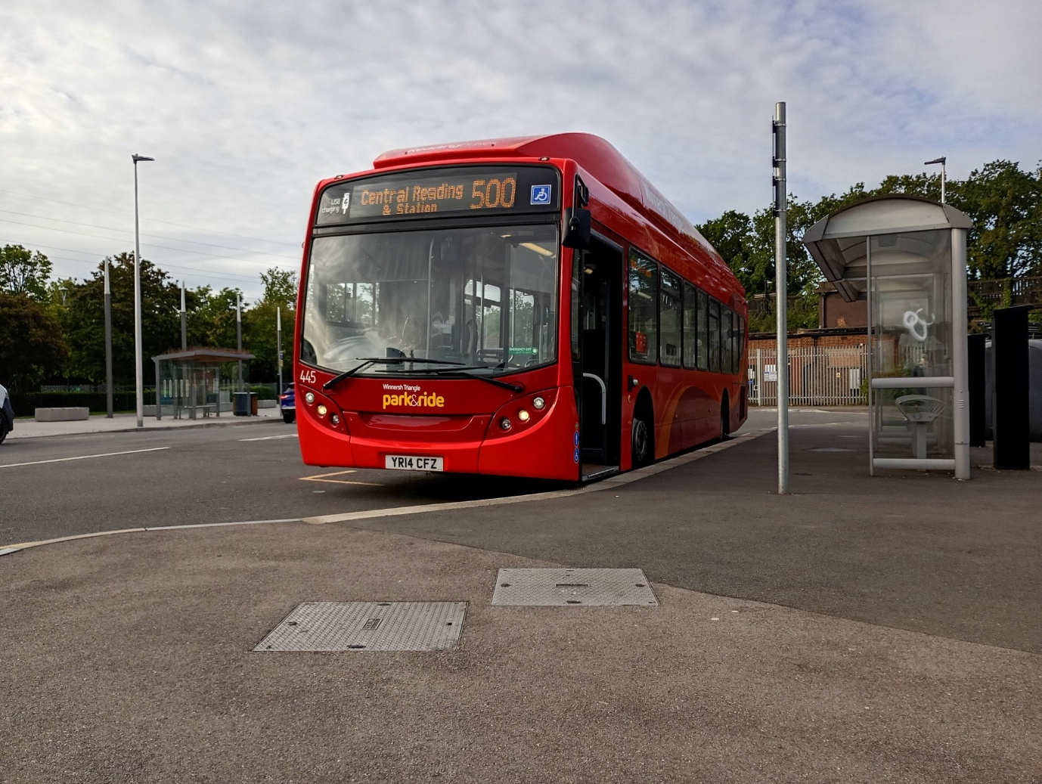
Photo credit to Katie Parry Smart member of Gary's bus and coach photos Reading buses 445 YR14CFZ ADL Enviro300 Scania gas bus Winnersh Park and ride.
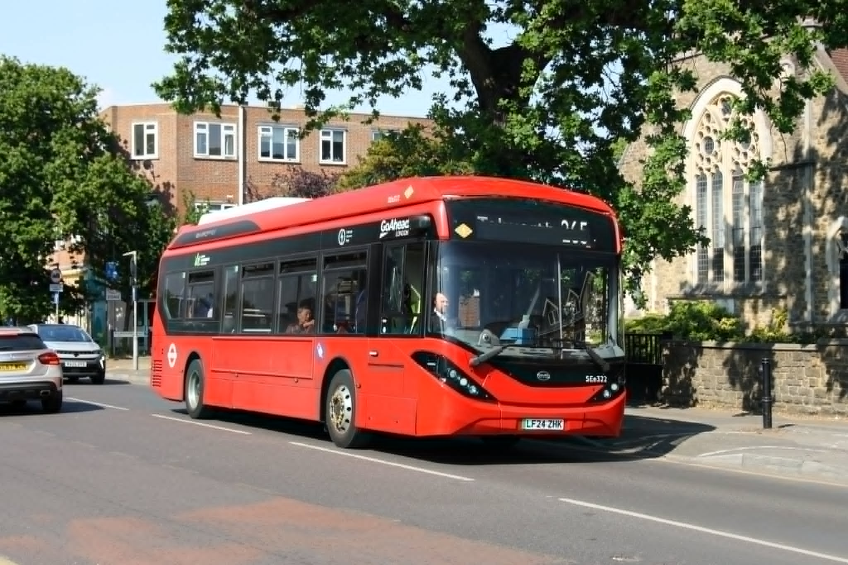
Photo credit to Terry Jay Longhurst member of Gary's bus and coach photos Go-Ahead London SEe322 LF24ZHK ADL Enviro200mmc on route 265 to Tolworth www.terrysbusphotos.smugmug.com
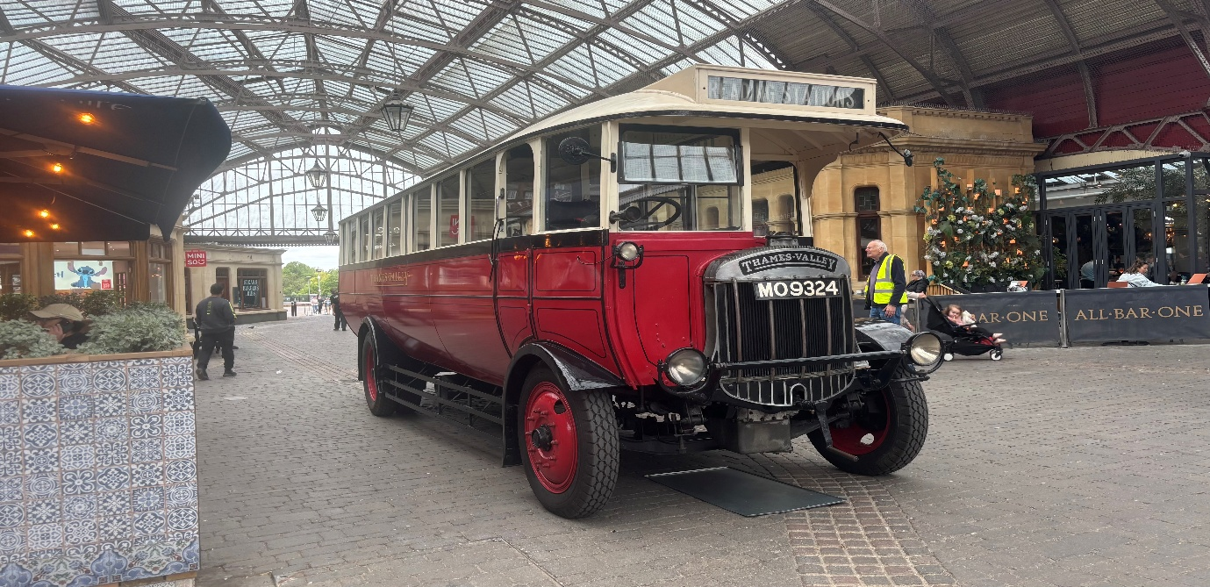
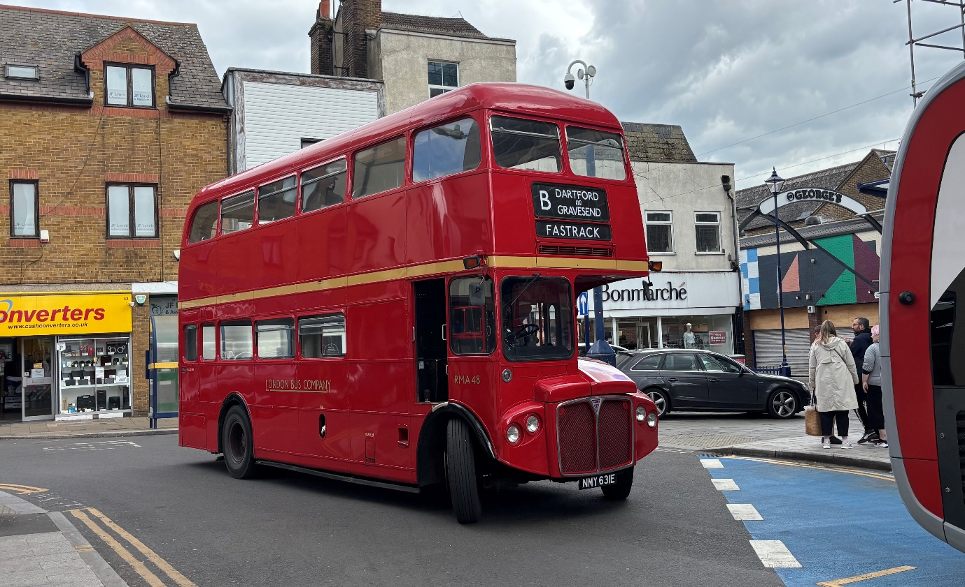
Photo above: Robert Thompson on behalf of Theo Thompson members of Gary's bus and coach photos Thames Valley MO9324 on display at Windsor and Eton central station.
Photo below: Robert Thompson on behalf of Theo Thompson members of Gary's bus and coach photos RMA48 NMY631E at Bluewater 20th anniversary running day Saturday 16th May 2026 available via his Flickr here: https://www.flickr.com/photos/199041540@N05/

Reading buses has repainted some of the ex-route seventeen buses and redeployed them on other routes in this report we are reporting on the route seventeen buses now being deployed on to sky blue routes fifteen and sixteen at least nine of the original 17 ADL Enviro400cities. Three are liveried up for Greenwave and nine now in Skyblue along with some coming to be in Berries livery. Fleet numbers and Registration numbers from Skyblue has follow in grid below.
Fleet No | Reg No | Colour
714 | YP67XCJ | Sky Blue
715 | YP67XCK | Sky Blue
716 | YP67XCL | Sky Blue
717 | YP67XCM | Sky Blue
718 | YP67XCN | Sky Blue
719 | YP67XCO | Sky Blue
720 | YP67XCR | Sky Blue
721 | YP67XCS | Sky Blue
722 | YP67XCT | Sky Blue

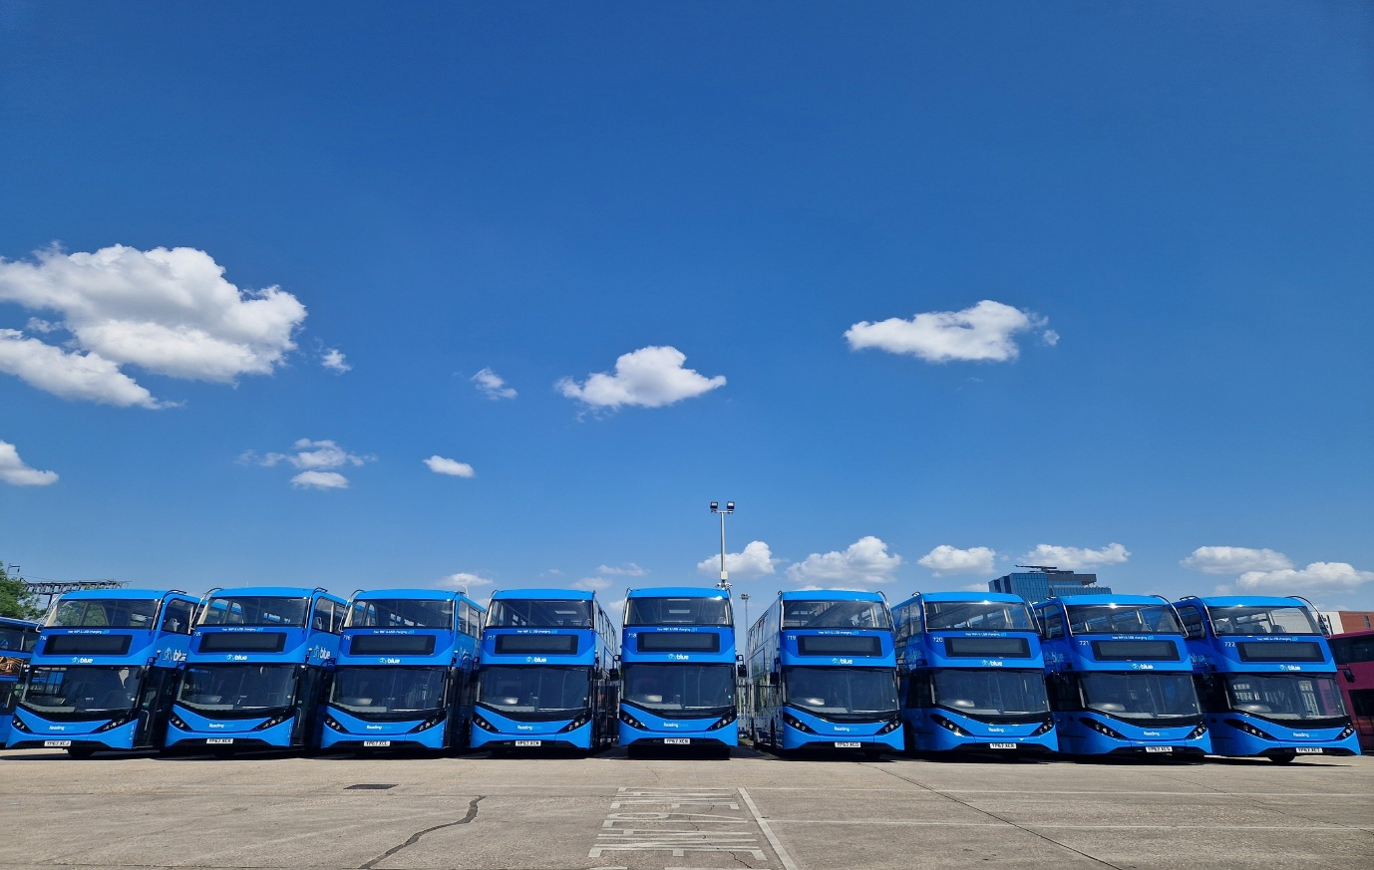
Photo credit to Robert Williams CEO at Reading buses and member of GB&CP Reading buses 714-722 YP67XCJ-T ADL E400cities.
www.garysbusandcoachphotos.co.uk

Friend YouTube channels
Names | Links | Covers
James Underwood | https://www.youtube.com/@james143611 | Coach driving / other bits
Theo Thompson | https://www.youtube.com/@theothompsonbusenthusiast | Bus spotting / other bit
Alex Young | https://www.youtube.com/@hellowallace | FOKAB / other stuff
Leon Daniels | https://www.youtube.com/@leon467 | LBM, Lunch with Leon and other bits including bus / coach
Reading buses | https://www.youtube.com/@readingbuses2608 | Bus and coach related items on there channel
Flat cap bus driver | https://www.youtube.com/@flatcapbusdriver | Bus driving and other topics
Micky two cams | https://www.youtube.com/@micky2cams147 | Bus and coach related items
Coach and bus week | https://www.youtube.com/@CoachBusWeek | Bus and coach related
John G Lidstone | https://www.youtube.com/@johng.lidstone2236 | Bus and coach related
London Transport Museum | https://www.youtube.com/@ltmuseumvideo | Bus, coach and other forms of transport related
VI-Media | https://www.youtube.com/@vimediamerch | General Transport related



