
Month: January 2025 Issue No: 80
Happy new year to all our followers, subscribers and members. Last month we reported that all new buses for Newbury and district had entered service on the 9th, December 2024 this was so, after having trouble with some of the buses they did enter service later than planned, but still entered service.
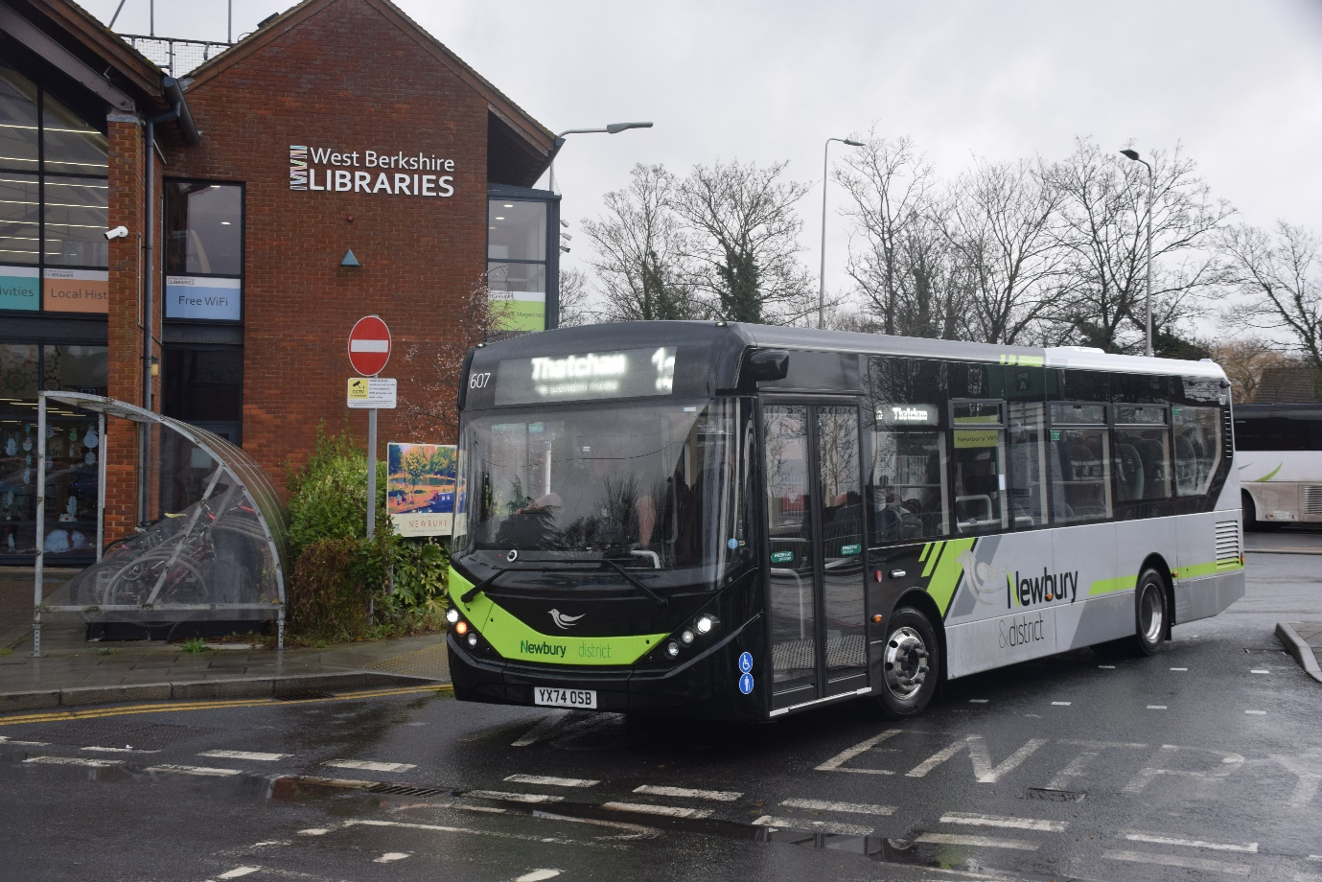
Newbury & district 607 YX74OSB Alexander Dennis Enviro200mmc photographed in Newbury wharf on the 9th, December 2024 on route 1A to Thatcham.

Social Media Name: | Month: | Stats
Facebook | December 2024 | 248 Likes, 288 followers and 525 Members
Instagram / Threads | December 2024 | 521 Followers and 72 Followers
X | December 2024 | 28 Followers
YouTube | December 2024 | 153 Subscribers, 255 Videos and 30,793 Views
Flickr | December 2024 | 6,739,732 Views and 527 Followers
Website | December 2024 | 4,371 Views.
Facebook | January 2025 | 248 Likes, 291 Followers, and 527 Members.
Instagram/ Threads | January 2025 | 531 Followers and 72 Followers
X | January 2025 | 29 Followers
YouTube | January 2025 | 154 Subscribers, 257 Videos and 31,386 Views.
Flickr | January 2025 | 6,940,839 Views and 525 Followers
Website | January 2025 | 4,392 Views
Social Medias

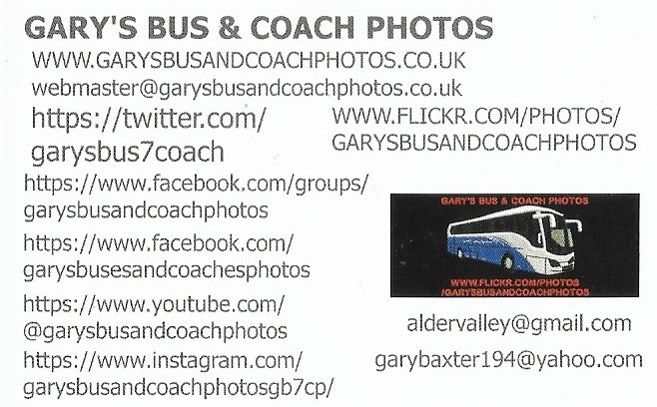
Facebook Group: Cover Photo Competition
Place: | Names:
1st | Buspix
2nd | Chris Errett
3rd | Alan Lockey
4th | Daniella West and Hirasawa Yui
5th | James Rayburn
Well done to all who take part in this month’s cover photo competition. The next Facebook group cover photo competition will be on the 7th, February 2025.
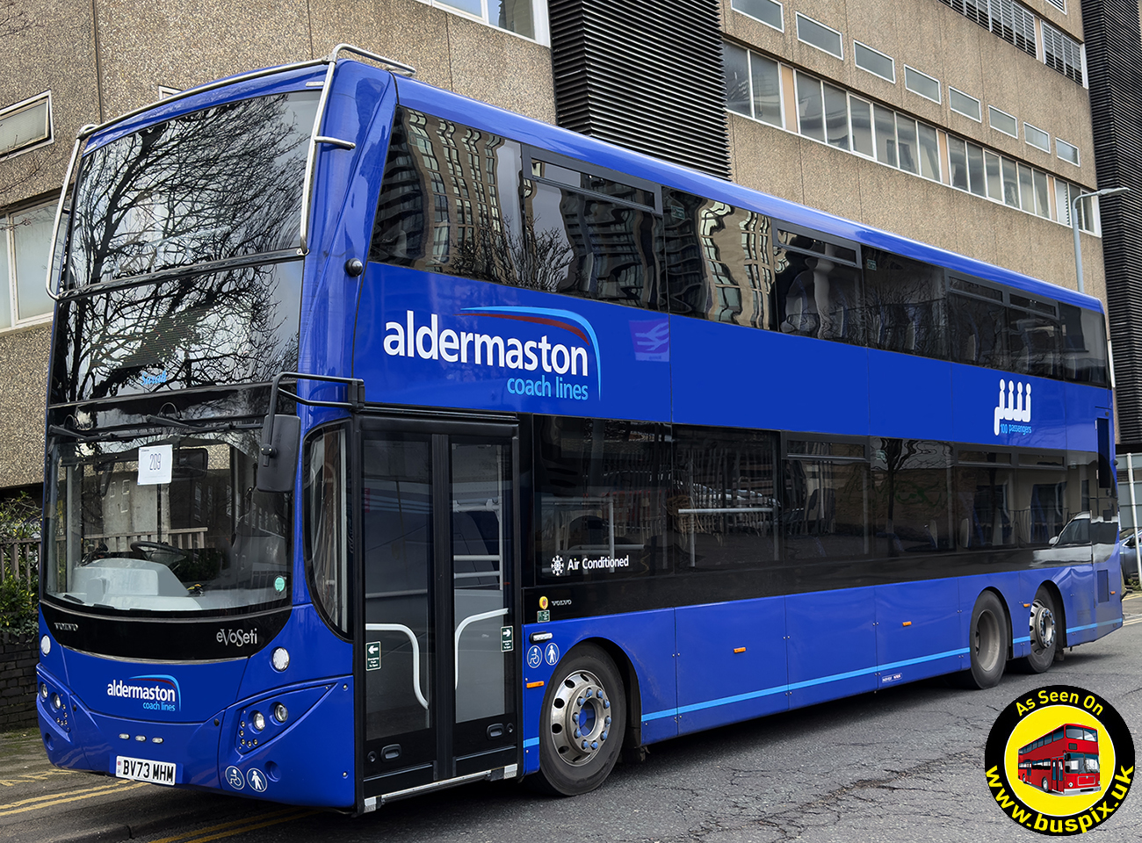
Photo credit to Buspix BV73MHM Volvo B8L MCV Evoseti Sarah in Woking operator Aldermaston coachlines
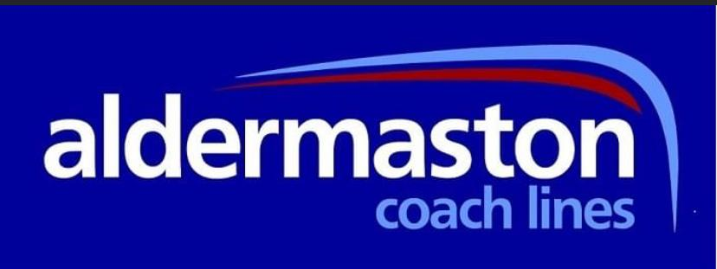

Last month we reported on still waiting on buses to enter service. We’re waiting for new lion buses 249/251 to enter service.
Fleet number: | Registration No: | Body / Engine | Date: | Livery
249 | YX74LVE | ADL Enviro400city | 05/01/25 | Lion
250 | YX74LVF | ADL Enviro400city | 03/01/25 | Lion
251 | YX74LVG | ADL Enviro400city | 03/01/25 | Lion

The generics for Reading buses did not enter service in December has planned. These are also expected to enter service soon.
Fleet number: | Registration No: | Body / Engine: | Date: | Livery:
259 | YX74ORP | ADL Enviro400city | 07/01/25 | Generic
260 | YX74ORT | ADL Enviro400city | 07/01/25 | Generic
261 | RG74BUS | ADL Enviro400city | 03/01/25 | Generic
262 | YY74RXL | ADL Enviro400city | 07/01/25 | Generic
263 | YY74RXM | ADL Enviro400city | 03/01/25 | Generic
264 | YY74RXN | ADL Enviro400city | 03/01/25 | Generic

The new London line buses did not enter service in December has planned to but hopefully will do soon.
Fleet number | Registration No: | Body/Engine: | Date: | Livery
745 | LL74LDN | ADL Enviro400city | 02/01/25 | London line
746 | LL74WND | ADL Enviro400city | 01/01/25 | London line

Over the coming months of 2025 Reading buses are still to receive another twenty-four buses for routes in Reading. I think when announced they are going to be for route seventeen and twenty-one.
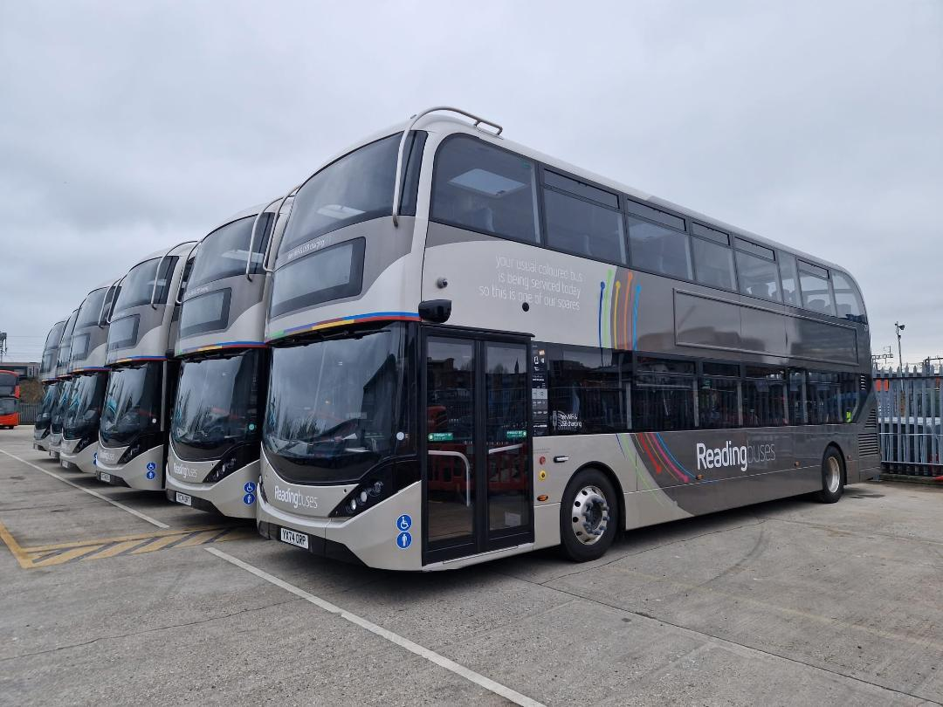
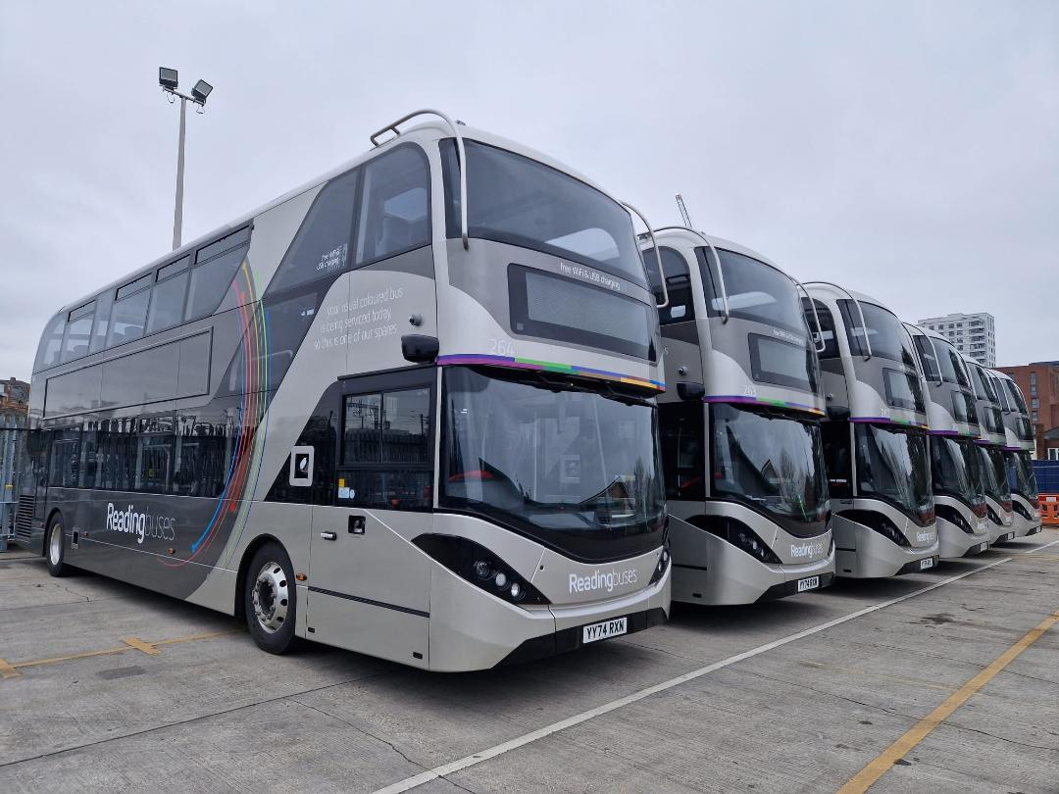
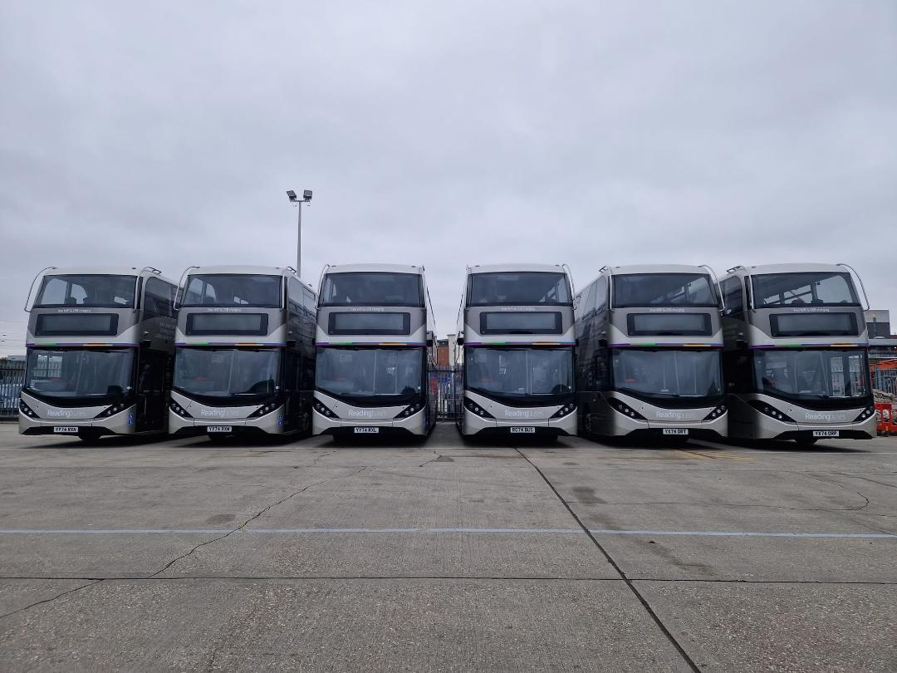
All photos copyright to Robert Williams of new Generic buses ADL Enviro400cities 259/264 in Great Knollys Street Reading prior to entering service 3rd & 7th January 2025.

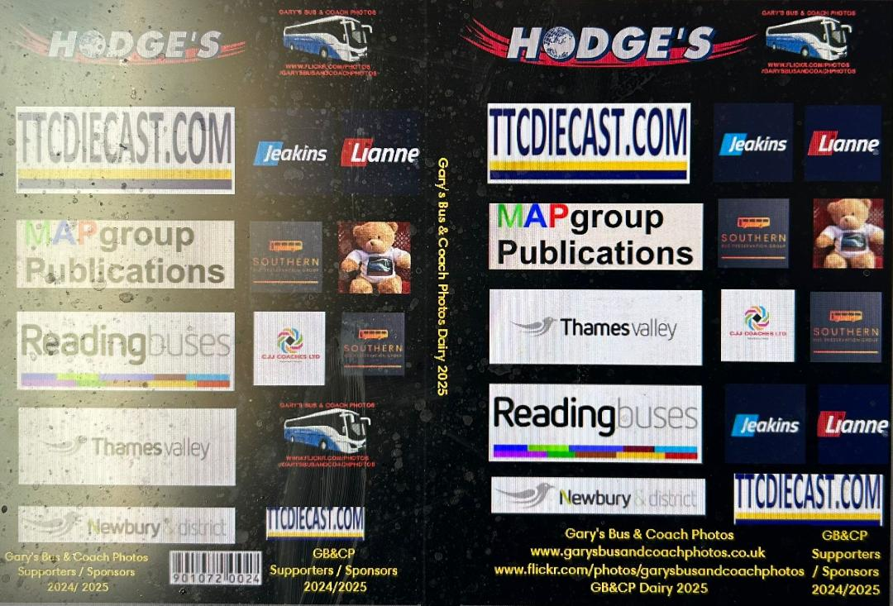
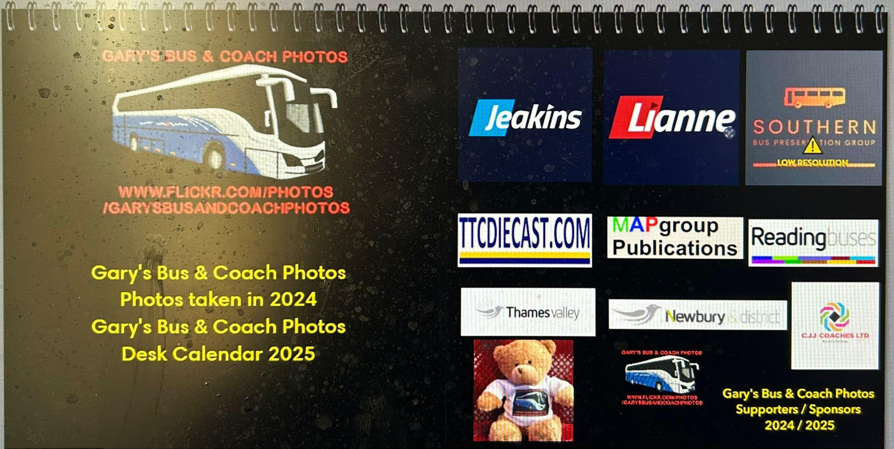

This month saw the end of selling the Gary’s bus and coach photos calendars. These will be coming off our website at www.garysbusandcoachphotos.co.uk on the 31st January 2025 / 1st,February 2025 if you wish to purchase one of these you can message on relevant social medias or email webmaster@garysbusandcoachphotos.co.uk
Prices as follows:
Diary: £25 including post and packing
Desk Calendar: £19 including post and packing
Kitchen / Wall calendar: £26 including post and packing.
Facebook Group: Member Photos
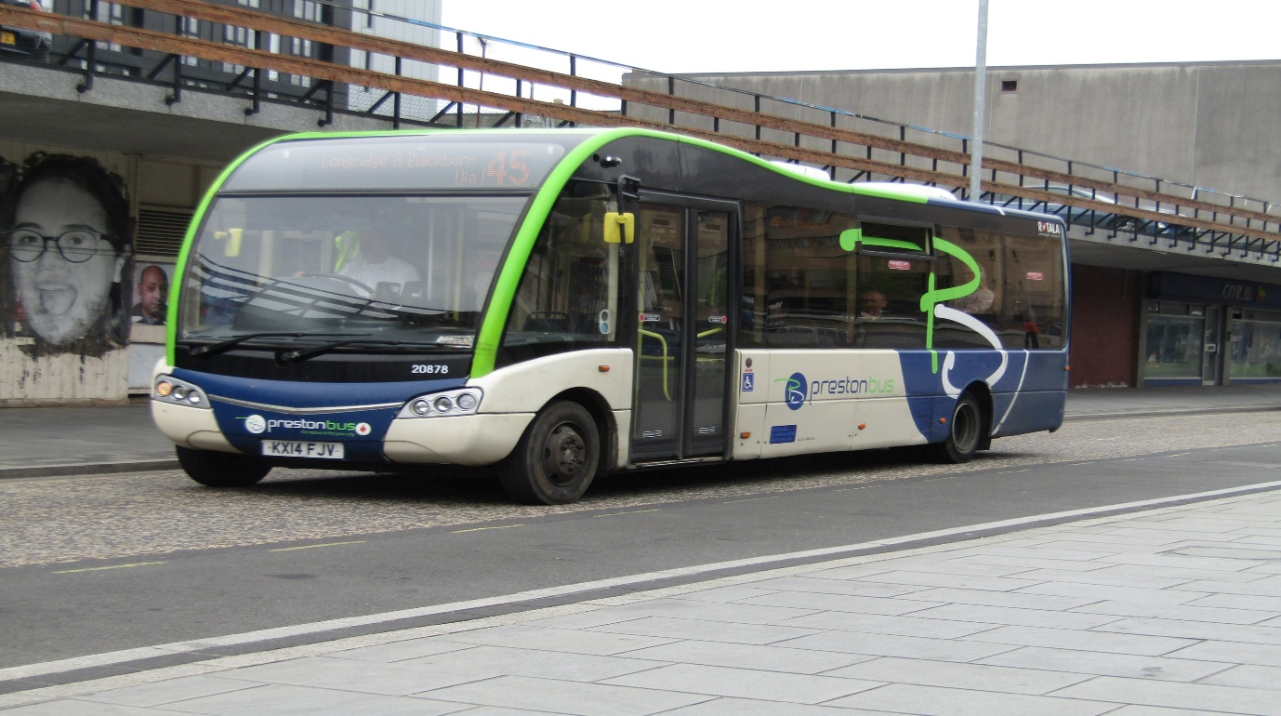
Photo credit to Alan Lockey member of GB&CP: Rotala Diamond Preston bus 20878 YJ14FJY Optare SoloSR
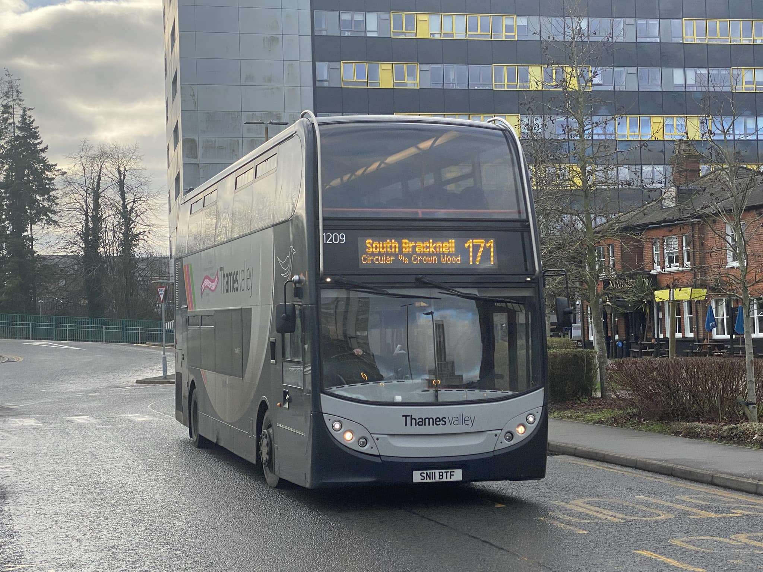
Photo credit to Hirasawa Yui member of GB&CP: Thames Valley 1209 SN11BTF Alexander Dennis Enviro400 photographed in Bracknell in Special 100 years livery for Thames Valley.
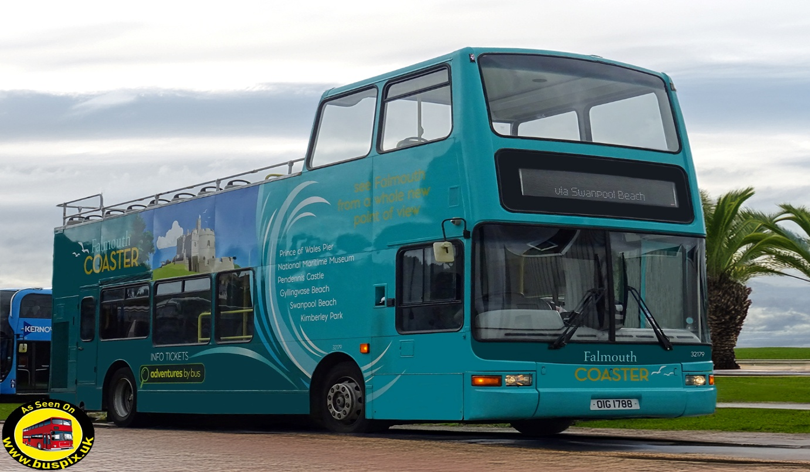
Photo credit to Buspix www.buspix.uk member of GB&CP: Buspix www.buspix.uk First Kernow Cornwall 32179 OIG1788 Plaxton president Falmouth coaster.
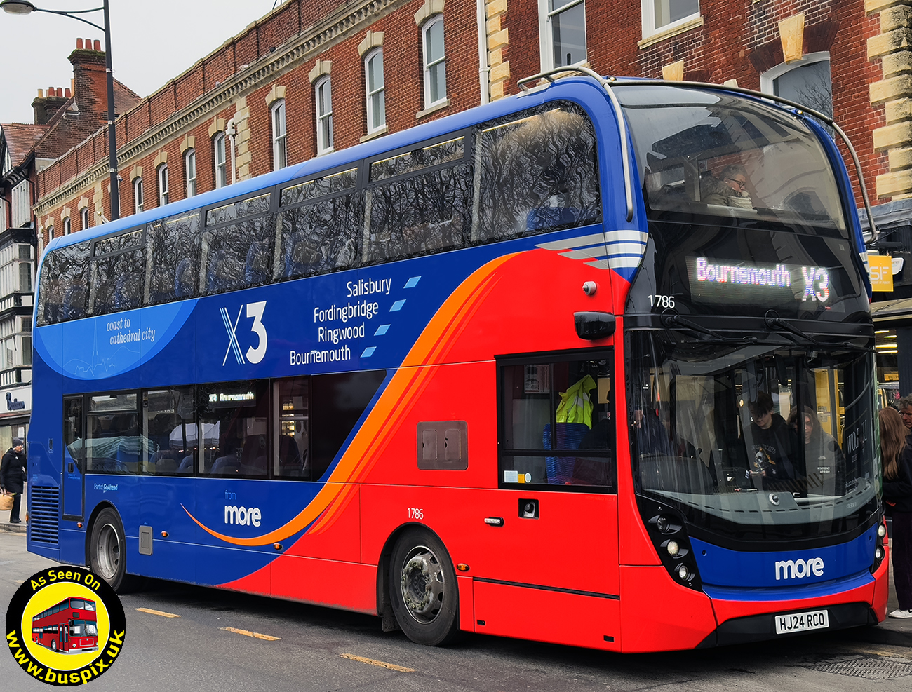
Photo credit to Buspix www.buspix.uk Go-Ahead More bus 1786 HJ24RCO Alexander Dennis Enviro400mmc X3 Bournemouth
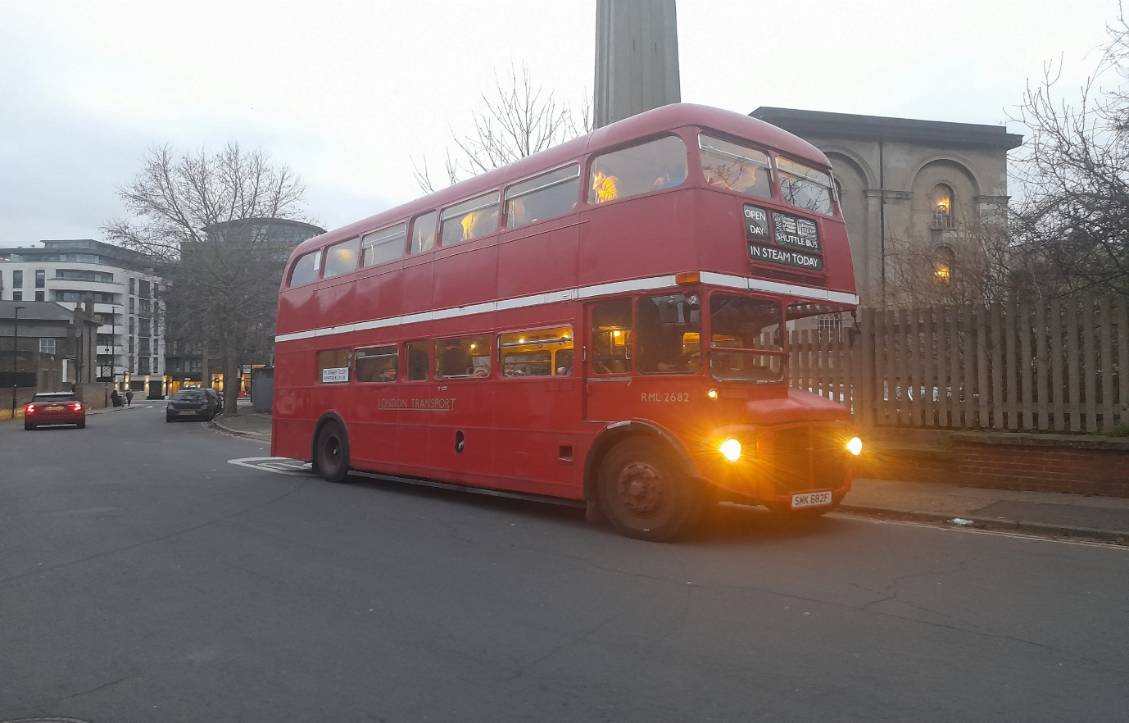
Photo credit to Alican Reilly member of GB&CP: RML2682 SMK682F London Transport Routemaster.
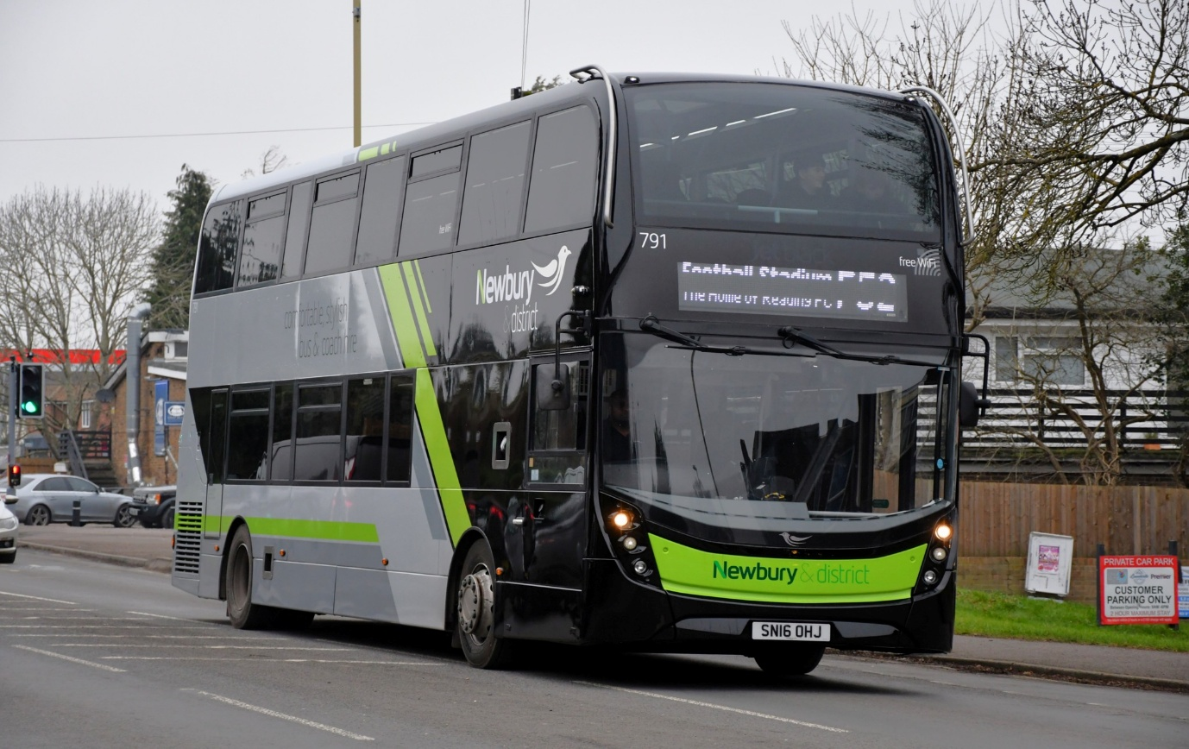
Photo credit to Steve Poole N&D791 SN16OHJ Alexander Dennis Enviro400mmc Newbury and district new livery
Letters from sponsors
This month saw receive a letter from sponsor about our desk calendars we take the time to sent out to all our sponsors. One sponsor writes to us saying thank you for sending out this kind gift which was a nice welcome response from them all at Thames Valley bus.
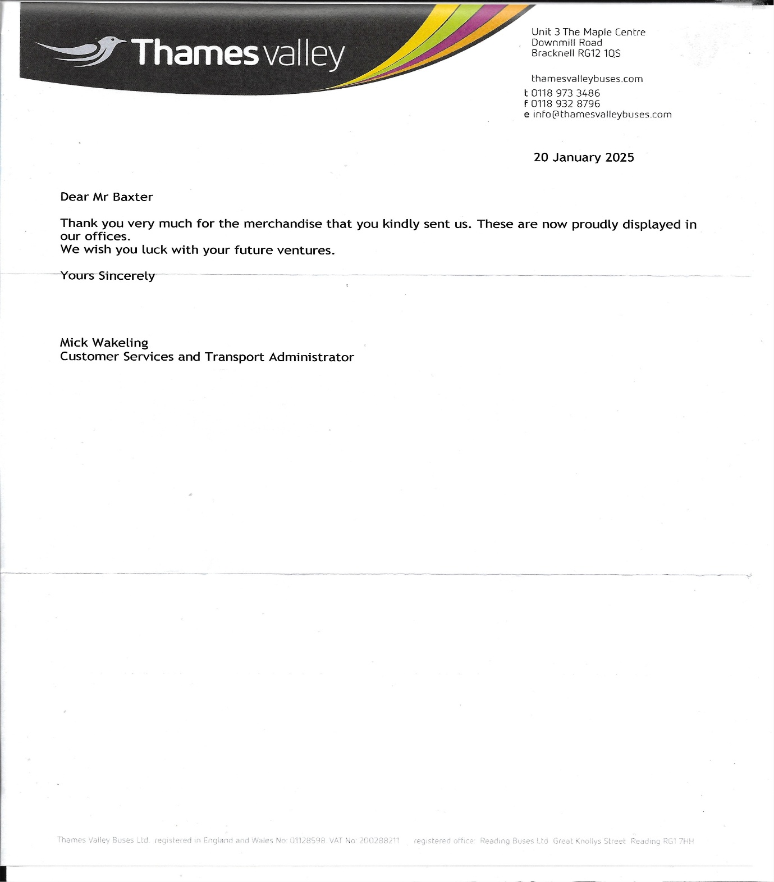
The letter above from Thames Valley bus with there nice response about my merchandise. Along with display in a pride of place at they offices.

This month has ended really well we paid a visit to a local coach company in Finchampstead near Wokingham on Friday 31st January 2025 this went really and we were welcomed with open arms to the company along with taking photographs of they coaches the visit was very pleasant Gavin Rutter and his team made us feel welcome now when I say us Tim Wild came with me and he had a good time looking in all the coaches and taking photographs of the insides I was mainly photographing the outside of the coaches more than the insides. After being they for about half hour or so we were offered warm drinks which was good. We also were waiting on one coach coming back from MOT to photograph has this was a special coach for Reading Football club, so we waited for that.
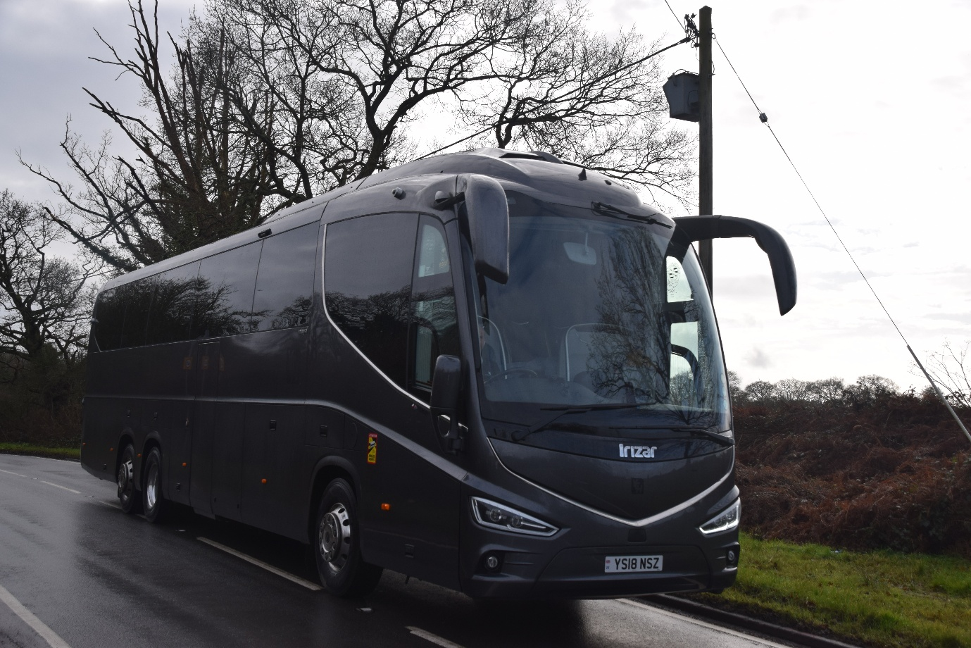
Photo credit to Gary Baxter Administrator of GB&CP: YS18NSZ Scania Irizar Reading Football Club Team bus arriving at Finchampstead Wokingham after having an MOT.
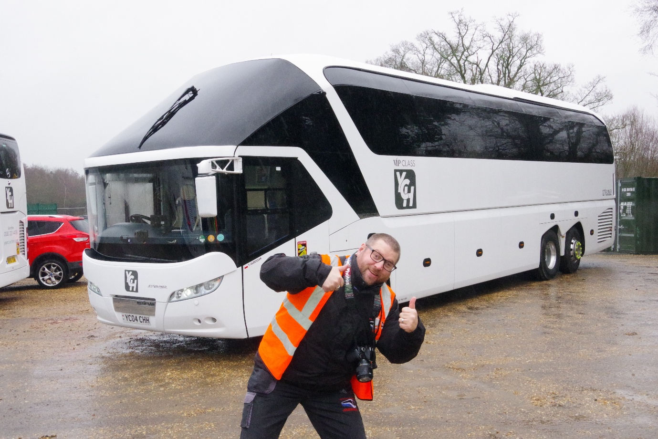
Photo credit to Tim Wild Administrator of GB&CP: photo of Gary Baxter Administrator Manager / Photographer & videographer photo bombing Tim Wild in front of YC04CHH Neoplan Skyliner at Yourcoachhire in Finchampstead Wokingham.

