
Month: October 2025 Issue no: 88
This month we attended the last event for 2025 at London bus museum Brooklands in Weybridge for the transport festival this day was a nice day and a very enjoyable day with friends with similar interests. More about this on page four.

Flickr Albums
Flickr Album Date: | Flickr Album Title | Flickr Album Link
19th October 2025 | LBM – Transport Festival | https://flic.kr/s/aHBqjCzGyQ
Photo of the month
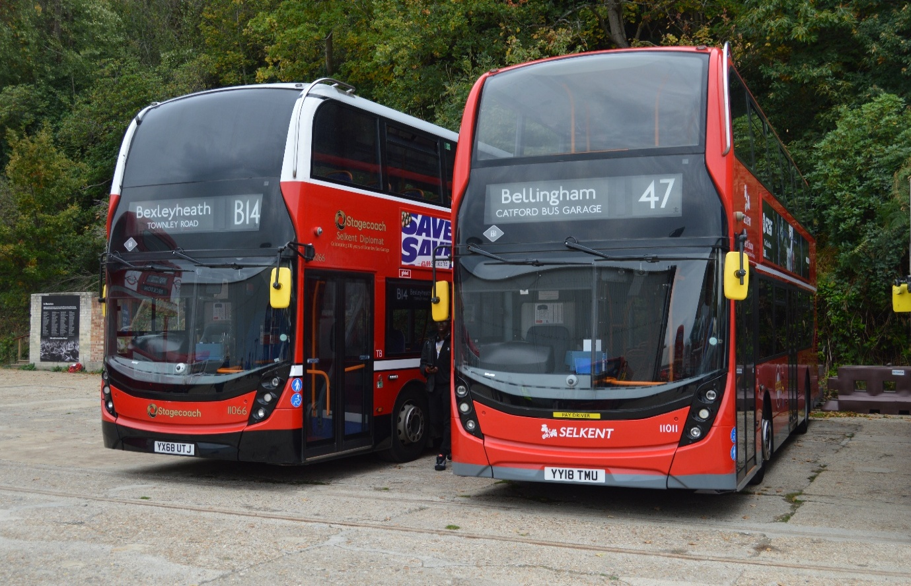
Photo credit to Gary Baxter Administration of GB&CP: Photo of the month for October 2025: 11066 YX68UTJ & 11011 YY18TMU ADL Enviro400mmc’s at Transport Festival organised by the London bus museum in Weybridge Brooklands on the 19th, October 2025. Album found on flickr www.flickr.com/photos/garysbusandcoachphotos
www.facebook/groups/garysbusandcoachphotos
www.facebook.com/garysbusandcoachphotos
Facebook Group Cover Photo Competition
Placed: | Name:
1st | Andy Dyer
2nd | Katie-Perry Smart
3rd | Alican Reilly & Nigel Wykes
4th | Barry Smith
Thanks for taking part in this month’s facebook group cover photo competition next month’s facebook group cover photo competition will be on the 14th, November 2025
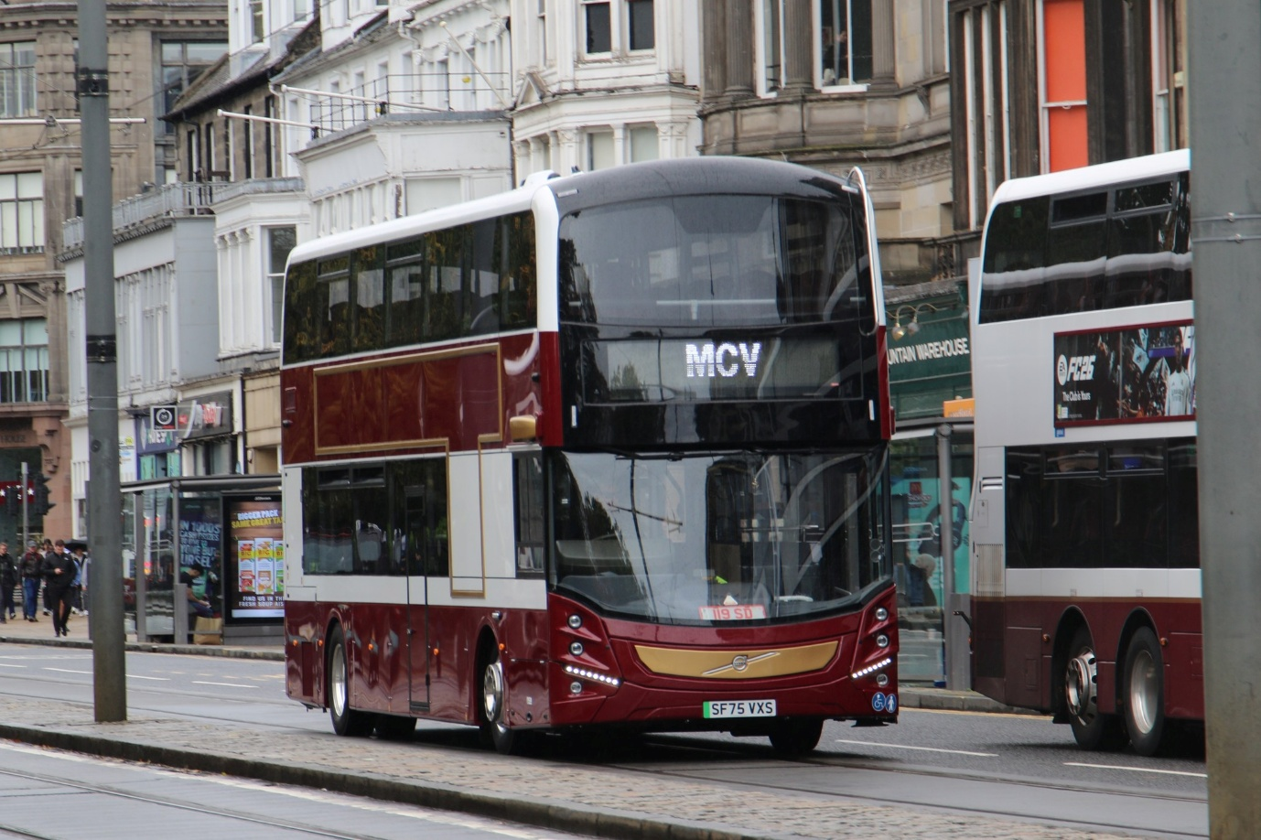
Photo credit to Andy Dyer Admin & member of GB&CP; Lothian buses E765 SF75VXS Volvo BZL Evosetti.
London Bus Museum Brooklands Weybridge: Transport Fest
We attended at the transport festival at Brooklands in Weybridge on the 19th, October 2025. This was a good day for the event, it was good to spend time with friends with the same interest and to ride the different buses on route 462 for the day. This is the last event at Weybridge Brooklands for 2025 until 2026. It was another well organised event by the London bus museum and Leon Daniels who is the chairman at the London bus museum. Photos from the event found here https://flic.kr/s/aHBqjCzGyQ Video to follow soon
Photo albums here: video will follow but due to personal reason this will follow later.

Events Diary
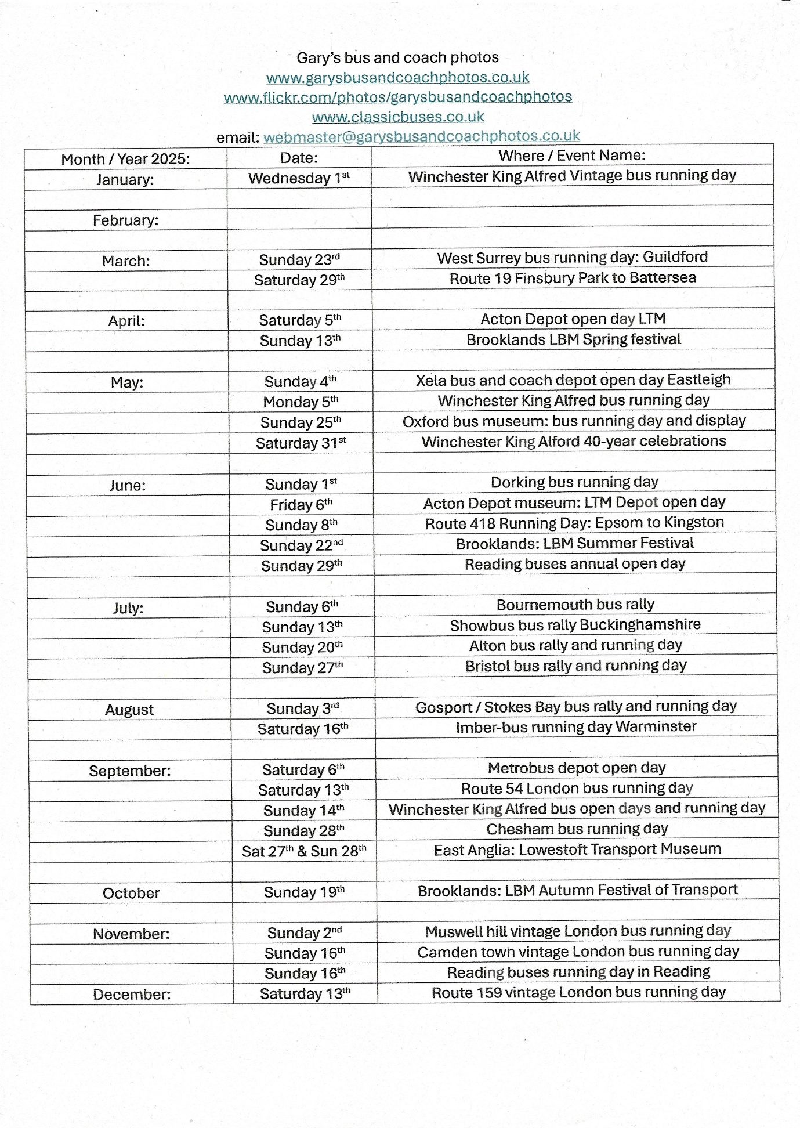

Friend’s Social media
Friends Name: | Media Name: | Link
Theo Thompson | YouTube | www.youtube.com/@theothompsonbusenthusiast
Theo Thompson | Flickr | Theo Thompson | Flickr
Tracy Churchill | Flickr | https://flickr.com/photos/202982794@N05
Alex Young | YouTube | www.youtube.com/@hellowallace
Alex Young | Flickr | Alex Young | Flickr
Adam Conner | Facebook Group | www.facebook.com/groups/RTEC-members
Adam Conner | Facebook Group | www.facebook.com/groups/rockytheroutemaster
Gary’s Bus & Coach Photos Links
Media Name | Link
Website | www.garysbusandcoachphotos.co.uk
Facebook Group | www.facebook.com/groups/garysbusandcoachphotos
Facebook Page | www.facebook.com/garysbusandcoachphotos
Flickr | www.flickr.com/photos/garysbusandcoachphotos
YouTube | www.youtube.com/@garysbusandcoachphotos
Instagram | www.instagram.com/@garysbusandcoachphotosgb7cp
Threads | www.threads.com/@garysbusandcoachphotos
Pinterest | www.pinterest.com/@garysbusandcoachphotos
Email | webmaster@garysbusandcoachphotos.co.uk

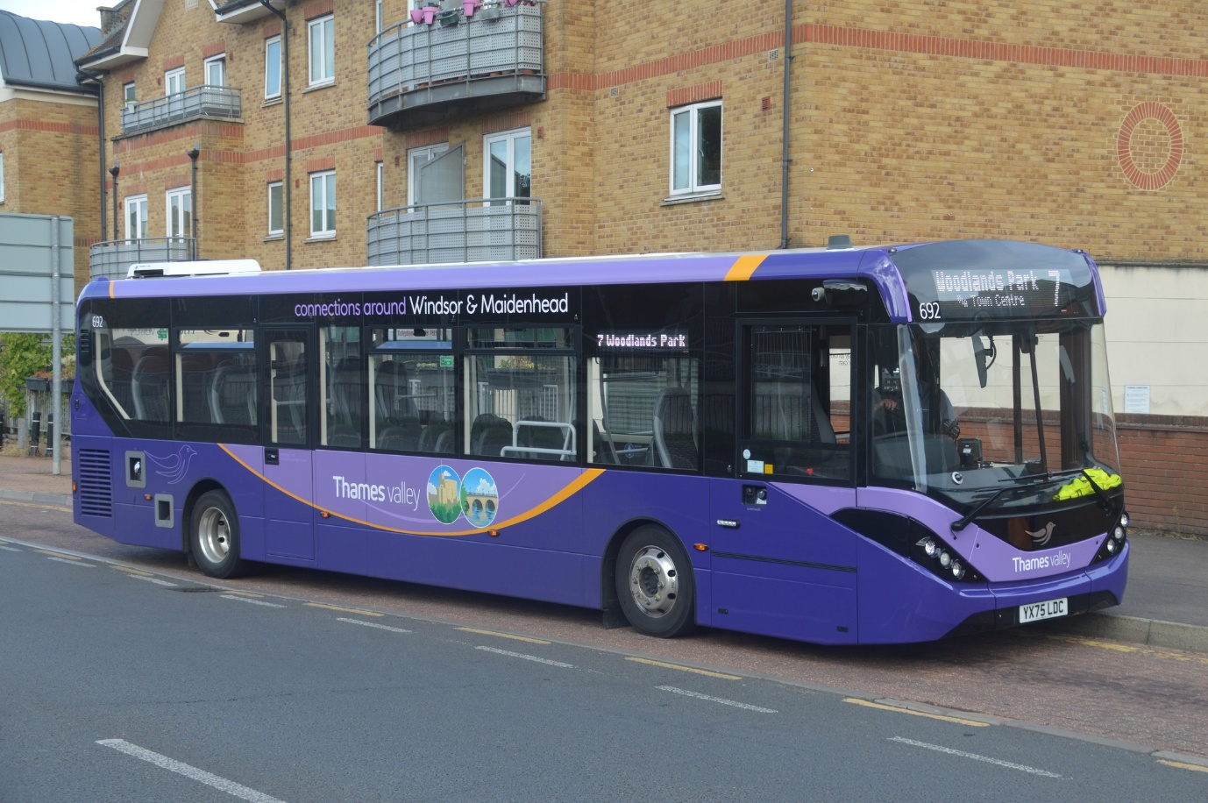
GB&CP Photo of the month September 2025: Photo credit to Gary Baxter Administration of Gary’s bus and coach photos: TV692 YX75LDC ADL Enviro200mmc in Windsor and Maidenhead Generic branding.

Thames Valley received new buses for its Maidenhead and Windsor fleet in August / September 2025 these are formed off 171 which is 8.9m 688-9 for 704 and 690/6 10.9m these entered service mid-September 2025 with 689 still awaiting its first time in service.
Fleet No: | Reg No | Body | Date Enter | Photographed | Lenth
171 | YX75LCY | ADL Enviro200mmc | 9th September | 24th September | 8.9m
688 | YX71OJA | ADL Enviro200mmc | 18th June | 19th June | 10.9m
689 | YX71OJB | ADL Enviro200mmc | ?????? | ?????? | 10.9m
690 | YX75LCZ | ADL Enviro200mmc | 1st September | 18th September | 10.9m
691 | YX75LDA | ADL Enviro200mmc | 2nd September | 16th September | 10.9m
692 | YX75LDC | ADL Enviro200mmc | 12th September | 16th September | 10.9m
693 | YX75LDD | ADL Enviro200mmc | 9th September | 16th September | 10.9m
694 | YX75LDE | ADL Enviro200mmc | 1st September | 16th September | 10.9m
695 | YX75LDF | ADL Enviro200mmc | 18th September | 18th September | 10.9m
696 | YX75LDJ | ADL Enviro200mmc | 13th September | 22nd September | 10.9m

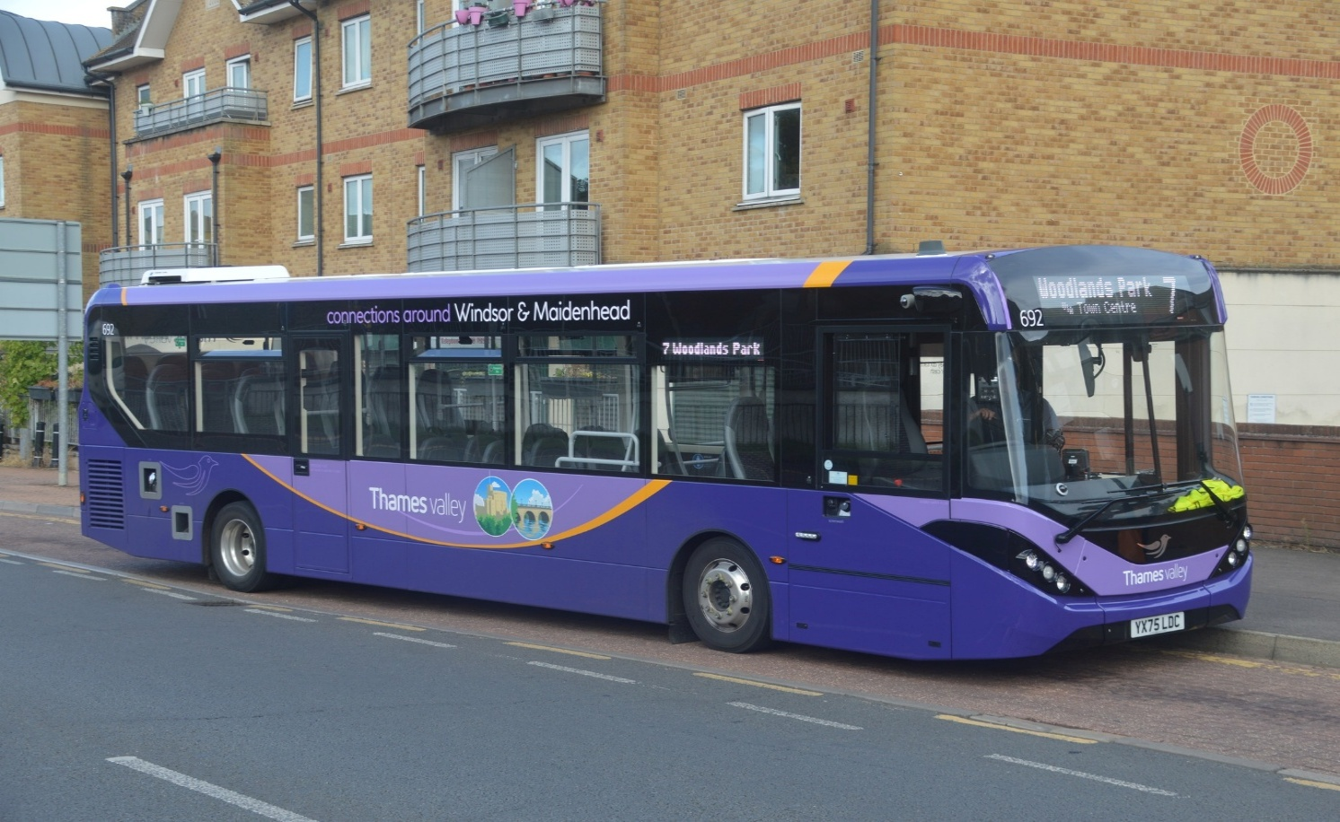
GB&CP Photo of the month September 2025: Photo credit to Gary Baxter Administration of Gary’s bus and coach photos: TV692 YX75LDC ADL Enviro200mmc in Windsor and Maidenhead Generic branding.
New timetables for Thames Valley Bracknell, Maidenhead, Slough, & Windsor
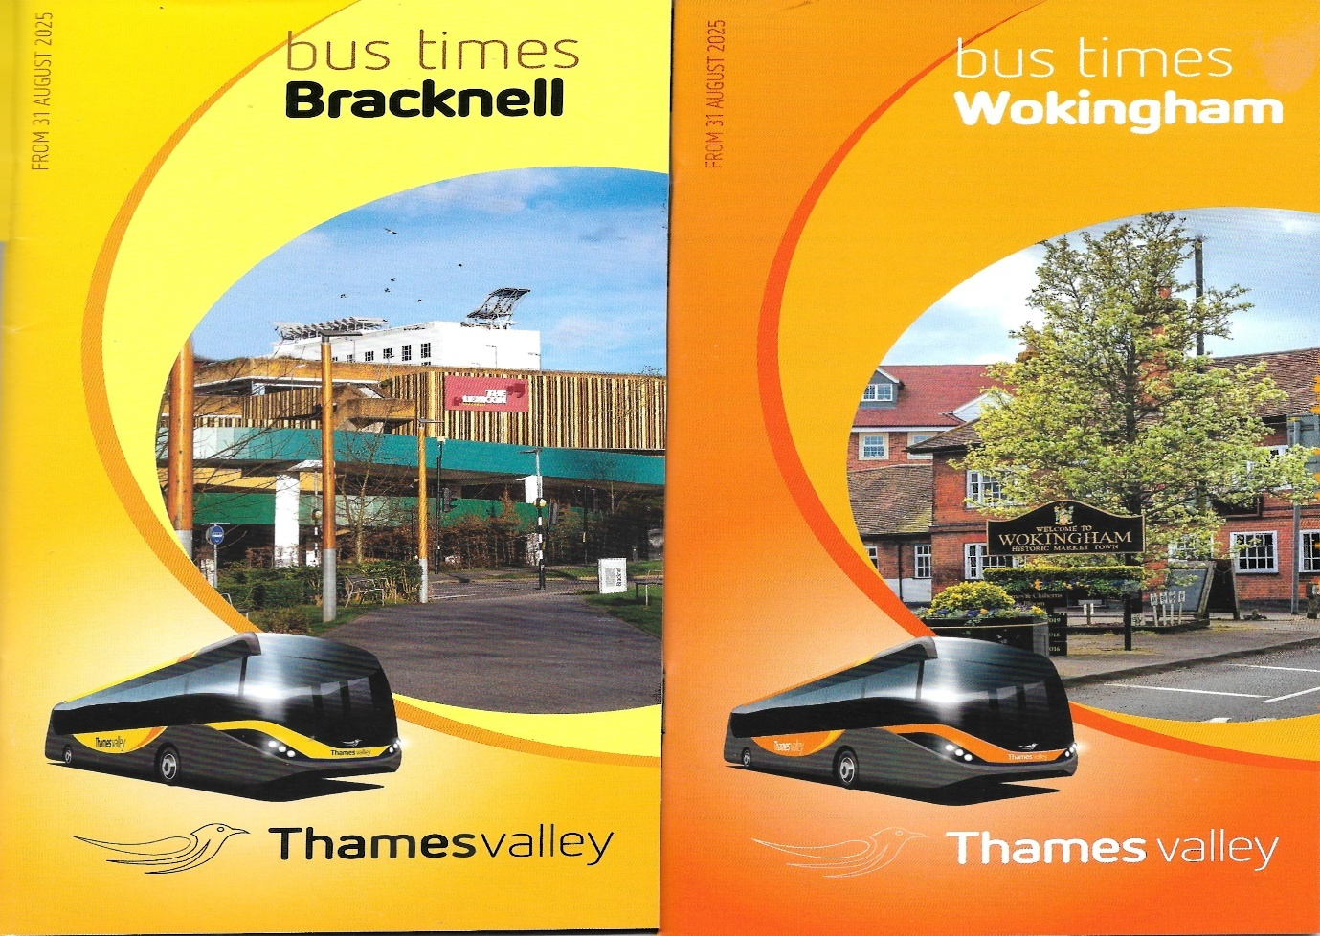
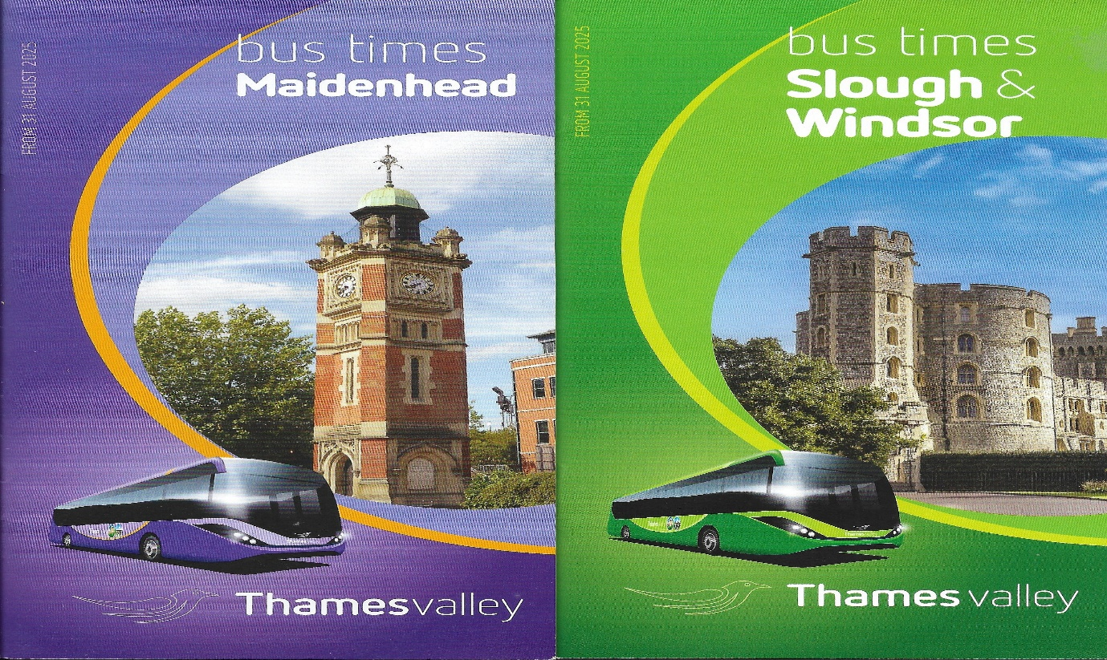
These were announced in late August / September 2025 with new timings and new routes such as route 1/1A to Ascot and Windsor and other route alterations. These can be found at the local travel shop in Bracknell and on the buses in Bracknell, Maidenhead, Slough, and Windsor.
Facebook Group: Member photos
To join the group please answer all three of the questions and agree to the group Rules to do this go to www.facebook.com/groups/garysbusandcoachphotos to follow and like our page www.facebook.com/garysbusandcoachphotos
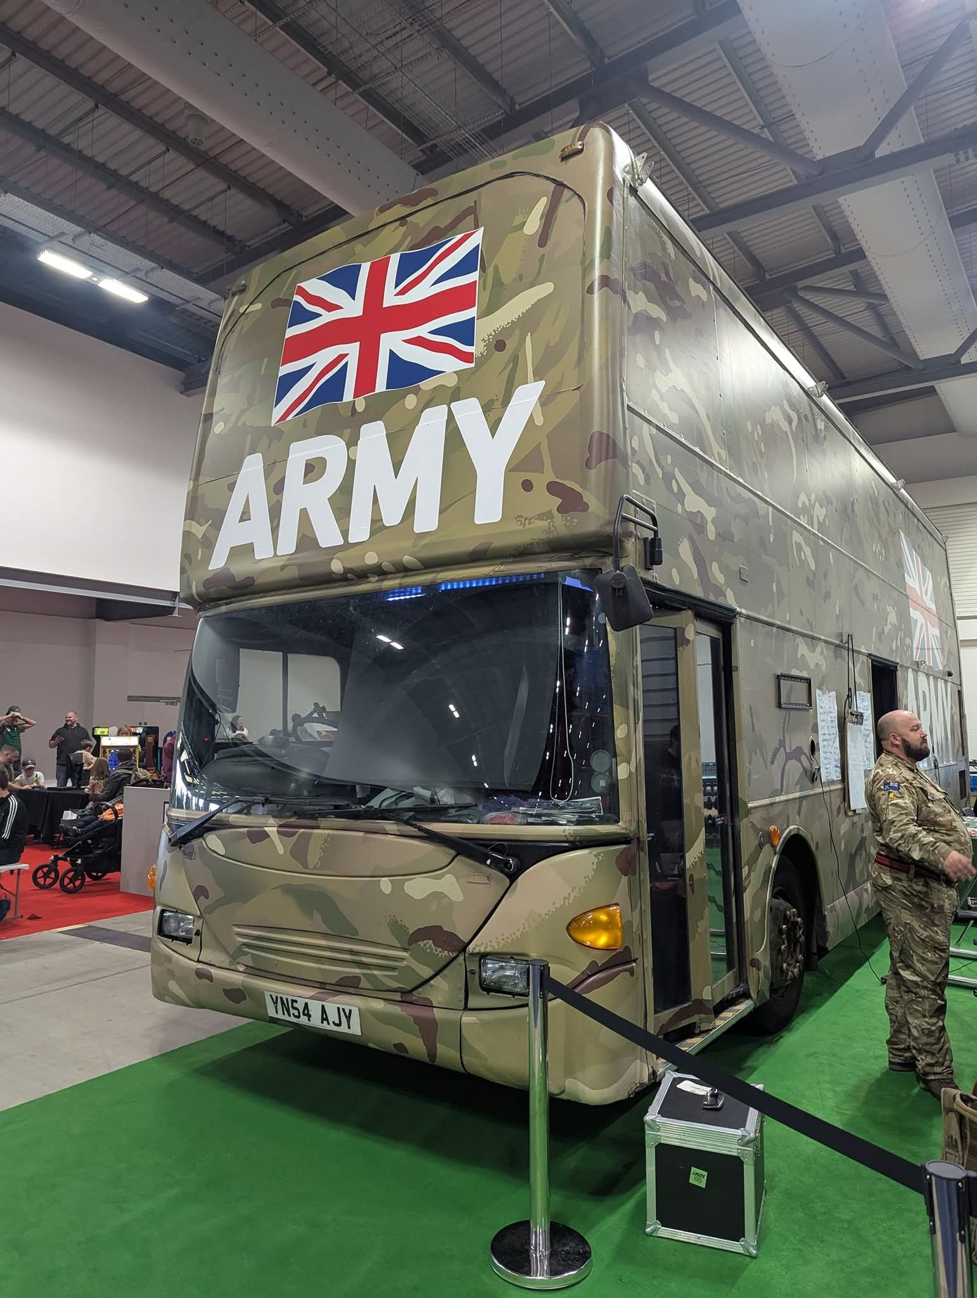
Photo credit to Gerwyn Cory member of GB&CP YN54AJY in Army recruit livery ex metrobus 6763
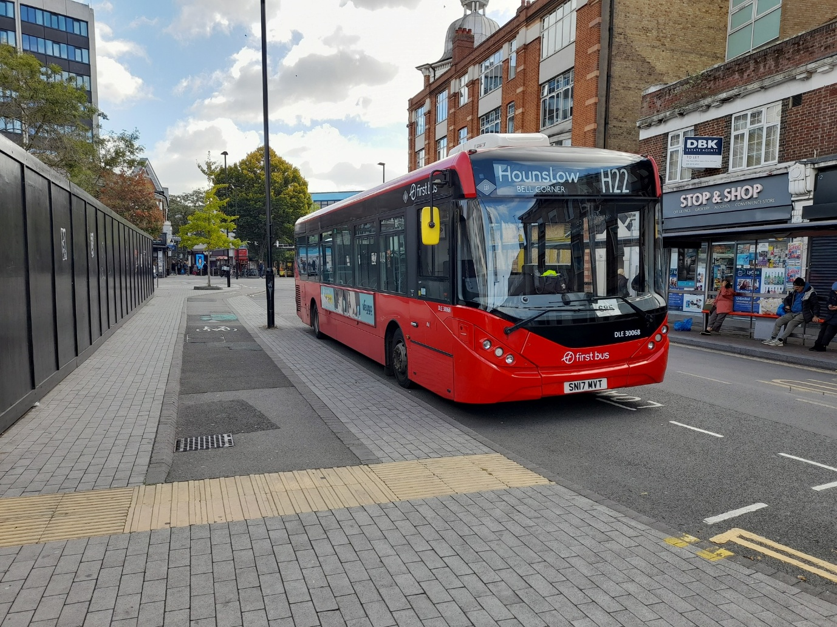
Photo credit to Alican Reilly member of GB&CP; DLE30068 SN17MVT ADL Enviro200mmc First London H22 to Hounslow.
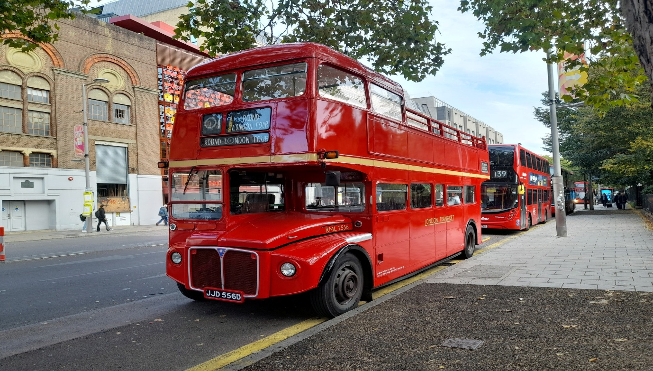
Photo credit to Alican Reilly member of GB&CP; RML2556 JJD556D London Transport Routemaster open top tour bus.
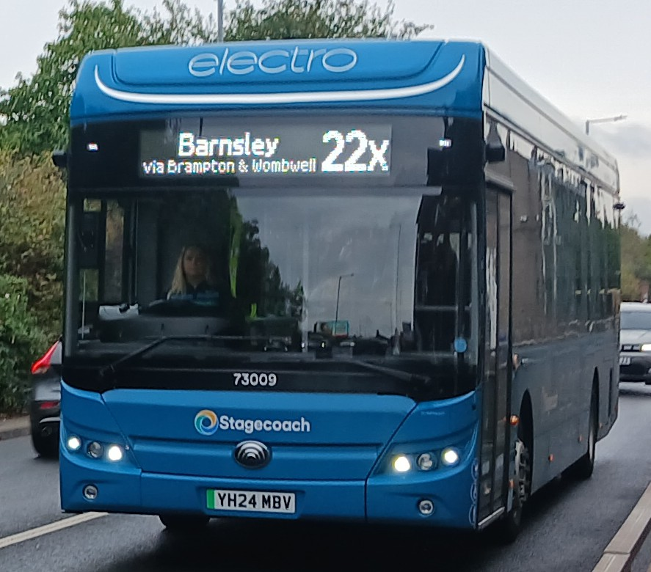
Photo credit to Barry Smith member of GB&CP; Stagecoach Yorkshire 73009 YH24MBV Yutong in Barnsley.
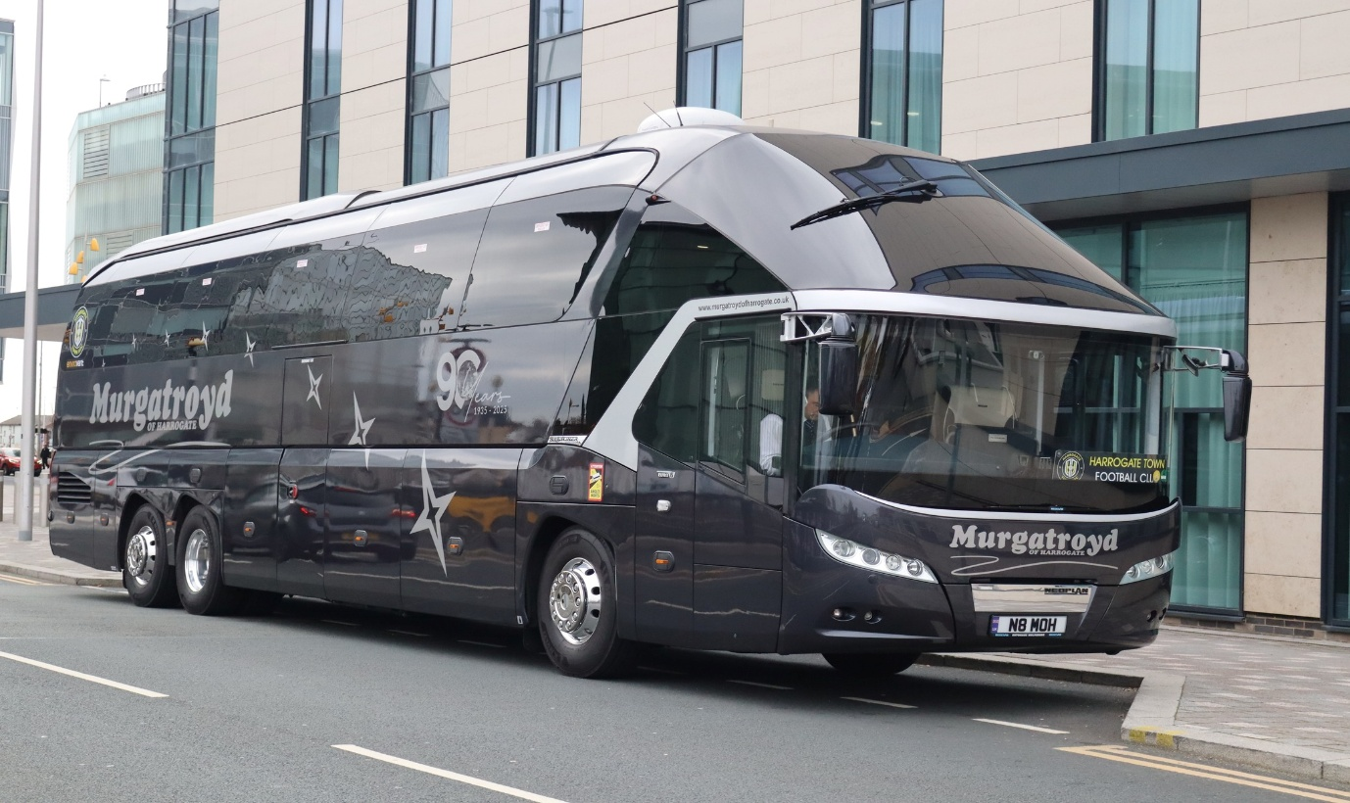
Photo credit to Alan Lockey member of GB&CP N8MOH Neoplan Murgatroyd Travel
www.facebook.com/group/garysbusandcoachphotos
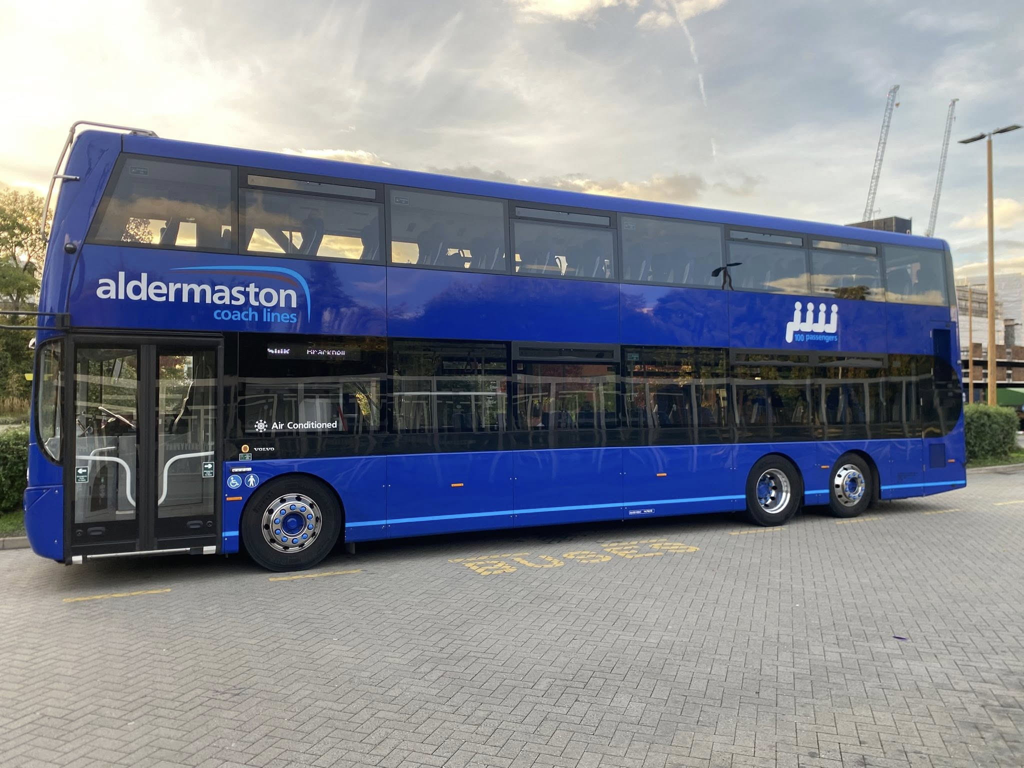
Photo credit to James Rayburn member of GB&CP BV73MHM Aldermaston Coachlines Sarah photographed on rail replacement from Bracknell to Reading.
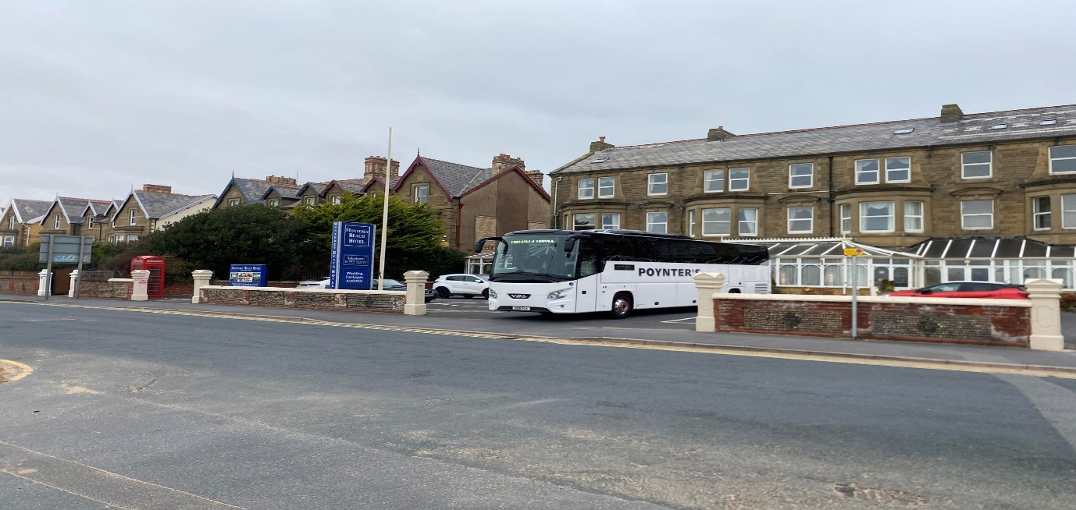
Photo credit to Nigel Wykes member of GB&CP N28POY Bova Futura VDL.
www.facebook.com/groups/garysbusandcoachphotos
www.facebook.com/garysbusandcoachphotos
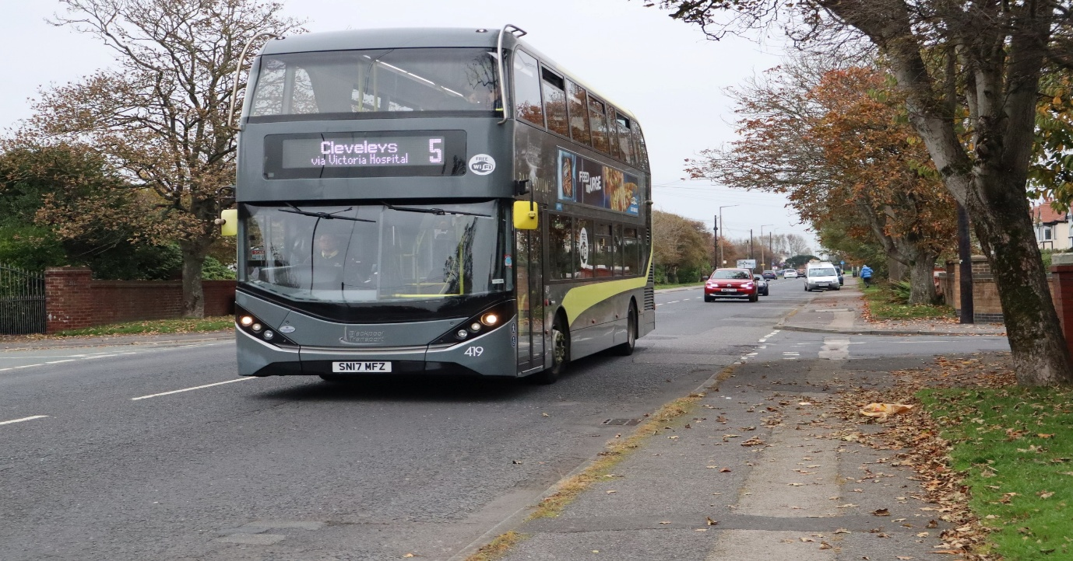
Photo credit to Alan Lockey member of GB&CP BPT419 SN17MFZ ADL Enviro400City Blackpool Transport.
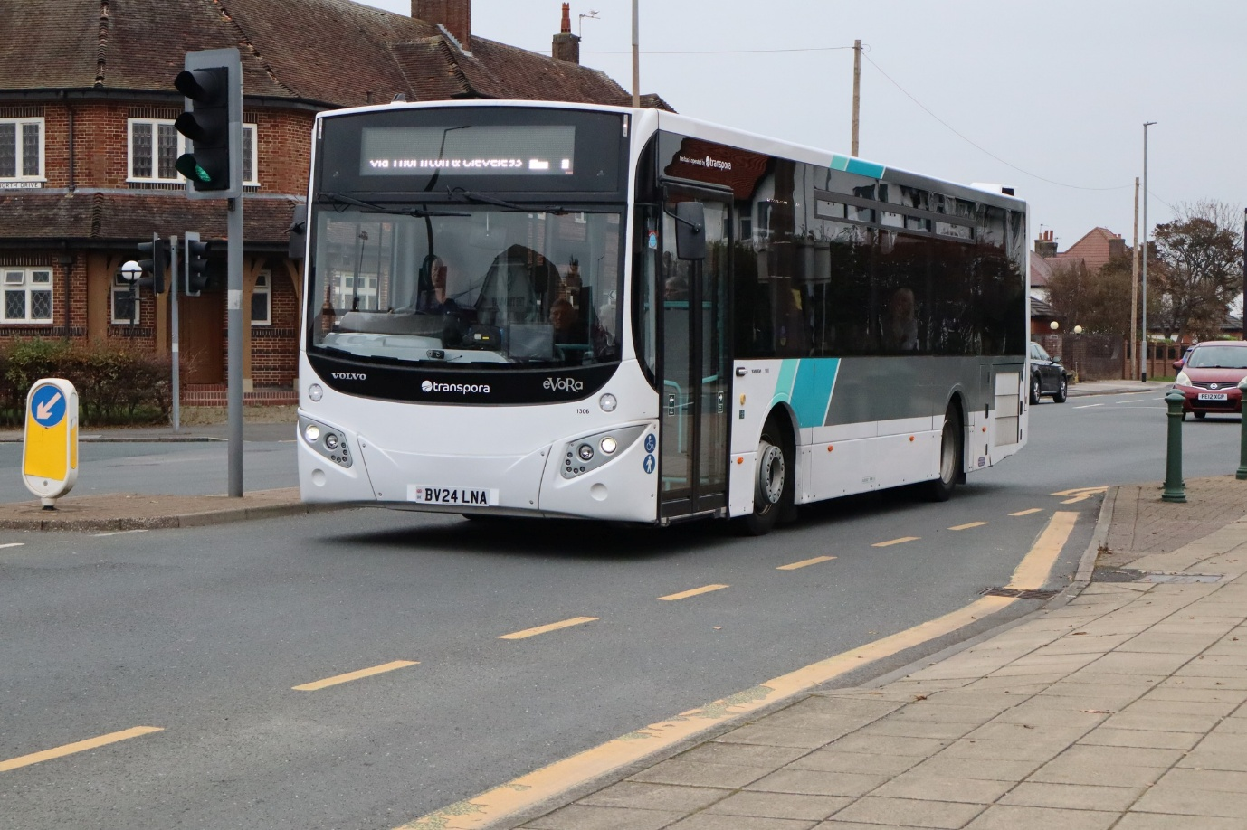
Photo credit to Alan Lockey member of GB&CP TNE1306 BV24LNA Transpora Northwest Volvo B8RLE MCV Evora.
www.facebook.com/groups/garysbusandcoachphotos
www.facebook.com/garysbusandcoachphotos
Friends of King Alfred Buses 40th Anniversary celebrations
The friends of King Alfred buses celebrated 40 years of running there group / community earlier on in the year in May 2025 to be more precise. We at Gary’s bus and coach photos did not attend this event due to other events going on at the same time but have watched videos from the hello Wallace channel on YouTube we are also good friends with him. Video links can be found below.
Video Name: | Video Link:
Friends of King Alfred 40 celebrations PT1 | https://youtu.be/uJlWatMEnZ0?si=G8SuuMkaMlcCIPNX
Friends of King Alfred 40 celebrations PT2 | https://youtu.be/SwNgk8LvJ5k?si=IINxs25WV4Fa8iIw

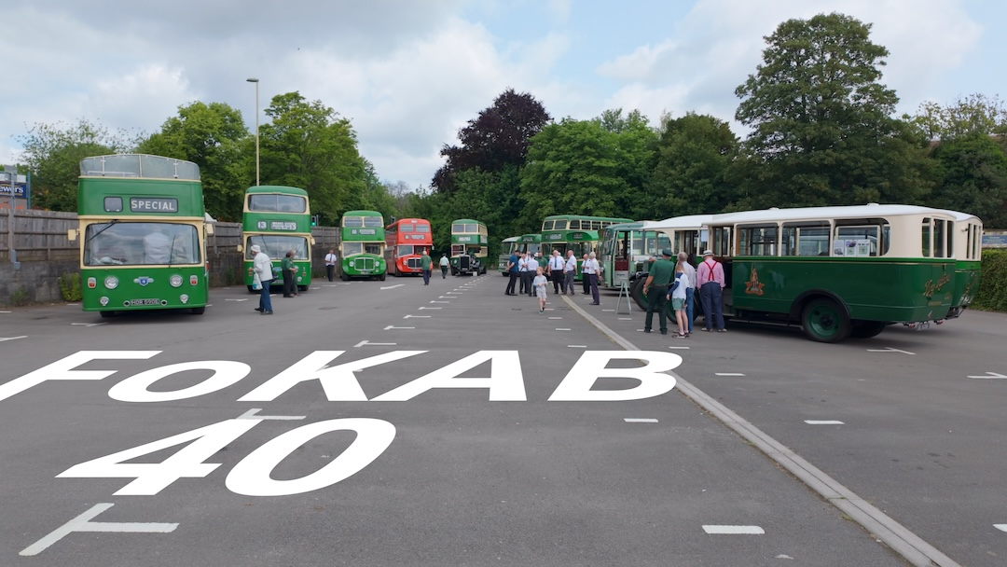
Photo credit to Alex Young Email follower of GB&CP; photo taken of all the FOKAB buses and coaches for the display for celebrating 40 years of the society or club & group.
Well done to Alex Young on filming the videos and catching the moments at FOKAB forty years like some of the people in the videos it has been going longer than the actual company that was ran by family so that is one big achievement for James Freeman and the members of Friends of King Alfred buses and coaches group, club or Society. Here is to another 40 years or more for the club. This has been going longer than Gary’s bus and coach photos but this club was created in 1985 by James Freeman I would have only been about three years old myself.
www.facebook.com/groups/garysbusandcoachphotos
www.facebook.com/garysbusandcoachphotos
www.facebook.com/friendsofkingalfredbuses

Fleet news:
Fleet No | Registration No | Type | Branding
659 | KX64AEF | ADL Enviro200 | Maidenhead 16’s
660 | KX64AEG | ADL Enviro200 | Maidenhead 16’s
661 | KX64AEJ | ADL Enviro200 | Bracknell Generic
662 | KX64AEK | ADL Enviro200 | Bracknell Generic
663 | KX64AEL | ADL Enviro200 | Bracknell Generic
This month saw the disposal of E200classics from the fleet or some of e200classics are being returned to dealership. 659/663 are being returned to the dealership they have not yet been an announcement of new buses to replace them but this will probably come in the November 2025 newsletter.

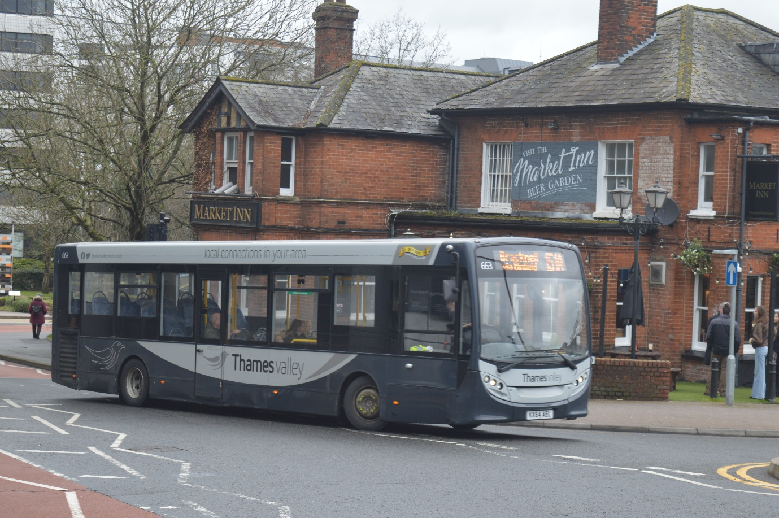
Photo credit to Gary Baxter Administration of GB&CP: TV663 KX64AEL ADL Enviro200 photographed in Bracknell on route 157 on a north Bracknell circular.
www.facebook.com/groups/garysbusandcoachphotos
www.facebook.com/garysbusandcoachphotos

