
Gary’s Bus & Coach Photos Events Calendar 2025
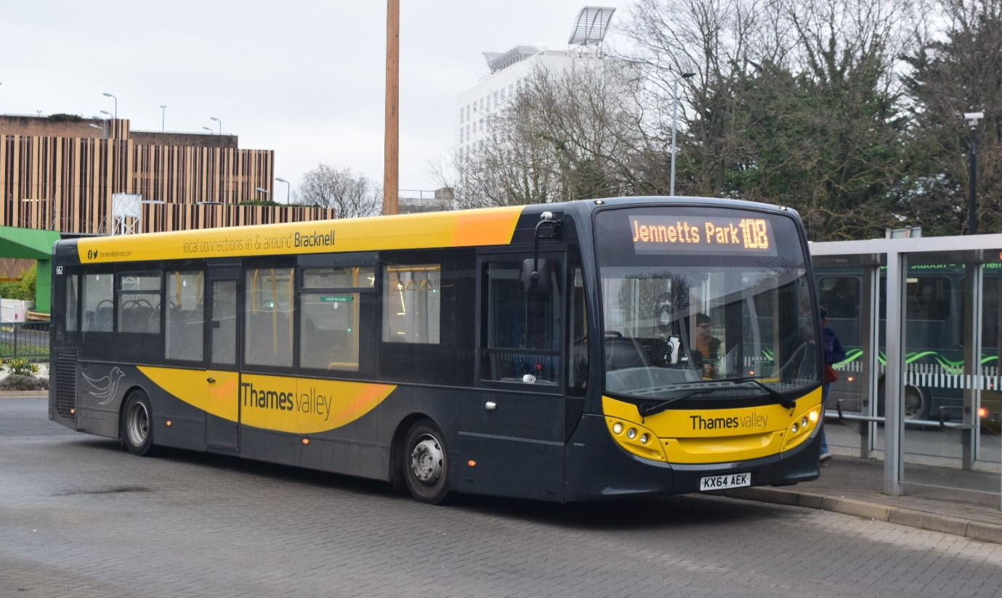
The events that we plan to do but are subject to change if needs be. As we might not be able to attend all the events, but any changes will be announced on the Gary’s Bus & Coach Photos website, Emailed and posted on relevant social media. Kind Regards Administrators Gary Baxter, Dorothy Baxter, & Tim Wild.

Month / Year 2025: | Date: | Where:
January: | Wednesday 1st | Friends of King Alfred New Year’s Day Running day
February:
March: | Sunday 23rd | West Surrey bus running day: Guildford Bus station
 | Saturday 29th | Route 19 Finsbury Park to Battersea
April: | Saturday 5th | Acton Depot Open Day London Transport Museum
 | Sunday 13th | Brooklands: LBM Spring Gathering Classic Bus
May: | Sunday 4th | Xela bus and coach depot open day Eastleigh
 | Monday 5th | King Alfred Winchester Vintage Bus Running Day
 | Sunday 25th | Oxford bus museum: bus running day & Display
 | Saturday 31st | King Alfred Celebrating 40th year’s celebration Win
June: | Sunday 1st | Dorking vintage bus running day
 | Friday 6th | Acton Museum Depot Open Day
 | Sunday 8th | Route 418 Epsom to Kingston
 | Sunday 22nd | Brooklands: LBM Summer Gathering
 | Sunday 29th | Reading buses Annual Open Day
July: | Sunday 6th | Bournemouth bus rally
 | Sunday 13th | Show bus Buckinghamshire railway centre
 | Sunday 20th | Alton bus rally & running day
 | Sunday 27th | Bristol Bus Rally & Running Day Brislington P&R
August: | Sunday 3rd | Gosport Stokes Bay bus rally and running day
 | Saturday 16th | Imber Bus running day Warminster / Sailsbury
September: | Saturday 13th | Route 54 Plumstead to Elmers End
 | Sunday 14th | Winchester King Alfred OpenDays & Running Day
October: | Sunday 12th | Reading buses running day
 | Sunday 19th | Brooklands LBM Autumn Gathering Transport Festival
November:
December:

