
Month: February 2024 Issue No: 69
An event we look forward to attending in March is organised by the London bus museum and this event also collided with an open day in Barking and is now organised in conjunction of this other event which is the Stagecoach open day and route 62-145 vintage bus running day from Dagenham to Barking so this should be an interesting event to attend on the 23rd, March 2024. The poster for this Is here more about this event will be found in the March 2024 newsletter.
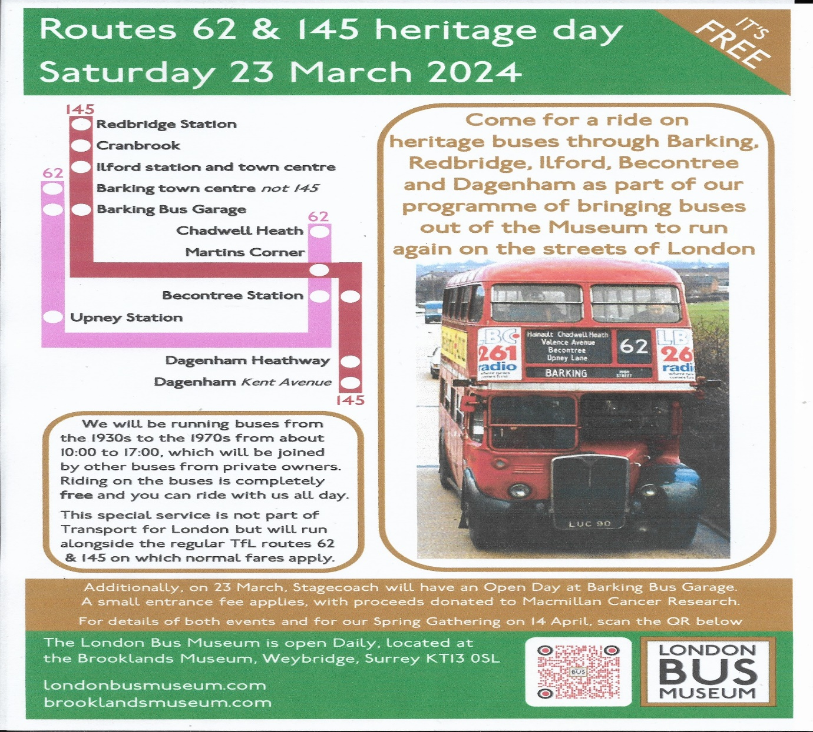
Social Media Feeds
Facebook:
January: 239 Likes, 278 Followers, and 489 Members.
February: 240 Likes, 279 Followers, and 492 Members.
Instagram:
January: 513 Followers.
February: 513 Followers.
Flickr:
January: 526 Followers and 5,002,539 Views.
February:5,223,225 View and 524 Followers.
Twitter:
January: 25 Followers
February: 24 Followers
YouTube:
January: 117 Subscribers, 21,716 Views and 226 Videos uploaded.
February: 120 Subscribers and 22,413 Views. 228 videos uploaded.
Website:
January: 3,184 Views.
February:3,413 Views.
Cover Photo Competition
1st: Daniella West
2nd: Andy Dyer / MapGroup publications Admin
3rd: Gary Baxter Admin
4th: James Rayburn
5th: Alan Lockey
Congratulations to winner and the runners up of this month cover photo competition the next cover photo competition will be on the 8th, March 2024. Please remember has always the cover photo also goes on the website at www.garysbusandcoachphotos.co.uk.
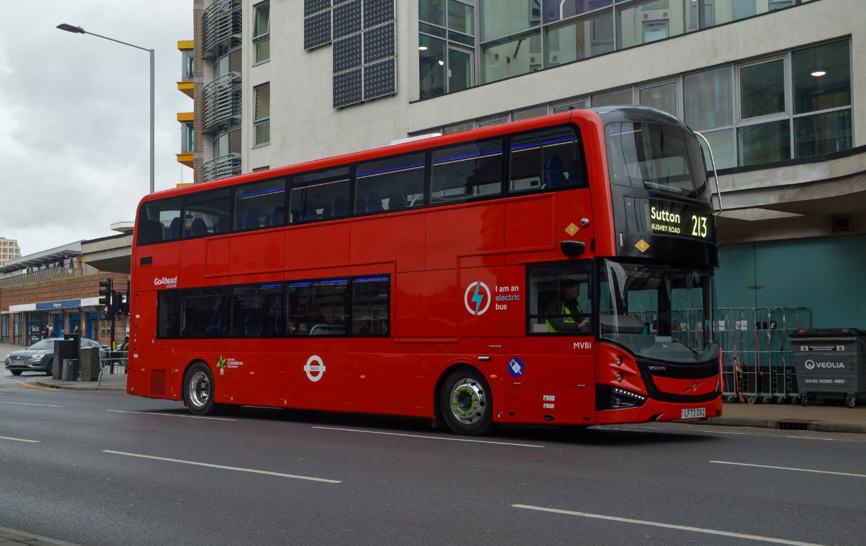
Photo credit to Daniella West member of GB&CP: GH/LMVB1 LF73DXZ Volvo BZL Double decker operated by Go-Ahead London. Winning cover photo for February 2024.

New Alexander Dennis Enviro400cities for route 4/X4 enter service from Bracknell to Reading
The Enviro400cities enter service this month and they was a special launch for them in Wokingham near to Broad Street / Wokingham town hall. This was to show off what the new Enviro400cities had to offer in the way of passenger comfort. The new Enviro400cities for the 4 and express 4 have three table seats two on the lower floor and one on the upper deck along with a bell press on every seat apart from when you get mid-way to the back on the lower deck, they are bells on poles instead of the seat they are bells on poles has well. When on the top deck they are bells on every seat including at the back of the bus. The bus is also mirror less and is covered with camera mirrors instead. They are eight of these buses liveried up for this route. The video of the launch can be found here by clicking on the link here https://youtu.be/w-NjaQT-wkI?si=nr-X6y4U6zKHGIvx
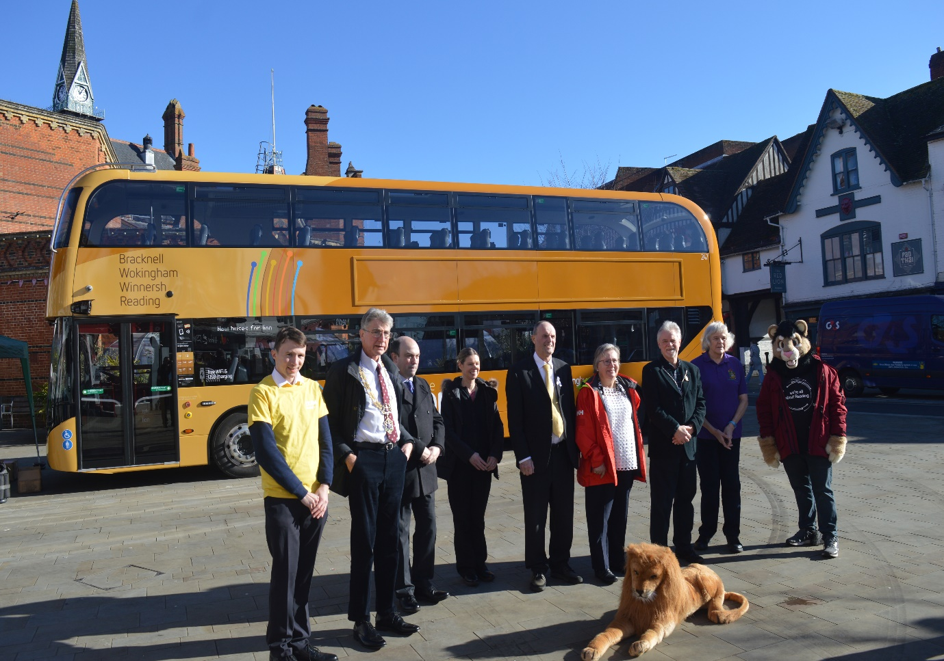
Photo credit to Gary Baxter Admin of GB&CP: RB247 YX73PHV also in this photo is the mayor of Reading standing next to Robert Williams along with a few councillors from Wokingham Borough council with the lion lying in front of them all.

New buses for route 171/2 were launched this month.
New Alexander Dennis Enviro200mmc’s were launched for route 171/2 on the 14th, February 2024. This actually entered service two weeks prior to the launch. The new buses host USB/c-type charging points and bell press on every seat until you get mid-way to the back. The seats also have a phone / tablet holder on the back of them and wireless charging. In the drivers cab you have digital speedo and new destination displays. Videos from the launch and taking a ride on one can be found via clicking on the links here. https://youtu.be/w6wvBMTgVYM?si=c__PZZ0wihdyoR04 https://youtu.be/kM3a-n4vHjg?si=7FdikVugYuv9YIVG
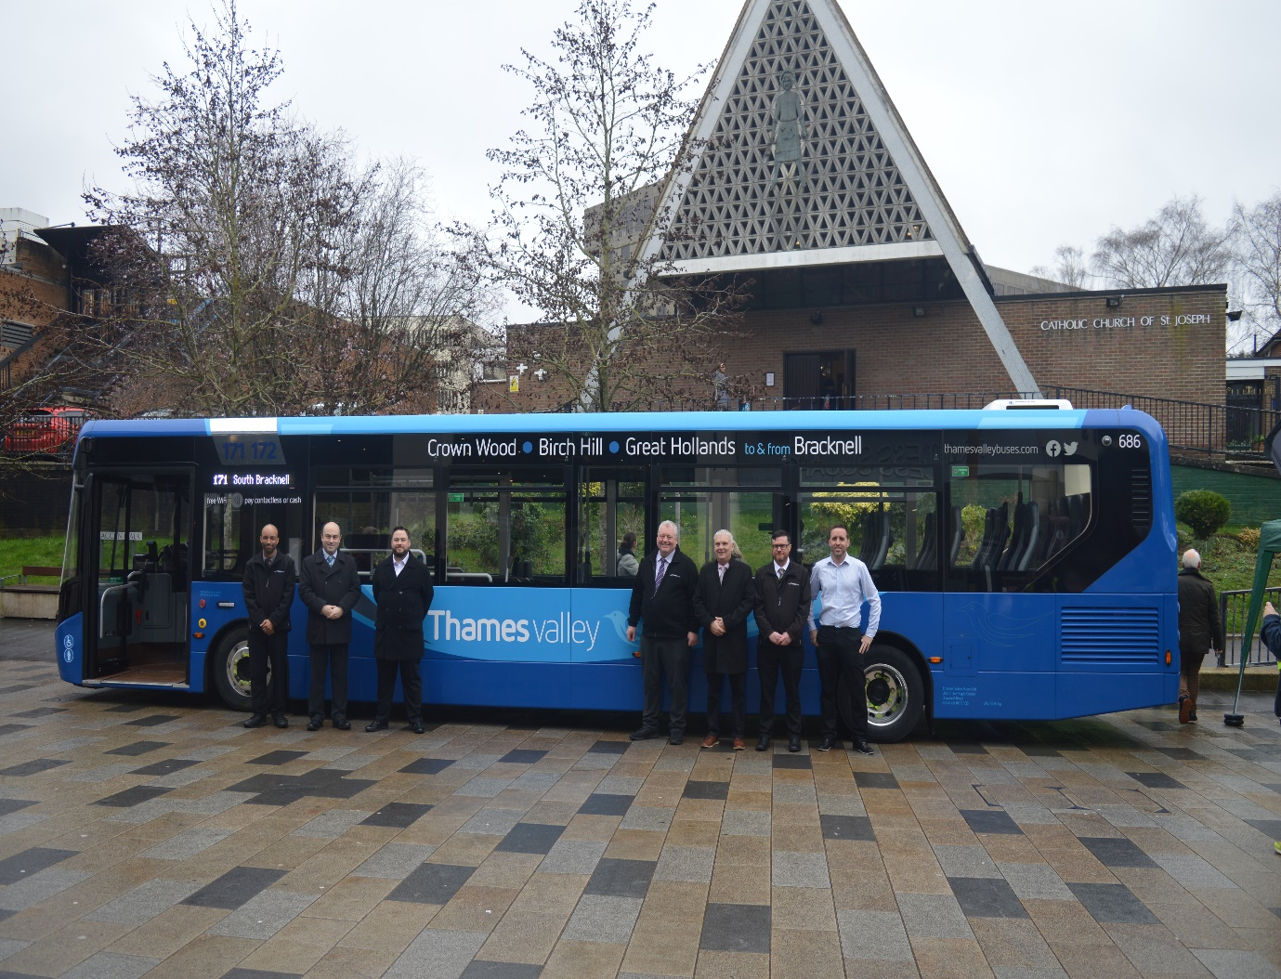
Photo credit to Gary Baxter Admin of GB&CP: TVB686 YY73OYN Alexander Dennis Enviro200mmc 171/2 branded launched in service on the 14th, February 2024. In the photo from right to left star driver Arron Jordan, Robert Williams, Bracknell Forest councillor, Simon Fisher, Nick West, Ben O’Shea, and some other Reading buses official. Photo taken near Princess Square the Lexicon.

New buses fleet list
Fleet no: | Registration no: | Branded: | Body Type / Engine: | Depot:
241 | YX73PHA | RB Lion | Alexander Dennis Enviro400city | Reading
242 | YX73PHF | RB Lion | Alexander Dennis Enviro400city | Reading
243 | YX73PHK | RB Lion | Alexander Dennis Enviro400city | Reading
244 | YX73PHN | RB Lion | Alexander Dennis Enviro400city | Reading
245 | YX73PHO | RB Lion | Alexander Dennis Enviro400city | Reading
246 | YX73PHU | RB Lion | Alexander Dennis Enviro400city | Reading
247 | YX73PHV | RB Lion | Alexander Dennis Enviro400city | Reading
248 | YX73PHY | RB Lion | Alexander Dennis Enviro400city | Reading
684 | YX73PGZ | TV 171/2 | Alexander Dennis Enviro200mmc | Bracknell
685 | YX73PHZ | TV 171/2 | Alexander Dennis Enviro200mmc | Bracknell
686 | YY73OYN | TV 171/2 | Alexander Dennis Enviro200mmc | Bracknell
687 | TV73BUS | TV Generic | Alexander Dennis Enviro200mmc | Bracknell


Fleet no: | Registration no: | Branded: | Body Type / Engine: | Depot:
781 | SN66WRC | Flightline 703 | Alexander Dennis Enviro400mmc | Bracknell
782 | SN66WRD | Flightline 703 | Alexander Dennis Enviro400mmc | Bracknell
795 | SN66WLK | Flightline 703 | Alexander Dennis Enviro400city | Bracknell
736 | GL23LHR | Flightline 703 | Alexander Dennis Enviro400city | Bracknell
737 | GL23BKL | Flightline 703 | Alexander Dennis Enviro400city | Bracknell
738 | FL73LHR | Flightline 703 | Alexander Dennis Enviro400city | Bracknell
739 | FL73WND | Flightline 703 | Alexander Dennis Enviro400city | Bracknell
740 | FL73LGO | Flightline 703 | Alexander Dennis Enviro400city | Bracknell

Here is the full list of the Flightline buses 738-740 have entered service has of 14th, February 2024.

Flightline new buses
New Flightline 703 buses arrived and have entered service has of 14th, February 2024 738-40 have arrived and have entered service. This along with 781-37 now brings the fleet up to eight buses. It is believed now that 738/40 have now arrived this will now free up 781-95 for generics or 781-82 will return to Reading for use in Newbury. 795 will be generic for Thames valley. Service 703 is also to believe to be turning in to a thirty-minute interval service from Bracknell to London Heathrow Airport this is believed to be happening in March 2024, but plans for that are still be unveiled by Reading buses and Thames valley.
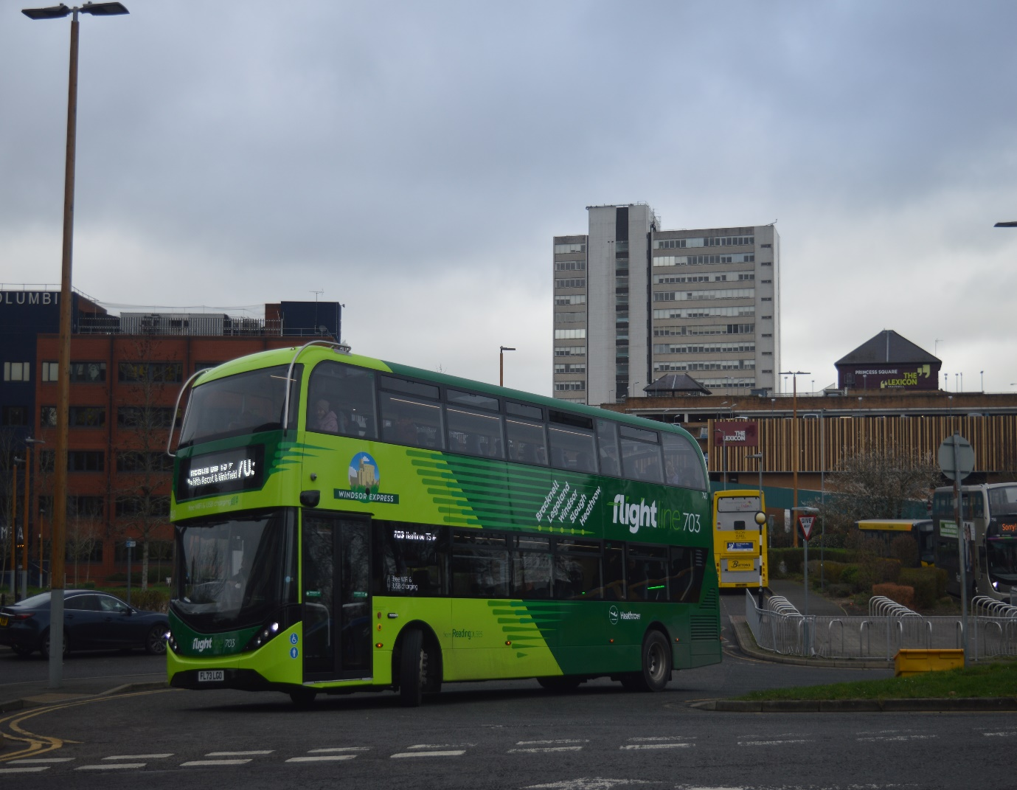
Photo credit to Gary Baxter Admin of GB&CP: TV/RB/FL740 FL73LGO Alexander Dennis Enviro400city Flightline 703 from Bracknell to London Heathrow Airport photo taken on departure from Bracknell on the 17th, February 2024. This along with 738/9 FL73LHR/WND have entered service for this route on or around the 14th, February 2024.
Reading buses had a couple of demonstration buses this month which was interesting to see the first bus that was on demonstration is LY71GJE which was a Wrightbus Electricliner, and the Second one was a Yutong Pelican Electric bus YD73FTP Fleet number and Reg numbers in Table below.
Fleet number: | Registration number: | Make:
1006 | LY71GJE | Wrightbus Electric liner
1007 | YD73FTP | Pelican Yutong

Photo of the second one below:
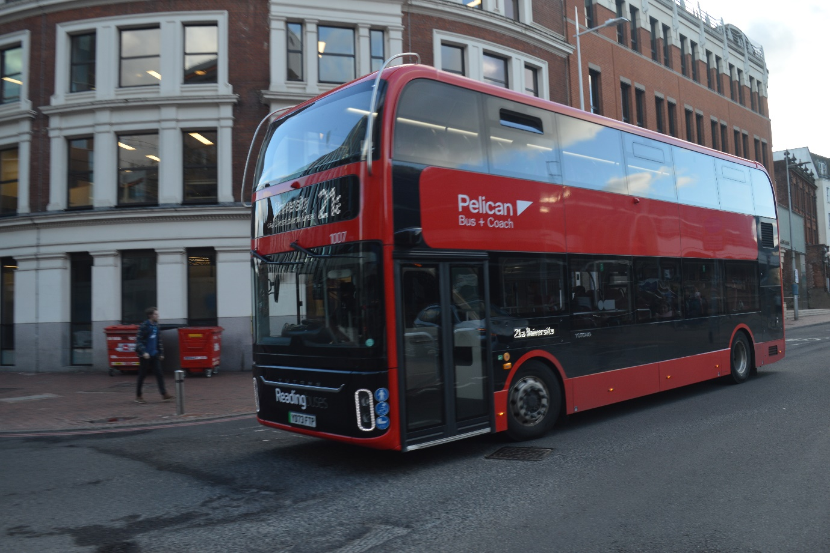
Photo credit to Gary Baxter Admin of GB&CP: RB1007 YD73FTP Pelican Yutong on Trial at Reading buses on route 21A or any route it was needed on but on route 21A in this photograph.
Facebook Group Member Posts
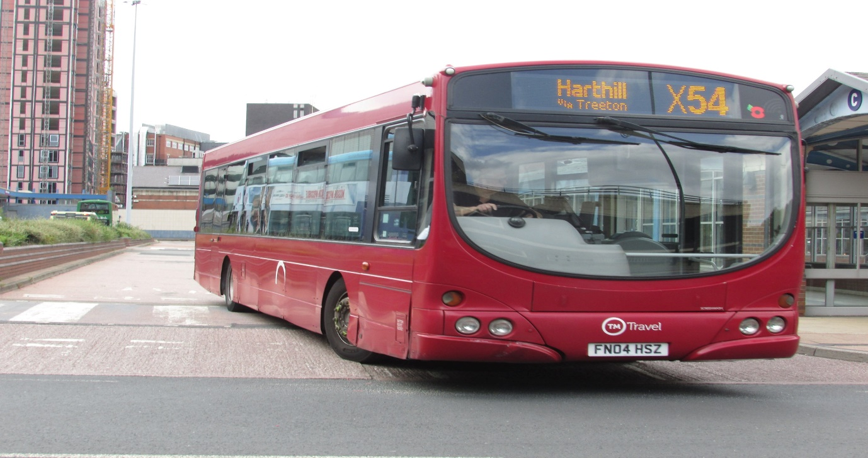
Photo credit to Alan Lockey member of GB&CP: FN04HSZ Wrightbus Gemini Scania L94UB TM Travel
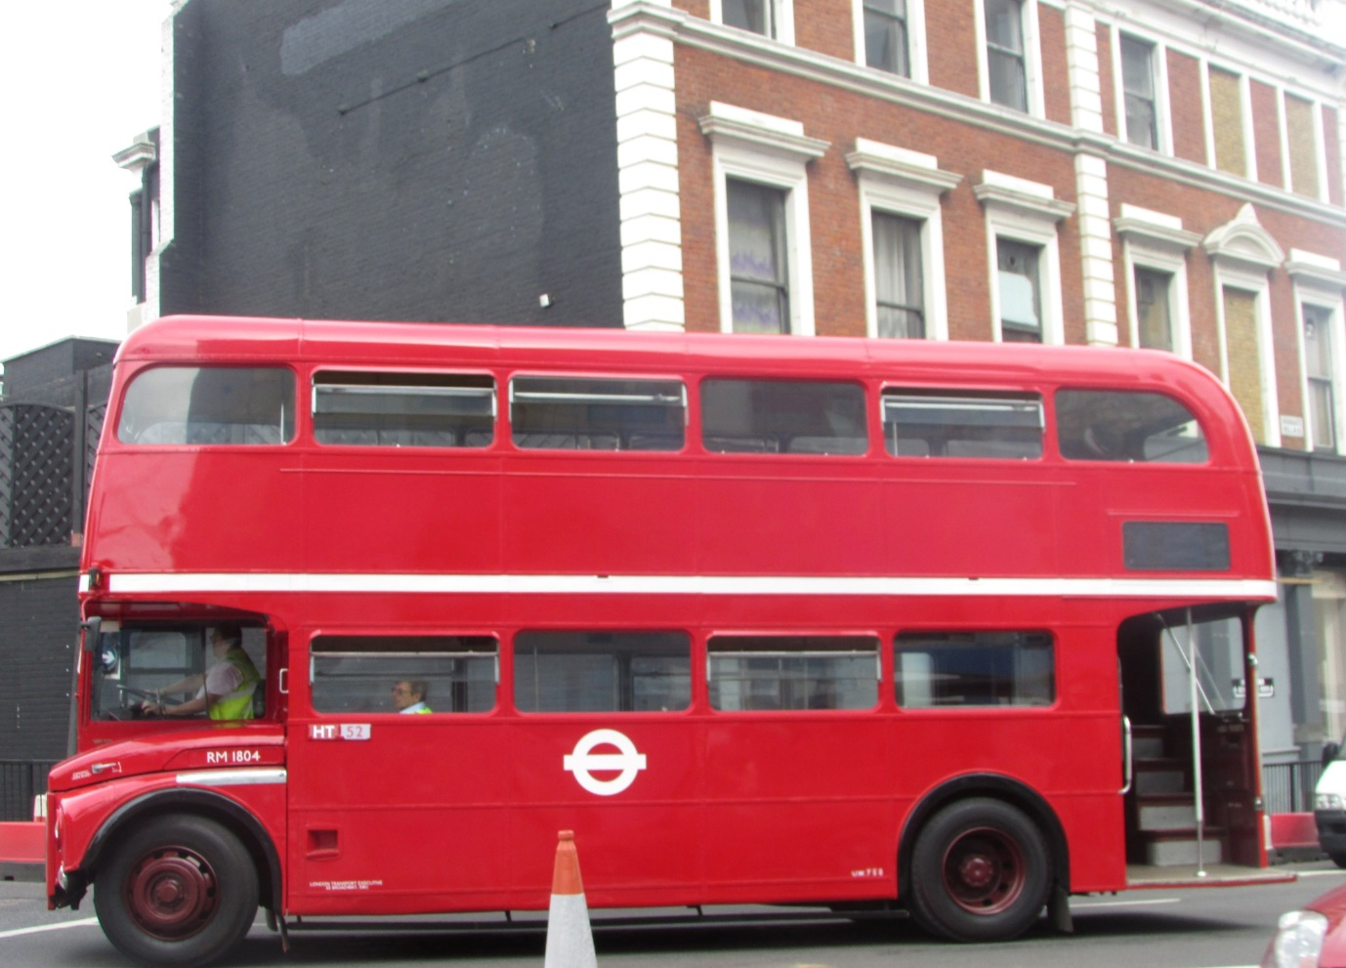
Photo credit to Alan Lockey member of GB&CP: RM1834 London Transport Routemaster photo taken in London or at a special event.
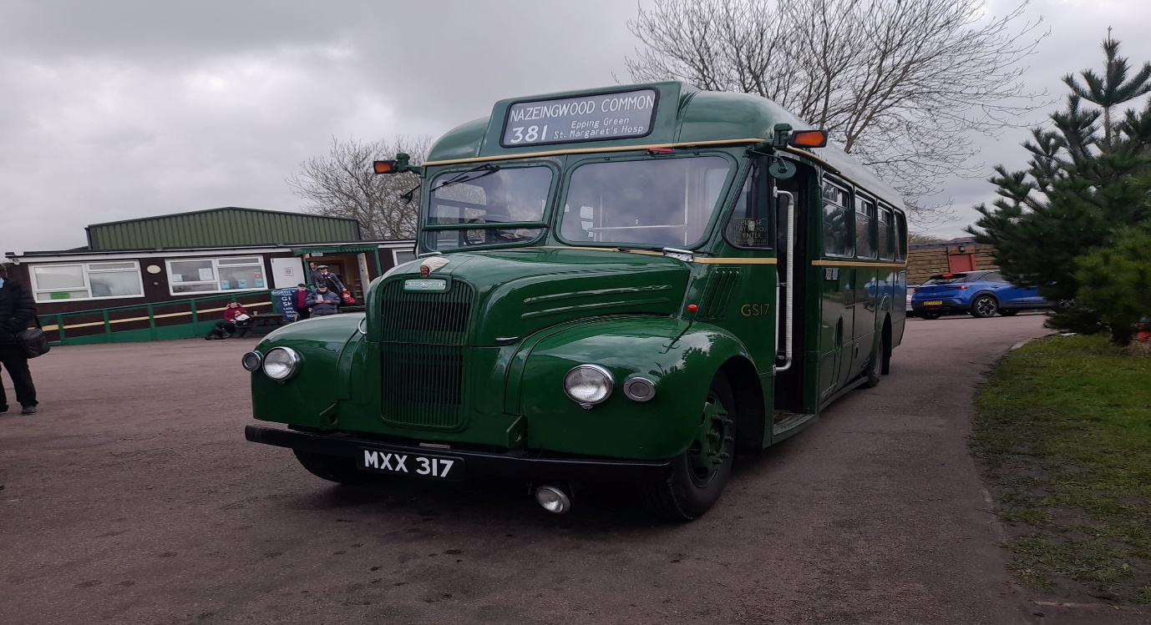
Alican Harry Reilly member of GB&CP: GS17 MXX317 at Epping Ongar vintage bus running day on the 25th, February 2024.
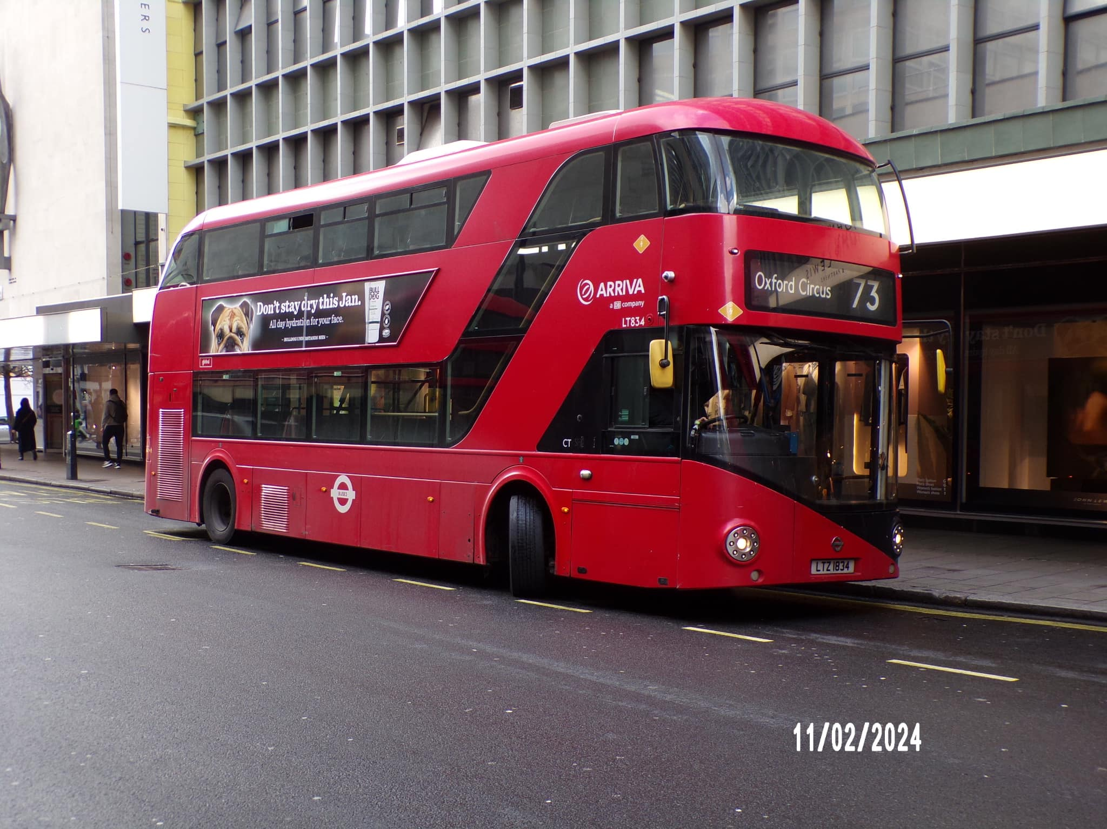
Photo credit to Gary Devlin member of GB&CP: LT834 LTZ1834 Transport for London Borismaster operated by Arriva London route 73 to Oxford Circus.
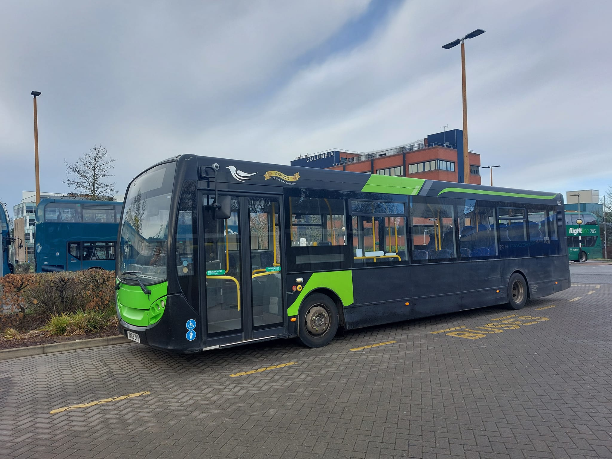
Photo credit to James Rayburn member of GB&CP: RB/N&D/TV650 YX63ZVR Alexander Dennis Enviro200 original Newbury and District vehicle either on loan to Thames Valley or now under ownership at Thames Valley.
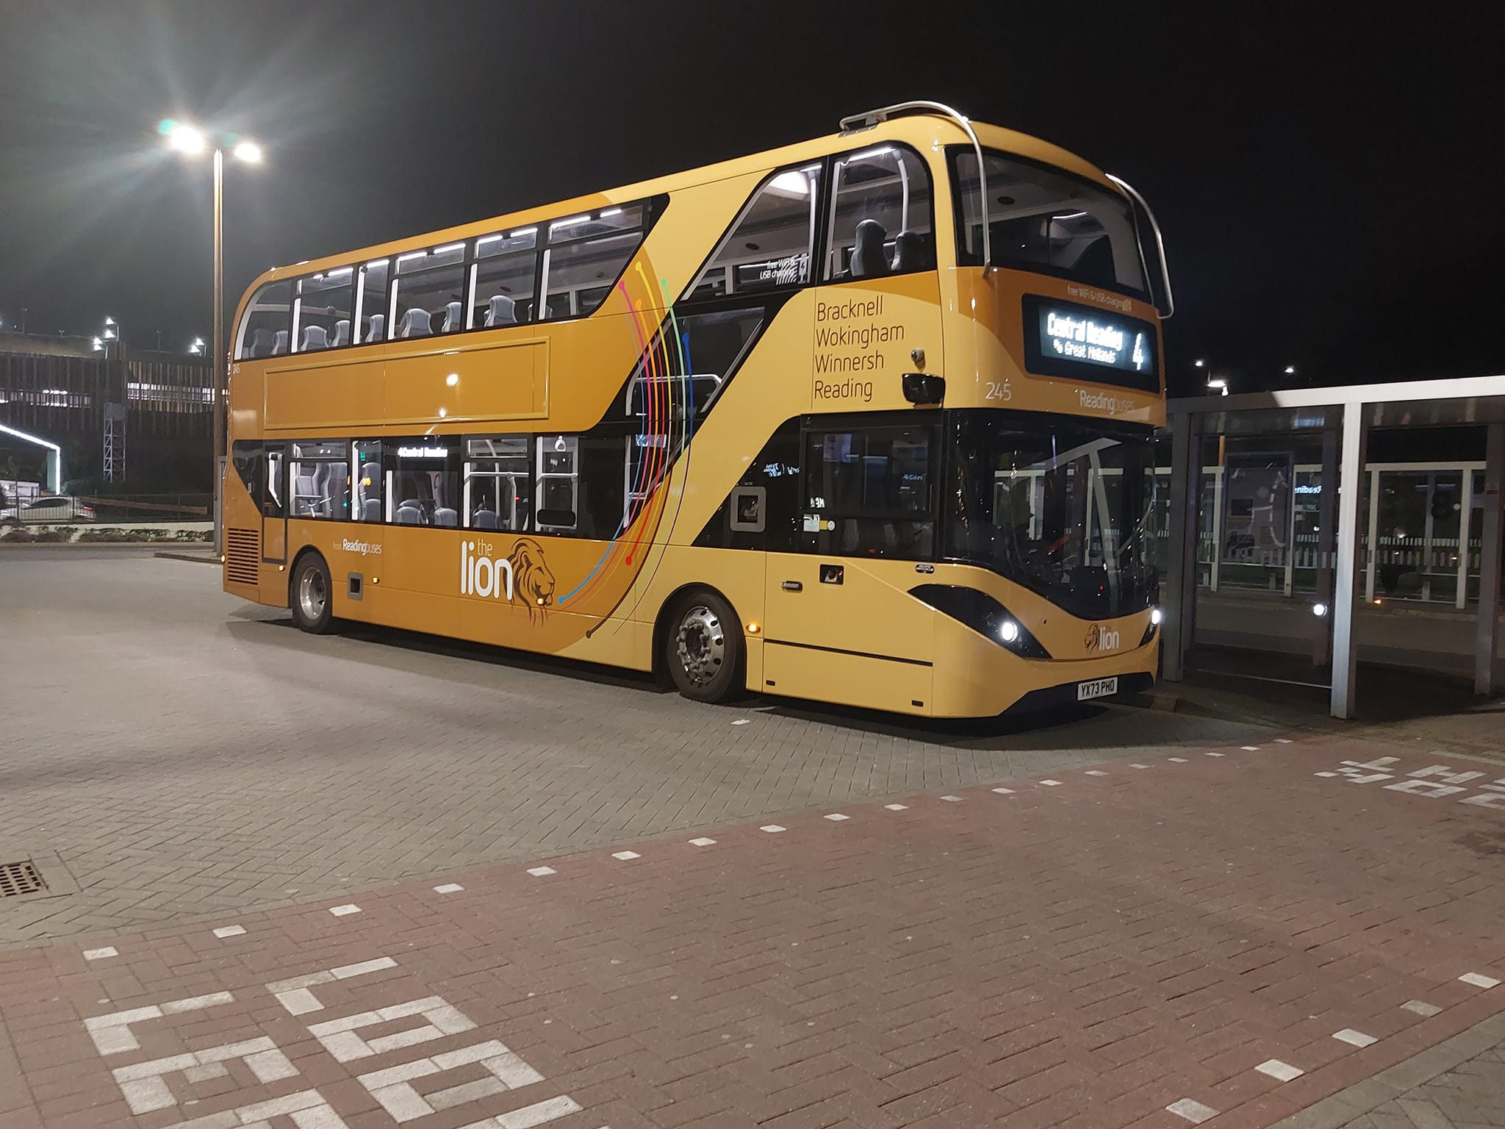
Photo credit to James Rayburn member of GB&CP: RB245 YX73PHO Lion 4/X4 branded route Alexander Dennis Enviro400city operated by Reading buses / Reading buses group of companies.
