
Month: March 2026 Issue no: 93
This month we attended at the route 38 heritage bus running day from Victoria to Clapton Pond. This day was a good day for meeting up with friends with the same interests. The day was also awesome with some nice rides on heritage buses from the 60’s and 80’s. more about this on page four.
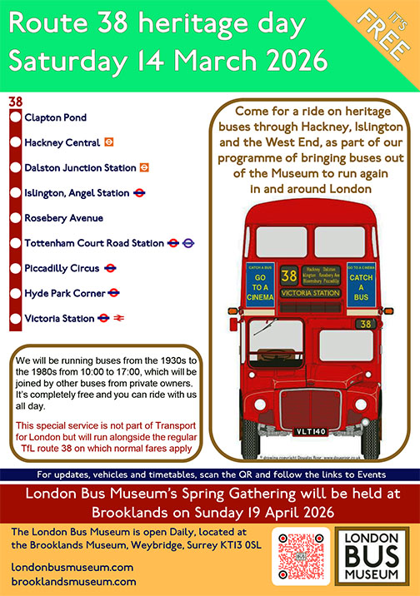
Flickr Photo Albums
Album Date: | Album Name: | Album Link
3rd March 2026 | Bracknell | https://flic.kr/s/aHBqjCMppf
6th March 2026 | Bracknell | https://flic.kr/s/aHBqjCMLsT
9th March 2026 | Bracknell | https://flic.kr/s/aHBqjCMHtk
13th March 2026 | Bracknell | https://flic.kr/s/aHBqjCNiVY
14th March 2026 | London / Route 38 heritage bus running day | https://flic.kr/s/aHBqjCNbbn
24th March 2026 | Bracknell & Reading | https://flic.kr/s/aHBqjCPpWQ
27th March 2026 | Bracknell | https://flic.kr/s/aHBqjCPrTB
30th March 2026 | Bracknell | https://flic.kr/s/aHBqjCPqTg
Photo of the Month
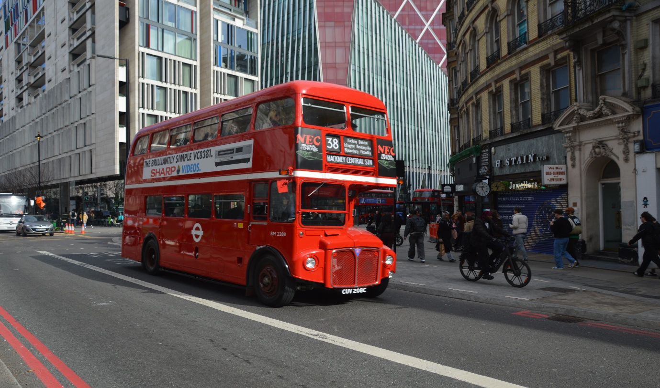
Photo credit to Gary Baxter Administration of GB&CP; RM2208 CUV208C photographed at London Victoria on route 38 from Clapton Pond to Victoria on heritage bus running day organised by London bus museum photo of the month for March 2026 more photos from this day can be found via this link https://flic.kr/s/aHBqjCNbbn also follow our Flickr at www.flickr.com/photos/garysbusandcoachphotos
Events
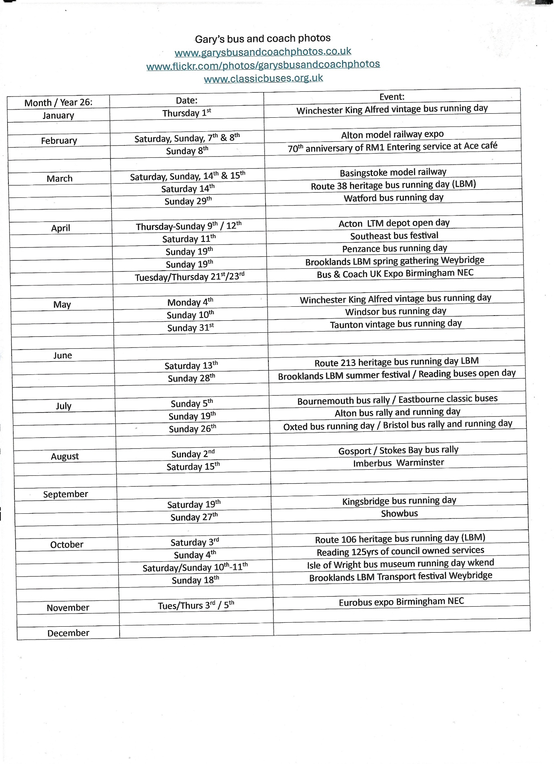
Route 38 heritage bus running day
We attended at the route thirty-eight heritage bus running day in central London which runs from Victoria to Clapton Pond this day was a nice for catching up with friends with similar interests and for riding some different buses from the early years. We had a lovely day riding on these and the day was met with some nice weather now we are in March the weather seems to be cheering up a bit. It was nice to be over to take some photos in Victoria and Hyde Park of all the different buses on this day photos from this day can be found at www.garysbusandcoachphotos.co.uk or on our at www.flickr.com/photos/garysbusandcoachphotos link also available here. https://flic.kr/s/aHBqjCNbbn

Reading buses / Reading Transport has special anniversary this year and in a way of commemorating this event they are having a handful of buses at the London bus museum on the 19th, April and on the 4th, October 2026 a special event. When Reading Transport / Reading buses started out back in the early years they used to operate out of Mill Lane depot in Reading which would later close and Reading buses moved to Great Knollys Street. All this time Reading buses has been operated under council ownership and is the only operator to be doing so right now. Mill lane depot closed in 1998 at the same time moved into Great Knollys Street. There might be more events to commemorate this hundred- and twenty-five-years occasion.
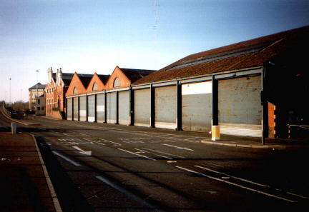
Photo credit to Robert Williams CEO at Reading buses and member of Gary’s bus and coach photos Mill Lane depot December 1996 / moved to Great Knollys Street in 1998 to make way for the oracle shopping centre / complex.
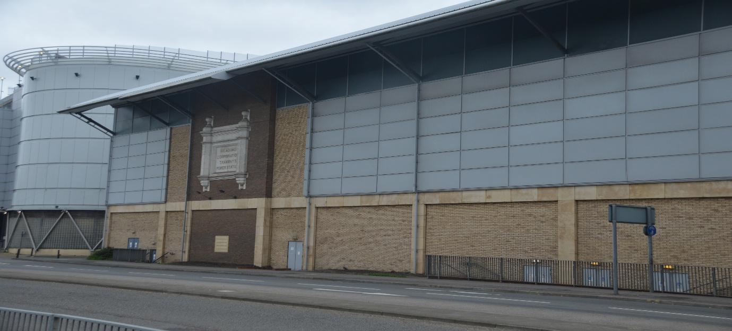
Photo credit to Gary Baxter Administration of Gary’s bus and coach photos: Oracle shopping centre Ex Mill Lane Reading transport depot.
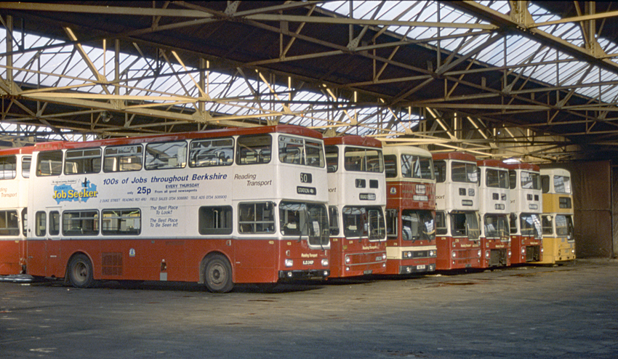
Inside Mill Lane bus depot photo thanks to Wikimedia this Is how it would have looked inside when Mill Lane was open.
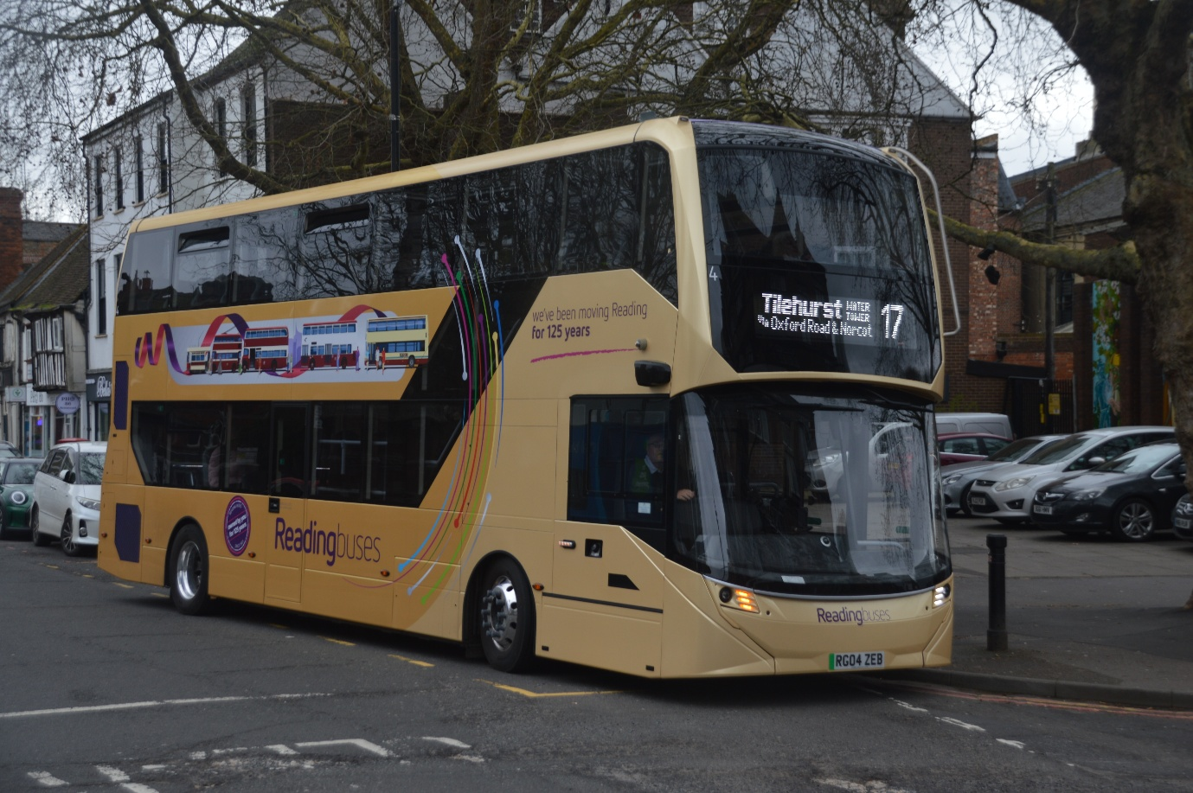
Photo credit to Gary Baxter Administration of GB&CP: Reading buses 4 RG04ZEB in 125YRS anniversary branding. Photographed on the backbone of Reading route 17 to Tilehurst Water Tower.

Gary’s bus and coach photos Events
April 2026
Date: | Event Name:
Saturday 11th | LTM Acton Depot open day
Sunday 19th | Brooklands LBM spring gathering
Tuesday 21st | Coach & Bus Expo in Birmingham
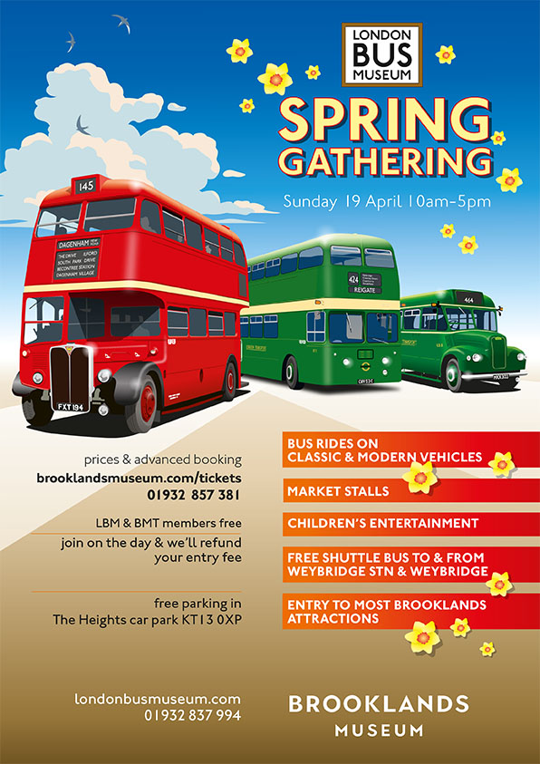
Thames Valley buses
This month it was announced that Thames valley / Bracknell council are withdrawn routes from the Thames Valley services these routes are 151/A 299, and 598 it is said the services are to be withdrawn and to leave some passengers / customers with no services for the local area, but like the saying goes use it or lose it. The service changes have been announced by Thames Valley and Bracknell Forest council. The first services will be withdrawn in April 14th and 15th which the routes are 299 and 598 and then last route to be withdrawn will be the 151/A in July.
Reading buses new buses entered service in February and the last one entering service in March 2026. The list below shows the dates on entry.
Fleet No: | Reg No | Branded | Entered Service
1 | RG01ZEB | Generic | 6th February 2026
2 | RG02ZEB | Zebra | 6th February 2026
3 | RG03ZEB | Climate strips | 6th February 2026
4 | RG04ZEB | Reading 125yrs | 6th February 2026
5 | RG05ZEB | Branded 17 | 6th February 2026
6 | RG06ZEB | Branded 17 | 6th February 2026
7 | RG07ZEB | Branded 17 | 6th February 2026
8 | RG08ZEB | Branded 17 | 6th February 2026
9 | RG09ZEB | Branded 17 | 6th February 2026
10 | RG10ZEB | Branded 17 | 6th February 2026
11 | RG11ZEB | Branded 17 | 6th February 2026
12 | RG12ZEB | Branded 17 | 6th February 2026
13 | RG13ZEB | Branded 17 | 6th February 2026
14 | RG14ZEB | Branded 17 | 6th February 2026
15 | RG15ZEB | Branded 17 | 6th February 2026
16 | RG16ZEB | Branded 17 | 6th February 2026
17 | RG17ZEB | Branded 17 | 6th February 2026
18 | RG18ZEB | Branded 17 | 6th February 2026
19 | RG19ZEB | Branded 21 Claret | 6th February 2026
20 | RG20ZEB | Branded 21 Claret | 6th February 2026
21 | RG21ZEB | Branded 21 Claret | 17th March 2026
22 | RG22ZEB | Branded 21 Claret | 6th February 2026
23 | RG23ZEB | Branded 21 Claret | 6th February 2026
24 | RG24ZEB | Branded 21 Claret | 6th February 2026

Facebook Group member photo
www.facebook.com/@garysbusandcoachphotos
www.facebook.com/groups/garysbusandcoachphotos
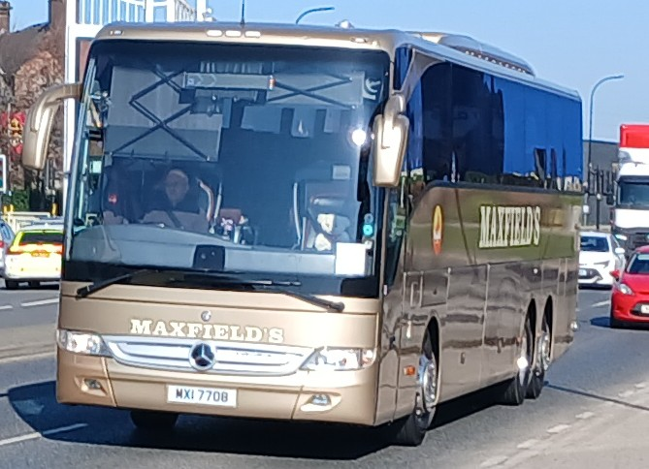
Photo credit to Barry Smith member of GB&CP; MXI7708 Mercedes Benz Tourismo in Sheffield
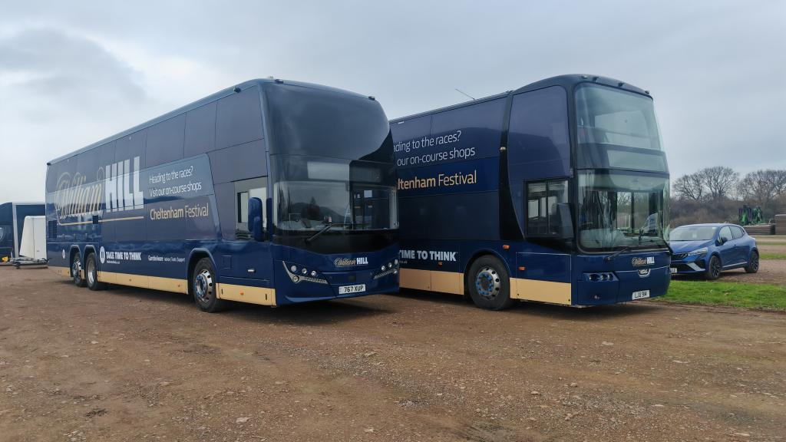
Photo credit to Andy Wilson Member of GB&CP; 767XUP & LJU914 William Hill betting coaches at Cheltenham Festival at Cheltenham racecourse.
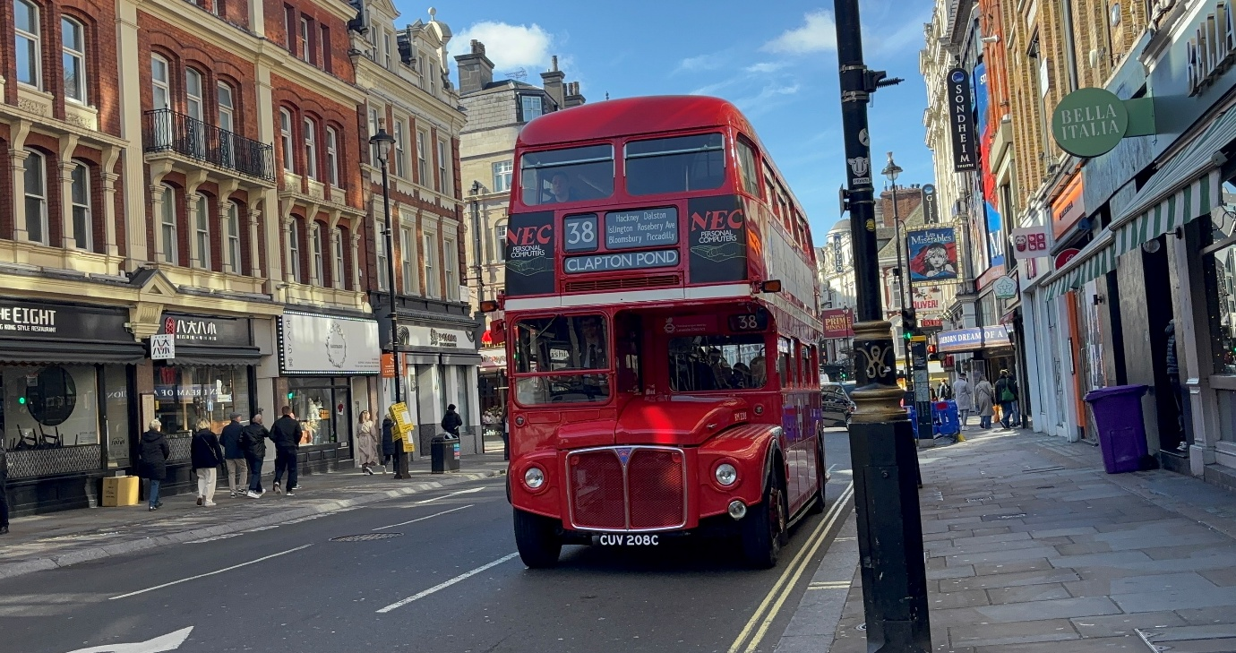
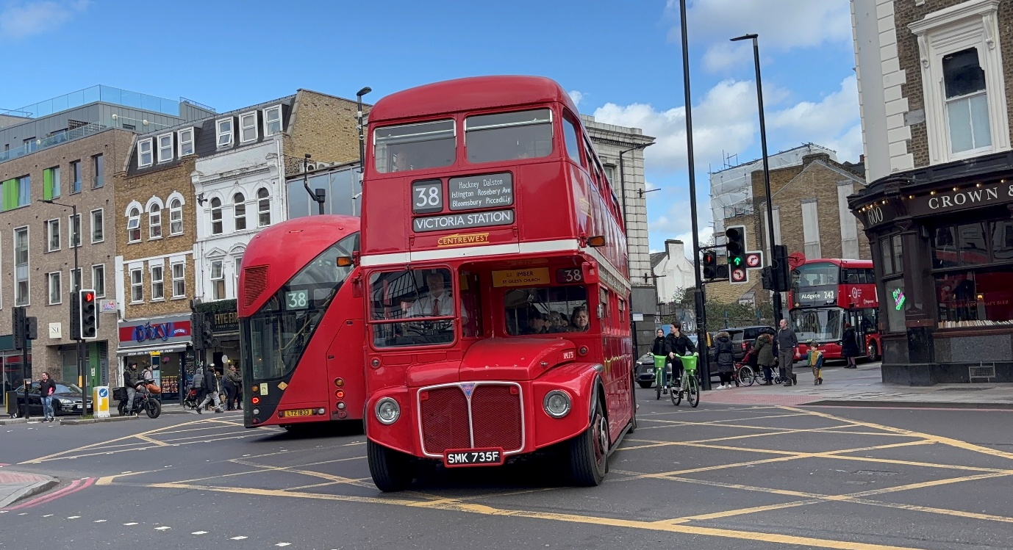
Photo Above: Photo credit to Robert Thompson on behalf of Theo Thompson members of GB&CP RM2208 CUV208C London Transport Routemaster on Route 38 heritage bus running day 2026.
Photo Below: Photo credit to Robert Thompson on behalf of Theo Thompson member of GB&CP; RM2735 SMK735F ex First Berkshire on the route 38 heritage bus running day 2026.
Both photos are taken are taken on the day of the route 38 heritage bus running day on Saturday 14th, March 2026. More photos from this person can be found via this link https://www.flickr.com/photos/199041540@N05
www.facebook.com/@garysbusandcoachphotos
www.facebook.com/groups/garysbusandcoachphotos
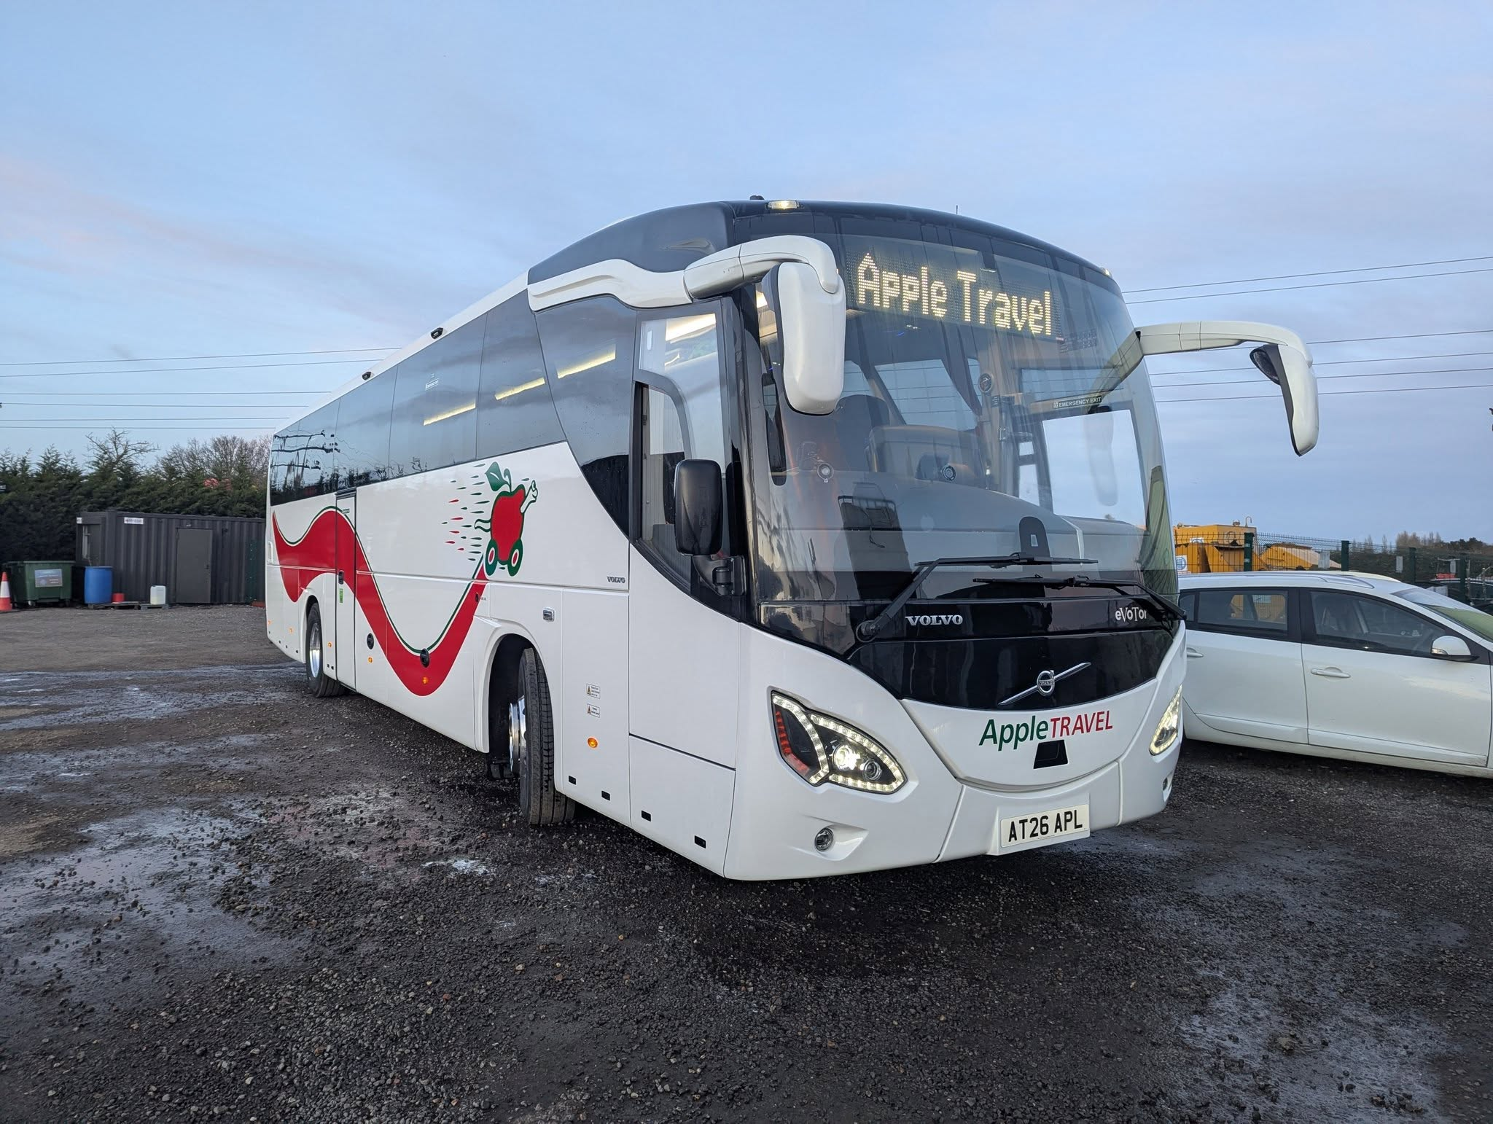
Photo credit to Gerwyn Cory member of GB&CP AT26APL Volvo Evotor new to Apple Travel.
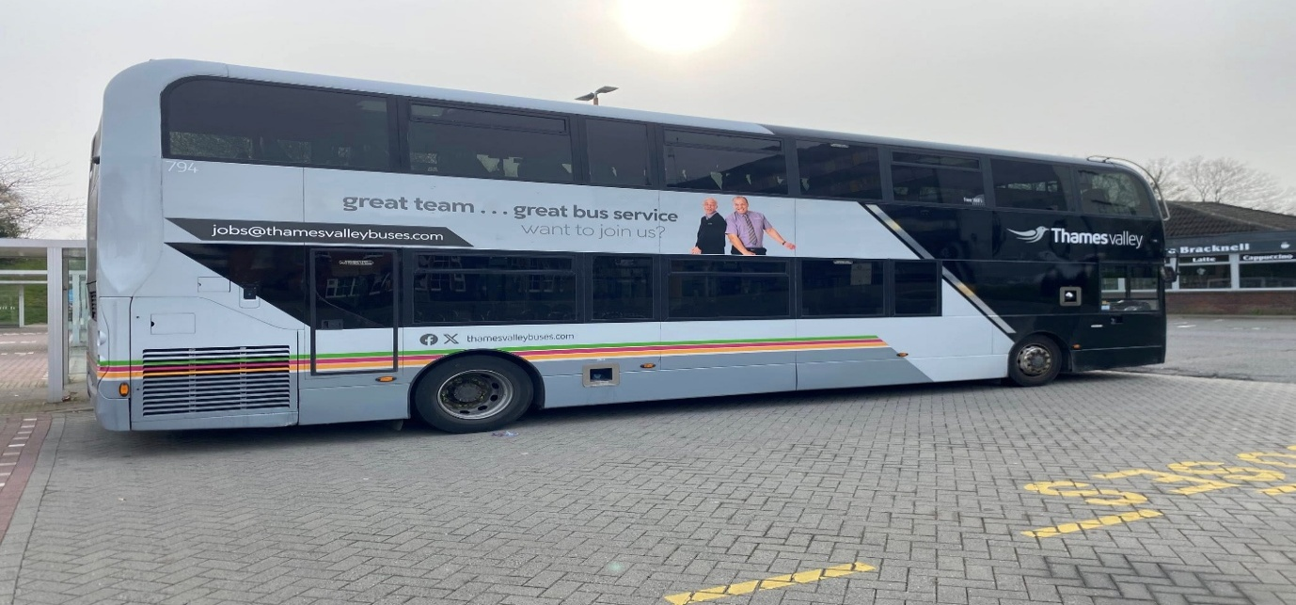
Photo credit to James Rayburn member of GB&CP TV794 SN16OHO ADL Enviro400mmc good company good service livery on route 703 to London Heathrow Airport.
www.facebook.com/@garysbusandcoachphotos
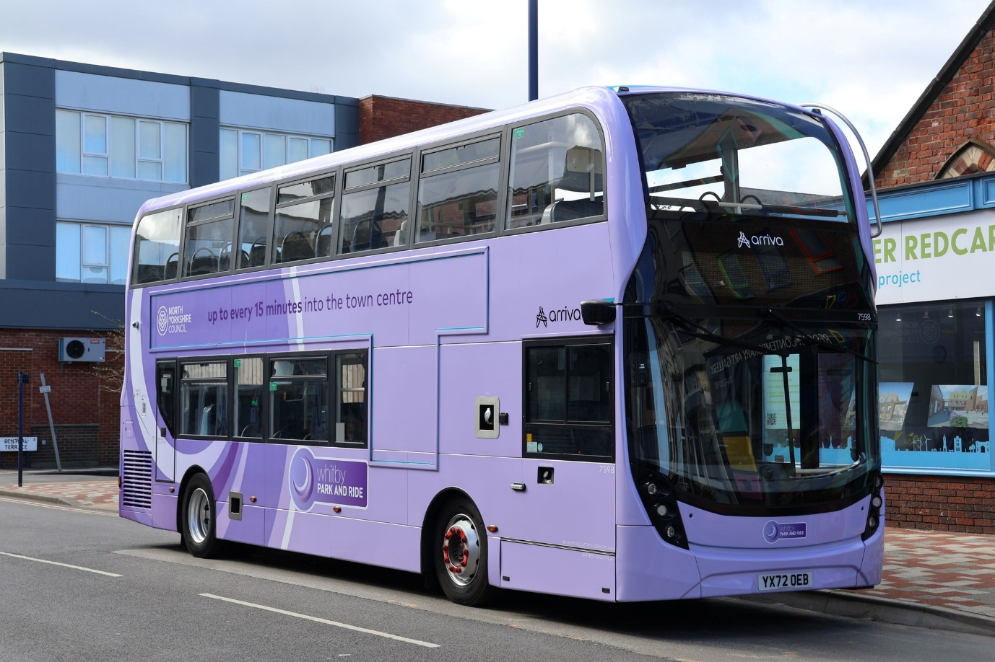
Photo credit to Lee Web member of GB&CP; 7598 YX72OEB ADL Enviro400mmc Arriva Northeast Whitby Redcar livered up in Whitby P&R livery.
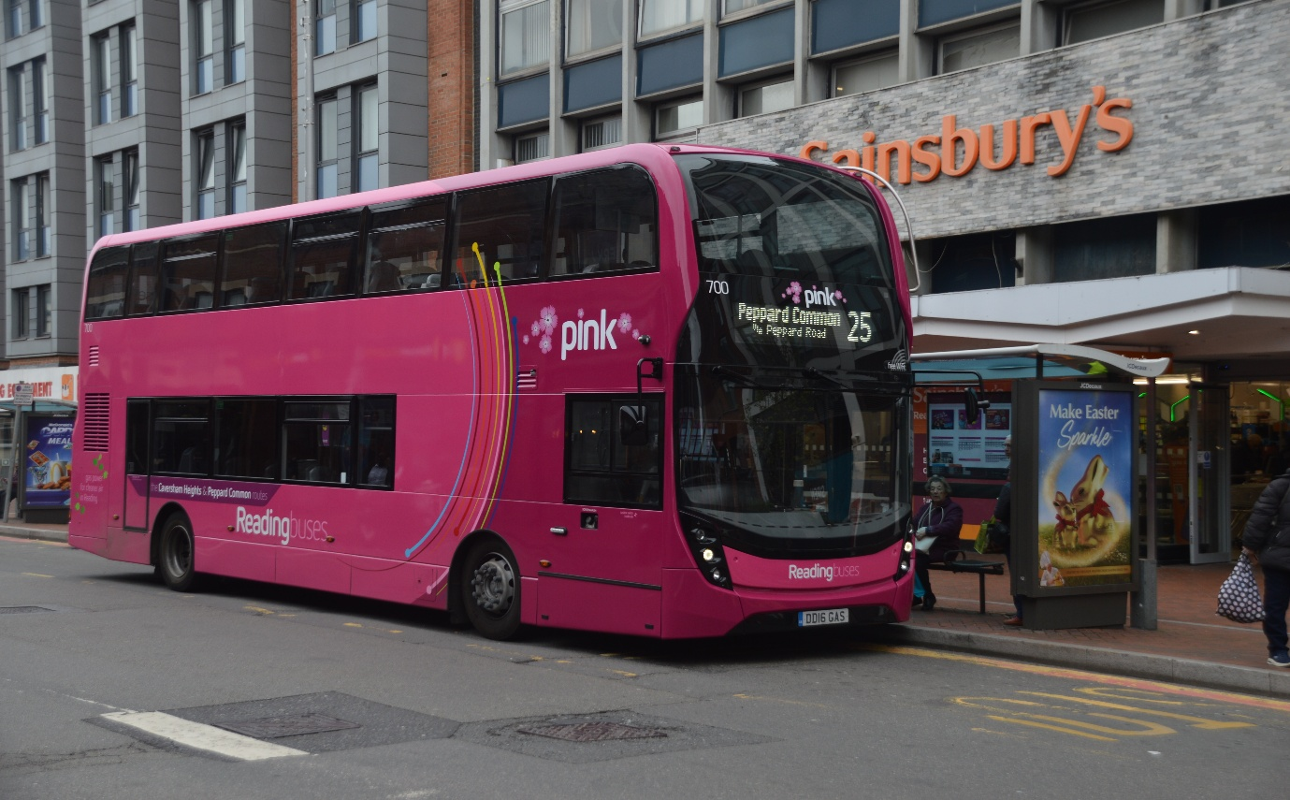
Photo credit to Gary Baxter Administration of GB&CP Reading buses 700 DD16GAS ADL Enviro400mmc in Pink livery.
Climate change buses
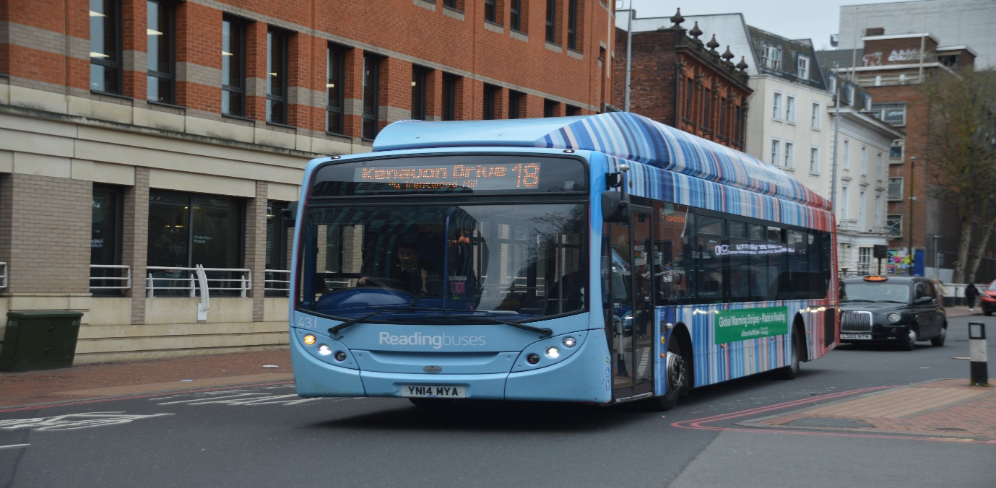
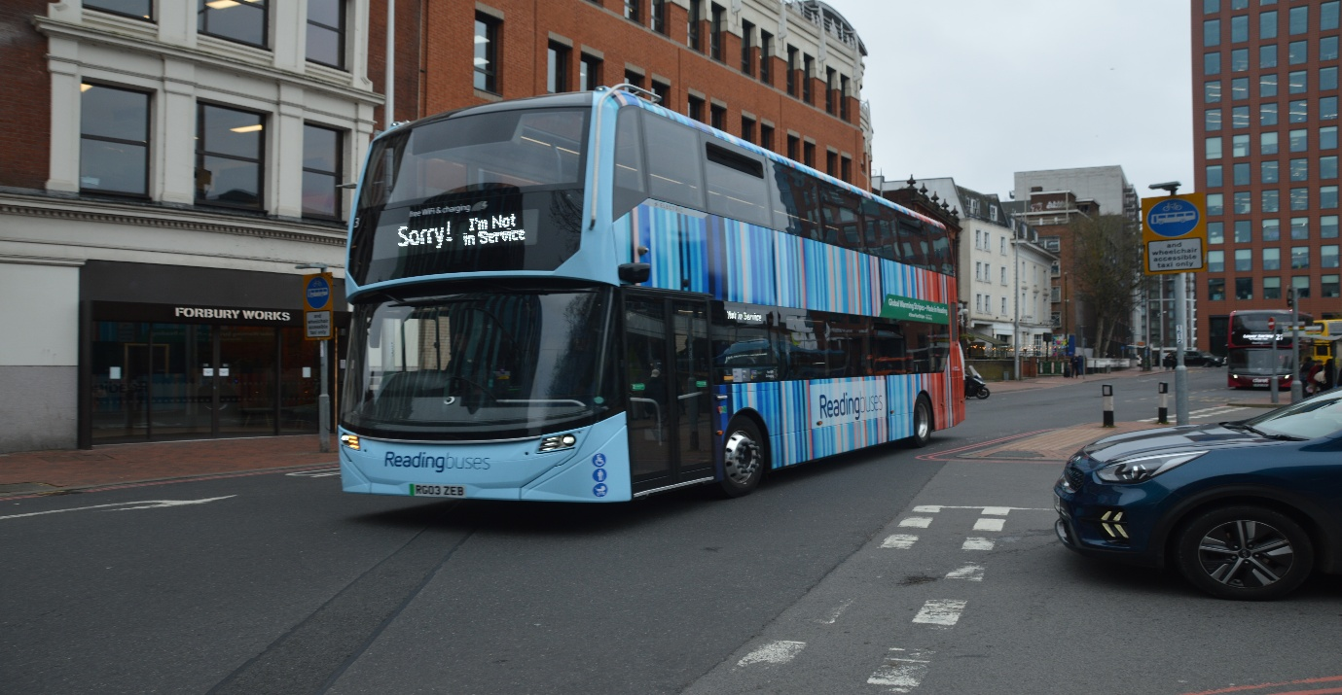
Photo above: Photo credit to Gary Baxter Administration of GB&CP Reading buses 431 YN14MYA ADL Enviro300SNG. Climate change livery on route 18 Kenavon Drive.
Photo below: Photo credit to Gary Baxter Administration of GB&CP Reading buses 3 RG03ZEB ADL Enviro400EV climate livery coming out of service.
The Londonline
The Londonline introduces three additional buses from London Victoria to Reading and Three from Reading. With six leaving Reading in the morning these times are 05:00, 05:15, 05:30, 06:25, 07:00 and 08:45 then 10:45, 12:35, and 14:05 timings from London for morning ones are has follow 07:45, 09:00, and 11:00. Timetables can be found at the local travel shops in Broad Street Reading or in Bracknell bus station or on the Londonline vehicles allocated for the route.
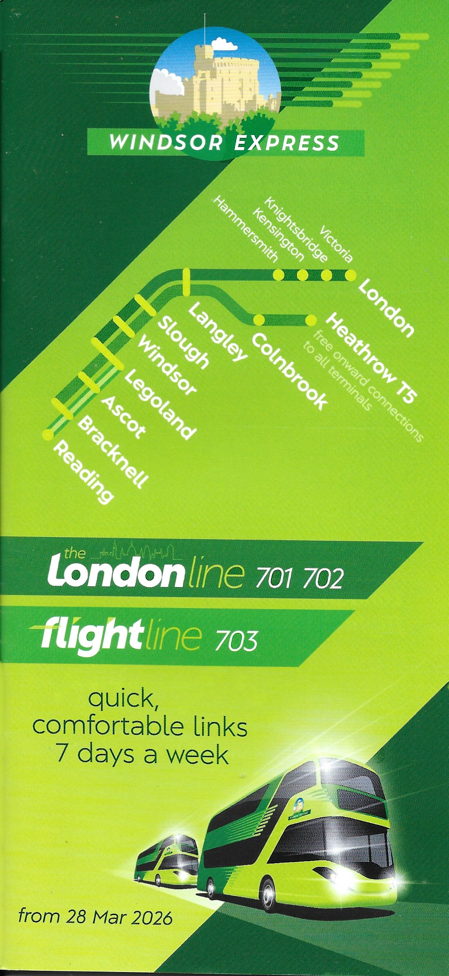
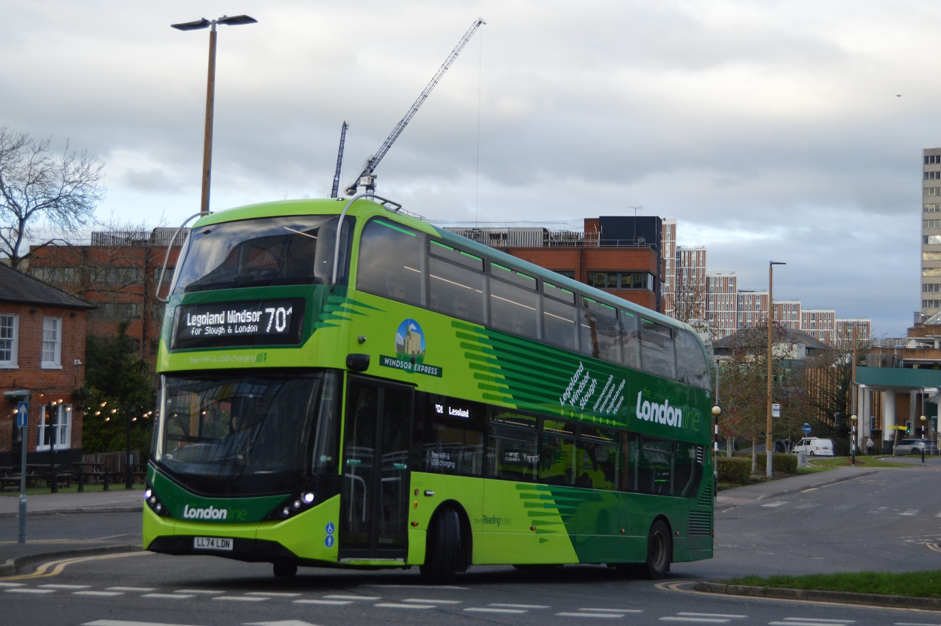
Photo credit to Gary Baxter Administration of GB&CP: LL745 LL74LHR ADL Enviro400city Reading buses The Londonline leaving Bracknell at 14:30 for Legoland / London Victoria.



