
Month: September 2026 Issue no: 99
This month we attended at the Friends of King Alfred buses heritage bus open day and running day in the city of Winchester. This was a good day for catching up with friends with similar interests and riding some heritage buses and coaches round the city of Winchester organised by the friends of King Alfred buses. More about this on page four.
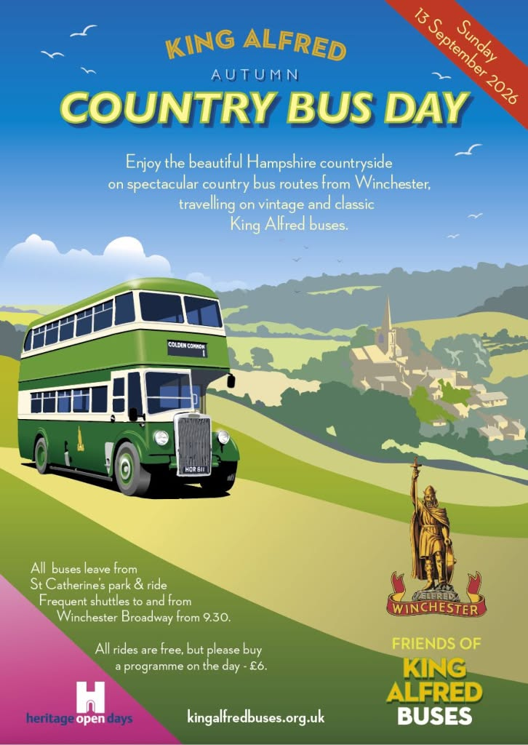

Photo Albums by Gary’s bus and coach photos
August / September 2026
Album Date | Album Name | Album link
13th September 2026 | Winchester friends of king Alfred buses heritage bus running day | https://flic.kr/s/aHBqjD4N9s
16th September 2026 | Reading Berkshire | https://flic.kr/s/aHBqjD5dNX
24th September 2026 | Camberley | https://flic.kr/s/aHBqjD5K4u
Photo of the month by Gary’s bus and coach photos
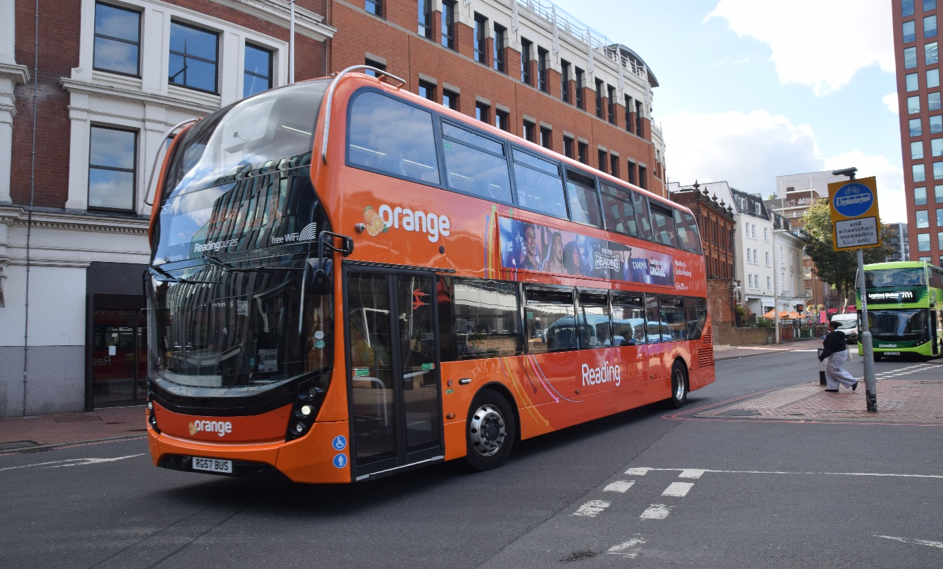
Photo credit to Gary Baxter Administration of Gary's bus and coach photos Reading buses 757 RG57BUS recently branded Orange 13-14 for Woodley photo of the month for September 2026 Album here https://flic.kr/s/aHBqjD5dNX
www.garysbusandcoachphotos.co.uk
www.facebook.com/garysbusandcoachphotos
Events
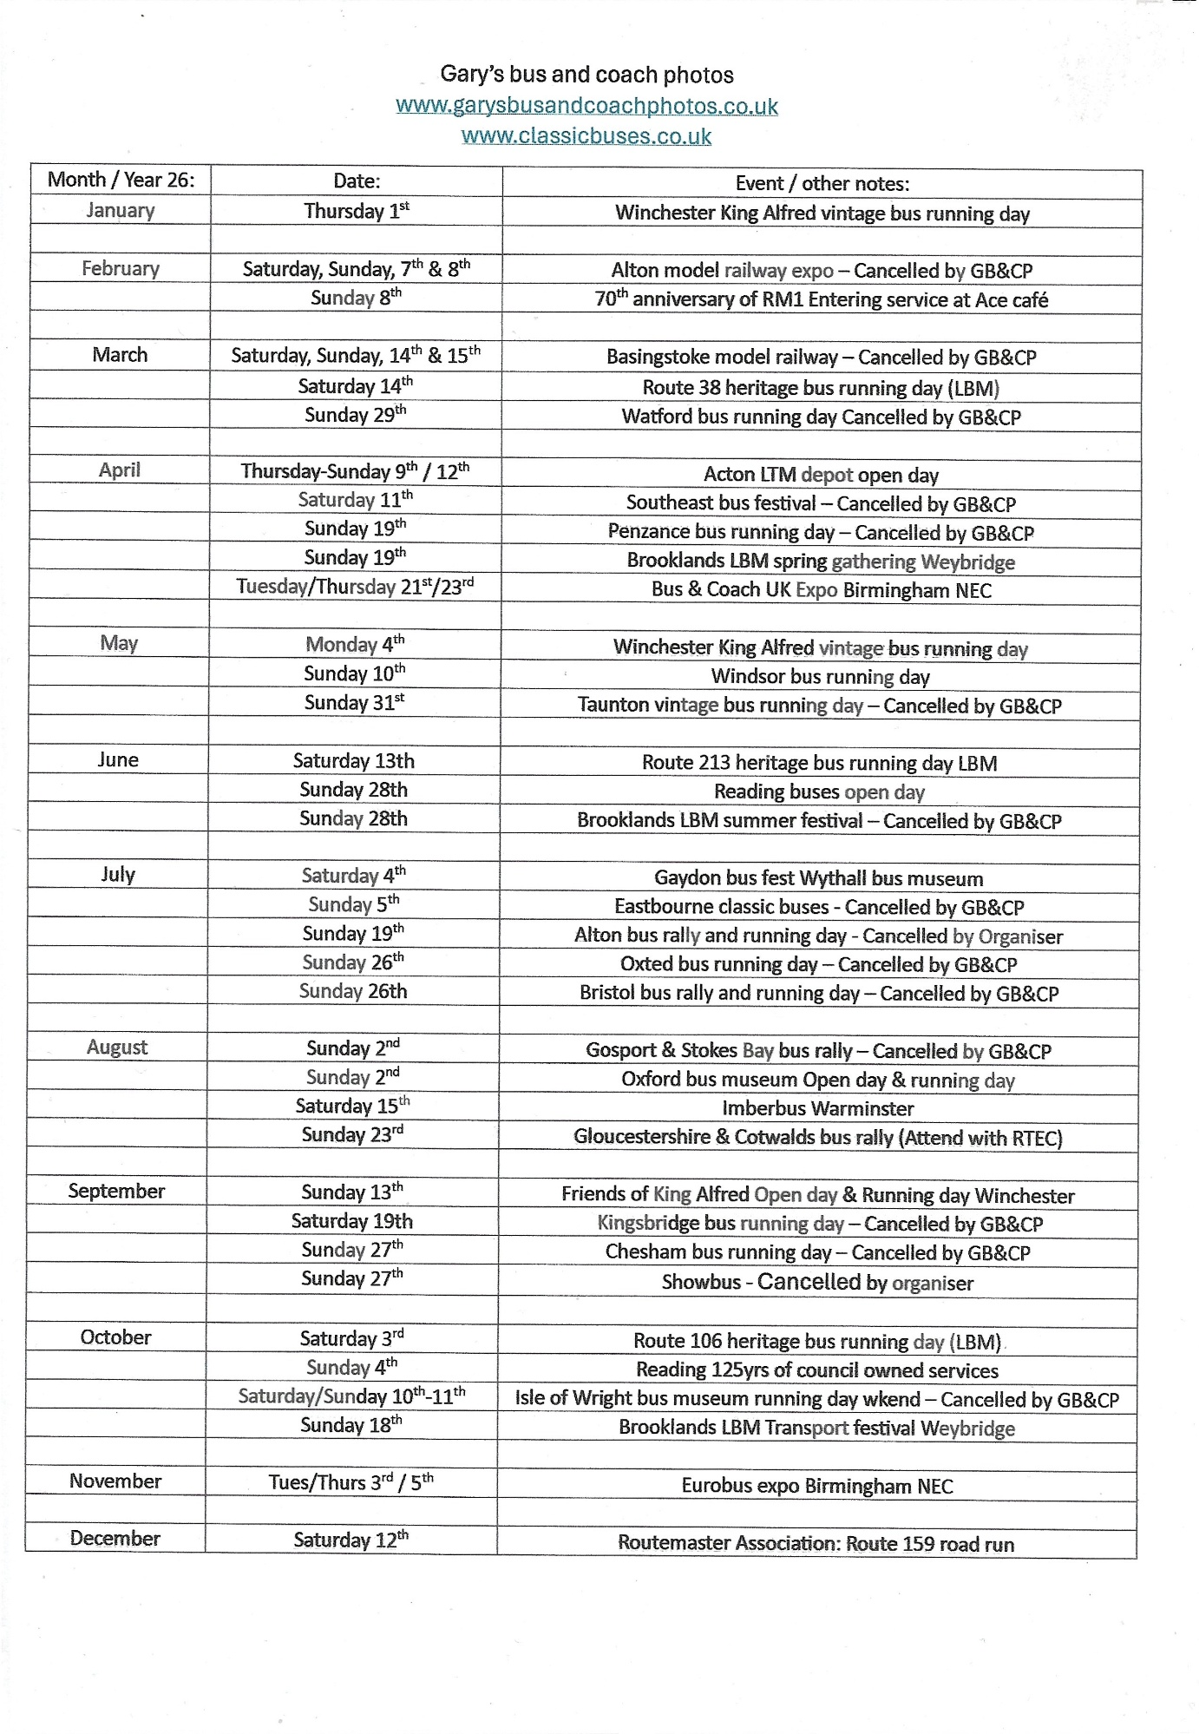
About events
Winchester & The friends of King Alfred buses heritage bus running day
We attended at the Winchester friends of King Alfred buses heritage bus running day on the 13th, September 2026 with our good friends Tim Wild and Steve we travelled to the event by car which was good has we parked at the St ’Catherine’s Park and ride in Winchester. The day was met with rain and sunshine, and a little bit of overheating has it was warm with overcast weather. We enjoyed some good rides round the city from the St ‘Catherine’s P&R to all the different destinations on offer for this event. This event was called buses in the countryside, and it sure did offer that photo album and video found at www.garysbusandcoachphotos.co.uk/socialmedia and clicking on the YouTube and Flickr link or via these links https://flic.kr/s/aHBqjD4N9s https://youtu.be/nm6HJ3pqmpQ?si=HsWgxMKW1Nv1Tm61
Chesham bus running day
We was meant to be attending at the Chesham bus running day on the 27th, September 2026 this day would have been a good for some lovely rides from Chesham to all the different locations on the programme for the day. We would have had a good time spending time with friends and catching up with them. Unfortunately, we did not go along to this event due to other problems. Video and photo album link here by Theo Thompson https://flic.kr/s/aHBqjD67Ha https://youtu.be/Izyt34WW48g?si=x9REa9fMSDOfc4bd or www.garysbusandcoachphotos.co.uk
Reading Transport Group of Companies
Last month it was reported that ADL Enviro400mmc’s would replace Streetdecks in Reading and this has happened bus fleet number 752-57 have replaced the Streetdecks from Wrightbus at the same time 752-57 got registered RG52/57BUS. Has well as 23-25 ADL Enviro400EV’s being branded up for Emerald 5&6
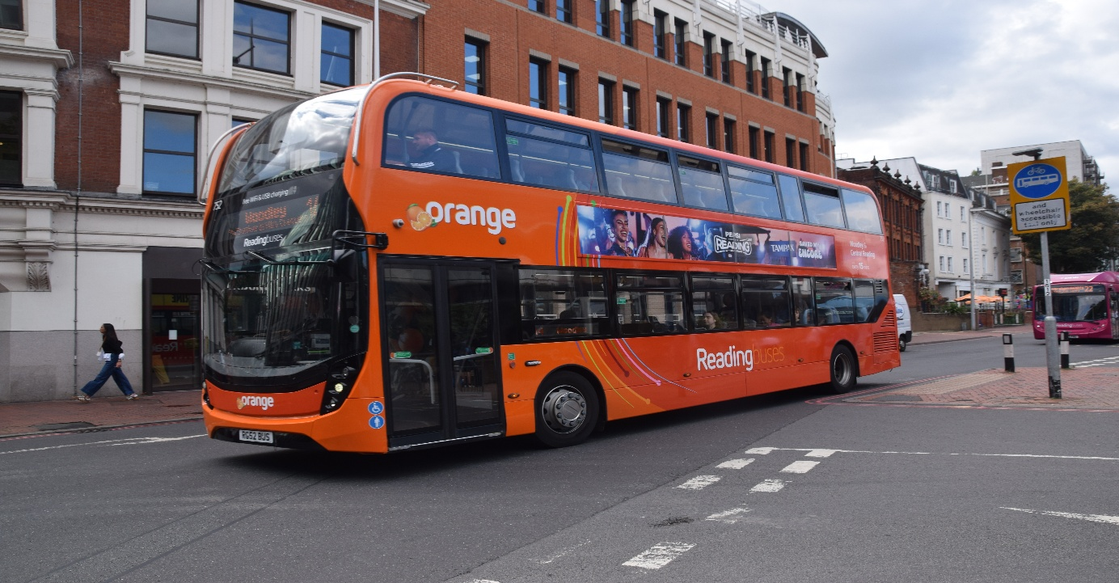
Photo credit to Gary Baxter Administrator of Gary’s bus and coach photos: Reading buses 752 RG52BUS Adl Enviro400mmc branded orange 13/14 for Woodley replacing Streetdecks 901/06 has 901 was damaged and unrepairable.
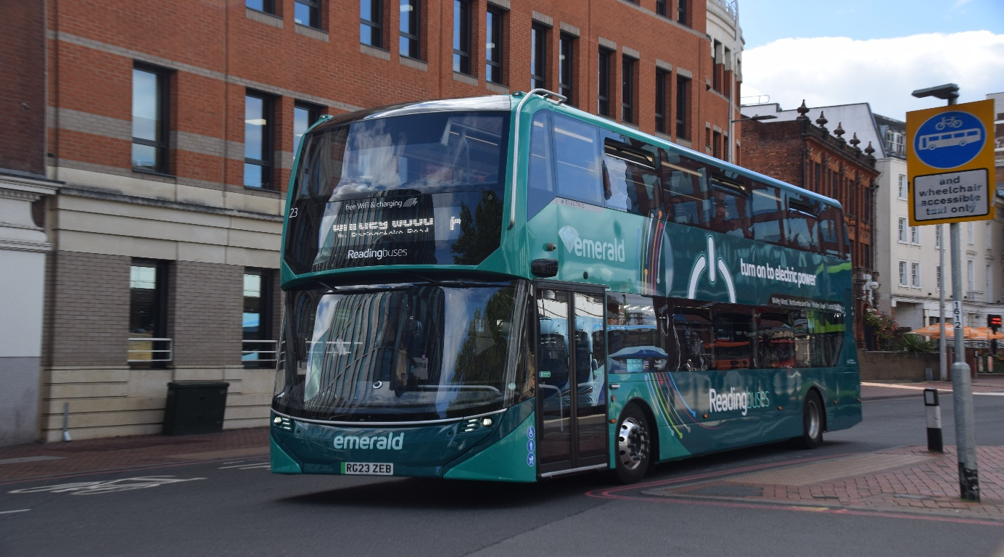
Photo credit to Gary Baxter Administrator of Gary’s bus and coach photos: Reading buses 23 RG23ZEB ADL Enviro400EV in Emerald livery in Reading Berkshire.
Newbury & District
New Scania Irizar I4’s have arrived at the N&D depot in Greenham these are fleet numbered 1433/1434 YT76AOX/OY.
Thames Valley in July or August saw the withdrawal of vehicles 688/89 YX71OJA/B from the fleet has route 20 to high Wycombe from Maidenhead so the Windsor and Maidenhead branded buses have replaced these for the time being fleet numbered from 690/96 but it is believed to be getting more buses for route 704 with a small language rack but when that will happen has not yet been announced.
Facebook group member photos
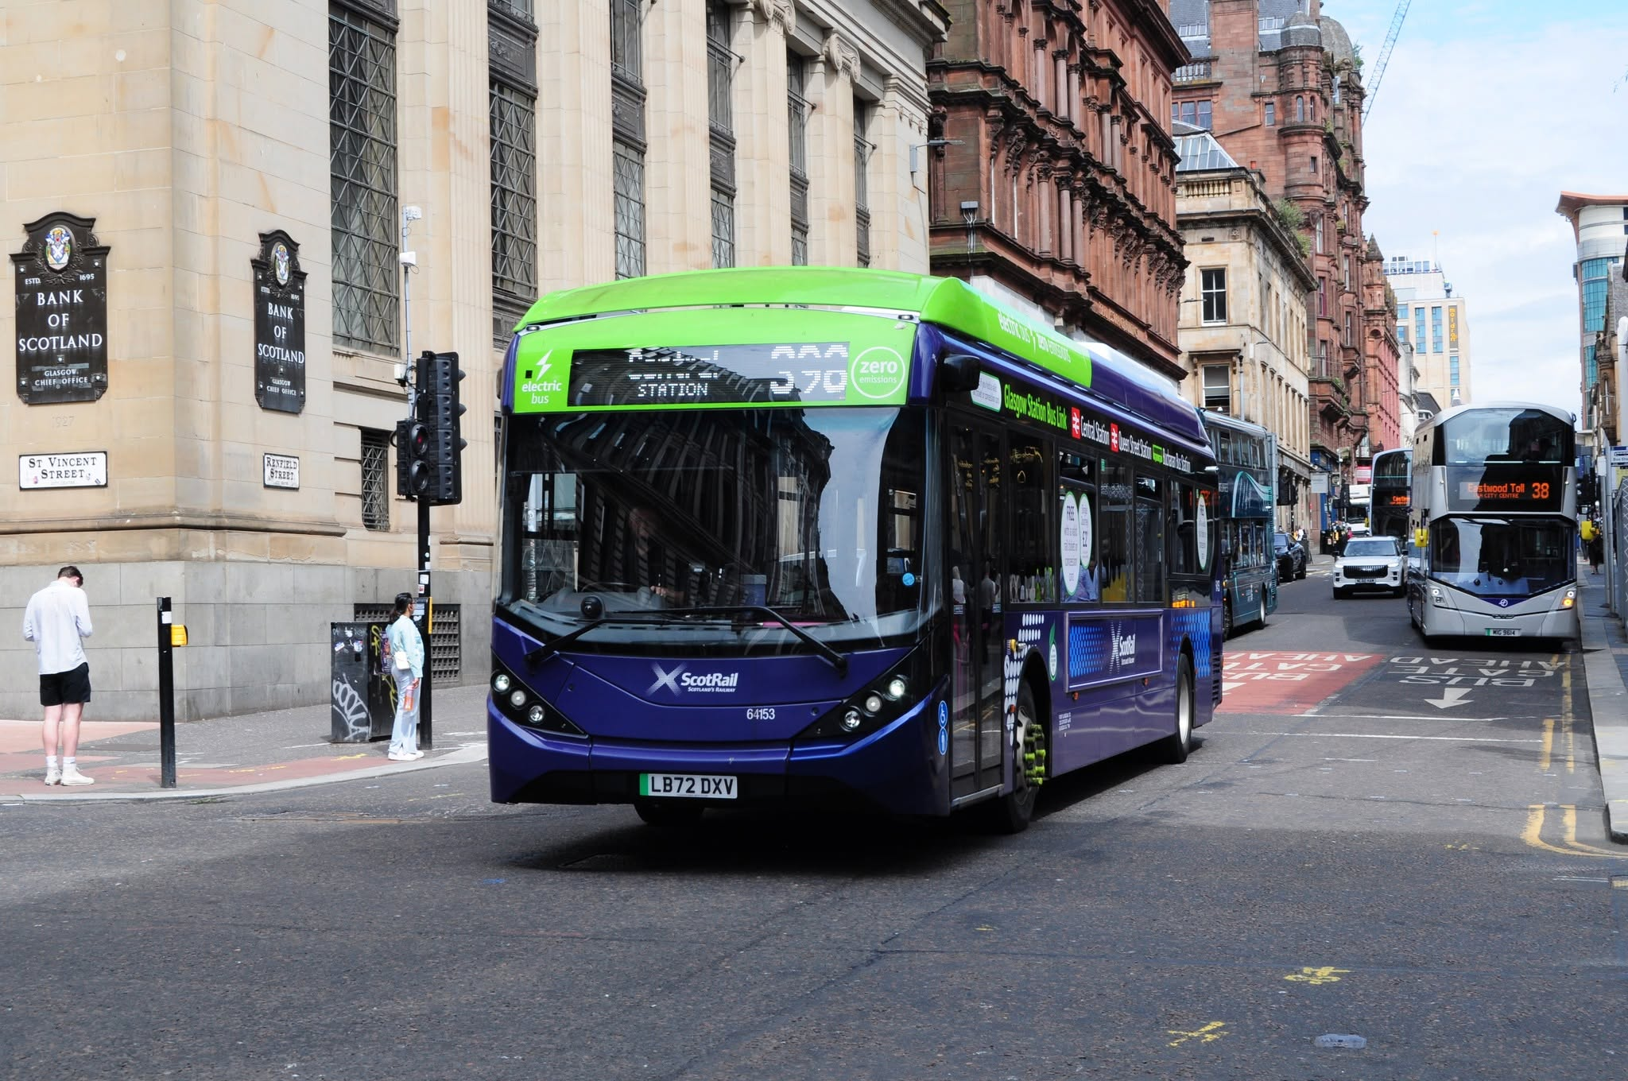
Photo credit to Anthony Moore member of Gary’s bus and coach photos: First Greater Glasgow 64153 LB72DXV on the 398 Scotrail Station link to Central Station.
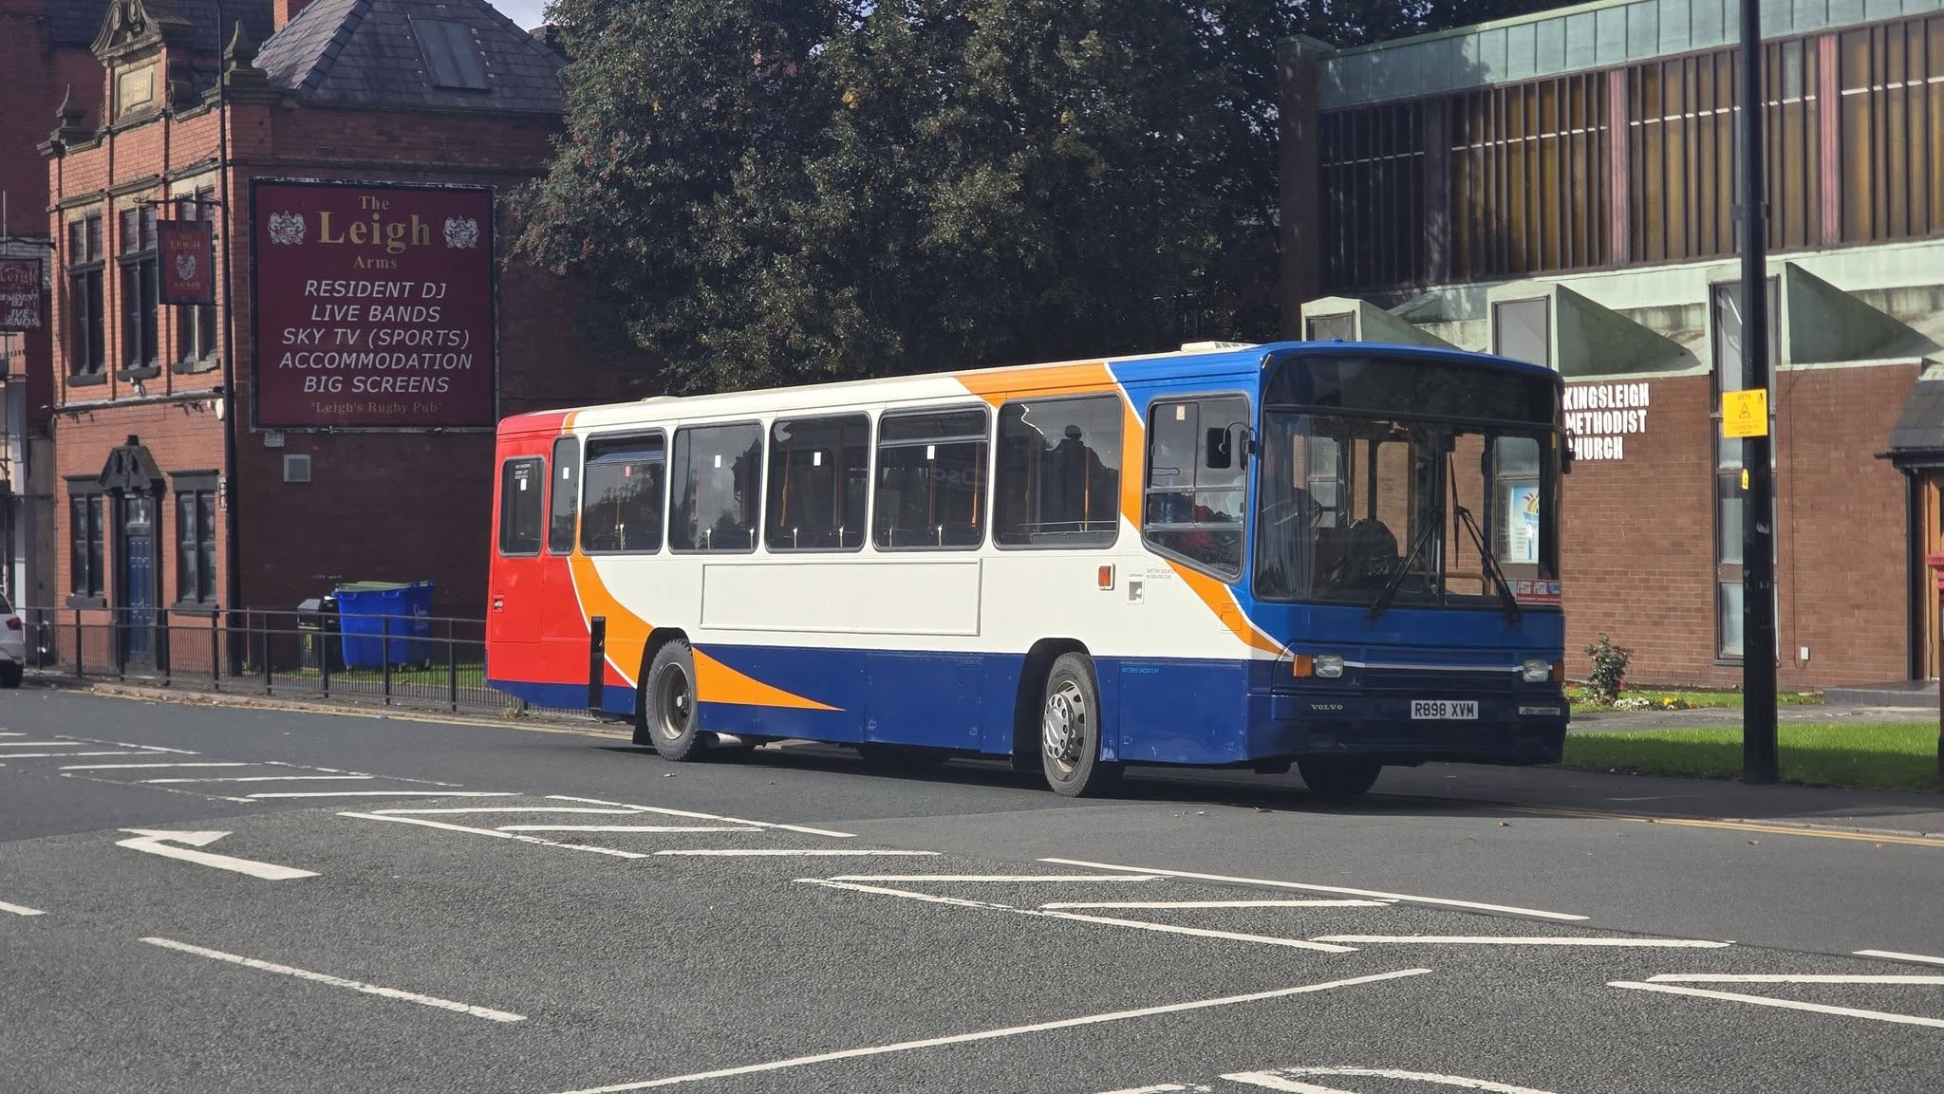Photo credit to Anthony Moore member of Gary’s bus and coach photos: R898XVM Volvo B10M Alexander PS ex Stagecoach Manchester now preserved privately.
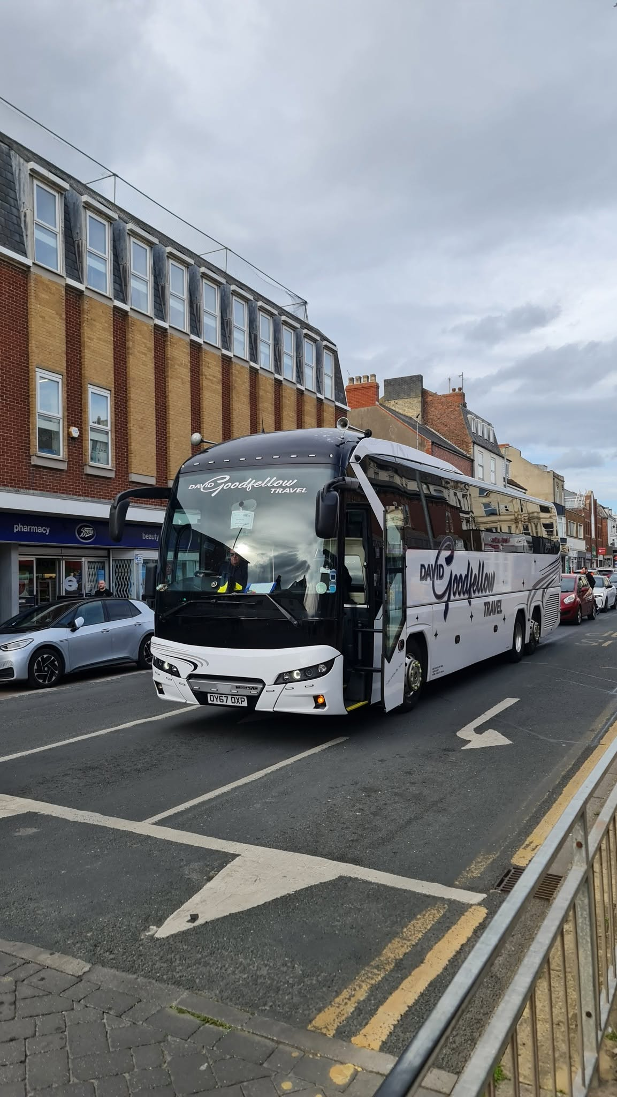
Photo credit to Shaun Maddocks (New) member of Gary’s bus and coach photos: David Goodfellow Travel - Neoplan Tourliner N2216 3SHDC OY67 DXP on Promenade Bridlington 19.09.26
Flickr Friends
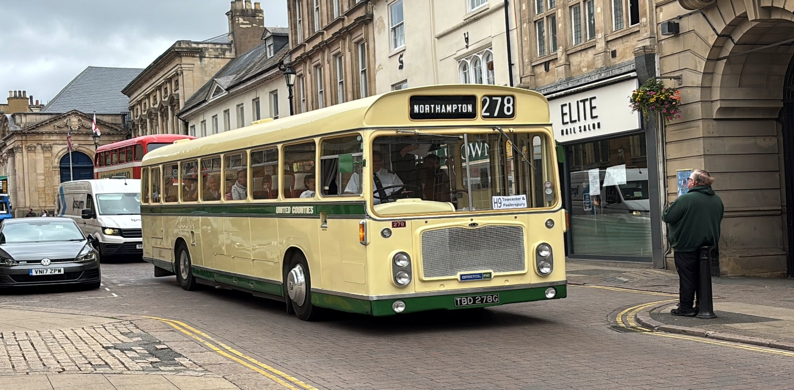
Theo Thompson member and friend of Gary's bus and coach photos United Counties 278 TBD278G Bristol RE This was taking part in the 2026 Northampton Heritage Open Day and was operating bus tours from George Row. It’s now departing on route H9 to Towcester & Paulers Pury.
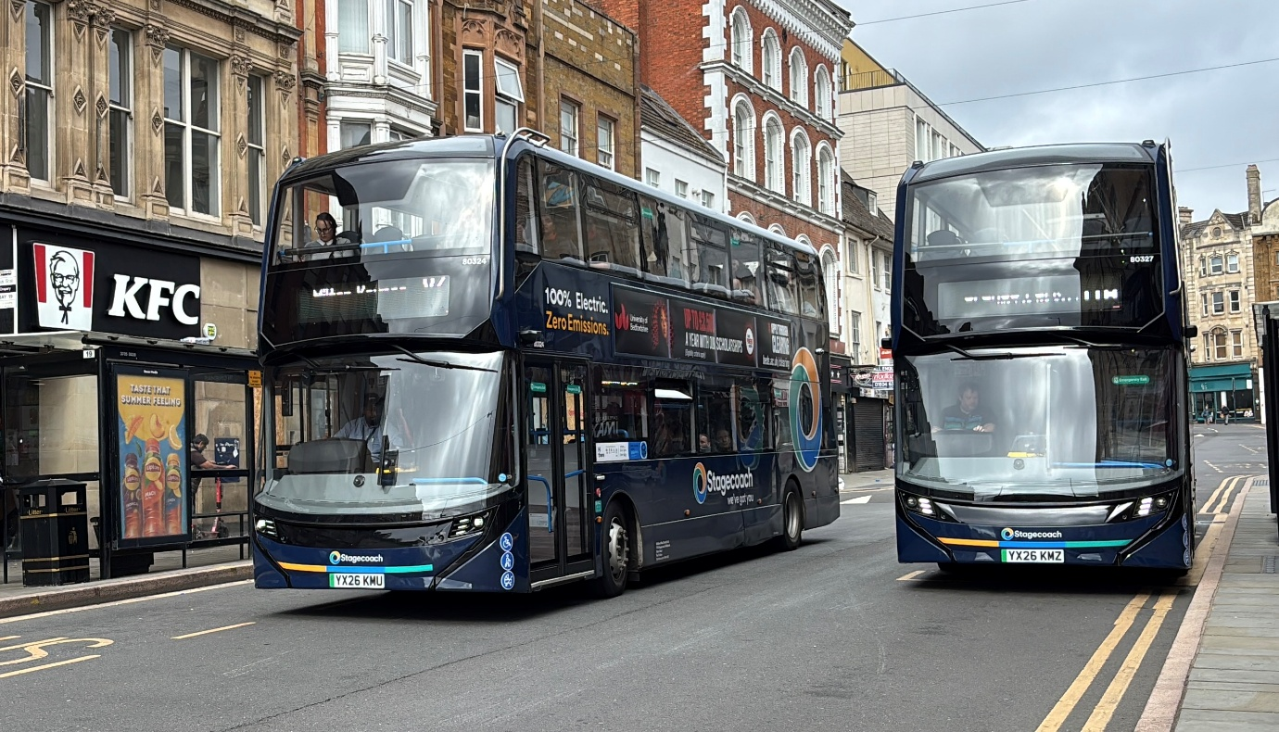
Theo Thomspon member and friend of Gary's bus and coach photos Stagecoach Midlands 80324 YX26KMU & 80327 YX26KMZ ADL Enviro400EV's
Theo’s Flickr
https://www.flickr.com/photos/199041540@N05
www.garysbusandcoachphotos.co.uk
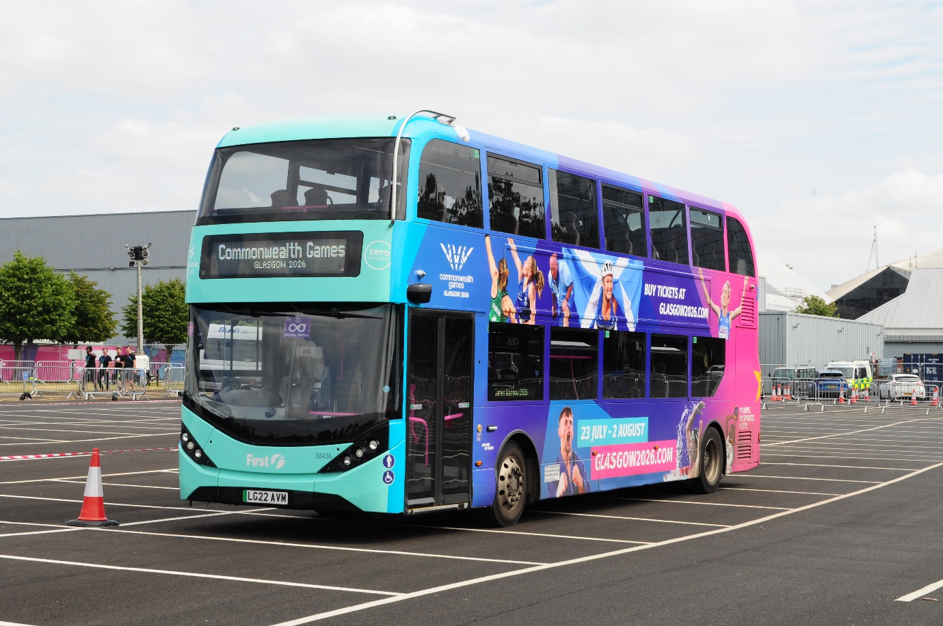
Anthony Moore member and friend of Gary's bus and coach photos 38436 LG22AVM ADL Enviro400city in Commonwealth games livery.
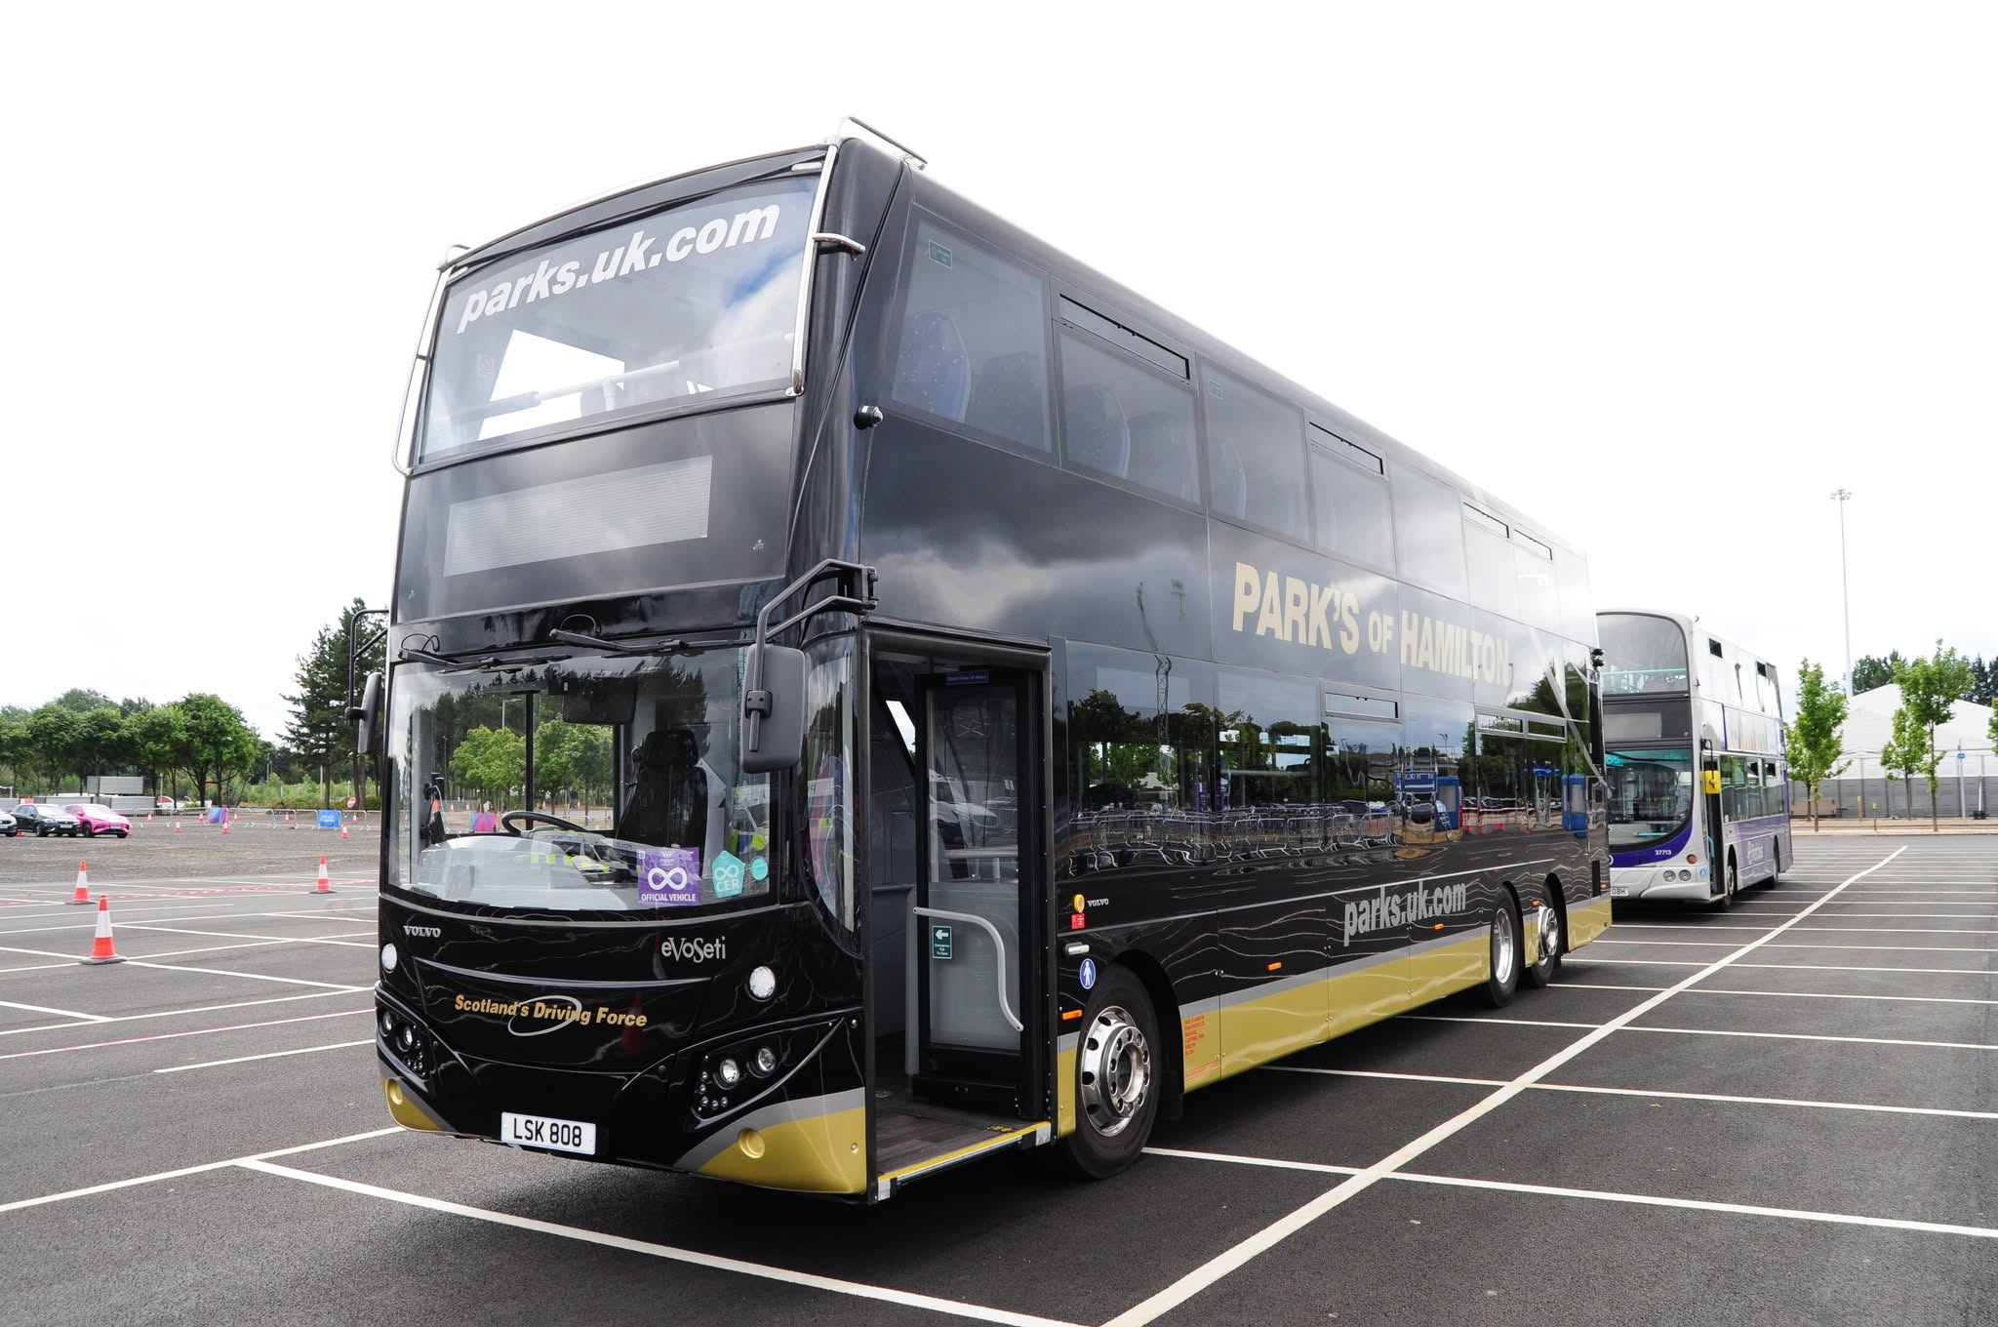
Anthony Moore member and friend of Gary's bus and coach photos: LSK808 Parks of Hamilton on Commonwealth Games Shuttles in Glasgow.
https://www.flickr.com/photos/92612526@N06/
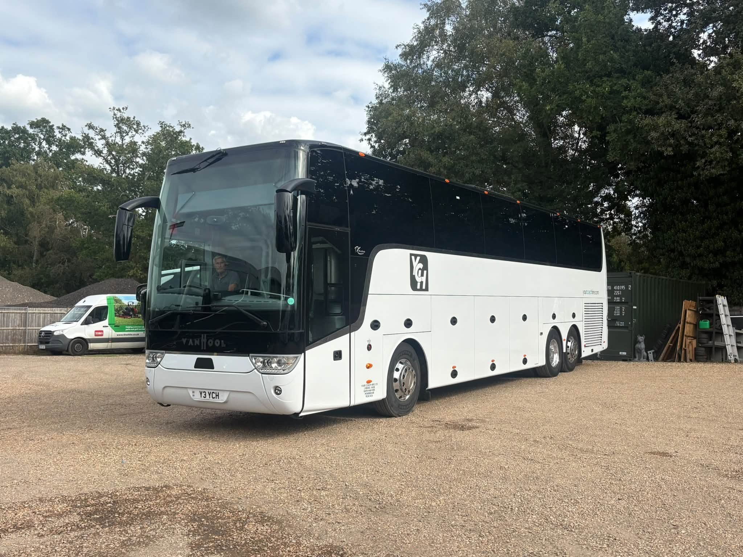
Photo credit to Gavin Rutter member and friend of Gary's bus and coach photos Y3YCH Vanhool coach Yourcoachhire Finchampstead Wokingham.
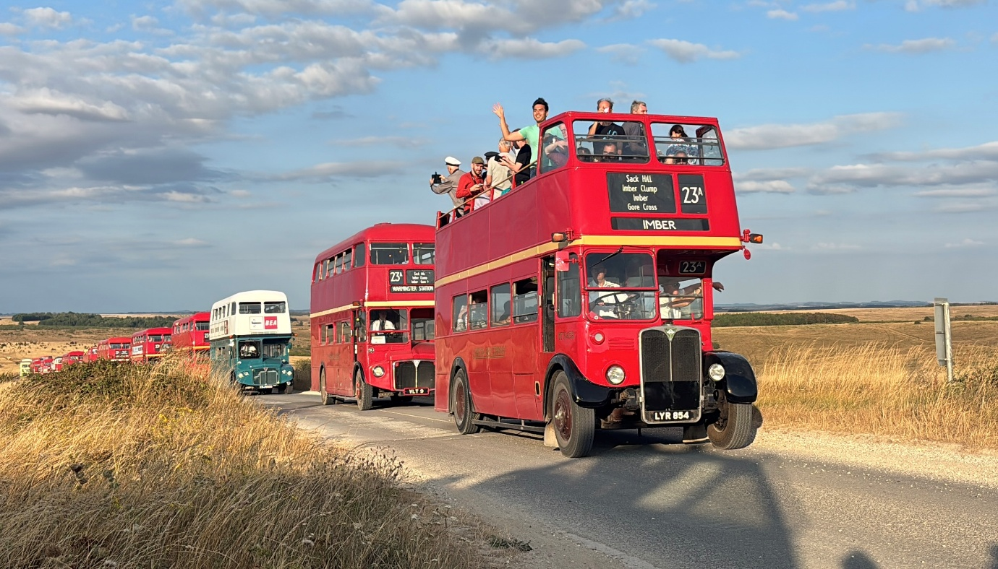
Photo credit to Theo Thompson. friend and member of Gary's bus and coach photos Imberbus cavalcade August 2026.
Reading transport established on 31st, October 1901. Celebrating a 125years of public service on the 4th, October 2026 in Broad Street with an estimated fifty to hundred buses in attendance for this event. Reading transport started life on Mill Lane before moving to Great Knollys Street to make way for the oracle shopping centre in 1998. This event will see displays of buses and coaches in Broad Street along with some doing runs on different routes around the local area. The event is being organised jointly with the Thames Valley and great western omnibus trust and Reading Transport / Reading buses to celebrate this big milestone in history.
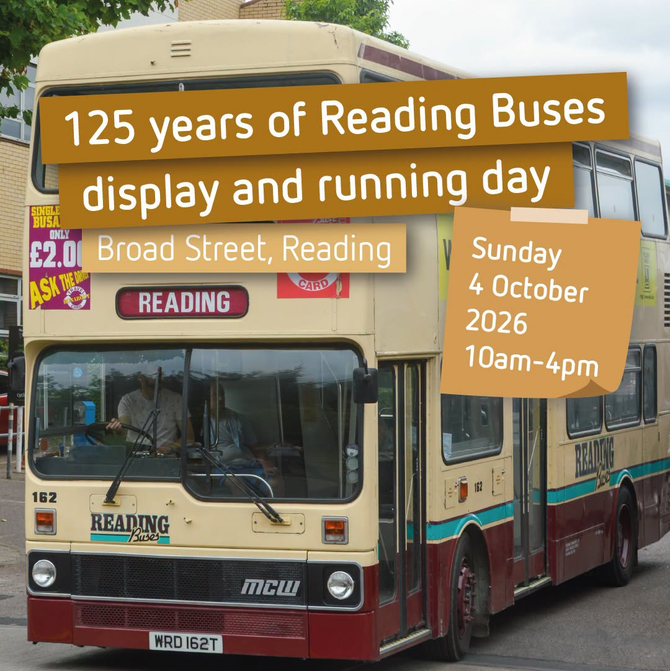
Stagecoach
The Stagecoach Electric buses have finally made the appearance on routes in Aldershot, Camberley and Guildford. This electric vehicle being built by the Chinese firm Yutong. The buses have been branded up in the new Stagecoach livery with a beach ball on the rear of the bus.
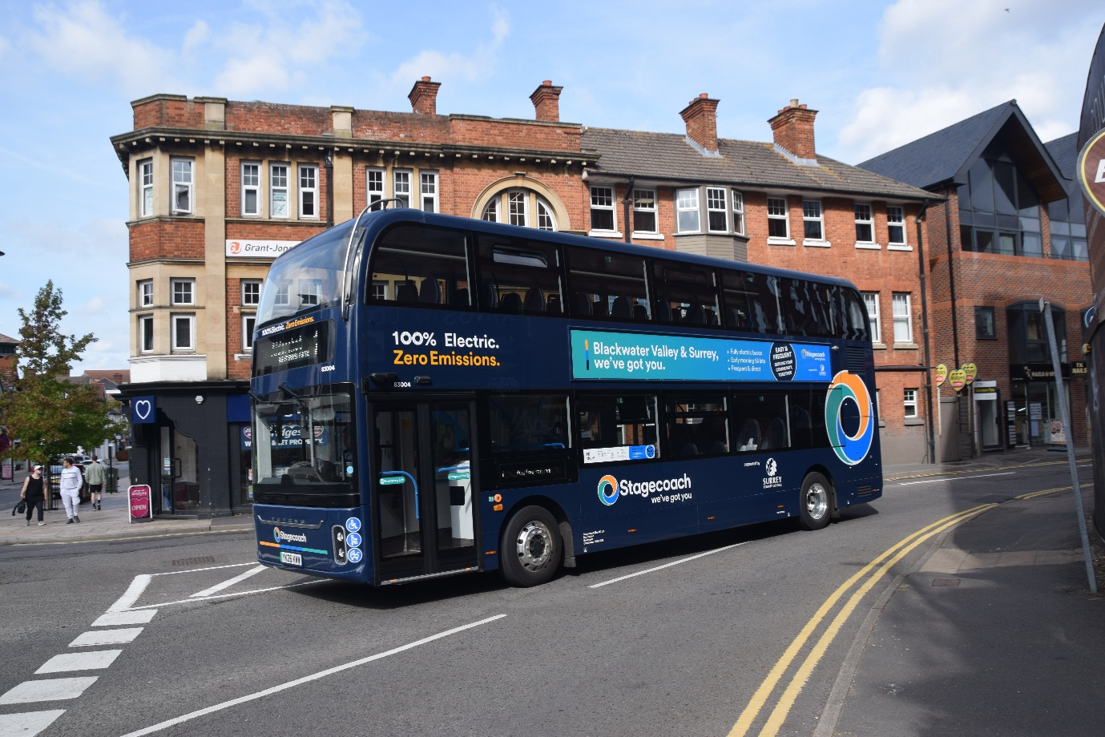
Photo credit to Gary Baxter Administration of Gary’s bus and coach photos: Stagecoach South Aldershot 83004 YK26KWW photographed in Camberley on route 1 back to Aldershot.
Stagecoach south Aldershot have twenty-two of these Yutong U11D’s in operations these operate on routes 1 and 20. Aldershot Camberley Old Dean and Aldershot Guildford.
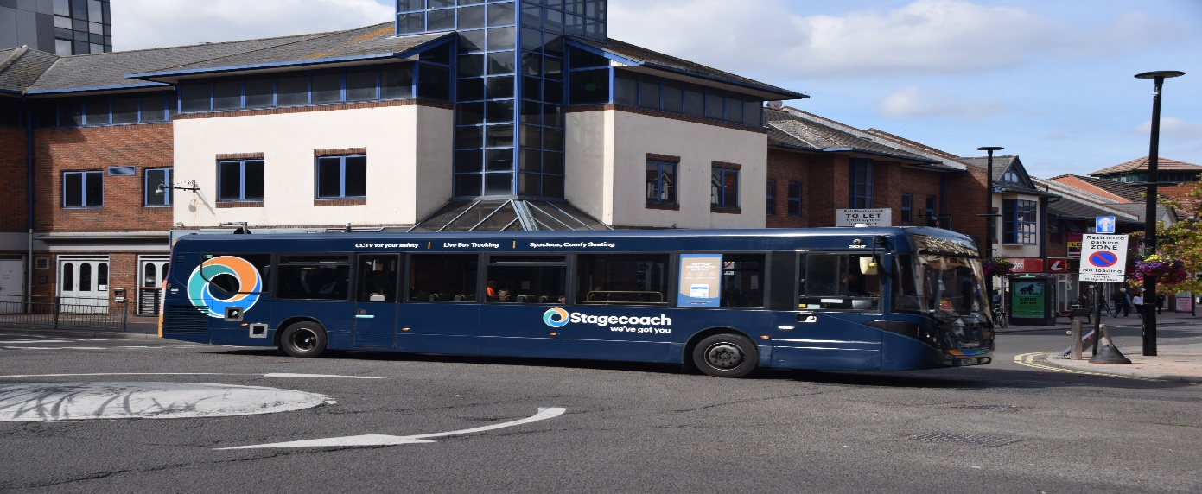
Photo credit to Gary Baxter Administrator of Gary’s bus and coach photos: 26217 SN67XCK ADL Enviro200mmc in New Stagecoach branding.

