
Month: April 2026 Issue No: 94
This month we have attended some excellent events the first event we attended was the Acton Depot museum in Acton and we attended with Robert and Theo Thompson his son it was a lovely day, and the museum had a lot to offer in the way of Exhibitions more about this on page four. This month we also attended the Spring gathering organised by the London bus museum in Weybridge it was a good day and Reading Transport / Reading buses put on a good display of vehicles from Preservation to previous vehicles to photograph them all leaving together was excellent more about this on page four. We attended our first exhibition in Birmingham this year for Coach and bus Expo or something along the lines mixed in with other exhibited of Lorries and other forms of Transportation more about this on page four.
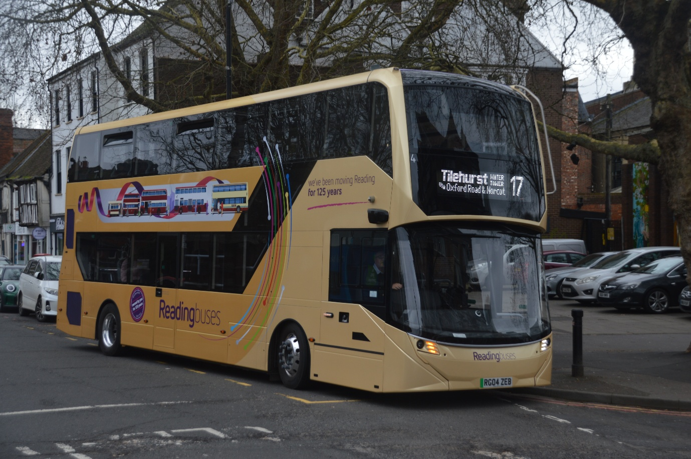
Photo credit to Gary Baxter Administration of GB&CP: Reading buses 4 RG04ZEB ADL Enviro400EV one of the displays at Brooklands Weybridge Spring gathering organised by the London bus museum. To commemorate hundred and twenty-five years of council service in Berkshire. This is photographed on the backbone of Reading route seventeen to Tilehurst Water Tower / Wokingham Road Three tuns.

Date of Album | Album Name | Album link
7th April | LHR & Maidenhead | https://flic.kr/s/aHBqjCQrdw
8th April | Bracknell & Reading | https://flic.kr/s/aHBqjCQrpU
11th April | Acton Museum depot & Acton | https://flic.kr/s/aHBqjCQKRY
19th April | Brooklands LBM Spring gathering | https://flic.kr/s/aHBqjCRqEw
21st April | Birmingham NEC bus and coach Expo | https://flic.kr/s/aHBqjCRDXm
Photo of the month
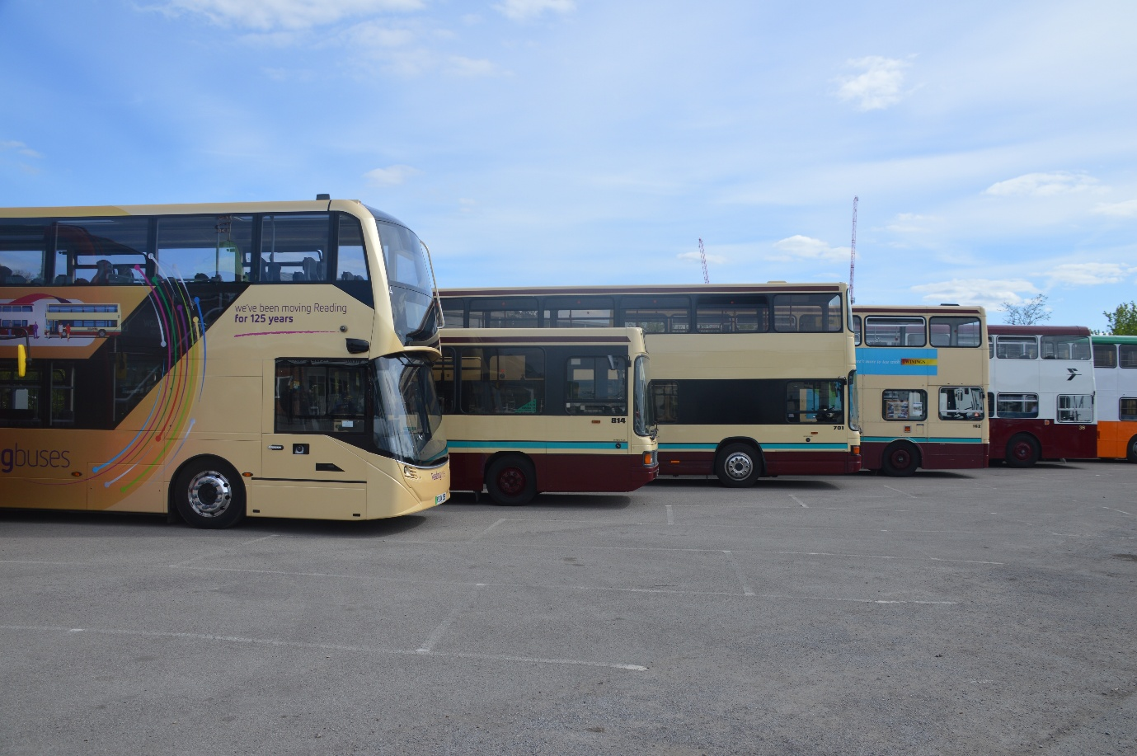
Photo credit to Gary Baxter Administration of GB&CP 38 NDP38R 162 WRD162T 701 MRD1R 814 M957VWY and 4 RG04ZEB reading transport 125yrs line up at Brooklands April 2026 photo of the month for April 26 more photos from this day found here https://flic.kr/s/aHBqjCRqEw or by going to www.flickr.com/photos/garysbusandcoachphotos.
www.facebook.com/garysbusandcoachphotos
Events
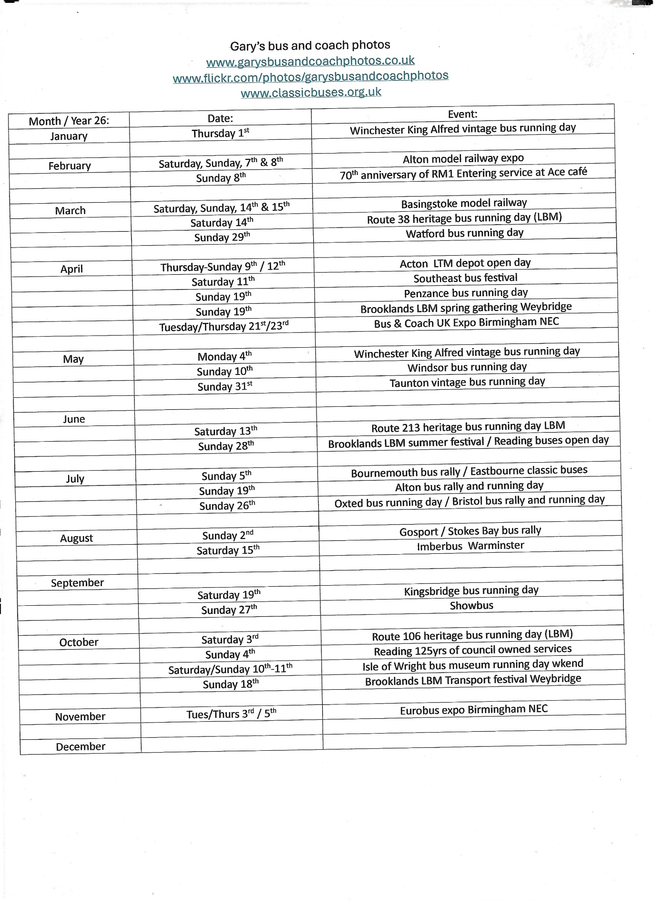

London Transport Museum – Museum Depot Acton Town
We attended at the Museum depot in Acton town on the 11th, April 2026 and this day was good it was good spending time with Robert and Theo Thompson his son at the museum in Acton. The Museum depot was a lovely day with some nice exhibits some has last year but this time managed to get video footage and photos to post from the actual day links to these here https://flic.kr/s/aHBqjCQKRY https://youtu.be/Te_N8OHd7ao?si=i7YUP5xf6u5YPbkG or on our website at www.garysbusandcoachphotos.co.uk
London Bus museum Spring gathering Brooklands Weybridge
We attended the London bus museum spring gathering in Brooklands Weybridge on the 19th, April 2026 again this was another well organised event by the London bus museum the day was nice and met with some nice weather it was good to spend time with friends and to photograph all the buses and coaches in attendance at this event it was good to see a lovely display of Reading Transport / Reading buses vehicles to commemorate hundred twenty-five years of council ownership. Photo album link and video link here https://flic.kr/s/aHBqjCRqEw https://youtu.be/Zw3_E4ocHVQ also available from our website at www.garysbusandcoachphotos.co.uk
Birmingham bus and coach exhibition
We attended our first exhibition this year in Birmingham this event was a good opportunity to mix with fallow enthusiast / fallow people in the same industry has you for you to promote yourself and what you do and what you have to offer fallow people the event had a nice display of vehicles for you to broad or just look around along with people who can talk to you about the vehicles and give you information plus free gifts our bags were full with these by the time we had finished especially free pens and lanyards laughing out loud we had an awesome time talking with people who do the same things we do and had a lot to offer our main focus was to photograph the buses and coaches and get a little bit of blog and talk and involve people in this to make things a little bit more interesting to get our subscriber count up on our YouTube channel photo album links and video links here https://flic.kr/s/aHBqjCRDXm https://youtu.be/VvUU_qIb4sM also available on our website at www.garysbusandcoachphotos.co.uk it was also good to see David Sheppard the Voice of buses, Trains and Stations Please mind the gap laughing out loud and the voice behind the bus inspectors podcast. He truly is one legend to know.
Forthcoming events
May 2026
Dates: | Event Name:
Monday 4th | Winchester Friends of King Alfred heritage bus running day
Sunday 10th | Windsor heritage bus running day
Sunday 31st | Taunton heritage bus running day

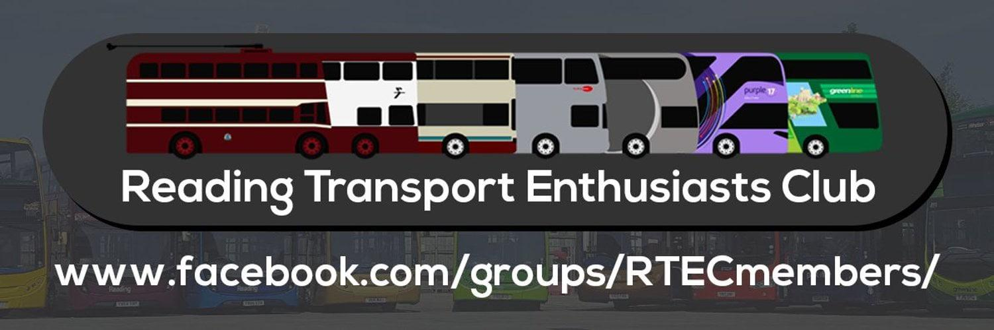
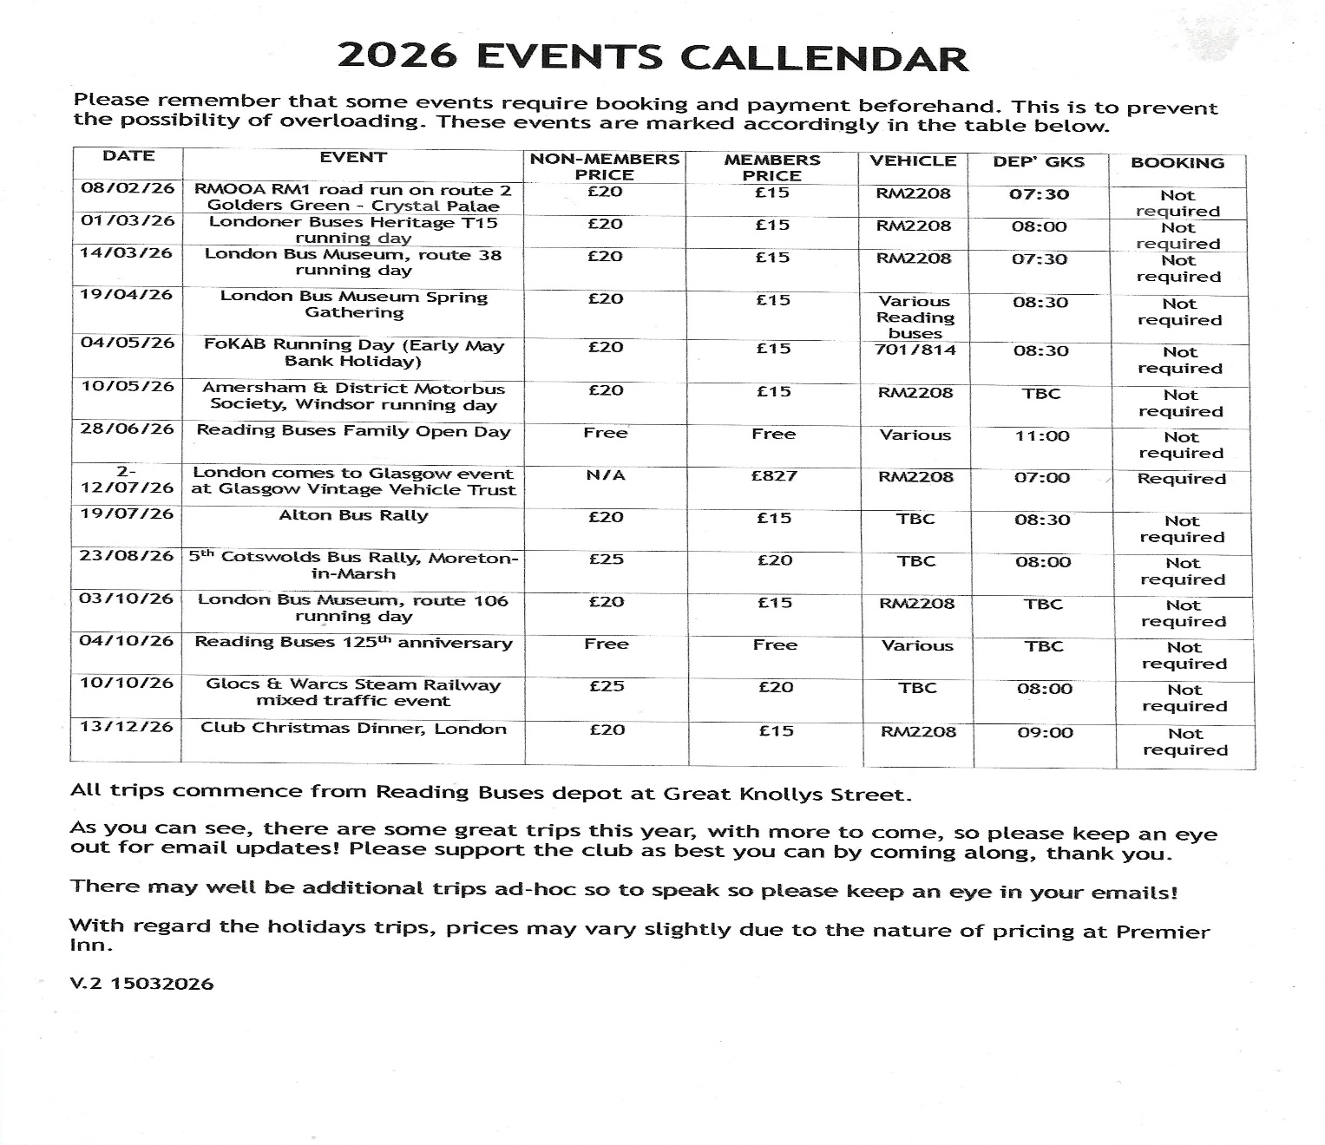

The new buses arriving for the 26 route some our still personalised with personalised number plates these are shown in the grid below along with Generic 32 RG26BUS
Fleet No | Reg No: | Colour | Body / Engine | Date Entry
25 | RG25ZEB | Yellow 26 | ADL / E400EV
26 | RG26ZEB | Yellow 26 | ADL / E400EV
27 | YX26JZG | Yellow 26 | ADL / E400EV
28 | YX26JZH | Yellow 26 | ADL / E400EV
29 | YX26JZJ | Yellow 26 | ADL / E400EV
30 | YX26JZK | Yellow 26 | ADL / E400EV
31 | YX26JZL | Yellow 26 | ADL / E400EV
32 | RG26BUS | Generic / Silver | ADL / E400EV
News from other Fleets
It was announced in late March / April 2026 that Arriva Herts and Essex would be joining the brand Flightline with 724/25 from Harlow and Stevenage and finishing at London Heathrow Airport. Along with this happening Arriva has painted up one of the E200MMC’s up in a Greenline heritage livery.
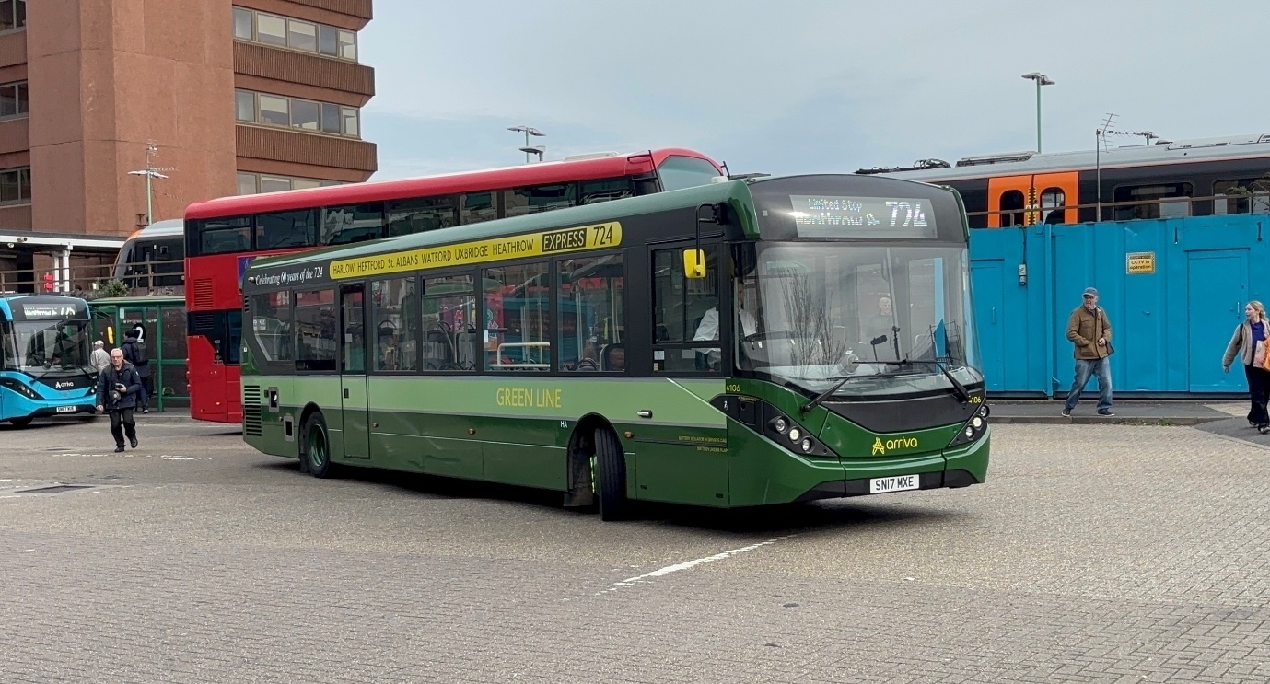
Photo credit to Robert Thompson on behalf of Theo Thompson members of Gary's bus and coach photos; ASC4106 SN17MXE heritage Greenline livery.
Routes withdrawn from Thames Valley this month on the 14th and 15th April were routes 299 and 598 this is due to council funding, and no fault of the operating service Thames valley has council give Thames valley the money to operate the two services. Tim Wild and I went to ride on route 299 on the 8th, April 2026 interesting route has it services two caravan parks in Winkfield area. The route 598 has also been withdrawn for the same reasons. This is a loss for Thames Valley and the regulars that use it, but this is due to cost of running the services and the passenger numbers not being very high which meant it was not really used. The routes cost the borough £16 each and with few passengers or customers using the service there had to be withdrawn to save council money.
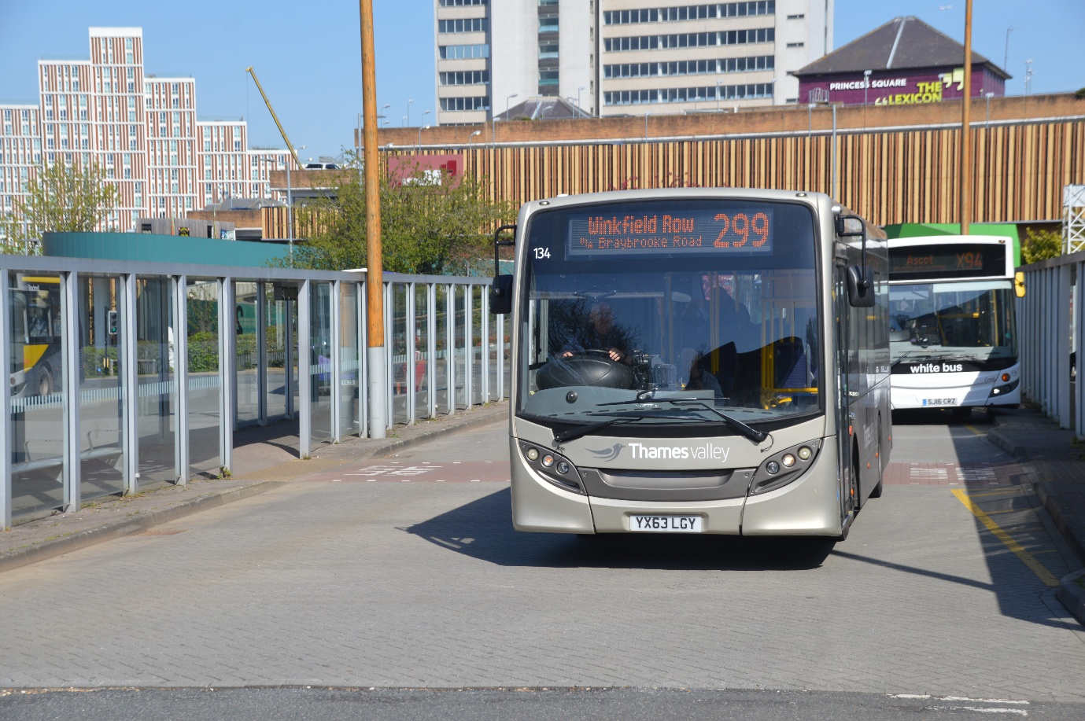
Photo credit to Gary Baxter Administration of Gary’s bus and coach photos: Thames Valley 134 YX63LGY ADL Enviro200 photographed on route 299 to Winkfield row before the last week of service.

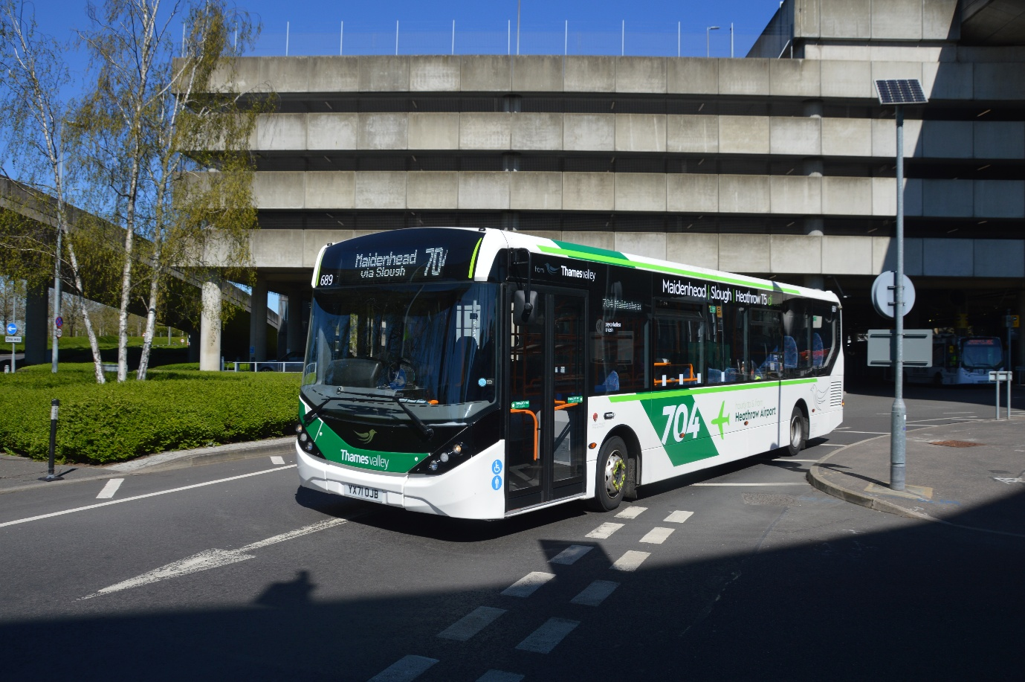
Thames Valley 689 YX71OJB ADL Enviro200mmc photographed at London Heathrow Airport finally in Service on route 704 from Maidenhead to London Heathrow Airport. So, this has now joined it sister 688 YX71OJA on the same route.
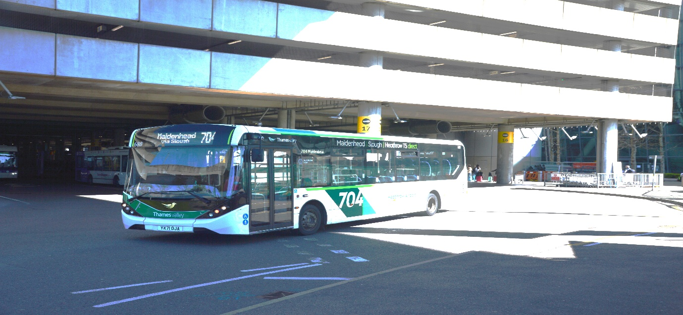
Photo credit to Gary Baxter Administration of Gary’s bus and coach photos: Thames Valley 688 YX71OJA ADL Enviro200mmc on route 704 from Maidenhead to London Heathrow Airport photographed departing Heathrow Airport.
May Events to look to
In May we are looking forward to so many events that are coming forth especially two at the beginning of May 2026 first one being the King Alfred heritage bus running day in Winchester on Monday 4th, May and then Sunday 10th, May at Windsor for the Amersham and district and Thames Valley and great western omnibus trust heritage bus day in Windor based at Windsor coach park.
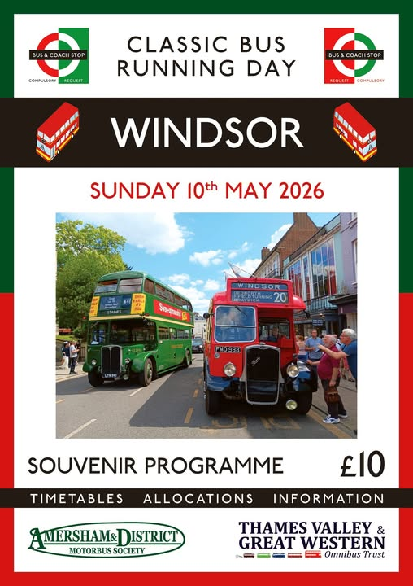

Arriva Herts and Essex
Arriva in Herts and Essex are to join the brand Flightline with their route 724 / 725 from Harlow and Stevenage to connect with London Heathrow Airport the Flightline routes have now grown in numbers of up to 6 or 7 routes. Route numbers and destinations in grid below here.
Route No | Destination from | Destination to | Operator
102 | High Wycombe | London Heathrow Airport central bus station | Carousel buses /GH
446 | Woking railway station | London Hatton Cross Heathrow Airport | Rowgate group / WB
555 | Walton on Thames | Hatton Cross London Heathrow Airport | Rowgate group / WB
703 | Bracknell bus station | London Heathrow Airport Terminal five | Reading Buses / TV
704 | Maidenhead | London Heathrow Airport Terminal five | Reading buses / TV
724 | Harlow | London Heathrow Airport central bus station | Arriva Herts & Essex
725 | Stevenage | London Heathrow Airport central bus station | Arriva Herts & Essex
730 | Basingstoke | Old Basing (Hatchet) Frimley | Reading buses / N&D
731 | Frimley Railway station | London Heathrow Airport | Reading buses / N&D

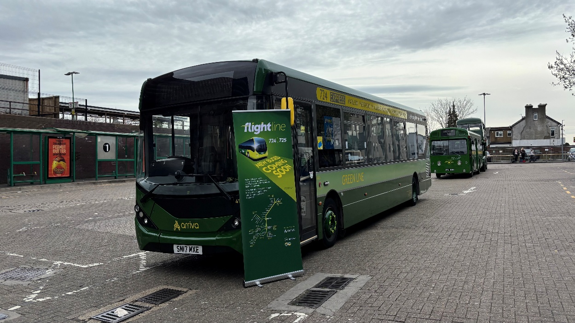
Photo credit to Robert Thompson on behalf of Theo Thompson his son members of GB&CP; 4106 SN17MXE advertising Flightline routes.
Facebook group member photos
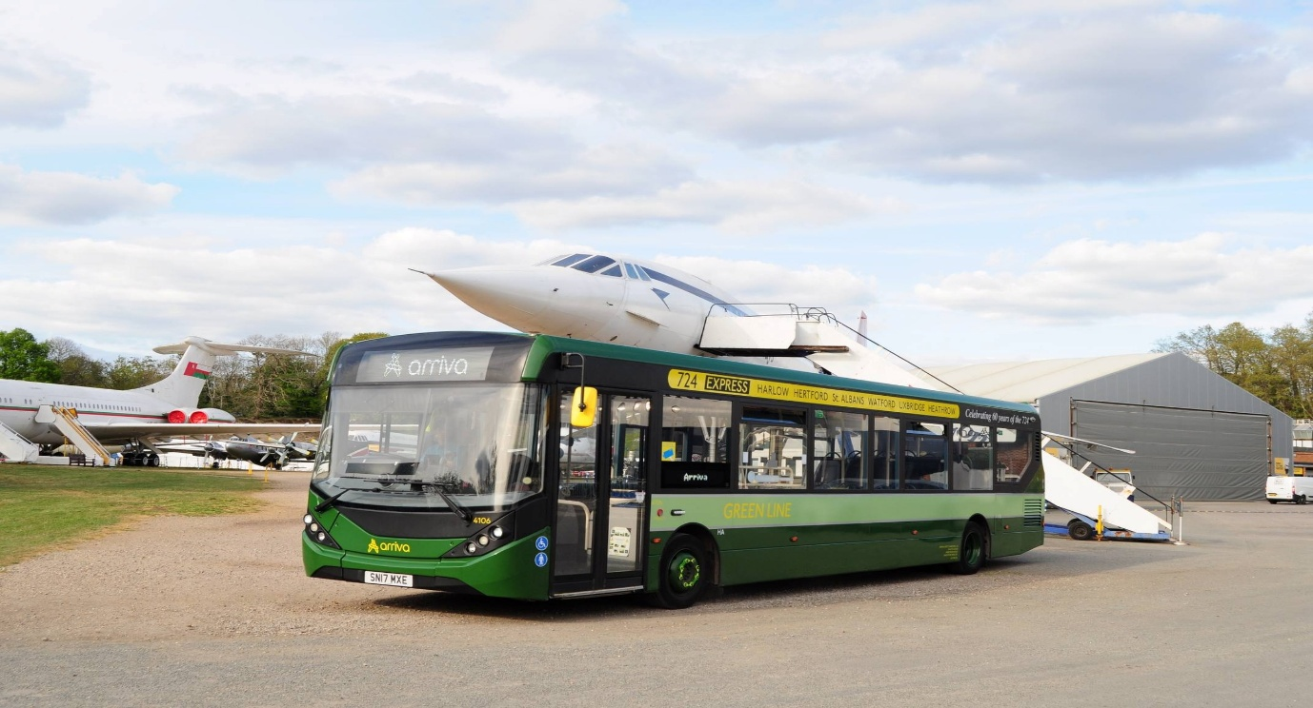
Photo credit to Anthony Moore Arriva Herts and Essex 4106 SN17MXE ADL Enviro200mmc in Greenline 60yrs livery at Brookland LBM Spring gathering in April 2026.
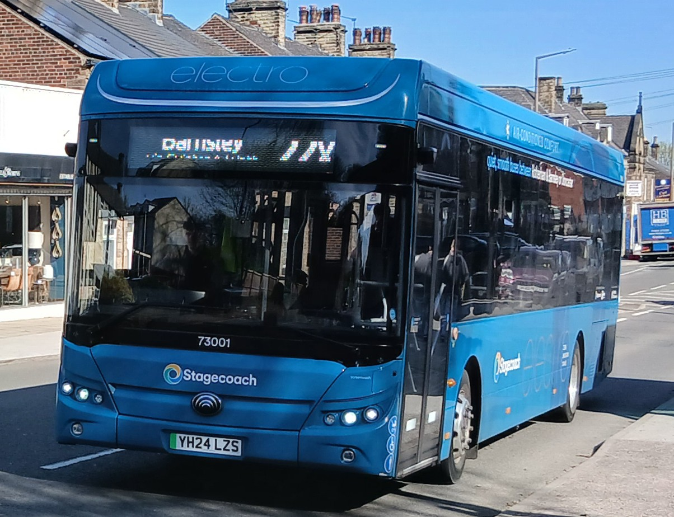
Photo credit to Barry Smith member of GB&CP Stagecoach Yorkshire 73001 YH24LZZS Yutong
Electric bus.
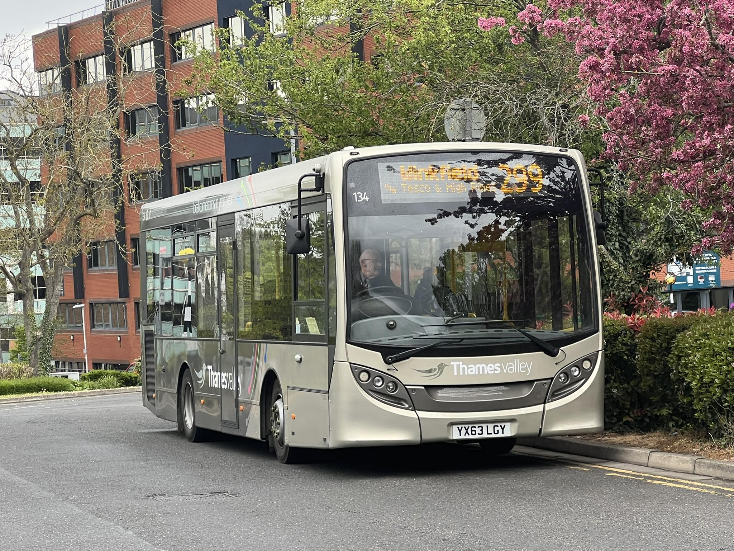
Photo credit to Blain Rhys member of GB&CP Thames Valley 134 YX63LGY ADL Enviro200 on the last day of route 299 to Winkfield & Bracknell.
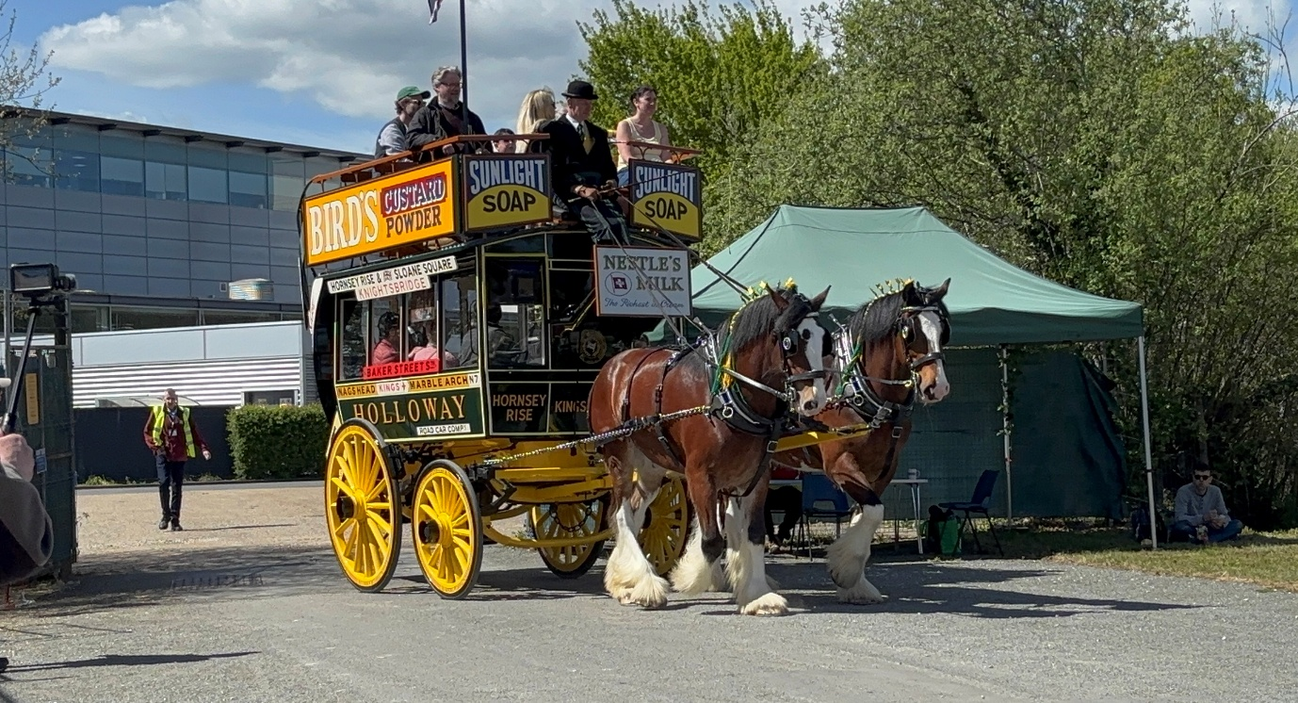
Photo credit to Robert Thompson on behalf of Theo Thompson members of GB&CP; horse bus at Brooklands LBM Spring gathering April 2026.
Reading buses 125yr anniversary presents at Brooklands LBM Spring gathering
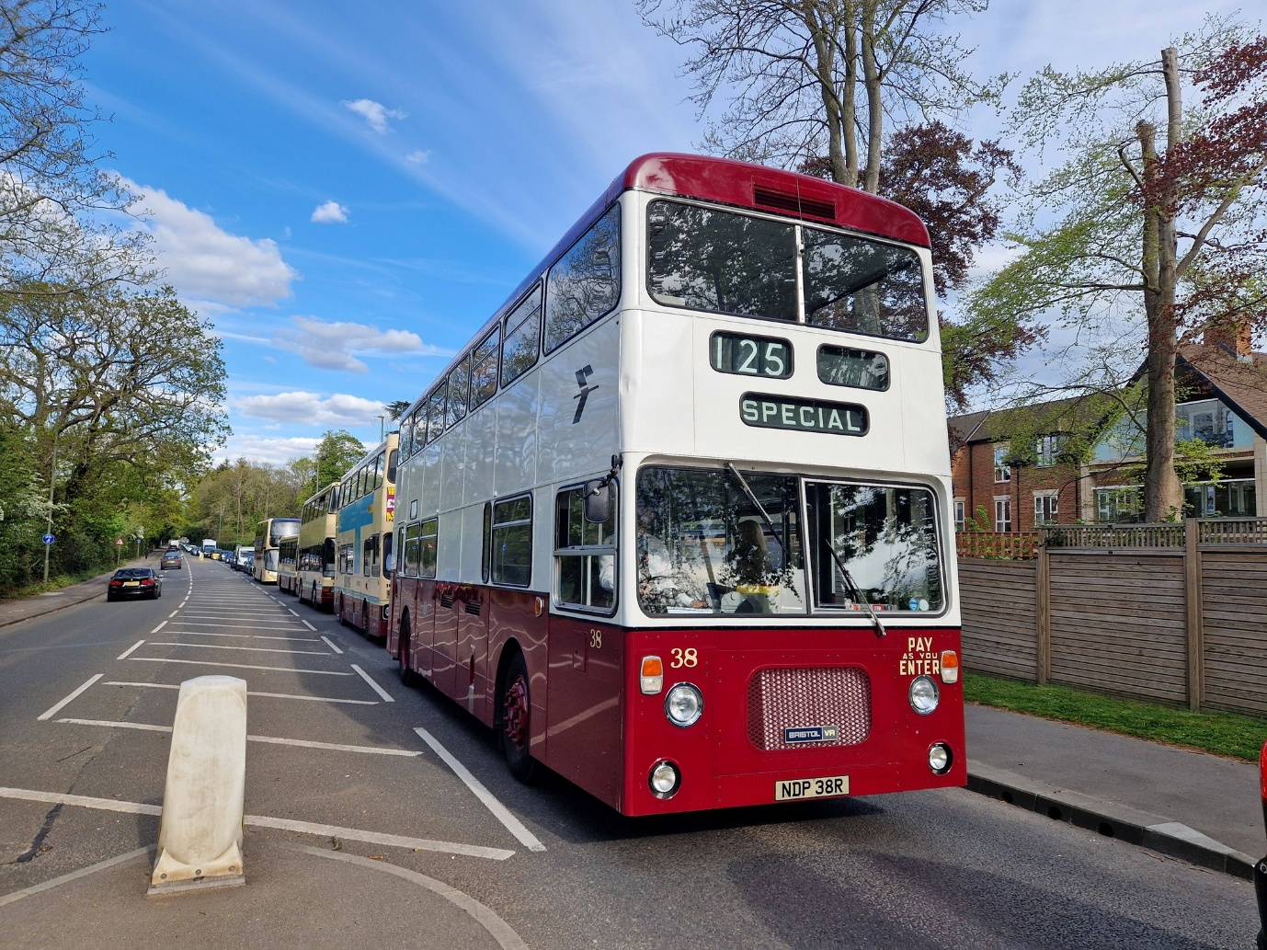
Photo credit to Robert Williams member of GB&CP 38 NDP38R 162 WRD162T 701 MRD1R 814 M957VWY 4 RG04ZEB convoy from Brooklands LBM Spring gathering April 2026.
A nice presence of Reading Transport / Reading buses convoy from the Brooklands LBM spring gathering in Weybridge heading back to Reading on the 19th, April 2026. To mark a 125yr anniversary.

Facebook Group Cover photo competitions
We have decided for the time being that we won’t be doing the Facebook group cover photo competitions I was looking to bring this back in April or May 2026, but due to ongoing suggestion I won’t be over to bring this back in this time. I’ll look to bring it back in January 2027/28 depending on how things go. It was hard decision to make and has not come easy by any means but due to this ongoing suggestion I can’t do it I wish I could, but I just don’t have the ability to be over to provide it right now.
Podcasts (YouTube or General)
We are looking in to bringing a new attention to our YouTube channel or in general of what is called a podcast in the time we have been running Gary’s bus and coach photos we have never thought about doing this but think it might be a good idea to try out something new once a month or every two months along with special guest appearances. It was recommended to me by someone and when I had thought about a little, I thought it might be an excellent idea and get some people on board with helping me to do this. So, if anyone would be interested and to hearing abit more about it then email me at webmaster@garysbusandcoachphotos.co.uk or messaging relevant social medias. This would be hosted by me Gary Baxter and Admin Dorothy Baxter sometimes.
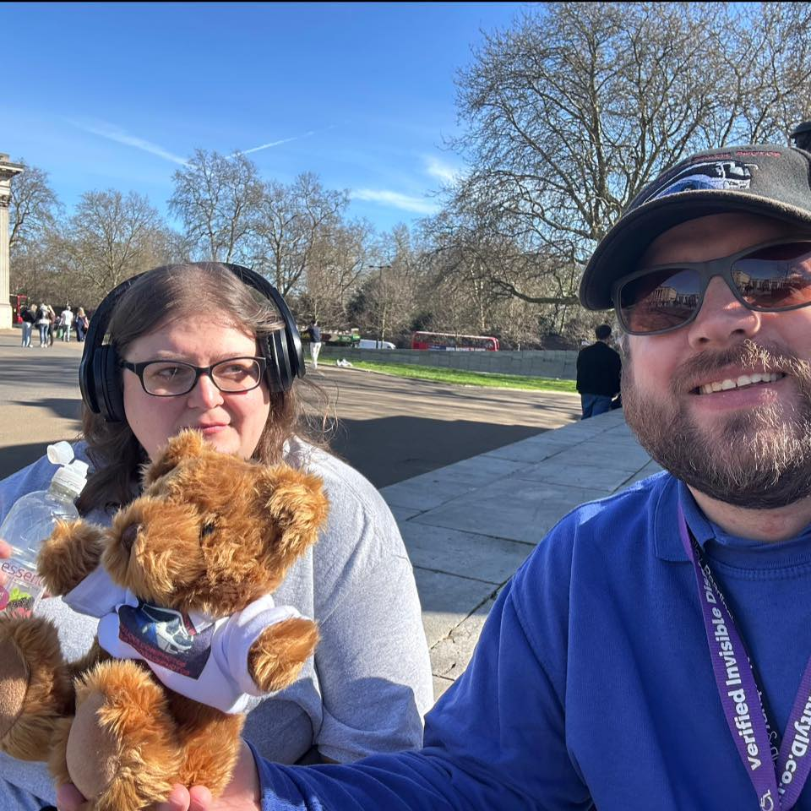
Photo credit to Gary Baxter Administration of GB&CP: myself, Dottie and teddy in Hyde Park London in March / April 2025.

