
Month: December 2025 Issue No: 90
This month we attended at the route one hundred and fifty-nine running day in Central London this day was not so bad we travelled into London on train and then went to the event has planned which was good. We ride on a few buses on the running day and take some photos it was good to see the old Routemaster’s back in service for this day. More about this on page twenty and twenty-one. This month we also celebrate another milestone which is the 90th issue of the Gary’s bus and coach photos newsletter this has been a big milestone to come. 90th issue cannot believe how far we have come.
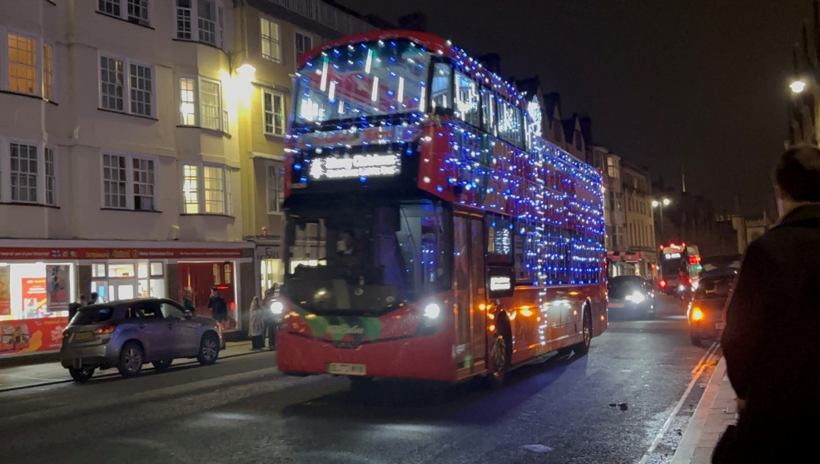
Photo credit to Robert Thompson on behalf of Theo Thompson his son members of Gary’s bus and coach photos: Go-Ahead OBC 80290 BJ73WVW Citysightseeing christmas bus.

www.garysbusandcoachphotos.co.uk
www.facebook.com/groups/garysbusandcoachphotos
www.facebook.com/@garysbusandcoachphotos
www.flickr.com/photos/garysbusandcoachphotos
Flickr Album grid
December 2025
Album Date: | Album Name: | Album Link
3rd December 2025 | Camberley | https://flic.kr/s/aHBqjCCB3W
10th December 2025 | Bracknell | https://flic.kr/s/aHBqjCDP2y
12th December 2025 | Bracknell | https://flic.kr/s/aHBqjCDTim
13th December 2025 | Route 159 commemorative day | https://flic.kr/s/aHBqjCDLQZ
Photo Of The Month
December 2025
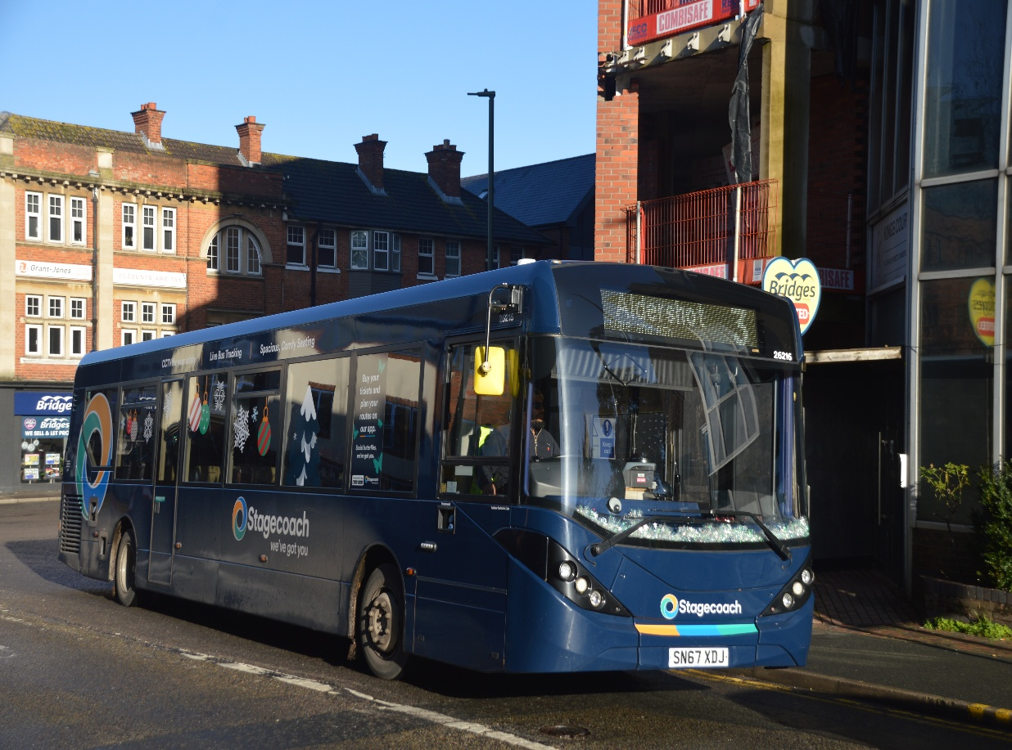

Photo credit to Gary Baxter Administration of Gary’s bus and coach photos Stagecoach South Aldershot 26216 SN67XDJ ADL Enviro200mmc christmas bus photo of the month for December 2025. More photos found here https://flic.kr/s/aHBqjCCB3W
www.garysbusandcoachphotos.co.uk
www.flickr.com/photos/garysbusandcoachphotos
www.youtube.com/@garysbusandcoachphotos
www.facebook.com/groups/garysbusandcoachphotos
Facebook Group Cover Photo Competition
Place | Names
1st | Andy Dyer
2nd | Robert Thompson on behalf of Theo Thompson his son
3rd | Busspotting.co.uk
4th | Hirasawa Yui
5th | Barry Smith & Gary Baxter
6th | Alan Lockey
Well done to everyone who take part in this month’s Facebook Group cover photo competition next month’s Facebook group cover photo competition will be on the 9th, January 2025.
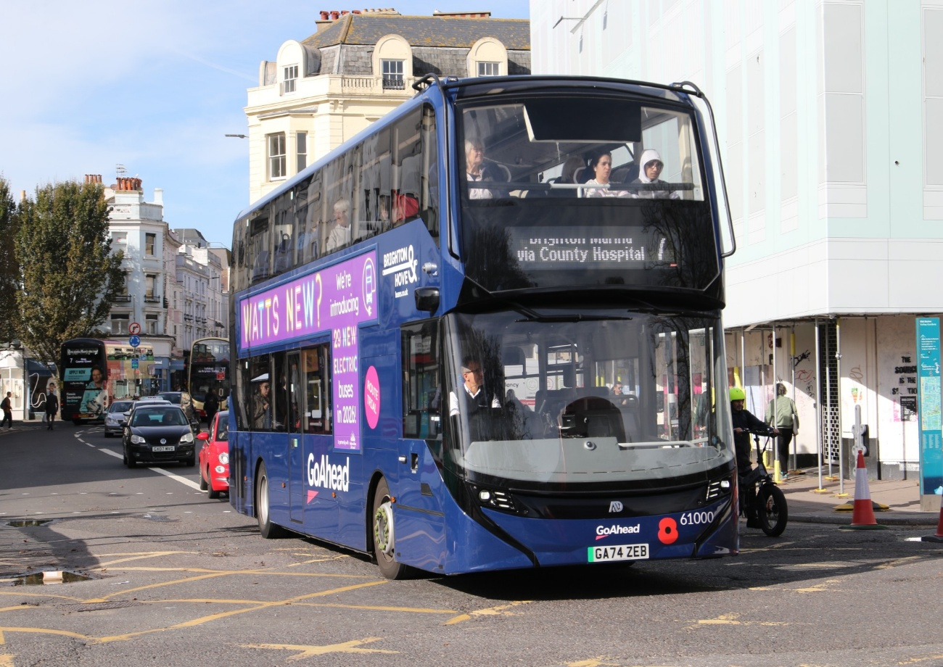Photo credit to Andy Dyer Administration of Gary’s bus and coach photos: Go-ahead Brighton and Hove 61000 GA74ZEB ADL Enviro400EV Facebook group cover photo of the month for December 2025.
Year 2025 year reviewed
We’ll 2025 will shortly be ending and what to say well it has been a busy year for us at Gary’s bus and coach photos like always we have had lots of events. Along with getting out and taking photos in different locations. In some aspects the year has not been so good for starters being arrested in February 2025 for something I clearly hadn’t done so that put one downer in 2025 and not be able to provide our YouTube channel with a full lot of videos. So that will be something will be looking back next year I just couldn’t believe it happened to me. Events we have enjoyed this year have been the going to Basingstoke with administration Tim Wild in early March for the model railway expo in Basingstoke and photographing the railway replacement in that town. Then attending at the route nineteen vintage bus running day in London organised by the London bus museum. This was a good event all be it a busy one has the public used the vintage buses along with the enthusiasts. So, we went from one end of the route till middle of the next which saw us spending the day in Hyde Park corner and photographing the vintage buses coming past us. Then in Early April since I am now a member of the London transport museum, we attend at the museum depot open day in Acton with our administration Tim Wild and his friend Steve this was lovely day. Then we attended the annual event at the London bus museum / Brooklands for the spring gathering now this was a good day again this year with lots of different buses and coaches attending this event. Then in May attending at King Alfred vintage bus running based in Winchester this was a good day in which we travelled down to the event with Tim Wild and his friend Steve again like always a good day. This year has seen lots of different events being attended not just bus shows or running days, but a lot of other different events. People I have enjoyed meeting this year are Theo Thompson and Robert Thompson Theo’s dad or Father Tracy Churchill and Mark Apcar. Things we have worked on over the 2025 year the website and its growth are processing well along with our YouTube channel processing in growth flickr growing and getting lots more followers for my photos. This year again helping my good friend Robert Williams Chef executive officer at Reading buses with the annual open day and taking photos and video for that meeting more new people like Marcus from Shed no 2 and the lovely people who created the Reading buses card game. Both the people who created the card game and shed no two Took part in video interview at the annual openday so was good. Like I said earlier on in the statement the only not so good part of the year was being arrest for something I have not done but I have had plenty of support from Dottie and family members over this and been told to talk to them. Now October, November and December 2025 October was good for Transport festival has I got to ride on the new Zebra ADL Enviro400EV which was awesome being the first one to ride one before they go in to service across the borough of Reading. Then November was meeting Mark Apcar and him taking my photo before the running day organised by the Thames Valley and Great Western Omnibus trust. I cannot believe how fast this year has passed us by, but we have got through it like any other year. It will soon be christmas and we at Gary’s bus and coach photos would like to which all our members, Followers and subscribers a lovely christmas and a happy new year for 2026.
www.garysbusandcoachphotos.co.uk
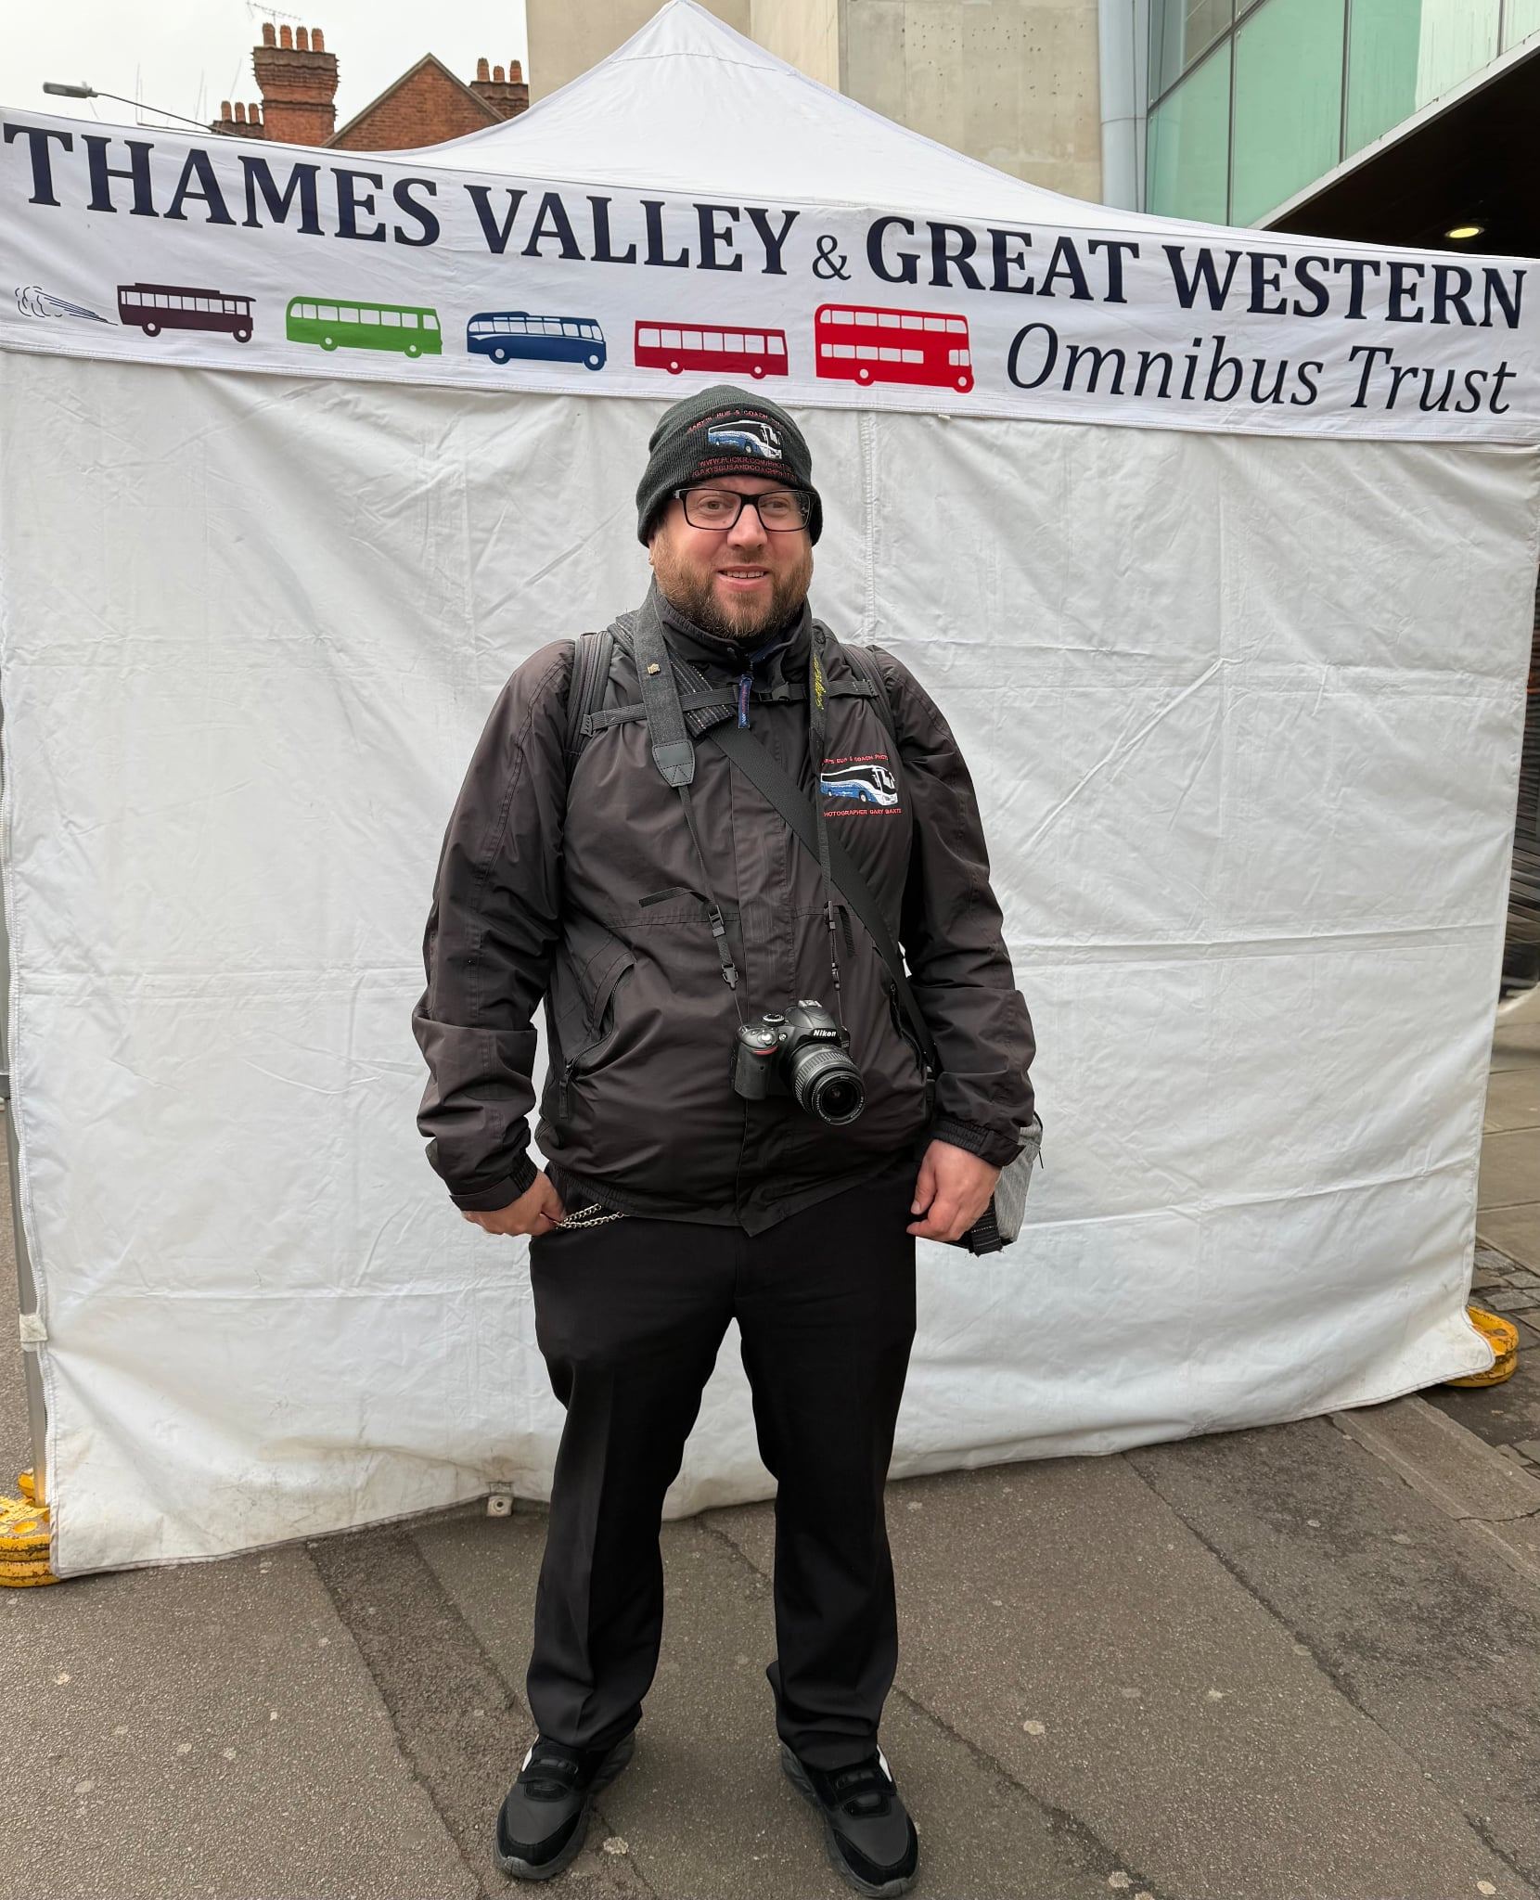
Photo credit to Mark Apcar member of Gary’s bus and coach photos: photo of yours truly Gary Baxter Administration of Gary’s bus and coach photos at Reading vintage bus running day in Reading on the 16th, November 2025.
www.garysbusandcoachphotos.co.uk
www.facebook.com/groups/garysbusandcoachphotos
www.facebook.com/@garysbusandcoachphotos
www.youtube.com/@garysbusandcoachphotos

Reading buses group of companies fleet list
Fleet no: | Registration | Engine Type | Body | Livery | Company
1 | MRD1 | Alexander Dennis | Enviro400EV | Generic | Reading buses
2 | RG02ZEB | Alexander Dennis | Enviro400EV | Zebra | Reading buses
3 | RG03ZEB | Alexander Dennis | Enviro400EV | Generic / climate strips | Reading buses
132 | YX63LGV | Alexander Dennis | Enviro200 | Wokingham Orange | Thames Valley
133 | YX63LGY | Alexander Dennis | Enviro200 | Wokingham Orange | Thames Valley
134 | YX63LGY | Alexander Dennis | Enviro200 | Generic | Thames Valley
141 | YA23ULU | Mercedes Benz | Sprinter 517 EVM | Go2Gate | Thames Valley
142 | YB23LRN | Mercedes Benz | Sprinter 517 EVM | Go2Gate | Thames Valley
143 | YJ23LSJ | Mercedes Benz | Sprinter 517 EVM | Go2Gate | Thames Valley
144 | YJ23CLA | Mercedes Benz | Sprinter 517 EVM | Go2Gate | Thames Valley
171 | YX75LCY | Alexander Dennis | Enviro200mmc | Windsor & Maidenhead Purple | Thames Valley
201 | RF60FUT | Alexander Dennis | Enviro400 | Generic | Reading buses
202 | SN60ECX | Alexander Dennis | Enviro400 | Yellow 26 | Reading buses
204 | SN60EDC | Alexander Dennis | Enviro400 | Yellow 26 | Reading buses
206 | SN60EDK | Alexander Dennis | Enviro400 | Yellow 26 | Reading buses
207 | SN11BVM | Alexander Dennis | Enviro400 | Yellow 26 | Reading buses
208 | SN11BVO | Alexander Dennis | Enviro400 | Yellow 26 | Reading buses
209 | SN11BVP | Alexander Dennis | Enviro400 | Yellow 26 | Reading buses
210 | SN11BVR | Alexander Dennis | Enviro400 | Yellow 26 | Reading buses
218 | SN11BVZ | Alexander Dennis | Enviro400 | Skyblue 15/16 | Reading buses
219 | SN11BAA | Alexander Dennis | Enviro400 | Generic | Reading buses
220 | SN11BAO | Alexander Dennis | Enviro400 | Berry | Reading buses
221 | SN11BAU | Alexander Dennis | Enviro400 | Berry | Reading buses
222 | SN11BAV | Alexander Dennis | Enviro400 | Berry | Reading buses
223 | SN11BCO | Alexander Dennis | Enviro400 | Berry | Reading buses
224 | SN11BCU | Alexander Dennis | Enviro400 | Skyblue 15/16 | Reading buses
225 | SN11BCV | Alexander Dennis | Enviro400 | Skyblue 15/16 | Reading buses
226 | SN11BCX | Alexander Dennis | Enviro400 | Skyblue 15/16 | Reading buses
227 | SN11BCY | Alexander Dennis | Enviro400 | Skyblue 15/16 | Reading buses
228 | SN11BCZ | Alexander Dennis | Enviro400 | Skyblue 15/16 | Reading buses
229 | SN61BDE | Alexander Dennis | Enviro400 | Skyblue15/16 | Reading buses
230 | SN61BDF | Alexander Dennis | Enviro400 | Skyblue 15/16 | Reading buses
231 | SN61BDO | Alexander Dennis | Enviro400 | Skyblue 15/16 | Reading buses
233 | SN59AWW | Alexander Dennis | Enviro400 | Generic | Reading buses
241 | RG73BUS | Alexander Dennis | Enviro400city | Lion 4/4A | Reading buses
242 | YX73PHF | Alexander Dennis | Enviro400city | Lion 4/4A | Reading buses
243 | YX73PHK | Alexander Dennis | Enviro400city | Lion 4/4A | Reading buses
244 | YX73PHN | Alexander Dennis | Enviro400city | Lion 4/4A | Reading buses
245 | YX73PHO | Alexander Dennis | Enviro400city | Lion 4/4A | Reading buses
246 | YX73PHU | Alexander Dennis | Enviro400city | Lion 4/4A | Reading buses
247 | YX73PHV | Alexander Dennis | Enviro400city | Lion 4/4A | Reading buses
248 | YX73PHY | Alexander Dennis | Enviro400city | Lion 4/4A | Reading buses
249 | YY74LVE | Alexander Dennis | Enviro400city | Lion 4/4A | Reading buses
250 | YY74LVF | Alexander Dennis | Enviro400city | Lion 4/4A | Reading buses
251 | YY74LVG | Alexander Dennis | Enviro400city | Lion 4/4A | Reading buses
252 | YX74ORG | Alexander Dennis | Enviro400city | Jetblack | Reading buses
253 | YX74ORH | Alexander Dennis | Enviro400city | Jetblack | Reading buses
254 | YX74ORJ | Alexander Dennis | Enviro400city | Jetblack | Reading buses
255 | YX74ORK | Alexander Dennis | Enviro400city | Jetblack | Reading buses
256 | YX74ORL | Alexander Dennis | Enviro400city | Jetblack | Reading buses
257 | YX74ORN | Alexander Dennis | Enviro400city | Jetblack | Reading buses
258 | YX74ORO | Alexander Dennis | Enviro400city | Jetblack | Reading buses
259 | YX74ORP | Alexander Dennis | Enviro400city | Jetblack | Reading buses
260 | YX74ORT | Alexander Dennis | Enviro400city | Generic | Reading buses
261 | RG74BUS | Alexander Dennis | Enviro400city | Generic | Reading buses
262 | YY74RXL | Alexander Dennis | Enviro400city | Generic | Reading buses
263 | YY74RXM | Alexander Dennis | Enviro400city | Generic | Reading buses
264 | YY74RXN | Alexander Dennis | Enviro400city | Generic | Reading buses
310 | RG54BUS | Alexander Dennis | Enviro300SG | Training school bus | Reading buses
311 | RG53BUS | Alexander Dennis | Enviro300SG | Training School bus | Reading buses
401 | YR13PLN | Alexander Dennis | Enviro300SG | Greenwave Mereock P&R | Reading buses
402 | YR13PLO | Alexander Dennis | Enviro300SG | Greenwave Mereock P&R | Reading buses
403 | YR13PLU | Alexander Dennis | Enviro300SG | Greenwave Mereock P&R | Reading buses
404 | YR13PNE | Alexander Dennis | Enviro300SG | Greenwave Mereock P&R | Reading buses
405 | YR13PLX | Alexander Dennis | Enviro300SG | Hospital P&R | Reading buses
406 | YR13PNJ | Alexander Dennis | Enviro300SG | Hospital P&R | Reading buses
407 | YR13PMO | Alexander Dennis | Enviro300SG | Hospital P&R | Reading buses
408 | YR13PMU | Alexander Dennis | Enviro300SG | Generic | Reading buses
409 | YR13PNN | Alexander Dennis | Enviro300SG | Generic | Reading buses
410 | YR13PNO | Alexander Dennis | Enviro300SG | Ruby 10 | Reading buses
412 | YR13PLV | Alexander Dennis | Enviro300SG | Leopard | Reading buses
413 | YR13PLZ | Alexander Dennis | Enviro300SG | Leopard | Reading buses
414 | YR13PMV | Alexander Dennis | Enviro300SG | Leopard | Reading buses
415 | YR13PNK | Alexander Dennis | Enviro300SG | Pink | Reading buses
416 | YR13PNL | Alexander Dennis | Enviro300SG | Pink | Reading buses
417 | YR13PNU | Alexander Dennis | Enviro300SG | Pink | Reading buses
418 | YR13PMX | Alexander Dennis | Enviro300SG | Bronze | Reading buses
419 | YR13PNV | Alexander Dennis | Enviro300SG | Bronze | Reading buses
420 | YR13PNF | Alexander Dennis | Enviro300SG | Generic | Reading buses
421 | YN14MXP | Alexander Dennis | Enviro300SG | Generic | Reading buses
422 | YN14MXR | Alexander Dennis | Enviro300SG | Generic | Reading buses
423 | YN14MXS | Alexander Dennis | Enviro300SG | Generic | Reading buses
424 | YN14MXT | Alexander Dennis | Enviro300SG | Leopard | Reading buses
425 | YN14MXU | Alexander Dennis | Enviro300SG | Leopard | Reading buses
427 | YN14MXW | Alexander Dennis | Enviro300SG | Leopard | Reading buses
428 | YN14MXX | Alexander Dennis | Enviro300SG | Leopard | Reading buses
429 | YN14MXY | Alexander Dennis | Enviro300SG | Leopard | Reading buses
430 | YN14MXZ | Alexander Dennis | Enviro300SG | Leopard | Reading buses
431 | YN14MYA | Alexander Dennis | Enviro300SG | Generic / climate strips | Reading buses
432 | YN14MYB | Alexander Dennis | Enviro300SG | Lime | Reading buses
433 | YN14MYC | Alexander Dennis | Enviro300SG | Lime | Reading buses
434 | YN14MYD | Alexander Dennis | Enviro300SG | Lime | Reading buses
435 | BU52GAS | Alexander Dennis | Enviro300SG | Generic | Reading buses
436 | YP14TGE | Alexander Dennis | Enviro300SG | Buzz | Reading buses
437 | YP14TGF | Alexander Dennis | Enviro300SG | Buzz | Reading buses
438 | YP14TGJ | Alexander Dennis | Enviro300SG | Buzz | Reading buses
439 | YP14TGK | Alexander Dennis | Enviro300SG | Buzz | Reading buses
440 | YR14CFM | Alexander Dennis | Enviro300SG | Aqua | Reading buses
441 | YR14CFN | Alexander Dennis | Enviro300SG | Aqua | Reading buses
442 | YR14CFO | Alexander Dennis | Enviro300SG | Aqua | Reading buses
443 | YR14CGX | Alexander Dennis | Enviro300SG | Aqua | Reading buses
444 | YR14CFY | Alexander Dennis | Enviro300SG | Winnersh P&R | Reading buses
445 | YR14CFZ | Alexander Dennis | Enviro300SG | Winnersh P&R | Reading buses
446 | YR14CGE | Alexander Dennis | Enviro300SG | Winnersh P&R | Reading buses
447 | YR14CGG | Alexander Dennis | Enviro300SG | Generic | Reading buses
448 | YR14CGK | Alexander Dennis | Enviro300SG | Generic | Reading buses
449 | YR14CGO | Alexander Dennis | Enviro300SG | Generic | Reading buses
450 | YR14CGU | Alexander Dennis | Enviro300SG | Generic | Reading buses
451 | YR14CGV | Alexander Dennis | Enviro300SG | Buzz | Reading buses
520 | V524ESC | Alexander Dennis | Plaxton Trident II | Rooftop tour (Generic) | Reading buses
601 | ND74BUS | Alexander Dennis | Enviro200mmc | Generic | Newbury & district
602 | YX74ORV | Alexander Dennis | Enviro200mmc | Generic | Newbury & district
603 | YX74ORW | Alexander Dennis | Enviro200mmc | Generic | Newbury & district
604 | YX74ORY | Alexander Dennis | Enviro200mmc | Generic | Newbury & district
605 | YX74ORZ | Alexander Dennis | Enviro200mmc | Generic | Newbury & district
606 | YX74OSA | Alexander Dennis | Enviro200mmc | Generic | Newbury & district
607 | YX74OSB | Alexander Dennis | Enviro200mmc | Generic | Newbury & district
608 | YX74OSC | Alexander Dennis | Enviro200mmc | Generic | Newbury & district
646 | YX17NTU | Alexander Dennis | Enviro200 | Generic | Thames Valley
647 | YY67HBU | Alexander Dennis | Enviro200 | Generic | Thames Valley
648 | YX18KUH | Alexander Dennis | Enviro200 | Generic | Thames Valley
649 | YX18KYE | Alexander Dennis | Enviro200 | Generic | Thames Valley
650 | YX63ZVR | Alexander Dennis | Enviro200 | Generic (Black) | Newbury & district
651 | YX64VLU | Alexander Dennis | Enviro200 | Little orange 19’s | Reading buses
652 | YX64VLV | Alexander Dennis | Enviro200 | Little orange 19’s | Reading buses
653 | YX64VLW | Alexander Dennis | Enviro200 | Little orange 19’s | Reading buses
654 | YX64VLY | Alexander Dennis | Enviro200 | Little orange 19’s | Reading buses
655 | YX65RWV | Alexander Dennis | Enviro200 | Generic | Thames Valley
656 | YX65RWW | Alexander Dennis | Enviro200 | Generic | Thames Valley
657 | YY66PFF | Alexander Dennis | Enviro200 | Generic | Newbury & district
658 | RX66PTZ | Alexander Dennis | Enviro200 | Generic | Newbury & district
664 | YX65RKK | Alexander Dennis | Enviro200mmc | Branded route 2 Green | Thames Valley
665 | YX65RLO | Alexander Dennis | Enviro200mmc | Branded route 2 Green | Thames Valley
666 | YX17NLF | Alexander Dennis | Enviro200mmc | Generic | Thames Valley
667 | YX67UXP | Alexander Dennis | Enviro200mmc | Generic – white branding | Thames Valley
668 | YX17NXA | Alexander Dennis | Enviro200mmc | Foundation Park | Thames Valley
669 | YX67UYL | Alexander Dennis | Enviro200mmc | Generic / Yellow | Thames Valley
670 | YX67UYM | Alexander Dennis | Enviro200mmc | Generic / Yellow | Thames Valley
671 | YX67UYN | Alexander Dennis | Enviro200mmc | Vintage Courtney Yellow / Red | Thames Valley
672 | YX67UYO | Alexander Dennis | Enviro200mmc | Vintage Courtney Yellow / Red | Thames Valley
673 | YX67UYP | Alexander Dennis | Enviro200mmc | Vintage Courtney Yellow / Red | Thames Valley
674 | YX67UYR | Alexander Dennis | Enviro200mmc | Thames Valley Wokingham | Thames Valley
675 | YX68ULZ | Alexander Dennis | Enviro200mmc | Thames Valley Generic | Thames Valley
676 | SN69ZMZ | Alexander Dennis | Enviro200mmc | Thames Valley Generic | Thames Valley
677 | SN69ZNA | Alexander Dennis | Enviro200mmc | Thames Slough Generic | Thames Valley
678 | SN69ZNB | Alexander Dennis | Enviro200mmc | Thames Valley Slough Generic | Thames Valley
679 | YY69TNF | Alexander Dennis | Enviro200mmc | Generic | Reading buses
680 | YY69TNE | Alexander Dennis | Enviro200mmc | Generic | Reading buses
681 | YX71OJE | Alexander Dennis | Enviro200mmc | Route 194 branding | Thames Valley
682 | YX22OJF | Alexander Dennis | Enviro200mmc | Route 194 branding | Thames Valley
683 | YX22OJG | Alexander Dennis | Enviro200mmc | Route 194 branding | Thames Valley
684 | YX73PGZ | Alexander Dennis | Enviro200mmc | Route 171/172 branding | Thames Valley
685 | YX73PHZ | Alexander Dennis | Enviro200mmc | Route 171/172 branding | Thames Valley
686 | YY73OYN | Alexander Dennis | Enviro200mmc | Route 171/172 branding | Thames Valley
687 | TV73BUS | Alexander Dennis | Enviro200mmc | Thames Valley Generic | Thames Valley
688 | YJ71OJA | Alexander Dennis | Enviro200mmc | Thames Valley FL704 branding | Thames Valley
689 | YX71OJB | Alexander Dennis | Enviro200mmc | Thames Valley FL704 branding | Thames Valley
690 | YX75LCZ | Alexander Dennis | Enviro200mmc | Windsor & Maidenhead purple | Thames Valley
691 | YX75LDA | Alexander Dennis | Enviro200mmc | Windsor & Maidenhead purple | Thames Valley
692 | YX75LDC | Alexander Dennis | Enviro200mmc | Windsor & Maidenhead purple | Thames Valley
693 | YX75LDD | Alexander Dennis | Enviro200mmc | Windsor & Maidenhead purple | Thames Valley
694 | YX75LDE | Alexander Dennis | Enviro200mmc | Windsor & Maidenhead purple | Thames Valley
695 | YX75LDF | Alexander Dennis | Enviro200mmc | Windsor & Maidenhead purple | Thames Valley
696 | YX75LDJ | Alexander Dennis | Enviro200mmc | Windsor & Maidenhead purple | Thames Valley
700 | DD16GAS | Alexander Dennis | Enviro400mmc | Royal blue 33 | Reading buses
701 | YN66EZM | Alexander Dennis | Enviro400mmc | Royal blue 33 | Reading buses
702 | YN66EZO | Alexander Dennis | Enviro400mmc | Royal blue 33 | Reading buses
703 | YN66EZP | Alexander Dennis | Enviro400mmc | Royal blue 33 | Reading buses
704 | YN66EZR | Alexander Dennis | Enviro400mmc | Royal blue 33 | Reading buses
705 | YN66EZS | Alexander Dennis | Enviro400mmc | Royal blue 33 | Reading buses
706 | YP67XCA | Alexander Dennis | Enviro400cityCNG | Greenwave | Reading buses
707 | YP67XCB | Alexander Dennis | Enviro400cityCNG | Generic | Reading buses
708 | YP67XCC | Alexander Dennis | Enviro400cityCNG | Greenwave | Reading buses
709 | YP67XCD | Alexander Dennis | Enviro400cityCNG | Greenwave | Reading buses
710 | YP67XCE | Alexander Dennis | Enviro400cityCNG | Purple 17 | Reading buses
711 | YP67XCF | Alexander Dennis | Enviro400cityCNG | Purple 17 | Reading buses
712 | YP67XCG | Alexander Dennis | Enviro400cityCNG | Purple 17 | Reading buses
713 | YP67XCH | Alexander Dennis | Enviro400cityCNG | Purple 17 | Reading buses
714 | YP67XCJ | Alexander Dennis | Enviro400cityCNG | Purple 17 | Reading buses
715 | YP67XCK | Alexander Dennis | Enviro400cityCNG | Purple 17 | Reading buses
716 | YP67XCL | Alexander Dennis | Enviro400cityCNG | Purple 17 | Reading buses
717 | YP67XCM | Alexander Dennis | Enviro400cityCNG | Purple 17 | Reading buses
718 | YP67XCN | Alexander Dennis | Enviro400cityCNG | Purple 17 | Reading buses
719 | YP67XCO | Alexander Dennis | Enviro400cityCNG | Purple 17 | Reading buses
720 | YP67XCR | Alexander Dennis | Enviro400cityCNG | Purple 17 | Reading buses
721 | YP67XCS | Alexander Dennis | Enviro400cityCNG | Purple 17 | Reading buses
722 | YP67XCT | Alexander Dennis | Enviro400cityCNG | Purple 17 | Reading buses
731 | RG23BUS | Alexander Dennis | Enviro400city | Generic | Reading buses
732 | GL23LDN | Alexander Dennis | Enviro400city | Windsor Express – Green | Londonline
733 | GL23SLH | Alexander Dennis | Enviro400city | Windsor Express – Green | Londonline
734 | GL23WND | Alexander Dennis | Enviro400city | Windsor Express – Green | Londonline
735 | GL23LGO | Alexander Dennis | Enviro400city | Windsor Express – Green | Londonline
736 | GL23LHR | Alexander Dennis | Enviro400city | Windsor Express – Green | Flightline
737 | GL23BKL | Alexander Dennis | Enviro400city | Windsor Express – Green | Flightline
738 | FL73LHR | Alexander Dennis | Enviro400city | Windsor Express – Green | Flightline
739 | FL73LHR | Alexander Dennis | Enviro400city | Windsor Express – Green | Flightline
740 | FL73LGO | Alexander Dennis | Enviro400city | Windsor Express – Green | Flightline
741 | RG24BUS | Alexander Dennis | Enviro400city | Windsor Express – Green | Reading buses
742 | FL74LHR | Alexander Dennis | Enviro400city | Windsor Express – Green | Flightline
743 | FL74SLH | Alexander Dennis | Enviro400city | Windsor Express – Green | Flightline
744 | FL74ASC | Alexander Dennis | Enviro400city | Windsor Express – Green | Flightline
745 | LL74LDN | Alexander Dennis | Enviro400city | Windsor Express – Green | Londonline
746 | LL74WND | Alexander Dennis | Enviro400city | Windsor Express – Green | Londonline
751 | YX64VRL | Alexander Dennis | Enviro400mmc | Generic | Reading buses
752 | YX64VRM | Alexander Dennis | Enviro400mmc | Claret | Reading buses
753 | YX64VRN | Alexander Dennis | Enviro400mmc | Claret | Reading buses
754 | YX64VRO | Alexander Dennis | Enviro400mmc | Claret | Reading buses
755 | YX64VRP | Alexander Dennis | Enviro400mmc | Rainbow colours / App livery | Reading buses
756 | YX64VRR | Alexander Dennis | Enviro400mmc | Generic | Reading buses
757 | YX64VRT | Alexander Dennis | Enviro400mmc | Generic | Reading buses
758 | YX64VRU | Alexander Dennis | Enviro400mmc | Generic / King Chales livery | Reading buses
759 | YY15OYA | Alexander Dennis | Enviro400mmc | Generic | Reading buses
760 | YY15OYB | Alexander Dennis | Enviro400mmc | Generic | Reading buses
761 | YY15OYC | Alexander Dennis | Enviro400mmc | Generic | Reading buses
762 | YY15OYD | Alexander Dennis | Enviro400mmc | Generic | Reading buses
763 | YY15OYE | Alexander Dennis | Enviro400mmc | Emerald | Reading buses
764 | YY15OYF | Alexander Dennis | Enviro400mmc | Emerald | Reading buses
765 | YY15OYG | Alexander Dennis | Enviro400mmc | Emerald | Reading buses
766 | YY15OYH | Alexander Dennis | Enviro400mmc | Emerald | Reading buses
767 | YY15OYJ | Alexander Dennis | Enviro400mmc | Emerald | Reading buses
768 | YY15OYK | Alexander Dennis | Enviro400mmc | Emerald | Reading buses
769 | YY15OYL | Alexander Dennis | Enviro400mmc | Emerald | Reading buses
770 | YY15OYM | Alexander Dennis | Enviro400mmc | Emerald | Reading buses
771 | YY15OYN | Alexander Dennis | Enviro400mmc | Emerald | Reading buses
772 | YY15OYO | Alexander Dennis | Enviro400mmc | Emerald | Reading buses
773 | YY15OYP | Alexander Dennis | Enviro400mmc | Emerald | Reading buses
774 | YY15OYR | Alexander Dennis | Enviro400mmc | Emerald | Reading buses
781 | SN66WRC | Alexander Dennis | Enviro400mmc | Generic | Reading buses
782 | SN66WRD | Alexander Dennis | Enviro400mmc | Generic | Reading buses
783 | SN16OHA | Alexander Dennis | Enviro400mmc | Generic N&D livery | Newbury & District
784 | SN16OHB | Alexander Dennis | Enviro400mmc | Generic N&D livery | Newbury & District
785 | SN16OHC | Alexander Dennis | Enviro400mmc | Generic N&D livery | Newbury & District
786 | SN16OHD | Alexander Dennis | Enviro400mmc | Generic N&D livery | Newbury & District
787 | SN16OHE | Alexander Dennis | Enviro400mmc | Generic N&D livery | Newbury & District
788 | SN16OHF | Alexander Dennis | Enviro400mmc | Reading Generic | Reading buses
789 | SN16OHG | Alexander Dennis | Enviro400mmc | Reading Route 12 Twyford | Reading buses
790 | SN16OHH | Alexander Dennis | Enviro400mmc | Reading Route 12 Twyford | Reading buses
791 | SN16OHJ | Alexander Dennis | Enviro400mmc | White Knight route 20 | Reading buses
792 | SN16OHK | Alexander Dennis | Enviro400mmc | White knight route 20 | Reading buses
793 | SN16OHL | Alexander Dennis | Enviro400mmc | White knight route 20 | Reading buses
794 | SN16OHO | Alexander Dennis | Enviro400mmc | Thames Valley Generic / special brand | Thames Valley
795 | SN66WLK | Alexander Dennis | Enviro400mmc | Thames Valley Generic | Thames Valley
796 | YY67HDO | Alexander Dennis | Enviro400mmc | Route 194 branding | Thames Valley
797 | YX18KNC | Alexander Dennis | Enviro400mmc | Route 194 branding | Thames Valley
805 | YN54AEW | Scania N94UD | OmniDekka | Special branding for 20yrs of colour | Reading buses
901 | SK66HRR | Wright StreetDeck | Ultroliner | Orange 13/14 | Reading buses
902 | SK66HRU | Wright StreetDeck | Ultroliner | Orange 13/14 | Reading buses
903 | SK66HRW | Wright StreetDeck | Ultroliner | Orange 13/14 | Reading buses
904 | SK66HRX | Wright StreetDeck | Ultroliner | Orange 13/14 | Reading buses
905 | SK66HRZ | Wright StreetDeck | Ultroliner | Orange 13/14 | Reading buses
906 | SK66HSA | Wright StreetDeck | Ultroliner | Orange 13/14 | Reading buses
1009 | YX24OZP | Alexander Dennis | Enviro200mmc | Thames Valley Generic DM | Thames Valley DM
1201 | SN11BWA | Alexander Dennis | Enviro400 | Reading buses app livery | Reading buses
1202 | SN11BWB | Alexander Dennis | Enviro400 | Generic | Reading buses
1208 | RG05BUS | Alexander Dennis | Enviro400 | Pride livery | Reading buses
1209 | SN11BTF | Alexander Dennis | Enviro400 | Thames Valley Generic 100yrs livery | Thames Valley
1210 | KX59GNU | Alexander Dennis | Enviro400 | Special Berkshire youth livery | Reading buses
1211 | KX59GNV | Alexander Dennis | Enviro400 | Tap on / off app livery | Reading buses
1406 | BK15AJX | Volvo B8R | Caetano Levante 2 | Newbury & District white livery | Newbury & District
1421 | ME69MPT | Volvo B11R | Plaxton Panther 3 | Newbury & district white livery | Newbury & District
1422 | YX73MUP | Volvo B8R | Plaxton Panther 3 | 730-731 flightline green livery | Flightline730/731
1423 | YX73MUU | Volvo B8R | Plaxton Panther 3 | 730-731 flightline green livery | Flightline730/731
1424 | YX73MUV | Volvo B8R | Plaxton Panther 3 | 730-731 flightline green livery | Flightline730/731
1425 | YX73MVA | Volvo B8R | Plaxton Panther 3 | 730-731 flightline green livery | Flightline730/731
1426 | YX73MVG | Volvo B8R | Plaxton Leopard | Newbury & district white livery | Newbury & District
1427 | YX73MVH | Volvo B8R | Plaxton Leopard | Newbury & District white livery | Newbury & District
1428 | ND24NBY | Scania | Irizar i6S Efficient | Newbury & district white livery | Newbury & District
1429 | ND24NDB | Scania | Irizar i6S Efficient | Newbury & district white livery | Newbury & District
The Reading buses has stands for December 2025
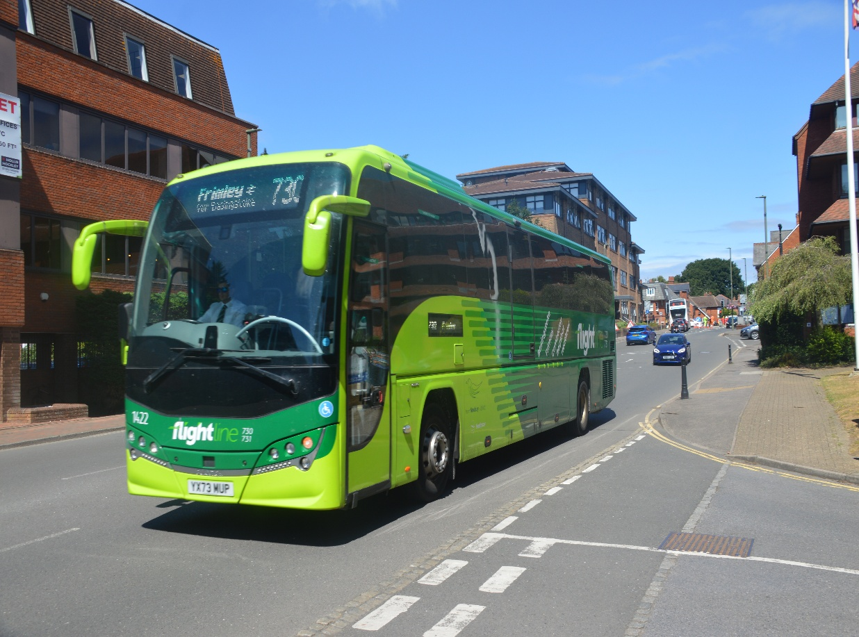
Photo credit to Gary Baxter Administration of Gary’s bus and coach photos: Newbury and district Flightline 1422 YX73MUP Volvo B8R Plaxton Panther 3 photographed on 730 to Frimley at Camberley in July 2025.

www.garysbusandcoachphotos.co.uk
www.flickr.com/photos/garysbusandcoachphotos
www.facebook.com/groups/garysbusandcoachphotos
www.facebook.com/@garysbusandcoachphotos
www.youtube.com/@garysbusandcoachphotos
www.x.com/@garysbus7coach
www.instagram.com/@garysbusandcoachphotosgb7cp
www.threads.com/@garysbusandcoachphotos

www.youtube.com/@garysbusandcoachphotos
Name of Video | Link to videos
January 2025 photo slideshow | https://youtu.be/tzRP6yTH6Fg?si=E_JTsPCvZ-l3-IBo
First blog of 2025 | https://youtu.be/qNPNj_52lik?si=WcM_Gnu7PiKOwqDL
Blog riding on local buses 19th March 2025 | https://youtu.be/qNPNj_52lik?si=WcM_Gnu7PiKOwqDL
Relegated route of Windsor blog | https://youtu.be/OWUwHlIZFhw?si=7BwtebNql3y2dETA
Route 19 running day | https://youtu.be/hIsIJX4v_HE?si=D9p91wHcqXiNRzmb
Friends of King Alfred vintage bus running day | https://youtu.be/Zb4bQD0aZlA?si=XsjO5J_qzfDlFjBl
Summer festival at Brooklands Weybridge | https://youtu.be/3V-BukakcYY?si=EQjf72Am-k0uqX37
Blog update | https://youtu.be/dnQVix3Ruu4?si=1T3z2Da1cImc5L5M
September 2025 blog | https://youtu.be/SEJZUhUWo3c?si=M2Bf_SAU827T3NVE
October 2025 blog | https://youtu.be/SEJZUhUWo3c?si=M2Bf_SAU827T3NVE
November 2025 blog | https://youtu.be/PlLTuczUfEs?si=r9ArmjQiQF04KO1E
December 2025 blog | https://youtu.be/kTdKdUHNtQw?si=ynYYNOUdZLIkok7P
The above grid shows videos that we have put on our YouTube channel this year with more videos to follow. We have not added many videos this year due to our personal issue, but hopefully in early January or anytime in 2026 this will all be sorted.
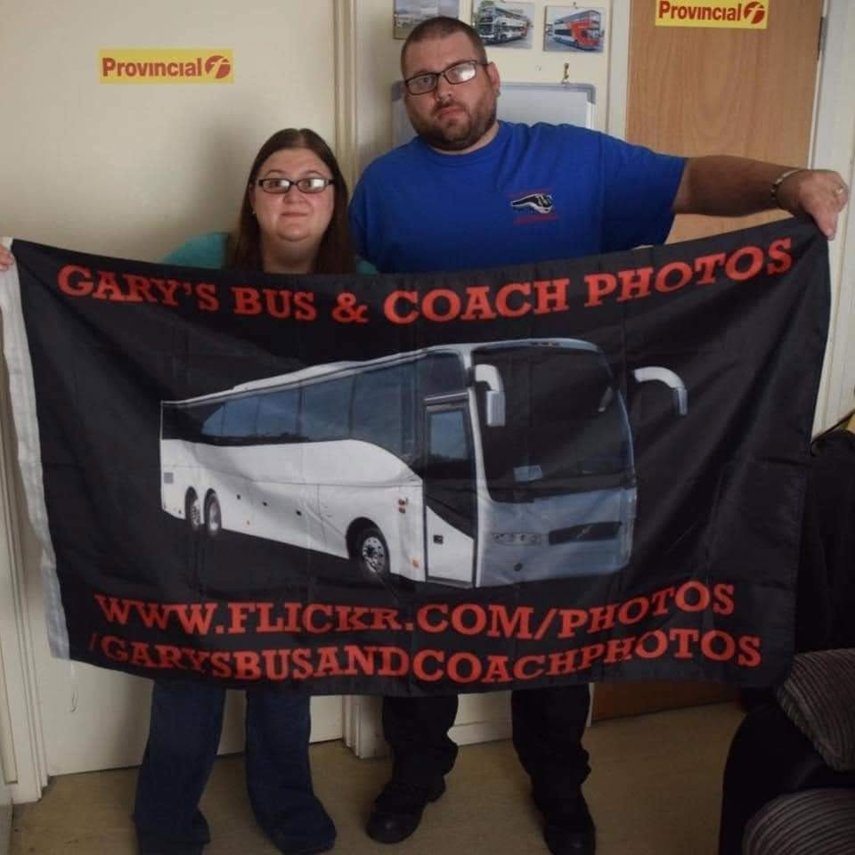
Thank you to everyone for you continued support hope this will continue in 2026. Thank you to all my administrations for your loyal work into our community has well bring on 2026 and want it has to offer.
Route 159 commemorative run at the Ace Café in Stonebridge
The Route 159 commemorative run was a big success yes it takes me hour or two to get to where it was being held but it was worth it, they were fourteen or fifteen buses at the site of the Ace Café in Stonebridge. The day would see buses going to Streatham Thorton heath clock tower. I went has Victoria on ride and headed back for Windsor / Bracknell just because I needed to pick up some lunch and get home. Has I did the main bit which was photograph the gathering of buses at the Ace café.
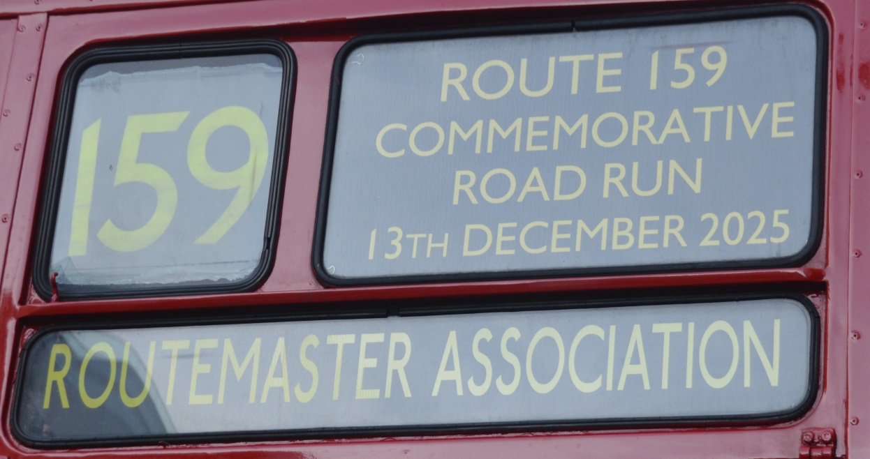
Photo credit to Gary Baxter Administration of Gary’s bus and coach photos the road run was all organised by the Routemaster Association.
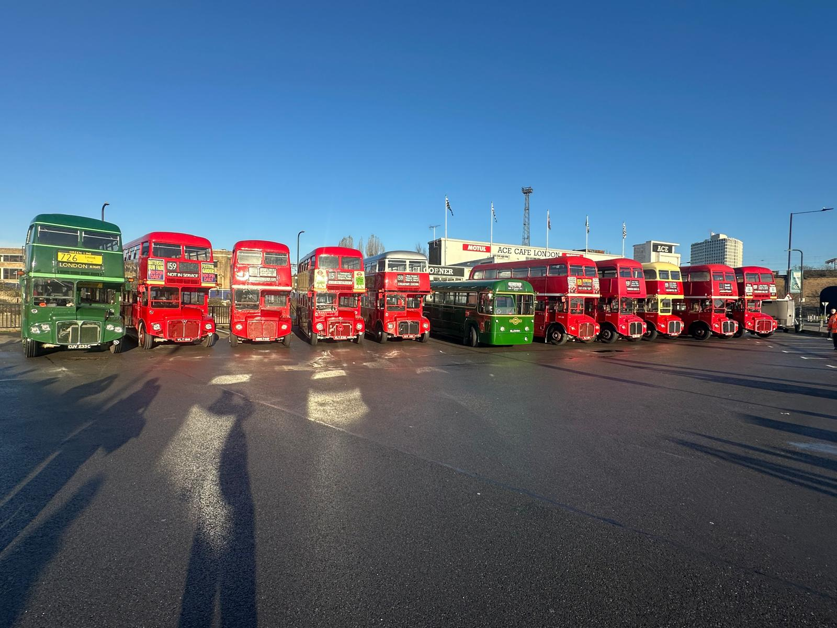
Photo credit to Gary Baxter Administration of Gary’s bus and coach photos: line up of Routemaster’s and a RF at the Ace café in Stonebridge.
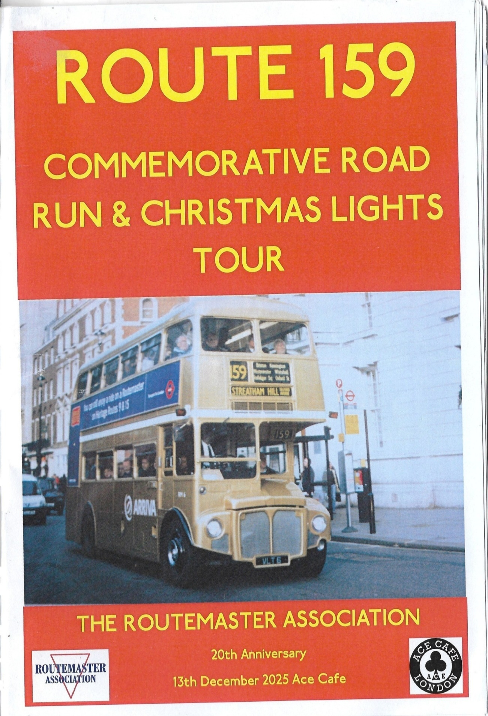
The road run programme the whole was organised by the Routemaster association and the Ace café in Stonebridge on the underground and overground line. Photo from the event found here https://flic.kr/s/aHBqjCDLQZ
Facebook group member photos
www.facebook.com/groups/garysbusandcoachphotos
www.facebook.com/@garysbusandcoachphotos
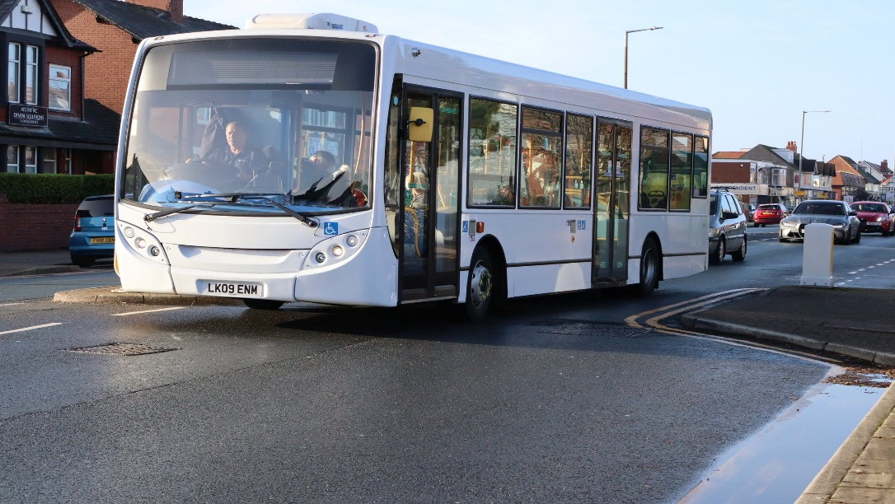
Photo credit to Alan Lockey member of Garys bus and coach photos new to Metroline London now with Transpora Northwest LK09 ENM on service 24 to Fleetwood.
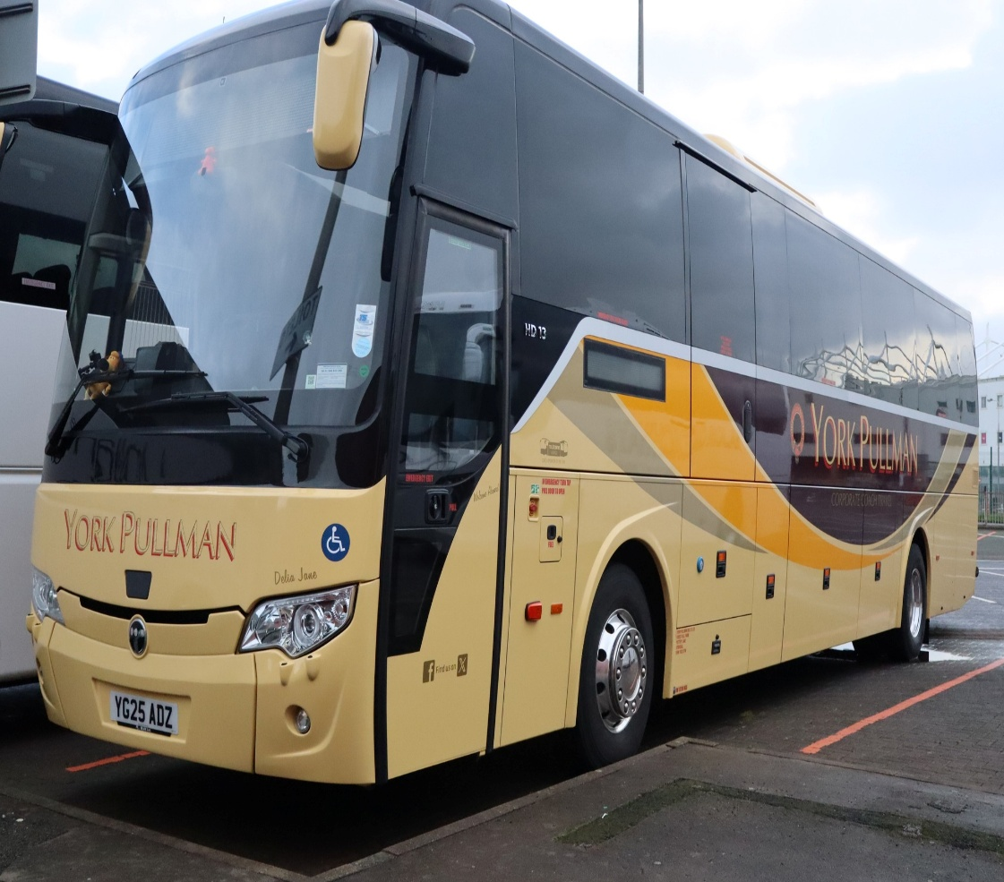
Photo credit to Alan Lockey member of Gary's bus and coach photos YG25ADZ York Pullman Temsa Electric coach.
www.facebook.com/groups/garysbusandcoachphotos
www.facebook.com/@garysbusandcoachphotos
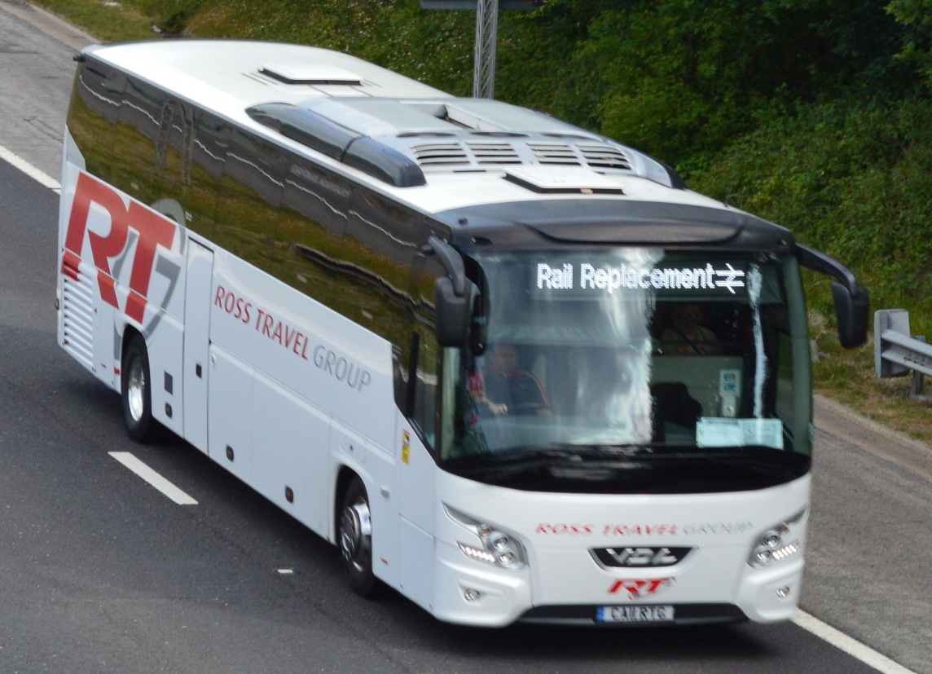
Photo credit to Barry Smith member of Gary's bus and coach photos CA11RTG VDL Bova futura on rail replacement.
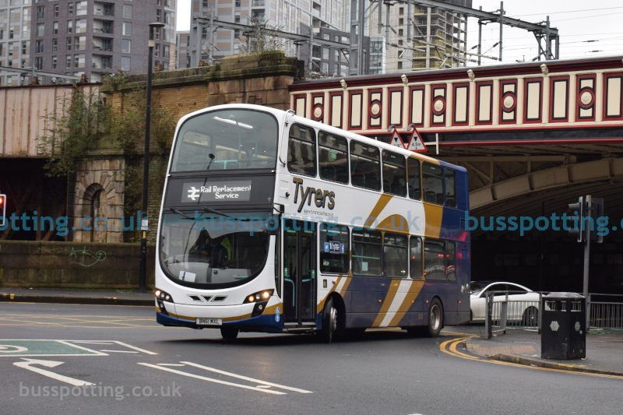
Photo credit to Busspotting.co.uk member of Gary's bus and coach photos BN61MXL Wrightbus Eclipse Gemini2 Tyrer’s coaches Volvo B9TL.
www.facebook.com/groups/garysbusandcoachphotos
www.facebook.com/@garysbusandcoachphotos
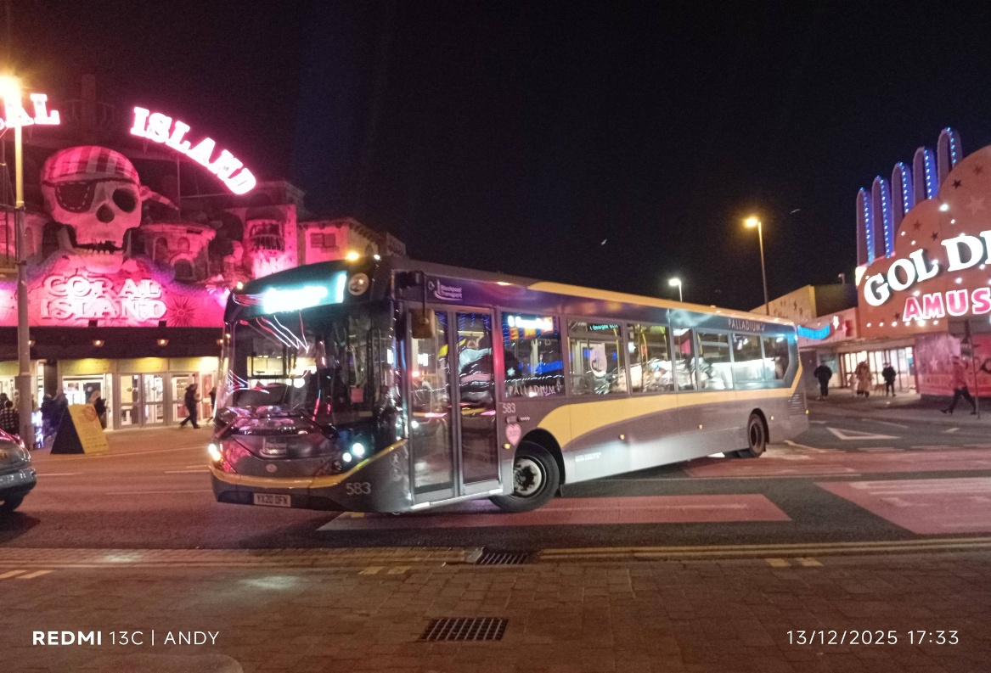
Photo credit to Andy Donald Sessford member of Garys bus and coach photos Blackpool transport 583 YX20OFN ADL Enviro200mmc.
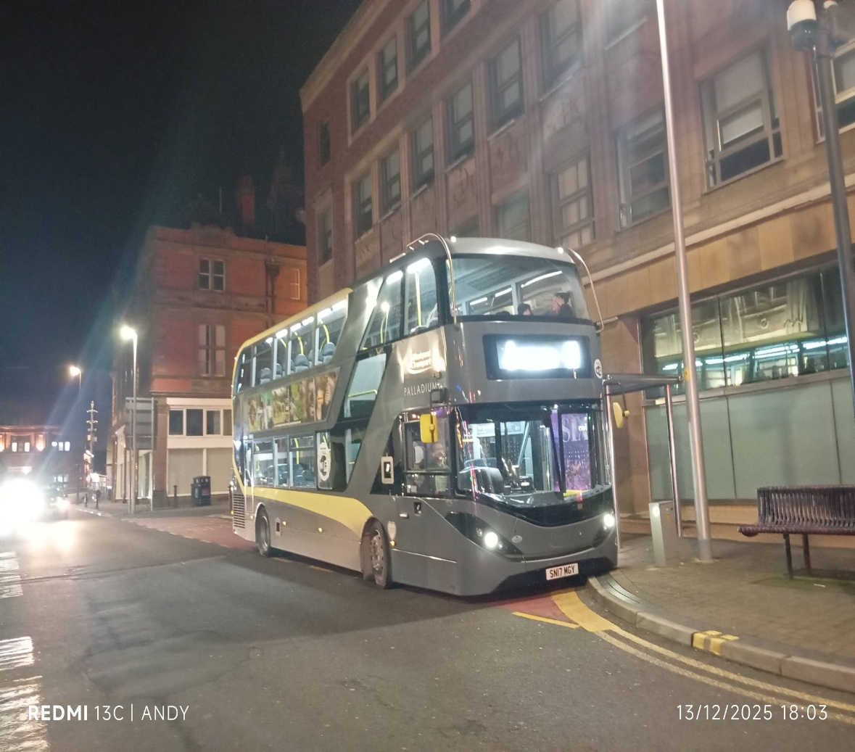
Photo credit to Andy Donald Sessford member of Garys bus and coach photos Blackpool transport 426 SN17MGY ADL Enviro400city.
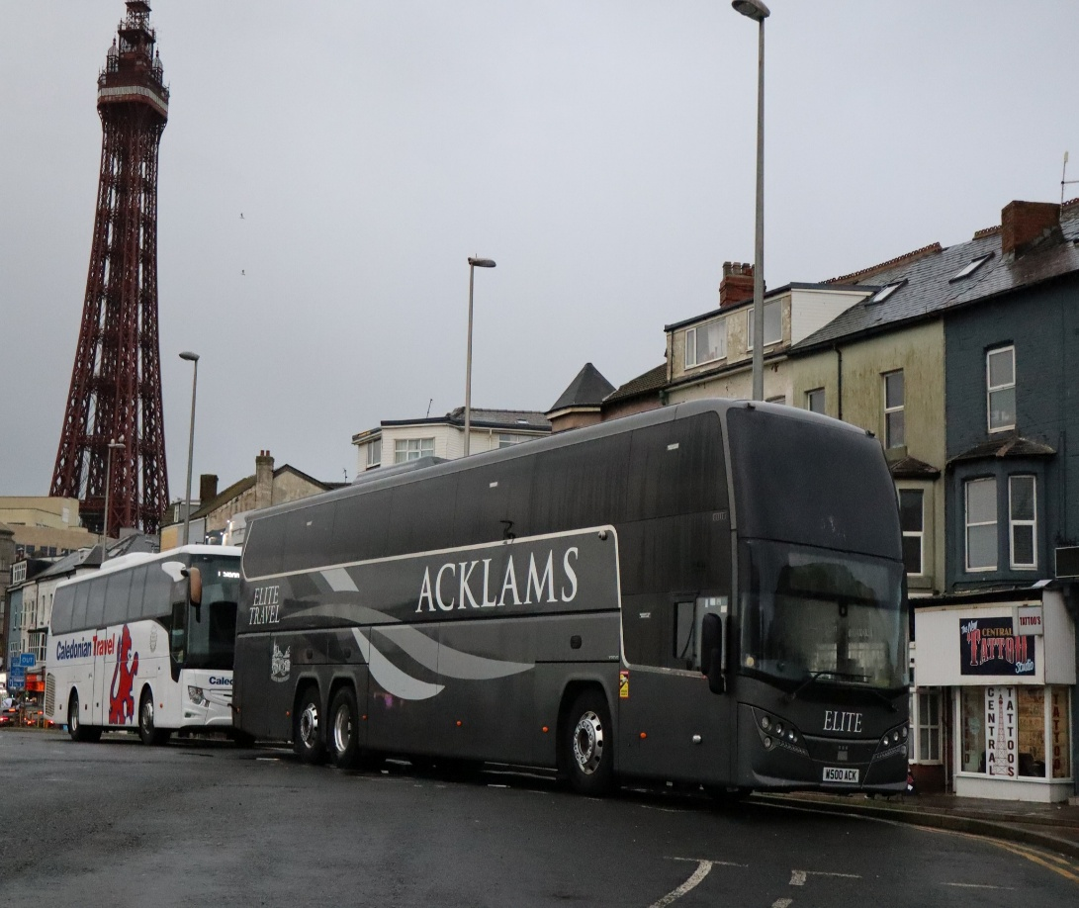
Photo credit to Alan Lockey member of Gary’s bus and coach photos: W500ACK Plaxton Elite I coach Volvo B11RT Acklam’s coaches in Blackpool.
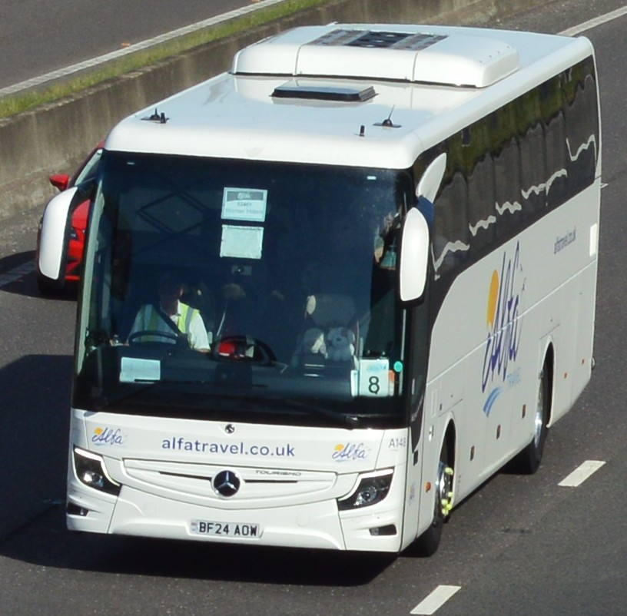
Photo credit to Barry Smith member of Gary’s bus and coach photos: A148 BF24AOW Alfa Travel Mercedes Benz Tourismo on the M1 to Barnsley.
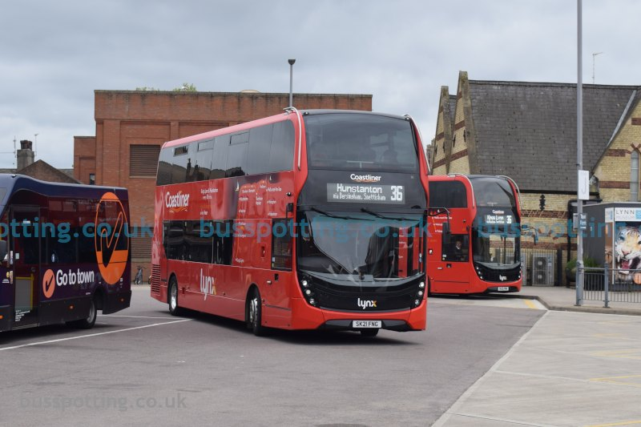
Photo credit to busspotting.co.uk member of Gary’s bus and coach photos: Lynx61 SK21FNG ADL Enviro400mmc branded Coastliner in Kings Lynn.
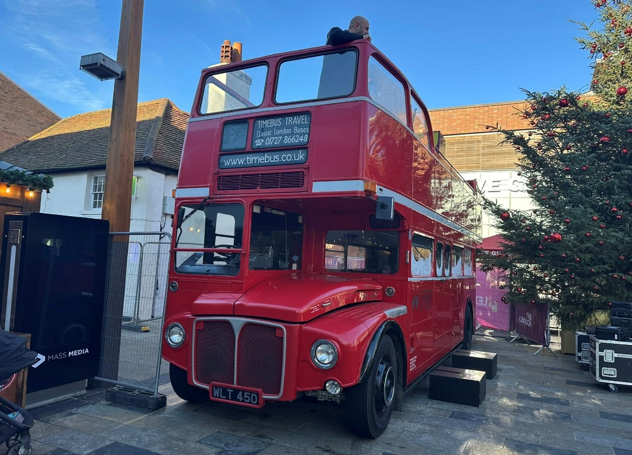
Photo credit to Gary Baxter Administration of Gary’s bus and coach photos; RM450 WLT450 London Transport Routemaster open topper at Bracknell town centre for christmas light switch on.
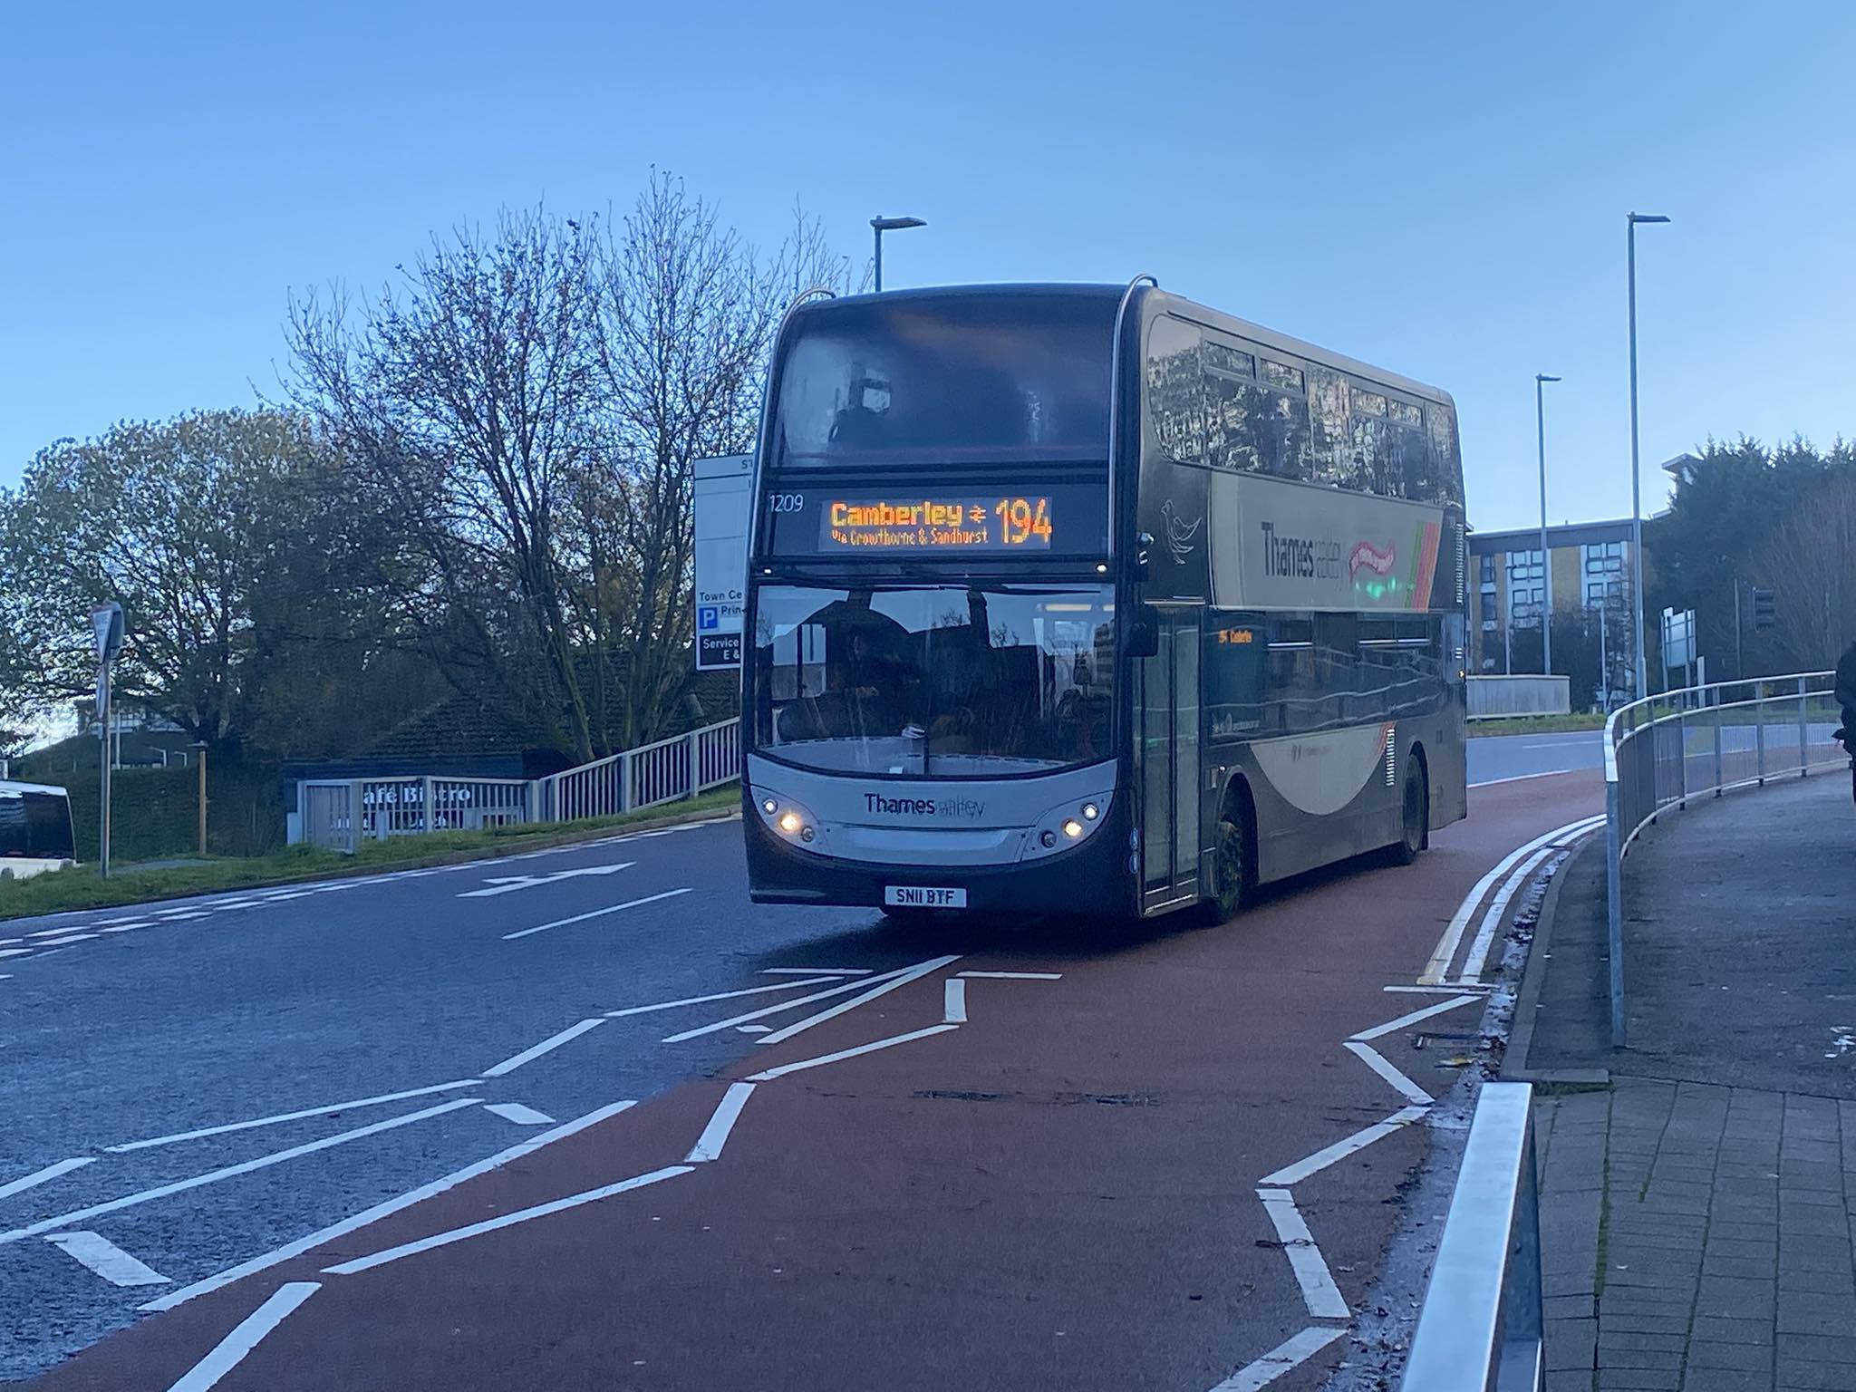
Photo credit to Hirasawa Yui member of Gary’s bus and coach photos: Thames Valley 1209 SN11BTF Enviro400 ADL arriving at Bracknell.
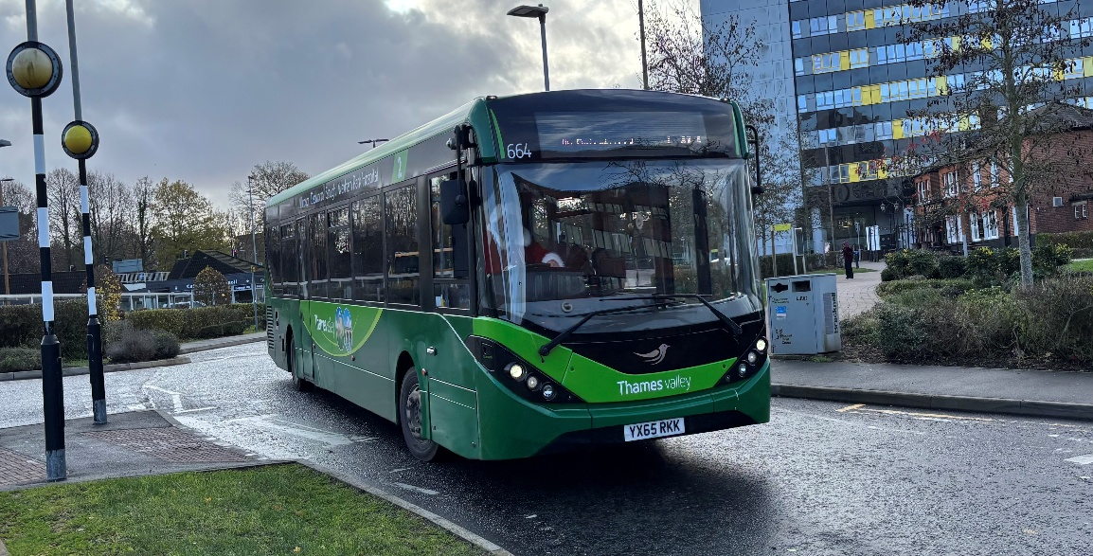
Photo credit to Robert Thompson on behalf of Theo Thompson his son members of Gary’s bus and coach photos; Thames valley 664 YX65RKK ADL Enviro200mmc.
www.facebook.com/groups/garysbusandcoachphotos
www.facebook.com/@garysbusandcoachphotos
www.flickr.com/photos/garysbusandcoachphotos

